|  |  |  |  |
| --- | --- | --- | --- |
|  |  | |  |
|  |  | |  |
|  |  | |  |
|  | **QA 4** | |  |
|  |  | |  |
|  | **C2FO plugin configuration guide for sap**  ***Version 1.0*** | |  |
|  |  |  |  |
|  |  | |  |

Document Revision, Review, & Approval History

|  |  |  |  |  |
| --- | --- | --- | --- | --- |
| Ver | date | author | reviewer/approver | remarks |
| 1.0 | June 10th,2011 | Avinash Ravipati |  | Initial version |
| 2.0 | May 3rd, 2012 | Avinash Ravipati |  | Updated inbound configuration interface, process log and error log |

Table of contents

1. configuring C2FO plugin for sap 4

1.1. Assigning C2FO plugin Configuration and Execution Authorizations 4

1.2. C2FO plugin Outbound Configuration 4

1.2.1. Saving Outbound files to FTP server 5

1.2.2. Saving Outbound files to SAP Application Server 6

1.2.3. Saving Outbound files to the Front end (PC) 6

1.2.4. Saving Outbound files to multiple locations 6

1.3. C2FO plugin Inbound Configuration 6

1.3.1. Reading Award file from FTP server 7

1.3.2. Reading Award file from SAP Application Server 8

1.3.3. Reading Award file from Front end (PC) 8

1.4. C2FO plugin Outbound Execution 8

1.4.1. Executing the Outbound Interface in Foreground 8

1.4.2. Scheduling the Outbound Interface for Background execution 9

1.5. C2FO plugin Inbound Execution 9

1.5.1. Executing the Inbound Interface in Foreground 9

1.5.2. Scheduling the Inbound Interface for Background execution 10

1.6. C2FO plugin Log Files 10

1.6.1. C2FO plugin Outbound Transaction Log 10

1.6.2. C2FO plugin Outbound System Log 11

1.6.3. C2FO plugin Inbound Application Log 12

1.6.4. C2FO Inbound Error Records Log 13

1.6.5. C2FO Inbound Process Log 13

# configuring C2FO plugin for sap

## Assigning C2FO plugin Configuration and Execution Authorizations

Generate and assign the imported role ZQUICKPAY to a user ID. This role allows the user to execute the C2FO plugin configuration program, outbound interface and inbound interface. In addition to this role, other standard authorization objects required for the user ID are as listed:

* S_DATASET
* S_GUI
* S_SPO_DEV
* S_DX_MAIN
* F_BKPF_BUK
* F_BKPF_KOA
* F_BKPF_GSB

In addition to these authorizations, maintain the decimal notation as 1,234,567.89 in the user profile settings.

## C2FO plugin Outbound Configuration

Execute the transaction ZQUICKPAY to configure the outbound interface. The outbound files will be saved to the locations configured in this transaction.

In the home screen of the configuration application, select the radio button ‘Configure Outbound Interface’ and click next.

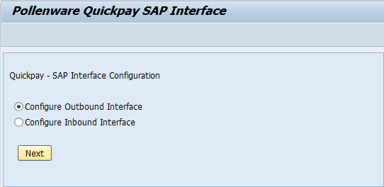

The screen ‘Outbound Interface Configuration’ provides options to save outbound files to multiple locations.

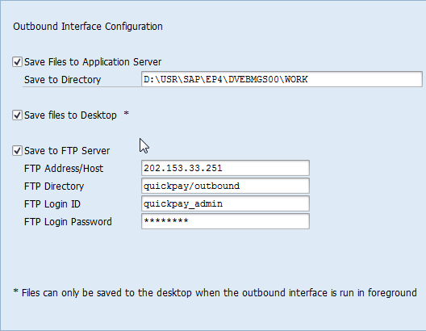

### Saving Outbound files to FTP server

By selecting the checkbox ‘Save to FTP Server’, the outbound files created by the interface program are saved to an FTP server directly.

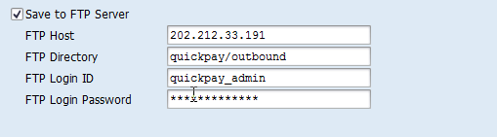

The required credentials are:

* FTP Address/Host – IP address or host name of the FTP server.
* FTP Directory – If the outbound files are required to be saved to a specific folder, provide the directory name or path name in this input field. If left blank, the outbound files are directly saved to the server.

Example: - The outbound files will be saved to the location <ftp://202.212.33.191/quickpay/outbound/> when configured as in the screen shot.

* FTP Login ID – User ID for logging in to the FTP server.
* FTP Login Password – User password for logging in to the FTP server.

### Saving Outbound files to SAP Application Server

By selecting the checkbox ‘Save Files to Application Server’, the outbound files created by the interface program are saved to a folder in the SAP application server.



By default, the ‘WORK’ directory is loaded into the input field. The outbound files can also be saved to a directory (in SAP application server) of user’s choice. However, the directory should have write permission.

### Saving Outbound files to the Front end (PC)

By selecting the checkbox ‘Save files to Desktop’, the outbound files are saved to a folder on the user’s PC when the interface program is executed.



When configured to save files to desktop, the interface program can be run in foreground alone. While executing the program, the user is prompted to select a folder path from the PC. Once the program execution is completed successfully, outbound files are transferred to the selected folder path.

### Saving Outbound files to multiple locations

The outbound interface program can also be configured to allow files to be saved to multiple locations. Any combination of the file save locations can be chosen. With these combinations, the outbound program can be executed either in foreground or scheduled to execute in background. An exception to this case is saving files to desktop. Any combination of file save locations including this option can be executed only in foreground.

## C2FO plugin Inbound Configuration

Execute the transaction ZQUICKPAY to configure the inbound interface. The award file will be read from the source as maintained in this transaction.

In the home screen of the configuration application, select the radio button ‘Configure Inbound Interface’ and click next.

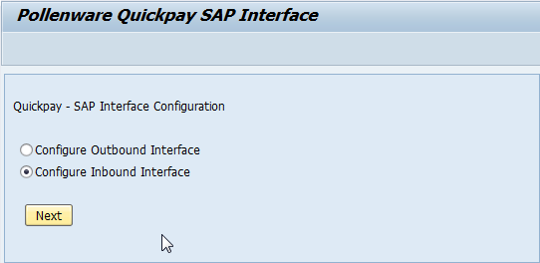

The screen ‘Inbound Interface Configuration’ provides options to read award files from multiple locations. Note that the inbound interface is programmed to read the first award file that is encountered when accessing any configured source.

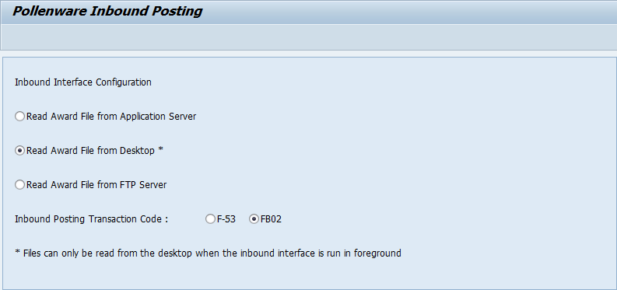

### Reading Award file from FTP server

Selecting this radio button configures the inbound interface program to read the award file from a FTP server.

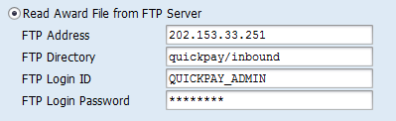

The required credentials are:

* FTP Address/Host – IP address or host name of the FTP server.
* FTP Directory – If the award file is placed in a FTP server directory. If left blank, the award file is directly read from the server.

Example: - The award file is read from location <ftp://202.153.33.251/quickpay/inbound/> when configured as in the screen shot.

* FTP Login ID – User ID for logging in to the FTP server.
* FTP Login Password – User password for logging in to the FTP server.

### Reading Award file from SAP Application Server

Selecting this radio button configures the inbound interface program to read the award file from SAP application server.



By default, the ‘WORK’ directory on SAP application server is loaded into the input field. This can be changed to another directory on the server of user’s choice. However, the directory should have read access.

### Reading Award file from Front end (PC)

Selecting this radio button configures the inbound interface to read the award file from a PC, provided by the user while executing the inbound interface program.



When configured to read the award file from desktop, the inbound interface can be executed in the foreground alone. Once the inbound interface is executed, the user is prompted to select a folder from where the award file is read.

## C2FO plugin Outbound Execution

### Executing the Outbound Interface in Foreground

User can execute the outbound interface program in foreground. Before executing the program, user is provided with a choice of filtering the data extracted.

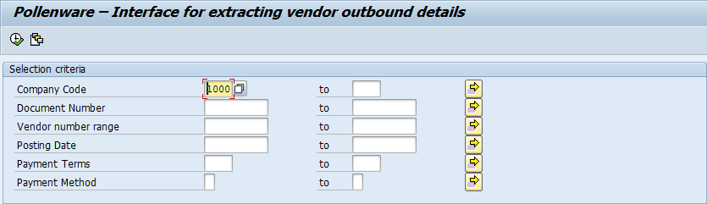

When the interface is configured to save outbound files to the front end, an additional input field appears for the user to provide a file path. On successful execution, the files are saved to the folder selected on the PC.

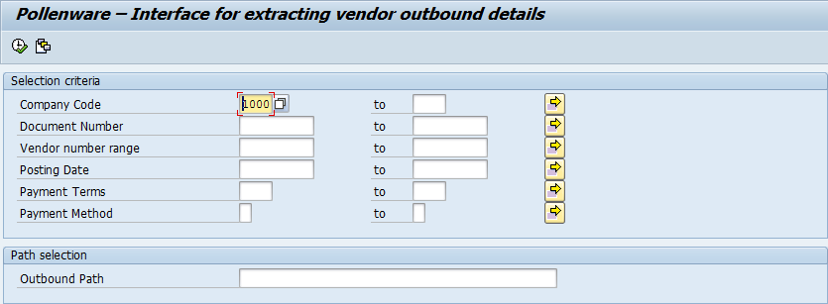

### Scheduling the Outbound Interface for Background execution

The outbound interface program can be scheduled to execute in background using any file save combination. An exception to this is saving files to desktop. Any file save combination which include saving files to desktop cannot be scheduled for execution in background.

## C2FO plugin Inbound Execution

### Executing the Inbound Interface in Foreground

User can execute the inbound interface program in foreground. The selection screen of the program provides the user with an input field for providing award file name, when configured to read from FTP or SAP application server.

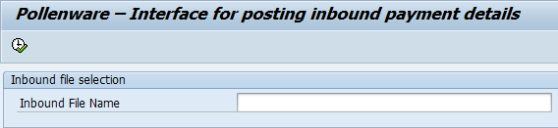

When configured to read the file from front end, the user will have to provide the folder path on the PC where award file is available along with the file name.

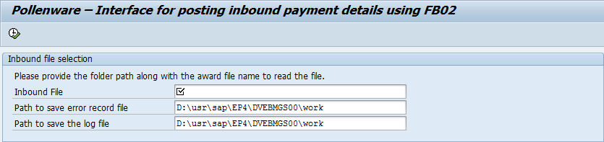

In any case, the end user is required to enter a file path on application server to save error records file and process log file. By default, both the files are saved to “DIR_HOME” on the application server.

### Scheduling the Inbound Interface for Background execution

The Inbound Interface program can be scheduled to execute in background. This is possible only when configured to read the award file either from FTP or from SAP application server.

## C2FO plugin Log Files

### C2FO plugin Outbound Transaction Log

The outbound transaction log provides details of the files created, extract process and errors if any. This log is created along with the three data files generated by the outbound interface program. The transaction log can be found in the same location to where the outbound data files are saved.

Log Details:

The log details section provides information on the system where the program was executed and user responsible.

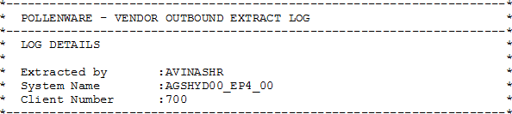

Extract File Details:

The extract file details segment contains the names of the three data files generated and the number of records contained in each file.

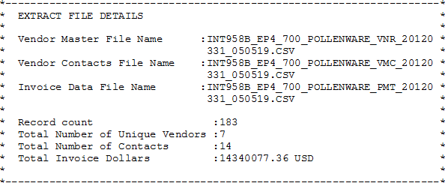

Process Details:

The process details section reports the steps executed as part of the outbound interface program run.

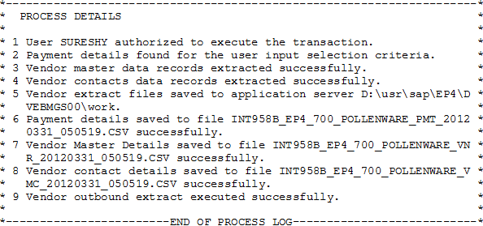

### C2FO plugin Outbound System Log

The system log provides details on the execution process of the outbound interface program, whether the process was a success or failure. A detailed systematic analysis of the extract is written to the log saved under the folder ‘WORK’ with the name VendorOutbound_AppServer_Log.rtf. The log is updated for every cycle of outbound interface program.

Log Details:

The log details section contains the user name, date and time of the program execution.

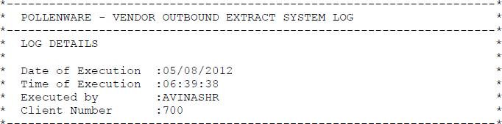

Process Details:

This section specifies the outbound interface extraction process systematically. This section of the log is similar to the extract log, only when the execution is successful. When the outbound interface fails to create files and extract log, the application log can be referred for particulars of the failure.

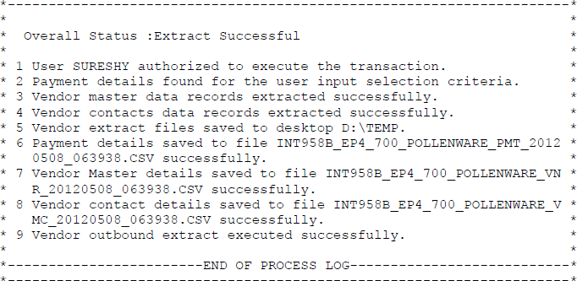

### C2FO plugin Inbound Application Log

The inbound application log provides details on the execution process of the inbound interface program. A detailed systematic analysis is written to the log and overall status, success or failure of the process is recorded. The log is saved to the file VendorInbound_AppServer_Log.rtf. The log is updated for every cycle of inbound interface program.

Log Details:

This section provides information on the vendor inbound execution. The details include the user name executing the interface, date and time of execution and the system client.

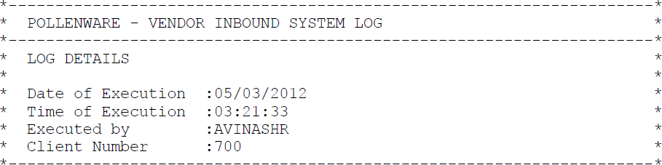

Process Details:

The process details section reports the steps carried out as part of the vendor inbound execution along with the overall status.

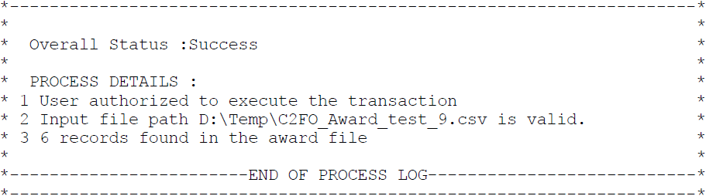

### C2FO Inbound Error Records Log

The error records log contains the records, which failed to update during inbound plugin run. Such records are collected, formatted and written to a file that is of the same structure as the award file. This log facilitates the end user to directly open the file, correct the records and execute the inbound program with minimal effort.

### C2FO Inbound Process Log

A log is written for every award file processed by the inbound plugin. This log carries information on the records passed to the plugin, error records, total value of invoices and discount provided. It also provides a step by step detail of the inbound file process.

