Configuring SAP Router in the test system:

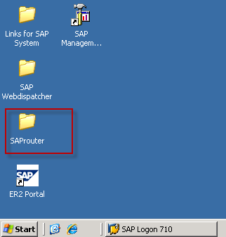

Access the folder SAProuter in the test system and open the highlighted file.

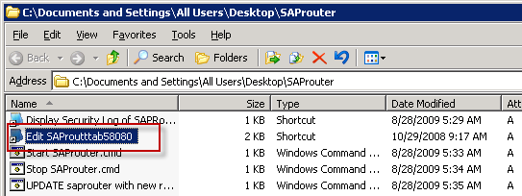

Add the set of IPs that would be accessing the server from windows GUI.

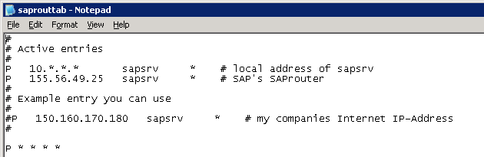

Configuring windows GUI:

Install the windows GUI on the local machine with default options selected. Once the GUI is installed successfully, run the following steps to configure and access SAP server.

Select “Connections” and click “New”.

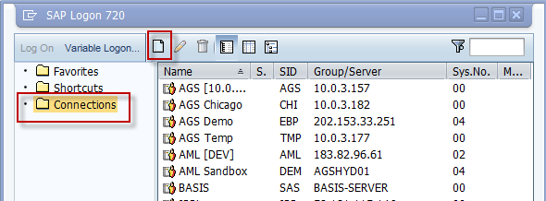

In the popup window, select “User Specified System” and click on “Next”.

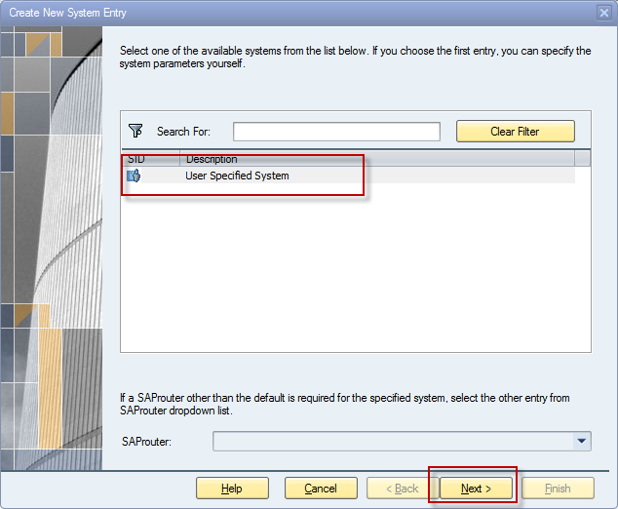

Enter the following details as shown in the screenshot,

Description: Pollenware (a name for the system connection)

Application server: sapsrv

Instance number: 20

System ID: SAP

SAP router String: pub4-158.env.cloudshare.com/S/3299

( the strings /H/ and /H/ are added automatically by the GUI)

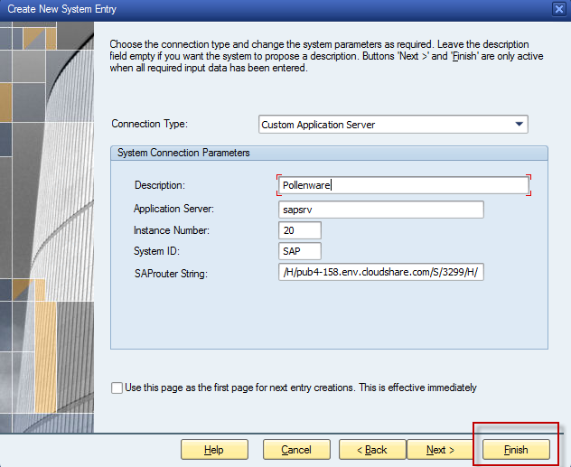

After entering the values, click “Finish” to save the configuration settings.

The system will be added to the list of connections and can be activated either by double clicking on the entry or clicking on the “Log on” push button.

