 |  | Outline Proposal Form  for Design Patterns Courses’ Project Work
Software Design Patterns Courses’ Project Work Review October 2023
Student |  | Polina Batova, Rustem Zhumabek, Igor Letunovsky
Group |  | SE-2212
Course Instructor |  | Mr. Nurtas N.K.
Topic of The Project:
The Topic: “Arkham Horror. Board game”
Working Name: “Arkham Horror”
Description:
Arkham Horror is a popular board game based on books of H.P. Lovecraft. In this game you play as an investigator that should figures out that happens in the city Arkham and save it. Investigators can travel through the city, fight with monsters, gather resources, update own skills, research clues and ward. Each investigator has own attributes like health and sanity, skills, and cards representing their asset (items, spells, allies). The game has both multiplayer and single player. However, in our project we implement only single player version. Besides, for the first steps we will omit some difficult mechanics like encounters. The game has 4 different scripts, but we will realize only one of them – Approach of Azathoth. In our project we will use different software design patterns. The interface will be realized with Java FX like a real desktop application, but at the first stage the interface will be in console.

Coding Language: Java, Java FX.
Interface: GUI
Pattern: Strategy, Singleton, Builder, Observer, Facade, State, Factory

Expected Result:
- All classes required for game are created.
- All players’ actions are available and working.
- Project is clearly working. It’s possible to start the game and make turns.
- Design Patterns are integrated
- User Friendly GUI. Desktop application.

ER Diagram
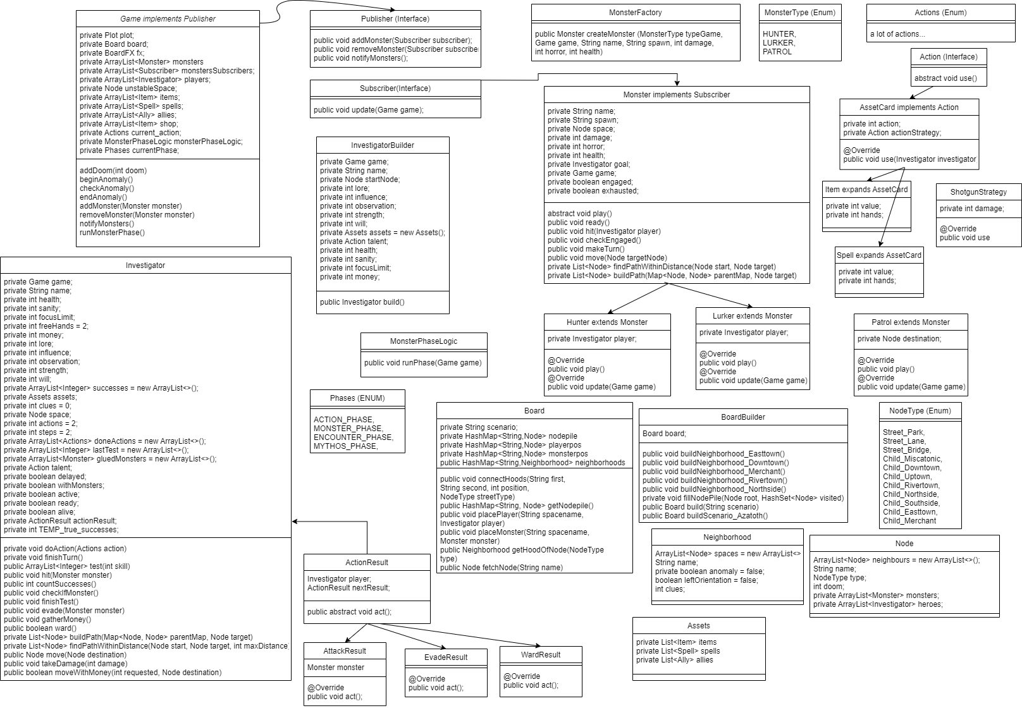
Progress (Completed)
- Created most of classes.
- The Builder pattern is implemented for a creation of an investigator.
- The Singleton pattern is implemented in order to have only one game facade.
- The Strategy pattern is implemented to allow items have different behavior.
- The Observer pattern is implemented in order to notify monsters about unstable zone.
- The Façade pattern is implemented to manipulate with the Game class.
- The State pattern is implemented to set different result of different hero’s actions.
- Movement of monsters was implemented.
- New types of monsters were added.
- The Factory method was implemented for creating different monsters;
Code/Screen your project 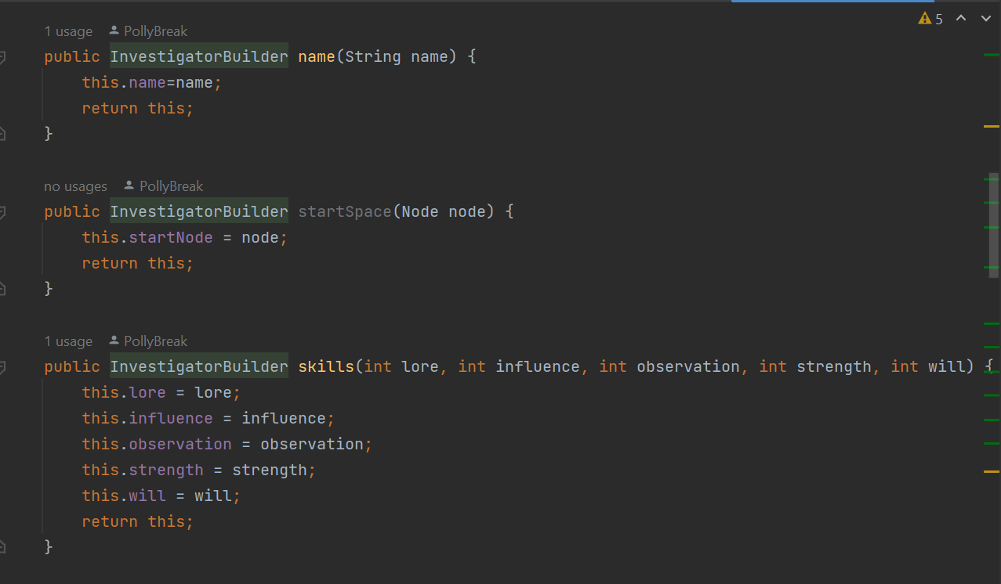
Pic. 1 - Builder Pattern
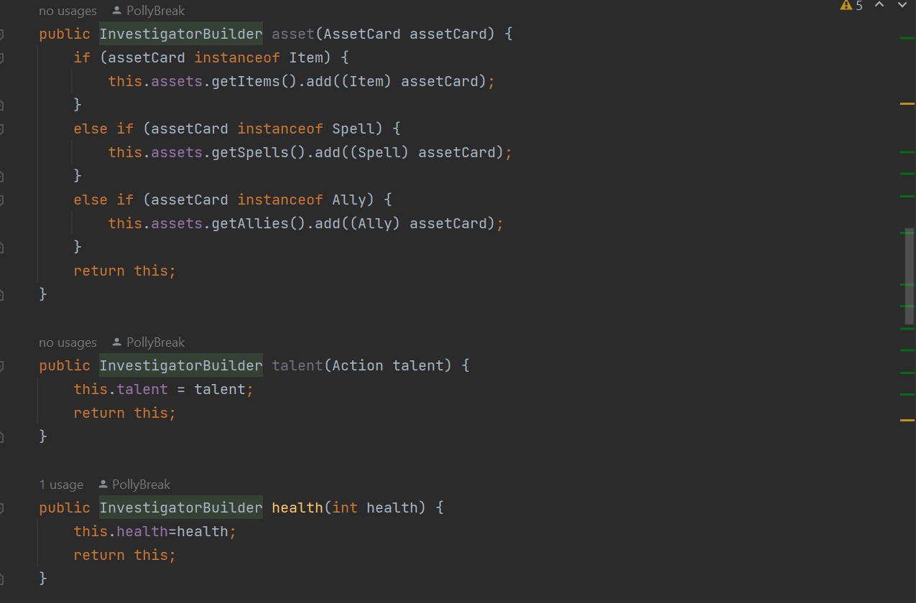
Pic. 2 - Builder Pattern 2

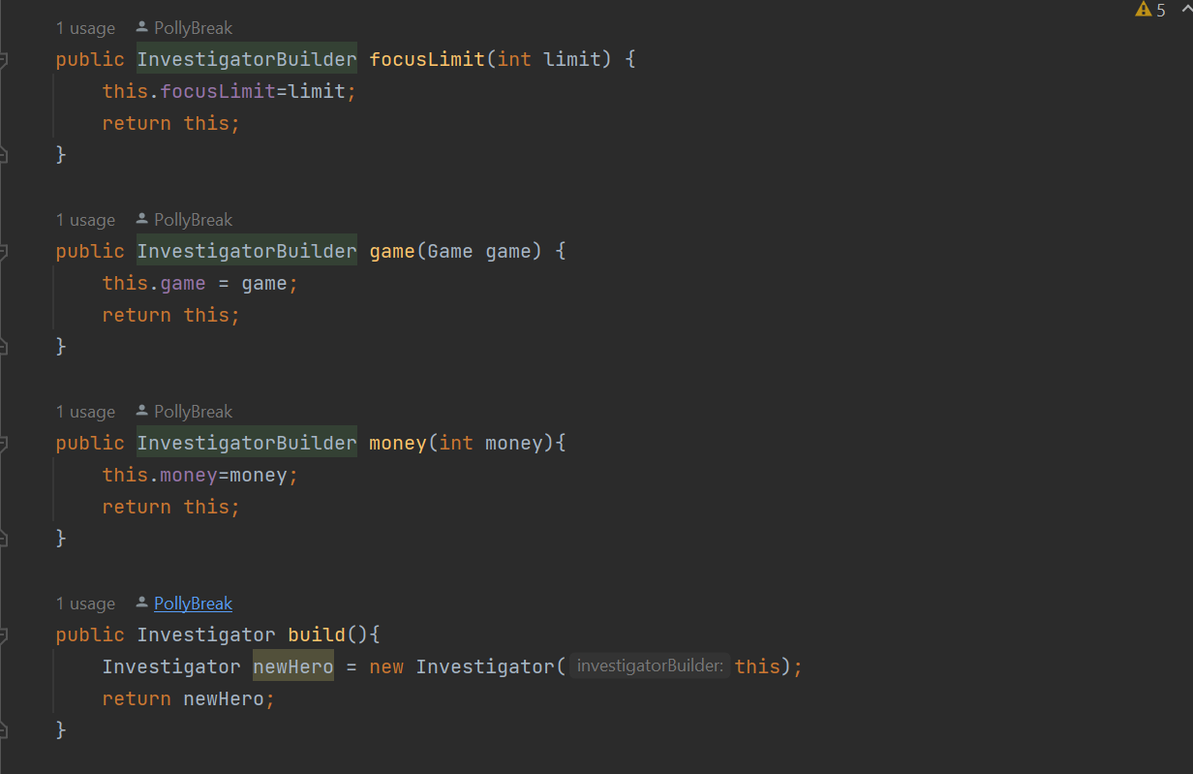
Pic. 3 - Builder Pattern 3
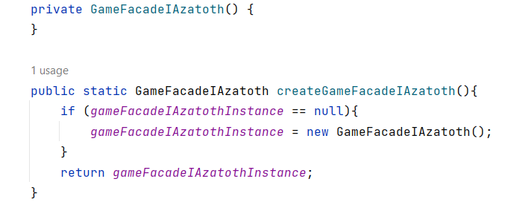
Pic. 4 - Singleton Pattern

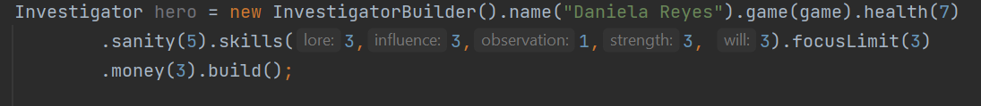
Pic. 5 –Builder Patterns - Usage

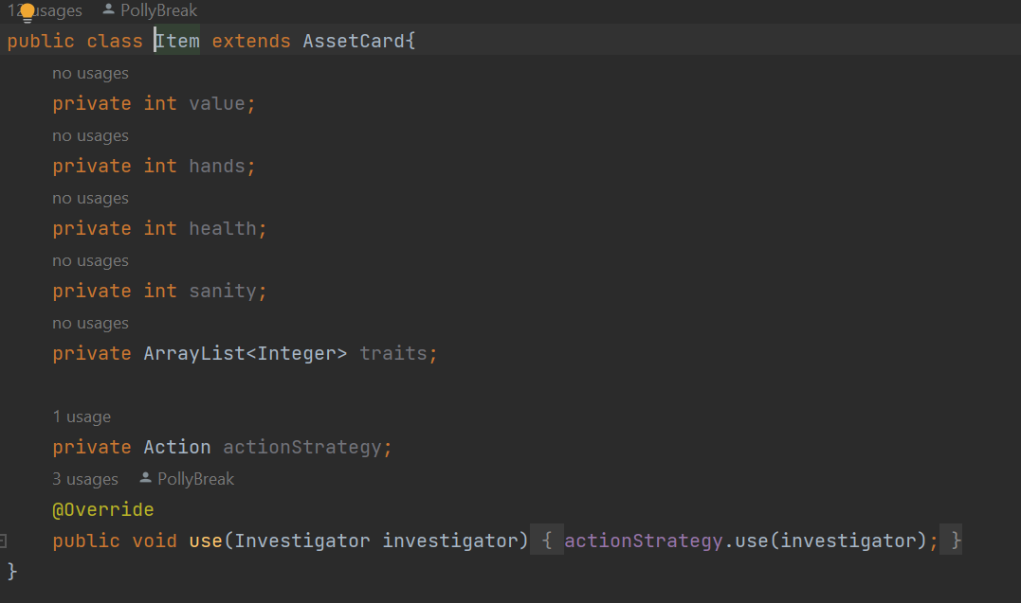
Pic. 6 – Strategy Pattern
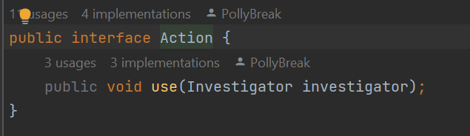
Pic. 7 – Strategy Pattern – Interface
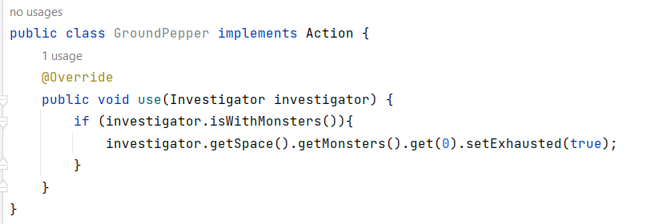
Pic. 8 – Strategy Pattern – Concrete Strategy
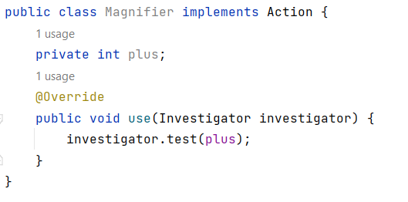
Pic. 9 – Strategy Pattern – Concrete Strategy
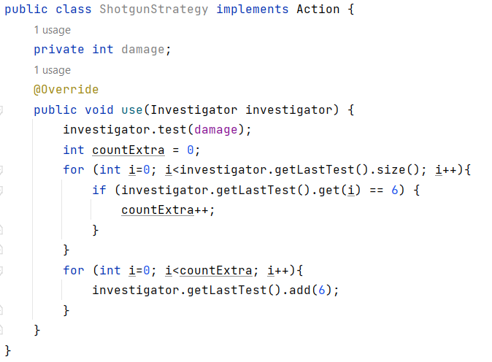
Pic. 10 – Strategy Pattern – Concrete Strategy
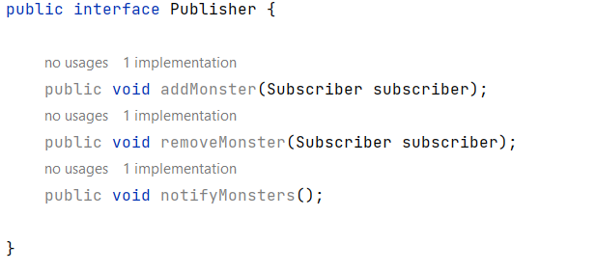
Pic. 11 – Observer Pattern
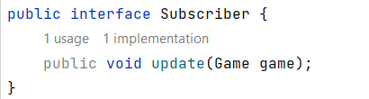
Pic. 12 – Observer Pattern
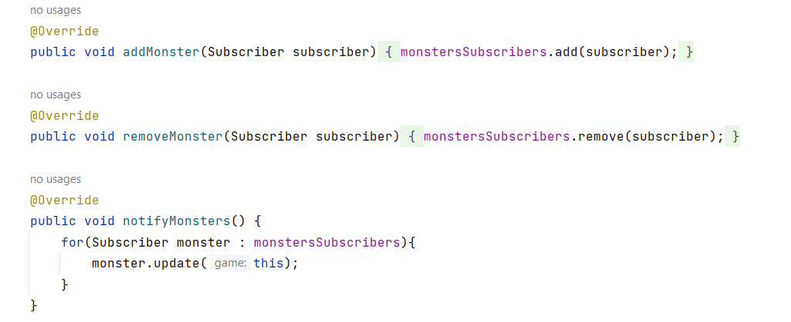
Pic. 13 – Observer Pattern – The Game class implements Publisher
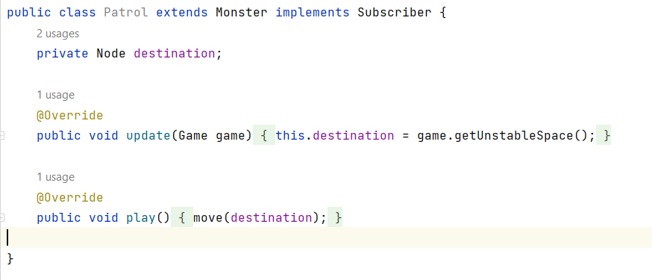
Pic. 14 – Observer Pattern – The Patrol class implements Subscriber

public interface GameFacadeInterface {
public void startGame();
}

public class GameFacadeIAzatoth implements GameFacadeInterface{
private static GameFacadeIAzatoth gameFacadeIAzatothInstance;
private Game game;
@Override
public void startGame() {
game = new Game();
BoardBuilder boarder = new BoardBuilder();
game.setBoard(boarder.build("Azatoth"));
game.setPlayers(new ArrayList<>());
game.setCurrentPhase(Phases.ACTION_PHASE);
MonsterPhaseLogic monsterPhaseLogic = new MonsterPhaseLogic();
game.setMonsterPhaseLogic(monsterPhaseLogic);
Investigator mainHero = new InvestigatorBuilder().name("Daniela Reyes").game(game).health(7)
.sanity(5).skills(3,3,1,3, 3).focusLimit(3)
.money(3).startSpace(game.getBoard().fetchNode("Arkham Advertiser")).build();
game.getPlayers().add(mainHero);
game.getBoard().placePlayer(mainHero.getSpace().getName(),mainHero);
Node monster1spawn = game.getBoard().fetchNode("Independance Square");
Monster monster1 = new Patrol(game,"Robbed Figure",
"Independance Square", monster1spawn, 1, 0, 1);
Node monster2spawn = game.getBoard().fetchNode("Black Cave");
Monster monster2 = new Patrol(game, "Robbed Figure",
"Black Cave", monster2spawn, 1, 0, 1);
game.subscribeMonsters(game.getMonsters().toArray(new Monster[0]));
game.setUnstableSpace(game.getBoard().fetchNode("Arkham Advertiser"));
game.notifyMonsters();
}
public Game getGame(){
return game;
}
private GameFacadeIAzatoth() {
}
public static GameFacadeIAzatoth createGameFacadeIAzatoth(){
if (gameFacadeIAzatothInstance == null){
gameFacadeIAzatothInstance = new GameFacadeIAzatoth();
}
return gameFacadeIAzatothInstance;
}
}
Pic. 15 – Facade Pattern
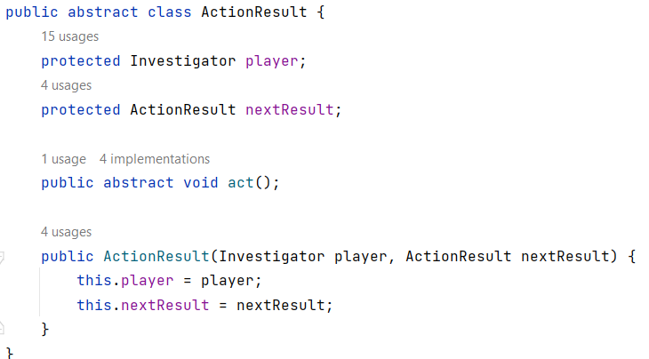
Pic. 15 – State Pattern. Abstract class
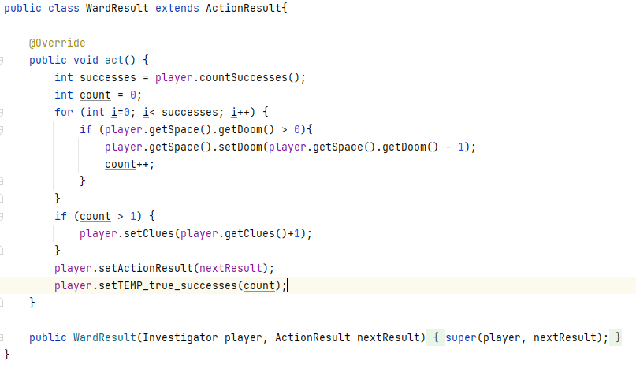
Pic. 16 – State Pattern. WardResult
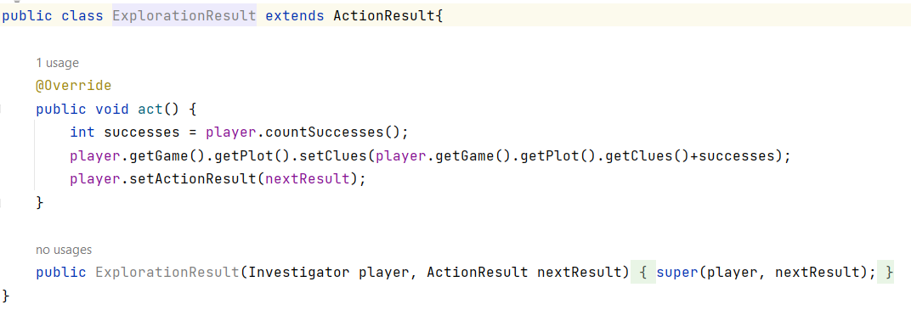
Pic. 17 – State Pattern. ExplorationResult
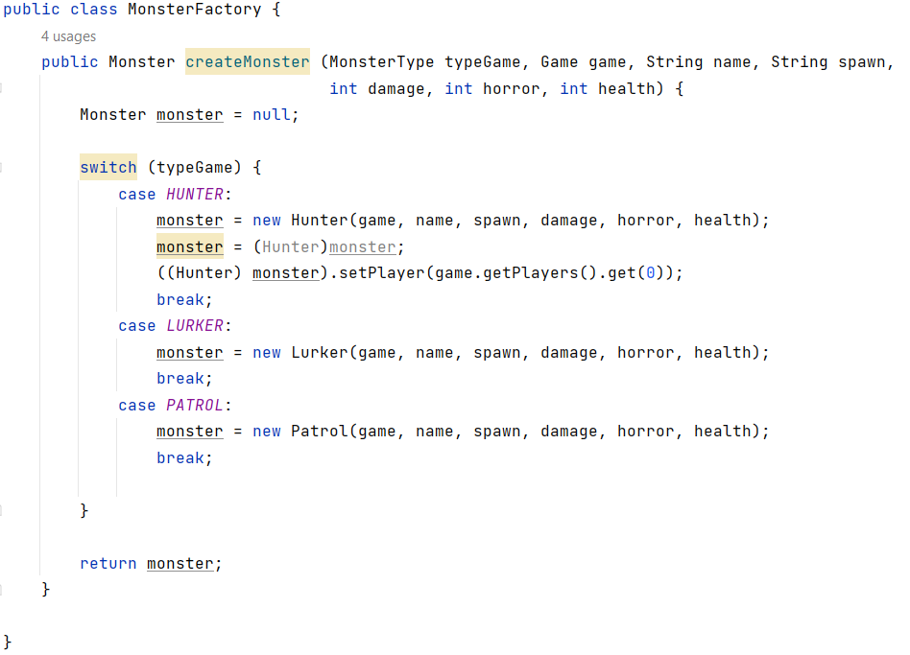
Pic. 18 – Factory Pattern. MonsterFactory

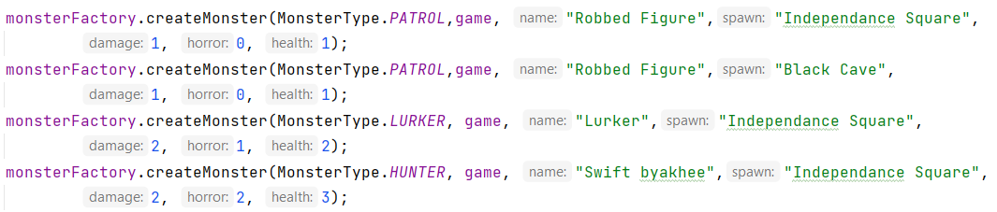
Pic. 19 – Factory Pattern. Use of factory

Github: https://github.com/PollyBreak/ArkhamHorror-Client
Presentation: https://www.canva.com/design/DAF0zswvHcA/BAIHrf3AmvmJNrK4UMIahw/edit?utm_content=DAF0zswvHcA&utm_campaign=designshare&utm_medium=link2&utm_source=sharebutton

