Table of Contents

Cancer Immunotherapies: Mechanisms, Toxicities & Management 2

Cancer Immunotherapies: Mechanisms, Toxicities & Management 4

Immune Checkpoint Inhibitors (ICIs) 4

Bispecific T-cell Engagers (BiTEs) 4

Chimeric Antigen Receptor T-Cell (CAR-T) Therapy 4

Advances in Immunotherapy in Gynecological Cancers 6

Endometrial Cancer 6

Cervical Cancer 6

Epithelial Ovarian Cancer 7

Gestational Trophoblastic Neoplasia 7

Advances in Immunotherapy in Gynecological Cancers – Refined Notes 8

Endometrial Cancer (EC) 8

Cervical Cancer (CC) 8

Epithelial Ovarian Cancer (EOC) 8

Gestational Trophoblastic Neoplasia (GTN) 9

Utility of Circulating Tumour DNA in Cervical Cancer: Early Detection and Disease Monitoring 10

Cervical Cancer Screening 10

Trials 10

Liquid Biopsy in Cervical Cancer 10

Cheap vaccines could prevent millions of deaths from cervical cancer 11

Utility of Circulating Tumour DNA in Cervical Cancer: Early Detection and Disease Monitoring –– Refined Notes 12

Cervical Cancer Screening & Prevention: Current Landscape 12

Liquid Biopsy & ctDNA Fundamentals in Cervical Cancer 12

HPV Biology & Integration: Relevance to ctDNA Detection 12

ctDNA Detection Methods: Technical Considerations 12

Key Clinical Insights from ctDNA Studies (e.g., HPV16/18 Study) 13

VI. Challenges & Future Directions 13

Antibody Drug Conjugates in Gynaecologic Cancers 14

Antigens in Ovarian Cancer 14

Only 3 microtubular inhibitor?? 14

Antibody Drug Conjugates in Gynaecologic Cancers –– Refined Notes 15

ADC Core Components 15

Approved ADCs in Gynecologic Cancers 15

Key Clinical Insights 16

# Cancer Immunotherapies: Mechanisms, Toxicities & Management

* High toxicity
* Low dose anti-pd1 🡪 cheaper + less side effect + still effective
* Immune related adverse events

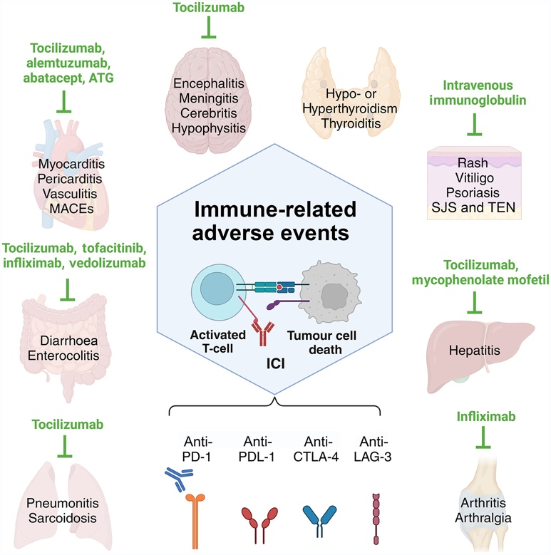

Bispecific t-cell engager (BiTE)

* Brings t-cells by binding CD3 to target cells expressing TAA
* Not via TCR and HLA
* Not classical immunological response

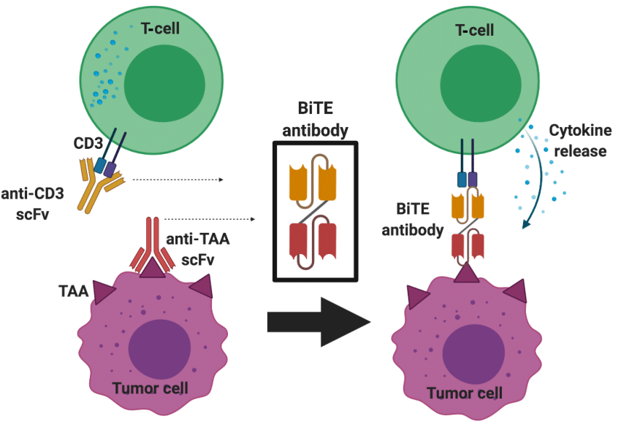

CAR-T cells

* Chimeric receptor made from combining TCR and BCR
* Cytokine release syndrome ––– co-stimulatory molecule stimulating cytokine release syndrome just 2 days upon infusing CAR-T
  + More of a local issue?
  + Activate other immune cells in local tumor microenvironment, sometimes spillover effect to systematic
* Management of Immune-Related Adverse Events in Patients Treated With Chimeric Antigen Receptor T-Cell Therapy: ASCO Guideline
* CARTOX app ––– an app that estimate the tumor grade and treatment recommended given patient information.
* Things similar to local CRS
  + Pseudo-progression with checkpoint inhibitors (PD-1)
    - Biopsy of that lesion showed that the clusters are CD8 and CD3 positive cells.
    - Mass arose because of clustering of T-cells
  + Tumor-flare with bi/tri-specific antibodies
* Example: destroy of entire nasal cavity from CRS.
* Continuation of CRS is Hemophagocytic Lymphohistiocystosis (HLH)
* Lympho-depletions by Bendamustine and Flu-Cy?? Use immunosuppressive cells to remove T- and B-cells before giving CAR-T therapies. However Bendamustine leads to less Cytopenia and is therefore preferred.

# Cancer Immunotherapies: Mechanisms, Toxicities & Management

### Immune Checkpoint Inhibitors (ICIs)

#### Mechanism:

1. Block inhibitory receptors (e.g., PD-1, CTLA-4) on T-cells, "releasing the brakes" on anti-tumor immunity.

#### Toxicity (Immune-Related Adverse Events - irAEs):

1. Nature: Off-target autoimmunity due to unleashed T-cell activity against healthy tissues.
2. Spectrum: Can affect **any** organ system (dermatitis, colitis, hepatitis, pneumonitis, endocrinopathies, nephritis, neurological, cardiac).
3. Onset: Typically delayed (weeks to months after starting therapy).
4. Grading: Crucial for management (Grade 1-4).

#### Low-Dose Anti-PD-1 Concept:

1. Inaccuracy: "Cheaper + less side effect + still effective" is an oversimplification. While some studies explore lower/fixed doses for cost reduction, standard dosing is based on extensive clinical trial evidence for efficacy and safety.
2. Reality: Dose reduction is primarily a strategy for **managing severe irAEs**, not a first-line approach for cost/toxicity. Efficacy at significantly lower doses across all indications isn't universally proven.
3. Toxicity Not Always "High": Severity varies greatly between agents (CTLA-4 generally > PD-1/PD-L1), patients, and indications. Many patients tolerate well; vigilance and early intervention are key.

#### Management:

1. Corticosteroids are first-line for moderate-severe irAEs. Refractory cases may require additional immunosuppressants (e.g., infliximab, mycophenolate).

### Bispecific T-cell Engagers (BiTEs)

#### Mechanism

1. Recombinant antibodies with two binding arms: one binds CD3ε on T-cells, the other binds a Tumor-Associated Antigen (TAA) on cancer cells. Directly bridges T-cells to tumor cells, independent of TCR recognition and MHC presentation.
2. “Non-Classical" Clarification: While it bypasses specific TCR-MHC interaction, it absolutely induces a classical effector T-cell response (cytotoxicity, cytokine release) once the bridge is formed. The "non-classical" aspect is the method of T-cell engagement.

#### Key Features:

1. Redirection: Forces T-cells to recognize tumor via the TAA.
2. HLA-Independent: Effective even if tumor downregulates MHC.
3. Off-the-Shelf: Unlike CAR-T, readily available.

#### Toxicities:

1. Cytokine Release Syndrome (CRS): Systemic inflammation from T-cell activation (fever, hypotension, hypoxia) - **common and often dose-limiting**.
2. Immune Effector Cell-Associated Neurotoxicity Syndrome (ICANS): Neurological symptoms (confusion, aphasia, seizures).
3. On-Target Off-Tumor: Toxicity to normal cells expressing low levels of the TAA.
4. Tumor Lysis Syndrome (TLS): With rapidly responding, bulky disease.
5. Infection Risk: Due to T-cell exhaustion/cytopenia and immunosuppression for toxicity management.

### Chimeric Antigen Receptor T-Cell (CAR-T) Therapy

#### Mechanism (Correction).

1. CARs are synthetic receptors, not direct combinations of TCR and BCR.
2. Extracellular Domain: Single-chain variable fragment (scFv) derived from an antibody (BCR-like for antigen binding).
3. Hinge/Spacer: Provides flexibility.
4. Transmembrane Domain: Anchors receptor.
5. Intracellular Signaling Domains:
   1. Primary: CD3ζ chain (TCR-like for activation signal 1).
   2. Costimulatory Domain(s): CD28 or 4-1BB (signal 2 for full activation/persistence).

#### Side Effects:

1. Cytokine Release Syndrome (CRS):
   1. Mechanism: Massive activation of infused CAR-T cells and bystander immune cells (macrophages, monocytes) → hyperinflammatory cytokine storm (IL-6, IFN-γ, GM-CSF dominant).
   2. Onset: Typically 1-14 days post-infusion, peaking around day 7 (not "just 2 days" - that's very early/atypical).
   3. Nature (Correction): Primarily systemic, not local. While initiated by CAR-T activity in tumor/tissues, cytokines rapidly enter circulation causing systemic effects (fever, hypotension, capillary leak, multiorgan dysfunction). "Spillover" is the rule, not the exception.
   4. Severe Example: Profound inflammation can cause devastating tissue damage (e.g., "destroy of entire nasal cavity" reflects uncontrolled local/systemic inflammation).
   5. Management: Tocilizumab (anti-IL-6R) +/- corticosteroids. Supportive care (fluids, vasopressors, oxygen).
2. HLH Relationship (Correction): HLH is NOT a direct continuation of CRS. It is a distinct, life-threatening hyperinflammatory syndrome driven by defective cytotoxic lymphocyte function (NK/T-cell). Severe CRS can trigger secondary HLH ("CRS-HLH" or "HLH-like"), especially with underlying immune dysregulation/genetic predisposition. HLH requires different, more aggressive therapy (e.g., etoposide, anakinra, emapalumab). Differentiate using HLH-2004 criteria (ferritin >10,000, cytopenias, splenomegaly, hemophagocytosis, etc.).
3. Lymphodepletion (LD):
   1. Purpose: Deplete host lymphocytes (T-regs, endogenous T-cells) to reduce competition for homeostatic cytokines (IL-7, IL-15), enhancing CAR-T expansion/persistence. Also reduces tumor burden.
   2. Regimens: Fludarabine + Cyclophosphamide (Flu/Cy) is the standard backbone due to robust efficacy data.
   3. Bendamustine is an alternative, particularly if contraindications to Flu/Cy exist.
4. Cytopenia Comparison (Clarification): Both Flu/Cy and Bendamustine cause significant cytopenias (neutropenia, lymphopenia, thrombocytopenia). Bendamustine may cause less prolonged neutropenia in some contexts compared to Flu/Cy, but both are profoundly immunosuppressive. Bendamustine is not universally preferred; choice depends on disease, protocol, and patient factors.
5. Other Toxicities:
   1. ICANS: Neurological toxicity distinct from CRS.
   2. Prolonged Cytopenias: Due to LD, CAR-T effects, or bone marrow suppression.
   3. Hypogammaglobulinemia: B-cell aplasia (especially with CD19-targeted CAR-T).
   4. On-Target Off-Tumor: Damage to normal cells expressing the target antigen.
   5. Infection: Significant risk due to LD, CAR-T effects, and immunosuppression for toxicity.
6. Management Guidelines & Tools:
   1. ASCO Guideline: Provides evidence-based recommendations for managing irAEs (including CRS/ICANS) post CAR-T therapy.
   2. CARTOX App: Primarily the CARTOX-10 (or 12) scoring system for grading neurological toxicity (ICANS), not estimating tumor grade. It assesses 10 domains (orientation, naming, following commands, writing, attention, etc.). Other apps/protocols exist for CRS grading (e.g., ASTCT consensus).
7. Phenomena Similar to Localized Inflammation:
   1. Pseudo-progression (ICIs): Apparent tumor growth on imaging due to immune cell infiltration (CD8+/CD3+ T-cells, macrophages), edema, necrosis. Biopsy confirmation is key. Not directly CRS, but a manifestation of immune activation within the tumor.
   2. Tumor Flare (Bi/Trispecifics): Transient worsening of tumor-related symptoms (pain, swelling) shortly after starting therapy, likely due to local inflammation/immune cell recruitment. Represents an acute, localized inflammatory response analogous to the initiating phase of CRS but often confined to tumor sites.

**Key Takeaways & Corrections:**

* Low-Dose Anti-PD1: Not a standard efficacy/cost strategy; dosing based on trials.
* BiTE Mechanism: Induces classical T-cell killing, just via redirected engagement (non-MHC).
* CAR Structure: Synthetic fusion, not TCR+BCR hybrid.
* CRS: Systemic (not local), peak ~day 7 (not day 2).
* HLH: Distinct entity triggered sometimes by severe CRS, not its continuation.
* Lymphodepletion: Flu/Cy is standard; Bendamustine is an alternative causing significant (though potentially less prolonged) cytopenia.
* CARTOX: Primarily for ICANS grading, not tumor grading.
* Pseudo-progression (ICIs) & Tumor Flare (BiTEs): Manifestations of local immune activation/inflammation, conceptually related to but distinct from systemic CRS.
* Toxicity Management: Guidelines (ASCO) and tools (CARTOX scoring) are essential.

# Advances in Immunotherapy in Gynecological Cancers

### Endometrial Cancer

#### dMMR Endometrial Carcinoma

* Subtype of endometrial cancer characterized by a deficiency in the DNA mismatch repair (MMR) system, leading to microsatellite instability (MSI).
* 25-30% of endometrial cancers are dMMR.
* This deficiency affects the tumour’s ability to repair DNA errors, resulting in a higher mutation rate and increased neoantigen load.

#### IO after IO?

In cancer treatment, "IO after IO?" refers to the concept of rechallenging with immunotherapy (IO) after a patient has previously received and progressed on an IO-based regimen.

#### Sequence immunotherapy remain high interest.

Sequence immunotherapy refers to the strategic order in which different immunotherapies are administered, either alone or in combination with other therapies like targeted therapy.

* PARP inhibitors
* HER2 therapy and HER2 ADC
* TROP2 ADC
* Bevacizumab
* IO combinations ––– CTLA4 + TIGIT etc…

### Cervical Cancer

#### Pembrolizumab (primary) + Cemiplimab (recurrent)

* CPS ≥ 1 patients experience more benefits
* Pembrolizumab + Chemotherapy = better treatments compared to chemotherapy alone.

#### Current Paradigm of Cervical Cancer Treatment

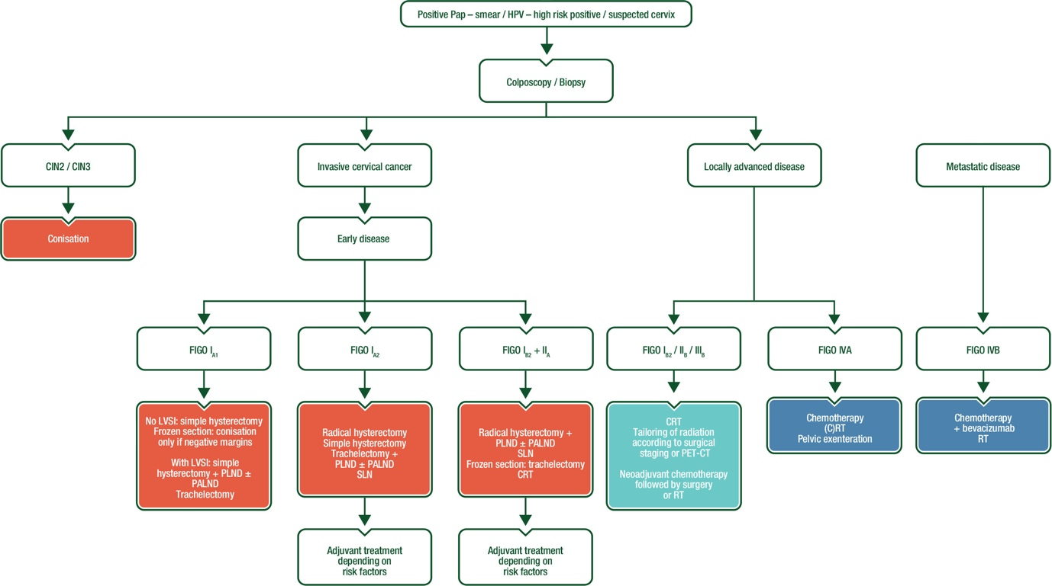

#### Future Opportunities

* Immunotherapy combinations
  + TIGIT + PDL1
  + Anti-CTLA4 + PDL1
* TILS therapy ± pembrolizumab
* Novel IO combinations –– reignite immune system to activate it.
  + Tisotumab vedotin + Penbrolizumab
  + Sac-TMT + Pembrolizumab

### Epithelial Ovarian Cancer

#### Background

* Immunosuppressive microenvironment
* Trials show no clear benefit to add checkpoint inhibitor to frontline EOC
  + ATHENA trial
  + KEYLYNK
  + ARTISTRY 7: Nemvaleukin + pembrolizumab –– not continued because no effect
  + KEYNOTE B96 –– no data so far (chemo + pembrolizumab)

#### Future Opportunities

* Biomarker Selections?
  + TMB/dMMR – tumur agnostic approval
  + CPS/TPS
  + ARID1A
* OVATION-2: IL-2 gene immunotherapy –– promising?
* CAR-T therapy
* Approach

### Gestational Trophoblastic Neoplasia

#### Background

* Expression of PD-L1 from staining
* Camrelizumab + apatinib –– high response rate in 55%

#### Trials

* TROPHIMMUM Phase 2 trial with Avelumab + Methotrexate
  + hGC normalisation in 96%?
  + No relapse after treatment discontinuation
  + PD1 and PD-L1

# Advances in Immunotherapy in Gynecological Cancers – Refined Notes

### Endometrial Cancer (EC)

#### dMMR/MSI-H Endometrial Carcinoma:

1. Definition: Subtype deficient in DNA mismatch repair (dMMR), leading to high microsatellite instability (MSI-H). Results in high tumor mutational burden (TMB-H) and neoantigen load.
2. Prevalence: ~25-30% of ECs, more common in non-endometrioid histologies but significant in endometrioid.

#### Established IO:

1. 1st Line Advanced: Pembrolizumab + Lenvatinib (KEYNOTE-775/Study 309) - Approved for all comers (dMMR/pMMR), but magnitude of benefit is largest in dMMR/MSI-H.
2. 2nd Line+ Advanced:
   1. Pembrolizumab (KEYNOTE-158) - FDA-approved for any TMB-H (≥10 mut/Mb) or dMMR/MSI-H solid tumors (including EC).
   2. Dostarlimab (GARNET) - FDA-approved for dMMR/MSI-H recurrent/advanced EC progressing on prior platinum.

#### "IO after IO?" / Sequencing Immunotherapy:

1. Concept: Re-challenging or sequencing different immunotherapies after progression on prior IO. Highly complex and investigational.
2. 12 months?
3. Challenges: Primary/acquired resistance mechanisms (e.g., T-cell exhaustion, alternative immune checkpoints, suppressive microenvironment).
4. Potential Strategies (Under Investigation):
   1. Switching IO classes (e.g., PD-1/PD-L1 → CTLA-4 → LAG-3 → TIGIT).
   2. IO + Targeted Agents: PARP inhibitors (esp. in HRD+), HER2 ADCs (Trastuzumab deruxtecan - DESTINY-PanTumor02), TROP2 ADCs (Sacituzumab govitecan), VEGF inhibitors (Bevacizumab).
   3. Novel IO Combinations: PD-1/PD-L1 + CTLA-4 (DUO-E trial - Durvalumab + Chemo ± CTLA-4 tremelimumab in 1L), PD-1/PD-L1 + TIGIT (SKYSCRAPER-03 - Tiragolumab + Atezolizumab in 1L maintenance), PD-1/PD-L1 + LAG-3.

#### Key Trials:

1. RUBY Part 2 (Dostarlimab + Chemo ± TSR-042 [anti-LAG-3] in 1L)
2. NRG-GY018 (Pembrolizumab + Chemo in 1L - dMMR/MSI-H cohort showed remarkable PFS benefit).

### Cervical Cancer (CC)

#### Established IO:

1. Recurrent/Metastatic:
   1. Pembrolizumab + Chemotherapy ± Bevacizumab (KEYNOTE-826) - Standard of Care 1L for CPS ≥1. Significant OS/PFS benefit vs chemo ± bev.
   2. Cemiplimab (EMPOWER-Cervical 1) - Approved 2L+ for PD-L1+ (CPS ≥1) tumors after chemo.
   3. Pembrolizumab (KEYNOTE-158) - Approved 2L+ for TMB-H (≥10 mut/Mb) tumors.
2. Neoadjuvant/Palliative: Pembrolizumab + CRT (CALLA trial) - Did not meet primary endpoint for PFS improvement in locally advanced CC.

#### Future Opportunities:

1. IO Combinations:
   1. PD-1/PD-L1 + CTLA-4: Balstilimab + Zalifrelimab (Phase 2 showed activity, Phase 3 ongoing).
   2. PD-1/PD-L1 + TIGIT: SKYSCRAPER-04 (Tiragolumab + Atezolizumab) failed in 1L recurrent/metastatic CC. Other TIGIT combos still in earlier phases.
2. Adoptive Cell Therapy:
   1. TILs ± Pembrolizumab (Phase 2 Innovate trial - promising ORR in chemo-refractory CC).
3. Novel IO Combinations:
   1. Tisotumab Vedotin (TF-directed ADC) + Pembrolizumab (innovaTV 205 trial - promising activity).
   2. Sacituzumab Govitecan (TROP2 ADC) + Pembrolizumab (Phase 1/2 trials ongoing).
   3. Bispecific Antibodies (e.g., targeting CD3 x TAAs).
4. Reigniting Immunity: Strategies to overcome suppressive TME (e.g., targeting TGFβ, adenosine, myeloid cells).

### Epithelial Ovarian Cancer (EOC)

#### Background

1. Highly immunosuppressive TME; modest single-agent IO activity; biomarker selection critical.
2. Frontline IO Trials (Mostly Negative):
   1. IMagyn050 (Atezolizumab + Chemo/Bev → Atezolizumab + Bev maintenance): No PFS/OS benefit in overall population or PD-L1+ subgroups.
   2. ATHENA-Mono (GARNET; Dostarlimab maintenance after 1L chemo): No significant PFS benefit in overall ITT population. Exploratory analysis suggested benefit in BRCA-mut and HRD+ subgroups? (Data immature).
   3. KEYLYNK-001 (Olaparib ± Pembrolizumab maintenance after 1L chemo in non-BRCA-mut): No PFS benefit.
   4. JAVELIN Ovarian 100 (Avelumab + Chemo → Avelumab maintenance): No PFS benefit.
   5. ARTISTRY-7 (Nemvaleukin [IL-2 variant] ± Pembrolizumab): Discontinued due to lack of efficacy.
   6. KEYNOTE-B96 (Pembrolizumab + Chemo vs Chemo in 1L): Awaiting results.

#### Niche Success:

1. dMMR/MSI-H or TMB-H: Pembrolizumab/Dostarlimab (Tumor-agnostic approvals).

#### Future Opportunities:

1. Biomarker Selection: Critical for success beyond dMMR/TMB-H.
   1. Refined PD-L1 (CPS/TPS): Still unclear cut-off.
   2. Homologous Recombination Deficiency (HRD): Includes BRCA1/2 mutations & genomic instability. PARPi are standard; IO+PARPi combos (e.g., MEDIOLA, TOPACIO/KEYNOTE-162 - modest activity in BRCA/selected populations).
   3. ARID1A Mutations: Preclinical rationale (neoantigen load, SWI/SNF complex); clinical validation needed (e.g., trials with EZH2 inhibitors + IO).
   4. Tertiary Lymphoid Structures (TLS)/Immune Gene Signatures.
2. Novel Immunotherapies:
   1. CAR-T: Targeting MUC16 (mesothelin), FRα (Phase 1 ELIMYNTE Ovarian Trial - Claudin6 CAR-T), others. Challenges: TME suppression, antigen heterogeneity.
   2. OVATION-2 (IL-12 Gene Therapy): INO-3112 (HPV16/18 E6/E7 DNA vaccine + IL-12 plasmid) + chemo/RT. Early phase showed immune activation; efficacy data awaited.
   3. Bispecific Antibodies: e.g., AMG 701 (BCMAxCD3) in FRα+ EOC.
   4. Antibody-Drug Conjugates (ADCs): Mirvetuximab soravtansine (FRα - approved), Upifitamab rilsodotin (NaPi2b), others. Potential combinations with IO.
   5. Targeting Suppressive Myeloid Compartment: CD47/SIRPα, CCR2, CSF1R inhibitors + IO.

### Gestational Trophoblastic Neoplasia (GTN)

#### Background

1. Very high PD-L1 expression in most cases
2. Highly chemosensitive, but IO offers potential for chemo-resistant/low-risk patients seeking fertility preservation.

#### Key Trials & Data:

1. TROPHIMMUN (Phase 2): Avelumab (anti-PD-L1) as 1st line for low-risk GTN. Results:
   1. Primary resistance: 18/44 (41%).
   2. Complete Response (hCG normalization): 24/44 (53.8%) with Avelumab alone.
   3. Salvage chemo induced CR in 17/18 resistant patients.
   4. No relapses after median 25 months follow-up post all therapy completion.
   5. Significance: Established Avelumab as a standard 1st-line option for low-risk GTN, avoiding chemotherapy toxicity for many.
2. Camrelizumab (anti-PD-1) + Apatinib (VEGFR2 TKI): High activity in chemo-resistant/refractory GTN.
   1. Phase 2 trial: ORR 55% (12/22), DCR 95.5% (21/22).
   2. Promising salvage option.
3. Mechanism: PD-1/PD-L1 blockade counteracts immune evasion in this highly immunogenic tumor.

# Utility of Circulating Tumour DNA in Cervical Cancer: Early Detection and Disease Monitoring

### Cervical Cancer Screening

### Trials

#### LACC Trial: Minimal Invasive vs Open

* Minimal Invasive surgery actually leads to worse PFS and OS?
* Simple Hysterectomy
* Radical Hysterectomy

### Liquid Biopsy in Cervical Cancer

#### ctDNA levels to monitor treatment response

* NGS or PCR
* Quantitative PCR vs Droplet-based PCR for monitoring ctDNA
  + Quantitative PCR = relative
  + Droplet PCR = absolute –– more benefit, high sensitivity and excellent for low-frequency variants, but cost higher

#### Structure of HPV

* 8000 base pair covered with capsid proteins
* Integration process leads to deletion of many early (E1, E2, E4) and late genes
* Normal case –– 47.3% HPV1 L1 positivity, in cancer patients its only 2.1% due to breakdowns?
* Physical status of HPV includes:
  + Episomal form –– more in normal
  + Mixed form ––– highest percentage in CIN and CIN2
  + Fully integrated –– more in cancer
* E7 is the more addictive type?

#### HPV16 and HPV18 Cervical Cancer Patients ctDNA comparison

* 92 patients
* ddPCR + blood plasma
  + DNA extracted
  + QX200 Droplet generator and reader to see ddPCR results
  + Know DNA copy number
* In HPV16, the detection copy is 1.5, but in HPV18, more are detected.
* Adenocarcinoma shows higher detection rate than squamous carcinoma.
* Undetected cohort has better PFS than detected cohort
* ctDNA guided adjuvant therapy

### Cheap vaccines could prevent millions of deaths from cervical cancer



# Utility of Circulating Tumour DNA in Cervical Cancer: Early Detection and Disease Monitoring –– Refined Notes

### Cervical Cancer Screening & Prevention: Current Landscape

#### Primary Screening:

1. Pap smear (cytology) + HPV DNA/RNA testing (co-testing) is standard in many regions. Identifies precancerous lesions (CIN).

#### Prevention:

1. HPV Vaccination (Cheap & Effective): Prophylactic vaccines (Gardasil-9, Cervarix) targeting high-risk HPV types (16/18/31/33/45/52/58) prevent initial infection and subsequent development of >90% of cervical cancers and precancers.
2. Widespread implementation could prevent millions of deaths globally.

#### Surgical Context (LACC Trial - Corrected Focus):

1. Trial: Compared Minimally Invasive Surgery (MIS - Laparoscopic/Robotic) vs. Open Radical Hysterectomy for early-stage cervical cancer.
2. Key Finding: MIS was associated with significantly worse Progression-Free Survival (PFS) and Overall Survival (OS) compared to open surgery. This challenged prior assumptions of MIS equivalence.
3. Proposed Reasons: Potential tumour spillage/capsule disruption during uterine manipulation in MIS, CO2 pneumoperitoneum effects, or learning curve issues.
4. Impact: Led to a significant shift in practice towards open surgery for radical hysterectomy in this setting. Note: This trial focused on surgical approach for diagnosed cancer, not screening itself.

### Liquid Biopsy & ctDNA Fundamentals in Cervical Cancer

Concept: Detection and analysis of tumour-derived DNA fragments released into the bloodstream (plasma).

#### Sources in Cervical Cancer:

1. HPV DNA: Viral DNA shed from infected/transformed cells. Dominant source due to viral oncogenesis.
2. Host Tumour DNA: Somatic mutations, copy number alterations, methylation changes from the cancer genome (less prominent than HPV DNA early on).

#### Key Applications:

1. Minimal Residual Disease (MRD) Detection: Post-treatment monitoring for recurrence.
2. Treatment Response Monitoring: Real-time assessment during therapy (chemo/RT/IO).
3. Early Detection/Recurrence Surveillance: Potential adjunct to imaging/clinical exam.
4. Guiding Adjuvant Therapy: Identifying high-risk patients needing intensified treatment (investigational).
5. Biomarker Discovery/Profiling: Identifying targetable alterations.

### HPV Biology & Integration: Relevance to ctDNA Detection

#### HPV Structure:

1. ~8,000 bp double-stranded DNA virus. Encapsulated by L1/L2 proteins. Genome divided into:
   1. Early Region (E): E1, E2, E4, E5, E6, E7 (regulatory & oncogenic functions).
   2. Late Region (L): L1, L2 (capsid proteins).
   3. Long Control Region (LCR): Regulatory region.

#### Integration into Host Genome:

1. Process: Viral DNA breaks and integrates into host chromosomes, often disrupting the viral genome.
2. Consequences:
   1. Loss/Deletion: Frequently loses E2 (viral repressor), E1, E4, E5 genes. L1/L2 genes are almost always deleted or disrupted.
   2. Preservation/Overexpression: E6 and E7 oncogenes are consistently retained and often overexpressed due to loss of E2 repression and proximity to strong host promoters. E7 is highly conserved and critical for transformation, not "addictive" (corrected).
3. Physical Status & Clinical Progression:
   1. Episomal: Circular, extrachromosomal viral DNA. Predominant in transient infections and low-grade lesions (CIN1).
   2. Mixed (Episomal + Integrated): Common in high-grade precancer (CIN2/3).
   3. Fully Integrated: Linear viral DNA integrated into host chromosomes. Predominant in invasive cancers.

#### Impact on ctDNA Detection:

1. L1/L2 Loss: Explains why antibodies/vaccines targeting L1 (e.g., Gardasil) have high efficacy in prevention (targeting episomal virus) but limited utility in detecting/measuring integrated virus in established cancers (L1 deleted). Detection assays focus on retained regions (E6/E7, LCR).
2. E6/E7 Retention: Makes E6/E7 DNA/RNA ideal targets for ctDNA detection in cancers.

### ctDNA Detection Methods: Technical Considerations

#### PCR-Based Methods:

1. Quantitative PCR (qPCR):
   1. Measures amplification in real-time. Output is relative (Cycle Threshold - Ct). Requires standard curve for absolute quantification, less precise at very low concentrations.
   2. Lower sensitivity (~1% variant allele frequency - VAF), lower cost.
2. Droplet Digital PCR (ddPCR):
   1. Partitions sample into ~20,000 droplets. PCR occurs in each droplet. Counts positive vs. negative droplets to provide absolute quantification (copies/µL).
   2. High sensitivity (~0.01-0.1% VAF), high precision at low concentrations, excellent for low-frequency variants (ideal for MRD).
   3. Higher cost per sample than qPCR.

#### Next-Generation Sequencing (NGS):

1. Tumor-Informed (Personalized): Sequences tumor tissue first, then designs patient-specific assays (e.g., Safe-SeqS, TARDIS) for ultra-sensitive MRD detection (down to 0.001% VAF).
2. Tumor-Agnostic: Panels targeting common HPV types (E6/E7) or host alterations. Broader coverage but generally lower sensitivity than tumor-informed ddPCR.
3. Higher cost, longer turnaround, but provides broader genomic information.

### Key Clinical Insights from ctDNA Studies (e.g., HPV16/18 Study)

#### Study Example (92 HPV16/18+ Cervical Cancer Patients):

1. Method: ddPCR targeting HPV E6/E7 in plasma.
2. Key Findings:
   1. Higher Detection in HPV18 vs. HPV16: Suggesting potential biological differences in shedding or tumor characteristics.
   2. Higher Detection in Adenocarcinoma vs. Squamous Cell Carcinoma: May reflect differences in tumor biology, vascularity, or microenvironment influencing ctDNA release.
   3. Prognostic Significance: Patients with undetectable ctDNA post-treatment had significantly better Progression-Free Survival (PFS) compared to those with detectable ctDNA. This is a critical finding for risk stratification.

#### General Clinical Utility:

1. Early Recurrence Detection: ctDNA often rises months before clinical/radiological recurrence.
2. Monitoring Therapy Response: Rapid decline/clearance correlates with response; rising levels indicate progression/resistance.
3. ctDNA-Guided Adjuvant Therapy (Emerging): Trials (e.g., CRAVAT Study) are investigating whether detecting MRD via ctDNA can identify patients who benefit from additional (adjuvant) therapy after primary treatment (surgery/chemoRT), potentially sparing low-risk patients unnecessary toxicity. (Concept added for context).

### VI. Challenges & Future Directions

1. Sensitivity: Especially for early-stage/low-volume disease.
2. Standardization: Assays, bioinformatics, reporting.
3. Cost & Accessibility: Implementing ddPCR/NGS widely.
4. HPV-Negative Cancers: ~10-15% of cervical cancers; reliance on host DNA alterations is harder.
5. Integration with Clinical Practice: Defining how results should guide treatment decisions (ongoing trials critical).
6. Combination Biomarkers: ctDNA + imaging, protein markers (e.g., SCC-Ag), or immune markers.

# Antibody Drug Conjugates in Gynaecologic Cancers

[Ka Yu Tse](https://hkuhs.med.hku.hk/en/Homepage/Our-Professional/Dr-Tse-Ka-Yu)

### Antigens in Ovarian Cancer

#### ADC Targets

* HER2, TROP2, B7-H4, Fra, CDH6

#### Linker?

* Should be stable in blood stream, not divide prematurely
* Rapid divide once entering tumour cells to release payload
* Different kinds of linkers
  + Cleavable
  + Non-cleavable

#### Payloads

* 1st generation –– doxorubicin, methotrexate
* 2nd generation –– microtube protein inhibitors etc…
* Different payloads are associated with different toxicity

### Only 3 microtubular inhibitor??

#### Tisotumab Vedotin (TV)

* Humanized IgG1 kappa mAb coupled to 4 molecules of …
* Second or third Line therapy for recurrent certivcal cancer, phase 3 trial
* InnovaTV 301 –– receive IC chemtherapu or TV
* [**FDA approves tisotumab vedotin-tftv for recurrent or metastatic cervical cancer**](https://www.fda.gov/drugs/resources-information-approved-drugs/fda-approves-tisotumab-vedotin-tftv-recurrent-or-metastatic-cervical-cancer)
* Better overall survival in patients treated with TV, however the Kaplan meier plot is banna shaped –– meaning that survival converges at the end, for both progression free survival and overall survival. Incremental imporment of survival.
* Antitumour Activity
  + Duration of response is 5 months for both
  + Higher response in TV (17) vs those with IC chemotherapy (5)
* Patients without IO receives more benefit from TV
* Common side effects
  + Neural toxicity
  + Ocular Toxicity

#### Mirvetuximab soravtansine (MERF)

* In Fra-positive platinimum resistant cervical cancer
* MIRASOL –– MERF vs chemotherapy
  + More patients responded to MERF than to chemotherapy
  + Better progression free survival –– 2.5 months
  + Better overall survival
* Toxicity?
  + GI toxicity
  + Ocular?

#### Trastuzumab derutixa

* HER2 ADC?
* Basket trial
* PanTumour01 and PanTunour02 –– two clinical trials
* Other trials
  + ADC targeted Trop2 –– Sactisumab govitecan –– TROPIC3 trial?
  + [Rinatabart Sesutecan (RinaS)](https://sgo.broadcastmed.io/p/s/a-phase-3-open-label-randomized-study-of-rinatabart-sesutecan-rina-s-versus-investigators-choice-of-chemotherapy-in-patients-with-platinum-resistant-ovarian-cancer-proc-357)
    - RAINFOL-01

# Antibody Drug Conjugates in Gynaecologic Cancers –– Refined Notes

### ADC Core Components

#### Target Antigen

1. Must be highly expressed on tumor cells with minimal normal tissue expression.
2. Ovarian Cancer Targets:
   1. FRα (Foliate Receptor Alpha): Mirvetuximab soravtansine
   2. NaPi2b (Sodium Phosphate Transporter): Upifitamab rilsodotin (XMT-1536)
   3. TROP2: Sacituzumab govitecan (IMMU-132)
   4. HER2: Trastuzumab deruxtecan (T-DXd)
   5. B7-H4: In clinical trials (e.g., AZD8205)
   6. CDH6: Rinatabart sesutecan (Rina-S; DS-6000)

#### Linker

1. Determines ADC stability and payload release
2. Cleavable Linkers:
   1. pH-Sensitive (e.g., hydrazone): Releases payload in acidic tumor microenvironment/lysosomes.
   2. Protease-Cleavable (e.g., Val-Cit, Gly-Gly-Phe-Gly): Cleaved by intracellular proteases (e.g., cathepsin B).
   3. Glucuronide Linkers: Cleaved by β-glucuronidase.
3. Non-Cleavable Linkers:
   1. Thioether/Succinimide: Requires complete antibody degradation for payload release → lower bystander effect but improved plasma stability.

#### Payload

1. Highly potent cytotoxic agents.
2. Microtubule Inhibitors:
   1. Monomethyl Auristatin E (MMAE): Vedotin-based ADCs (e.g., Tisotumab vedotin).
   2. Monomethyl Auristatin F (MMAF): Mafodotin-based ADCs (e.g., Belantamab mafodotin).
   3. Maytansinoids (DM1/DM4): Soravtansine-based ADCs (e.g., Mirvetuximab soravtansine).
3. Topoisomerase I Inhibitors:
   1. Deruxtecan (DXd): Exatecan derivatives (e.g., Trastuzumab deruxtecan, Datopotamab deruxtecan).
   2. SN-38: Active metabolite of irinotecan (e.g., Sacituzumab govitecan).
4. DNA Alkylators:
   1. Calicheamicin: Older payload (e.g., Gemtuzumab ozogamicin).
5. Toxicities:
   1. MMAE/MMAF: Neuropathy, neutropenia.
   2. DXd/SN-38: Interstitial lung disease (ILD), GI toxicity.
   3. DM1/DM4: Ocular toxicity, hepatotoxicity.

### Approved ADCs in Gynecologic Cancers

#### Approved Drugs

|  |  |  |  |  |  |
| --- | --- | --- | --- | --- | --- |
| **ADC** | **Target** | **Cancer Type** | **Key Trial** | **Efficacy** | **Key Toxicites** |
| **Tisotumab Vedotin** | Tissue Factor | Recurrent/Metastatic Cervical Cancer | innovaTV 301 (Phase 3) | **OS**: 11.5 mo vs 9.5 mo (chemo) **ORR**: 17.8% vs 5.2% *KM curves converge due to crossover/sequential therapies* | Peripheral neuropathy (50%), ocular toxicity (40%), bleeding |
| **Mirvetuximab Soravtansine** | FRα | FRα+ Platinum-Resistant Ovarian Cancer | MIRASOL (Phase 3) | **OS**: 16.5 mo vs 12.7 mo (chemo) **PFS**: 5.6 mo vs 4.0 mo **ORR**: 42% vs 16% | Blurred vision (41%), keratopathy (29%), GI toxicity |
| **Trastuzumab Deruxtecan** | HER2 | HER2+ Endometrial/Ovarian | DESTINY-PanTumor02 (Phase 2) | **ORR**: 57.5% in HER2+ endometrial cancer | ILD (10-15%), nausea, fatigue |

#### Emerging ADCs & Clinical Trials

1. Sacituzumab Govitecan (TROP2 ADC):
   1. TROPiCS-03 Trial: Phase 2 in platinum-resistant ovarian cancer (ORR: 36%).
   2. Toxicity: Neutropenia (64%), diarrhea (58%).
2. Rinatabart Sesutecan (Rina-S; DS-6000):
   1. Target: CDH6 (Cadherin-6).
   2. RAINFALL Trial (Phase 1): Promising activity in ovarian cancer.
3. Datopotamab Deruxtecan (Dato-DXd; TROP2 ADC):
   1. TROPION-PanTumor01: Phase 1 activity in ovarian/endometrial cancer.
4. Upifitamab Rilsodotin (XMT-1536; NaPi2b ADC):
   1. Phase 1 UPLIFT Trial: Activity in platinum-resistant ovarian cancer.

### Key Clinical Insights

#### Drugs Insights

1. Tisotumab Vedotin:
   1. Ocular Toxicity Management: Prophylactic steroid/vasoconstrictor eye drops, cooling goggles.
   2. Survival Curve Convergence: Reflects real-world treatment sequencing (e.g., post-progression immunotherapy).
2. Mirvetuximab Soravtansine:
   1. Biomarker Requirement: FRα positivity (≥75% cells @ ≥2+ intensity by IHC).
   2. Ocular Prophylaxis: Lubricating drops, avoid contact lenses.

#### Payload-Specific Toxicities:

1. DXd Payload: Mandatory monitoring for ILD (baseline CT, symptom checks).
2. MMAE Payload: Dose adjustments for neuropathy.

#### Future Directions

1. Combination Strategies:
   1. ADCs + PARP inhibitors (e.g., mirvetuximab + rucaparib).
   2. ADCs + Immune Checkpoint Inhibitors (e.g., tisotumab + pembrolizumab).
2. Novel Targets:
   1. B7-H4 (AZD8205), PTK7 (Cofetuzumab pelidotin), STEAP1.
3. Bystander Effect Optimization:
   1. Cleavable linkers enhance killing of antigen-heterogeneous tumors.