COSC 600 Project 6 Spring 2015

Due: May 5, 2015

You are to write a Java program that constructs a map of the United States excluding Hawaii and Alaska. According to the theory of Four Colors, you only need to use four colors to mark adjacent states with different colors. Use the breadth first traversal and depth first traversal to visit each state, displaying its name along with its color assigned.

INPUT:

A subset of input data is shown below:
1. There will be exactly one line of data for each state on the map. The number of states N on the map is determined when the end of the file is reached.
2. The i^{th} line contains the numbers representing the states that share a border with state i.
For example, a portion of the map can be represented by the following input file:

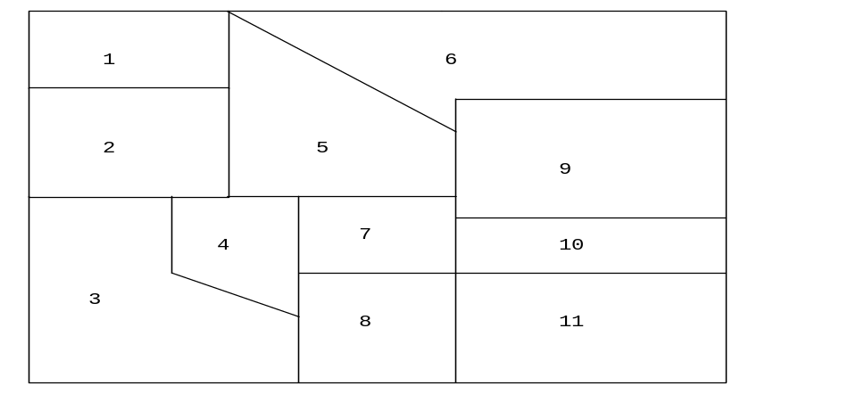2 5 6
1 3 4 5
2 4 8
2 3 5 7 8
1 2 4 6 7 9
1 5 9
4 5 8 9 10 11
3 4 7 10 11
5 6 7 10
7 8 9 11
7 8 10

where
1 Washington
2 Oregon
3 California
4 Nevada
5 Idaho
6 Montana
7 Utah
8 Arizona
9 Wyoming
10 Colorado
11 New Mexico

OUTPUT:

A sequence of states according to the order they were visited, along with their color assignments and level numbers.

HINTS:

- You need to create a file representing the map of the United States. The example above only shows a portion of the map.
- Map can be represented by a set of numbers. When being printed, these numbers should be translated into the state names using the above data type you define.

- Method GetMap reads the map data.
- Method WriteStateName writes out the state names.
- Method DFS visits each state and then prints its name.
- Method BFS visits each state and them prints its name.
- Other Methods if necessary
- If you do not have time to implement the color portion, you would lose only 10% of the points

