# Project Readme

**Resource Locations**

Project Outline:

[BGPOutline.docx](documents/BGPOutline.docx)

Project Paper:

[BGP_Report.pdf](documents/BGP_Report.pdf)

Project PowerPoint Presentation:

[Presentation BGP.pptx](documents/Presentation%20BGP.pptx)

Wireshark Responses:

[Question 1 – Wireshark Responses.docx](documents/Question%201%20-%20Wireshark%20Responses.docx)

Wireshark Capture:

[groupDHCPv6.pcapng](data/groupDHCPv6.pcapng)

Program Javadocs:

[Javadoc Homepage](javadocs/index.html)

Program Version Control History:

[GitHub Repository](https://github.com/Polo08816/COSC650)

Java Version: JDK1.7

## How to Run Program

### Client – List of Webpages

* 1. Open Eclipse and switch the workspace to the COSC650 folder.
  2. Run as a Java Application on “main.java” within the “launcher” package.
  3. 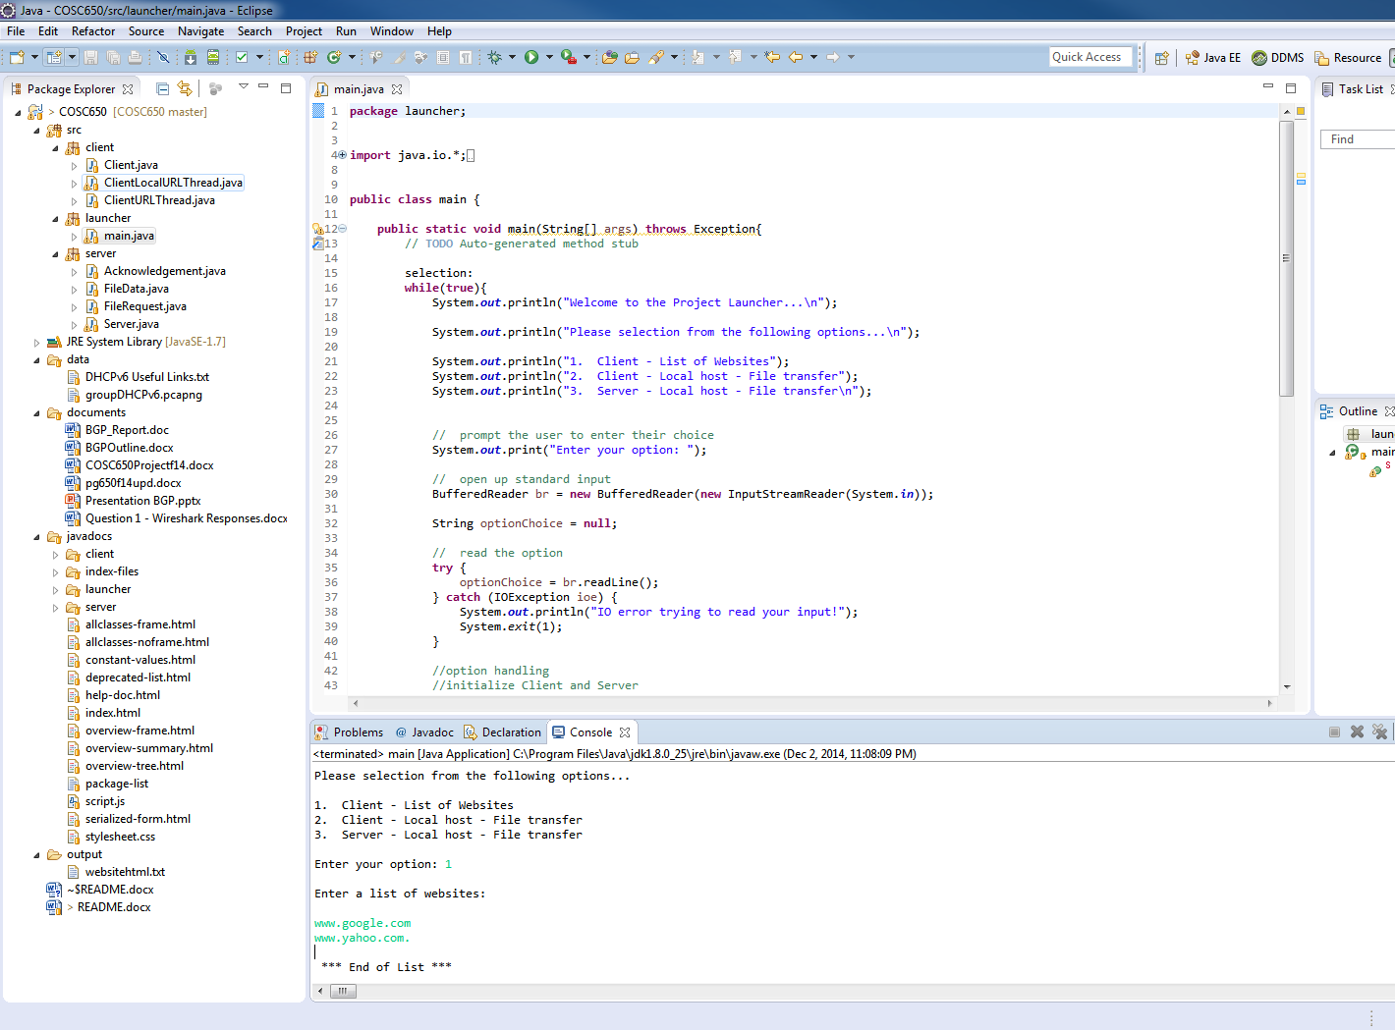Enter “1” in the console to select the option for “Client - List of Websites”
  4. Enter the list of websites. Each URL will be delimited by a “newline” by pressing Enter/Return. The end of the list will be indicated by a period “.”.
  5. Output will be written to the console as well as to [disk](output/websitehtml.txt). (output folder)

### Client/Server File Sharing

The main purpose of this part is to demonstrate how two instances of the same main.java can be executed in the same instance of Eclipse.

1. 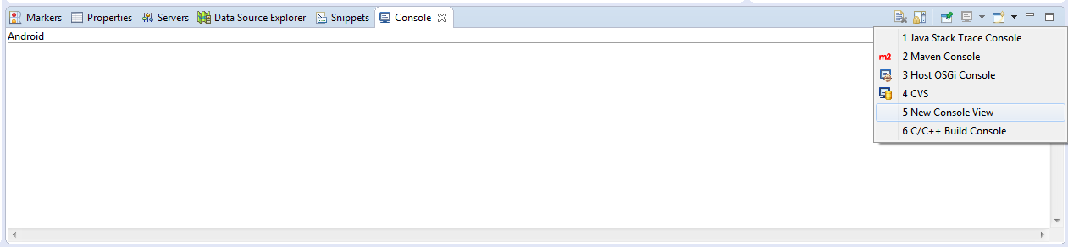 Switch to “Console View” by going to Window 🡪 Show View 🡪 Console. Click “New Console View”.
2. 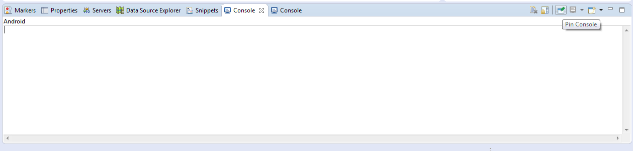Pin both consoles by click the “Pin Console” button.

3 . Launch the program on main.java. Press the “Run” button twice.

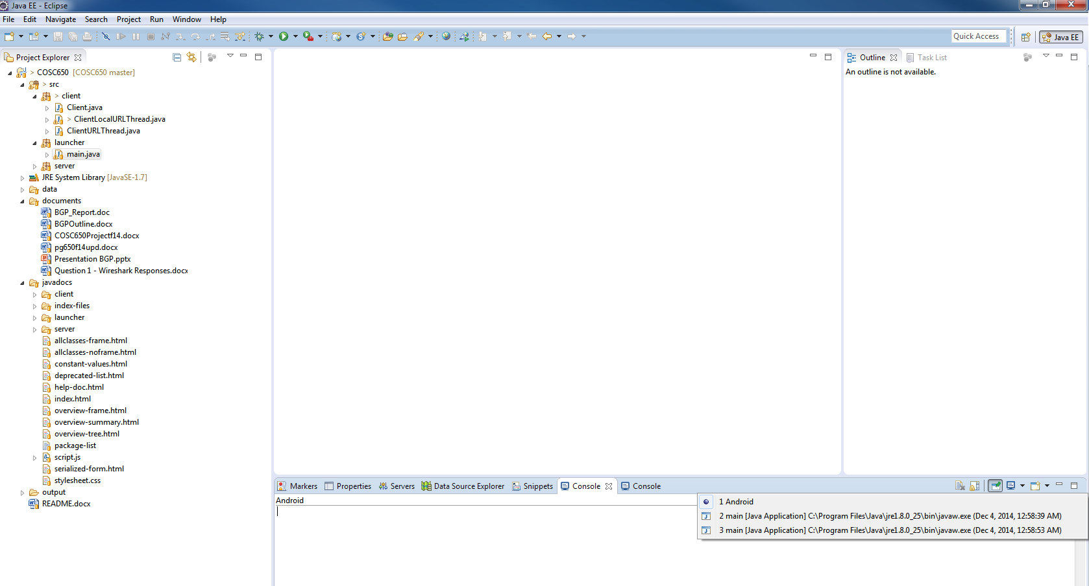

Notice that if you click the drop by button you will notice TWO instances of main running. Select a different instance for each Console View.

You can separate the views by dragging one Console View to the left in order to split screen your display.

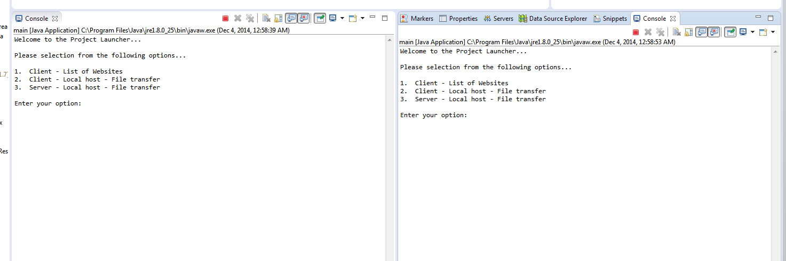

4. Enter option “3” which selects “Server – Local host – File Transfer” into one Console View.

Then enter option “2” which selects “Client – Local host – File Transfer” into the second Console View.

In the Client Console View, enter the ABSOLUTE PATH of the text file you are requesting.

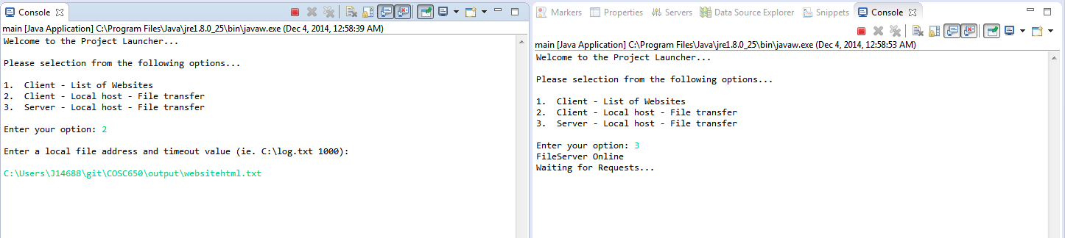

5. Retrieve output file (which will be prepended by fromServer-) in the output directory of the project.