Question 1 – Wireshark

The industry standard reference for DHCPv6 is the RFC3315: https://www.ietf.org/rfc/rfc3315.txt

1.1

* Filtered by “dhcpv6”

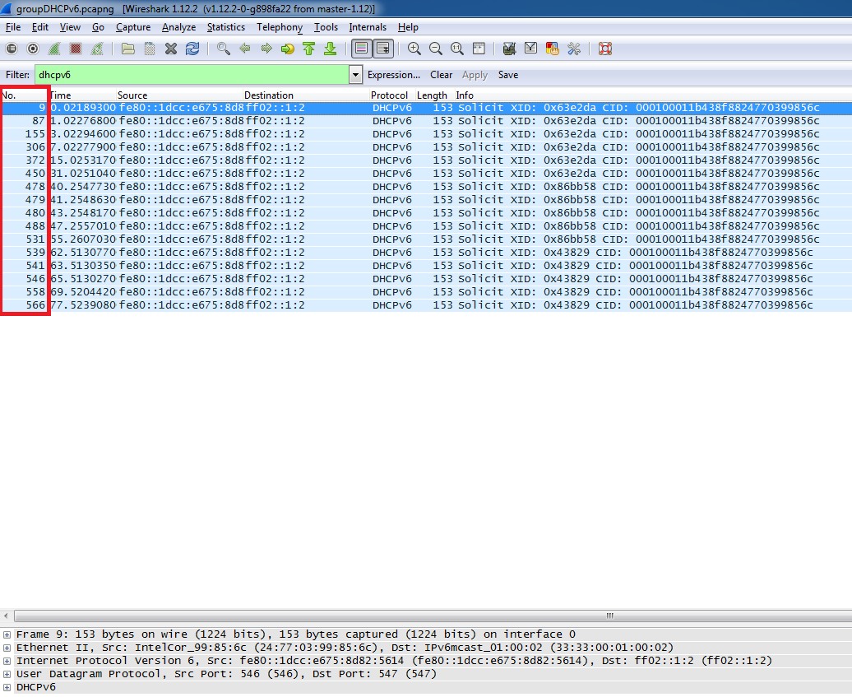

The purpose of the Solicit XID message is for a client to locate servers via a broadcast message. It is based on the DHCPv6 protocol and it’s DHCPv4 protocol equivalent would be a DHCP Discover message.

1.2 Selected frame #9

* double click on frame #9

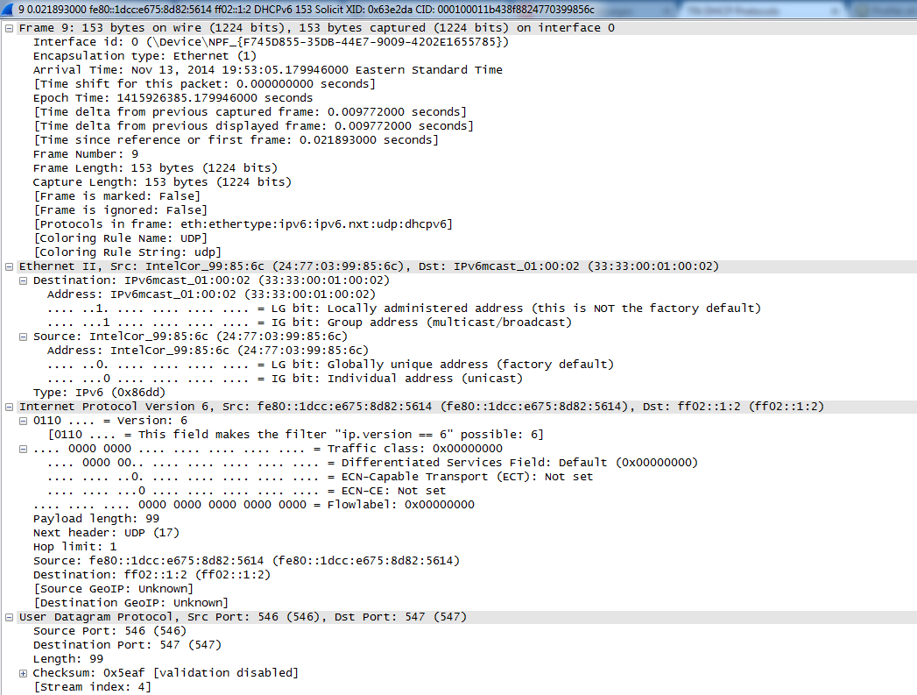

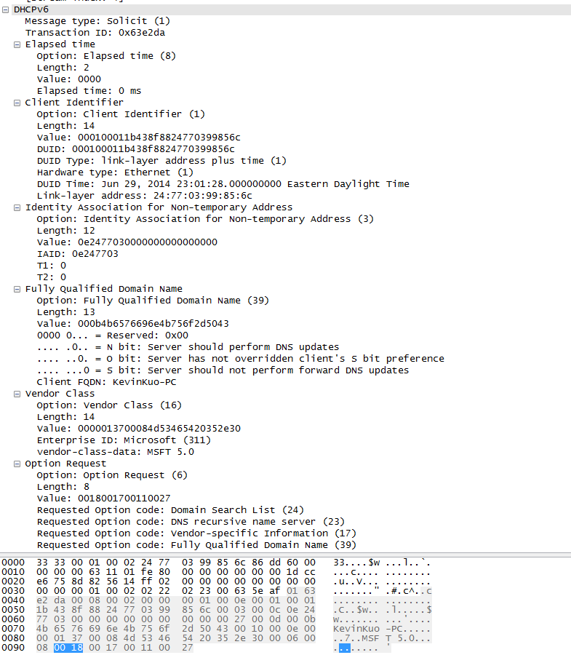

|  |  |  |
| --- | --- | --- |
| **Protocol** | **Header Field** | **Description** |
| Ethernet | Source | States where the Ethernet frame is coming from. |
|  | Destination | States where the Ethernet frame is going to. In this case it is a broadcast message |
| Internet Protocol | Version | Describes the Internet Protocol version number which in this case is IPv6. |
|  | UDP | Specifies that this packet is UDP and states the source and destination ports. |
| DHCPv6 | Message type | Describes the type of DHCPv6 message. In this case, it is a solicit message so the source machine is trying to find a DHCPv6 enabled DHCP server. |
|  | Transaction ID | Unique transaction ID that is associated with a set of DHCPv6 Solicit attempt |
|  | Client Identifier | Identifies itself to the server. The client adds any other appropriate options, including one or more IA options (if the client is requesting that the server assign it some network addresses). |
|  | Option Request |  |

* Note: According to RFC 3315, the following fields are required in the creating of a DHCPv6 Solicit message:

18.1.1. Creation and Transmission of Request Messages

The client uses a Request message to populate IAs with addresses and

obtain other configuration information. The client includes one or

more IA options in the Request message. The server then returns

addresses and other information about the IAs to the client in IA

options in a Reply message.

The client generates a transaction ID and inserts this value in the

"transaction-id" field.

The client places the identifier of the destination server in a

Server Identifier option.

The client MUST include a Client Identifier option to identify itself

to the server. The client adds any other appropriate options,

including one or more IA options (if the client is requesting that

the server assign it some network addresses).

The client MUST include an Option Request option (see section 22.7)

to indicate the options the client is interested in receiving. The

client MAY include options with data values as hints to the server

about parameter values the client would like to have returned.

The client includes a Reconfigure Accept option (see section 22.20)

indicating whether or not the client is willing to accept Reconfigure

messages from the server.

The client transmits the message according to section 14, using the

following parameters:

IRT REQ_TIMEOUT

MRT REQ_MAX_RT

MRC REQ_MAX_RC

MRD 0

If the message exchange fails, the client takes an action based on

the client's local policy. Examples of actions the client might take

include:

- Select another server from a list of servers known to the client;

for example, servers that responded with an Advertise message.

- Initiate the server discovery process described in section 17.

- Terminate the configuration process and report failure.

1.3 Actual values

|  |  |  |  |
| --- | --- | --- | --- |
| **Protocol** | **Header Field** | **Actual Value** | **Interpretation** |
| Ethernet | Source | 24:77:99:85:6c | States where the Ethernet frame is coming from. |
|  | Destination | 33:33:00:01:00:02 | States where the Ethernet frame is going to. In this case it is a broadcast message |
| Internet Protocol | Version | 6 | IPv6 |
|  | UDP | Src Port: 546  Dst Port: 547 | Standard UDP ports for this type of message |
| DHCPv6 | Message type | Solicit(1) | This is a DHCP Request equivalent message. |
|  | Transaction ID | 0x63e2da | Unique transaction ID that is associated with a set of DHCPv6 Solicit attempt. If the source machine receives a DHCPv6 Advertise message, it will know if it is in response to a particular DHCPv6 Solicit message within a certain timeout interval. |
|  | Client Identifier | 000100011b438f8824770399856c | Identifies itself to the server. |
|  | Option Request | 6  Suboptions: 24, 23, 17, 39 | 24: Domain Search List  23: DNS recursive name server  17: Vendor-specific equipment  39: Fully qualified domain name  These option requests are consistent with what one would expect for a DHCPv6 Solicit message. |