Report for a project

Made by: Komekbayev Zeiin, Polozov Michael

Group: SE-2116

**Project description**

For the current project idea, the blog website has been chosen. The following website will comprise a plenty of posts related to various topics and fields. We encourage people to share their happy moments with thousands of other users of our website and this is the main goal of our project. Sometimes there is a lack of such platforms where people can easily express themselves in the way they fill comfortable. Therefore, we decided to create a brand-new blog website.

**Technical part**

Here are the programming languages, frameworks, and other technologies that we shall use in order to implement this project:

1. Node.js
2. Express.js
3. MongoDB
4. HTML
5. CSS
6. JavaScript
7. Anime.js
8. jQuery
9. AOS.js
10. Bootstrap

Here are some additional packages that will be used in compound with main technologies:

1. Nodemon
2. Body Parser
3. Mongoose

Websites reviewed:

<https://blogs.worldbank.org/>

<https://www.huffpost.com/>

<https://mashable.com/>

We looked on the internet for web applications which are similar to our project. For example: mashable.com.

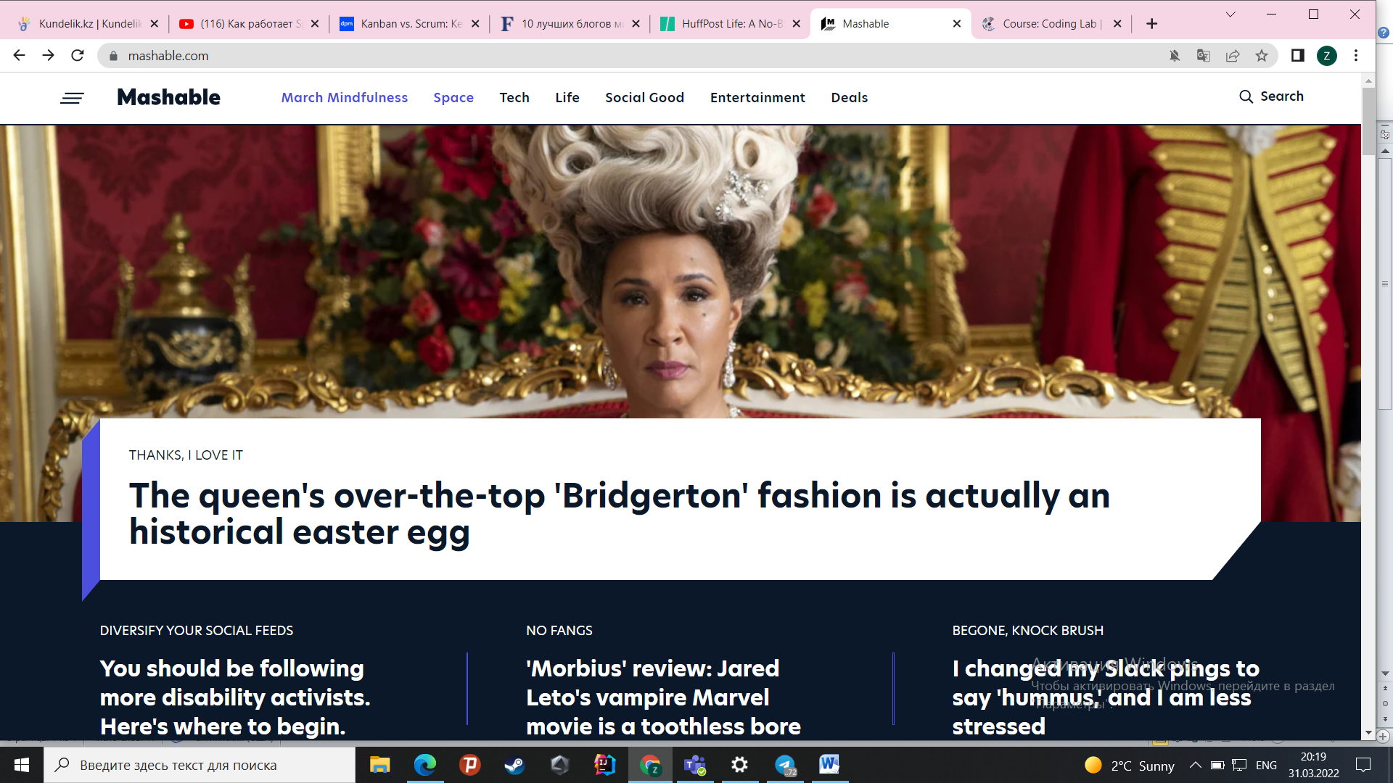

From that blog we will take their idea such as including in the main page a list of popular themes and searching function for customers to find a blogs they are searching for. Moreover, each customer can post their own blog and other users can see a date when that blog was posted and by whom (to post they must be signed up).

Another blog we searched for was huffpost.com



We will add signed up method for new users and signed up method for users who are already created account, only users who have account will be able to post their own blog. When they posting their own blog they must write a date when they posted a blog so other users can see. Each post and users account we will collect in the database.