Poltak Pancarian Situmorang

CQUNIVERSITY

Name: Poltak Pancarian Situmorang

Data Structures and Algorithms

Table of Contents

**1.0 UML Class Diagrams for The Classes** 3

**1.1 UML diagram of Nutrient class, Item class, DataFile class, ProcessedFood GUI, ProcesedFoodGUI class and Comparator** 3

**2.0 Test Plan** 4

**2.1 Enter Data and Enter Name Button Function** 4

**2.1.0 Test Case** 4

**2.1.1Expected result** 4

**2.1.2Actual result** 4

**2.2 Input User Name** 5

**2.2.0 Test Case** 5

**2.2.1Expected Result** 5

**2.2.2Actual result** 5

**2.3 Select the User ID** 6

**2.3.0 Test Case** 6

**2.3.1Expected Result** 6

**2.3.2Actual result** 6

**2.4 Select the Group of products** 7

**2.4.0 Test Case** 7

**2.4.1Expected Result** 7

**2.4.2Actual result** 7

**2.5 Select the Product** 8

**2.5.0 Test Case** 8

**2.5.1Expected Result** 8

**2.5.2 Actual result** 9

**2.6 Toast Message** 9

**2.6.0 Test Case** 9

**2.6.1Expected Result** 10

**2.6.2Actual Result** 10

**2.7 Clear Display Button Function** 10

**2.7.0 Test Case** 10

**2.7.1Expected Result** 11

**2.7.2Actual Result** 11

**2.8 Quit Button Function** 12

**2.8.0 Test Case** 12

**2.8.1 Expected Result** 12

**2.8.2Actual Result** 12

**REPORT**

# **1.0 UML Class Diagrams for The Classes**

## **1.1 UML diagram of Nutrient class, Item class, DataFile class, ProcessedFood GUI, ProcesedFoodGUI class and Comparator**



Figure 1.0: UML Class Diagram for all classes and comparator

# **2.0 Test Plan**

## **2.1 Enter Data and Enter Name Button Function**

### **2.1.0 Test Case**

Test case Run the Program

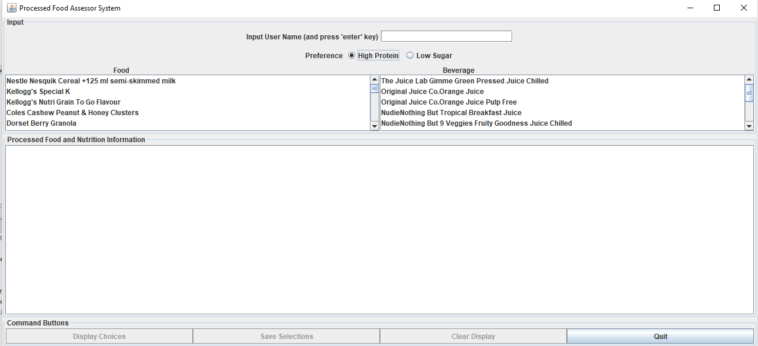

Figure 2.0: Run the program

### 

### **2.1.1Expected result**

When press the run of the program, the Netbeans should run the GUI of the program

### **2.1.2Actual result**

After press run button, the GUI of the Netbeans has shown / run.

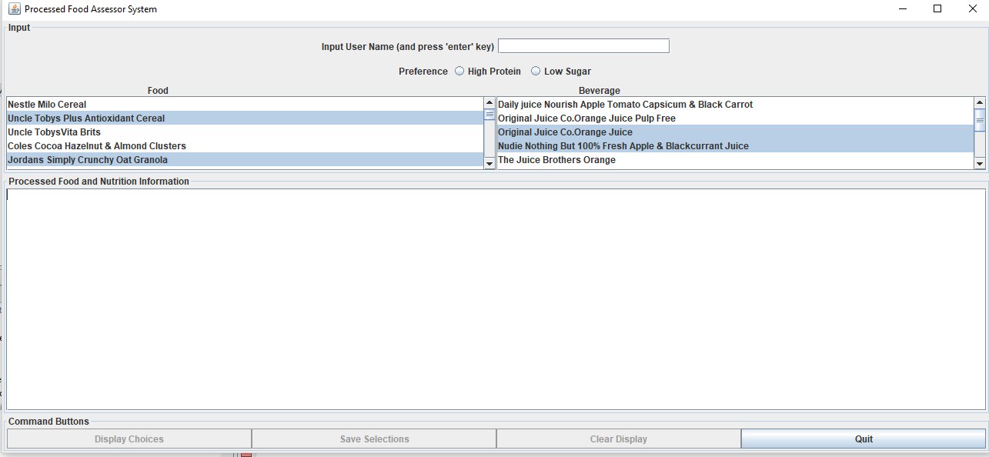

Figure 3.0: Actual result of GUI

## **2.2 Input User Name**

### **2.2.0 Test Case**

Test case will input the user name

### **2.2.1Expected Result**

The GUI will show welcome message to the user name

### **2.2.2Actual result**

When input the user name, the welcome message has shown

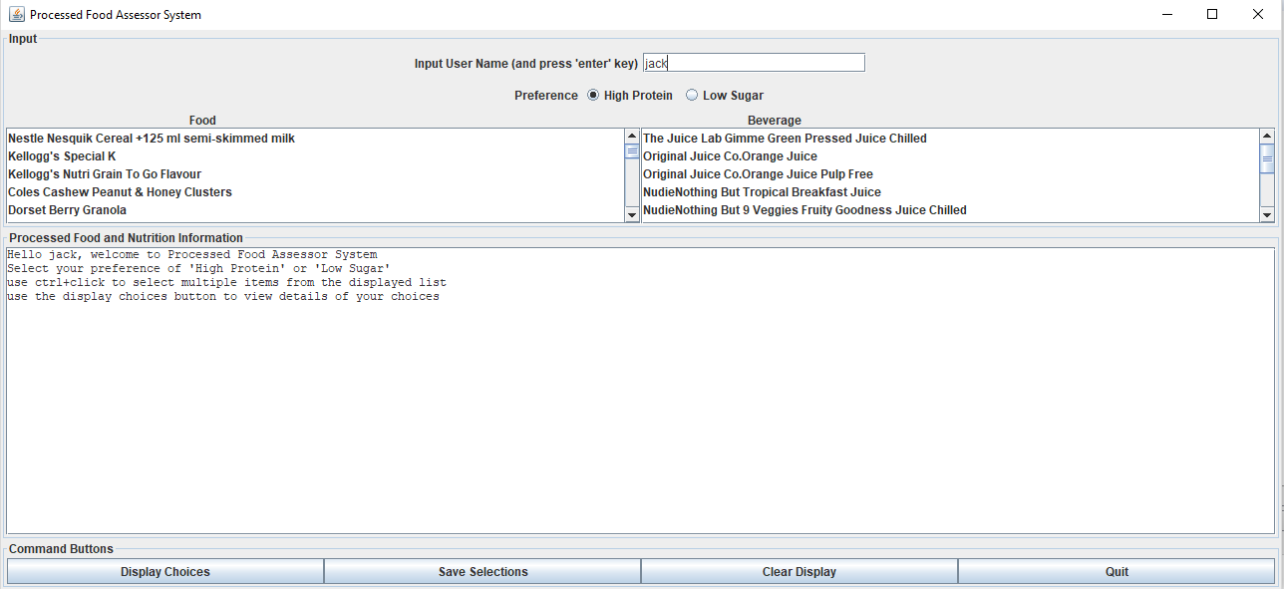

Figure 4.0: Actual result of welcome message and also included user name provided

## **2.3 Select the User ID**

### **2.3.0 Test Case**

Test case will show the user ID

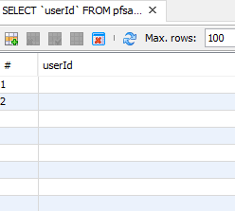

Figure 5.0: Test plan of user ID

### **2.3.1Expected Result**

The test plan will show user ID

### **2.3.2Actual result**

The GUI has shown the food and beverage selected product

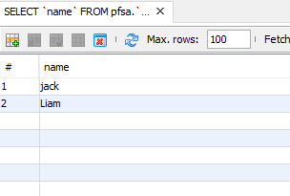

Figure 6.0: Actual result user ID

## **2.4 Select the Group of products**

### **2.4.0 Test Case**

Test case will select the group food product

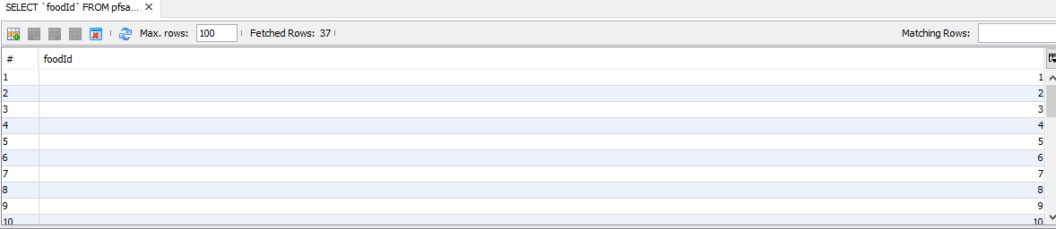

Figure 7.0: Test plan with select group of food

### **2.4.1Expected Result**

The GUI will show group of food item

### **2.4.2Actual result**

The GUI already show the group of food item

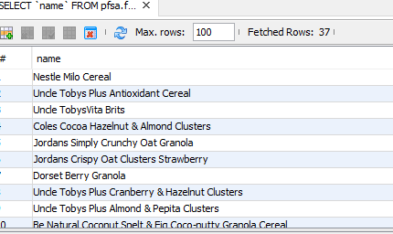

Figure 8.0: The item of food shown after clicked

## **2.5 Select the Product**

### **2.5.0 Test Case**

Test case will select the product between foods and beverages

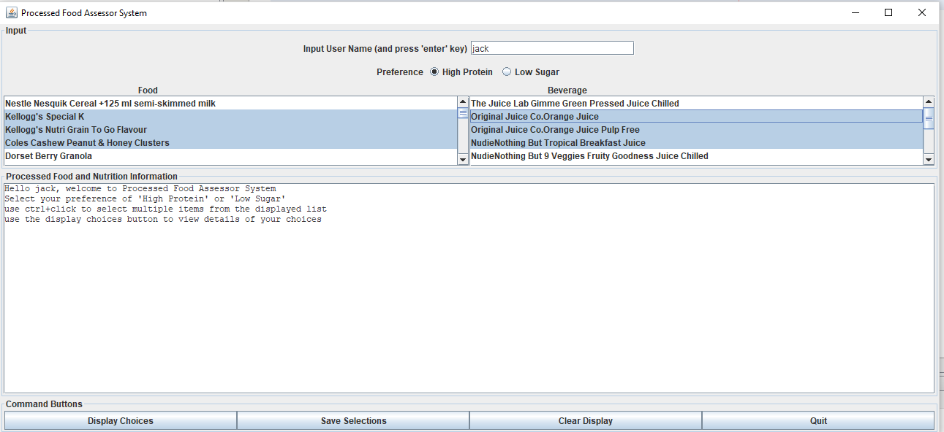

Figure 9.0: Test plan of select food and beverage product

### **2.5.1Expected Result**

The GUI will show the products selected

### **2.5.2 Actual result**

The GUI has shown the food and beverage selected product

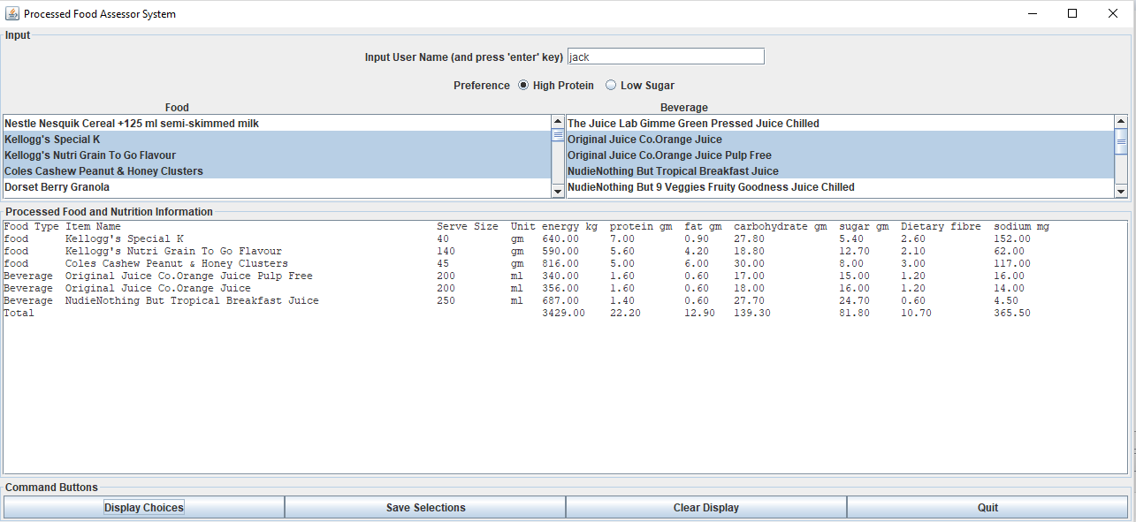

Figure 10.0: The detail product selected has shown

## **2.6 Toast Message**

### **2.6.0 Test Case**

Test case is select the item

Figure 11.0: Choice and select the product

### **2.6.1Expected Result**

After selected the product, the GUI will show the short message that indicate the product has been selected.

### **2.6.2Actual Result**

Detail of Uncle Toby Vita Brits has shown after click display choices button

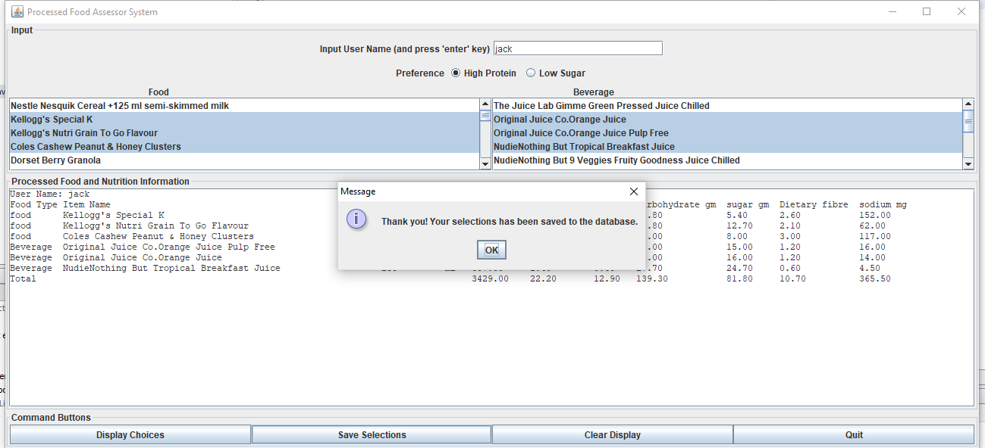

Figure 12.0: The short message has shown “Thank you! Your selection has been save to the database.

## **2.7 Clear Display Button Function**

### **2.7.0 Test Case**

Test case will click Clear Display button



Figure 13.0: Before click ‘Clear Display button’.

### **2.7.1Expected Result**

It will clear all detail item in the panel

### **2.7.2Actual Result**

All detail of the item select and message has erased



Figure 14.0: After clicked Clear Display button, all detail of foods and beverages product has been erased, the welcome message also erased.

## **2.8 Quit Button Function**

### **2.8.0 Test Case**

This test plan will click Quit button

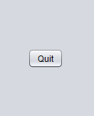

Figure 15.0: The Quit button before click

### **2.8.1 Expected Result**

It will be exit the program

### **2.8.2Actual Result**

After press the ‘Quit Button, the program has already exit.

-Thank you_