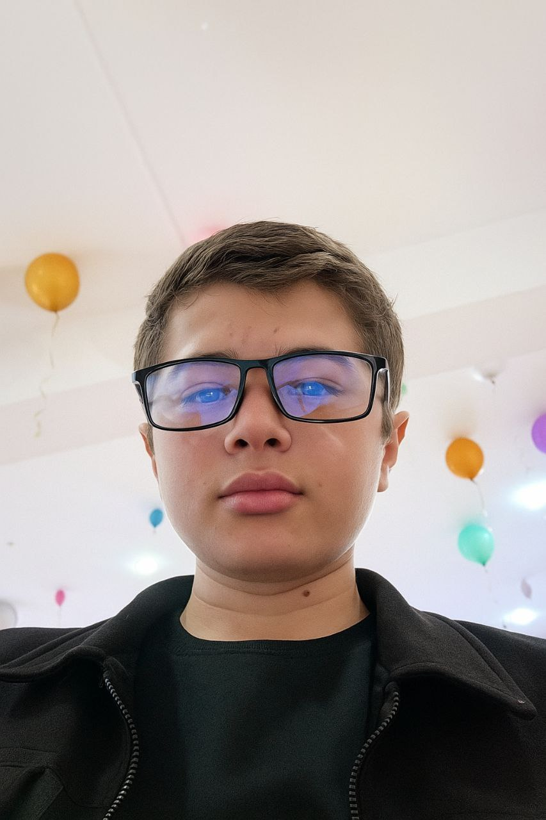**📌 Full Name:** Polvonbek Boltabayev

**🎂 Date of Birth:** September 27, 2009

📞 **Phone:** +998 33 656 27 09

**📧 Email:** polvonbekbaltabayev@gmail.com

**📍 Address:** Republic of Karakalpakstan, Turtkul District

## 🎯 Career Objective:

To work as a Frontend Developer, contribute to the company’s success and enhance my personal experience.

## 🎓 Education:

School No. 4 – 10th grade

## 💼 Work Experience:

- Creating web pages (HTML, CSS, JavaScript)  
- 7 months of experience

## 🧠 Skills:

- HTML, CSS, JavaScript  
- Git, GitHub, Figma, Tailwind CSS, GetBootstrap  
- Microsoft Word, Excel

## 📜 Certificates:

(Not specified)

## 🗣 Languages:

- Uzbek – Native  
- English – Intermediate