maps-pin-line-icon.pngtel-icon.pngenvelope-line-icon.pngvecteezy_linkedin-png-icon_16716470.png**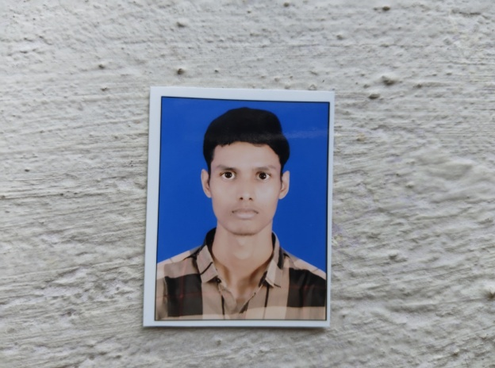**

**EDUCATION**

**Diploma**

**(Plastic Mould Technology)**

Govt. Polytechnic, Kanpur

*09/2022 - 07/2025*,

**Intermediate**

**(Physics,Chemistry,Maths)**

S C A Inter College

*04/2021 - 05/2022*, *60.33%*

**High School**

S C A Inter College

*04/2019 - 05/2020*, *77.66%*

**INTERNSHIP**

**Assistant Engineer**

MSME TC

*07/2024 - 08/2024*, *Kanpur*

A General Engineering focused Technology center is being set up by the ministry of MSME under the World Bank funded Technology center systems programs in Kanpur to cater the technological training needs of the general engineering industry in the catchment area of Kanpur, India

Achievements/Tasks

**Mould & Die Design or Manufacturing**

**Known Languages**

*HINDI*

*ENGLISH*

**NEERAJ**

**Polymer Engineer**

7991308024

386/1550 Ratanpur Colony, Panki, Kanpur Nagar, U.P, INDIA

[neerajkumarmaurya248@gmail.com](mailto:neerajkumarmaurya248@gmail.com)

<https://www.linkedin.com/in/neeraj-kumar-6406b7332>

**SUMMARY**

Motivated Plastic Mould Technology Diploma holder seeking to leverage hands-on skills in mould design and manufacturing within a dynamic organization. Passionate about delivering high quality plastic solutions and committed to continuous learning and improvement.

**SKILLS**

* Time Management
* Effective Communication
* Adaptability

**TECHNICAL SKILLS**

* Various Moulding techniques
* Material knowledge
* Mould & Die Design
* Quality Control
* Advance level Computer knowledge

**STRENGTHS**



**Troubleshooting:** Evaluating issues and finding the best ways to resolve them.



**Positive Attitude:** I am a person with a Can-Do Attitude.

**CERTIFICATION**

* **IAD:** MS Office, Tally, Busy, Corel Draw X3, Photoshop CS3.
* Time management certification By **Infosys Springboard.**
* **Agnirva** space internship program.
* Build a free website with **WordPress.**
* Personality enhancement Certification By **Unatti Foundation.**