Vivek Gidla

260623415

COMP 551

1.1 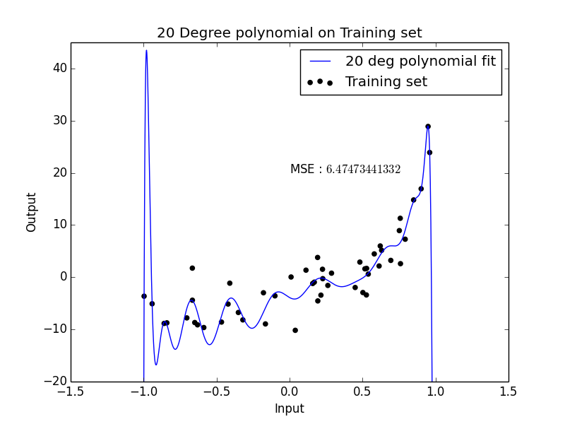

Figure . 20 Degree polynomial fit on Training Set

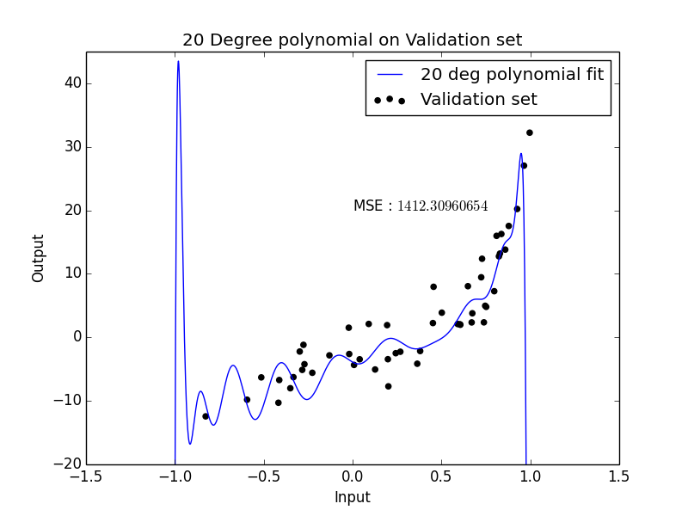

Figure . 20 Degree polynomial fit on Validation Set

Training MSE: 6.47

Validation MSE: 1412.31

It can be seen that a 20 - degree polynomial is excessive. This is obvious when looking at how the polynomial over fits to the first 2 data points and the last few data points. This is an example of over fitting.

1.2

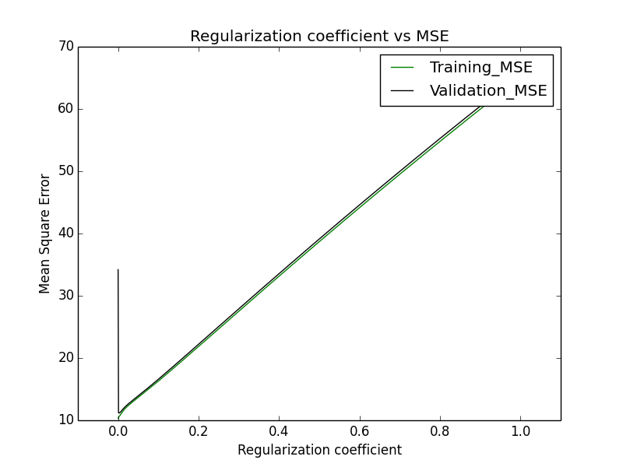

Figure . Varying Regularization coefficient to see change in MSE

At regularization coefficient = 0, the MSE is on validation set is 1412.31 and 6.47 on training set (hence not shown in graph).

The regularization coefficient that gives the smallest MSE on validation set (MSE = 11.16) is 0.002003.

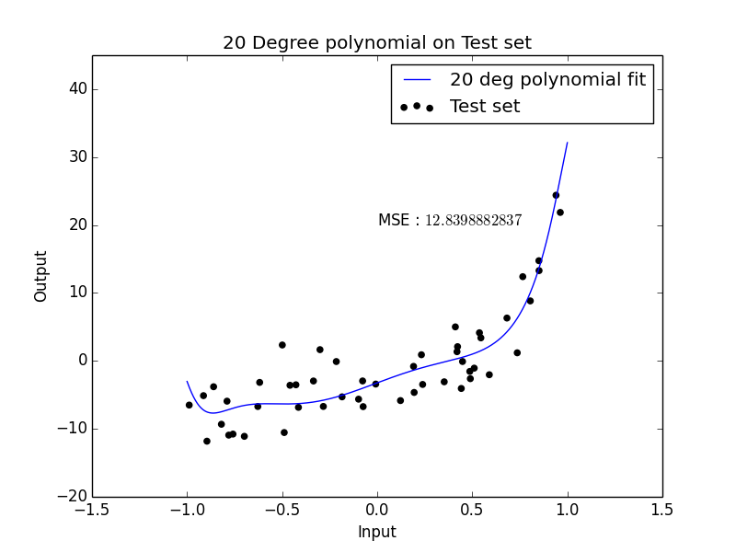

Figure . Regularization coefficient = 0.002003 used on Test set

Best regularization coefficient was used for polynomial on the test set. It can be seen in this graph, that there is little to no over fitting, when compared to Figure 1.

1.3

It seems like the true degree of the polynomial is somewhere between degree 4 and degree 6. By counting the number of bends in the polynomial in Figure 4 (5 bends), the true degree of polynomial is degree 6. It is not fully obvious from the above-mentioned graph, for that too could have some level of over fitting.

2.1

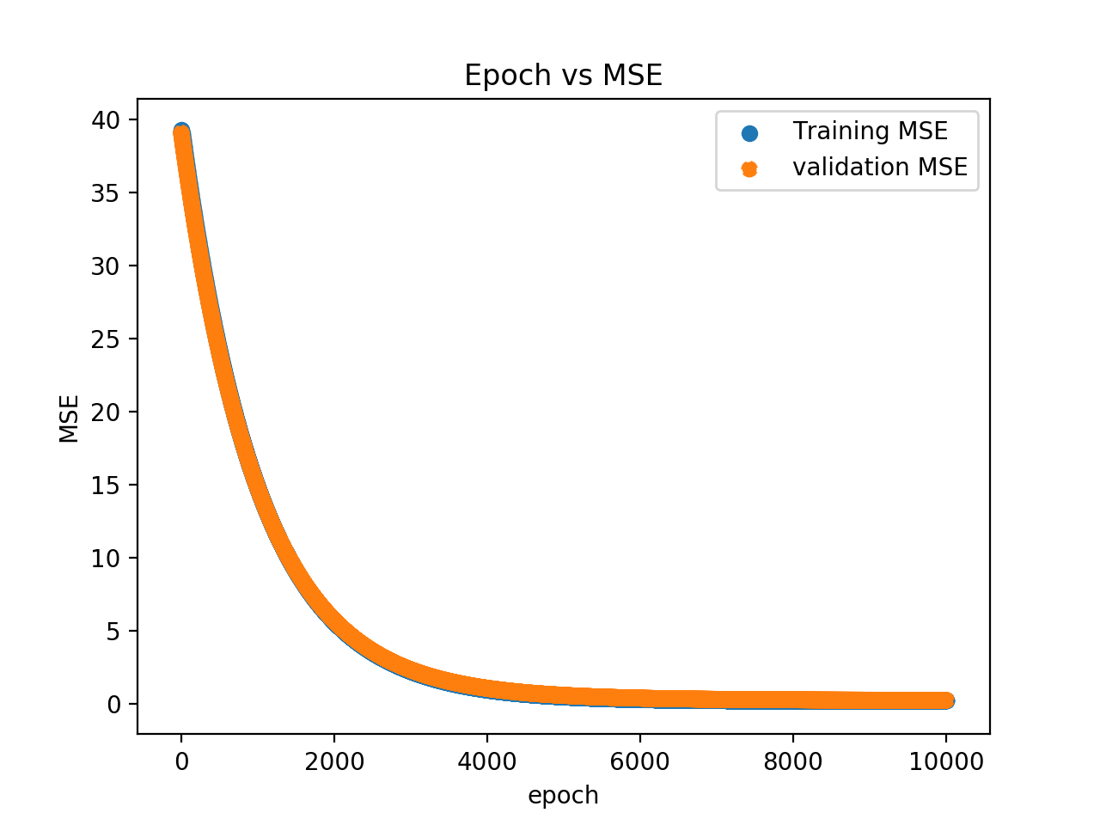

Figure . MSE vs Epoch on Training and validation set (both are plotted). Step size of 1e-6

Exponential decay of training and validation MSE as number of epochs increase. Although the two curves look identical, the individual training MSE per epoch and validation MSE per epoch are different. This can be verified by looking at the respective code.

2.2

best learning rate was = 0.010

this gives a Test MSE of 0.067

2.3

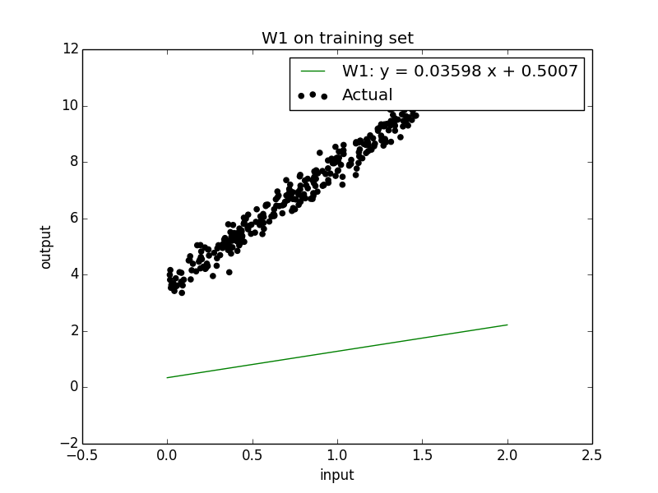

Figure . w vecto at epoch 0 on dataset

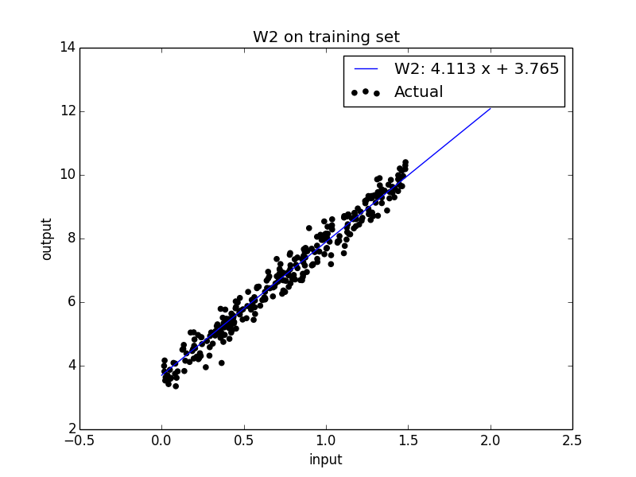

Figure . w vector at epoch 10

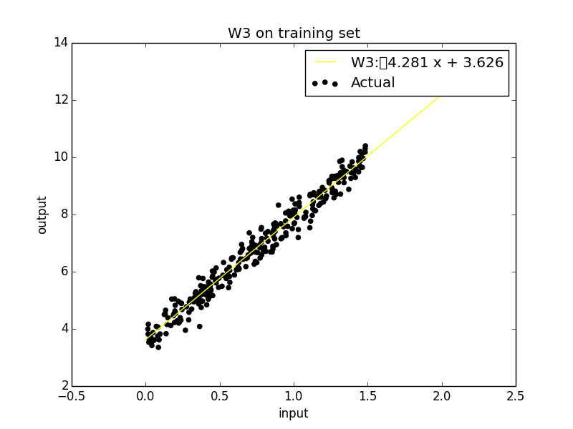

Figure . w vector at epoch 20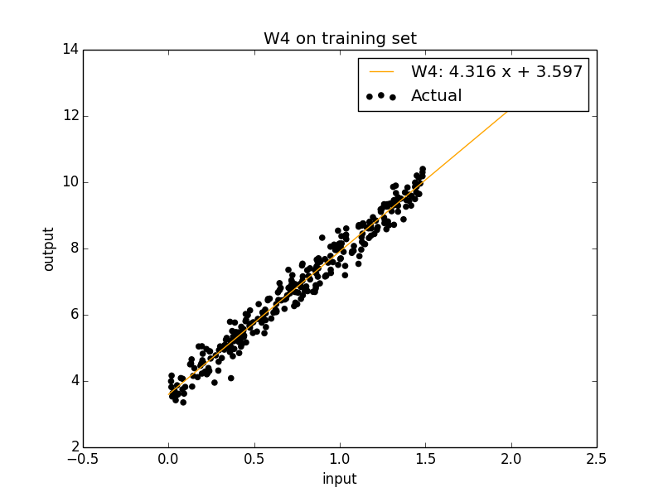

Figure . w vector at epoch 30

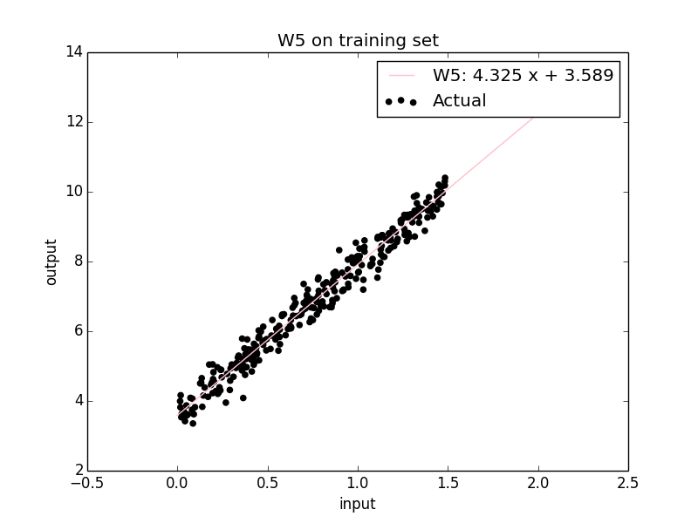

Figure w vector at epoch 40. This is best fit