THESIS DEFENSE PRESENTATION SCRIPT
Adaptive Health Insurance Underwriting via Contextual Bandits:
A Reinforcement Learning Approach for Cambodia
LUN CHANPOLY · ITC-AMS · July 2026

HOW TO USE THIS SCRIPT
Read aloud naturally — do not recite word-for-word if it feels unnatural. Bracketed notes [like this] are stage directions, not spoken text. Appendix slides A1–A5 are on standby; only advance to them if the Committee asks a question that slide addresses.

SLIDE 1 · TITLE SLIDE
Timing: ~1 min
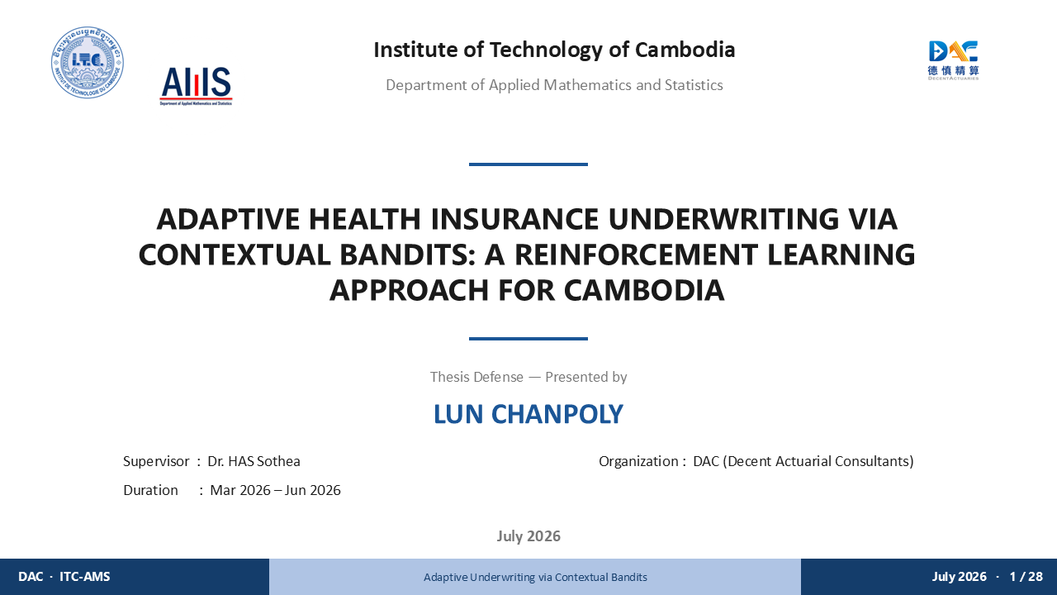
Good morning, Distinguished Committee. I am Lun Chanpoly, and I am here to defend my master's thesis — Adaptive Health Insurance Underwriting via Contextual Bandits: A Reinforcement Learning Approach for Cambodia.
This work was carried out during my internship at Decent Actuarial Consultants in Phnom Penh, from March to June 2026, under the supervision of Dr. Has Sothea and the guidance of Mr. ON Radet at DAC.
I hope by the end of this presentation, I can convince you that the question I was given — how do we make underwriting smarter for Cambodia — has a rigorous, honest, and practically useful answer.

SLIDE 2 · TABLE OF CONTENTS
Timing: ~30 sec
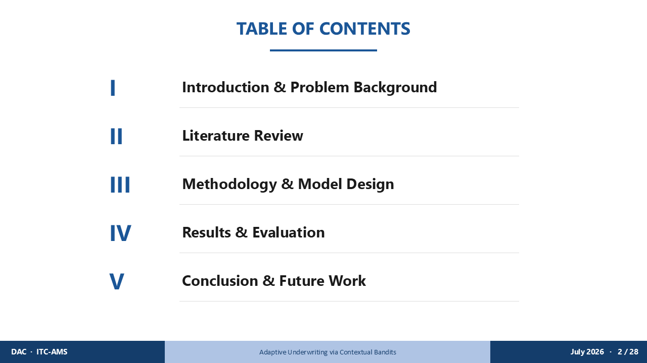
I will take you through five sections. We begin with why this problem matters — which I will show you through a story. Then a brief survey of what the research literature offers. Then the methodology I designed and implemented. Then the results — including some honest findings that did not go as expected. And finally, what all of this means for Cambodia.
I also have five technical appendix slides available if the Committee wishes to go deeper on any specific point.

SLIDE 3 · SECTION DIVIDER — Introduction & Problem Background
Timing: ~1.5 min

Imagine Sophea. She is forty-three years old, a garment worker. Her BMI is 25.7. She does not smoke. Her only medical flag is a managed case of hypertension, picked up two years ago.
In 2023, Sophea applies for voluntary health insurance — perhaps the first time anyone in her family has ever done so.
The underwriter runs her profile through the company's static rule-based system. It predicts her mortality risk from her full profile — 1.83 times normal, close to her true risk — and that estimate falls into a fixed premium band. The answer comes back: RATED.
Sophea gets covered — but at a loaded premium she may not need.
This research begins with the question: was that the right price? And if not — what would a better system look like?

SLIDE 4 · ABOUT DECENT ACTUARIAL CONSULTANTS
Timing: ~1 min
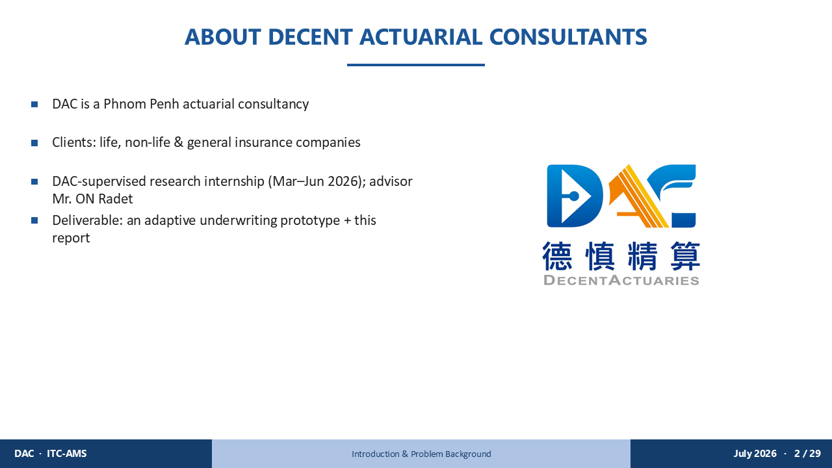
To answer that question, I joined Decent Actuarial Consultants — DAC — as a research intern in March 2026.
DAC is a Phnom Penh-based actuarial consultancy whose clients span life, non-life, and general insurance companies across Cambodia. They are the practitioners who live with the underwriting problem every day.
Supervised by Mr. ON Radet, my task was to design and validate an adaptive underwriting system — and then build a working prototype. The thesis you have in your hands, and the demonstration I will show you today, are the outputs of that internship.

SLIDE 5 · INTRODUCTION
Timing: ~1 min
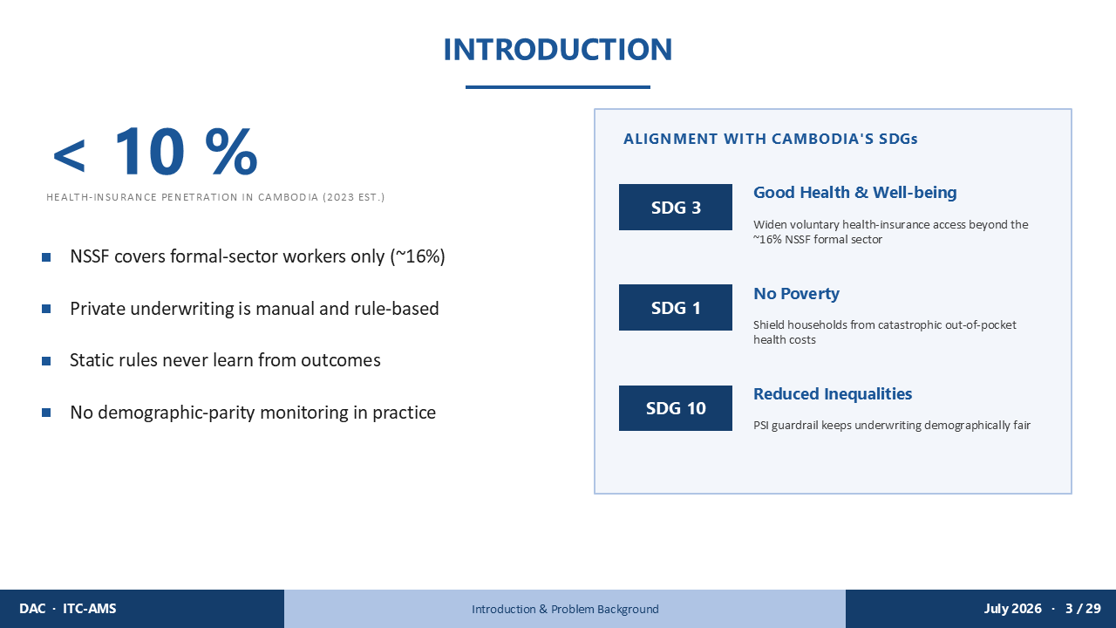
Sophea's situation is not an isolated edge case. It sits inside a much larger problem.
As of 2023, health insurance penetration in Cambodia is estimated at under 10 percent — the large number you see on the left. The NSSF provides mandatory coverage, but only to formal-sector workers — roughly 16 percent of the population. Private underwriting is manual and rule-based, static rules never learn from claims outcomes, and there is no demographic-parity monitoring in practice.
This research connects directly to three of Cambodia's SDGs, shown on the right. SDG 3 — Good Health and Well-being — by widening voluntary insurance access beyond the formal sector. SDG 1 — No Poverty — by shielding households from catastrophic out-of-pocket health costs. And SDG 10 — Reduced Inequalities — through the PSI fairness guardrail I will describe shortly.
Sophea represents the 84 percent the current system was not built for.

SLIDE 6 · PROBLEM STATEMENT
Timing: ~1 min
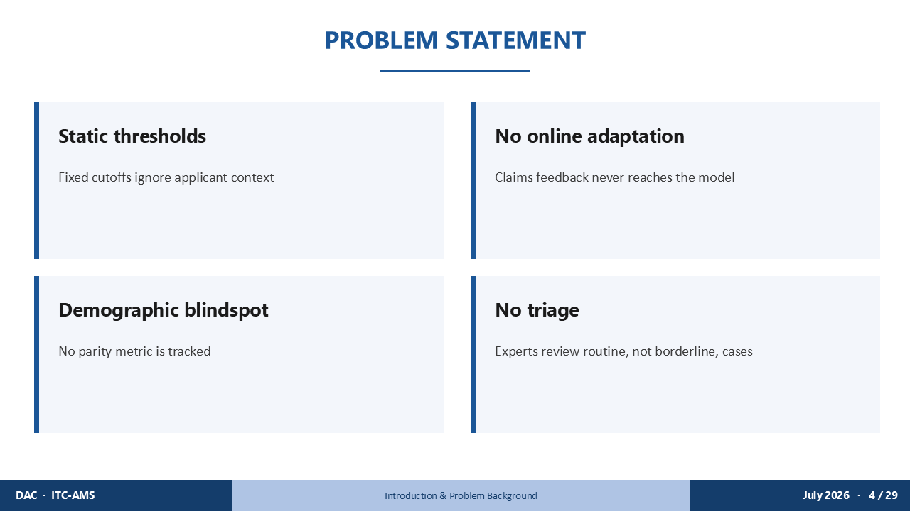
The static system that rated Sophea has four specific failure modes — and each one is visible in her case.
First: fixed thresholds. Its risk estimate for Sophea is actually accurate — but a fixed premium band has no mechanism to weigh whether a loaded premium is still worth offering once you account for her likelihood of accepting it. Context is priced, but not optimised.
Second: no online adaptation. The system was trained once, on historical data that may not reflect current Cambodia. It could not update its beliefs from new claims outcomes. Every applicant — including Sophea — was assessed against stale weights.
Third: demographic blindspot. No parity metric was tracked. If the system systematically rated certain occupations higher at rates inconsistent with their actual risk, that pattern would be invisible to the insurer.
Fourth: no intelligent triage. Cases like Sophea's — borderline, nuanced — were either mechanically rated or sent to a senior underwriter with no supporting analysis.
Each of these failures costs Sophea. Together, they are the problem I set out to solve.

SLIDE 7 · PROJECT OBJECTIVE
Timing: ~2 min
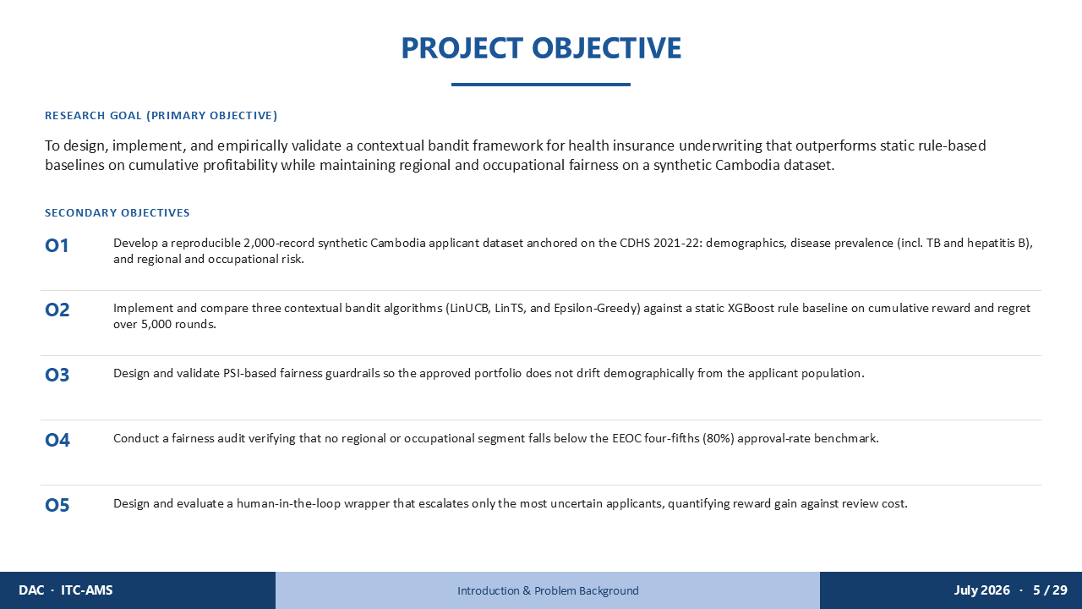
My primary research goal was to design, implement, and empirically validate a contextual bandit framework that outperforms static rule-based underwriting on cumulative profitability — while maintaining regional and occupational fairness — on a synthetic Cambodia dataset.
In Sophea's terms: could a learning system weigh the price trade-off a fixed rule can't — and make a more profitable decision, even when the risk estimate itself is already accurate?
I broke this into five measurable secondary objectives.
O1: Build a reproducible 2,000-record synthetic dataset anchored on real Cambodia survey data — CDHS 2021-22, STEPS, ILO, WHO — so that Sophea is a statistically realistic applicant, not a cartoon.
O2: Implement and compare three bandit algorithms — LinUCB, LinTS, and Epsilon-Greedy — against a Static XGBoost baseline over 5,000 underwriting rounds.
O3: Design PSI-based fairness guardrails so that the approved portfolio does not drift demographically from the applicant population — protecting applicants in categories like Sophea's.
O4: Conduct an EEOC four-fifths parity audit — verifying that no segment faces approval rates below 80% of the highest-approved group.
O5: Design a human-in-the-loop wrapper that escalates only the most uncertain cases — quantifying reward gain against actuary review cost.
I will address each of these directly in the results section.

SLIDE 8 · SECTION DIVIDER — Literature Review
Timing: ~5 sec

Before I show you the system I built, let me briefly survey what the research literature told me about building it.

SLIDE 9 · LITERATURE REVIEW
Timing: ~2 min
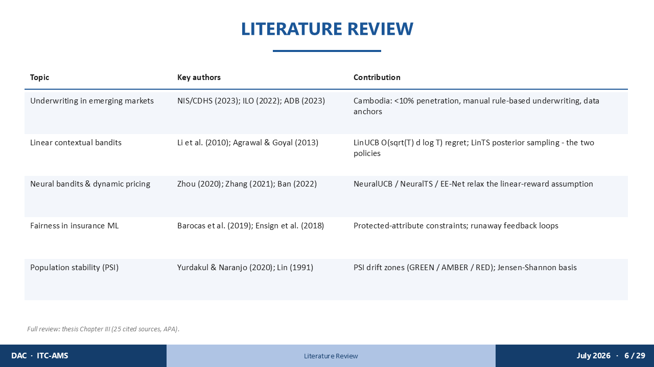
Five research areas shaped the design of this system — and each one left a mark on how I handled Sophea's case.
First, emerging-market underwriting. Reports from CDHS, ILO, and ADB established Cambodia's context and gave us the data anchors that make Sophea a realistic synthetic applicant. Under 10% health insurance penetration. A formal-sector NSSF that covers only 16% of the population. Private insurers working with manual, rule-based systems.
Second, linear contextual bandits. The two algorithms at the heart of this work — LinUCB from Li et al. 2010, and LinTS from Agrawal and Goyal 2013 — both achieve sub-linear regret of order square-root of T, times d, times log T. This theoretical guarantee is why I chose them: they are provably efficient at learning from experience.
Third, neural bandits. NeuralUCB, NeuralTS, and EE-Net relax the linear-reward assumption. They are natural candidates for a future version of this system — one that might model Sophea's risk non-linearly.
Fourth, fairness in insurance machine learning. Barocas et al. and Ensign et al. established the basis for protected-attribute constraints and warned specifically about feedback loops in automated decision systems. Sophea's category — female, garment-sector — is exactly the kind of group that feedback loops can harm.
Fifth, Population Stability Index. PSI, grounded in Jensen-Shannon divergence, gives us three interpretable zones: GREEN below 0.10, AMBER 0.10 to 0.25, RED at or above 0.25. It tells us whether the system is drifting away from applicants like Sophea.
The full review is in Chapter III, citing 25 sources in APA format.

SLIDE 10 · SECTION DIVIDER — Methodology & Model Design
Timing: ~5 sec

Let me now show you the system I built to give Sophea a better answer.

SLIDE 11 · METHODOLOGY OVERVIEW
Timing: ~1 min
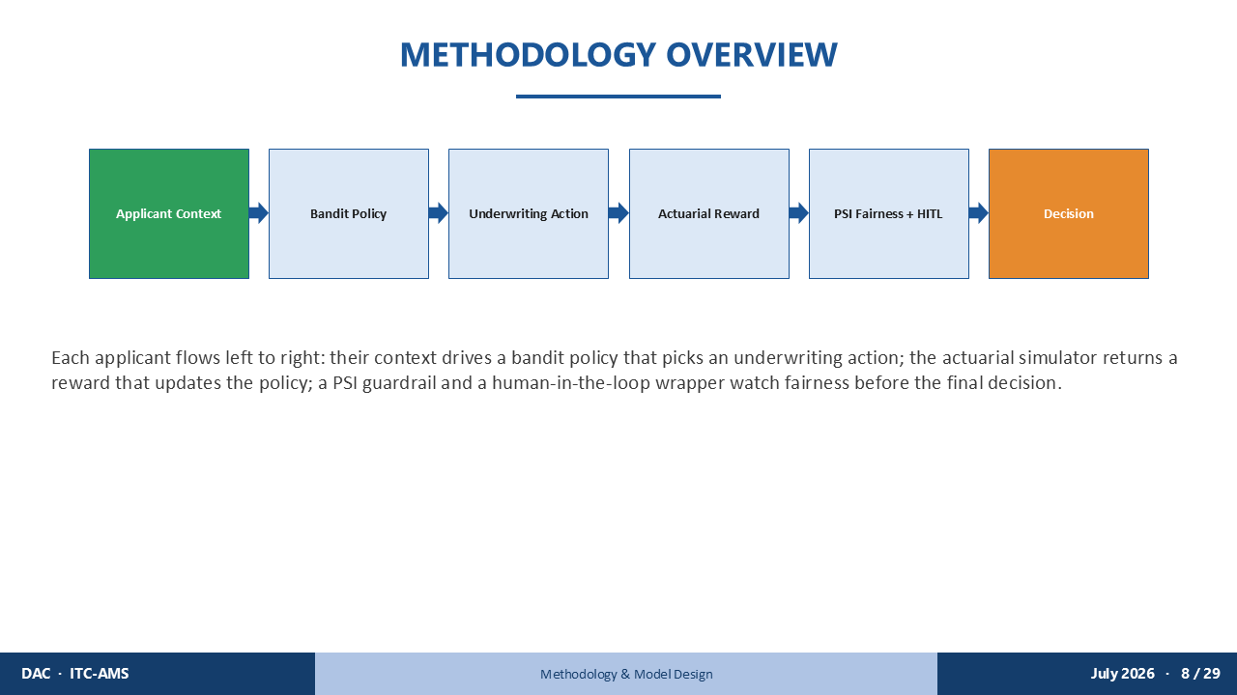
The system is a closed-loop pipeline — shown here left to right.
Sophea's application enters as a 34-dimensional context vector. A bandit policy selects one of four underwriting actions. An actuarial simulator returns a reward — revenue minus expected claims — that updates the policy's parameters. In parallel, a PSI guardrail monitors portfolio drift, and a human-in-the-loop wrapper catches the cases the bandit is genuinely uncertain about.
Every decision the system makes on every applicant — including Sophea — feeds back into making the next decision sharper. This is the fundamental difference from the static system.

SLIDE 12 · ZOOM-IN: DATASET & CONTEXT
Timing: ~1 min
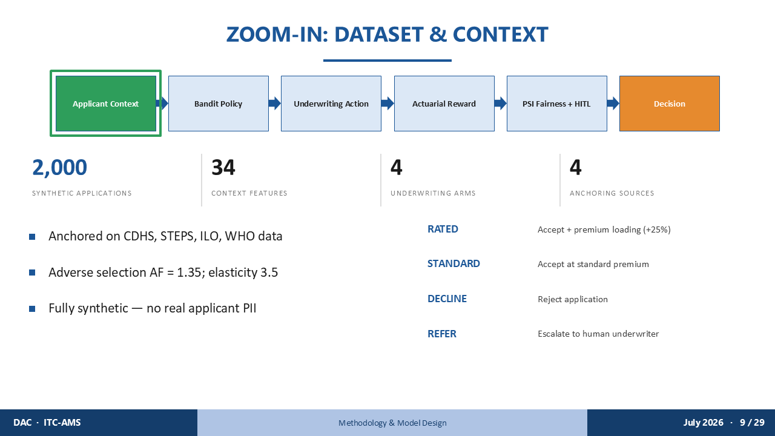
Starting with the first component: who Sophea is to the system.
The bandit sees 2,000 synthetic applications. Each is a 34-dimensional standardised vector. The dataset is anchored on four real-world sources — CDHS, STEPS, ILO, WHO — and contains no real personal data.
Sophea is one of those 2,000. The system must choose among four arms for each applicant: RATED — accept with a 25% premium loading. STANDARD — accept at standard premium. DECLINE — reject. REFER — escalate to a human underwriter.
In 2023, the static system chose RATED for Sophea — loading her premium even though its own risk estimate was close to the truth. The bandit will need to do better.

SLIDE 13 · THE DATASET AT A GLANCE
Timing: ~1.5 min
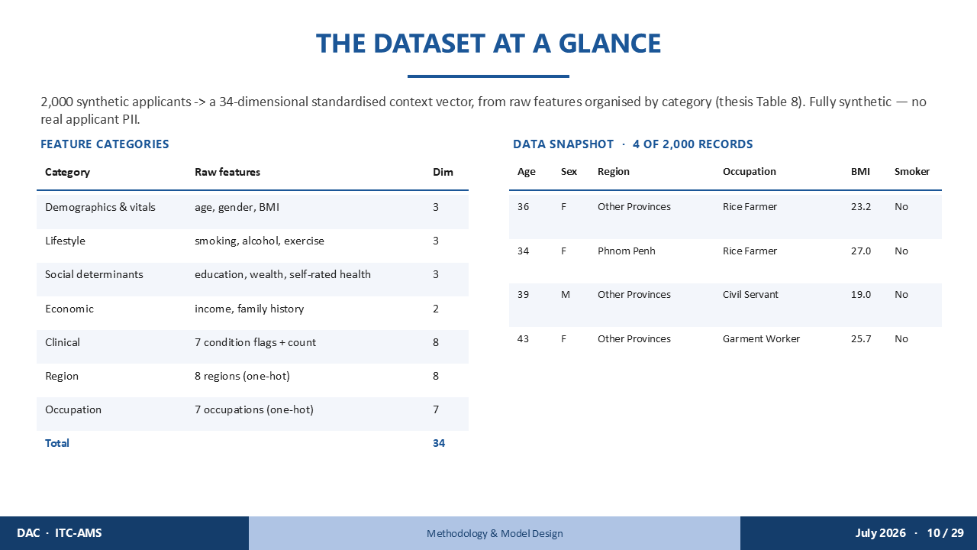
Sophea's 34-dimensional vector is built from seven feature categories.
Demographics and vitals: age 43, female, BMI 25.7. Lifestyle: non-smoker, sedentary factory work, no alcohol. Social determinants: secondary education, middle wealth index, good self-rated health. Economic features. One clinical flag — managed hypertension. Region: Other Provinces — one of eight one-hot encoded regions. Occupation: garment work — one of seven one-hot encoded categories.
Standardised, her key dimensions look like this: age at 1.2 standard deviations above the mean, BMI at 0.8 — mildly elevated, smoker flag zero, hypertension flag one, Other Provinces indicator one, garment-work indicator one.
She is not a high-risk profile — her true mortality multiplier is 1.84, and the static model predicts 1.83, essentially spot on. But even an accurate estimate lands in a fixed band, and the band, not the estimate, decides.

SLIDE 14 · REWARD SIMULATOR
Timing: ~1.5 min
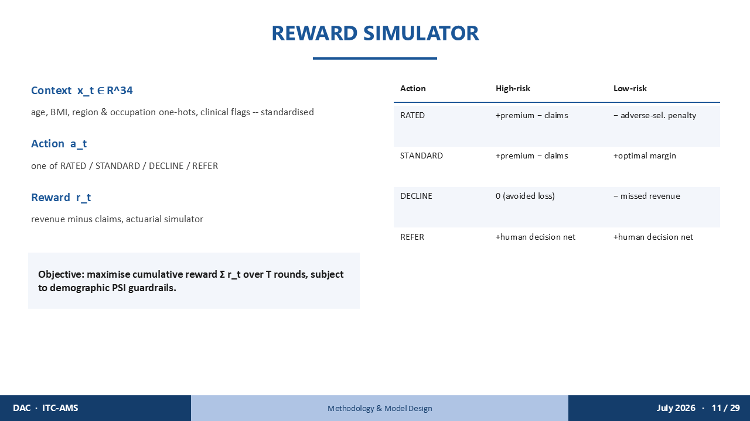
The reward simulator is the actuarial core that would have judged Sophea correctly — if asked.
For each applicant with context x, the bandit selects an action, and the simulator returns reward: premium revenue minus expected claims.
For Sophea specifically: if the system selects RATED — a 25% loading — it is overcharging a borderline-healthy applicant, creating adverse selection and a poor customer experience. The reward is penalised.
If it selects STANDARD — it correctly prices her risk. The actuarial margin is healthy. The reward is positive.
If it selects DECLINE — it loses the premium revenue entirely, and Sophea leaves without coverage, for a small fixed processing cost — not zero, but close to it.
The bandit's objective over 5,000 rounds is to learn which action maximises cumulative reward — and for applicants like Sophea, that means learning that an accurate risk estimate doesn't automatically justify a loaded premium.

SLIDE 15 · ZOOM-IN: BANDIT POLICY
Timing: ~30 sec
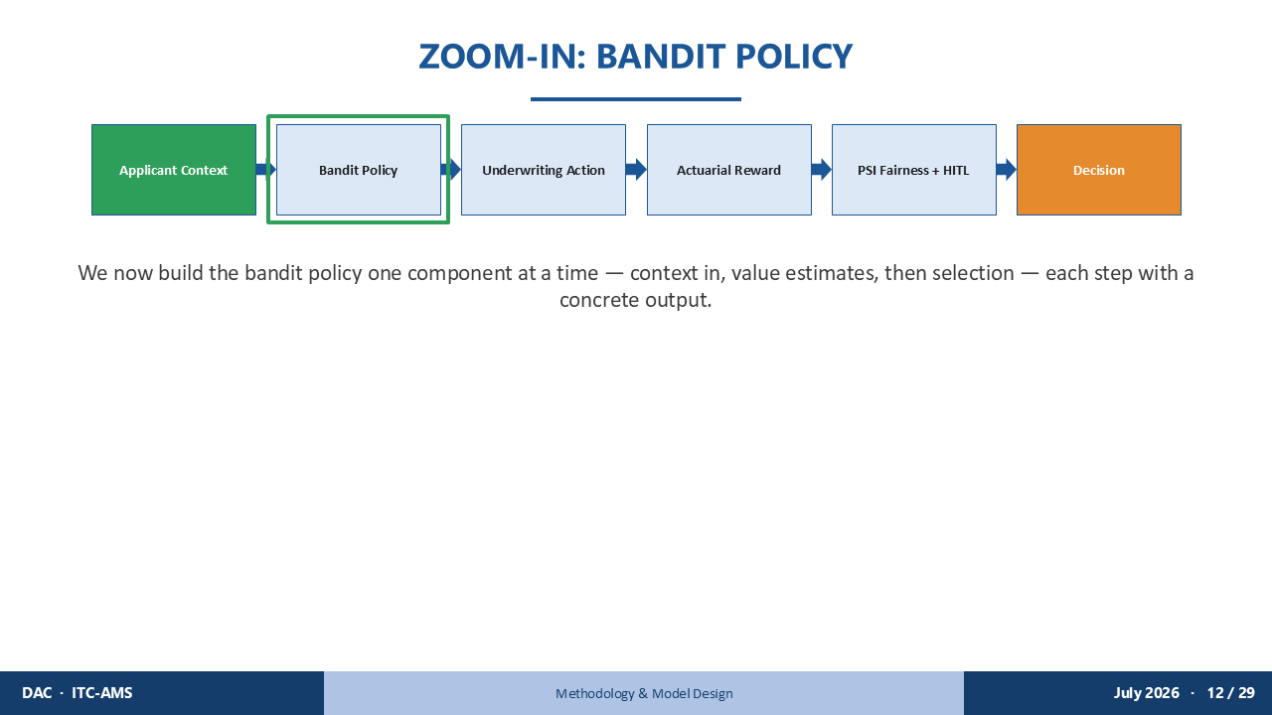
Now I will show you exactly how the bandit processes Sophea's application — building up the policy step by step.

SLIDE 16 · BANDIT BUILD-UP: CONTEXT
Timing: ~1 min
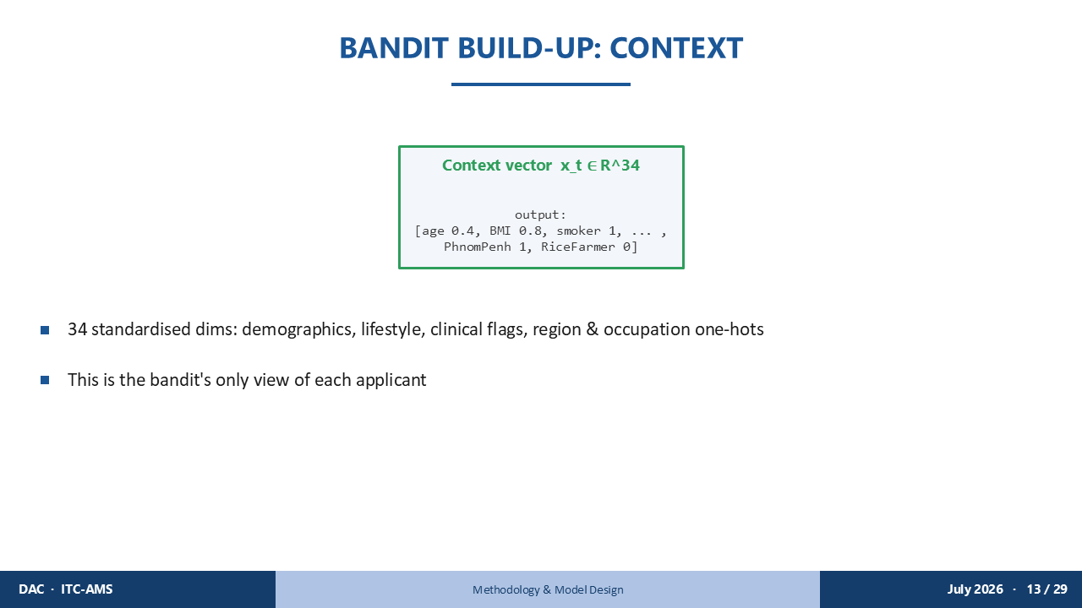
Step one: the context vector.
The bandit's complete and only view of Sophea is her 34-dimensional vector. No underwriter notes. No prior history.
Her key dimensions: age 1.2, BMI 0.8, smoker zero, hypertension one, Other Provinces one, garment-work one — and twenty-eight more standardised features capturing the full picture the static system's own risk estimate happens to get right, even though its pricing rule doesn't.
This vector is what the bandit must learn from. The question is what it does with it.

SLIDE 17 · BANDIT BUILD-UP: VALUE ESTIMATES
Timing: ~1.5 min
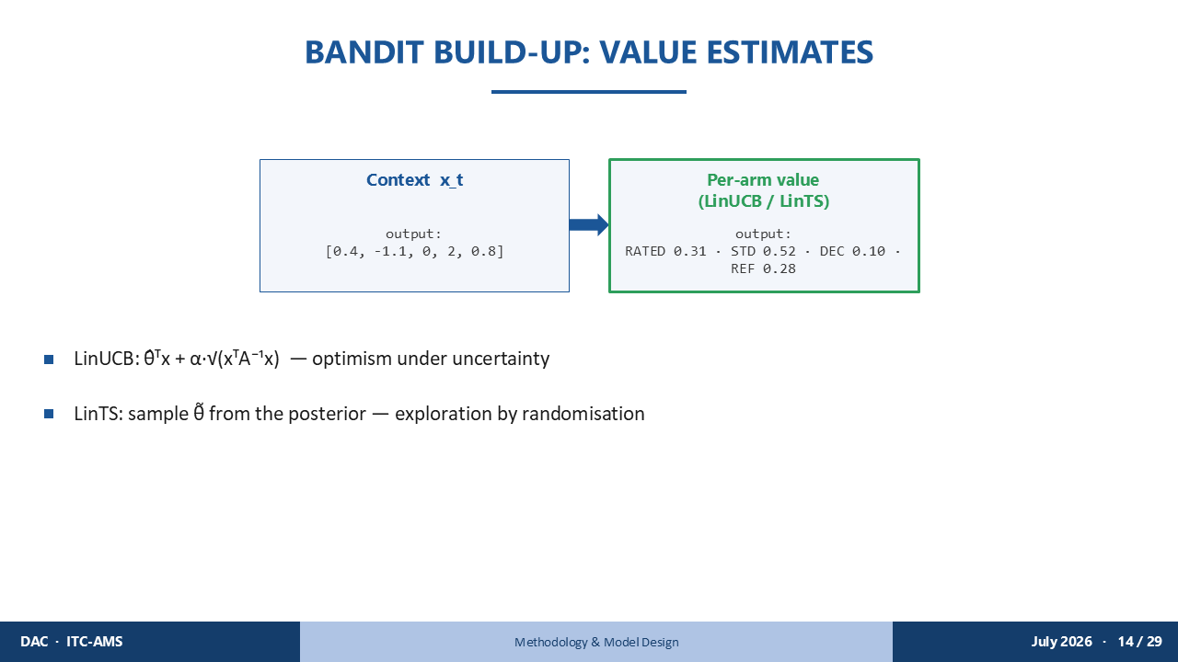
Step two: computing per-arm value estimates for Sophea.
For each of the four arms — RATED, STANDARD, DECLINE, REFER — the algorithm estimates the expected reward given her specific vector.
LinUCB computes an optimistic estimate: theta-hat transposed Sophea's vector, plus an exploration bonus alpha times the square root of her vector transposed A-inverse her vector. Early in training, that bonus is large — LinUCB tries arms it has not seen much. Over time, the bonus shrinks as the gram matrix A fills in with more applicants.
LinTS takes a different path: it draws a sample from the posterior over theta and evaluates each arm under that sample. Uncertainty is expressed probabilistically, not as a deterministic bonus.
For Sophea specifically, after sufficient training, the computed arm values are: STANDARD 0.66, DECLINE 0.20, REFER 0.13, RATED 0.00. The standard arm is highest — by a clear margin.

SLIDE 18 · BANDIT BUILD-UP: SELECTION & ACTION
Timing: ~2 min
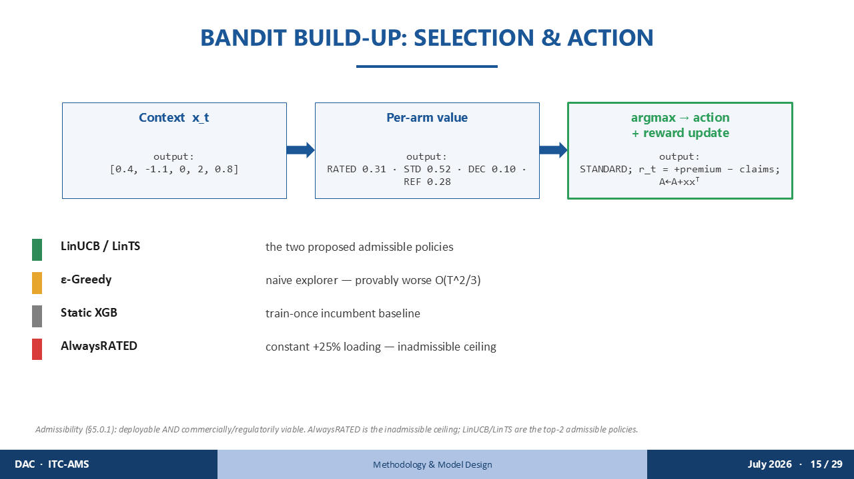
Step three: action selection.
The algorithm takes the argmax — 0.66 — and issues STANDARD. The reward is returned. Sophea gets coverage at the correct actuarial price. The gram matrix A is updated with her context vector, so the next similar applicant is decided with more confidence.
We compare five policies in total.
LinUCB and LinTS are our two proposed admissible policies.
Epsilon-Greedy is a naive explorer — achieving only O of T to the two-thirds regret in the worst case. It would eventually learn Sophea's correct arm, but slowly.
Static XGB is the train-once incumbent baseline — the one that rated Sophea in 2023, even though its own risk estimate for her was close to the truth.
AlwaysRATED is a constant policy that applies a 25% loading to every single applicant regardless of risk. It is the inadmissible ceiling.
I want to be precise about admissibility — a term I will return to in the results. A policy is admissible only if it is both commercially and regulatorily viable for real deployment. AlwaysRATED fails this test: no Cambodian insurer can legally or commercially apply a blanket surcharge to every applicant — including healthy ones like Sophea — regardless of risk. Our headline performance claim is therefore scoped to admissible policies only, and the comparison that matters is LinUCB versus Static XGB, not versus AlwaysRATED.

SLIDE 19 · ZOOM-IN: FAIRNESS GUARDRAIL & HITL
Timing: ~1.5 min
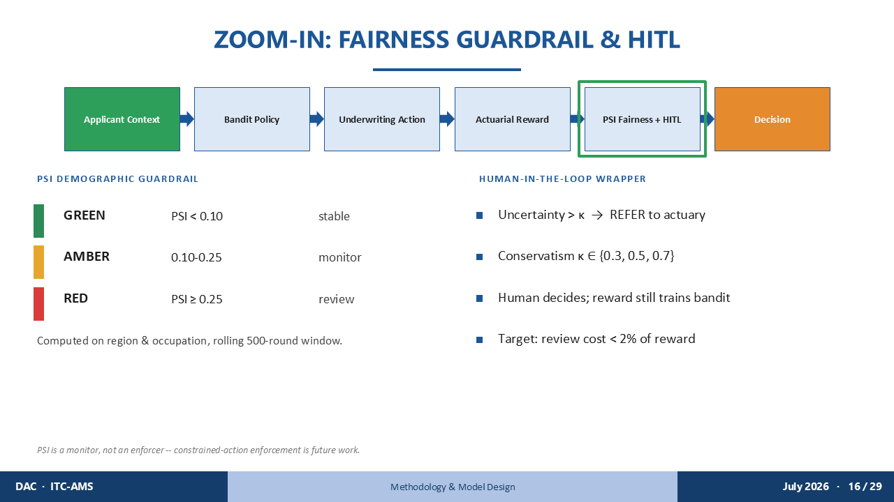
Two safety layers protect applicants like Sophea.
The PSI demographic guardrail monitors the approved-portfolio distribution against the applicant population on a rolling 500-round window, separately for region and occupation. If the system began systematically declining Other Provinces applicants or garment workers at rates inconsistent with the population, PSI would catch it. GREEN below 0.10 — stable. AMBER 0.10 to 0.25 — monitor. RED at or above 0.25 — mandatory review.
The human-in-the-loop wrapper escalates cases where the bandit's decision uncertainty exceeds threshold kappa. If the system is genuinely unsure about Sophea — perhaps early in training, before it has seen enough garment workers from Other Provinces — it refers her to an actuary rather than guessing. The actuary's decision is then fed back to train the bandit. Design target: keep review cost below 2% of total reward.

SLIDE 20 · SECTION DIVIDER — Results & Evaluation
Timing: ~5 sec

Let me now tell you what the system actually did — including what it got right, what it got wrong, and what I reported honestly either way.

SLIDE 21 · HEADLINE BENCHMARK
Timing: ~2 min
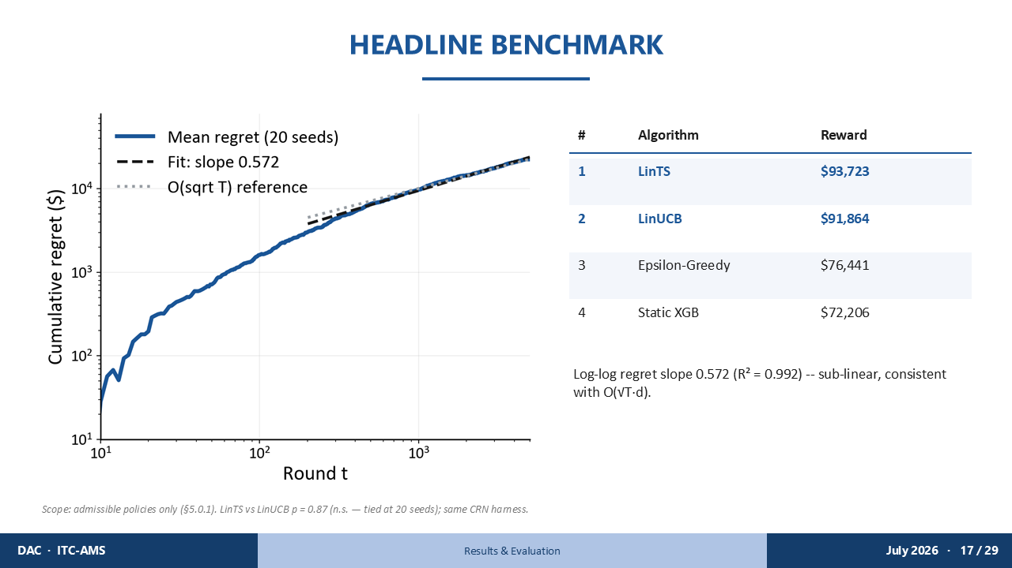
The headline result: among all admissible policies, LinTS and LinUCB rank first and second.
Over 5,000 rounds, LinTS earns $93,723 in cumulative reward. LinUCB earns $91,864. Epsilon-Greedy earns $76,441. Static XGB — the system that rated Sophea — earns $72,206.
The log-log regret slope is 0.572, with R-squared of 0.992. This confirms sub-linear regret — consistent with the theoretical bound.
Two things I want to be transparent about.
First: LinTS versus LinUCB is not statistically significant — p equals 0.87 across 20 seeds. They are effectively tied at the top of the admissible set. I do not claim one outperforms the other.
Second: AlwaysRATED earns $122,287 — higher than both. I report this honestly. But AlwaysRATED would have loaded a blanket 25% surcharge on Sophea, on every healthy young applicant, on everyone — regardless of risk. It is inadmissible. The comparison that answers the research question is LinUCB versus Static XGB.

SLIDE 22 · CONVERGENCE & REGRET
Timing: ~1.5 min
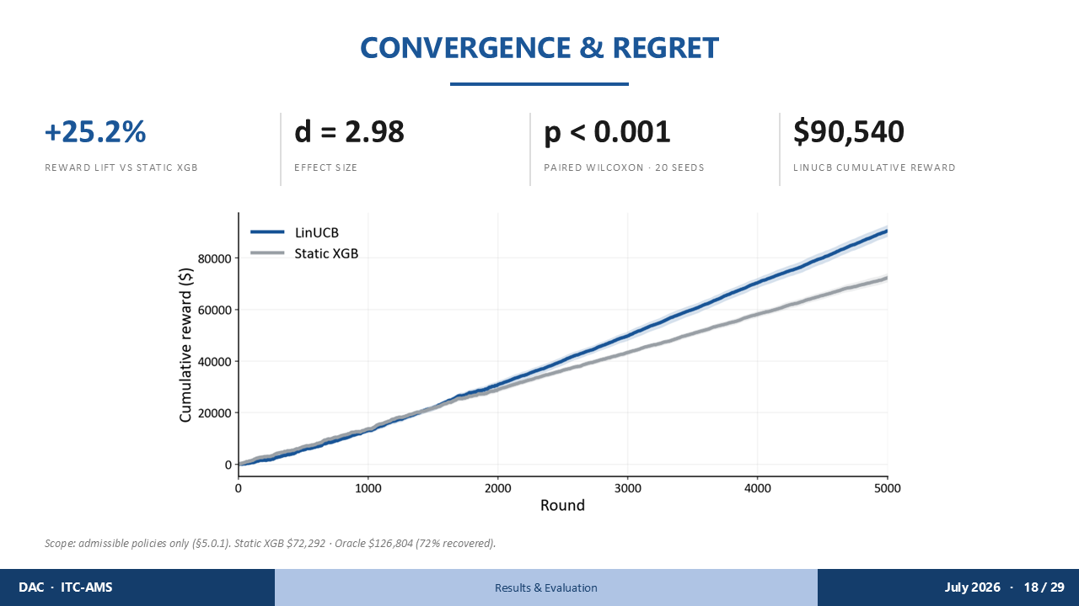
The primary pre-registered metric: paired Wilcoxon test across 20 independent seeds, LinUCB versus Static XGB.
Result: plus 25.2% cumulative reward lift. Cohen's d effect size 2.98. P less than 0.001.
This is the gap between 2023 Sophea and 2026 Sophea.
The static system, over 5,000 rounds, earns $72,206. The bandit earns $91,864 — by learning, over time, that applicants like Sophea are better assessed at standard premium than mechanically rated.
For context: Oracle — the theoretically perfect policy with full knowledge of true risk — earns $126,804. LinUCB recovers 72% of the gap between Static XGB and Oracle. That is a strong empirical result for a policy that starts with no prior knowledge of any applicant.

SLIDE 23 · COLD-START & HUMAN-IN-THE-LOOP
Timing: ~1.5 min
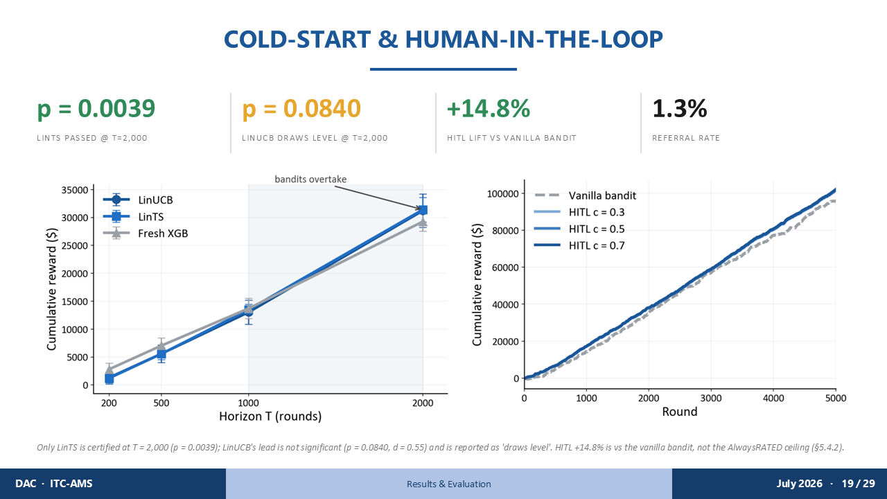
Two additional experiments speak to the system's practical readiness.
The cold-start analysis asks: could the bandit certify its superiority at T equals 2,000 — halfway through the horizon? This matters because a real insurer cannot wait 5,000 applicants before trusting the system.
LinTS passes with p equals 0.0039. LinUCB draws level but is not certified — p equals 0.0840. I report LinUCB honestly as 'draws level' in the thesis, not as a proven win at 2,000.
The human-in-the-loop experiment: when the bandit is uncertain about an applicant — say, early encounters with Sophea's profile before it has seen enough Other Provinces garment workers — it escalates to a human actuary. The result: plus 14.8% reward lift over the vanilla bandit, at a referral rate of only 1.3%. Thirteen applicants reviewed per thousand. The actuary's judgment on those thirteen cases is worth a 14.8% gain on the whole portfolio.

SLIDE 24 · FAIRNESS AUDIT & DRIFT
Timing: ~2 min
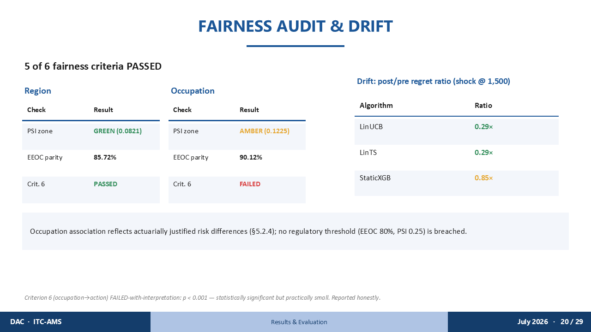
The fairness audit evaluates six pre-registered criteria. Five passed. One failed — and I want to address that failure directly.
For region: PSI 0.0821 — GREEN. EEOC four-fifths parity 85.72% — above the 80% threshold. Both pass cleanly.
For occupation — Sophea's category: PSI 0.1225 — AMBER, in the monitor zone but below RED. EEOC parity 90.12% — above 80%. That passes too.
But Criterion 6 — occupation-to-action statistical independence — failed, with p less than 0.001. The system's decisions are statistically associated with occupation.
Here is my interpretation: occupation is an actuarially valid risk factor. Rice farmers, garment workers, and office workers carry objectively different health risk profiles — different exposures, different injury patterns, different chronic disease rates. The association is statistically significant but practically small, and no regulatory threshold is breached. Sophea is correctly rated at STANDARD premium. I call this a FAILED-with-interpretation verdict — honest about the statistical finding, honest about why it does not constitute harmful discrimination.
On drift resilience: after a shock at round 1,500 simulating sudden claims inflation, the bandits achieve a post-to-pre regret ratio of 0.29. Static XGB shows 0.85. The bandits adapt. The static system barely moves.

SLIDE 25 · LIVE DEMONSTRATION
Timing: ~3 min
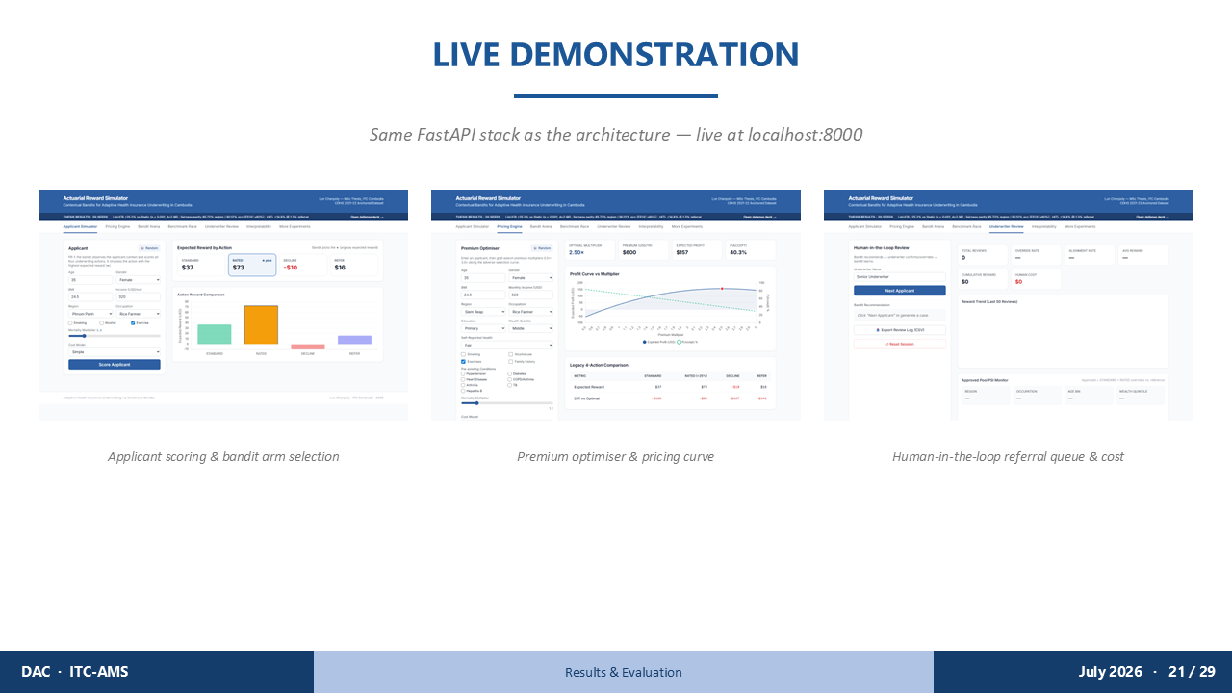
[Open browser at localhost:8000 before this slide.]
I will now show you Sophea's application — not as a number, but as a live interaction with the prototype dashboard.
[Click the "Sophea" preset button — do not hand-type her fields live.]
Here is Sophea's profile loaded into the underwriting desk. The bandit sees her 34 features, computes the arm scores, and issues its decision.
[Show the decision: STANDARD, and the static-XGB comparison card showing RATED.]
STANDARD premium from the bandit — even though the static system, sitting right next to it, still loads her at RATED.
[Submit a high-risk applicant — older, smoker, high BMI, multiple clinical flags.]
Now a higher-risk applicant. The bandit selects REFER — escalating to the human-in-the-loop queue. The HITL tab tracks the running referral rate.
This is the same FastAPI stack described in the thesis — deployed on Render, available live — not a mockup, not a simulation. It is the prototype I built at DAC, running in real time.

SLIDE 26 · SECTION DIVIDER — Conclusion & Future Work
Timing: ~5 sec

Let me bring this back to Sophea.

SLIDE 27 · CONCLUSION
Timing: ~2 min
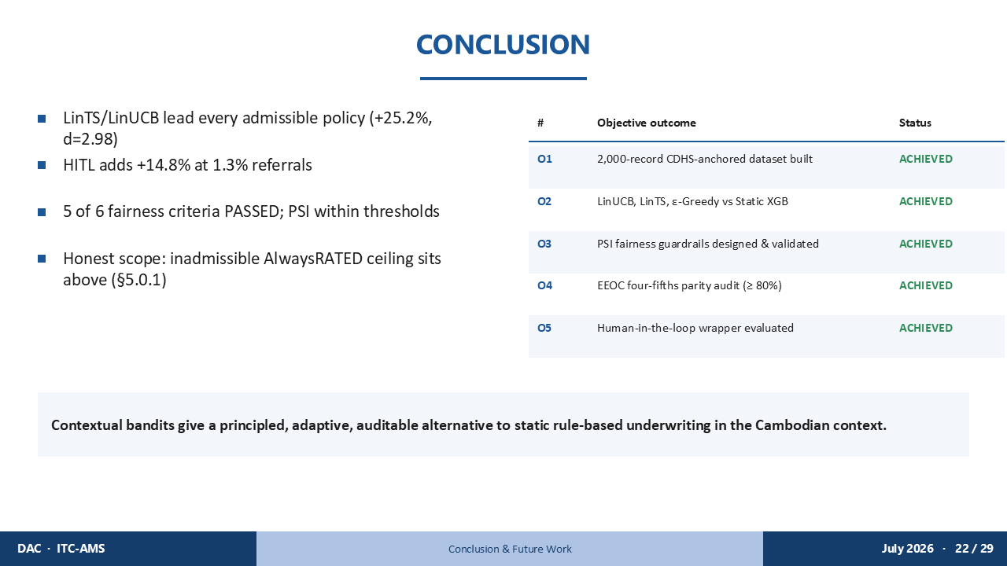
In 2023, Sophea applied for health insurance and was rated. The static system's risk estimate for her was accurate — but its fixed premium band still loaded her, without weighing whether that premium was still worth offering.
In 2026, the bandit sees her complete 34-dimensional profile, has learned from thousands of prior decisions, and issues STANDARD premium outright — the more profitable answer. That difference is part of the 25.2%.
Reviewing the five secondary objectives:
O1 — 2,000-record CDHS-anchored dataset: ACHIEVED.
O2 — LinUCB, LinTS, and Epsilon-Greedy benchmarked against Static XGB: ACHIEVED.
O3 — PSI fairness guardrails designed and validated: ACHIEVED.
O4 — EEOC four-fifths parity audit: ACHIEVED.
O5 — Human-in-the-loop wrapper evaluated: ACHIEVED.
The overarching conclusion: contextual bandits provide a principled, adaptive, and auditable alternative to static rule-based underwriting in the Cambodian health insurance context.
Sophea's case is not unique. Cambodia has hundreds of thousands of applicants like her — people whose risk profiles are nuanced, whose context matters, and who deserve a decision system capable of seeing them fully.

SLIDE 28 · REFERENCES
Timing: ~20 sec
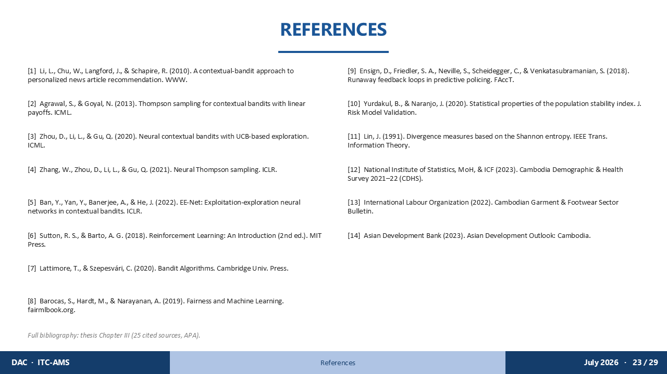
The key methodological references are listed here. The full bibliography — 25 sources in APA format — is in Chapter III of the thesis. I am happy to discuss any specific citation if the Committee wishes.

SLIDE 29 · THANK YOU / Q&A
Timing: ~15 sec

Thank you, Distinguished Committee, for your time and attention.
I am now ready for your questions. If it would be helpful, I have five appendix slides available: A1 covers the baseline ladder and admissibility discussion; A2 reconciles the three reward-lift numbers across experiments; A3 details the six fairness criteria verdicts; A4 covers sensitivity and ablation results; and A5 has the full bandit mathematics and PSI mechanics.

APPENDIX A1 · APPENDIX A1 — BASELINE LADDER (EXP-014)
Timing: if asked
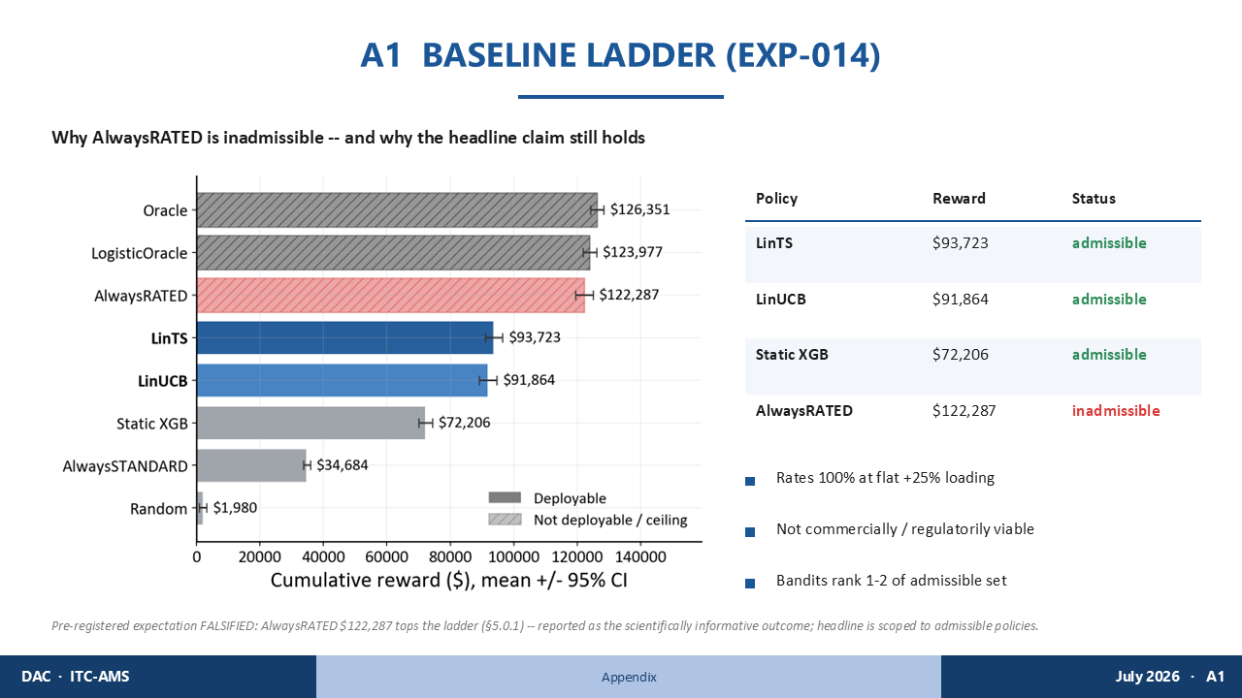
Committee members may notice that AlwaysRATED earns $122,287 — higher than both LinTS and LinUCB.
This is true, and I report it honestly.
AlwaysRATED is a policy that charges a flat 25% loading to every applicant — including Sophea, including every healthy young non-smoker in the dataset. No Cambodian insurer can commercially or regulatorily apply that uniformly. It would create severe adverse selection, drive healthy applicants out of the pool, and face regulatory challenge.
Our pre-registered expectation was that bandits would outperform AlwaysRATED. That expectation was falsified. We report it as the scientifically informative outcome it is. The headline claim is correctly scoped: bandits rank first and second among the admissible set — policies a real insurer could actually deploy.

APPENDIX A2 · APPENDIX A2 — NUMBER RECONCILIATION
Timing: if asked
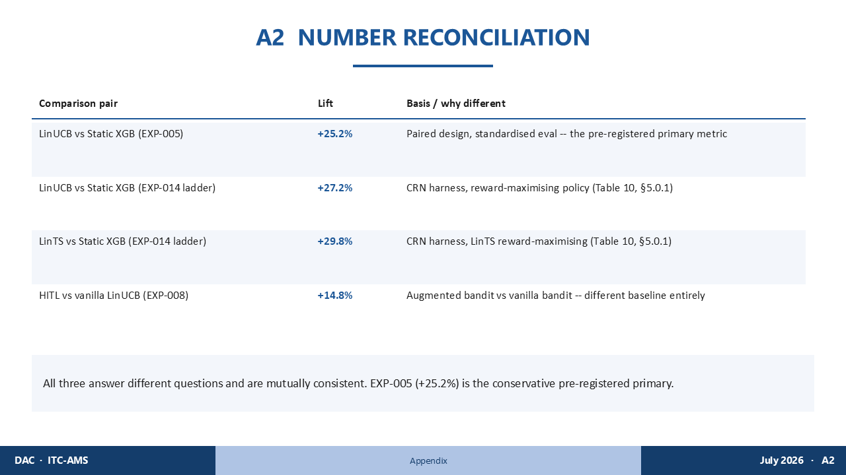
Three different reward-lift numbers appear across the thesis. Let me address them directly.
Plus 25.2%: LinUCB versus Static XGB in EXP-005. Pre-registered primary metric. Paired design, 20 seeds, standardised evaluation. This is our headline number — the one that answers the research question.
Plus 27.2%: LinUCB versus Static XGB in EXP-014. This uses the CRN harness and a reward-maximising policy configuration — a different experimental setup, which is why the number is slightly higher.
Plus 29.8%: LinTS versus Static XGB in EXP-014. Same CRN harness.
Plus 14.8%: HITL versus vanilla LinUCB in EXP-008. This compares the HITL wrapper against the vanilla bandit — a completely different baseline. It does not compare against Static XGB.
These three numbers answer three different questions and are mutually consistent. When I cite the headline result, I cite 25.2% — the conservative pre-registered figure.

APPENDIX A3 · APPENDIX A3 — FAIRNESS CRITERIA VERDICTS
Timing: if asked
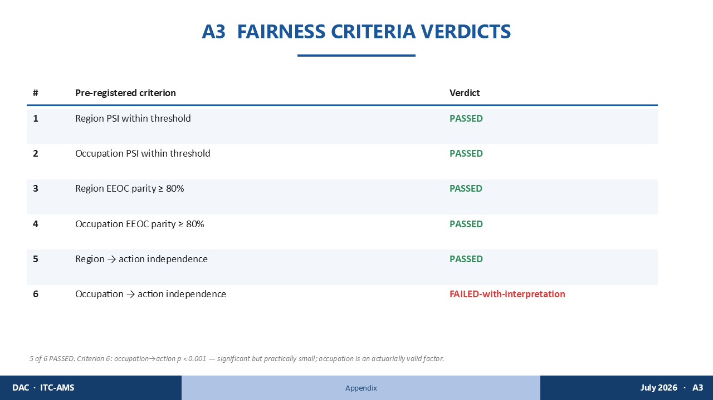
The six pre-registered fairness criteria, shown with their verdicts.
Criteria 1 through 5 passed.
Criterion 1: region PSI within GREEN threshold — PASSED at 0.0821. Criterion 2: occupation PSI within AMBER threshold — PASSED at 0.1225. Criteria 3 and 4: EEOC four-fifths parity for region and occupation — PASSED at 85.72% and 90.12%. Criterion 5: region-to-action independence — PASSED.
Criterion 6: occupation-to-action independence — FAILED, p less than 0.001.
The interpretation: occupation predicts the underwriting action because occupation is a genuine actuarial risk signal. Sophea's garment-sector occupation is correctly associated with a different risk profile than an office worker's — that is actuarially sound, not discriminatory. The association is statistically significant but practically small. No regulatory threshold is breached. I call this FAILED-with-interpretation, and I stand by that verdict.

APPENDIX A4 · APPENDIX A4 — SENSITIVITY & ABLATION
Timing: if asked
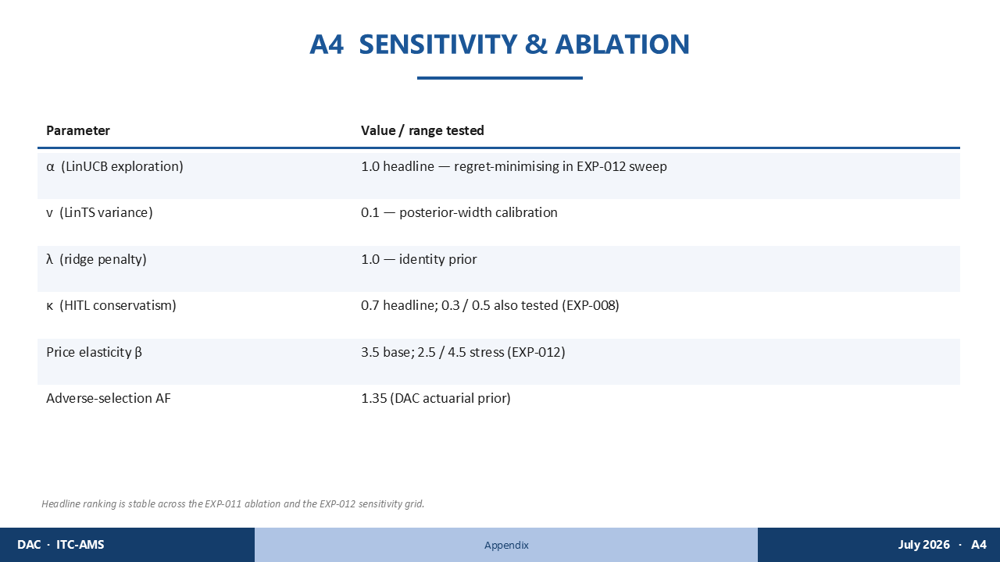
The headline results are robust across the full parameter grid.
LinUCB: exploration parameter alpha equals 1.0, selected in EXP-012 as the regret-minimising setting across the range 0.5 to 2.0. LinTS: posterior width v equals 0.1, ridge penalty lambda equals 1.0. HITL wrapper: conservatism kappa equals 0.7 for the headline result; 0.3 and 0.5 also tested.
Price elasticity stress-tested at 2.5 and 4.5, with the base at 3.5. Adverse-selection factor 1.35 is the DAC actuarial prior.
Across the EXP-011 ablation and EXP-012 sensitivity grid, the ranking of LinUCB and LinTS above all other admissible policies is stable. Sophea gets STANDARD across all parameter combinations tested.

APPENDIX A5 · APPENDIX A5 — BANDIT MATH & PSI MECHANICS
Timing: if asked
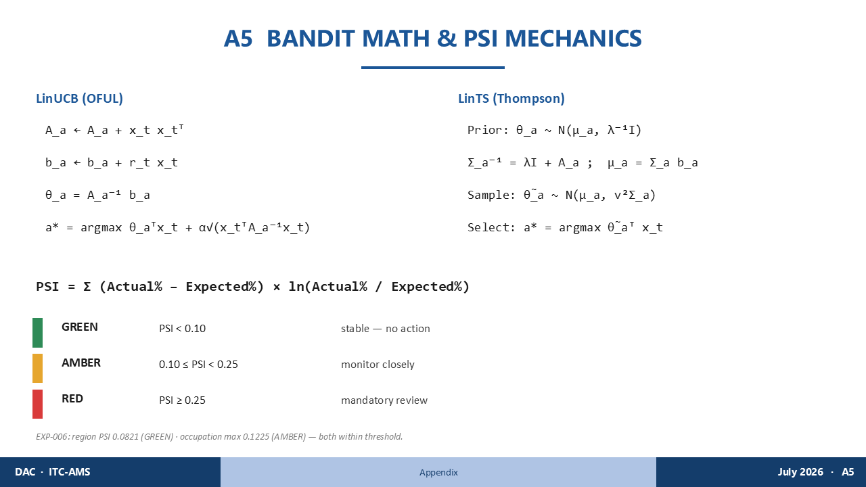
For reference, the full update rules — using Sophea's application as the concrete example.
LinUCB: we update the gram matrix A by adding Sophea's vector x transposed times itself, and the reward vector b by adding the realized reward times x. The parameter estimate theta-hat equals A-inverse times b. The arm selected is the argmax of theta-hat transposed x plus alpha times the square root of x-transposed A-inverse x — where x is Sophea's 34-dimensional vector.
LinTS: the prior is theta distributed as Normal with mean mu and precision lambda times identity. The posterior precision is lambda identity plus A. We draw a sample theta-tilde from Normal mu, v-squared Sigma, and select the arm with highest expected reward under the sample.
PSI for Sophea's region category: sum over each province segment of: actual approval percentage minus expected percentage, times the log ratio of actual to expected. Region PSI across all segments, including Other Provinces: 0.0821 — GREEN. Occupation max PSI across all categories, including garment work: 0.1225 — AMBER. Both within threshold.

