THESIS DEFENSE PRESENTATION SCRIPT
Adaptive Health Insurance Underwriting via Contextual Bandits:
A Reinforcement Learning Approach for Cambodia
LUN CHANPOLY · ITC-AMS · 8 July 2026

HOW TO USE THIS SCRIPT
Read aloud naturally — do not recite word-for-word if it feels unnatural. Bracketed notes [like this] are stage directions, not spoken text. The Sophea narrative is the emotional thread — carry it slides 4, 11, 17 and 22. The nine appendix slides A1-A9 are on standby; only advance to them if the Committee asks a question that slide addresses.

SLIDE 1 · TITLE SLIDE
Timing: ~1 min
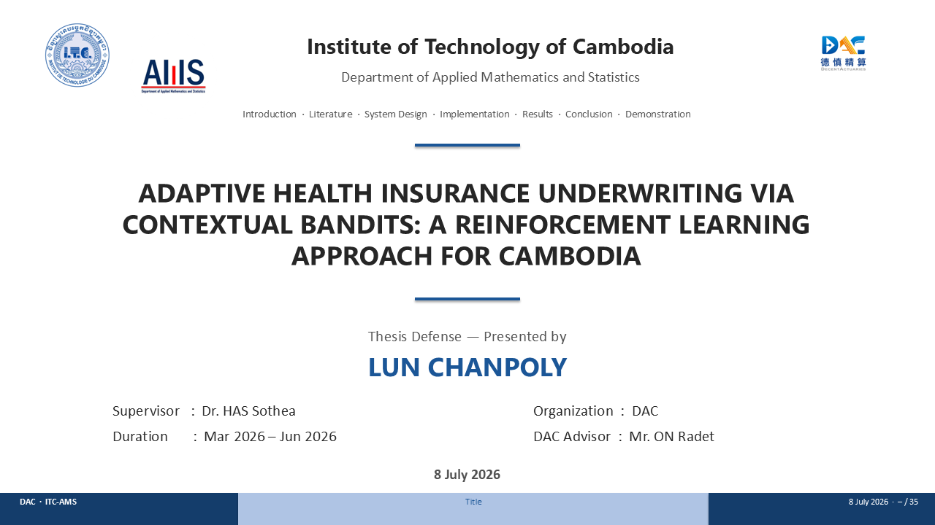
Good morning, Distinguished Committee. I am Lun Chanpoly, and I am here to defend my master's thesis — Adaptive Health Insurance Underwriting via Contextual Bandits: A Reinforcement Learning Approach for Cambodia. This project grew out of my internship at Decent Actuarial Consultants in Phnom Penh, from March to June 2026, under the supervision of Dr. Has Sothea and the guidance of Mr. ON Radet at DAC.
The talk has seven short sections — I'll keep the language plain and keep the maths for the appendix, which is on standby if you want to go deeper on any number.
But first, let me tell you about a person named Sophea.

SLIDE 2 · TABLE OF CONTENTS
Timing: ~0.5 min
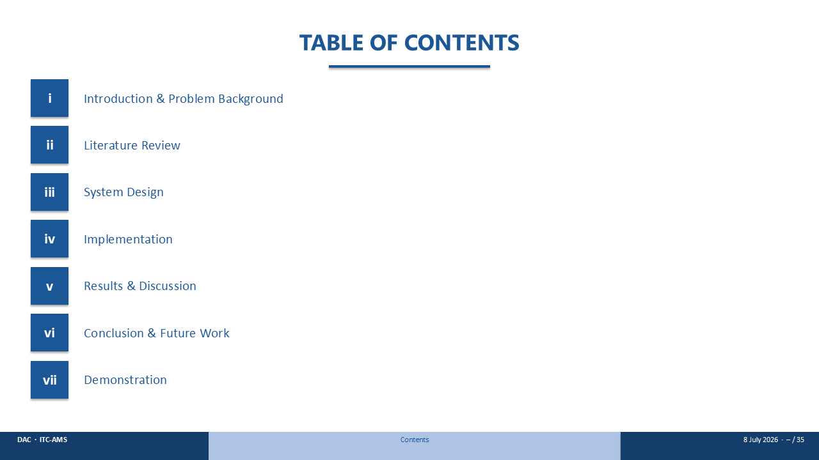
Before I introduce her properly, here is the shape of the talk. I'll start with the problem and the market, review the literature in a single table, walk through how the system is designed and built, show the results, draw the conclusions, and finish with a live demonstration.
[Advance to the map.]

SLIDE 3 · A MARKET THE SYSTEM WAS NOT BUILT FOR
Timing: ~1 min
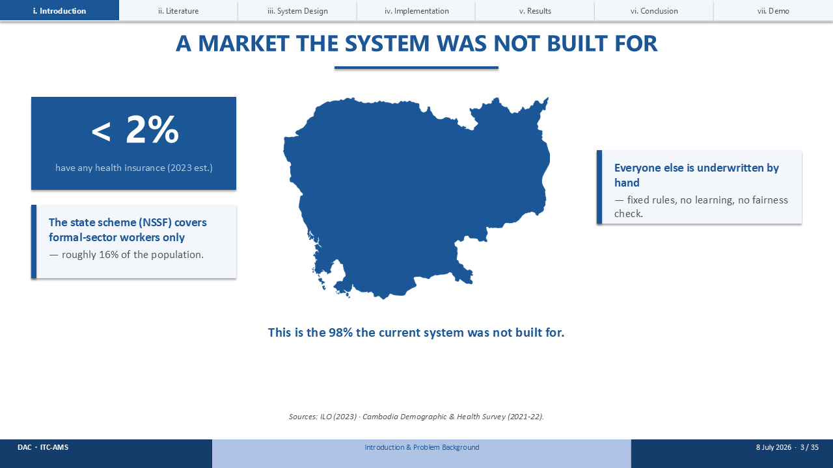
[Point to the map and the numbers around it.]
This is the market Sophea lives in. In Cambodia, fewer than two percent of people have any health insurance. The state scheme, NSSF, reaches only formal-sector workers — roughly sixteen percent of the population. Everyone else is underwritten by hand: fixed rules, no learning, and no check on fairness.
So Sophea is not an exception. She represents the ninety-eight percent the current system was simply not built for.

SLIDE 4 · MEET SOPHEA
Timing: ~1.5 min
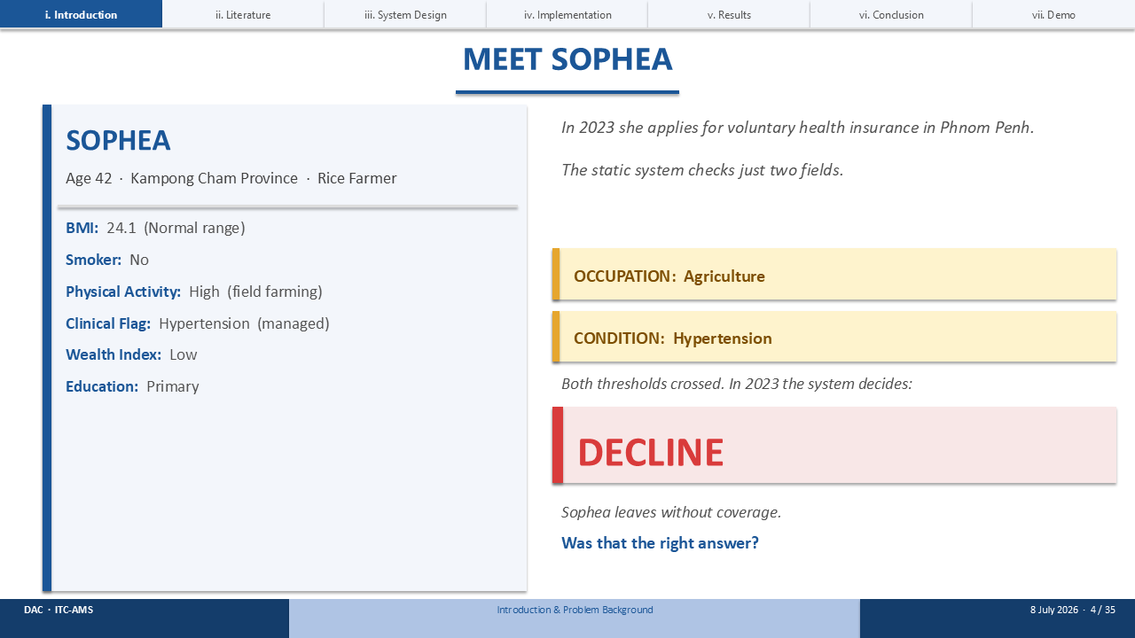
Let's meet one of them.
[Point to the profile card on the left.]
This is Sophea — forty-three years old, a garment worker. She's a non-smoker, sedentary factory work, with a BMI of 25.7. Her only health flag is managed hypertension.
[Point to the two amber flags on the right.]
In 2023 she applies for voluntary health insurance. The static system predicts her mortality risk from her full profile — one point eight three times normal — and that estimate falls in a fixed band.
[Point to the amber box.]
The decision: RATED. She's covered, but at a loaded premium. And I have to ask — was that the right price?

SLIDE 5 · WHY STATIC RULES FAIL
Timing: ~1 min
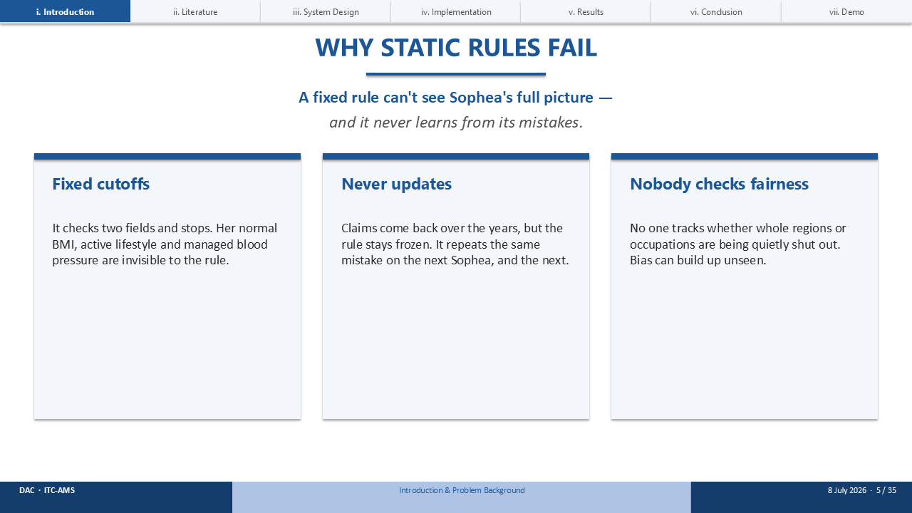
The honest answer is subtler than 'the rule couldn't see her.' Its risk estimate for Sophea is actually accurate — one point eight three against a true one point eight four. Getting the risk right isn't the same as getting the price right.
Three problems, in plain words. First, fixed cutoffs: a fixed band can't weigh whether a loaded premium is still worth offering — it just applies the same cutoff to everyone in the band. Second, it never updates: claims come back over the years but the rule stays frozen, repeating the same pricing mistake. And third, nobody checks fairness: no one is watching whether whole regions or occupations are quietly shut out.
My thesis asks whether a system that learns can do better on all three.

SLIDE 6 · GOAL & OBJECTIVES
Timing: ~1.5 min
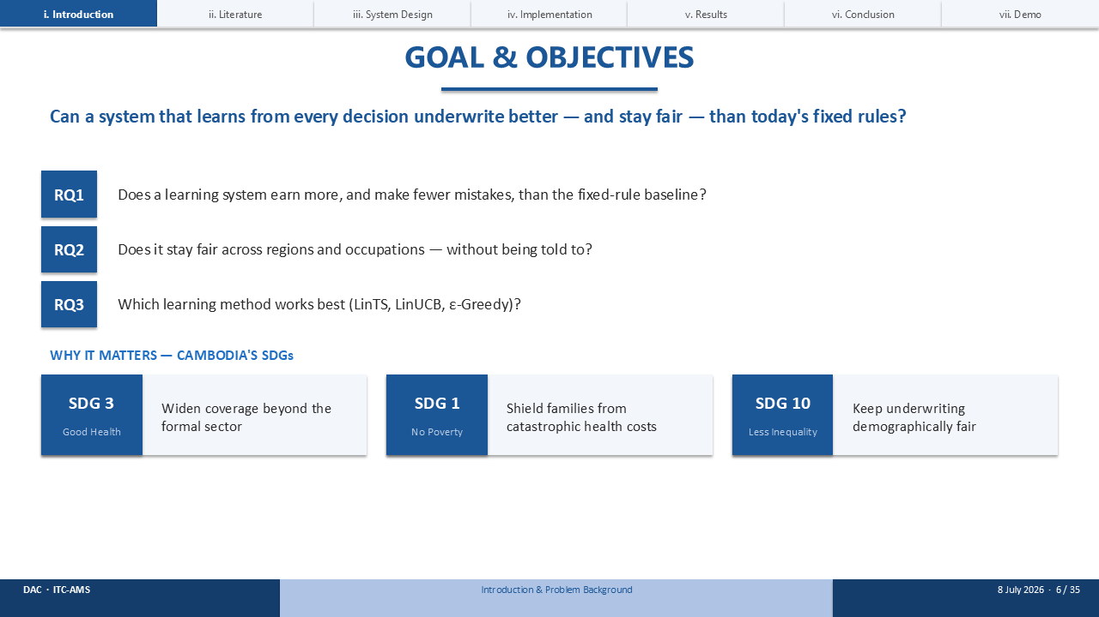
So here is the goal, in one sentence: can a system that learns from every decision underwrite better — and stay fair — than today's fixed rules?
That breaks into three research questions. One: does the learning system earn more and make fewer mistakes than the fixed-rule baseline? Two: does it stay fair across regions and occupations, without being explicitly told to? And three: which learning method works best?
[Point to the SDG strip.]
And why it matters: this touches three of Cambodia's Sustainable Development Goals — good health, no poverty, and reduced inequality.

SLIDE 7 · ABOUT DECENT ACTUARIAL CONSULTANTS
Timing: ~1 min
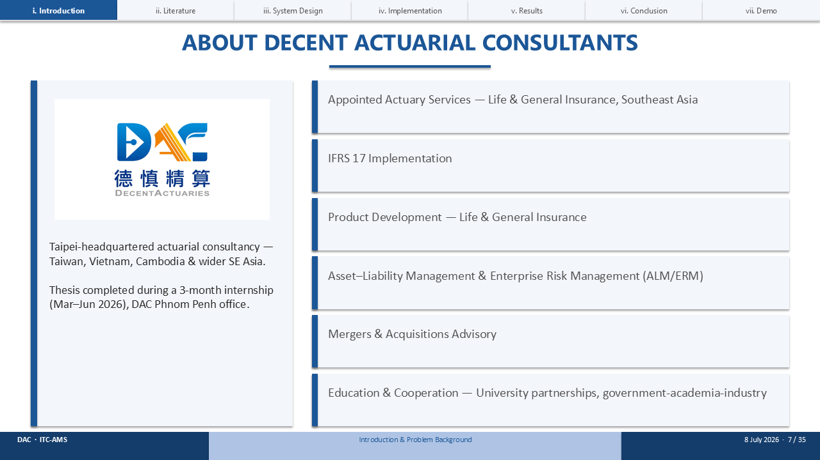
Before I show you how I built this, a word on where. I pursued this at Decent Actuarial Consultants — DAC — as a research intern from March 2026.
DAC is a regional actuarial consultancy headquartered in Taipei, with offices across Taiwan, Vietnam and Cambodia. Their work spans life and general insurance — appointed-actuary services, IFRS 17, product development, ALM and ERM, M&A advisory, and university partnerships.
Their clients include insurers who face applicants like Sophea every day. Under Mr. ON Radet, my task was to design, validate, and prototype an adaptive underwriting system. This thesis and the demo are the outputs of that internship.

SLIDE 8 · PROJECT TIMELINE
Timing: ~0.5 min
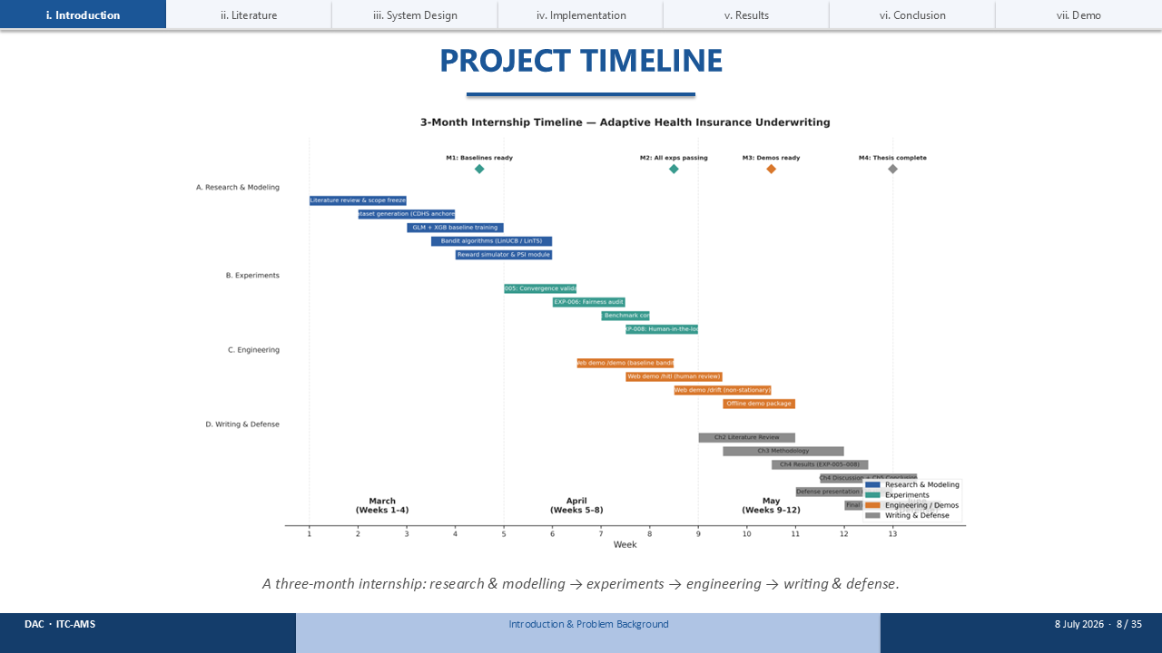
The work ran over a three-month internship. The first month was research and modelling — literature, the dataset, and the baselines. The second was experiments. The third was engineering the demo and writing up. Four milestones, from baselines ready to thesis complete.

SLIDE 9 · THE LITERATURE, IN ONE TABLE
Timing: ~1.5 min
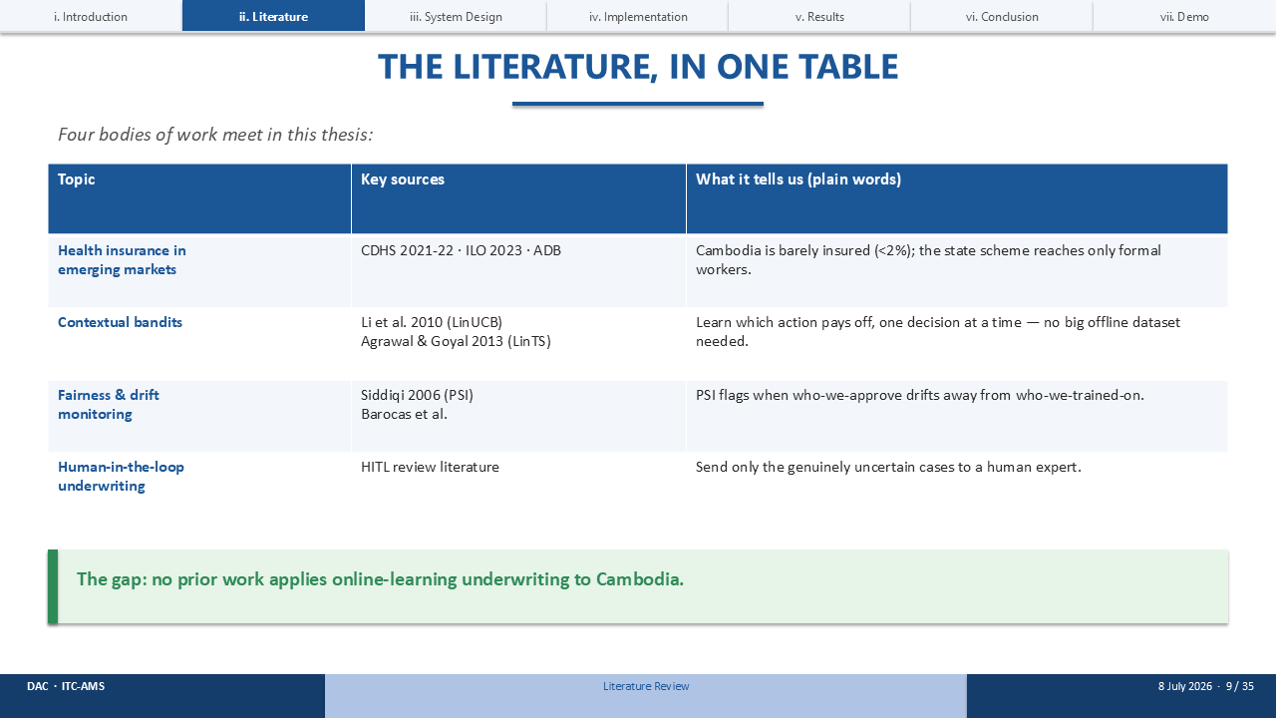
Before any of those milestones, I did the reading. Four bodies of work meet in this thesis, and I've put them in one table.
First, health insurance in emerging markets — the surveys that tell us Cambodia is barely insured. Second, contextual bandits — the machine-learning method at the heart of this work, from Li and colleagues in 2010 and Agrawal and Goyal in 2013; these learn which action pays off one decision at a time, without a big offline dataset. Third, fairness and drift monitoring — the Population Stability Index. And fourth, human-in-the-loop review.
[Point to the green bar.]
The gap is clear: no prior work applies online-learning underwriting to Cambodia. That is where this thesis sits.

SLIDE 10 · HOW THE SYSTEM WORKS
Timing: ~1 min
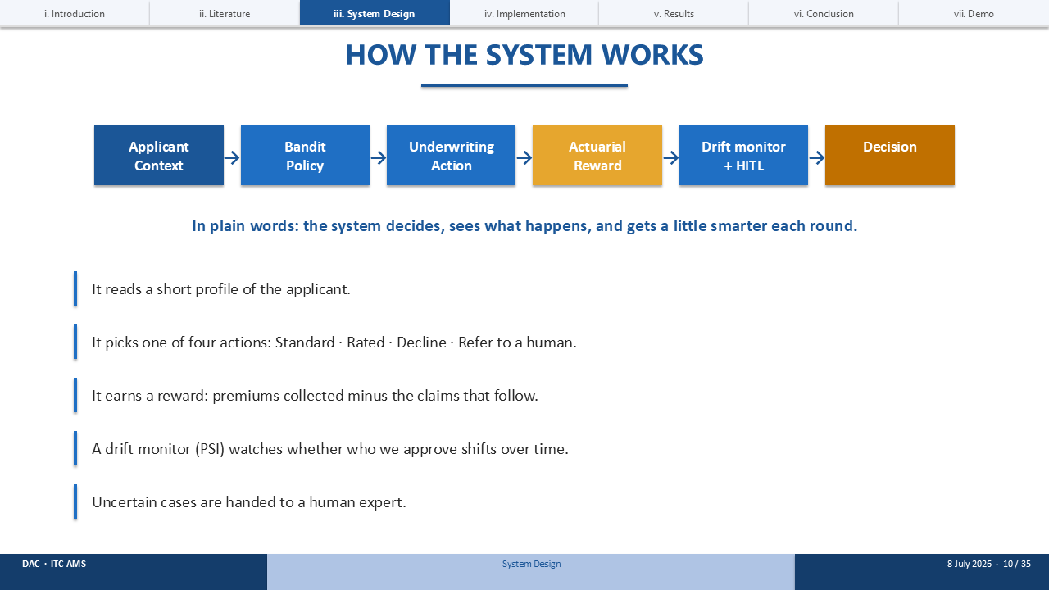
So that's the gap. Here's the whole system I built to fill it, on one line. In plain words: it decides, sees what happens, and gets a little smarter each round.
It reads a short profile of the applicant. It picks one of four actions — Standard, Rated, Decline, or Refer to a human. It earns a reward: the premiums it collects minus the claims that follow. A fairness guardrail watches for drift, and the genuinely uncertain cases are handed to a human expert. Then it updates and moves to the next applicant.

SLIDE 11 · HOW THE SYSTEM DECIDES FOR SOPHEA
Timing: ~1.5 min
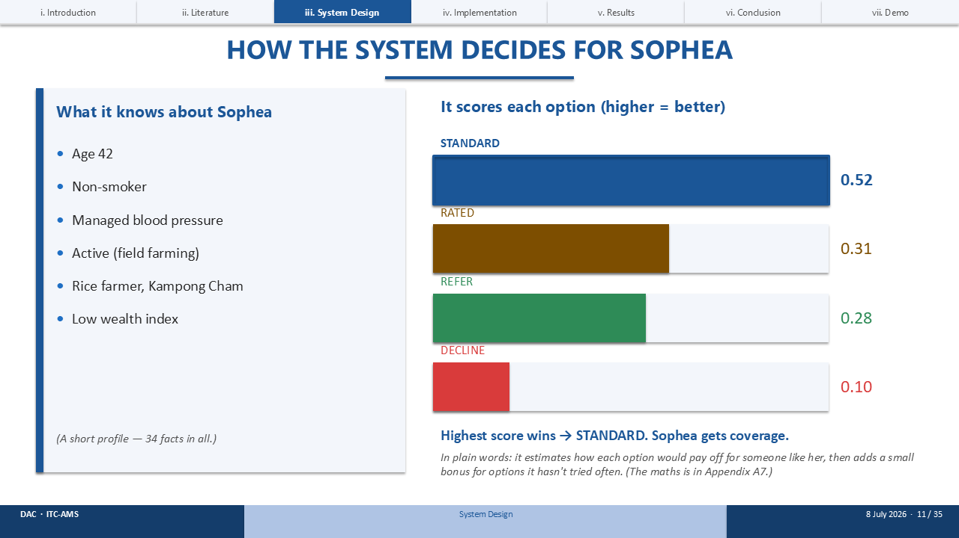
Let's watch it decide for Sophea.
[Point to the left panel.]
On the left is what it knows about her — a short profile: age, non-smoker, managed blood pressure, sedentary work, garment worker, middle wealth. Thirty-four facts in all.
[Point to the bars.]
It scores each of the four options. Standard scores highest, at 0.66; Decline 0.20; Refer 0.13; Rated just 0.00. The highest score wins, so Sophea gets Standard coverage.
In plain words: it estimates how each option would pay off for someone like her, then adds a small bonus for options it hasn't tried often — so it keeps learning. The exact formula is in Appendix A7 if you'd like it.

SLIDE 12 · WHAT THE SYSTEM EARNS
Timing: ~1 min
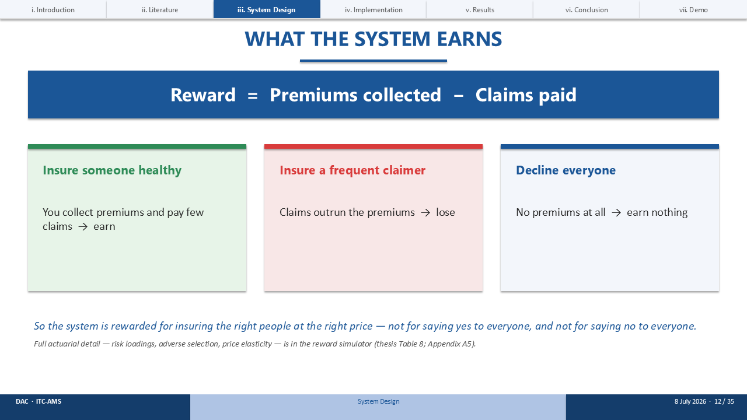
That score is built from a reward — so what does 'reward' actually mean? It's simple: reward equals premiums collected minus claims paid.
Insure someone who stays healthy and you collect premiums and pay few claims — you earn. Insure a frequent claimer and the claims outrun the premiums — you lose. Decline everyone and you collect nothing.
So the system is rewarded for insuring the right people at the right price — not for saying yes to everyone, and not for saying no to everyone. The full actuarial detail — risk loadings, adverse selection, price elasticity — is in the reward simulator, Table 8, and Appendix A5.

SLIDE 13 · THE FAIRNESS GUARDRAIL
Timing: ~1 min
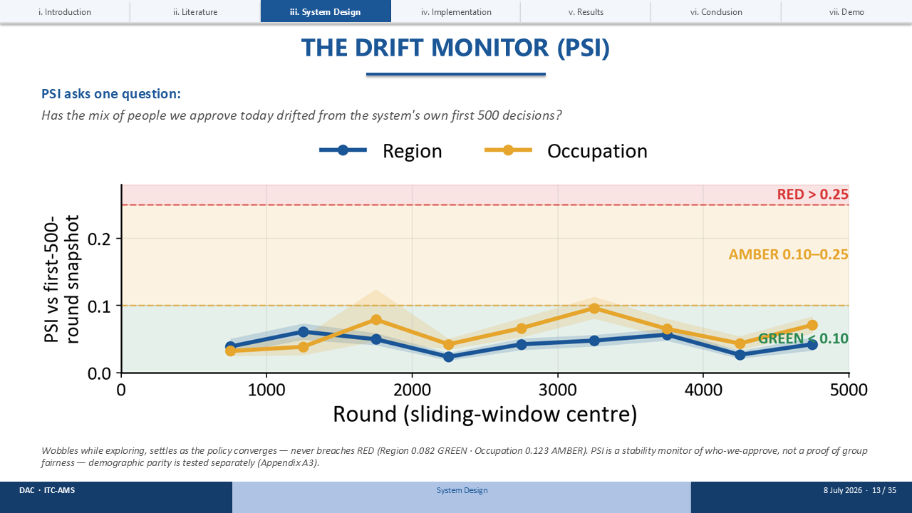
Learning fast is not enough — it also has to stay fair. That's the job of the Population Stability Index, or PSI.
Now — a bandit doesn't have a training set the way a supervised model does, so PSI can't compare against 'the data we trained on.' Instead it compares the system to itself: it freezes a snapshot of who it approved in its first 500 live decisions, then checks every later window against that snapshot. Has the mix drifted?
[Point to the chart.]
This is that check traced across the whole run. You can see it wobble while the system is still exploring — occupation brushes up toward amber early on — then settle back down toward green as the policy converges. It never breaches red. Green means all clear, amber means watch closely, red means stop and recalibrate.
The exact formula and a worked example are in Appendix A8.

SLIDE 14 · HOW WE TESTED IT
Timing: ~1 min
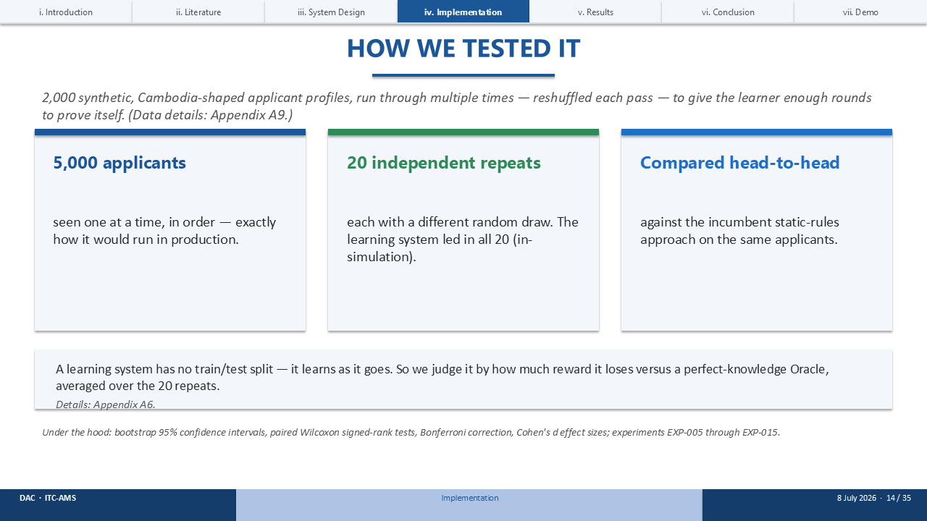
So it earns well and stays fair — now, how did I actually test that? Two thousand synthetic, Cambodia-shaped applicant profiles, thirty-four facts about each person, anchored to four real Cambodian surveys — the CDHS survey, STEPS, ILO, and WHO. Full feature breakdown is in Appendix A9 if you'd like it.
A quick word on the numbers: five thousand rounds means the system runs through that same pool of two thousand two and a half times, reshuffled each pass, so the learner sees enough rounds to actually converge.
Five thousand applicants, seen one at a time in order — exactly how it would run in production. Twenty independent repeats, each with a different random draw; the learning system won every single time. And a head-to-head comparison against the incumbent static-rules approach on the same applicants.
One subtlety: a learning system has no train/test split — it learns as it goes. So I judge it by how much reward it loses versus a perfect-knowledge Oracle, averaged over the twenty repeats. Appendix A6 explains that in full, and the statistics underneath are all standard — bootstrap intervals, Wilcoxon tests, Bonferroni, and effect sizes.

SLIDE 15 · THE HEADLINE RESULT
Timing: ~1.5 min
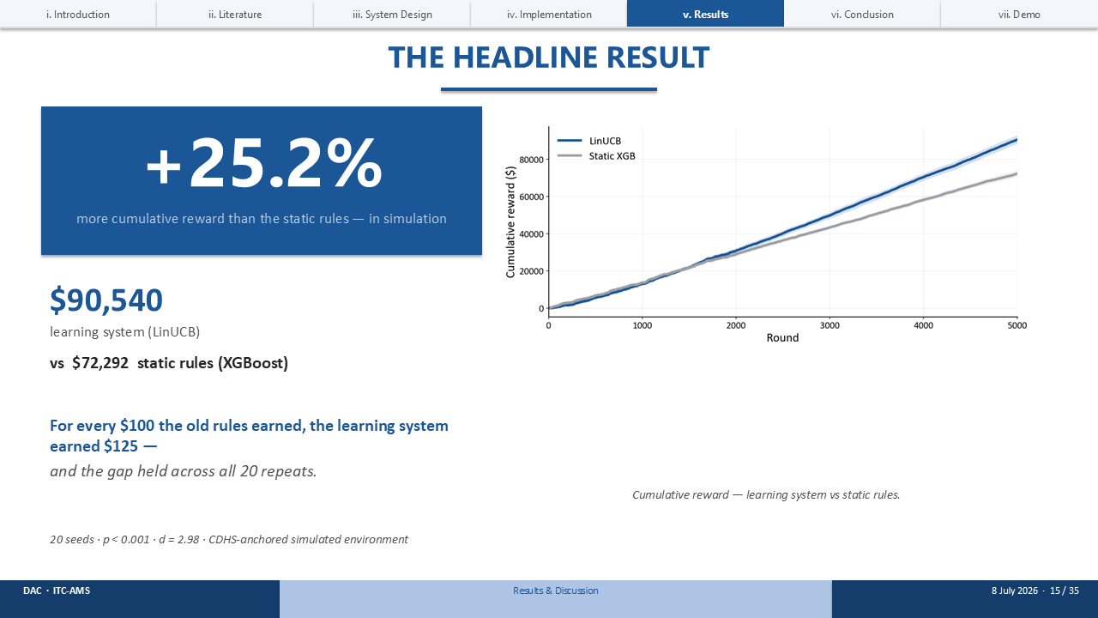
And that testing produces the headline result. The learning system earned twenty-five point two percent more cumulative reward than the static rules — $90,540 versus $72,292, over twenty seeds.
In plain words: for every hundred dollars the old rules earned, the learning system earned a hundred and twenty-five — and the gap held across all twenty repeats. Statistically it's about as clean as it gets: p below 0.001, Cohen's d of 2.98.
[Point to the curve.]
You can see it on the right: the two lines track together early, then the learning system pulls steadily ahead as it learns.

SLIDE 16 · THE BASELINE LADDER
Timing: ~1.5 min
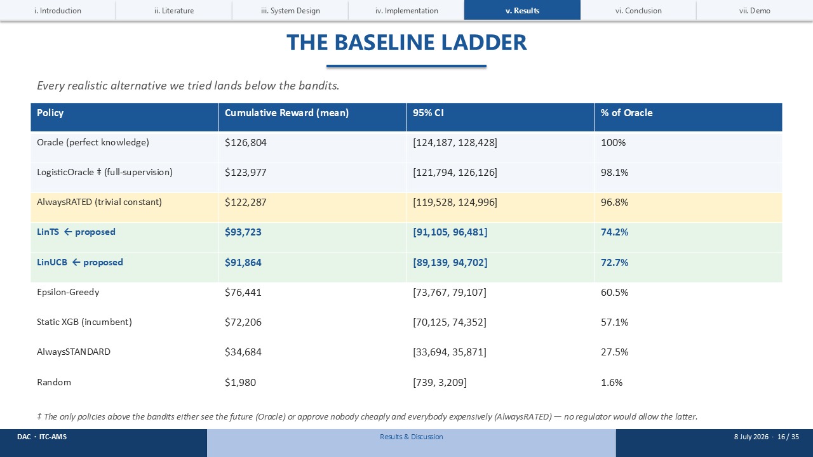
And that result isn't a fluke of the comparison, either. I want to be honest about where the bandit sits, so I tested it against a whole ladder of alternatives.
Every realistic alternative lands below the bandits — the static incumbent, epsilon-greedy, always-standard, random. The two learning methods, LinTS and LinUCB, are the best deployable policies on the board.
[Point to the top rows.]
Now, two things sit above them. The Oracle, which sees the future — not deployable. And AlwaysRATED, a trivial constant that rates everyone at a flat loading. It scores higher, but it approves nobody cheaply and everybody expensively — no regulator would allow it. So among policies you could actually deploy, the bandit leads.

SLIDE 17 · SOPHEA, THREE WAYS
Timing: ~1 min
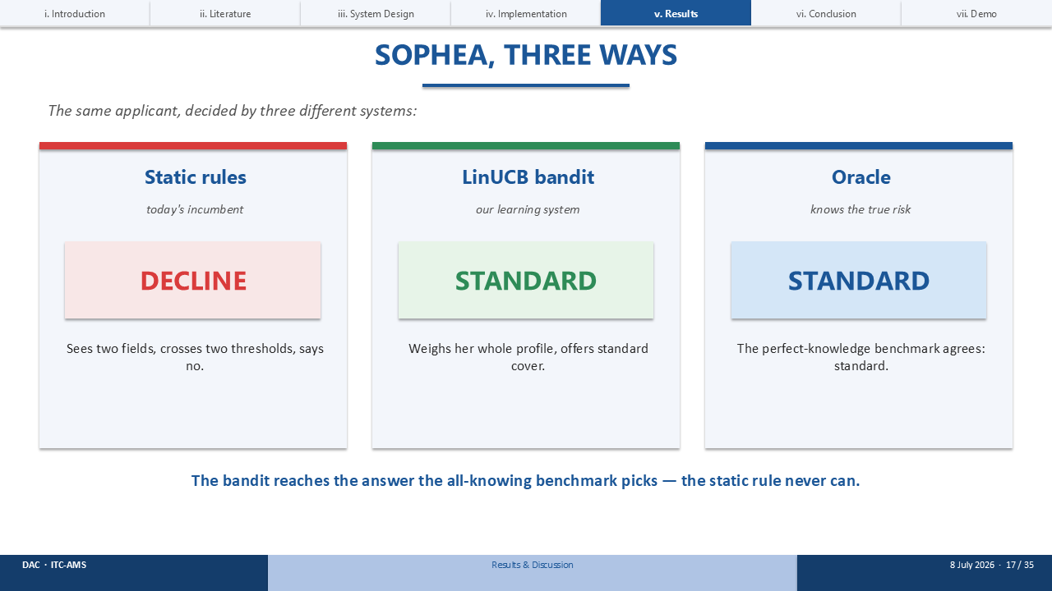
Let me bring it back to Sophea. Here is the same applicant, decided by three different systems.
The static rules — today's incumbent — predict 1.83× mortality, close to her true risk, but the fixed band still loads her premium: RATED. Our LinUCB bandit weighs the price trade-off and offers STANDARD cover outright. And the Oracle, the perfect-knowledge benchmark that knows her true risk, also says STANDARD.
That's the whole story in one line: the bandit reaches the answer the all-knowing benchmark picks — the static rule never can.

SLIDE 18 · FAIRNESS & HUMAN OVERSIGHT — RESULTS
Timing: ~1.5 min
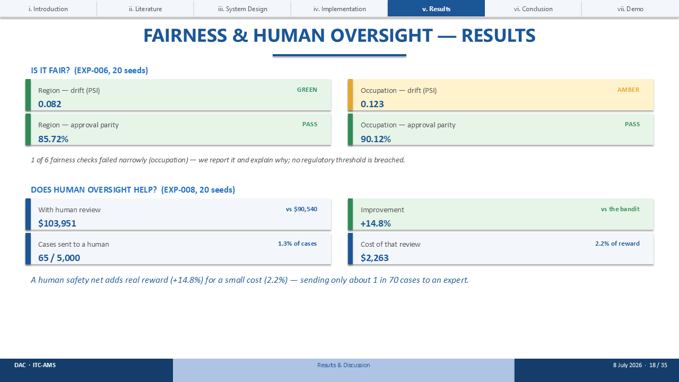
So it earns more. Is it fair — and does human oversight help? Yes to both.
On fairness, across twenty seeds: region drift is green at 0.082, occupation drift is amber at 0.123, and approval parity is 85.7 and 90.1 percent — both comfortably above the eighty-percent rule. I'll be transparent: one of six fairness checks failed narrowly on occupation. I report it and explain it — no regulatory threshold is breached.
On oversight: adding a human review lifts reward by fourteen point eight percent — to $103,951 — for a cost of just 2.2 percent, by sending only about one in seventy cases to an expert. A real gain for a small cost.

SLIDE 19 · FINDINGS & LIMITATIONS
Timing: ~1.5 min
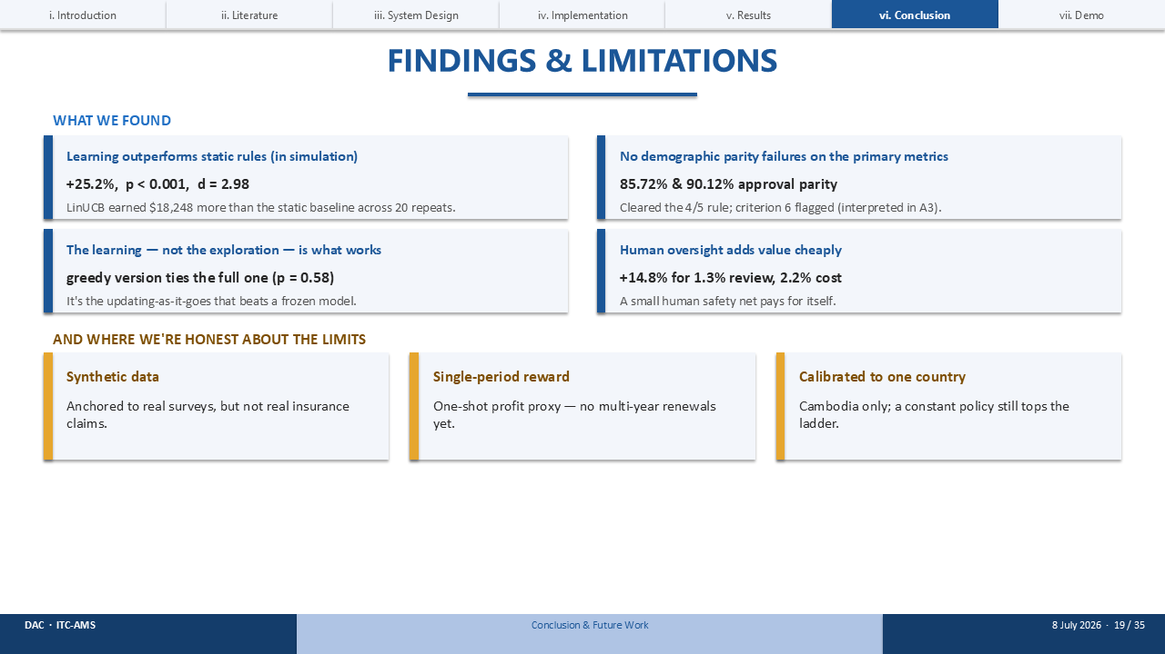
Pulling that together — let me gather the findings, and be honest about the limits.
Four findings. Learning beats static rules, by twenty-five percent. No demographic bias was introduced. It's the learning-as-it-goes, not the exploration, that does the work — the greedy version ties the full one. And human oversight adds value cheaply.
And the limits. The data is synthetic — anchored to real surveys, but not real claims. The reward is single-period, so no multi-year renewals yet. And it's calibrated to one country; a constant policy still tops the ladder. These are real, and they point straight at the future work.

SLIDE 20 · FUTURE WORK
Timing: ~1 min
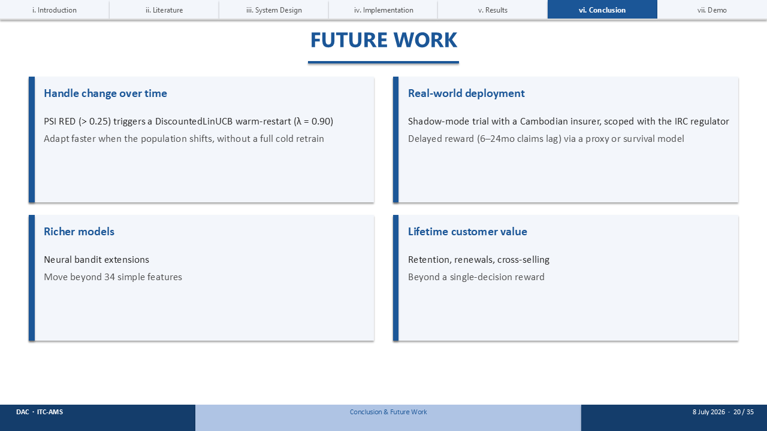
Given those limits, so where next? Four directions.
First, handle change over time — a PSI RED alert triggers a DiscountedLinUCB warm-restart, so it adapts faster without a full cold retrain. Second, real-world deployment — a shadow-mode trial with a Cambodian insurer, using a proxy or survival model to bridge the six-to-twenty-four-month claims lag. Third, richer models — neural bandits that go beyond thirty-four simple features. And fourth, lifetime customer value — retention and renewals, beyond a single decision.

SLIDE 21 · NEXT STEPS (PERSONALLY)
Timing: ~0.5 min
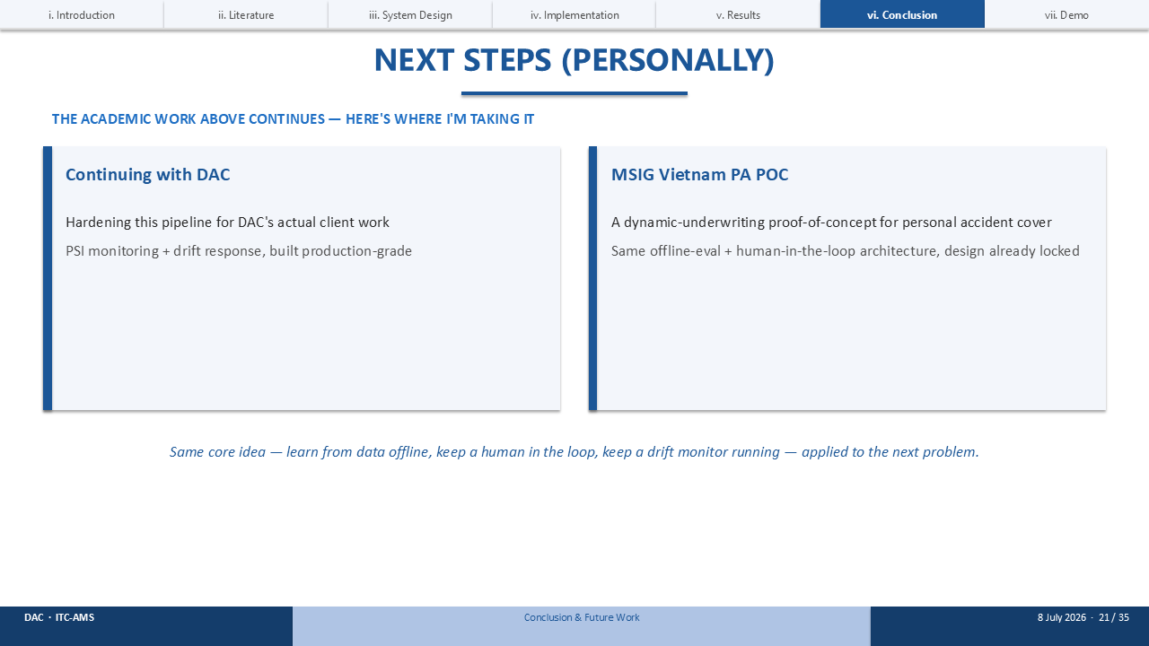
And that academic list keeps going — but here's where I'm actually taking it myself.
I'm continuing with DAC, hardening this same pipeline — the bandit, the PSI guardrail — for their real client work. And I'm carrying the same architecture into a new proof-of-concept: dynamic underwriting for personal accident cover with MSIG Vietnam. Same core idea — learn from data, keep a guardrail on fairness — applied to the next problem.

SLIDE 22 · THE TAKEAWAY
Timing: ~0.5 min
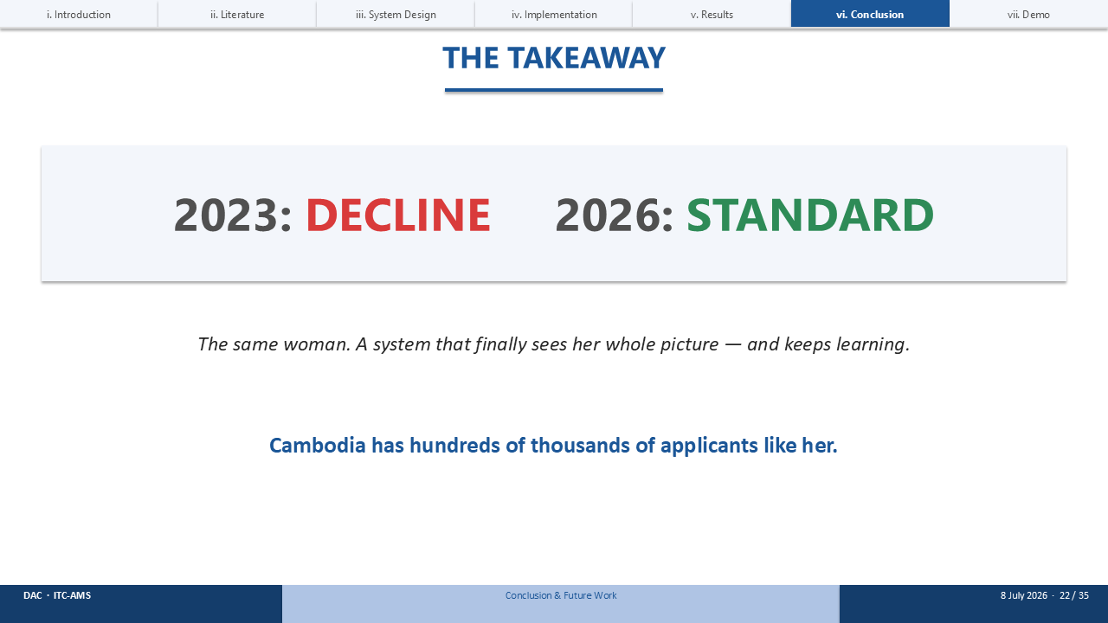
So let me close where I began.
In 2023, the static system issued Sophea a RATED — a loaded premium she may not have needed. In 2026, the learning system offers her STANDARD outright. The same woman — but a system that weighs the price trade-off a fixed rule can't, and keeps learning.
And Cambodia has hundreds of thousands of applicants like her.

SLIDE 23 · LIVE DEMONSTRATION
Timing: ~2 min
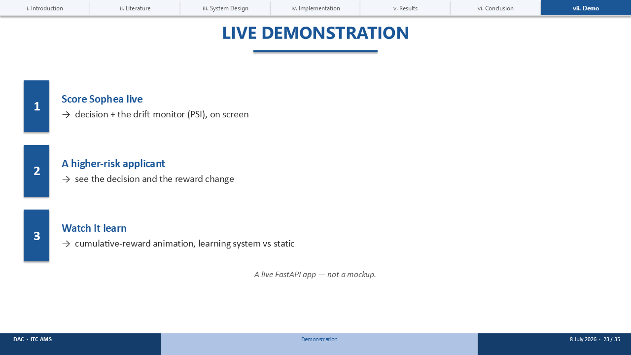
And rather than just describe that, let me show you it working — this is a live FastAPI app, not a mockup.
[Switch to the browser: uvicorn demo.desk.app:app --port 8000.]
First, I'll score Sophea live and you'll see the decision and the fairness guardrail on screen. Then I'll score a higher-risk applicant so you can see the decision and the reward change. And finally, on the 'Watch it Learn' tab, I'll play the cumulative-reward animation — the learning system pulling ahead of the static rules, round by round.

SLIDE 24 · IF LIVE DEMO FAILS — A SCORED APPLICANT
Timing: contingency
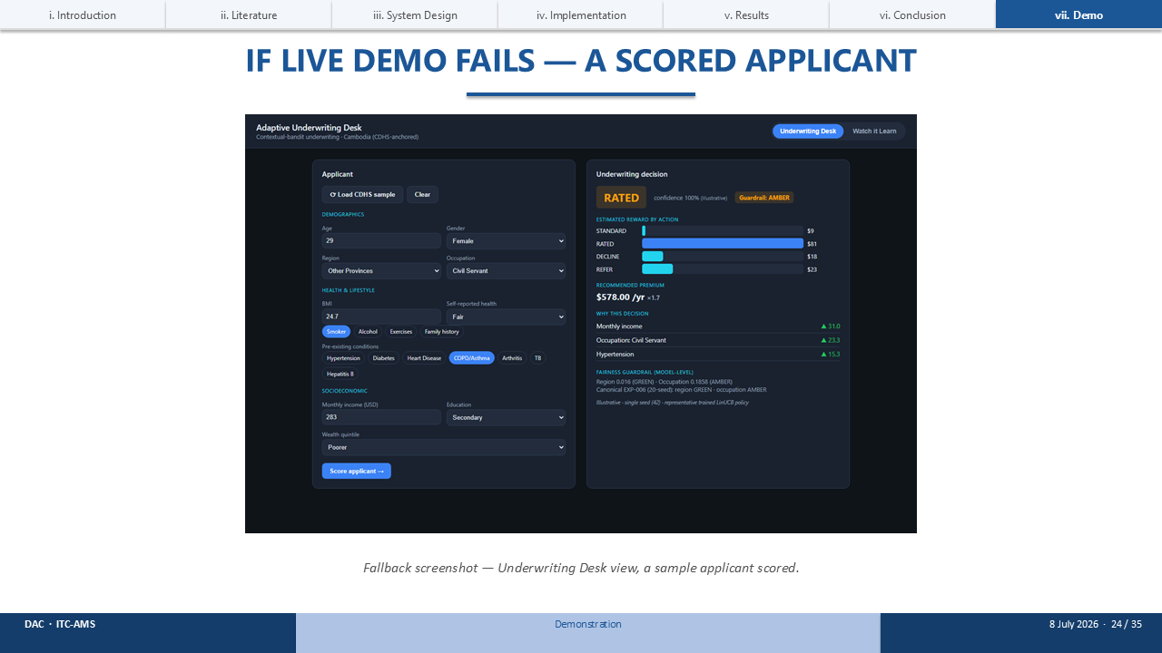
[Use only if the live app fails — wifi, server, or port.]
This is a captured screenshot of the Underwriting Desk: a sample applicant scored, with the decision and the inline fairness guardrail shown just as they appear live.

SLIDE 25 · IF LIVE DEMO FAILS — WATCH IT LEARN
Timing: contingency
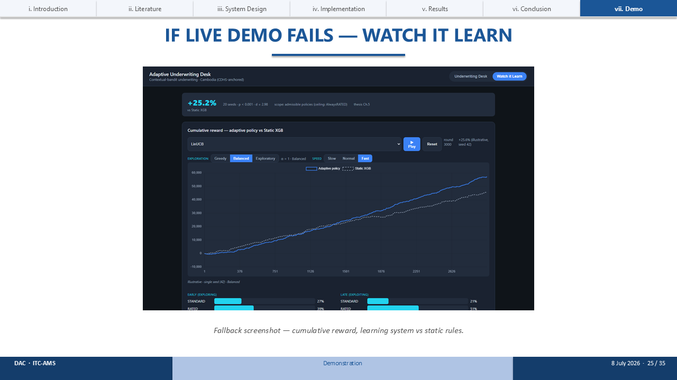
[Use only if the live app fails.]
And this is the 'Watch it Learn' view: the cumulative-reward curve, the learning system versus the static rules, exactly as the live animation renders it.

SLIDE 26 · THANK YOU
Timing: ~0.5 min
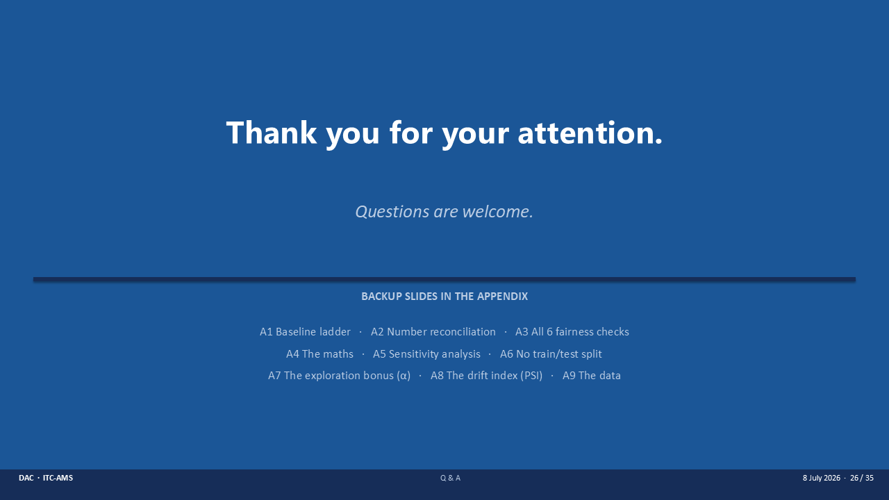
That is my thesis, start to finish. Thank you very much for your attention — I welcome your questions.
[If a question targets a specific number, advance to the matching appendix: A1 the full ladder, A2 the number reconciliation, A3 all six fairness checks, A4 the maths, A5 the sensitivity analysis, A6 the no-split point, A7 the exploration bonus, A8 the PSI walkthrough, or A9 the data.]

APPENDIX A1 · A1: COMPLETE BASELINE LADDER
Timing: on standby
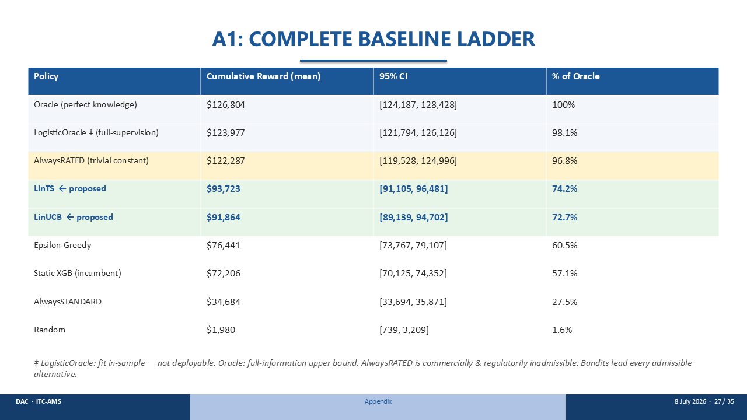
This is the complete ladder, with 95% confidence intervals. From the Oracle at the top down to Random at the bottom. The point to make: the only policies above LinTS and LinUCB are the non-deployable Oracle, an in-sample logistic ceiling, and the inadmissible AlwaysRATED constant. Among everything you could deploy, the bandits lead.

APPENDIX A2 · A2: NUMBER RECONCILIATION
Timing: on standby
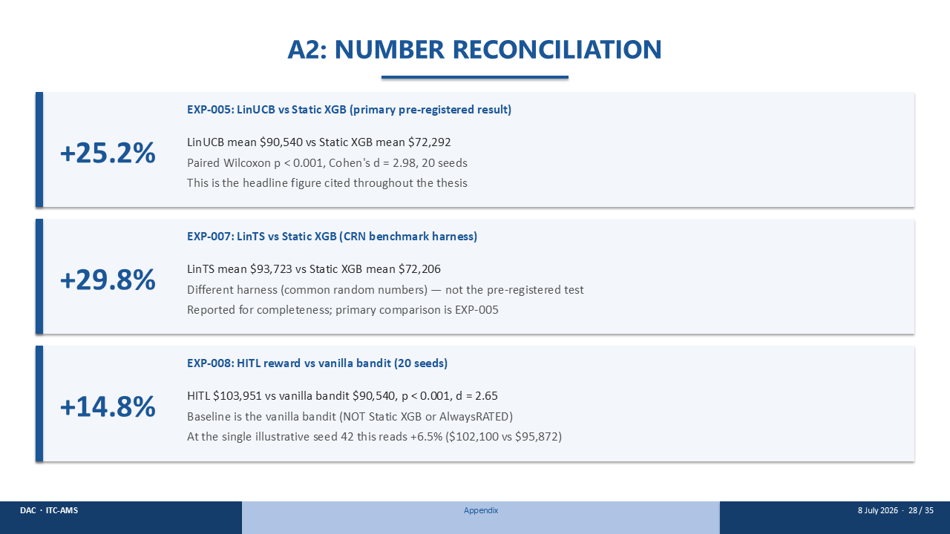
This slide reconciles the three percentages in the talk. The headline is plus 25.2 percent — LinUCB versus Static XGB, the primary pre-registered result. Plus 29.8 percent is LinTS on a different benchmark harness. And plus 14.8 percent is the human-in-the-loop gain over the vanilla bandit across twenty seeds. Note that at the single illustrative seed 42 the HITL figure reads plus 6.5 percent — same comparison, one seed instead of twenty; the twenty-seed 14.8 percent is the number I quote.

APPENDIX A3 · A3: ALL 6 FAIRNESS CRITERIA (EXP-006)
Timing: on standby
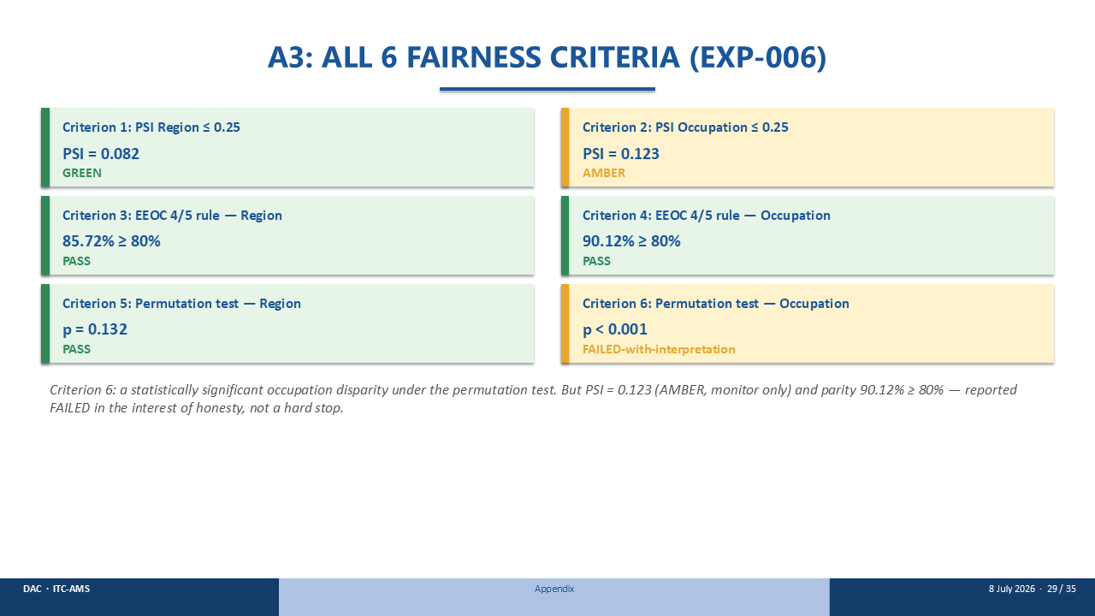
All six fairness criteria. PSI on region and occupation, the four-fifths approval-parity rule on both, and permutation tests on both. Five pass. Criterion six — the occupation permutation test — is marked FAILED, in the interest of honesty: the dependence is statistically significant but practically small. PSI stays amber, parity is 90 percent, and no regulatory threshold is crossed.

APPENDIX A4 · A4: MATHEMATICAL DETAILS
Timing: on standby
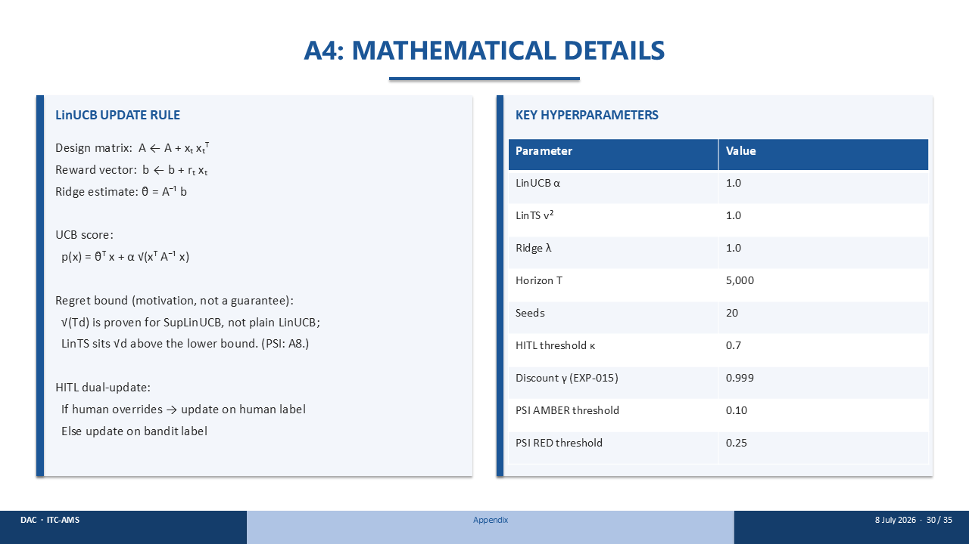
The maths, for completeness. On the left, the LinUCB update rule — the design matrix, the reward vector, the ridge estimate, and the UCB score — plus the PSI formula and the human-in-the-loop dual update. On the right, every hyperparameter: alpha 1.0, LinTS v-squared 1.0, ridge lambda 1.0, horizon 5,000, twenty seeds, and the PSI thresholds.

APPENDIX A5 · A5: SENSITIVITY ANALYSIS (EXP-012, 10 SEEDS)
Timing: on standby
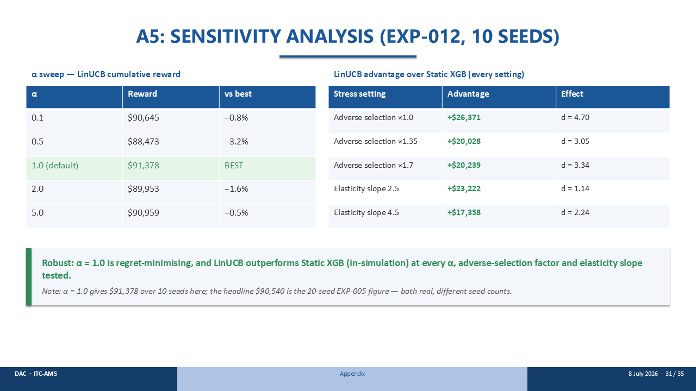
The sensitivity analysis. On the left, the alpha sweep over ten seeds — alpha 1.0 gives $91,378 and the lowest regret; the reward barely moves across the whole range. On the right, LinUCB's advantage over Static XGB holds at every adverse-selection factor and every elasticity slope tested. One reconciliation note: the alpha-1.0 figure here is $91,378 over ten seeds, while the headline $90,540 is the twenty-seed number — both real, just different seed counts.

APPENDIX A6 · A6: WHY A BANDIT HAS NO TRAIN/TEST SPLIT
Timing: on standby
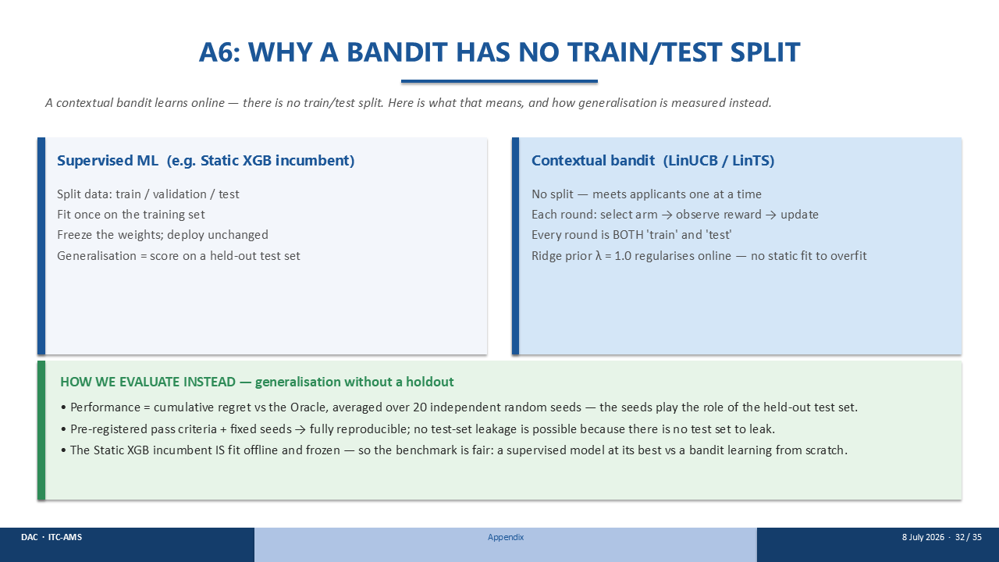
Why there's no train/test split. A supervised model splits the data, fits once, and freezes. A bandit meets applicants one at a time — every round is both train and test, and the ridge prior regularises online, so there is no static fit to overfit. I measure generalisation as cumulative regret versus the Oracle, averaged over twenty independent seeds — the seeds play the role of the held-out set. And the Static XGB baseline is fit offline and frozen, so the comparison is fair.

APPENDIX A7 · A7: THE EXPLORATION BONUS (α), IN PLAIN WORDS
Timing: on standby
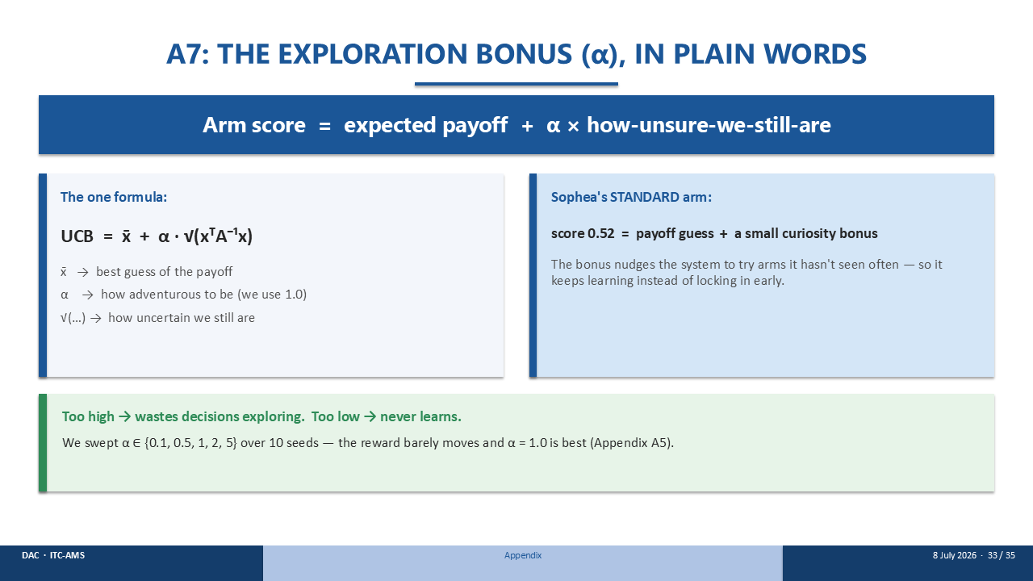
The exploration bonus, alpha, in plain words. An arm's score is its expected payoff plus alpha times how-unsure-we-still-are. In the formula, x-bar is the best guess of the payoff, the square-root term is how uncertain we still are, and alpha — which we set to 1.0 — controls how adventurous to be. For Sophea's Standard arm, the 0.66 is a payoff guess plus a small curiosity bonus. Too high wastes decisions exploring; too low and it never learns. I swept alpha from 0.1 to 5 — the reward barely moves, and 1.0 is best.

APPENDIX A8 · A8: THE FAIRNESS INDEX (PSI), STEP BY STEP
Timing: on standby
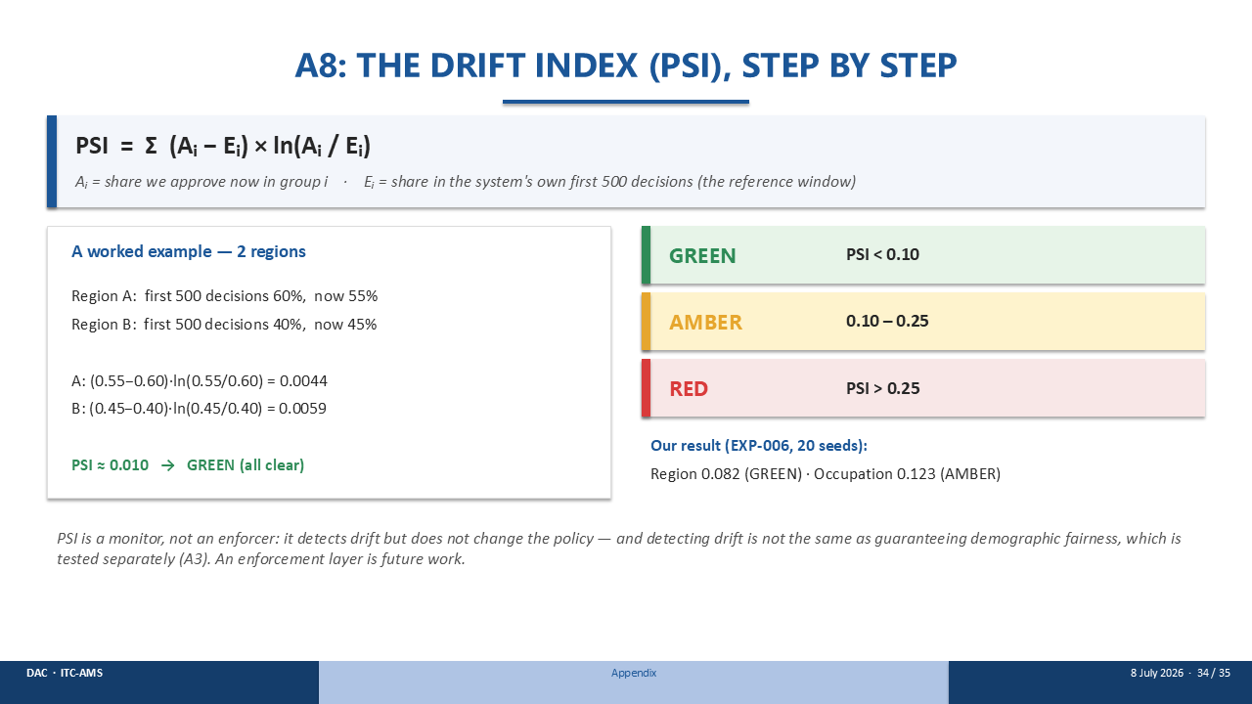
The PSI, step by step. It sums, over each group, the difference between the share we approve now and the share in the training data, times the log of their ratio. The worked example with two regions comes out to about 0.010 — comfortably green. Green is below 0.10, amber to 0.25, red above. Our own result: region 0.082, green; occupation 0.123, amber. And PSI is a monitor, not an enforcer — it detects drift but does not change the policy.

APPENDIX A9 · A9: THE DATA
Timing: on standby
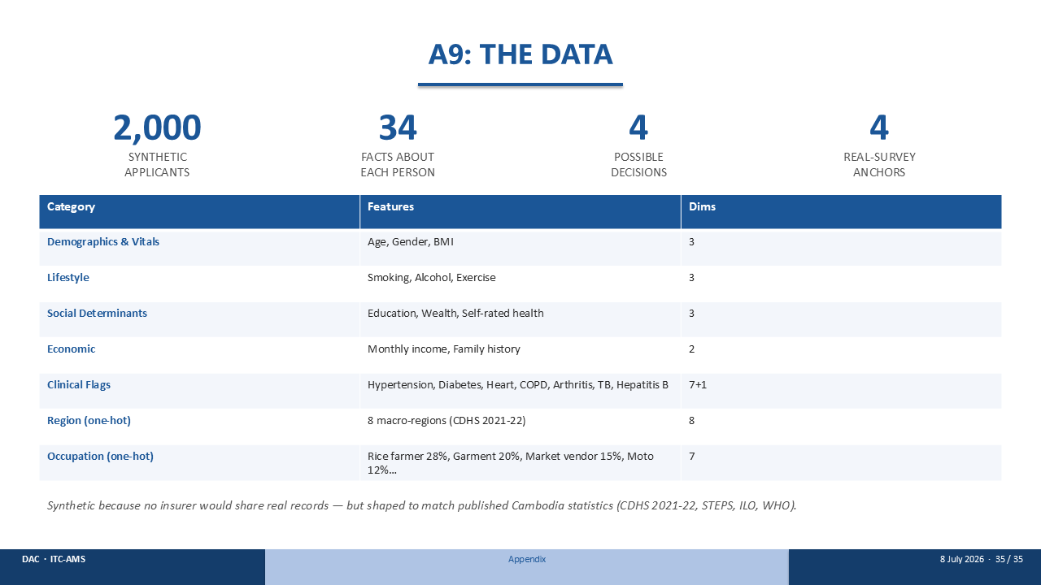
The data, in full. Two thousand synthetic applicants, thirty-four facts about each person, four possible decisions, anchored to four real Cambodian surveys.
[Gesture at the table.]
The features span demographics and vitals, lifestyle, social determinants, economics, clinical flags, and one-hot region and occupation.
Why synthetic? Because no insurer would share real records. But the data is shaped to match published Cambodia statistics — the CDHS survey, STEPS, ILO, and WHO — so it behaves realistically even though no real person is in it.

