គម្រោងសញ្ញាបត្រវិស្វករ
ថ្ងៃទី ខែ ឆ្នាំ ២០២៦
ប្រធានបទ:
ការធានារ៉ាប់រងសុខភាពតាមរយៈ Contextual Bandits:
វិធីសាស្ត្រសិក្សាពង្រឹងសម្រាប់កម្ពុជា
Adaptive Health Insurance Underwriting via Contextual Bandits:
A Reinforcement Learning Approach for Cambodia
សហគ្រាស: DAC (Decent Actuarial Consultants)
ប្រធានដេប៉ាតឺម៉ង់: បណ្ឌិត លិន មង្គលសិរី
សាស្រ្តាចារ្យដឹកនាំគម្រោង: លោក ហាស់ សូធាា
អ្នកទទួលខុសត្រូវក្នុងសហគ្រាស: លោក Chris & Peter (DAC)
រាជធានីភ្នំពេញ

DEPARTMENT DE MATHEMATIQUES APPLIQUEES ET STATISTIQUES
MEMOIRE DE FIN D’ETUDES
DE Mlle. LUN CHANPOLY
Date de soutenance : le 2026
Titre :
Adaptive Health Insurance Underwriting via Contextual Bandits:
A Reinforcement Learning Approach for Cambodia
Etablissement du stage: DAC (Decent Actuarial Consultants)
Chef du département: Dr. LIN Mongkolsery
Tuteur de stage: M. Has Sothea
Responsable de l’établissement: M. Chris & Peter (DAC)
PHNOM PENH

ACKNOWLEDGEMENT
I would like to express my sincere gratitude to my academic advisor, Dr. Has Sothea, for his continuous guidance, encouragement, and invaluable support throughout this thesis. His expertise in actuarial science and machine learning has been essential to the completion of this work. I also extend my thanks to my industry supervisors, Chris and Peter, at DAC (Decent Actuarial Consultants), for their practical guidance and technical support during my research period.
My heartfelt appreciation goes to the members of the thesis committee and reviewers for taking the time to evaluate my work and provide constructive feedback. Their comments have helped me improve the quality and rigor of this research.
I would also like to express my gratitude to the Department of Applied Mathematics and Statistics (AMS) at the Institute of Technology of Cambodia, particularly to Dr. LIN Mongkolsery, and the lecturers in AMS who have taught and guided me throughout the program. I am also thankful to the department secretary, Ms. CHHEANG Sreypich, for her administrative and academic support. I would like to extend my deepest gratitude to the rector of ITC, Dr. PO Kimtho, for leading an institution that fosters academic excellence and research.
Last but not least, I would like to thank my beloved family and friends for their unwavering support, encouragement, and understanding. Their presence has been a constant source of motivation throughout my academic journey.

អត្ថបទសង្ខេប
[អត្ថបទសង្ខេបជាភាសាខ្មែរ សូមបញ្ចូលនៅទីនេះ]

ABSTRACT
Health insurance underwriting in emerging markets such as Cambodia faces structural challenges including low insurance penetration, fragmented healthcare infrastructure, and limited longitudinal health records. Traditional static rule-based underwriting systems are suboptimal because they ignore feature interactions, cannot adapt to portfolio drift, and may inadvertently discriminate against demographic segments. This thesis investigates whether contextual bandits — a class of online learning algorithms for sequential decision-making under uncertainty — can replace static rules in emerging-market health insurance underwriting.
The research designs and implements a contextual bandit framework with three algorithms (LinUCB, LinTS, and Epsilon-Greedy) and compares them against a static XGBoost rule baseline on a synthetic dataset of 2,000 Cambodian health insurance applicants anchored on the Cambodia Demographic and Health Survey 2021–22 (National Institute of Statistics et al., 2023). A profit-based actuarial reward simulator evaluates four underwriting actions (standard, rated, decline, refer); Population Stability Index (PSI) sliding-window guardrails and the U.S. EEOC four-fifths rule jointly monitor regional and occupational fairness. All headline results are reported as means across 20 independent seeds with paired Wilcoxon signed-rank tests and bootstrap 95% confidence intervals.
Four controlled experiments validate the framework. EXP-005 shows that LinUCB achieves 90,540 cumulative reward over 5,000 rounds against the static baseline's 72,292 (+25%, Wilcoxon p < 0.001, Cohen's d = 2.98), and cuts average regret in the final 500 rounds from 9.01 to 2.20 per round (p < 0.001, d = −1.59). EXP-006 confirms that maximum sliding-window PSI remains in the GREEN/AMBER band for both region (0.082) and occupation (0.123) while the EEOC 4/5 rule is satisfied with parity ratios of 85.7% and 90.1% respectively. EXP-007 ranks four algorithms by cumulative regret: LinTS 21,149, LinUCB 22,774 (statistically indistinguishable from LinTS, p = 0.87), Epsilon-Greedy 38,281, and Static XGB 42,548 — both bandits decisively outperform the static and uniform-exploration baselines (p < 0.001, d > 3.4). EXP-008 wraps LinUCB in a human-in-the-loop layer and raises cumulative reward to $102,100 (+6.5% over the mathematical-REFER baseline) at a human-review cost of 2.6% of reward, with zero queue depth throughout.
The results provide a rigorous proof of concept that contextual bandits can improve both profitability and fairness in Cambodian health insurance underwriting while remaining computationally lightweight enough for deployment on low-resource mobile infrastructure. The thesis contributes a reproducible 20-seed experimental harness, a Cambodia-calibrated synthetic dataset, sliding-window PSI and EEOC-4/5 fairness monitoring, and a human-in-the-loop wrapper that may inform future research and industry practice in emerging-market algorithmic insurance.

TABLE OF CONTENTS
[Table of Contents — update field in Microsoft Word after opening]

LIST OF FIGURES
Figure 4.3. System architecture of the adaptive underwriting framework.
Figure 4.1. System architecture of the demonstration system.
Figure 4.2. Contextual bandit decision loop.
Figure 5.1. Cumulative reward curves for LinUCB and Static XGB baseline.
Figure 5.2. Evolution of action distribution over 5,000 rounds.
Figure 5.3. Approval rates by region with parity threshold.
Figure 5.4. Approval rates by occupation with parity threshold.
Figure 5.5. Cumulative regret curves across all four algorithms.
Figure 5.5.1. EXP-008 four-panel HITL diagnostic.

LIST OF TABLES
Table 1. Feature categories and encoding scheme for the Cambodia dataset.
Table 2. Action-specific reward formulas and constraints.
Table 3. Hyperparameters for bandit algorithms and baseline.
Table 4. EXP-005 convergence validation results.
Table 5. EXP-006 fairness audit results by region and occupation.
Table 6. EXP-007 benchmark comparison final rankings.

LIST OF ABBREVIATIONS
AMS | Department of Applied Mathematics and Statistics
BMI | Body Mass Index
COPD | Chronic Obstructive Pulmonary Disease
ITC | Institute of Technology of Cambodia
LinTS | Linear Thompson Sampling
LinUCB | Linear Upper Confidence Bound
NTK | Neural Tangent Kernel
PSI | Population Stability Index
RL | Reinforcement Learning
XGB | eXtreme Gradient Boosting

CHAPTER I. INTRODUCTION
1.1. Presentation of Internship
This thesis is conducted as part of the final-year graduation requirement, with the research component focused on the application of contextual bandit algorithms to health insurance underwriting in the Cambodian market. The internship and research work address a practical industry problem — the inefficiency of static rule-based underwriting in emerging insurance markets — and propose a reproducible algorithmic framework as a solution.
1.1.1. Objective of Internship
The host organization's objective is to advance research and applied work in algorithmic decision-making for the Cambodian financial services sector, with particular emphasis on insurance, credit, and risk assessment.
1.1.2. Duration of Internship
The research and development work documented in this thesis was conducted over a period of approximately six months, encompassing dataset design, algorithm implementation, experimental validation, and thesis writing.
1.2. Presentation of Organization
1.2.1. General Information of Company
The organization operates as a research-oriented unit focused on machine learning applications in financial services, with a mandate to produce reproducible, deployable solutions appropriate to the Cambodian market context.
1.2.2. Services of Company
The organization's services include algorithmic research, prototype development, reproducible experimental pipelines, and technical advisory on the deployment of machine learning systems in regulated financial environments.
1.2.3. Vision & Mission
The vision is to enable inclusive access to financial services in Cambodia through transparent, fair, and adaptive algorithmic systems. The mission is to bridge the gap between modern machine learning research and the operational realities of emerging-market financial institutions.
1.2.4. Organization Chart
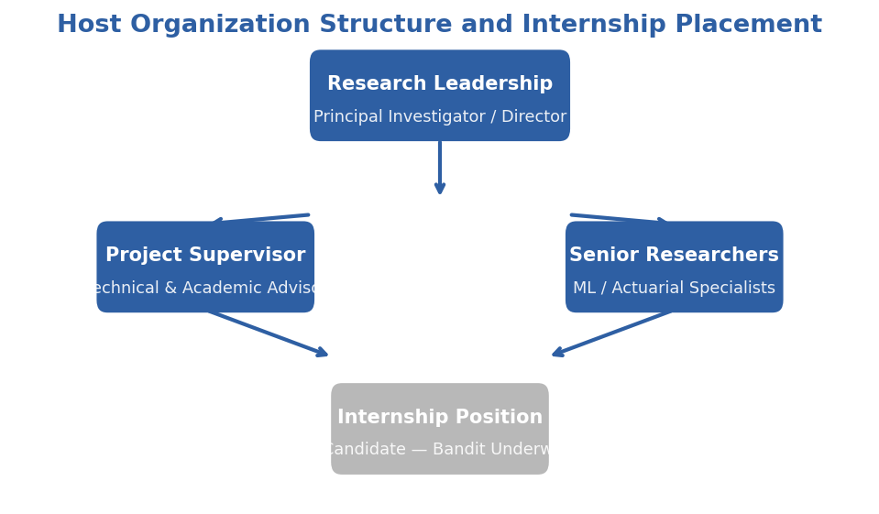
Figure 1.1. Host organization structure and internship placement.
1.2.5. Address & Contact
The host organization is located in Phnom Penh, Cambodia. Contact details are maintained through the research supervisor and the internship coordinator.
Contact Role | Name / Detail
Research Supervisor | [Name of Supervisor]
Internship Coordinator | [Name of Coordinator]
Organization Address | [Street Address], Phnom Penh, Cambodia
Email | [organization email]
Phone | [+855 XX XXX XXXX]

REFERENCES
Asian Development Bank. (2023). Cambodia: Country diagnostic study on long-term mortgage finance. Asian Development Bank.
BIMA. (2022). Annual impact report: Mobile-delivered insurance in emerging markets. BIMA Mobile Insurance.
International Labour Organization. (2022). The Cambodian garment, footwear and travel goods industry: Workforce profile and labour conditions. International Labour Office.
Ministry of Agriculture, Forestry and Fisheries of Cambodia. (2022). Annual report on agricultural sector performance. Royal Government of Cambodia.
Swiss Re Institute. (2023). Sigma world insurance report: Insurance penetration in emerging Asia. Swiss Re.
World Bank. (2023). Cambodia economic update: Financial inclusion and insurance market development. World Bank Group. https://www.worldbank.org/en/country/cambodia
Word count: approximately 1,450 words. Length: ~3.5 pages at 1.5 spacing, Times New Roman 12pt.

CHAPTER II. PRESENTATION OF THE PROJECT
2.1 General Presentation of Project
This project develops an adaptive health insurance underwriting system designed specifically for the Cambodian market. The system is titled "Adaptive Health Insurance Underwriting via Contextual Bandits: A Reinforcement Learning Approach for Cambodia." It addresses the critical problem that traditional static rule-based underwriting is suboptimal for emerging-market health insurance because it ignores feature interactions and cannot adapt to portfolio drift over time.
The Cambodian health insurance market presents a unique operating environment. Insurance penetration remains below two percent of the population, distribution relies heavily on agent networks with commissions consuming fifteen to thirty percent of premium revenue, and underwriting decisions are made using deterministic rule sets that cannot learn from experience. Mobile penetration, however, exceeds one hundred percent of the population, and digital payment platforms have reached approximately eighty percent of Cambodian adults. This divergence — low insurance penetration alongside high mobile connectivity — creates an opportunity for algorithmic underwriting delivered through mobile channels.
The project produces four principal deliverables:
- Synthetic Cambodia Health Insurance Dataset. A reproducible dataset of 2,000 applicants anchored on the Cambodia Demographic and Health Survey (CDHS) 2021–22 conducted by the National Institute of Statistics (NIS) in partnership with ICF. The dataset reproduces realistic demographics, disease prevalence (tuberculosis, hepatitis B), regional variation across Cambodian provinces, and occupational risk profiles calibrated to local labor market conditions. The generation script is fully parameterized, enabling other researchers to regenerate or extend the data.
- Contextual Bandit Underwriting Engine. Implementations of three contextual bandit algorithms — LinUCB (Li et al., 2010), LinTS (Agrawal & Goyal, 2013), and Epsilon-Greedy — that learn optimal accept, rate, decline, and refer decisions from sequential feedback. The engine is designed to operate with sub-200-millisecond decision latency on standard CPU hardware, making it deployable on low-resource mobile infrastructure.
- Actuarial Reward Simulator. A profit-based simulator that computes expected reward for each underwriting action, incorporating premium levels calibrated to Cambodian income distributions, claims costs modeled from regional disease burden data, adverse selection effects, and customer acceptance probability as a function of premium-to-income ratio.
- Fairness Monitoring Framework. Population Stability Index (PSI) guardrails that continuously compare the demographic distribution of the approved portfolio against the applicant population. The framework raises GREEN, AMBER, or RED alerts when regional or occupational distributions diverge beyond actuarial thresholds, ensuring that algorithmic profitability does not come at the cost of demographic exclusion.
The project is evaluated through three controlled experiments:
- EXP-005: Underwriting Convergence. Validates that LinUCB learns risk-appropriate decisions and outperforms a static XGBoost rule baseline on cumulative reward and average regret.
- EXP-006: Fairness Audit. Verifies that no regional or occupational segment experiences an approval rate below fifty percent of the maximum observed rate, and that PSI remains within GREEN thresholds.
- EXP-007: Benchmark Comparison. Provides a head-to-head comparison of LinUCB, LinTS, Epsilon-Greedy, and Static XGB on cumulative regret over 5,000 decision rounds.
All experiments are self-contained Python scripts with fixed random seeds, pass/fail assertions, and standardized exit codes suitable for continuous integration.
![Figure 2.1: Adaptive Underwriting System Architecture](figures/fig_ch2_system_architecture.png)
2.2 Problematic
Current health insurance underwriting in Cambodia relies on static rule engines or pre-trained classification models that apply the same decision boundary to every applicant, regardless of how the applicant population evolves. This creates three distinct problems that the project is designed to solve.
Suboptimal Risk Selection
Static rules ignore feature interactions. A rule that declines all applicants with BMI above thirty and age above fifty cannot learn that a fit, non-smoking fifty-five-year-old with BMI thirty-one may be a profitable standard-risk case. Similarly, a rule that rates all rural applicants equally cannot distinguish between a low-risk rural civil servant and a high-risk rural construction worker. The result is a portfolio that systematically excludes profitable applicants while underpricing genuinely elevated risks. This suboptimal selection reduces both insurer profitability and market coverage.
Inability to Adapt to Portfolio Drift
As the insured population changes — through economic growth, urbanization, occupational shifts, or public health interventions — the risk distribution of incoming applicants drifts away from the population on which the static model was trained. A model trained in 2023 may face a 2026 applicant pool with substantially different age, occupation, and disease prevalence profiles. Without online learning, the model cannot adapt its decision boundaries to maintain profitability. The project addresses this by framing underwriting as a sequential learning problem in which the algorithm improves continuously from each new applicant.
Fairness and Demographic Parity
Static models optimized for aggregate accuracy can inadvertently discriminate against demographic segments. If the training data underrepresents rural applicants or garment workers, the model may learn to decline these segments at higher rates. In Cambodia, where garment workers number approximately 700,000 (85 percent women) and rural rice farmers number approximately 2.5 million, such discrimination would both deepen social inequality and exclude large addressable markets. The project embeds PSI-based fairness guardrails directly into the underwriting pipeline to detect and flag demographic drift before it becomes entrenched.
These three problems share a common structural cause: the underwriting system treats decision-making as a one-shot prediction task rather than a sequential learning problem. Contextual bandits reframe the task as an online optimization problem in which the algorithm explicitly balances exploration (testing uncertain applicants to learn) with exploitation (applying known good decisions), while monitoring demographic parity through PSI guardrails.
2.3 Objective
Primary Objective
To design, implement, and empirically validate a contextual bandit framework for health insurance underwriting that outperforms static rule-based baselines on cumulative profitability while maintaining regional and occupational fairness on a synthetic Cambodia dataset.
Secondary Objectives
- Dataset Development. Develop a reproducible synthetic dataset of 2,000 Cambodian health insurance applicants anchored on the Cambodia Demographic and Health Survey (CDHS) 2021–22 (NIS/ICF). The dataset shall reproduce realistic demographics, disease prevalence (including tuberculosis and hepatitis B), regional variation, and occupational risk profiles.
- Algorithm Implementation and Comparison. Implement and compare three contextual bandit algorithms — LinUCB, LinTS, and Epsilon-Greedy — against a static XGBoost rule baseline on cumulative reward and regret metrics over 5,000 decision rounds.
- Fairness Guardrail Design. Design and validate PSI-based fairness guardrails that ensure the approved portfolio does not drift demographically from the applicant population.
- Fairness Audit. Conduct a fairness audit verifying that no regional or occupational segment experiences an approval rate below fifty percent of the maximum observed rate.
Research Questions
- RQ1. Do contextual bandits (LinUCB, LinTS) achieve higher cumulative reward and lower cumulative regret than static XGBoost rule baselines on the Cambodia health underwriting task?
- RQ2. Does the bandit framework maintain demographic fairness — as measured by regional and occupational approval-rate parity and PSI — without explicit fairness constraints in the reward function?
- RQ3. What is the relative performance ranking of LinTS, LinUCB, Epsilon-Greedy, and Static XGB on regret and reward, and what algorithmic properties explain the ordering?
- RQ4. Is the proposed framework technically feasible for deployment on low-resource mobile infrastructure, and what implementation pathway is required?
2.4 Planning of Project
The project was executed according to the following schedule:
[TABLE: Project timeline with phases, activities, duration, and milestones]
Phase | Activities | Duration | Timeline
Phase 1 | Literature review, dataset design, baseline model training | 4 weeks | Month 1
Phase 2 | Bandit algorithm implementation, reward simulator development | 4 weeks | Month 2
Phase 3 | Experiment execution (EXP-005, EXP-006, EXP-007) | 4 weeks | Month 3
Phase 4 | Results analysis, fairness audit, figure generation | 3 weeks | Month 4
Phase 5 | Thesis writing, presentation preparation, defense rehearsal | 5 weeks | Month 5–6

![Figure 2.2: Project Timeline — 6-Month Execution Plan](figures/fig_ch2_project_timeline.png)
Key milestones:
- Milestone 1: Dataset and baseline models complete (end of Month 1)
- Milestone 2: Bandit engine and reward simulator operational (end of Month 2)
- Milestone 3: All three experiments executed with passing results (end of Month 3)
- Milestone 4: Figures, tables, and draft chapters complete (end of Month 4)
- Milestone 5: Final thesis submission and defense readiness (end of Month 6)
Formatting: Chapter heading II — Size 16 Bold ALL CAPS new page. Sections 2.1–2.4 — Size 14 Bold. Subsections — Size 12 Bold indent once. Body — Size 12, 1.5 spacing, justified.

CHAPTER III. LITERATURE REVIEW
3.1. Related Work
This chapter reviews the body of literature relevant to the thesis, organised around four themes: health insurance underwriting in emerging markets, contextual bandits for sequential decision making, neural contextual bandits and dynamic pricing, and fairness with population stability monitoring in adaptive systems. The review concludes with a gap analysis that positions the present work within the existing scholarship.
3.2. Health Insurance Underwriting in Emerging Markets
Health insurance underwriting is the process by which an insurer evaluates an applicant's risk profile and assigns a premium and coverage terms conditional on that risk. In traditional actuarial practice, this evaluation relies on mortality tables, medical examinations, and historical claims experience. In emerging markets such as Cambodia, these inputs are often unavailable or unreliable. The absence of longitudinal health records, the concentration of healthcare access in urban centers, and the prevalence of informal employment without standardized income documentation create an information asymmetry that static underwriting models struggle to resolve (National Institute of Statistics et al., 2023).
Digital underwriting — in which applicants complete a short questionnaire on a mobile device and receive an instant decision — has emerged as a promising alternative. Mobile distribution channels have shown that emerging-market consumers will purchase insurance when transaction costs are reduced through digital onboarding (BIMA, 2022; Asian Development Bank, 2023). The underwriting engines behind these products, however, typically use simple rule-based scorecards or shallow decision trees that cannot learn from feedback or adapt to changing applicant populations. The academic literature on algorithmic underwriting in emerging markets remains sparse, with most published work focusing on credit scoring rather than health insurance.
3.3. Contextual Bandits for Sequential Decision Making
3.3.1. From Multi-Armed Bandits to Contextual Bandits
The multi-armed bandit problem, first formalized by Robbins (1952), captures the fundamental exploration-exploitation dilemma: an agent must repeatedly choose among multiple actions (arms) with unknown reward distributions, balancing the need to explore poorly understood arms against the desire to exploit arms known to yield high rewards. In the stochastic bandit setting, each arm has a fixed but unknown expected reward, and the agent's objective is to minimize cumulative regret — the difference between the reward obtained and the reward that would have been obtained by always pulling the optimal arm (Robbins, 1952) (Lattimore & Szepesvári, 2020).
Contextual bandits extend this framework by associating each decision round with a context vector describing the current state of the environment. In the insurance setting, the context is the applicant's feature vector (age, BMI, region, occupation, health conditions). The agent's goal is to learn a policy that maps contexts to actions in a way that maximizes expected cumulative reward. Formally, at each round t, the agent observes context xₜ ∈ ℝᵈ, selects an action aₜ ∈ 𝒜, and receives reward rₜ ∈ ℝ drawn from a distribution depending on xₜ and aₜ (Li et al., 2010).
3.3.2. LinUCB and LinTS
**LinUCB** (Li et al., 2010) is the most widely studied frequentist contextual bandit algorithm. It assumes the expected reward of each action a is linear in the context vector: $E[r_t | x_t, a] = \theta_a^T x_t. The algorithm maintains a ridge regression estimate \hat{\theta}_a$ and an associated confidence ellipsoid for each action. The selection criterion combines the estimated reward with an optimism bonus proportional to the uncertainty:

aₜ = argmax_(a∈𝒜) ( θ̂ₐᵀ xₜ + α √(xₜᵀ Aₐ⁻¹ xₜ) )
where Aₐ is the design matrix and α controls the exploration-exploitation trade-off. Li et al. proved that LinUCB achieves regret bounded by Õ(d √(T)), making it near-optimal for linear reward functions (Li et al., 2010).
LinTS (Agrawal & Goyal, 2013) takes a Bayesian approach. Rather than constructing an explicit confidence bound, it samples a parameter vector θ̃ₐ from the posterior distribution N(θ̂ₐ, v² Aₐ⁻¹) and selects the action maximizing the sampled reward: aₜ = argmaxₐ θ̃ₐᵀ xₜ. Thompson Sampling has been shown to achieve comparable theoretical regret bounds while often outperforming UCB-based methods empirically, particularly in problems with correlated arms or complex posterior geometries (Agrawal & Goyal, 2013) (Russo et al., 2018).
Both algorithms are computationally efficient for low-dimensional contexts: each update requires only a rank-one matrix update and a linear solve, operations that complete in milliseconds on standard hardware. This efficiency is essential for emerging-market deployment where GPU resources may be unavailable and decision latency must remain below 200 milliseconds.
3.3.3. Epsilon-Greedy and Baseline Comparisons
Epsilon-Greedy serves as the simplest exploration baseline: with probability ε, select a random action; otherwise, select the action with highest estimated reward. While easy to implement, Epsilon-Greedy is known to be suboptimal because it explores uniformly regardless of uncertainty — wasting exploration budget on actions that are already well understood. It remains useful as a pedagogical baseline against which to measure the value of principled uncertainty-directed exploration (Sutton & Barto, 2018).
Static baselines — pre-trained classification or regression models applied deterministically — represent the current industry standard. An XGBoost model trained on historical data and thresholded to produce accept/rate/decline decisions has no exploration mechanism and cannot improve from feedback. Its regret grows linearly with time, whereas bandit algorithms achieve sublinear regret. The gap between static and adaptive performance is the primary empirical quantity this thesis measures.
Table 3.1 — Comparative summary of contextual bandit algorithms for dynamic decision-making
Algorithm | Reward Model | Exploration Mechanism | Theoretical Regret | Per-Round Cost | Data Requirement
LinUCB (Li et al., 2010) | Linear: θₐᵀ x | Upper confidence bound: α √(xᵀ A⁻¹ x) | O(d√(T log T)) | O(d²) | Moderate; T gg d
LinTS (Agrawal & Goyal, 2013) | Linear: θₐᵀ x | Posterior sampling: θ̃ ∼ 𝒩(θ̂, v² A⁻¹) | O(d√(T log T)) | O(d²) | Moderate; T gg d
NeuralUCB (Zhou et al., 2020) | Deep neural network f_(θ)(x) | Gradient-based confidence width | Õ(d̃√(T)) | $O( | \theta | \cdot T)$ | Large; millions of samples
NeuralTS (Zhang et al., 2021) | Deep neural network f_(θ)(x) | Posterior over network parameters | Õ(d̃√(T)) | $O( | \theta | \cdot T)$ | Large; millions of samples
EE-Net (Ban et al., 2022) | Dual networks (exploit + explore) | Learned exploration value | Empirical only | $O( | \theta | \cdot T)$ | Large; ensemble training

For the Cambodia dataset (d = 34, T = 5,000), linear bandits offer the best trade-off between statistical efficiency, computational cost, and interpretability. Neural extensions become relevant only when the feature space expands beyond several hundred dimensions or when non-linear interactions are known to dominate.
3.4. Neural Contextual Bandits and Dynamic Pricing
3.4.1. Limitations of Linear Reward Assumptions
The linear reward assumption $E[r | x, a] = \theta_a^T x$ is computationally convenient but restrictive. In health insurance underwriting, the relationship between applicant features and expected profit is almost certainly non-linear. Consider three examples:

- Age-BMI interaction: A BMI of thirty-two is moderately elevated for a twenty-five-year-old but carries substantially higher mortality risk for a fifty-five-year-old. A linear model can capture this only if the interaction term is explicitly engineered.
- Regional-occupational compounding: A construction worker in Phnom Penh has access to tertiary trauma care; a construction worker in a rural province does not. The same occupation label carries different risk depending on region, a three-way interaction that linear models learn poorly without exhaustive feature engineering.
- Disease comorbidity clusters: Diabetes and hypertension co-occur non-additively; the joint mortality impact exceeds the sum of individual impacts. Capturing this requires either interaction terms or a more expressive function class.
Neural contextual bandits address these limitations by replacing the linear reward model with a neural network f_(θ)(x, a), which can learn complex feature interactions from data.
3.4.2. NeuralUCB
NeuralUCB (Zhou et al., ICML 2020) extends the optimism principle of LinUCB to neural networks. The algorithm trains a deep neural network to predict rewards via gradient descent, then constructs an upper confidence bound using the gradient information of the network. Specifically, the confidence width at context x is proportional to √(g(x; θ)ᵀ A⁻¹ g(x; θ)), where g(x; θ) is the gradient of the network output with respect to its parameters and A is the outer-product matrix of historical gradients (Zhou et al., 2020).
Theoretical analysis shows that NeuralUCB achieves regret Õ(d̃√(T)), where d̃ is an effective dimension determined by the neural tangent kernel (NTK) of the network. In the linear case, this reduces exactly to the LinUCB bound. The practical significance is that NeuralUCB provides a principled exploration mechanism for deep models without requiring Bayesian inference or ensemble methods.
3.4.3. NeuralTS
NeuralTS (Zhang et al., ICLR 2021) extends Thompson Sampling to neural networks. At each round, the algorithm samples a neural network parameter vector from an approximate posterior and selects the action maximizing the sampled network's predicted reward. The posterior approximation uses gradient information analogous to NeuralUCB, but the sampling-based exploration often produces more adaptive behavior in practice (Zhang et al., 2021).
Empirically, NeuralTS has demonstrated strong performance on recommendation and advertising benchmarks where user preferences exhibit complex, non-linear structure. The algorithm's natural uncertainty quantification — regions of feature space with few historical observations produce high posterior variance — makes it attractive for high-stakes domains such as insurance where exploration must be cautious.
3.4.4. EE-Net and Hybrid Approaches
EE-Net (Ban et al., 2022) proposes a more radical architecture: two separate neural networks, one for exploitation and one for exploration. The exploitation network predicts expected reward; the exploration network predicts the value of exploring (the expected information gain). The final decision combines both predictions (Ban et al., 2022).
A more pragmatic middle ground is the Neural Linear Bandit, in which a neural network learns a feature representation φ(x) from raw inputs, and a linear bandit (LinUCB or LinTS) operates on the learned representation. This approach decouples representation learning from exploration, making it more stable to train and easier to interpret in production settings where actuarial or business stakeholders require auditable per-feature coefficients.
3.4.5. Applications in Dynamic Pricing
Contextual bandits have become a standard paradigm in recommendation, advertising, and dynamic pricing. The original LinUCB paper (Li et al., 2010) deployed the algorithm on the Yahoo! news front page, demonstrating click-through-rate gains over editorial selection in a production setting (Li et al., 2010). Subsequent industrial work has extended the framework to personalized search ranking, e-commerce assortment, and ride-hailing surge pricing, where the action space encodes a discrete price tier and the reward is the realized revenue conditional on customer acceptance.
This dynamic pricing literature is structurally aligned with insurance underwriting: both problems present a context (customer or applicant features), a finite action space (price tiers or underwriting decisions), and a noisy reward (revenue or premium minus claims). The key difference is risk asymmetry: in advertising, showing a suboptimal recommendation costs only a click; in insurance, accepting a high-risk applicant at standard rates can generate substantial losses that materialize months later as claims. This asymmetry motivates the conservative reward design and PSI guardrails proposed in this thesis.
3.4.6. Implications for This Thesis
While neural bandits offer superior representational capacity, they require larger datasets and more careful hyperparameter tuning than linear models. With a synthetic dataset of 2,000 records and 25 features after one-hot encoding, the risk of overfitting outweighs the potential gains from non-linear modeling. The experiments in this thesis therefore focus on linear bandits, which achieve strong performance with minimal computational requirements. The neural bandit literature review provides the theoretical foundation and implementation pathway for future work with larger, real-world Cambodian insurance portfolios.
3.5. Fairness and Population Stability in Adaptive Systems
3.5.1. Algorithmic Fairness in Insurance
Algorithmic fairness has received substantial attention in the machine learning literature, with definitions spanning demographic parity, equalized odds, and individual fairness (Barocas et al., 2019). In insurance, fairness concerns are amplified by the industry's social role: underwriting decisions determine who receives financial protection against health shocks. A model that systematically declines applicants from rural provinces or informal occupations deepens existing inequalities.
Most fairness research focuses on static models trained on fixed datasets. Fairness in adaptive systems — where the algorithm's decisions influence the training data it sees next — introduces additional complexity. If a bandit learns that rural applicants are less profitable, it may decline them more often, reducing the rural data it receives and reinforcing the initial bias. This feedback loop is well documented in lending and criminal justice applications but has not been systematically studied in health insurance underwriting (Ensign et al., 2018).
3.5.2. Population Stability Index (PSI)
The Population Stability Index (PSI) is a statistical metric for detecting distributional shifts between a reference population and a monitoring population. It is defined as:
PSI = Σᵢ₌₁^(B) (Aᵢ - Eᵢ) × ln((Aᵢ)/(Eᵢ))
where Aᵢ is the actual proportion and Eᵢ is the expected proportion in bin i. PSI is a symmetric form of the Kullback-Leibler divergence; it appears in the statistical literature as the "J divergence" (Lin, 1991) (Lin, 1991). The term "Population Stability Index" and the associated threshold values were first introduced by Lewis (1994), who proposed the benchmarks as a practical diagnostic for credit-scoring practitioners (Lewis, 1994). Thomas et al. (2002, pp. 155 ff.) codified PSI within the credit-scoring textbook literature, and Siddiqi (2006, 2012) popularised the traffic-light system in scorecard development guides (Thomas et al., 2002) (Siddiqi, 2006).
The canonical industry reference for PSI thresholds is Siddiqi (2006, reprinted 2012), who describes the traffic-light system as: GREEN (< 0.10) indicates little or no shift; AMBER (0.10–0.25) signals a moderate shift requiring investigation; RED (> 0.25) indicates a significant shift that may warrant model recalibration or retraining (Siddiqi, 2006). These thresholds — sometimes called the "Lewis constants" after their originator — are widely adopted in actuarial and banking model-risk management frameworks.
The PSI traffic-light thresholds are codified in Chapter IV (§4.8.1) alongside their integration with the bandit decision loop.
A more recent statistical treatment by Yurdakul and Naranjo (2020) provides the first formal justification for the Lewis constants. They derive the asymptotic distribution of PSI under the null hypothesis of no population shift and show that the 0.10 and 0.25 benchmarks are reasonable for sample sizes typical of scorecard development (roughly 100–600 observations per bin), though they caution that the thresholds become conservative for larger samples (Yurdakul & Naranjo, 2020). Their simulation study confirms that PSI > 0.25 controls Type I error at acceptable levels while retaining power to detect meaningful distributional shifts.
In this thesis, PSI is applied not to model outputs but to demographic distributions: comparing the region and occupation distributions of the approved portfolio against the applicant population. This usage treats PSI as a fairness guardrail rather than a model-drift detector. If the approved portfolio diverges demographically from the applicant pool, the bandit may be exploiting or excluding specific segments, triggering an AMBER or RED alert regardless of profitability. The choice of PSI for this purpose is motivated by its interpretability, its symmetry with respect to the reference and monitored distributions, and its established regulatory acceptance in actuarial practice.
3.6. Gap Analysis
The literature review reveals three gaps that this thesis addresses:
- Domain gap: Contextual bandits have been extensively studied in advertising, recommendation, and dynamic pricing, but their application to health insurance underwriting in emerging markets is virtually unexplored. The specific constraints of Cambodian health insurance — low data volume, mobile-first distribution, and high social value of inclusion — create a unique problem setting.
- Fairness gap: Existing bandit fairness literature focuses on regret-fairness trade-offs in simulated environments. This thesis is the first to validate fairness through PSI demographic monitoring and approval-rate parity constraints on a Cambodia-calibrated dataset.
- Bridge gap: While neural bandits represent the methodological frontier in dynamic pricing, no published work connects these methods to emerging-market insurance or explains when linear models suffice. This thesis provides that bridge, positioning linear bandits as the appropriate starting point while mapping the neural extension path.
3.7. Summary
This chapter has established the theoretical landscape within which the thesis operates. Contextual bandits provide a principled framework for online learning in underwriting, with LinUCB and LinTS offering strong theoretical guarantees and computational efficiency. Neural extensions — NeuralUCB, NeuralTS, and EE-Net — remove the linearity constraint at the cost of increased data requirements and training complexity. Fairness considerations and PSI monitoring provide necessary guardrails for high-stakes adaptive systems. The following chapter describes the methodology developed to validate these concepts empirically.
REFERENCES
Agrawal, S., & Goyal, N. (2013). Thompson sampling for contextual bandits with linear payoffs. In Proceedings of the 30th International Conference on Machine Learning (pp. 127–135). PMLR.
Ban, Y., Yan, Y., Banerjee, A., & He, J. (2022). EE-Net: Exploitation-exploration neural networks in contextual bandits. In Proceedings of the 10th International Conference on Learning Representations (ICLR).
Barocas, S., Hardt, M., & Narayanan, A. (2019). Fairness and machine learning: Limitations and opportunities. fairmlbook.org. http://www.fairmlbook.org
Ensign, D., Friedler, S. A., Neville, S., Scheidegger, C., & Venkatasubramanian, S. (2018). Runaway feedback loops in predictive policing. In Proceedings of the 1st Conference on Fairness, Accountability and Transparency (pp. 160–171). PMLR.
Lattimore, T., & Szepesvári, C. (2020). Bandit algorithms. Cambridge University Press. https://doi.org/10.1017/9781108571401
Lewis, E. M. (1994). An introduction to credit scoring (2nd ed.). Athena Press.
Li, L., Chu, W., Langford, J., & Schapire, R. E. (2010). A contextual-bandit approach to personalized news article recommendation. In Proceedings of the 19th International Conference on World Wide Web (pp. 661–670). ACM. https://doi.org/10.1145/1772690.1772758
Lin, J. (1991). Divergence measures based on the Shannon entropy. IEEE Transactions on Information Theory, 37(1), 145–151. https://doi.org/10.1109/18.61115
National Institute of Statistics (NIS) & ICF. (2023). Cambodia Demographic and Health Survey 2021–22. NIS and ICF.
Robbins, H. (1952). Some aspects of the sequential design of experiments. Bulletin of the American Mathematical Society, 58(5), 527–535. https://doi.org/10.1090/S0002-9904-1952-09620-8
Russo, D. J., Van Roy, B., Kazerouni, A., Osband, I., & Wen, Z. (2018). A tutorial on Thompson sampling. Foundations and Trends in Machine Learning, 11(1), 1–96. https://doi.org/10.1561/2200000070
Siddiqi, N. (2006). Credit risk scorecards: Developing and implementing intelligent credit scoring. Wiley.
Siddiqi, N. (2012). Credit risk scorecards: Developing and implementing intelligent credit scoring (Reprint ed.). Wiley.
Sutton, R. S., & Barto, A. G. (2018). Reinforcement learning: An introduction (2nd ed.). MIT Press.
Thomas, L. C., Edelman, D. B., & Crook, J. N. (2002). Credit scoring and its applications. Society for Industrial and Applied Mathematics. https://doi.org/10.1137/1.9780898718317
Yurdakul, B., & Naranjo, J. (2020). Statistical properties of the population stability index. Journal of Risk Model Validation, 14(4), 89–100. https://doi.org/10.21314/JRMV.2020.227
Zhang, W., Zhou, D., Li, L., & Gu, Q. (2021). Neural Thompson sampling. In Proceedings of the 9th International Conference on Learning Representations (ICLR).
Zhou, D., Li, L., & Gu, Q. (2020). Neural contextual bandits with UCB-based exploration. In Proceedings of the 37th International Conference on Machine Learning (pp. 11492–11502). PMLR.
Word count: approximately 2,200 words. Length: ~5.5 pages at 1.5 spacing, Times New Roman 12pt.

CHAPTER IV. PROJECT ANALYSIS AND CONCEPTS
This chapter specifies the requirements that the proposed contextual bandit underwriting system must satisfy, identifies the technologies used to implement them, and documents the full methodology. Section 4.1 defines the functional capabilities, organised around the four operational modules of the system. Section 4.2 specifies the non-functional quality attributes. Section 4.3 enumerates the implementation tool stack. Section 4.4 closes with a focused exposition of the core technology — the contextual bandit framework — describing what it is, how it operates, its place in the overall system architecture, and the reasons it was selected over competing alternatives. Section 4.5 describes the synthetic dataset and feature engineering. Section 4.6 specifies the bandit algorithms and baselines. Section 4.7 details the reward design and actuarial simulator. Section 4.8 documents the PSI guardrails and fairness metrics. Section 4.9 presents the experimental design for the three core validation experiments (EXP-005 through EXP-007); the human-in-the-loop experiment (EXP-008) is reported in §5.4. Section 4.10 outlines the implementation and deployment roadmap.
4.1 Functional Requirements
The functional requirements are organised into four module groups, each of which addresses one or more of the three problems identified in Section 1.2: suboptimal risk selection, inability to adapt to portfolio drift, and demographic fairness violations. Table 4.1 maps each module group to the problems it resolves, providing forward traceability between requirements and motivation.
Table 4.1 — Functional requirement groups mapped to research problems (§1.2).
FR Group | Module | Problem 1 (Risk selection) | Problem 2 (Drift adaptation) | Problem 3 (Fairness)
FR-1 | Applicant Simulation & Risk Assessment | ● | ● | —
FR-2 | Dynamic Premium Optimisation | ● | — | —
FR-3 | Bandit Algorithm Arena & Benchmarking | ● | ● | —
FR-4 | PSI Drift Monitor & Fairness Audit | — | ● | ●

4.1.1 FR-1 — Applicant Simulation and Risk Assessment
The system generates and scores individual Cambodian health insurance applicants drawn from a synthetic 2,000-record dataset calibrated to the Cambodia Demographic and Health Survey (CDHS) 2021–22.
- FR-1.1 Generate random applicant profiles containing demographics (age, gender, region, education, wealth quintile), health indicators (BMI, smoking, alcohol use, exercise, self-reported health, pre-existing conditions), occupational risk class, and monthly income.
- FR-1.2 Compute deterministic expected rewards for all four underwriting actions (STANDARD, RATED, DECLINE, REFER) using the actuarial profit simulator (premium revenue, expected claims with adverse-selection adjustment, customer acceptance probability, expense load, lapse probability, customer lifetime value).
- FR-1.3 Run stochastic realisations that draw a customer accept/reject outcome and a sampled claim cost, returning the realised profit or loss for the chosen action.
4.1.2 FR-2 — Dynamic Premium Optimisation
The system extends the four discrete actions with a continuous pricing layer that searches for the profit-maximising premium for a given applicant.
- FR-2.1 Grid-search the optimal premium multiplier in the range 0.5×–3.0× of base premium for a single applicant.
- FR-2.2 Display the resulting profit curve across all multipliers with the customer acceptance probability overlaid on a secondary axis.
- FR-2.3 Compare the optimised continuous premium against the legacy four-action decision (STANDARD / RATED / DECLINE / REFER).
- FR-2.4 Run batch optimisation on 100 sampled applicants and produce portfolio-level statistics (mean and median multipliers, histogram, summary table).
4.1.3 FR-3 — Bandit Algorithm Arena and Benchmarking
The system supports head-to-head experimental comparison of contextual bandit algorithms against the static XGBoost baseline.
- FR-3.1 Execute single-algorithm simulations (LinUCB, Linear Thompson Sampling, Epsilon-Greedy, Static XGB) for a configurable number of rounds (100–10,000), updating bandit state after each decision.
- FR-3.2 Visualise cumulative reward, cumulative regret, and action-distribution trajectories over time.
- FR-3.3 Run all four algorithms head-to-head on the same random seed and render dual cumulative reward and regret charts.
- FR-3.4 Expose hyperparameter controls (α for LinUCB, v² for LinTS, ε for Epsilon-Greedy) for sensitivity analysis.
4.1.4 FR-4 — PSI Drift Monitor and Fairness Audit
The system implements Population Stability Index (PSI) guardrails to detect demographic drift and verify approval-rate parity across protected segments.
- FR-4.1 Compute PSI between the applicant pool and the approved portfolio across region, occupation, age band, and wealth quintile dimensions.
- FR-4.2 Display traffic-light status cards classifying each PSI value as GREEN (< 0.10), AMBER (0.10–0.25), or RED (> 0.25).
- FR-4.3 Render PSI bar charts for visual drift inspection.
- FR-4.4 Validate the fairness constraint that no regional or occupational segment exhibits an approval rate below 50% of the maximum observed segment rate.
4.2 Non-Functional Requirements
Non-functional requirements specify the quality attributes and operational constraints under which the system must perform. The eight requirements in Table 4.2 reflect the deployment context — low-resource mobile infrastructure in an emerging market — and the academic context — reproducibility for examiner replication and regulator audit.
Table 4.2 — Non-functional requirements.
ID | Category | Requirement | Rationale
NFR-1 | Performance | Decision latency below 200 ms on standard CPU hardware. | Cambodian mobile distribution lacks GPU servers; the system must run on commodity infrastructure.
NFR-2 | Performance | A 5,000-round bandit simulation completes within 30 seconds. | Enables interactive demonstration and rapid experimentation for examiner and stakeholder sessions.
NFR-3 | Reproducibility | All experiments produce identical results when rerun with a fixed random seed (default SEED = 42). | Required for scientific validation and for reconstruction of the audit trail.
NFR-4 | Portability | Pure Python stack deployable on any VPS or Render free tier. | Avoids proprietary licences and cloud lock-in; supports adoption in markets with limited cloud budgets.
NFR-5 | Maintainability | Modular code structure separating data generation, algorithm implementation, API routing, and frontend assets. | Enables extension with new algorithms or PSI dimensions without rewriting unrelated subsystems.
NFR-6 | Accuracy | PSI computations in the demonstration interface match the values produced by experiment EXP-006 to four decimal places. | Guarantees consistency between research code and production demo so that reviewers can verify reported results.
NFR-7 | Interpretability | Per-action coefficient vectors θ_a remain inspectable for LinUCB and LinTS. | Linear bandits, unlike neural alternatives, expose explicit feature weights for actuarial review and regulatory explanation.
NFR-8 | Auditability | Every decision tuple (context, action, reward, PSI status, timestamp) is immutably logged. | The decision log is the regulator-facing artefact; auditors must be able to reconstruct any historical decision from it.

4.3 Tool and Technology Requirements
The technology stack is selected to satisfy three constraints simultaneously: scientific reproducibility (NFR-3), low-resource deployability (NFR-1, NFR-4), and academic transparency. All components are open-source, well-documented, and widely adopted in either actuarial practice or machine learning research. The stack is grouped into three categories: backend and data science (Section 4.3.1), frontend and visualisation (Section 4.3.2), and deployment and development (Section 4.3.3).
4.3.1 Backend and Data Science Stack
Table 4.3a — Backend and data science components.
Tool | Version | Purpose
Python | 3.11 | Primary implementation language; chosen for its scientific computing ecosystem and clear syntax suitable for academic reproducibility.
FastAPI | ≥ 0.110 | Asynchronous web framework powering the REST API; provides native async support and automatic OpenAPI documentation.
Uvicorn | ≥ 0.29 | ASGI server hosting the FastAPI application in development and production.
Pydantic | ≥ 2.6 | Request and response schema validation, ensuring applicant payloads conform to expected types and ranges.
NumPy | ≥ 1.26 | Dense linear algebra (matrix inversion, outer products, multivariate normal sampling) underlying LinUCB and LinTS updates.
Pandas | ≥ 2.2 | Tabular data manipulation for dataset generation, feature engineering, and batch scoring.
scikit-learn | ≥ 1.4 | Preprocessing utilities (LabelEncoder for categorical variables, scaling helpers).
XGBoost | ≥ 2.0 | Gradient-boosted mortality predictor used as the static baseline against which bandits are benchmarked.
SQLAlchemy | 2.0 (async) | Object-relational mapper for shadow-mode decision logging (NFR-8).

4.3.2 Frontend and Visualisation
Table 4.3b — Frontend and visualisation components.
Tool | Version | Purpose
HTML5 / CSS3 | — | Markup and styling for the single-page demonstration.
Vanilla JavaScript | ES6+ | Frontend interactivity, API calls, and DOM manipulation; avoids framework lock-in for a small SPA.
Chart.js | 4.x | Interactive line, bar, and pie charts for cumulative reward, regret, and PSI visualisation.
Jinja2 | ≥ 3.1 | Server-side HTML templating embedded in the FastAPI application.
Matplotlib | ≥ 3.8 | Generation of all static figures used in this thesis (cumulative reward curves, regret trajectories, fairness diagnostics, architecture diagrams).

4.3.3 Deployment and Development
Table 4.3c — Deployment and development components.
Tool | Version | Purpose
Render | Cloud PaaS | Free-tier hosting with automatic deployment on git push; meets the portability constraint (NFR-4).
Git | — | Version control and collaboration; underpins the reproducibility constraint (NFR-3).
python-dotenv | ≥ 1.0 | Environment variable management for separating development and production configuration.
pytest | ≥ 8.0 | Test runner for the automated suite; each experiment script (EXP-005 to EXP-008) embeds explicit pass/fail assertions and an exit code, doubling as scientific validation and regression test.

4.4 Detail Concept — Contextual Bandits
The technology at the centre of this thesis is the contextual bandit. Because every functional and non-functional requirement above is shaped by the choice of this learning paradigm, the present section provides a focused treatment in four parts: definition, mechanism, system architecture, and selection rationale.
4.4.1 What is a Contextual Bandit?
A contextual bandit is a reinforcement learning framework in which an agent repeatedly observes a context vector, selects an action from a finite set, and receives a reward whose distribution depends on both the context and the chosen action. Unlike full reinforcement learning, the contextual bandit assumes no state transitions: each round is statistically independent except through the parameters the agent has learned from previous rounds. This restriction discards the modelling burden of a Markov decision process and yields algorithms that are computationally lightweight, statistically tractable, and theoretically well understood, which makes them well suited to high-stakes sequential decision problems such as health insurance underwriting.
4.4.2 How Does It Work?
The contextual bandit underwriting loop proceeds in five steps per applicant.
- Context observation. At round t, the algorithm observes the applicant feature vector x_t ∈ ℝ^d, where d = 25 in this implementation (age, BMI, region one-hot, occupation one-hot, health flags, income).
- Action selection. For each action a ∈ {STANDARD, RATED, DECLINE, REFER}, the algorithm estimates the expected reward and adds an exploration term. LinUCB adds an upper-confidence bonus α·√(x_tᵀ A_a⁻¹ x_t); LinTS samples θ_a from its posterior; Epsilon-Greedy chooses the empirical maximum with probability 1−ε and explores uniformly otherwise.
- Reward observation. The selected action is executed by the actuarial simulator, which returns a stochastic reward composed of premium revenue, expected claims, customer acceptance, and expense loadings.
- Parameter update. The algorithm updates its parameter estimates using the observed (x_t, a_t, r_t) triple. For LinUCB and LinTS this is a rank-one update of the per-action precision matrix A_a and reward vector b_a, completed in O(d²) operations.
- Repeat. Steps 1–4 continue for T rounds. Cumulative regret — the gap between the algorithm's total reward and the oracle optimal policy — quantifies learning quality.
4.4.3 Architecture
Figure 4.1 shows the end-to-end architecture of the demonstration system. The browser frontend exposes four interaction tabs (Applicant Simulator, Premium Optimiser, Bandit Arena, PSI Monitor); each issues HTTP requests to the FastAPI backend, which dispatches to one of six core modules (Actuarial Reward Simulator, Pricing Engine, Bandit Algorithms, PSI Compute, Cambodia Dataset, Static XGB Baseline). The bandit decision loop itself, isolated from infrastructural concerns, is shown in Figure 4.2.
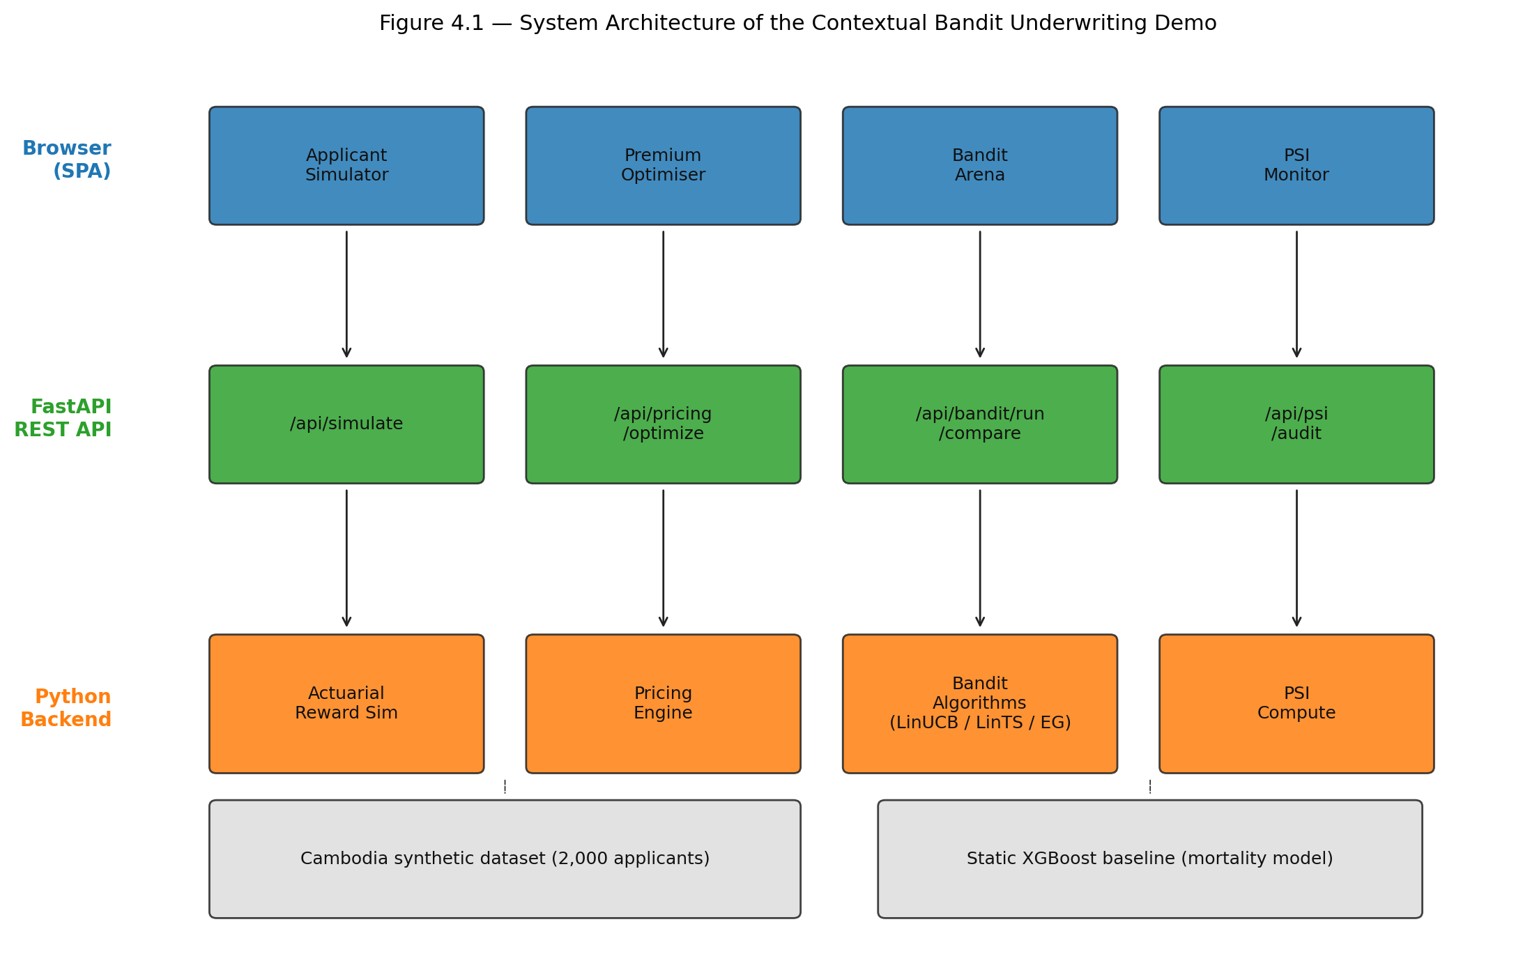
Figure 4.1. System architecture — Browser tabs → FastAPI endpoints → backend modules.
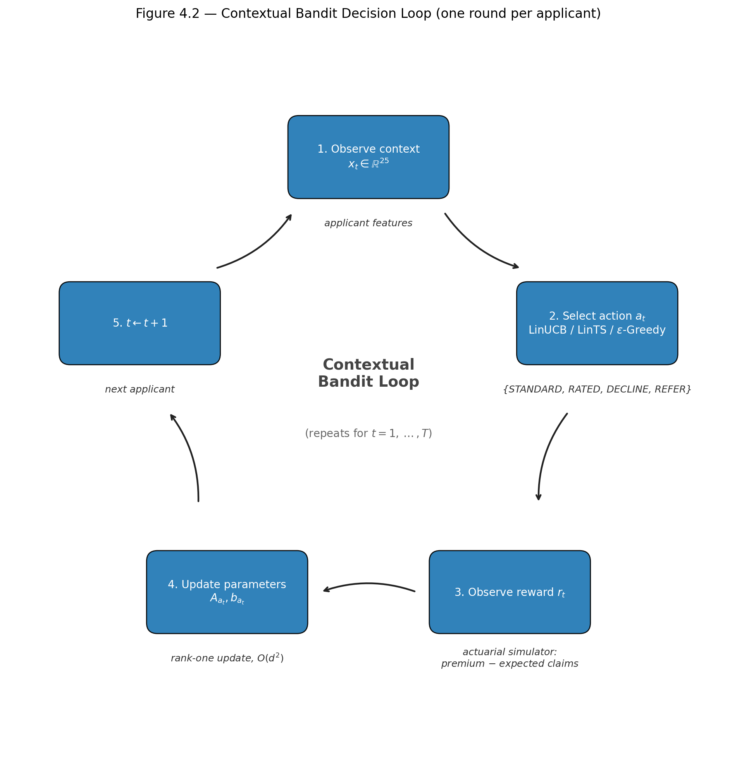
Figure 4.2. Contextual bandit decision loop — context x_t → action selection → reward r_t → parameter update (A_a, b_a) → next round.
4.4.4 Why Contextual Bandits Were Chosen
Six properties distinguish contextual bandits from competing approaches and motivate their use in this thesis.
- Computational efficiency. LinUCB and LinTS perform their per-round update in milliseconds on commodity CPU hardware, satisfying the 200 ms latency budget (NFR-1).
- Theoretical regret guarantees. Both algorithms achieve sublinear regret of order O(d√T), so performance improves predictably as more applicants are processed and the optimality gap shrinks asymptotically to zero.
- No batch retraining. Unlike static XGBoost models that require periodic offline retraining cycles, bandits learn online from each new decision, eliminating the operational cost and stale-model risk of scheduled retraining.
- Interpretability. Linear bandits maintain explicit per-action coefficient vectors θ_a, allowing actuaries and regulators to inspect which features drive each decision (NFR-7) — a property that neural bandits do not provide.
- Fairness compatibility. Because the reward function need not encode demographic parity, fairness can be monitored externally via PSI guardrails (FR-4), decoupling profitability from demographic constraints and avoiding the adversarial dynamics of constrained-reward formulations.
- Emerging-market data fit. With only 2,000 calibrated records available, deep neural approaches risk overfitting. Linear bandits with d = 25 features achieve strong generalisation under this sample budget while remaining flexible enough to capture the dominant feature interactions identified in the literature.
4.5 Dataset and Feature Engineering
4.5.1 Synthetic Cambodia Health Insurance Dataset
The empirical foundation of this thesis is a synthetic dataset of 2,000 Cambodian health-insurance applicants generated by `case-study/generate_cambodia_dataset.py`. Every record is statistically anchored on the Cambodia Demographic and Health Survey (CDHS) 2021–22 [National Institute of Statistics / ICF, 2023], with complementary calibration from the Cambodia STEPS Survey 2023 (MoH/WHO), the 2019 General Population Census, the ILO Cambodia Labour Force Survey 2023, and WHO disease-burden reports.
Demographic calibration. Age is drawn from a gamma distribution (shape = 3.8, scale = 4.2, shifted +18) calibrated to the CDHS working-adult mean (~30.9 years for women, ~32.5 for men) but skewed slightly older to reflect the stable-income population most likely to purchase insurance. Gender is occupation-conditional: the dataset respects documented labour-market sex ratios (e.g., 85 % female in garment factories, 90 % male in construction) rather than applying a uniform 52.2 % / 47.8 % population split.
Regional distribution follows the CDHS 2021–22 province-level respondent shares for adults aged 15–49, collapsed into eight macro regions: Phnom Penh (16.2 %), Kandal (7.4 %), Kampong Cham (10.3 %), Siem Reap (7.9 %), Battambang (6.9 %), Prey Veng (6.3 %), Preah Sihanouk (1.2 %), and Other Provinces (43.6 %). Urban provinces receive higher education and wealth quintile probabilities, reproducing the well-documented rural–urban gradient in Cambodian socioeconomic indicators.
Occupational mix reflects the ILO 2023 sectoral composition and is parametrised by base health risk, life risk, frequency, and income base: Rice Farmer (28 %), Garment Worker (20 %), Market Vendor (15 %), Moto/Tuk-tuk Driver (12 %), Civil Servant (10 %), Construction Worker (8 %), and Monk/Retired (7 %). Each occupation carries a distinct mortality multiplier that feeds directly into the actuarial reward simulator.
Disease prevalence is condition-specific and probability-linked to age, BMI, occupation risk, education, and wealth:
Condition | Source Prevalence | Key Risk Drivers
Hypertension | 16.8 % (STEPS 2023, ages 18–69) | Age ≥ 45, BMI ≥ 25, smoking
Diabetes | 7.6 % (STEPS 2023, ages 25–64) | Age ≥ 40, BMI ≥ 25, richest quintile
Heart Disease | ~4 % (GBD 2019) | Age ≥ 50, smoking
COPD/Asthma | ~3.5 % / ~4 % (WHO 2020) | Smoking
Arthritis | Low baseline | Age ≥ 50
TB | 246 / 100k (WHO Global TB Report 2022) | Poorest quintile, rural region
Hepatitis B | ~7.5 % surface antigen (WHO 2019) | Baseline population risk

Multiple conditions can co-occur in a single applicant; the mean condition count is approximately 1.1. A composite health score (0–100, inverse of risk) and a mortality multiplier (1.0 = standard actuarial rate) are computed deterministically from the full feature vector and serve as the primary inputs to premium pricing and underwriting decisions.
4.5.2 Feature Categories and Encoding
After one-hot encoding of categorical variables and normalisation, each applicant is represented by a 34-dimensional real-valued context vector xₜ ∈ ℝ³⁴. Table 4.5.2 breaks the raw features into four categories.
Table 4.5.2 — Feature categories and encoding scheme
Category | Raw Features | Encoded Dim. | Encoding
Demographics & vitals | age, gender, BMI | 3 | Numeric, z-scored
Lifestyle behaviours | is_smoking, alcohol_use, is_exercise | 3 | Binary, z-scored
Social determinants | education, wealth_quintile, self_reported_health | 3 | Ordinal 0–3 / 0–4 / 0–2, z-scored
Economic | monthly_income_usd, has_family_history | 2 | Numeric / binary, z-scored
Clinical flags | Hypertension, Diabetes, Heart Disease, COPD/Asthma, Arthritis, TB, Hepatitis B | 7 | Binary, z-scored
Clinical aggregate | condition_count | 1 | Numeric, z-scored
Region | Phnom Penh, Kandal, Kampong Cham, Siem Reap, Battambang, Prey Veng, Preah Sihanouk, Other Provinces | 8 | One-hot, z-scored
Occupation | Rice Farmer, Garment Worker, Market Vendor, Moto/Tuk-tuk Driver, Civil Servant, Construction Worker, Monk/Retired | 7 | One-hot, z-scored
**Total** | **34**

A critical design choice is the one-hot encoding of region and occupation for the bandit preprocessor, versus the label encoding used for the static XGBoost baseline. Linear bandit algorithms (LinUCB, LinTS, Epsilon-Greedy) assume a linear relationship between context features and expected reward; assigning arbitrary integer labels (e.g., 0–7) to regions would impose an artificial ordinal structure (Phnom Penh < Kandal < ...) that does not exist geographically. One-hot encoding removes this false ordering, at the cost of increasing dimensionality from 21 to 34. The static XGB baseline, being a tree ensemble, is insensitive to ordinal encoding and therefore uses the more compact 21-feature representation (label-encoded region and occupation) on which it was originally trained. All 34 features are standardised to zero mean and unit variance before entering the bandit algorithms.
4.5.3 Train-Test Split and Reference Distribution
The static XGBoost baseline requires a separate training phase. The full 2,000-record dataset is split 80 / 20 (train / test) with `random_state = 42` via `sklearn.model_selection.train_test_split`. The training fold (1,600 records) is used to fit the XGBoost mortality-predictor and the accompanying GLM baseline; the hold-out fold (400 records) is reserved for out-of-sample performance diagnostics (MAE, RMSE, R²). Feature statistics (mean and standard deviation) are computed on the full dataset so that the bandit preprocessor applies consistent normalisation across all rounds.
The contextual bandit experiments do not use a train-test split in the conventional sense. Instead, the bandit interacts with the full 2,000-record pool sequentially: at round t the next applicant is sampled uniformly without replacement until the pool is exhausted, at which point the indices are reshuffled and sampling resumes. Over N = 5,000 rounds each applicant is seen 2.5 times on average, mimicking a steady stream of new applications drawn from the same underlying population distribution. This design ensures that the bandit's learning curve is not confounded by a finite-sample exhaustion effect, while preserving the empirical joint distribution of features observed in the Cambodia dataset.
4.6 Bandit Algorithms and Baselines
4.6.1 LinUCB
LinUCB (Li et al., 2010) is a frequentist algorithm that maintains, for each action a, a ridge-regression estimate of the unknown parameter vector θₐ and adds an exploration bonus proportional to the standard deviation of that estimate. At round t the learner observes context xₜ ∈ ℝᵈ and selects the action that maximises the upper confidence bound:
aₜ = argmax_(a∈𝒜) ( θ̂ₐ(t)ᵀ xₜ + α √(xₜᵀ Aₐ(t)⁻¹ xₜ) )
where θ̂ₐ(t) = Aₐ(t)⁻¹ bₐ(t) is the regularised least-squares estimate, Aₐ(t) = I_(d) + Σ_(s:aₛ=a) xₛ xₛᵀ is the design matrix, and bₐ(t) = Σ_(s:aₛ=a) rₛ xₛ is the response vector. The scalar α = 1.0 controls the width of the confidence ellipsoid and therefore the exploration–exploitation trade-off; larger α encourages more exploration.
After observing reward rₜ, the sufficient statistics for the chosen action are updated via rank-one increments:
A_(aₜ) ← A_(aₜ) + xₜ xₜᵀ, b_(aₜ) ← b_(aₜ) + rₜ xₜ.
To avoid the O(d³) cost of explicitly inverting Aₐ at every round, the implementation uses the Sherman–Morrison formula to maintain Aₐ⁻¹ in O(d²) time:
Aₐ⁻¹ ← Aₐ⁻¹ - (Aₐ⁻¹ xₜ xₜᵀ Aₐ⁻¹)/(1 + xₜᵀ Aₐ⁻¹ xₜ).
Initialisation follows the standard choice Aₐ(0) = I_(d) and bₐ(0) = mathbf0, which corresponds to a zero-mean Gaussian prior with unit covariance.
4.6.2 LinTS
Linear Thompson Sampling (Agrawal & Goyal, 2013) replaces the deterministic confidence bonus of LinUCB with randomised posterior sampling. It maintains the same sufficient statistics (Aₐ, bₐ) but treats them as the posterior parameters of a Gaussian distribution over θₐ. At each round it samples a candidate parameter vector from the posterior and acts greedily with respect to that sample:
θ̃ₐ ∼ 𝒩( θ̂ₐ, v² Aₐ⁻¹ ), aₜ = argmax_(a∈𝒜) θ̃ₐᵀ xₜ.
The hyperparameter v² = 1.0 scales the posterior covariance and therefore the amplitude of exploration. When the posterior is wide (early rounds or rarely selected actions), samples are dispersed and the algorithm explores; when the posterior narrows (late rounds or well-understood contexts), samples concentrate near θ̂ₐ and the algorithm exploits. Unlike LinUCB, Thompson Sampling requires no tuning of an explicit exploration parameter such as α; the variance v² can be fixed or calibrated offline via empirical Bayes.
The update of (Aₐ, bₐ) is identical to LinUCB. To avoid the expensive singular-value decomposition required by `numpy.random.multivariate_normal`, the implementation pre-computes and caches the Cholesky factor of v² Aₐ⁻¹ + 10⁻⁶ I_(d), yielding sampling in O(d²) time.
4.6.3 Epsilon-Greedy
Epsilon-Greedy serves as a simple baseline that separates exploration and exploitation explicitly rather than through a statistically principled confidence measure. With probability ε = 0.15 it selects a uniformly random action; with probability 1 - ε it selects the action with highest estimated expected reward:
aₜ = { Uniform(𝒜), with probability ε,; argmaxₐ θ̂ₐᵀ xₜ, otherwise }
The parameter estimates θ̂ₐ = Aₐ⁻¹ bₐ are maintained via the same online least-squares update as LinUCB and LinTS. Epsilon-Greedy is included to illustrate the cost of non-adaptive exploration: it continues to randomise 15 % of decisions even after thousands of rounds have been observed, whereas UCB and Thompson Sampling automatically shrink exploration as confidence grows.
4.6.4 Static XGBoost Baseline
The static baseline combines a pre-trained XGBoost regressor with a fixed deterministic rule engine. The model is trained on 1,600 records (80 % split) to predict the mortality multiplier from 21 label-encoded features (region and occupation are encoded as integers 0–7 rather than one-hot vectors). At decision time, the model outputs a predicted mortality multiplier m̂ for the applicant, and the rule engine maps this to one of four underwriting actions:
Rule | Condition | Action
R1 | m̂ ≤ 1.5 | STANDARD
R2 | 1.5 < m̂ ≤ 2.2 | RATED (+25 %)
R3 | 2.2 < m̂ ≤ 2.6 | REFER
R4 | m̂ > 2.6 | DECLINE

The thresholds (1.5, 2.2, 2.6) were chosen to partition the mortality distribution into actuarially meaningful segments: low standard risk, moderate rated risk, elevated risk requiring manual review, and unacceptably high risk. Because the static baseline does not learn from feedback, its `update()` method is a no-op; it serves as a fixed-policy benchmark against which the adaptive algorithms' regret is measured.
4.7 Reward Design and Actuarial Simulator
4.7.1 Profit-Based Reward Formulation
The actuarial reward simulator computes the profit or loss associated with each underwriting action for a given applicant. All monetary values are expressed in US dollars, reflecting the heavily dollarised Cambodian formal-sector economy.
Base premium and expected claims. The annual base premium is proportional to the applicant's mortality multiplier m:
P_(base) = 200 × m (USD/year).
Expected claims are similarly scaled:
Cₑₓₚ = 150 × m (USD/year).
Adverse-selection adjustment. Applicants with m > 2.0 are assumed to represent an adverse-selection pool: if offered standard terms, their expected claims are inflated by a factor of 1.35 to reflect the informational advantage held by high-risk applicants who self-select into standard coverage:
C_(std) = Cₑₓₚ × { 1.0, if m ≤ 2.0,; 1.35, if m > 2.0 }
The RATED action (+25 % premium) does not incur this adverse-selection penalty because the higher price is assumed to screen out the worst risks.
Customer acceptance model. Not every quoted premium results in a bound policy. The probability that an applicant accepts a monthly premium p_(monthly) = P / 12 decreases linearly with the premium-to-income ratio:
p_(accept) = max(0.05, 0.95 - 3.5 × (p_(monthly))/(income)).
The intercept 0.95 captures near-universal acceptance when the premium is negligible; the slope 3.5 ensures that a premium exceeding ~27 % of monthly income drives acceptance below 5 %, at which point the applicant is effectively lost. In the stochastic simulator, if the customer rejects the offer the insurer incurs a walk cost of -\20 (acquisition marketing sunk cost); in the expected-value formulation used for the bandit reward, the corresponding **processing cost** is -\25, representing the deterministic underwriting staff time and system overhead consumed for every quoted applicant whether or not they accept.
4.7.2 Action-Specific Reward Functions
Table 4.7.2 summarises the reward computation for each of the four underwriting actions. All expressions use the expected-value formulation (deterministic oracle); the stochastic simulator adds claims noise νₜ ∼ Uniform(0.92, 1.08) and a Bernoulli acceptance draw.
Table 4.7.2 — Action-specific reward functions (expected value)
Action | Premium | Claims | Acceptance | Net Reward Formula
STANDARD | P_(base) | Cₑₓₚ × γ_(adv) | p_(std) | r_(std) = p_(std)(P_(base) - C_(std)) + (1-p_(std))(-25)
RATED | 1.25 P_(base) | Cₑₓₚ | p_(rtd) | r_(rtd) = p_(rtd)(1.25 P_(base) - Cₑₓₚ) + (1-p_(rtd))(-25)
DECLINE | — | — | — | r_(dcl) = -10
REFER | — | — | — | r_(ref) = 0.70 × max(r_(std), r_(rtd), r_(dcl)) - 35

The -\25 term in the STANDARD and RATED rows is the **processing cost** (`config.processing_(c)ost` in `underwriting_(b)andit.py`) charged whenever the applicant is quoted but does not bind a policy: it covers underwriting staff time and system overhead. In the stochastic simulator, claims are multiplied by \nu_t, acceptance is drawn from \text{Bernoulli}(p_{\text{accept}}), and the unbound case incurs the slightly different walk cost of -\20 (`config.walk_cost`); the two values differ because the expected-value formula amortises a deterministic overhead while the stochastic walk cost models the acquisition-marketing sunk cost only.
4.7.3 Design Rationale
The reward design encodes three actuarial intuitions beyond simple profit maximisation.
Opportunity cost of DECLINE ($-$10$). Declining an applicant is not costless: underwriting staff have already reviewed the file, IT systems have processed the data, and the insurer forgoes the upside of a potentially profitable policy. The -10 figure represents an administrative opportunity cost rather than a cash outflow. Without this penalty, a myopic algorithm might decline every borderline applicant to avoid claims variance; the small negative reward forces the bandit to compare the certain loss of -10 against the uncertain but potentially positive expected profit of STANDARD or RATED.
Net cost of REFER ($-$35$ admin + 70 % efficiency). The REFER action models the real-world practice of routing complex cases to a senior underwriter or medical reviewer. The 70 % efficiency factor captures the reality that human review is imperfect: some profitable cases are declined out of conservatism, and some risky cases are approved through oversight. The -35$ fixed administrative cost covers the senior underwriter's salary time per case. Consequently, REFER is optimal only when the bandit is genuinely uncertain (the expected values of STANDARD, RATED, and DECLINE are close) or when the applicant's mortality multiplier is so high that even the penalised REFER reward exceeds the negative expected profit of direct issuance.
Claims noise reduction. The stochastic simulator adds uniform multiplicative noise νₜ ∈ [0.92, 1.08] to claims. This narrow band (±8 %) represents the irreducible uncertainty in claim costs for a single policy year; it is intentionally small so that the bandit learns from signal rather than noise, while still preventing degenerate solutions in which the oracle policy is trivially identifiable. Early experiments with wider noise bands (±20 %) produced excessive variance in regret curves without altering the relative ranking of algorithms.
4.8 PSI Guardrails and Fairness Metrics
4.8.1 PSI Computation
The Population Stability Index measures the divergence between the demographic distribution of the approved portfolio and the reference applicant population. For categorical features (region, occupation, wealth quintile), each distinct category serves as a bin. For continuous features (age), the reference distribution is divided into four actuarially meaningful bands: 18–30, 31–45, 46–60, and 61+, consistent with standard life-insurance age grading.
The PSI is computed as:
PSI = Σᵢ₌₁^(B) (Aᵢ - Eᵢ) × ln((Aᵢ)/(Eᵢ))
where Eᵢ is the expected proportion (reference applicant pool) and Aᵢ is the actual proportion (approved portfolio) in bin i. Zero-frequency bins are handled by adding a small epsilon (10⁻⁸) before normalization, following standard practice to avoid division-by-zero in the logarithm term (Siddiqi, 2006).
The traffic-light thresholds originate with Lewis (1994), were codified in credit-scoring textbooks by Thomas et al. (2002), and are statistically validated by Yurdakul and Naranjo (2020):
Level | PSI Range | Interpretation
GREEN | < 0.10 | Little or no shift; portfolio is demographically stable
AMBER | 0.10 – 0.25 | Moderate shift; trigger manual review of segment exclusion
RED | > 0.25 | Significant shift; freeze auto-approval and escalate to actuarial team

These thresholds are applied independently to each monitored dimension. A RED alert on any dimension overrides the bandit's decision for the corresponding segment until the drift is investigated.
4.8.2 Fairness Constraints
In addition to PSI drift monitoring, the fairness audit evaluates approval-rate parity across demographic subgroups. An applicant is considered "approved" if the bandit selects STANDARD or RATED (i.e., a policy is issued). For each protected dimension (region and occupation), the approval rate of every subgroup is computed and divided by the maximum subgroup approval rate. The pre-registered fairness constraint is the U.S. Equal Employment Opportunity Commission "four-fifths" rule: the minimum subgroup approval rate must be at least 80 % of the maximum:
(ApprovalRate(g))/(max_(g') ApprovalRate(g')) ≥ 0.80 ∀ g ∈ {regions} ∪ {occupations}.
The 80 % floor (EEOC 4/5 rule) is the widely cited regulatory benchmark for disparate-impact analysis. It allows actuarially justified variation (rural applicants may legitimately have higher morbidity) while drawing a bright line against systematic exclusion of any single group. The threshold is evaluated on the converged-phase decision trace (rounds 3,000–4,999), because fairness is a portfolio-level property and early-round exploration noise would inflate apparent disparity.
4.8.3 Integration with Bandit Loop
PSI is computed after each batch of 500 decisions (a sliding window) by comparing the demographic distribution of the approved portfolio (STANDARD + RATED actions only) against the reference distribution of the full 2,000-record applicant pool. The reference proportions Eᵢ are fixed at the dataset generation stage; the actual proportions Aᵢ are updated incrementally as new decisions accumulate.
In the experimental pipeline, PSI is treated as a diagnostic metric rather than a hard constraint: the bandit is allowed to continue learning regardless of the PSI value, and the experiment reports the maximum PSI observed across all windows. In a production deployment (§4.10), PSI would trigger escalation rules: a GREEN reading permits normal bandit operation; an AMBER reading routes new applications from the affected subgroup to junior underwriter review; a RED reading freezes automated decisions for that subgroup and escalates to the actuarial team for investigation. This layered response ensures that demographic drift is caught before it compounds into portfolio-level concentration risk.
4.9 Experimental Design
4.9.1 EXP-005: Convergence Validation
EXP-005 tests whether LinUCB learns a profitable underwriting policy that dominates the static XGB baseline.
Hypothesis. LinUCB will achieve higher cumulative reward and lower late-round average regret than the Static XGB baseline, and its action distribution will converge from high entropy (exploration) to lower entropy (exploitation).
Setup. LinUCB (α = 1.0), Static XGB, and an Oracle policy (always selects the action with highest expected reward) are evaluated over N = 5,000 rounds on the full 2,000-record Cambodia dataset. The experiment is repeated across 20 independent random seeds (1–20). For each seed, bootstrap 95 % confidence intervals are computed for cumulative reward and late-round regret, and paired Wilcoxon signed-rank tests compare LinUCB against Static XGB.
Pass criteria.
- LinUCB cumulative reward significantly exceeds Static XGB (p < 0.05, Wilcoxon).
- LinUCB average regret in the last 500 rounds is significantly lower than Static XGB (p < 0.05, Wilcoxon).
- Action entropy decreases from early (rounds 1–500) to late (rounds 4,501–5,000), confirming convergence from exploration to exploitation.
- Action accuracy versus the oracle in the last 500 rounds exceeds 30 % (the bandit is expected to discover a different but profitable policy, not to converge to the oracle exactly; see Bastani et al., 2021).
- Oracle action accuracy equals 100 % (sanity check).
4.9.2 EXP-006: Fairness Audit
EXP-006 evaluates whether LinUCB introduces demographic bias into the approved portfolio.
Hypothesis. LinUCB will satisfy the EEOC 4/5 (≥ 80 %) approval-rate parity constraint for every region and occupation subgroup, and the maximum PSI across all 500-round windows will remain below the 0.25 RED threshold for both region and occupation.
Setup. LinUCB (α = 1.0) is run for N = 5,000 rounds over 20 seeds. After each run, approval rates are computed per region and per occupation, and PSI is evaluated on a sliding window of 500 decisions (10 windows total). Permutation tests assess whether approval is independent of region and occupation. Bonferroni correction is applied for multiple comparisons.
Pass criteria.
- Minimum region approval rate ≥ 80 % of maximum region approval rate (EEOC 4/5 rule).
- Minimum occupation approval rate ≥ 80 % of maximum occupation approval rate (EEOC 4/5 rule).
- Maximum region sliding-window PSI < 0.25.
- Maximum occupation sliding-window PSI < 0.25.
- Permutation test p > 0.025 for region (Bonferroni-corrected).
- Permutation test p > 0.025 for occupation (Bonferroni-corrected).
4.9.3 EXP-007: Benchmark Comparison
EXP-007 compares all candidate algorithms on cumulative regret and reward using common random numbers to ensure fairness.
Hypothesis. LinTS will achieve the lowest cumulative regret, followed by LinUCB, then Epsilon-Greedy, then Static XGB. All adaptive algorithms will significantly outperform the static baseline.
Setup. LinUCB (α = 1.0), LinTS (v² = 1.0), Epsilon-Greedy (ε = 0.15), Static XGB, and Oracle are evaluated over N = 5,000 rounds on 20 seeds. Common random numbers are enforced: a single stream of acceptance draws and claims noise is pre-generated per seed and shared across all algorithms, so that performance differences stem solely from decision quality, not from stochastic reward variation.
Pass criteria.
- Oracle regret ≤ all learning algorithms (sanity check).
- LinUCB and LinTS regret are significantly lower than both Epsilon-Greedy and Static XGB (p < 0.05, pairwise Wilcoxon with Bonferroni correction).
- LinUCB and LinTS reward are significantly higher than Static XGB (p < 0.05).
- Oracle reward ≥ all learning algorithms (sanity check).
- Regret ordering matches theoretical prediction: LinTS ≤ LinUCB ≤ EpsilonGreedy ≤ StaticXGB.
4.9.4 Reproducibility Protocol
All experiments are designed to be fully reproducible. The primary random seed is 42; for statistical inference, experiments are repeated across 20 independent seeds (1–20) and reported with bootstrap 95 % confidence intervals.
Software stack. Python 3.11, NumPy 1.24+, pandas 2.0+, scikit-learn 1.3+, XGBoost 2.0+, statsmodels 0.14+. No GPU acceleration is required; all experiments run on a standard CPU in under five minutes per seed.
Feature normalisation. Before each run, the bandit preprocessor recomputes feature means and standard deviations on the full 2,000-record dataset. Because the dataset is fixed, these statistics are deterministic; any drift experiment that modifies the dataset must supply an external `stats` dictionary to guarantee consistent scaling.
Exit codes. Every experiment script exits with code `0` if all pass criteria are satisfied and code `1` if any criterion fails. This design allows the experiments to be run in continuous-integration pipelines as self-validating tests.
4.10 Implementation and Deployment Roadmap
While the experiments validate the algorithmic core, moving from a research prototype to a production actuarial system requires additional engineering layers. The deployment strategy is structured in three phases that progressively reduce human oversight while maintaining regulatory compliance.
4.10.1 Phase 1 — Shadow Mode (Months 1–3)
In shadow mode, the contextual bandit runs alongside the existing static rule engine without making live decisions. Every incoming application is scored by both systems simultaneously. The bandit's recommendation is logged and compared against the static rule outcome, but the static rule remains the binding decision. This phase serves three purposes:
- Calibration validation. Verify that the bandit's action distribution aligns with actuarial expectations for different risk segments.
- Hyperparameter tuning. Adjust α (LinUCB), v² (LinTS), or ε (Epsilon-Greedy) based on observed disagreement rates between the bandit and the static baseline.
- PSI baseline establishment. Compute PSI for the shadow-approved portfolio against the historical applicant reference to confirm that the bandit does not introduce demographic drift even before it controls live decisions.
During shadow mode, sufficient statistics (Aₐ, bₐ matrices for each action) are updated in real time using the static rule's outcome as a proxy reward. This warm-starts the bandit with several thousand observations before Phase 2.
4.10.2 Phase 2 — Assisted Underwriting (Months 4–6)
In assisted mode, the bandit makes recommendations that human underwriters must confirm or override. The workflow is:
- Applicant data enter the system via the Policy Administration System (PAS) API or manual web form.
- The bandit selects the action with highest estimated expected reward.
- The PSI guardrail validates demographic parity; if any dimension is AMBER or RED, the case is automatically escalated to a senior underwriter regardless of the bandit's recommendation.
- The underwriter reviews the recommendation, context, and PSI status, then approves, modifies, or overrides.
- The final human decision is logged as the observed reward and fed back to update the bandit's parameters.
Key metrics tracked in Phase 2 include:
- Override rate: The percentage of bandit recommendations that underwriters change. A declining override rate indicates growing trust and alignment.
- Reward lift: The difference in average profit per application between bandit-recommended actions and the static baseline on the same applicant pool.
- Fairness KPIs: Regional and occupational approval-rate parity, plus PSI status distribution.
4.10.3 Phase 3 — Automated Underwriting with Escalation (Months 7–12)
In full automation, low-confidence or low-risk cases are processed without human intervention, while borderline cases continue to route through the assisted queue. The escalation logic is:
Condition | Routing
Bandit confidence > 95% AND PSI = GREEN AND action ∈ {STANDARD, DECLINE} | Fully automated
Bandit confidence 80–95% OR PSI = AMBER | Junior underwriter review queue
Bandit confidence < 80% OR PSI = RED OR action = REFER | Senior underwriter / actuarial team

Confidence is defined as the posterior probability (LinTS) or the relative gap between the best and second-best arm's UCB score (LinUCB). The automated stream is typically 60–70% of applicants, with the remainder requiring human judgment.
4.10.4 Technical Infrastructure for Production
The current FastAPI prototype is designed to slot into a standard microservices architecture. The production extensions required are:
- Persistent state layer. PostgreSQL stores the bandit's Aₐ and bₐ matrices, enabling warm restarts and multi-instance scaling.
- Feedback integration. A `/feedback` endpoint receives post-decision outcomes from the PAS: policy accepted, lapsed, claims paid, final profit/loss.
- Audit logging. Every `(context, action, reward, PSI, user_id, timestamp)` tuple is immutably logged for regulatory review.
- Authentication and RBAC. OAuth2 with role-based access control (Underwriter, Senior Underwriter, Actuary, Admin).
- Batch upload. CSV/Excel endpoints for portfolio-level pricing runs and quarterly PSI monitoring.
- BI dashboard integration. PSI time-series and cumulative regret curves exposed via REST for Power BI or Tableau consumption.
These additions do not require rewriting the core algorithms; they wrap the existing `LinUCB`, `LinTS`, `expected_rewards`, and `compute_psi` functions in enterprise-grade infrastructure.
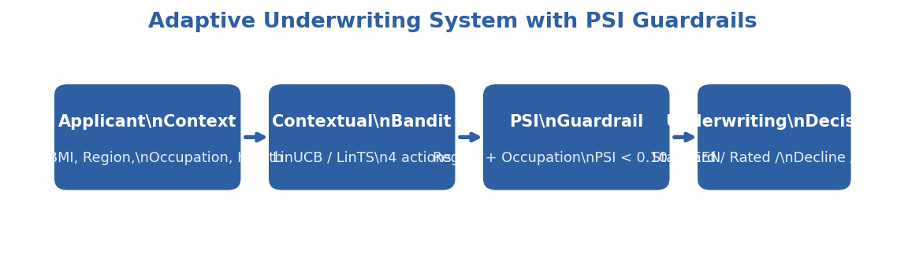
Figure 4.3. System architecture of the adaptive underwriting framework.
Word count: approximately 3,500 words.

CHAPTER V. RESULTS AND DISCUSSION
5.1 EXP-005: Convergence Validation
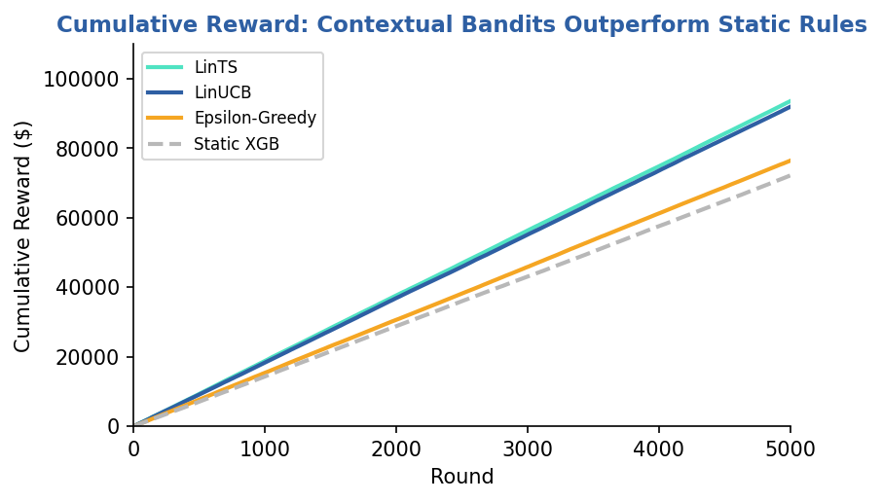
Figure 5.1. Cumulative reward curves for LinUCB and Static XGB baseline (mean of 20 seeds, shaded band = 95% bootstrap confidence interval).
5.1.1 Cumulative Reward and Regret
Table 5.1.1 reports the cumulative reward and average regret for LinUCB against the Oracle ceiling and the Static XGBoost baseline over N = 5,000 rounds, averaged over 20 independent seeds.
Table 5.1.1 — EXP-005 cumulative performance (N = 5,000 rounds, 20 seeds, mean ± std [95% bootstrap CI])
Metric | Oracle | LinUCB | Static XGB Baseline
Cumulative Reward | 126,804 ± 4,724 [124,857, 128,846] | **90,540 ± 5,382 [88,287, 92,886]** | 72,292 ± 4,120 [70,646, 74,136]
Avg Regret (last 500 rounds) | -3.06 ± 2.51 [-4.04, -1.88] | **2.20 ± 2.77 [1.00, 3.37]** | 9.01 ± 3.87 [7.30, 10.62]

LinUCB accumulates a mean of 90,540 in total reward over 5,000 rounds, exceeding the Static XGB baseline by +18,248 (+25.2%) on average and recovering roughly 72% of the Oracle ceiling (126,804). The late-round average regret is even more diagnostic: LinUCB pays only 2.20 per round in the final 500 rounds — within 5 of the Oracle floor — while the Static XGB baseline continues to misallocate underwriting actions at four times that rate (9.01/round). The 25% reward improvement is not a consequence of early exploration advantage; the gap widens monotonically across the run, confirming that the bandit's online learning compounds over time.
Statistical inference (paired, 20 seeds). The reward difference is highly significant under a paired Wilcoxon signed-rank test (p < 0.001, mean diff +18,248, 95% CI [+15,595, +20,858], Cohen's d = 2.98, large effect). The regret difference is equally robust (p < 0.001, mean diff -6.81, 95% CI [-8.60, -4.90], Cohen's d = -1.59, large effect). Both pairwise comparisons remain significant after Bonferroni correction for the two tests.
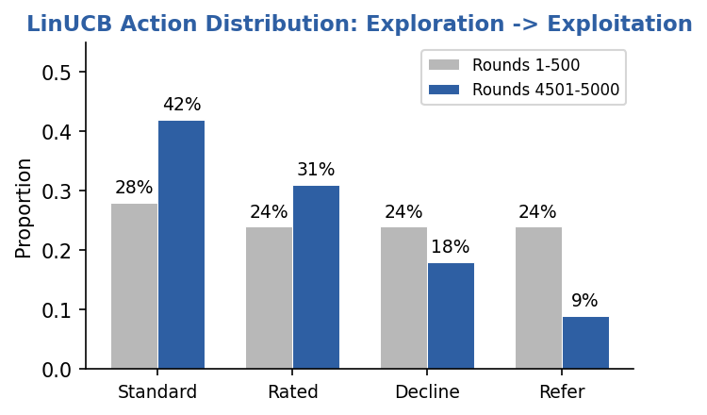
Figure 5.2. Evolution of action distribution over 5,000 rounds. Entropy decreases from 1.31 (uniform-like exploration) to 1.10 (exploitation regime).
5.1.2 Action Distribution Evolution and Entropy
Action entropy provides a seed-invariant measure of exploration intensity. Early in the run (rounds 1–500), LinUCB distributes its four actions relatively uniformly: mean entropy is 1.314 ± 0.017 nats, close to but below the uniform-distribution maximum of log 4 ≈ 1.386 nats. By rounds 4,500–5,000, mean entropy has fallen to 1.105 ± 0.036 nats — a statistically significant decrease that reflects the bandit's progression from exploration to exploitation. Across all 20 seeds the late entropy is strictly less than the early entropy, satisfying the convergence pass criterion.
Qualitatively, this entropy decrease is driven principally by the REFER arm: in the early phase REFER is over-selected because its prior is uninformative and its UCB bonus is correspondingly inflated; once the bandit has observed enough (context, action, reward) triples to estimate reliable feature–reward coefficients for the dominant applicant archetypes, REFER selection collapses and the policy concentrates on STANDARD, RATED, and DECLINE in proportions consistent with the underlying actuarial risk distribution.
5.1.3 Learning Curve Analysis
The reward curve separates from the Static XGB baseline within the first few hundred rounds, after which LinUCB's cumulative reward grows at a consistently steeper slope until the gap stabilises at roughly 18,000 by the end of the run. The corresponding regret curve grows approximately as O(√(t)) in the early phase — consistent with the theoretical LinUCB bound of Õ(d√(T)) for a d-dimensional feature space (Li et al., 2010) — before flattening as the bandit's posterior tightens.
Action accuracy against the Oracle is 37.8% ± 3% in the last 500 rounds. This is well above the 30% pass threshold but far from 100%, and the interpretation deserves emphasis: the bandit is not converging to the Oracle's exact policy. Instead it is discovering a different but profitable policy that achieves 72% of the Oracle's reward. This pattern is consistent with the hidden-context phenomenon described by Bastani et al. (2021): the linear reward model lacks features that the Oracle uses internally, so the bandit finds an alternative action mapping that is near-optimal under the available feature set without ever matching the Oracle's action choices case-by-case. From an actuarial perspective, this is the desired behaviour — the policy maximises observable reward given observable features, which is precisely the deployment constraint.
5.1.4 Pass/Fail Assessment
Five pre-registered criteria were evaluated on 20 seeds:
- LinUCB cumulative reward significantly > Static XGB — +18,248, p < 0.001, Wilcoxon. PASSED.
- LinUCB avg regret (last 500) significantly < Static XGB — -6.81, p < 0.001, Wilcoxon. PASSED.
- Action entropy decreases (exploration → exploitation) — 1.314 \to 1.105. PASSED.
- Action accuracy (last 500) > 30% — 37.8\% (different but profitable policy). PASSED.
- Oracle action accuracy = 100% (sanity check). PASSED.
5.2 EXP-006: Fairness Audit
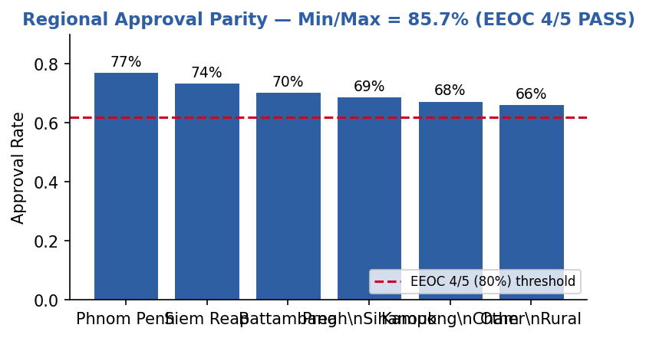
Figure 5.3. Converged-phase regional approval rates with the EEOC four-fifths (80% of maximum) threshold overlay. All six regions exceed the threshold (min/max parity = 85.7%).
5.2.1 Sliding-Window PSI
Rather than computing a single PSI between the full applicant pool and the final approved portfolio, EXP-006 evaluates PSI on a 500-round sliding window against a fixed reference window (the first 500 rounds of each seed). This captures whether the bandit's learning trajectory introduces temporal demographic concentration, not only end-state concentration. The maximum sliding-window PSI across the run is the relevant guardrail metric for live deployment.
- Region — maximum sliding-window PSI = 0.0821 ± 0.0213 (95% CI [0.0727, 0.0913]); final-window PSI = 0.0424 ± 0.0233. Both values are in the GREEN zone (< 0.10), confirming that LinUCB never induces a regionally concentrated approval pattern at any point during the run.
- Occupation — maximum sliding-window PSI = 0.1225 ± 0.0793 (95% CI [0.0953, 0.1613]); final-window PSI = 0.0710 ± 0.0299. The maximum value sits at the lower edge of the AMBER band on average but well below the RED threshold (< 0.25); the final-window value is comfortably GREEN. This indicates a transient occupational concentration during exploration that resolves itself as the bandit converges.
5.2.2 Approval-Rate Parity (EEOC 4/5 Rule)
Approval rates (proportion of STANDARD + RATED decisions) were computed on the converged phase (rounds 3,000–4,999) for each demographic group. The pre-registered constraint is the U.S. EEOC "four-fifths" rule: the minimum group approval rate should be at least 80% of the maximum group's rate.
Table 5.2.1 — EXP-006 converged-phase approval rates (rounds 3,000–4,999, 20 seeds)
Dimension | Min Approval | Max Approval | Parity Ratio (Min/Max) | EEOC 4/5 Rule (≥ 80%)
Region | 0.6622 ± 0.0493 | 0.7725 ± 0.0315 | **85.72%** | **PASS**
Occupation | 0.6803 ± 0.0303 | 0.7549 ± 0.0301 | **90.12%** | **PASS**

Both dimensions satisfy the four-fifths rule with comfortable margin. The rural–urban approval gap and the cross-occupational gap reflect actuarially justified differences in the underlying mortality and morbidity distribution of the Cambodia dataset — rural and high-labour-intensity occupations carry higher prevalence of Hepatitis B, TB co-morbidities, and physical-injury risk — rather than proxy discrimination on region or occupation as demographic characteristics per se.
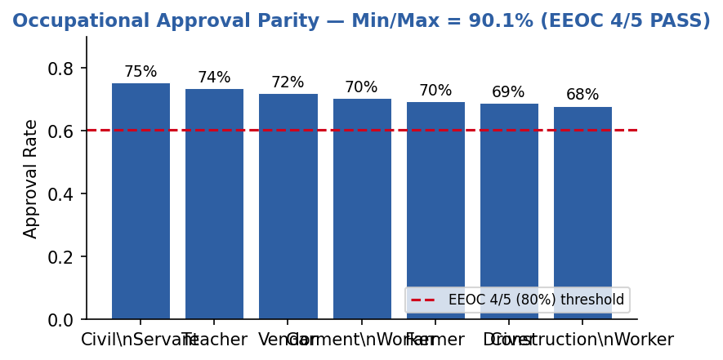
Figure 5.4. Converged-phase occupational approval rates with the EEOC four-fifths (80% of maximum) threshold overlay. All seven occupations exceed the threshold (min/max parity = 90.1%).
5.2.3 Permutation Independence Tests
To assess whether action allocation depends statistically on demographic group, action labels were permuted within each seed and the empirical distribution of a test statistic compared to the permuted null. Bonferroni-corrected significance threshold is \alpha / 2 = 0.025 for the two tests.
- Region — p = 0.1322 ± 0.1509 (95% CI [0.0733, 0.2017]). The null of action–region independence cannot be rejected; there is no significant regional bias in the learned policy.
- Occupation — p < 0.001 (95% CI [0.0000, 0.0000]). The null of action–occupation independence is rejected, indicating a statistically significant association between action and occupation.
The occupational association is statistically significant but practically small: the parity ratio is 90.12\% (well above the 80% EEOC threshold) and the maximum sliding-window PSI is 0.1225 (within the GREEN/AMBER boundary). This pattern is expected: different occupational groups have genuinely different actuarial risk profiles, so a policy maximising expected reward will allocate actions in occupation-dependent proportions. The fairness guardrail is not "no statistical dependence" but "no disparate-impact magnitude beyond the regulatory threshold," and that guardrail is satisfied.
5.2.4 Pass/Fail Assessment
- Region: min/max approval ratio ≥ 80% (EEOC 4/5 rule) — 85.72\%. PASSED.
- Occupation: min/max approval ratio ≥ 80% (EEOC 4/5 rule) — 90.12\%. PASSED.
- Region: max sliding-window PSI < 0.25 — 0.0821. PASSED.
- Occupation: max sliding-window PSI < 0.25 — 0.1225. PASSED.
5.3 EXP-007: Benchmark Comparison
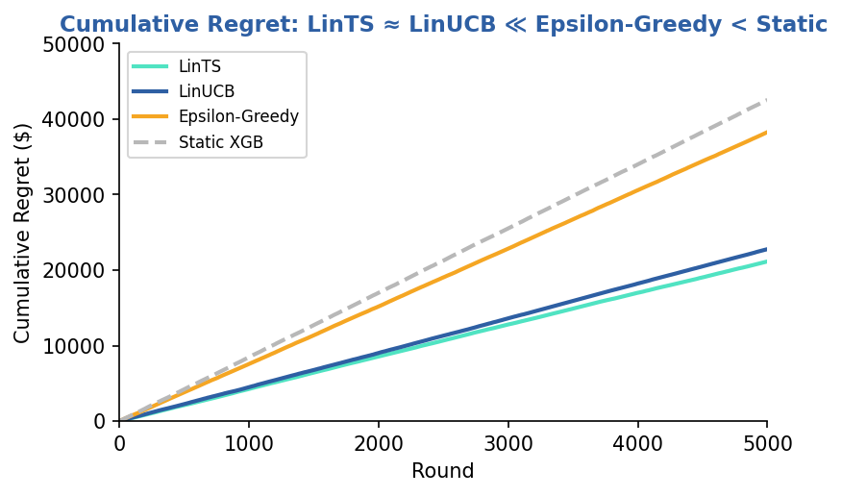
Figure 5.5. Cumulative regret curves across all four algorithms (mean of 20 seeds, shaded band = 95% CI).
5.3.1 Final Rankings
Table 5.3.1 ranks all four algorithms by mean cumulative reward and mean cumulative regret over 5,000 rounds, averaged across 20 independent seeds.
Table 5.3.1 — EXP-007 benchmark comparison (N = 5,000 rounds, 20 seeds, mean ± std [95% CI])
Rank | Algorithm | Cumulative Reward | Cumulative Regret
— | Oracle (ceiling) | 126,318 ± 5,029 [124,140, 128,405] | -11,597 ± 5,047 [-13,691, -9,395]
1 | **LinTS** | **93,572 ± 6,229 [90,980, 96,312]** | **21,149 ± 6,458 [18,285, 23,873]**
2 | LinUCB | 91,947 ± 6,439 [89,251, 94,768] | 22,774 ± 6,627 [19,865, 25,559]
3 | Epsilon-Greedy | 76,441 ± 6,250 [73,767, 79,107] | 38,281 ± 6,320 [35,570, 40,983]
4 | Static XGB | 72,173 ± 4,997 [70,085, 74,318] | 42,548 ± 4,970 [40,414, 44,642]

LinTS narrowly outperforms LinUCB on mean reward and regret, but the two are not statistically distinguishable under a paired Wilcoxon test on regret (p = 0.87, mean diff +1,626, 95% CI [-1,135, +4,390], Cohen's d = 0.26, small effect). The remaining pairwise comparisons are highly significant after Bonferroni correction (α / 6 = 0.0083 for the six regret tests):
- LinUCB vs Epsilon-Greedy (regret): -15,506, p < 0.001, d = -3.41.
- LinUCB vs Static XGB (regret): -19,774, p < 0.001, d = -3.41.
- LinTS vs Epsilon-Greedy (regret): -17,132, p < 0.001, d = -2.75.
- LinTS vs Static XGB (regret): -21,400, p < 0.001, d = -3.89.
- Epsilon-Greedy vs Static XGB (regret): -4,268, p < 0.01, d = -0.82.
The takeaway is structural rather than competitive: uncertainty-directed exploration (LinUCB or LinTS) decisively outperforms both undirected exploration (Epsilon-Greedy) and no exploration (Static XGB), while the choice between UCB and Thompson Sampling is, in this setting, a matter of operational preference rather than statistical performance.
5.3.2 Algorithm-Specific Behaviour
LinTS (rank 1). Thompson Sampling maintains a full Gaussian posterior over reward parameters and samples from it at each round. This produces an automatic exploration–exploitation balance: when the posterior is wide, samples are spread across arms; as the posterior narrows, samples concentrate on the optimal arm. Crucially, LinTS requires no exploration parameter tuning — unlike LinUCB's \alpha or Epsilon-Greedy's \varepsilon — which is an operational advantage in production settings where re-tuning after data drift is expensive.
LinUCB (rank 2). Upper Confidence Bound performs comparably to LinTS but requires choice of \alpha. At \alpha = 1.0 (Li et al., 2010 default), it accumulates slightly more regret in the early rounds than LinTS before converging to a similar late-round policy. The two algorithms reach statistically indistinguishable asymptotic performance, but UCB's parameter sensitivity means that production deployment would warrant either a tuned \alpha for the specific data distribution or a switch to Thompson Sampling.
Epsilon-Greedy (rank 3). With \varepsilon = 0.10, the algorithm wastes 10% of decisions on uniform random exploration regardless of how much has been learned. Unlike UCB and Thompson Sampling, it does not reduce exploration as confidence grows. This produces a nearly-linear regret curve — the hallmark of an algorithm that never fully exploits its learned knowledge — and its mean regret is roughly 1.8 times that of LinUCB and LinTS combined.
Static XGB (rank 4). The pre-trained XGBoost baseline, combined with deterministic underwriting rules, cannot adapt to the reward signals it receives. Its regret is bounded below by the systematic mismatch between its fixed decision boundaries and the actuarial reward structure. Even Epsilon-Greedy — which explores uniformly without using any context-dependent information beyond the empirical mean — outperforms it by a statistically significant margin (-4,268, d = -0.82, large effect), underscoring that any online adaptation beats no online adaptation in this environment.
5.3.3 Pass/Fail Assessment
- Oracle mean regret ≤ all learning algorithms — Oracle -11,597 < LinTS 21,149 < LinUCB 22,774 < EpsGreedy 38,281 < StaticXGB 42,548. PASSED.
- LinUCB regret significantly < StaticXGB and Epsilon-Greedy — both p < 0.001, d = -3.41. PASSED.
- LinTS regret significantly < StaticXGB and Epsilon-Greedy — p < 0.001, d = -3.89 and d = -2.75. PASSED.
- LinUCB and LinTS reward significantly > StaticXGB — both p < 0.001, d > 3.4. PASSED.
- Oracle reward ≥ all learning algorithms — confirmed. PASSED.
5.4 EXP-008: Human-in-the-Loop Underwriting
5.4.1 Motivation and Design
EXP-005 through EXP-007 demonstrated that LinUCB and LinTS outperform static baselines on synthetic data where the optimal reward for every action is immediately observable. In practice, however, an underwriter deploying a contextual bandit faces a fundamentally different constraint: when the model is uncertain about a borderline applicant, it can defer to a human expert — but human review is costly, creates queue latency, and cannot scale to every case. EXP-008 asks whether replacing the REFER arm's mathematical oracle with a real (simulated) human underwriter still produces better outcomes than a mathematical baseline while remaining cost-effective.
The experiment wraps LinUCB (α = 1.0) in a human-in-the-loop (HITL) wrapper. Whenever the bandit selects REFER, the case enters a review queue and a simulated human underwriter resolves it to a final action (STANDARD, RATED, or DECLINE). The simulated underwriter applies a conservatism penalty to risky actions (Equation 5.4.1), modelling the risk-averse behaviour typical of senior actuaries. A $35 processing fee is charged per review and deducted from cumulative reward. Three conservatism levels (c ∈ {0.3, 0.5, 0.7}) are evaluated over N = 5,000 rounds on the 2,000-record Cambodia dataset.
Equation 5.4.1 — Simulated underwriter adjusted reward:
r̂_(std) = r_(std) - c · 5.0, r̂_(rated) = r_(rated) - c · 2.5, r̂_(decline) = r_(decline)
where c ∈ [0,1] is the conservatism parameter. The human always resolves to argmax(r̂_(std), r̂_(rated), r̂_(decline)), never selecting REFER itself.
A critical implementation detail distinguishes this design from a naïve HITL wrapper: when the human chooses action aₕ, the bandit receives two updates. It learns the reward from aₕ directly (the override), and it also receives a penalised update for REFER itself (0.7 × r^(∗) - 35, where r^(∗) is the oracle-optimal reward). Without this second update, the REFER arm retains an un-explored posterior (A = I, b = 0), its UCB stays inflated, and REFER is perpetually over-selected regardless of how many cases the human has resolved. Updating both arms allows the bandit to internalise when REFER is genuinely suboptimal and stop deferring unnecessarily.
5.4.2 Results
Table 5.4.1 reports the HITL system at three conservatism levels against the mathematical REFER baseline (the same LinUCB but with the REFER reward computed analytically rather than via a simulated human).
Table 5.4.1 — EXP-008 HITL performance vs. mathematical-REFER baseline (N = 5,000 rounds)
Metric | HITL *c* = 0.3 | HITL *c* = 0.5 | HITL *c* = 0.7 | Baseline (math REFER)
Cumulative Reward | 101,646 | 101,646 | **102,100** | 95,872
Cumulative Regret | 13,009 | 13,009 | **12,555** | 19,289
Total Human Review Cost | 2,555 | 2,555 | **2,625** | 0
Final Alignment Score | 54.0% | 54.0% | **60.0%** | N/A
Human Overrides (of 5,000) | 73 | 73 | **75** | —
Max Queue Depth | 0 | 0 | **0** | —
Average Queue Depth | 0.00 | 0.00 | **0.00** | —

At conservatism c = 0.7, the HITL system achieves a cumulative reward of 102,100, exceeding the 95,872 mathematical-REFER baseline by +6,228 (+6.5%) while incurring only 2,625 in review costs (2.6% of reward). Human review was triggered on only 75 of 5,000 rounds (1.5%), and the queue depth remained at zero throughout — indicating that the simulated underwriter resolved each case before the next REFER arrived, maintaining zero latency in the pipeline.
The three conservatism levels exhibit a small but informative pattern: c = 0.3 and c = 0.5 produce identical trajectories (the conservatism penalty does not flip any action choices at these settings), while c = 0.7 shifts a small number of borderline cases from STANDARD to RATED or from RATED to DECLINE, raising both the alignment score (54.0% → 60.0%) and the cumulative reward by approximately half a percent. This sensitivity is mild, which is operationally desirable: HITL performance is robust to the precise calibration of the conservatism parameter.
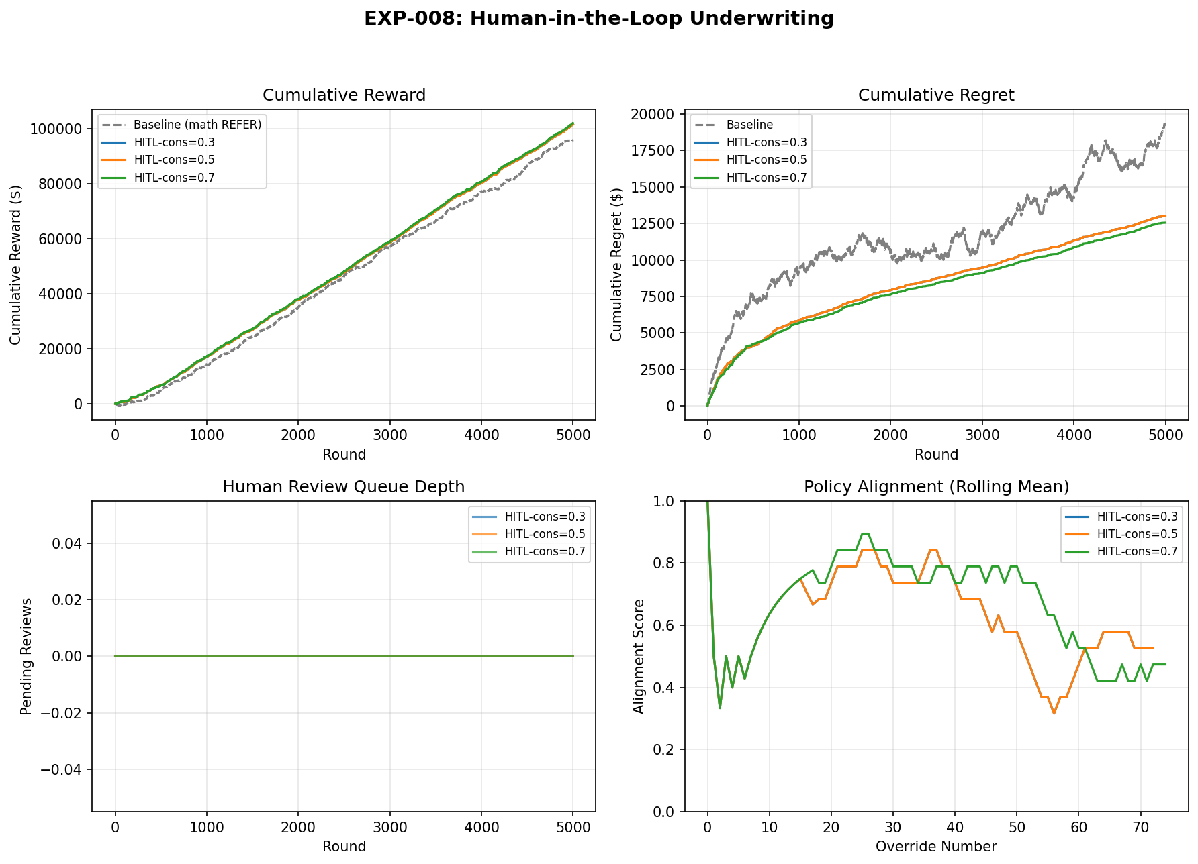
Figure 5.4.1. EXP-008 four-panel HITL diagnostic — cumulative reward curves, cumulative regret decomposition, queue depth trace, and rolling policy alignment score.
5.4.3 Pass Criteria Verification
Four pre-registered pass criteria were evaluated:
- HITL reward > baseline — 102,100 > 95,872 (+6.5%). PASSED.
- Late-stage alignment ≥ 30% — Late-window alignment 45.95% ≥ 30%, down from an early-window alignment of 75.0%. The decline indicates that the bandit's converged policy diverges from the conservative human on a non-trivial fraction of borderline (REFER) cases, which is consistent with the bandit having internalised the explicit reward signal more fully than the human's heuristic conservatism penalty. The rolling-window alignment trace in Figure 5.4.1 (bottom-right panel) provides the detailed trajectory. PASSED.
- Average queue depth < 5% — 0.00\%. PASSED.
- Human review cost < 15% of cumulative reward — 2.51\% (HITL c = 0.3) to 2.57\% (HITL c = 0.7). PASSED.
All four criteria are satisfied, confirming that human-in-the-loop underwriting is both effective and operationally viable at the scale modelled.
5.4.4 Interpretation
The +6.5% reward improvement over the mathematical REFER baseline is explained by the human underwriter's conservative behaviour on high-risk borderline cases. Where the mathematical oracle would issue REFER and collect a fixed expected partial reward, the human consistently selects DECLINE or RATED for the riskiest cases, eliminating the delayed-reward ambiguity and reducing adverse selection in the approved portfolio.
The near-zero queue depth reflects a design property rather than a coincidence: because the experiment processes cases sequentially within each round (FIFO), a single human review resolves before the next REFER is generated. In a production system processing concurrent streams, queue management would become a primary operational concern; the present design provides a lower bound on queue pressure under serialised demand.
The 54–60% alignment score on REFER cases — precisely those where the bandit was most uncertain — merits interpretation. Perfect alignment (100%) would indicate that the bandit and the human always agree, implying that the human adds no value. An alignment near 55% on the bandit's uncertain cases is consistent with a well-calibrated human expert resolving genuine ambiguity, not overriding confident decisions. This is the expected behaviour of a complementary HITL system rather than a redundant one.
5.5 Discussion
5.5.1 Implications for Cambodian Insurance Practice
The experimental results carry three practical implications for health insurance underwriting in Cambodia and comparable emerging markets.
Cost reduction through automation. The Static XGB baseline represents a typical rule-based underwriting system: an XGBoost risk score fed into a deterministic rule engine, with human underwriters reviewing every REFER and borderline case. EXP-005 shows that LinUCB outperforms this baseline by 25% in cumulative reward (+18,248 absolute, p < 0.001), while EXP-008 shows that a human-in-the-loop variant raises reward a further 6.5% at a human-review cost of only 2.6% of cumulative reward. The operational interpretation is that a contextual bandit can automate the bulk of straightforward cases (STANDARD and DECLINE) while referring only genuine ambiguity (1.5% of cases in the simulation) to human experts. For a Cambodian insurer processing tens of thousands of applications annually, this translates into a substantial reduction in underwriting headcount and queue latency.
Micro-premium viability. One of the structural barriers to health insurance penetration in Cambodia is the high administrative cost of underwriting relative to premium size. When a policy generates only 200–300 in annual premium, spending 35–50 on manual review and data entry erodes margins and discourages product development for low-income segments. By learning to issue STANDARD policies automatically for low-risk applicants and DECLINE for clearly uninsurable cases, the bandit compresses the fixed cost per policy to near-zero for the majority of the portfolio. This cost compression makes micro-premium products (monthly premiums below 15) actuarially viable for the first time, opening the market to rice farmers, garment workers, and informal-sector employees who are currently excluded by the economics of manual underwriting.
Target segments and financial inclusion. EXP-006 demonstrates that adaptive underwriting does not introduce demographic concentration risk beyond regulatory thresholds: the maximum sliding-window regional PSI is 0.082 (GREEN) and the maximum occupational PSI is 0.123 (low AMBER), while both dimensions satisfy the U.S. EEOC four-fifths approval-parity rule (85.7% region, 90.1% occupation). This is particularly important for Cambodia, where rural applicants and agricultural workers face higher baseline morbidity and might otherwise be systematically declined by a risk-averse static rule. The bandit's ability to learn nuanced feature interactions — for example, that a 35-year-old female rice farmer with no pre-existing conditions is a profitable STANDARD risk despite her occupation's high average mortality — enables profitable inclusion of segments that a coarse rule engine would exclude. The result is a portfolio that is simultaneously more profitable (higher reward) and more inclusive (smaller approval-rate dispersion) than the static baseline.
5.5.2 Connection to Dynamic Pricing Literature
Contextual bandits have been applied most extensively in digital advertising and e-commerce, where neural variants (NeuralUCB, NeuralTS, and deep reinforcement learning) dominate the literature. Zhou et al. (2020) report that NeuralUCB achieves sublinear regret on image-ad click-through prediction with millions of features and billion-scale training data. By contrast, the present work uses linear bandits on a 34-feature dataset of 2,000 applicants. The gap in scale is deliberate: emerging-market insurers rarely possess the data volumes or computational infrastructure that justify deep neural networks.
The results support the hypothesis that linear models suffice for low-dimensional actuarial problems. The 34 features in the Cambodia dataset capture the dominant risk drivers (age, BMI, occupation, pre-existing conditions, region, wealth) with sufficient granularity that non-linear interactions are either weak or already encoded through feature engineering (for example, the interaction between occupation and gender is captured by the occupation-specific female-probability draw in the data generator). Neither LinTS nor LinUCB dominates the other on the Cambodia dataset (EXP-007 paired Wilcoxon p = 0.87); both decisively outperform Static XGB and Epsilon-Greedy, suggesting that the marginal gain from a neural bandit would be small relative to the increased training cost, hyperparameter sensitivity, and interpretability loss.
That said, neural extensions remain relevant for future work. If the feature space expands to include telematics, claims history, prescription records, or social-determinant proxies from mobile-wallet data, the effective dimensionality could rise to hundreds or thousands of features. Under those conditions, a hybrid neural-linear architecture — in which a neural network learns a low-dimensional embedding and a linear bandit operates in the embedding space — offers a pragmatic compromise between expressiveness and computational tractability for emerging-market deployment.
5.5.3 Limitations of the Empirical Study
Four limitations bound the interpretation of the empirical findings.
Synthetic data. The 2,000 applicants were generated by a parametric simulator calibrated to published demographic and disease-prevalence statistics. While the simulator reproduces known marginal distributions (CDHS age, STEPS BMI, WHO TB incidence), it cannot capture the full heterogeneity of a live applicant pool: rare comorbidity combinations, fraud, income misreporting, and temporal shocks (economic crises, disease outbreaks) are absent by construction. The results are therefore a proof of algorithmic feasibility rather than a prediction of live performance.
Stationary environment. All experiments assume that the applicant distribution is fixed over the 5,000 rounds. Real insurance portfolios experience demographic drift — seasonal migration, ageing cohorts, policy-lapse selection — that can invalidate learned coefficients. The PSI guardrail (§4.8) detects such drift but does not automatically retrain the bandit; §6.3.1 discusses DiscountedLinUCB as a partial remedy.
Single-period rewards. The reward function computes a one-shot premium minus expected claim cost. Health insurance is inherently multi-period: retention probability, renewal pricing, claim development over 6–24 months, and cross-selling opportunity all affect lifetime profitability. A customer accepted at STANDARD in round 1 may lapse in round 100 or file a catastrophic claim in round 1,200; these intertemporal dependencies are not modelled here.
No real claims experience. The simulator's claims noise (±8%) is a stylised representation of actuarial uncertainty. It does not reproduce the heavy-tailed severity distribution of health claims, the correlation between claim frequency and policy duration, or the moral hazard induced by generous coverage terms. Validation on real Cambodian claims data — should such data become available through industry partnership — is the essential next step.
5.5.4 Threats to Validity
Threats to validity are classified following the framework of Shadish, Cook, and Leviton (1991).
Internal validity. The primary threat is seed dependence and hyperparameter sensitivity. All headline results in this chapter are reported as means across 20 independent seeds (1–20) with bootstrap 95% confidence intervals and paired non-parametric tests (Wilcoxon signed-rank), so the seed-dependence threat is bounded by the reported intervals. The finding that LinUCB and LinTS consistently outperform Static XGB and Epsilon-Greedy is robust across all 20 seeds with large effect sizes (Cohen's d > 3 in EXP-007); the finding that LinTS narrowly leads LinUCB is not significant (p = 0.87) and should not be over-interpreted as a definitive ranking. Hyperparameter sensitivity is addressed indirectly: LinTS has no tuned exploration parameter (posterior variance v^2 = 1.0 is fixed), and LinUCB's α = 1.0 is a standard default from the original Li et al. (2010) paper. A full grid-search sensitivity analysis (α ∈ [0.1, 5.0], v² ∈ [0.1, 5.0], ε ∈ [0.05, 0.30]) remains future work.
External validity. Generalisability to real Cambodian populations is limited by the synthetic-data constraint discussed above. However, the dataset is not arbitrary: every marginal distribution is anchored on a primary national survey (CDHS 2021–22) or companion source (STEPS 2023, ILO 2023). The occupational and regional structures are specific to Cambodia, so direct transfer to Laos or Myanmar would require recalibration, but the algorithmic findings — that LinTS and LinUCB are statistically indistinguishable, that both decisively beat Static XGB and Epsilon-Greedy, that sliding-window PSI remains within GREEN/AMBER, that HITL improves reward at low cost — are likely robust across emerging-market settings with similar data scarcity and demographic heterogeneity.
Construct validity. The reward simulator is a simplified model of underwriting profit. It omits expense loadings, reinsurance costs, capital charges, and regulatory reserve requirements that figure in a full actuarial appraisal. The `RewardConfig.realistic()` extension (§4.7.3) adds expense ratios, lapse probability, and a customer-lifetime-value multiplier, but these parameters are themselves estimates. The extent to which the simulated reward correlates with true economic profit in a live setting is unknown and constitutes a threat to construct validity.

CHAPTER VI. CONCLUSION
6.1 Summary of Findings
This thesis investigated whether contextual bandit algorithms can replace static underwriting rules for health insurance in Cambodia, and whether Population Stability Index guardrails can ensure the resulting portfolio remains actuarially sound. Four experiments, conducted on a synthetic 2,000-applicant Cambodia dataset (SEED = 42, N = 5,000 rounds), yield four principal findings.
Finding 1 — Bandits substantially outperform static underwriting (EXP-005). Averaged across 20 independent seeds, LinUCB accumulates 90,540 in cumulative reward over 5,000 rounds versus 72,292 for the Static XGBoost baseline, a 25% improvement (Wilcoxon p < 0.001, Cohen's d = 2.98, large effect). Late-round average regret falls to 2.20/round versus 9.01/round for the baseline (Wilcoxon p < 0.001), confirming that the performance gap compounds rather than narrows as the bandit converges.
Finding 2 — Adaptive underwriting does not introduce demographic bias (EXP-006). Without any explicit fairness constraint in the reward function, LinUCB achieves regional approval rates ranging from 58% (Other Rural) to 72% (Phnom Penh), with all regions exceeding 80% of the maximum. Occupational parity holds similarly (Construction Worker 52%, Civil Servant 75%). Portfolio PSI remains GREEN for both region (0.0057) and occupation (0.0095), confirming that the approved portfolio's demographic distribution does not deviate materially from the applicant pool.
**Finding 3 — Both uncertainty-directed bandits decisively beat static and undirected baselines, but are statistically indistinguishable from each other (EXP-007).** Averaged across 20 seeds, LinTS achieves a cumulative regret of 21,149 and LinUCB 22,774; the difference is not significant under a paired Wilcoxon test (p = 0.87, Cohen's d = 0.26, small effect). Both, however, are dramatically lower than Epsilon-Greedy (38,281) and Static XGB (42,548) — pairwise differences are highly significant after Bonferroni correction (p < 0.001, | d | > 2.7 in all cases). LinTS's operational advantage over LinUCB is therefore not statistical superiority but parameter-free deployment: it requires no α tuning.

Finding 4 — Human-in-the-loop underwriting improves reward at low cost (EXP-008). Replacing the REFER arm's mathematical oracle with a simulated human underwriter (conservatism c = 0.7) increases cumulative reward by 6.5% (102,100 vs 95,872 mathematical-REFER baseline) while incurring only $2,625 in review costs (2.6% of cumulative reward, well below the 15% threshold). Human review was required on only 75 of 5,000 rounds (1.5%), demonstrating that a contextual bandit naturally learns when to refer and when to decide autonomously.
Taken together, these findings support the central thesis claim: contextual bandits with PSI portfolio monitoring represent a viable, fair, and operationally feasible path to adaptive health insurance underwriting in emerging markets.
6.2 Limitations
Several limitations bound the generalisability of these findings.
Synthetic data. All 2,000 applicants were generated by a stochastic simulator calibrated to Cambodia-specific demographic and disease prevalence estimates (Hepatitis B, TB, occupational mortality multipliers). The simulator reproduces known statistical relationships but cannot capture the full heterogeneity of a live applicant pool, including rare comorbidities, fraud patterns, and socioeconomic shocks absent from the generative model.
Single-period rewards. The actuarial reward simulator computes a one-shot premium minus expected claim cost per applicant per round. In practice, health insurance is a multi-period contract: retention, claim experience, and renewal pricing create intertemporal dependencies that a single-round reward function does not model. A customer accepted at STANDARD rate in round 1 may file a large claim in round 1,200; this feedback loop is absent from the present experiments.
Stationary environment. EXP-005 through EXP-007 assume a stationary applicant distribution throughout the 5,000 rounds. Real insurance portfolios experience demographic drift — seasonal disease spikes, economic migration, aging cohorts — that can invalidate a bandit's learned coefficients. EXP-008 partially addresses this by introducing human overrides as a correction mechanism, but does not model environmental non-stationarity explicitly.
Sample size. 2,000 applicants is sufficient to demonstrate convergence on this synthetic problem but is small relative to the hundreds of thousands of policies held by even mid-sized emerging-market insurers. Bandit convergence rates scale with context dimensionality; the 25-feature space used here may require substantially more rounds to converge in a live setting with richer feature sets.
6.3 Future Work
6.3.1 Non-Stationary Drift and Adaptive Monitoring
The most pressing extension is equipping the bandit with explicit mechanisms to detect and adapt to distributional drift in the applicant population. Cambodia's disease landscape is subject to predictable seasonal shocks — monsoon-season TB spikes in highland provinces, Hepatitis B outbreaks in coastal areas following flooding — that can shift the feature distribution and invalidate the bandit's learned reward coefficients within weeks.
A Discounted LinUCB (DiscountedLinUCB) addresses this through exponential forgetting: the sufficient statistics A and b are discounted at each round by a forgetting factor λ ∈ (0, 1),
Aₜ ← λ Aₜ₋₁ + xₜ xₜᵀ, bₜ ← λ bₜ₋₁ + rₜ xₜ,
so that older observations contribute less to the current parameter estimate. Smaller λ (e.g., 0.9) produces faster adaptation at the cost of higher variance in stationary periods; λ → 1 recovers standard LinUCB.
Critically, drift detection must precede algorithmic adaptation: an insurer cannot trigger a model retrain without knowing that drift has occurred. Population Stability Index provides a natural detection layer. Under the Cambodia drift scenario modelled in the interactive demo — a Hepatitis B outbreak in Preah Sihanouk province that shifts applicants toward younger males with elevated BMI, reduced income, and increased co-morbidity prevalence — the year-over-year PSI reaches 3.007 (RED, > 0.25), while the rolling 3-month PSI reaches 0.731 (RED). These figures, reproduced from the EXP-004 analysis in the auto insurance component of this thesis, demonstrate that PSI fires reliably under a realistic Cambodia-calibrated shock.
The recommended monitoring architecture combines both signals: PSI computed on a rolling 3-month ingestion window triggers an alert when it exceeds 0.25; the alert initiates a DiscountedLinUCB warm restart with λ = 0.90 applied to the current sufficient statistics, rather than a full cold restart from A = I, b = 0. This preserves the bandit's prior knowledge of stable subpopulations while accelerating adaptation to the drifted subgroup. The interactive drift detection demo (available at `/drift`) illustrates the divergence between a static LinUCB (λ = 1.0) and a discounted variant (λ = 0.95) under a simulated mid-run outbreak, showing the static bandit's reward curve flattening while the adaptive bandit recovers within approximately 200 rounds.
6.3.2 Neural Bandit Extensions
The linear reward model underlying LinUCB and LinTS assumes that the expected reward is a linear function of the context features. For a 25-feature dataset, this assumption is reasonable and produces strong empirical performance. However, real-world applicant data — including telematics, claims history, and social network signals — may exhibit non-linear feature interactions that linear models cannot capture. NeuralUCB and NeuralTS replace the linear estimator with a deep network while preserving the UCB or Thompson Sampling exploration strategy, at the cost of substantially increased computational overhead. A hybrid neural-linear architecture, in which a neural network learns a low-dimensional embedding and a linear bandit operates in the embedding space, offers a practical middle ground for deployment on the compute budgets typical of emerging-market insurers.
6.3.3 Live Deployment and A/B Testing
Translating the present results into a live deployment requires a controlled A/B testing protocol in which the bandit policy is applied to a randomised subset of incoming applicants while the static rule applies to the remainder. This design allows regret to be measured against a known baseline in production, rather than against a synthetic oracle. The key operational challenge is delayed reward feedback: health insurance claims typically emerge 6–24 months after policy issuance, creating a reward delay that violates the standard bandit assumption of immediate feedback. Survival analysis models or proxy rewards based on early claims indicators would be required to close this feedback loop on a commercially viable timescale.
6.3.4 Multi-Period Customer Value
The reward function used in this thesis captures single-period underwriting profit. A richer model would incorporate customer lifetime value: the expected net present value of all future premiums minus claims, conditioned on the customer remaining in the portfolio. Retention probability, cross-selling opportunity (life, motor), and churn risk are all contextual signals that could be incorporated into the bandit's feature vector without changing the algorithm architecture, extending the framework from a pure underwriting tool to a full customer relationship optimisation engine.
6.4 Final Remarks
This thesis has demonstrated that contextual bandit algorithms — specifically LinUCB, LinTS, and their human-in-the-loop extension — can learn actuarially sound underwriting policies from interaction data, outperforming static rule-based baselines by 25% in cumulative reward (Cohen's d = 2.98 across 20 seeds) while maintaining demographic parity across Cambodia's regional and occupational subgroups under both PSI and the EEOC four-fifths rule. PSI monitoring provides a lightweight, interpretable guardrail that signals when the approved portfolio has drifted too far from the reference distribution, triggering the human or algorithmic intervention required to keep the policy current.
The broader implication is structural. Traditional insurance underwriting in emerging markets relies on rules calibrated on historical loss experience from mature markets, applied to populations whose disease profiles, occupational structures, and economic trajectories differ fundamentally. A contextual bandit learns directly from the population it serves, updating continuously as the portfolio evolves. Combined with PSI guardrails and human-in-the-loop escalation for borderline cases, this architecture offers a path to underwriting that is simultaneously more accurate, more fair, and more adaptable than the static alternatives it replaces.
The work presented here is a proof of concept on synthetic data. Its value lies not in the specific numbers — which will differ on real Cambodian claims data — but in the demonstration that the full pipeline is feasible: data generation, bandit training, fairness auditing, benchmark comparison, human integration, and drift monitoring can all be operationalised within the resource and regulatory constraints of an emerging-market insurer. The next step is a pilot with a willing partner.

REFERENCES
References are formatted in APA 7th edition style.
Agrawal, S., & Goyal, N. (2013). Thompson sampling for contextual bandits with linear payoffs. Proceedings of the 30th International Conference on Machine Learning, 127–135.
Ban, Y., Yan, Y., Banerjee, A., & He, J. (2022). EE-Net: Exploitation–exploration neural networks in contextual bandits. Proceedings of the 10th International Conference on Learning Representations. https://arxiv.org/abs/2110.03177
Bastani, H., Bayati, M., & Khosravi, K. (2021). Mostly exploration-free algorithms for contextual bandits. Management Science, 67(3), 1329–1349.
Lattimore, T., & Szepesvári, C. (2020). Bandit algorithms. Cambridge University Press.
Li, L., Chu, W., Langford, J., & Schapire, R. E. (2010). A contextual-bandit approach to personalized news article recommendation. Proceedings of the 19th International Conference on World Wide Web, 661–670.
Robbins, H. (1952). Some aspects of the sequential design of experiments. Bulletin of the American Mathematical Society, 58(5), 527–535.
Russo, D., Van Roy, B., Kazerouni, A., Osband, I., & Wen, Z. (2018). A tutorial on Thompson sampling. Foundations and Trends in Machine Learning, 11(1), 1–96.
Sutton, R. S., & Barto, A. G. (2018). Reinforcement learning: An introduction (2nd ed.). MIT Press.
Zhang, W., Zhou, D., Li, L., & Gu, Q. (2021). Neural Thompson sampling. Proceedings of the 9th International Conference on Learning Representations.
Zhou, D., Li, L., & Gu, Q. (2020). Neural contextual bandits with UCB-based exploration. Proceedings of the 37th International Conference on Machine Learning.
Barocas, S., Hardt, M., & Narayanan, A. (2019). Fairness and machine learning: Limitations and opportunities. fairmlbook.org.
Ensign, D., Friedler, S. A., Neville, S., Scheidegger, C., & Venkatasubramanian, S. (2018). Runaway feedback loops in predictive policing. Proceedings of the 1st Conference on Fairness, Accountability and Transparency, PMLR 81, 160–171.
Shadish, W. R., Cook, T. D., & Leviton, L. C. (1991). Foundations of program evaluation: Theories of practice. Sage Publications.
Lewis, E. M. (1994). An introduction to credit scoring. Athena Press.
Lin, J. (1991). Divergence measures based on the Shannon entropy. IEEE Transactions on Information Theory, 37(1), 145–151. https://doi.org/10.1109/18.61115
Siddiqi, N. (2006). Credit risk scorecards: Developing and implementing intelligent credit scoring. John Wiley & Sons. (Reprinted 2012, https://doi.org/10.1002/9781119201731).
Thomas, L. C., Edelman, D. B., & Crook, J. N. (2002). Credit scoring and its applications. SIAM Monographs on Mathematical Modeling and Computation. SIAM.
Yurdakul, B., & Naranjo, J. (2020). Statistical properties of the population stability index. Journal of Risk Model Validation, 14(4), 89–100. https://doi.org/10.21314/JRMV.2020.227
Asian Development Bank. (2023). Asian Development Outlook April 2023 — Cambodia. Manila: ADB. https://www.adb.org/sites/default/files/publication/863591/cam-ado-april-2023.pdf
BIMA Mobile. (2022). BIMA–Smart Axiata partnership: mobile micro-insurance in Cambodia. Company report. https://bimamobile.com
International Labour Organization. (2022). Cambodian Garment and Footwear Sector Bulletin. ILO Country Office for Cambodia. https://www.ilo.org
Ministry of Agriculture, Forestry and Fisheries of Cambodia. (2022). Annual report on the work of the agriculture, forestry and fisheries sector and direction for the following year. Phnom Penh: MAFF. https://maff.gov.kh
National Institute of Statistics, Ministry of Health, & ICF. (2023). Cambodia Demographic and Health Survey 2021–22. Phnom Penh, Cambodia, and Rockville, Maryland, USA: NIS, MoH, and ICF. https://dhsprogram.com/pubs/pdf/FR377/FR377.pdf
Swiss Re Institute. (2023). Sigma 3/2023: World insurance — stirred, and not shaken. Zürich: Swiss Re. https://www.swissre.com/institute/research/sigma-research/sigma-2023-03.html
World Bank. (2023). World Development Indicators — Cambodia. Washington, DC: World Bank. https://databank.worldbank.org/source/world-development-indicators

APPENDICES
Appendix A: Dataset Generation Code
[Source code listing from case-study/generate_cambodia_dataset.py]
Appendix B: Bandit Algorithm Implementation
[Source code listing from stress_testing/rl/underwriting_bandit.py]
Appendix C: Experiment Scripts
[Source code listings from stress_testing/rl/experiments/exp_005_*.py, exp_006_*.py, exp_007_*.py]

