THESIS DEFENSE — 20-MINUTE DELIVERY SCRIPT
Adaptive Health Insurance Underwriting via Contextual Bandits:
A Reinforcement Learning Approach for Cambodia
LUN CHANPOLY · ITC-AMS · 8 July 2026

HOW TO USE THIS SCRIPT
This is the STRICT 20-minute cut, synced to the 34-slide deck (Poly_defense_presentation_v3.pptx) — see the budgeted total below, which leaves buffer for pacing and the live demo. Rehearse from THIS script against a clock; use Poly_defense_script_v2.docx only for deeper background study. Bracketed notes [like this] are stage directions. The eight appendix slides A1-A8 are not part of the timed 20 minutes; A2 and A6 are transcribed here as the two most likely Q&A follow-ups.

Budgeted talk-time (excluding 'skip if live demo worked' and Q&A slides): ~11 min 35 sec

SLIDE 1 · TITLE SLIDE
Timing budget: 30 sec
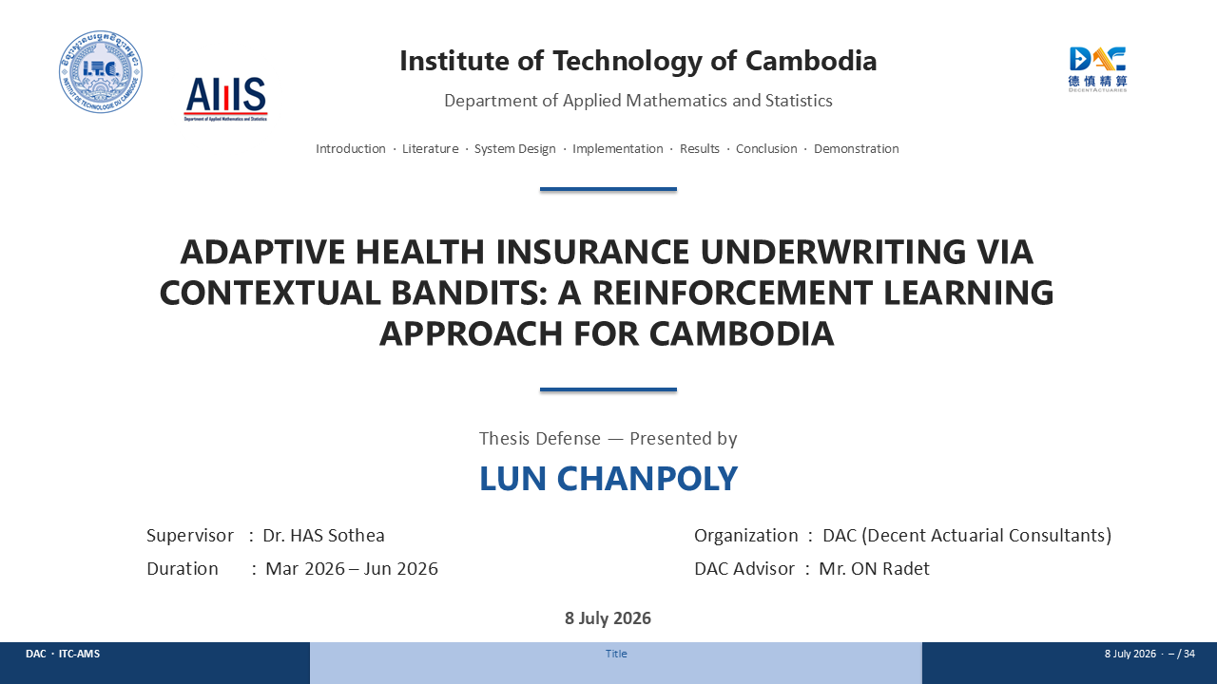
Good morning, Distinguished Committee. My name is Lun Chanpoly, and I'm here to defend Adaptive Health Insurance Underwriting via Contextual Bandits — a reinforcement learning approach for Cambodia. This grew out of my internship at Decent Actuarial Consultants, under Dr. Has Sothea and Mr. ON Radet.
I've kept this to seven short sections, in plain language — the math lives in the appendix if you want it. But I'd rather start with a person. Her name is Sophea.

SLIDE 2 · TABLE OF CONTENTS
Timing budget: 8 sec
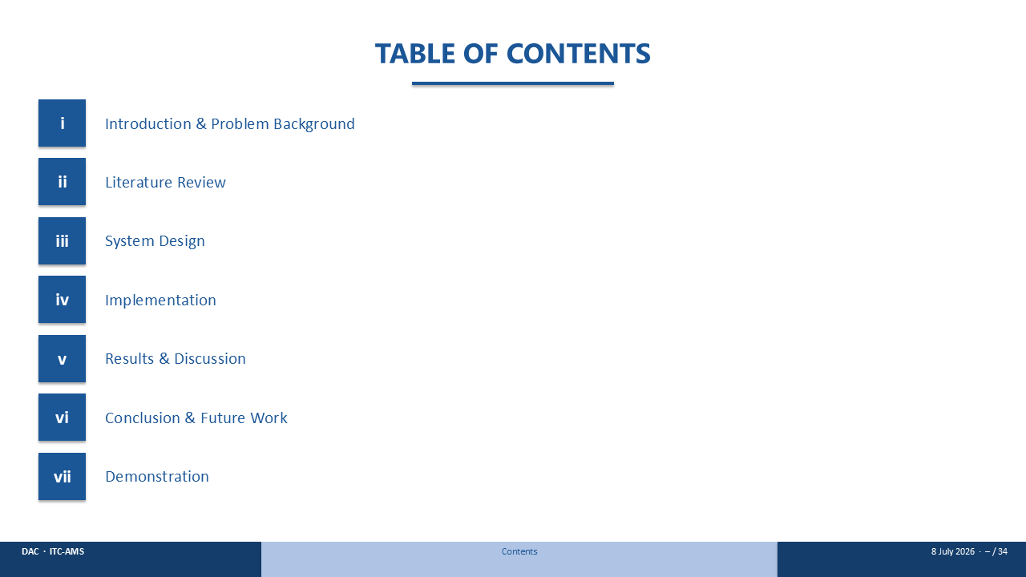
Quick roadmap: the problem, what's been tried before, how I built this, what it found, and then I'll show it to you live. [Advance.]

SLIDE 3 · A MARKET THE SYSTEM WAS NOT BUILT FOR
Timing budget: 25 sec
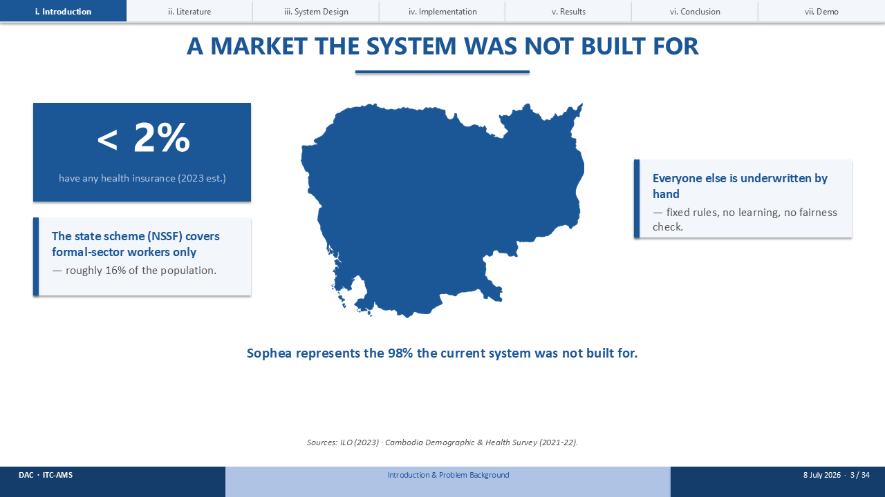
This is the market Sophea lives in. In Cambodia, fewer than two percent of people carry any health insurance at all. The state scheme only reaches formal-sector workers — roughly sixteen percent of the workforce. Everyone else? Underwritten by hand, one judgment call at a time. Sophea is part of that other ninety-eight percent — the market this system was never built for.

SLIDE 4 · MEET SOPHEA
Timing budget: 40 sec
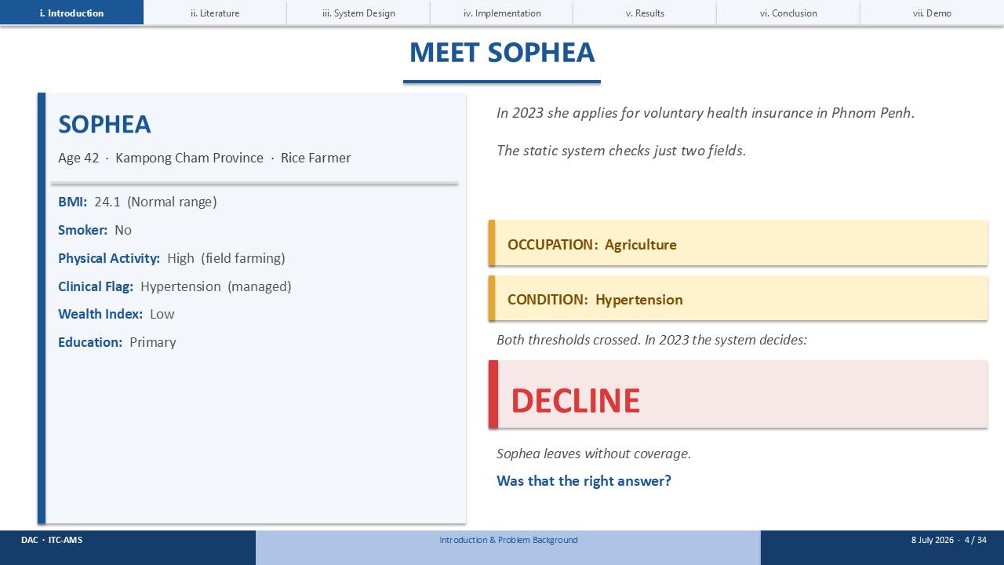
[Point to the profile, then the flags, then the red box.]
Meet Sophea. She's forty-two, a rice farmer in Kampong Cham. Active, doesn't smoke, BMI of 24.1 — and one flag on her chart: managed hypertension.
In 2023, she applies for cover. The static system looks at exactly two fields — occupation is agriculture, condition is hypertension — and both cross a hard-coded threshold. The decision comes back: DECLINE.
Was that the right call?

SLIDE 5 · WHY STATIC RULES FAIL
Timing budget: 25 sec
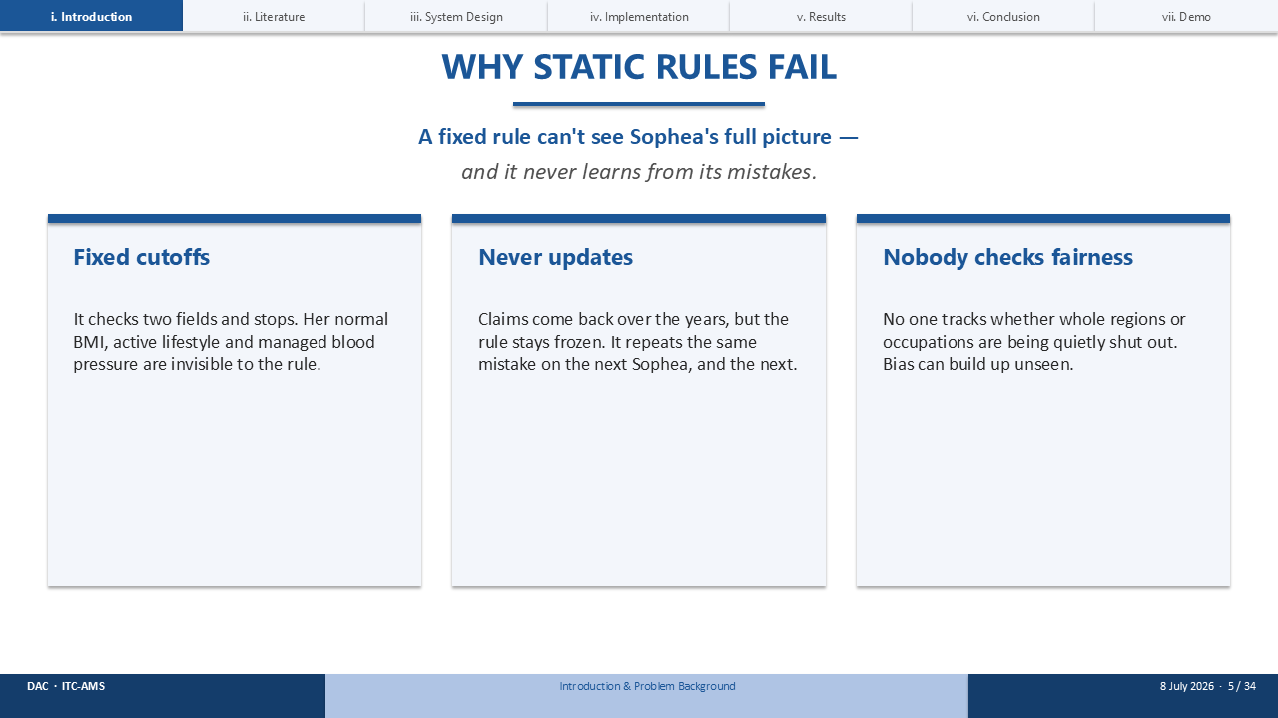
Here's the problem — the rule couldn't have known better. It only sees two fields, not her whole picture, and it never learns from what actually happens afterward. Three things are broken here: the cutoffs are fixed and ignore context, the model never updates itself from real claims, and nobody's checking whether whole groups are quietly getting shut out.

SLIDE 6 · GOAL & OBJECTIVES
Timing budget: 30 sec
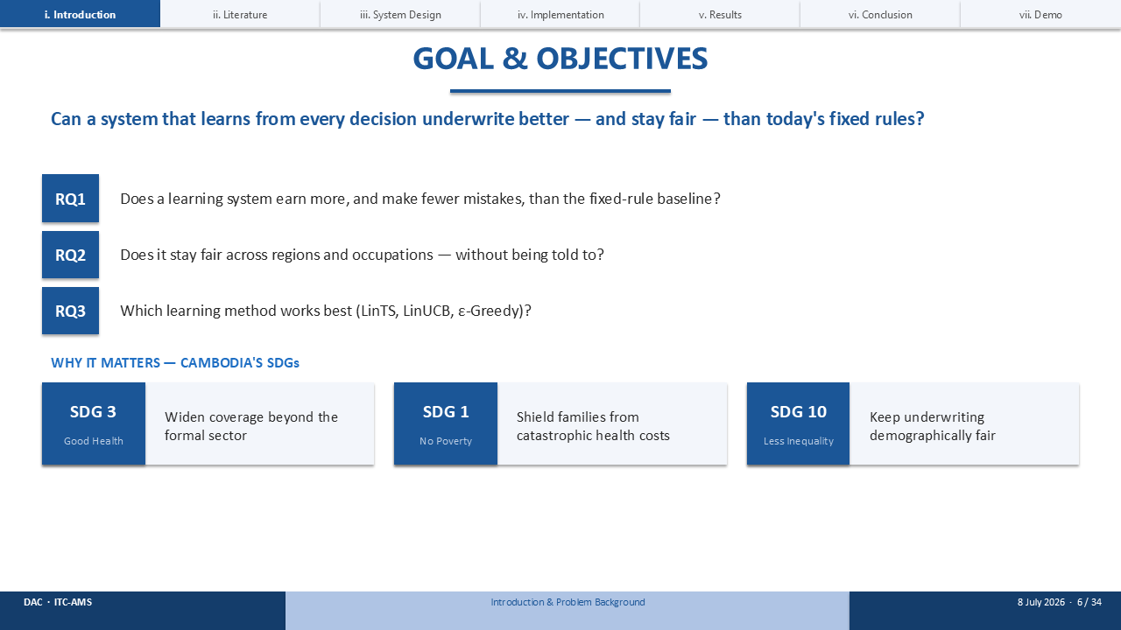
So here's the goal, in one sentence: can a system that learns from every decision underwrite better — and stay fairer — than today's fixed rules? That breaks into three questions I set out to answer: does it earn more money, does it stay fair without anyone telling it to, and which learning method actually wins. And underneath all of that, this touches three of Cambodia's Sustainable Development Goals — health, poverty, and inequality.

SLIDE 7 · ABOUT DECENT ACTUARIAL CONSULTANTS
Timing budget: 20 sec
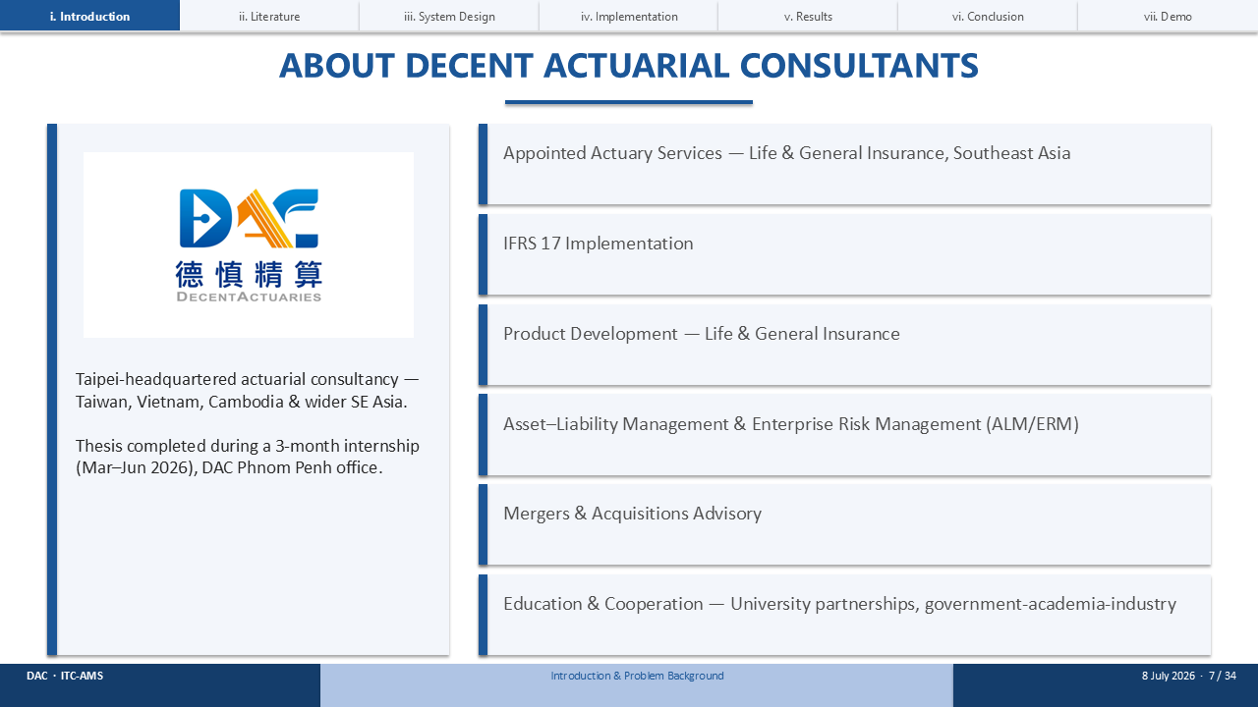
I did this work at Decent Actuarial Consultants — a regional actuarial firm operating across Taiwan, Vietnam, and Cambodia. Their clients face applicants like Sophea every single day. My task was to design, validate, and prototype an adaptive underwriting system for exactly that problem.

SLIDE 8 · PROJECT TIMELINE
Timing budget: 12 sec
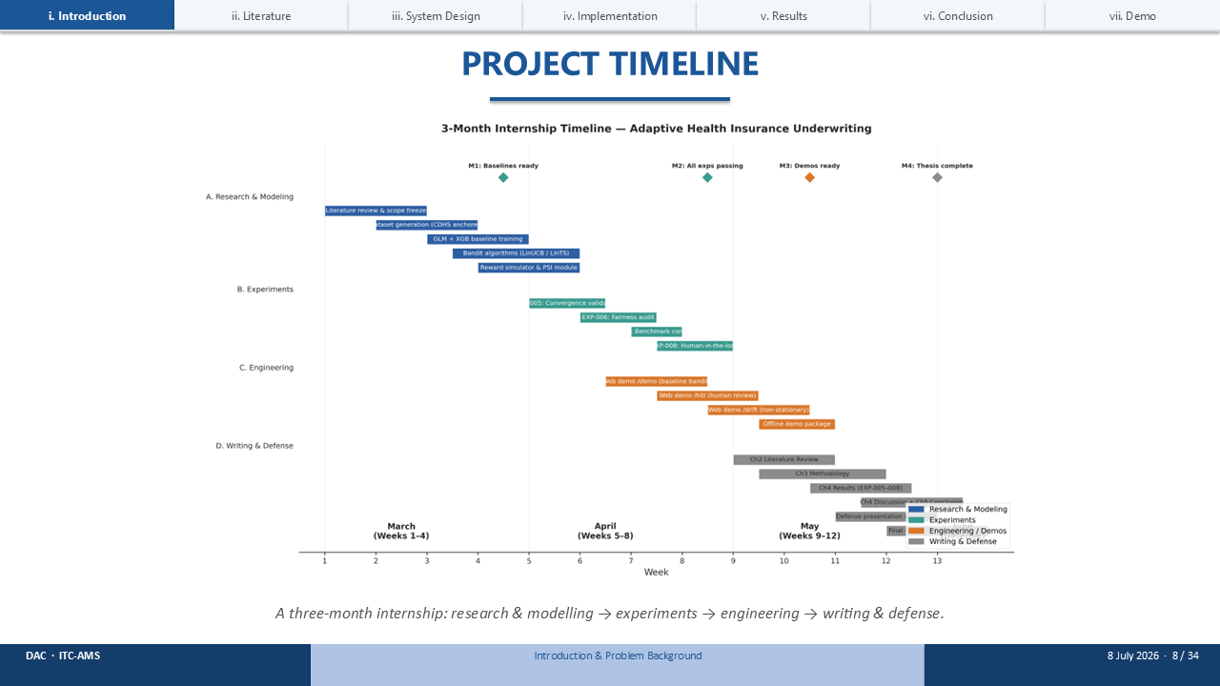
Three months, roughly three phases: research and modelling first, then the experiments, then building the demo and writing it all up. [Advance.]

SLIDE 9 · THE LITERATURE, IN ONE TABLE
Timing budget: 35 sec
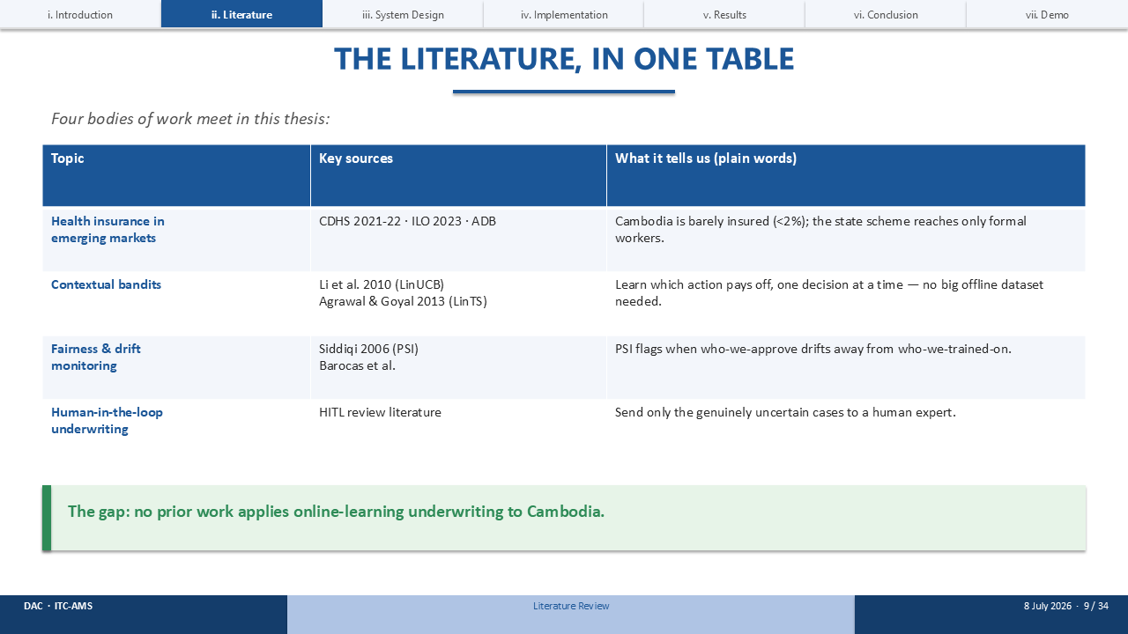
I pulled together four bodies of work into one table. Emerging-market health insurance. Contextual bandits — the method at the core of this thesis, going back to Li in 2010 and Agrawal and Goyal in 2013. Fairness and drift monitoring. And human-in-the-loop review. Put them side by side, and one gap jumps out: nobody had applied online-learning underwriting to Cambodia before.

SLIDE 10 · HOW THE SYSTEM WORKS
Timing budget: 25 sec
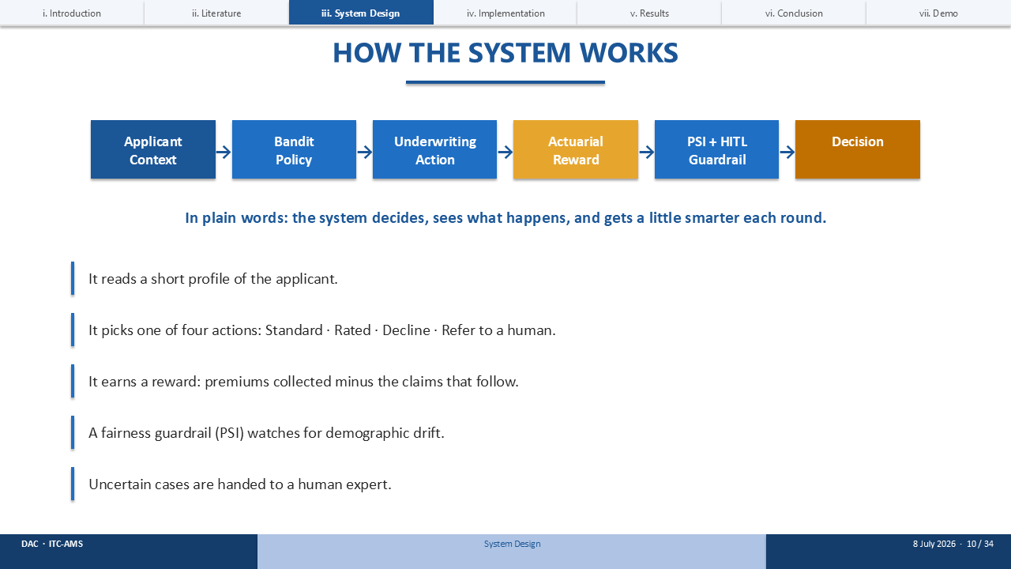
The whole system, in one line: it decides, watches what happens, and gets a little smarter every round. Concretely — it reads a short applicant profile, picks one of four actions, earns a reward based on the outcome, checks itself for fairness, and hands off the uncertain cases to a human.

SLIDE 11 · HOW THE SYSTEM DECIDES FOR SOPHEA
Timing budget: 35 sec
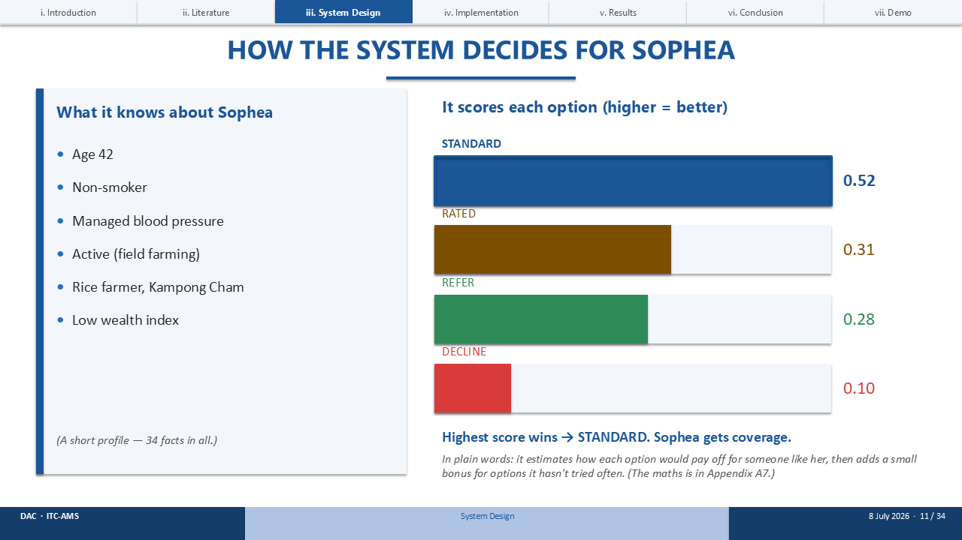
Let's watch it actually decide, for Sophea specifically. On the left is everything it knows about her — that short profile. It scores all four options: Standard comes out highest at 0.52, then Rated, then Refer, then Decline. Highest score wins, so Sophea gets Standard. In plain words, it's estimating how each option would pay off — plus a small bonus for options it hasn't tried very often yet.

SLIDE 12 · WHAT THE SYSTEM EARNS
Timing budget: 25 sec
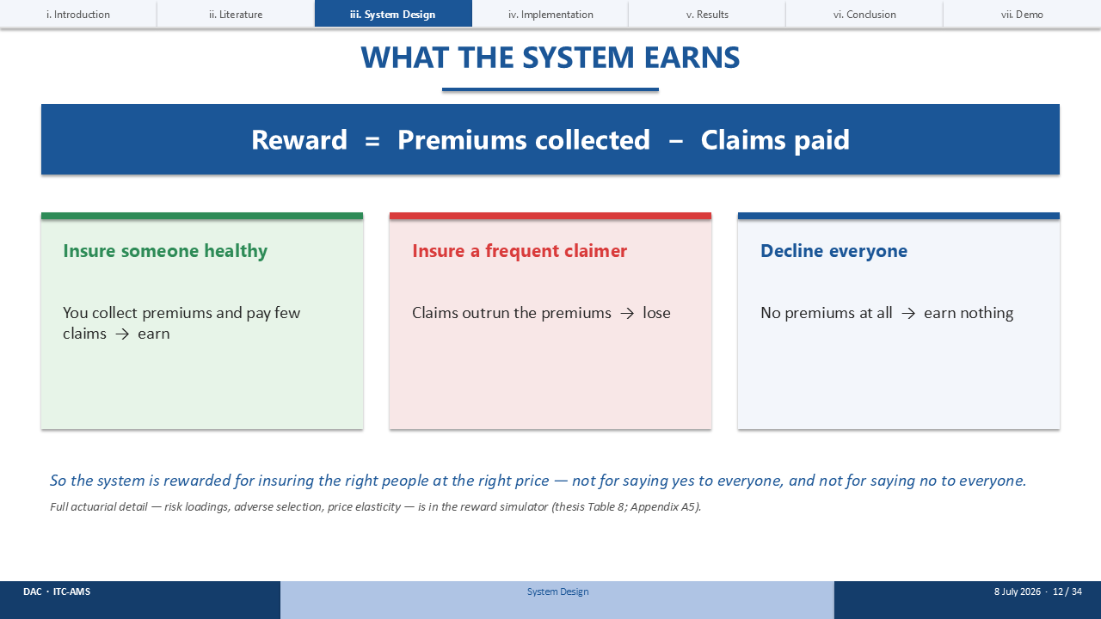
The reward function is deliberately simple: premiums collected, minus claims paid. Insure someone healthy, and you earn. Insure a frequent claimer, and you lose. Decline everyone, and you earn nothing at all. So the incentive is exactly what you'd want — insure the right people, at the right price.

SLIDE 13 · THE FAIRNESS GUARDRAIL
Timing budget: 30 sec
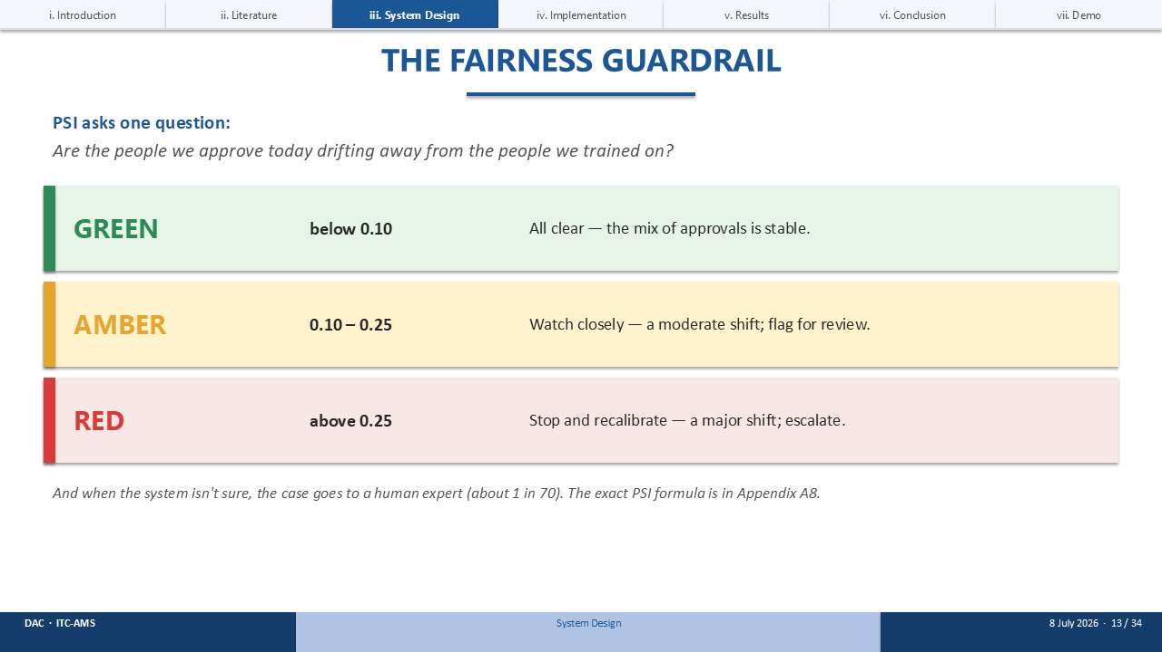
The fairness guardrail is called PSI, and it asks one question: are the people we're approving today drifting away from the people we originally trained on? Think of it as a traffic light — green below 0.10, amber up to 0.25, red above that. And whenever the system's uncertain, it hands the case to a human — that's about one in every seventy applicants.

SLIDE 14 · THE DATA
Timing budget: 25 sec
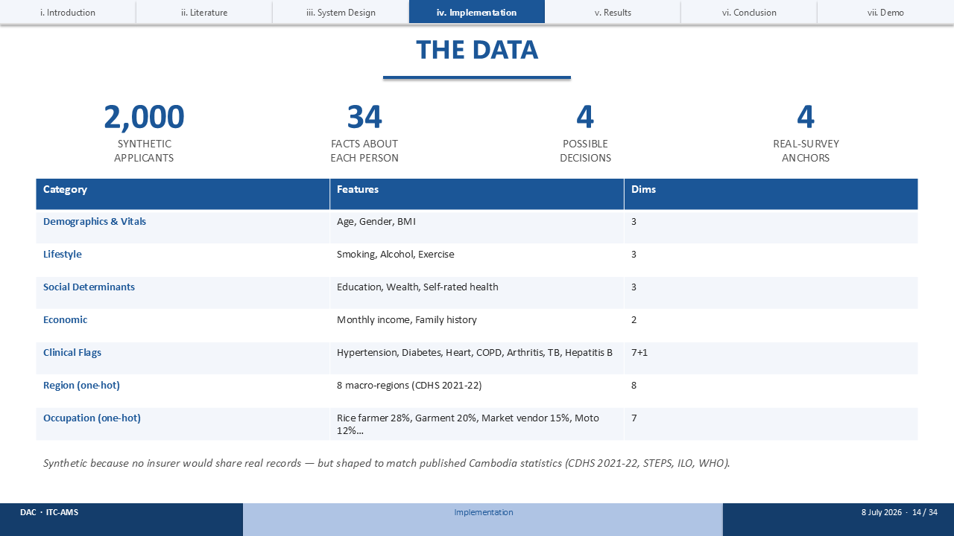
The dataset is two thousand synthetic applicants, thirty-four facts each, across four possible decisions. Synthetic, because no insurer was going to share real records with me — but shaped carefully to match published Cambodia statistics: the CDHS, STEPS, ILO, and WHO surveys.

SLIDE 15 · HOW WE TESTED IT
Timing budget: 25 sec
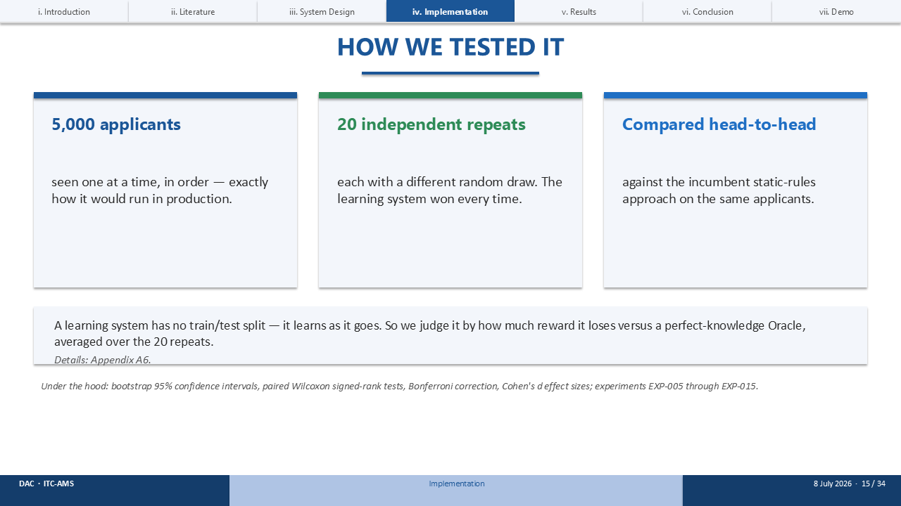
I ran five thousand applicants through, one at a time, twenty independent repeats — head-to-head against the static rules. The learning system won every single time. Now, a bandit doesn't have a train/test split the way a normal model does, so instead I judge it by how much reward it loses compared to a perfect Oracle, averaged across those twenty repeats.

SLIDE 16 · THE HEADLINE RESULT
Timing budget: 40 sec
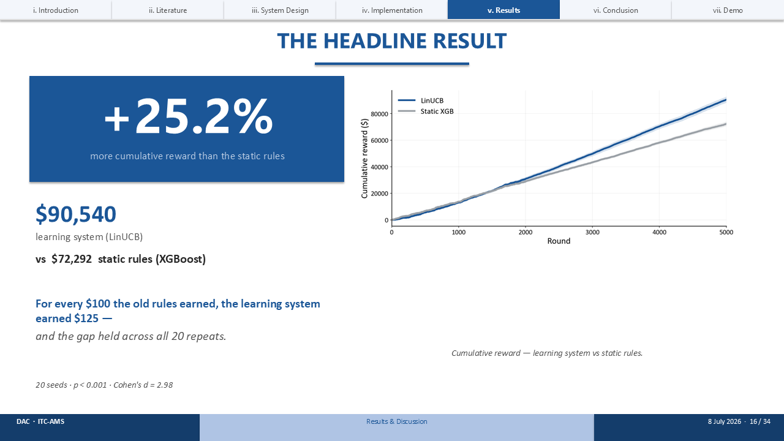
So here's the headline number: twenty-five point two percent more reward than the static rules — $90,540 against $72,292, averaged over twenty seeds. Put plainly, for every hundred dollars the old rules earned, the learning system earned a hundred and twenty-five. And this wasn't a lucky run — the gap held across all twenty repeats, p below 0.001, effect size d of 2.98.

SLIDE 17 · THE BASELINE LADDER
Timing budget: 30 sec
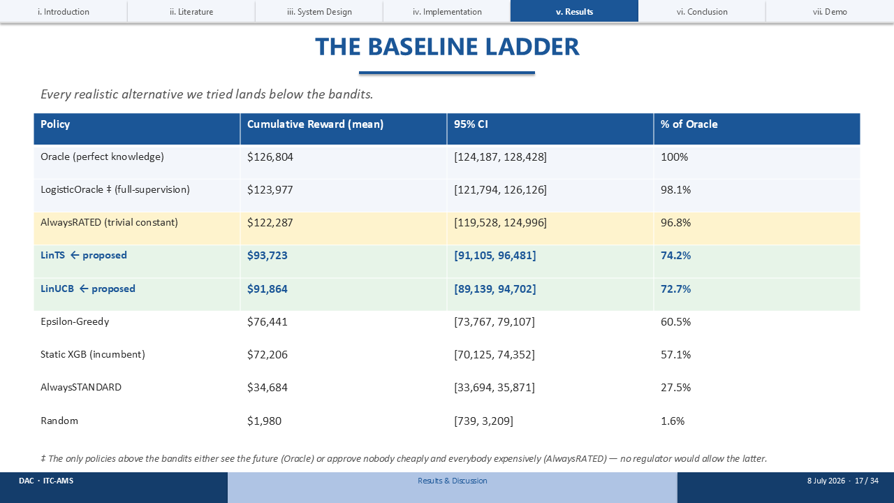
I didn't just compare against one baseline — I built a full ladder of them. And every realistic alternative lands below the bandit. Only two things sit above it: the Oracle, which cheats by seeing the future, and AlwaysRATED, which just rates every single applicant at a flat loading — something no regulator would ever actually allow. Among the policies you could actually deploy, the bandit leads.

SLIDE 18 · SOPHEA, THREE WAYS
Timing budget: 25 sec
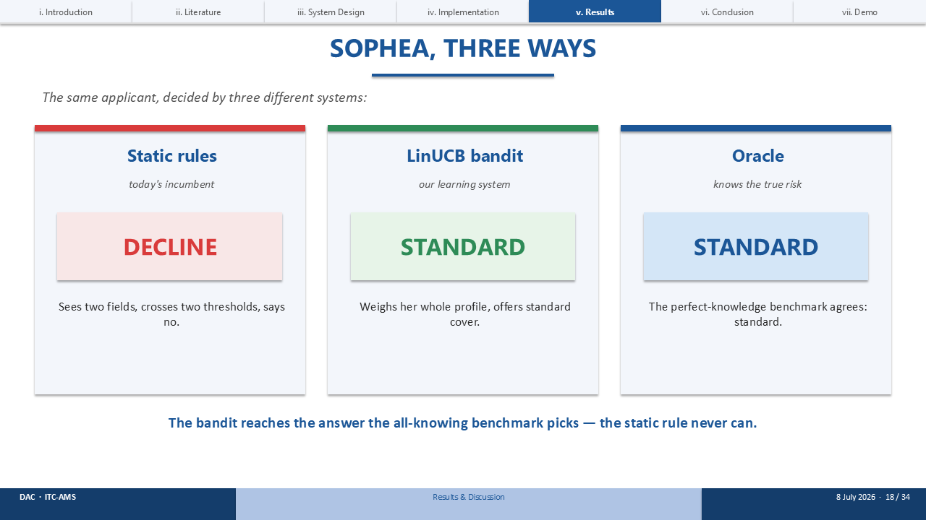
Same applicant, three systems, three answers. The static rules say DECLINE. Our LinUCB bandit says STANDARD. And the Oracle — the one with perfect, all-knowing information — also says STANDARD. So the bandit lands on the same answer as the all-knowing benchmark. The static rule never gets there.

SLIDE 19 · FAIRNESS & HUMAN OVERSIGHT — RESULTS
Timing budget: 40 sec
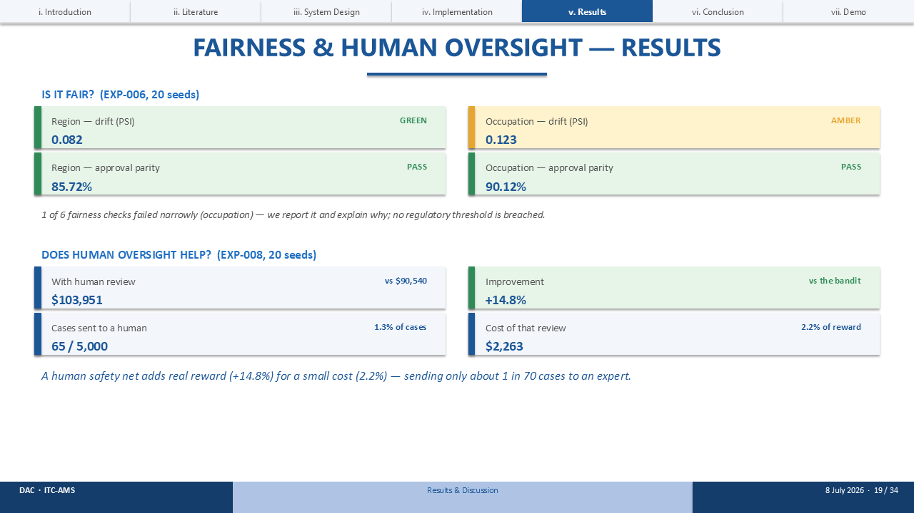
Two questions here: is it fair, and does human oversight actually help? On fairness — region drift is green at 0.082, occupation is amber at 0.123, and approval parity sits at 85.7 and 90.1 percent, both clearing the eighty-percent rule. One of six checks came in narrowly on occupation — I report that honestly, though no threshold was actually breached. And on oversight — adding a human reviewer lifts reward by fourteen point eight percent, for a cost of just 2.2 percent of cases, about one in seventy.

SLIDE 20 · FINDINGS & LIMITATIONS
Timing budget: 35 sec
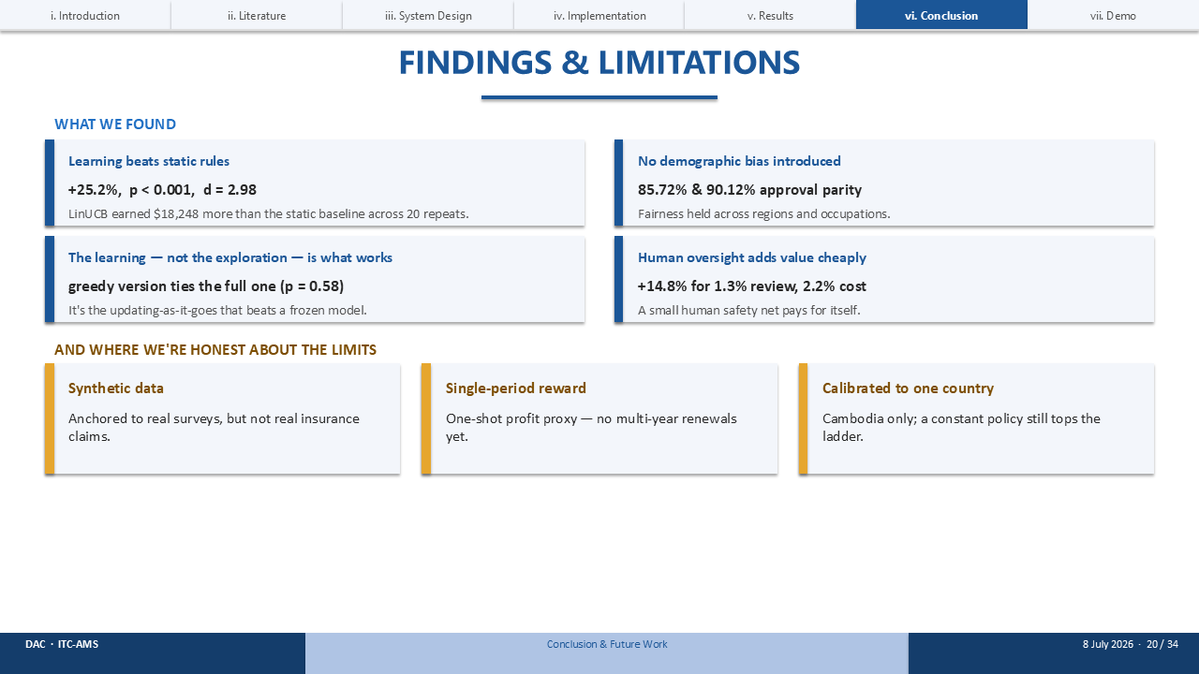
So, what does this actually add up to? Four findings. Learning beats static rules by twenty-five percent. It doesn't introduce new bias while doing it. It's the learning itself doing the work, not just lucky exploration — I checked. And human oversight adds real value, cheaply. Now, the honest limits, because there are some: this is synthetic data, a single-period reward, one country — and a constant policy still tops the full ladder.

SLIDE 21 · FUTURE WORK
Timing budget: 25 sec
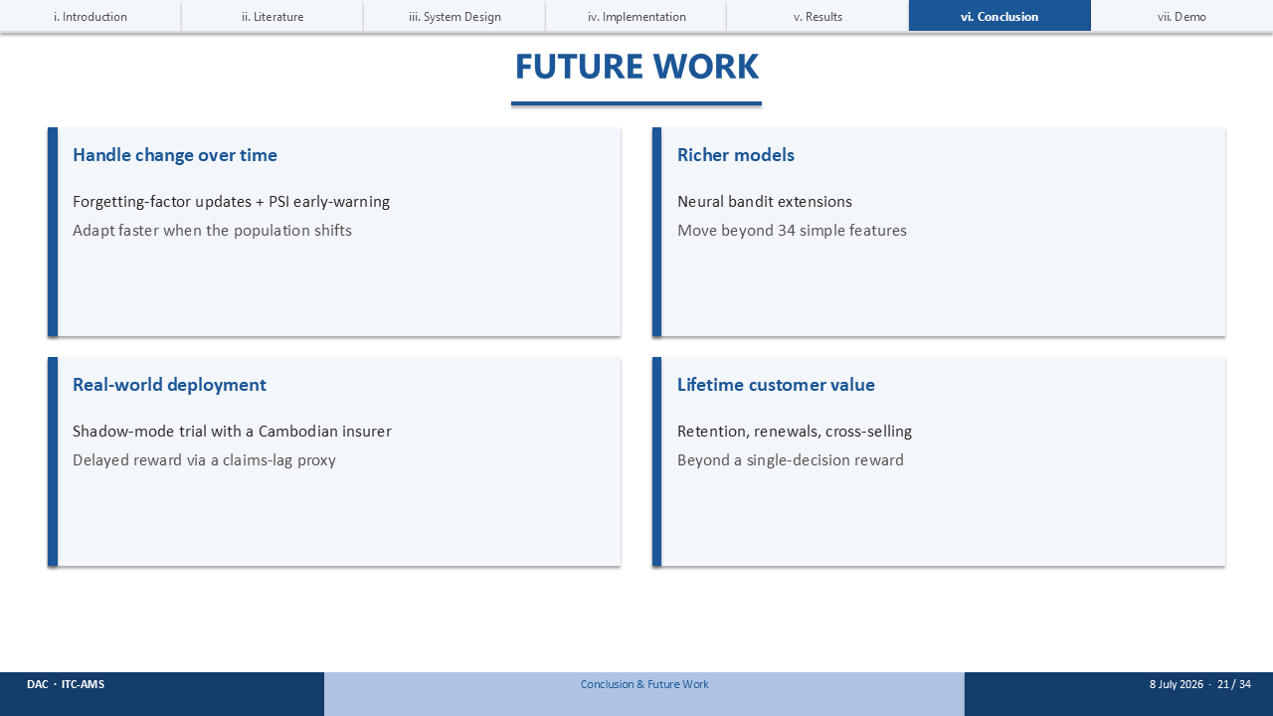
Looking ahead, four directions feel worth chasing: handling change over time, using forgetting alongside PSI as an early-warning system; richer neural models; an actual shadow-mode trial with a Cambodian insurer; and thinking about lifetime customer value, not just a single decision.

SLIDE 22 · THE TAKEAWAY
Timing budget: 20 sec
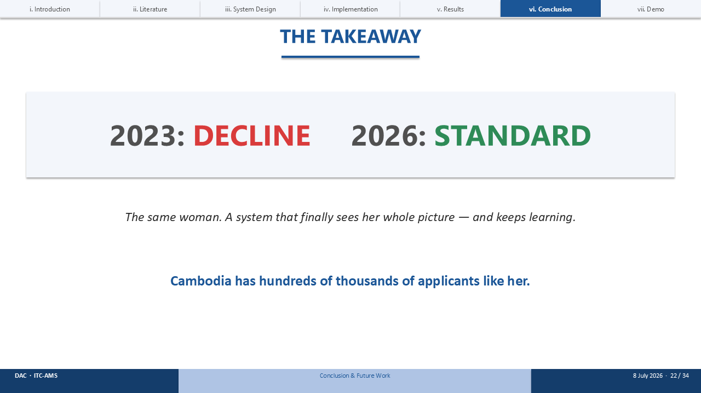
So, to close where I started. In 2023, the static system declined Sophea. Run the same profile through the learning system today, and it offers her Standard cover. Same woman — but finally, a system that sees her whole picture. And Cambodia has hundreds of thousands more like her.

SLIDE 23 · LIVE DEMONSTRATION
Timing budget: 75 sec
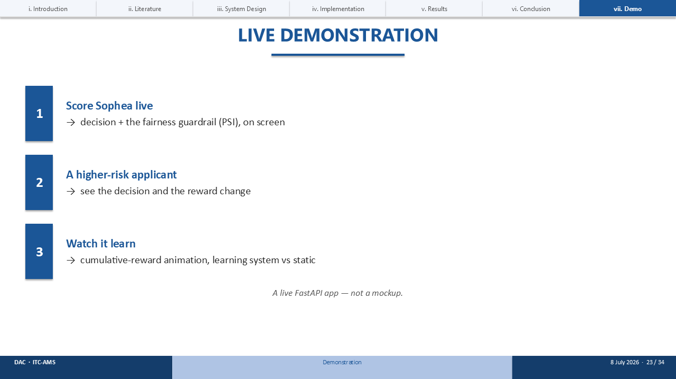
[Switch to the browser — a live FastAPI app, not a mockup.]
Let me show you this actually running. First, I'll score Sophea live, right here, with the fairness guardrail visible on screen. Then I'll run a higher-risk applicant through, so you can see the decision and the reward change. And finally, 'Watch it Learn' — a live animation of cumulative reward, watching the learning system pull ahead of the static rules in real time.

SLIDE 24 · IF LIVE DEMO FAILS — A SCORED APPLICANT
Timing budget: skip if live demo worked
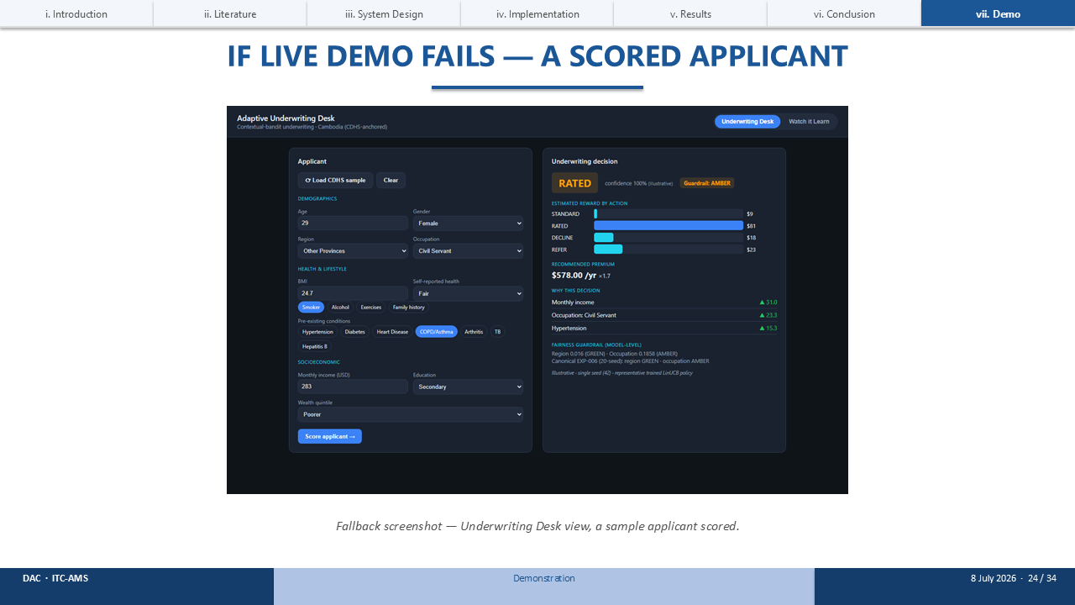
[Backup only.] If the live demo didn't cooperate — here's a captured screenshot from the Underwriting Desk, a sample applicant already scored, decision and fairness guardrail both visible.

SLIDE 25 · IF LIVE DEMO FAILS — WATCH IT LEARN
Timing budget: skip if live demo worked
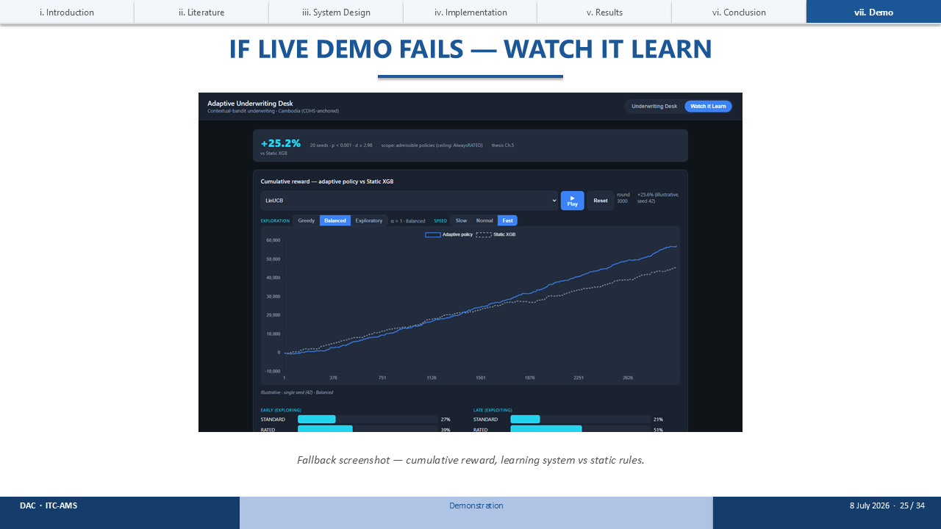
[Backup only.] And here's the cumulative-reward curve itself — learning system against static rules — exactly as the live animation would have rendered it.

SLIDE 26 · THANK YOU / Q&A
Timing budget: 15 sec
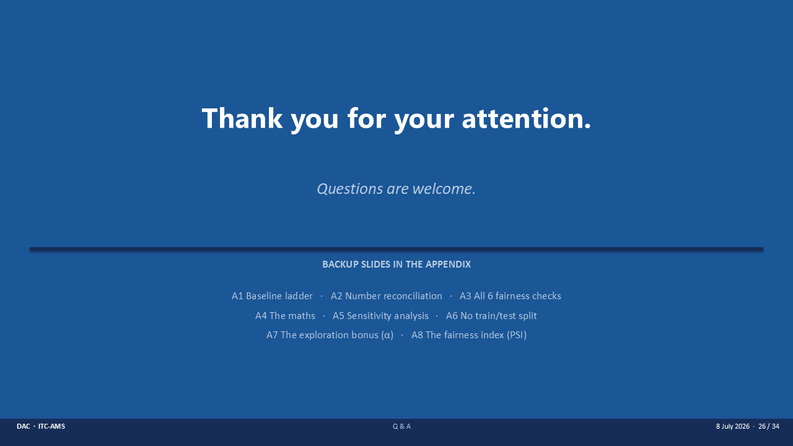
That's my thesis. Thank you for your attention — I'd welcome your questions. And if a question needs a specific number, I've got eight appendix slides standing by.

SLIDE 28 · APPENDIX A2: NUMBER RECONCILIATION
Timing budget: if asked (Q&A)
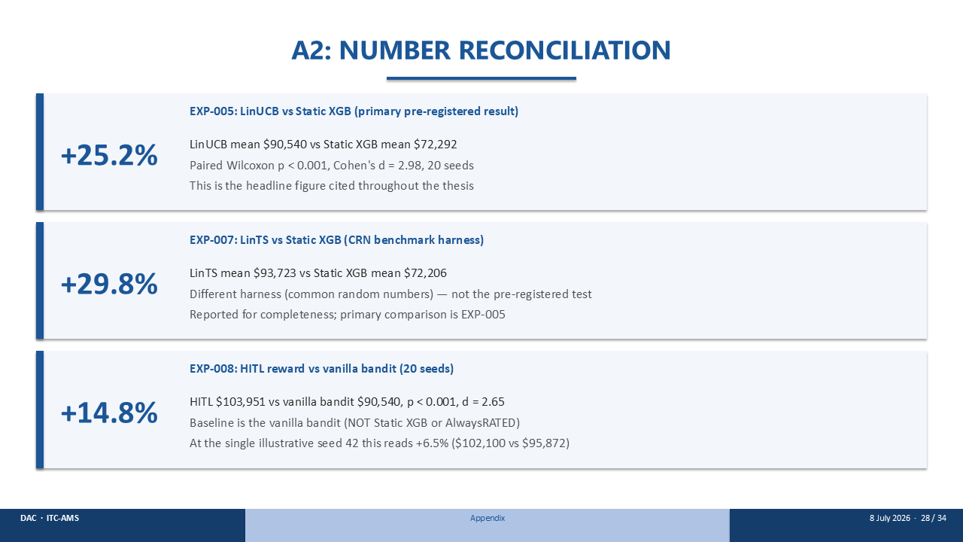
Let's untangle the three percentages you might have seen. Plus 25.2 percent is the headline — LinUCB against Static XGB, pre-registered before I ran it. Plus 29.8 percent is LinTS, measured on a different harness. And plus 14.8 percent is the human-in-the-loop gain over the vanilla bandit, across twenty seeds. If you only look at seed 42 alone, that same HITL comparison reads plus 6.5 percent — but that's one seed, not twenty, and the number I actually quote and stand behind is the twenty-seed 14.8 percent.

SLIDE 32 · APPENDIX A6: WHY A BANDIT HAS NO TRAIN/TEST SPLIT
Timing budget: if asked (Q&A)
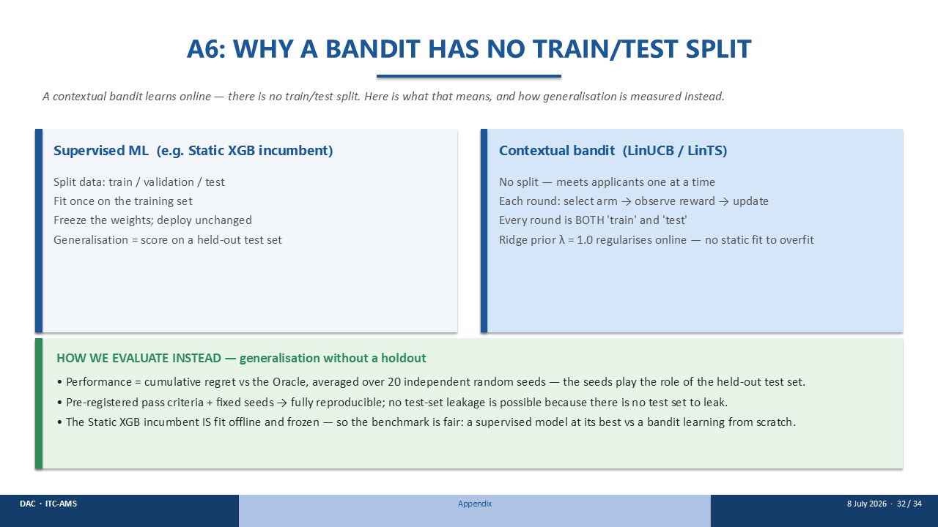
Good question, and it's a fair one. A supervised model splits its data, fits once, and freezes. A bandit doesn't work that way — it meets applicants one at a time, so every single round is both training and testing at once, regularised online by a ridge prior, which means there's no static fit sitting around to overfit. So instead, I measure generalisation as cumulative regret against the Oracle, averaged over twenty seeds. And the Static XGB baseline, by contrast, is fit offline and frozen — so the comparison between them is still fair.

