

Core Skills ICT

Observation Portfolio

Student Name:

Course:

Year: 2018/2019

|  |  |  |  |  |
| --- | --- | --- | --- | --- |
| Evidence No: | 1 |  | Task: | Logging On & Off Securely |

|  |  |
| --- | --- |
| **Task** | **Dates Observed \ Comments** |
| **One or more observations of each** | |
| **Logged on Securely** |  |
| **Logged off Securely** |  |
| **Locked Workstation** |  |

|  |  |  |  |  |
| --- | --- | --- | --- | --- |
| Evidence No: | 2 |  | Task: | Using File Manager |

Reason: This is my using one drive, the default storage system on the cloud, this shows I can store, retrieve, name and launch files on my own.

Screen Print:

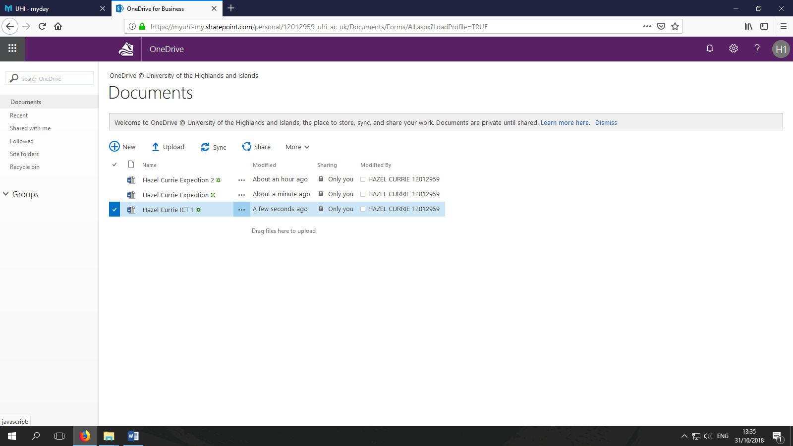

|  |  |  |  |  |
| --- | --- | --- | --- | --- |
| Evidence No: | 2 |  | Task: | Using Print Manager |

Reason: Print Manager allows me to select which printer is used by this computer. Printer properties allows me to change settings like, colour, orientation and size. Here I am printing a document.

Screen Print:

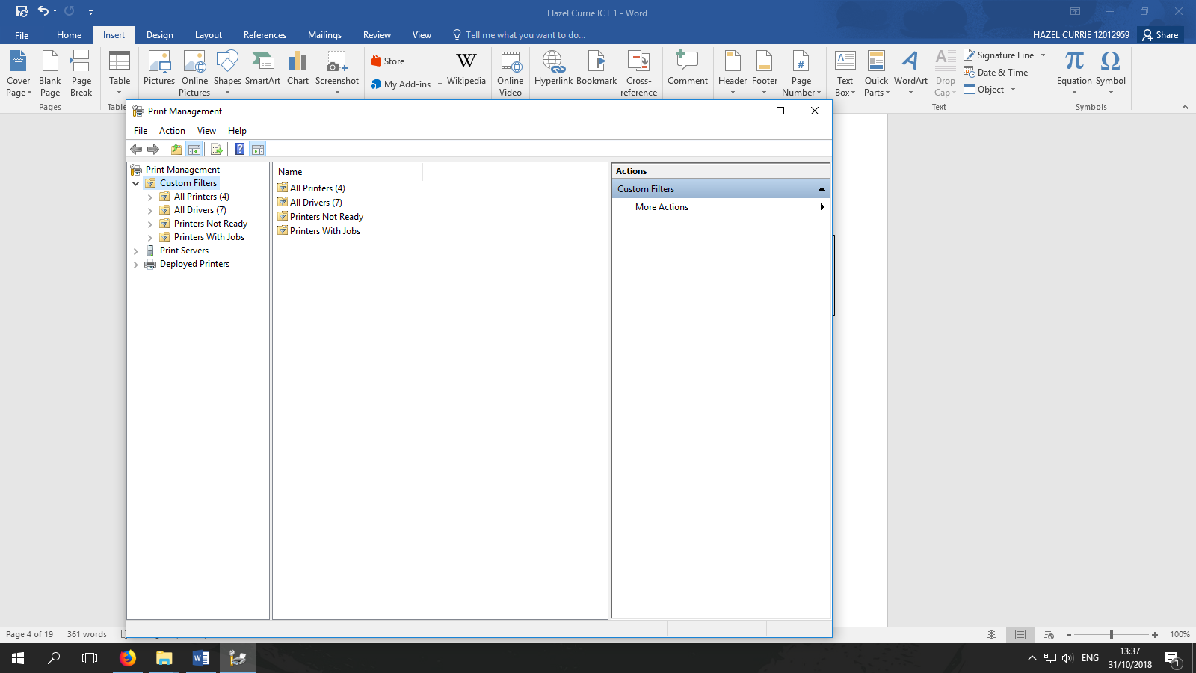

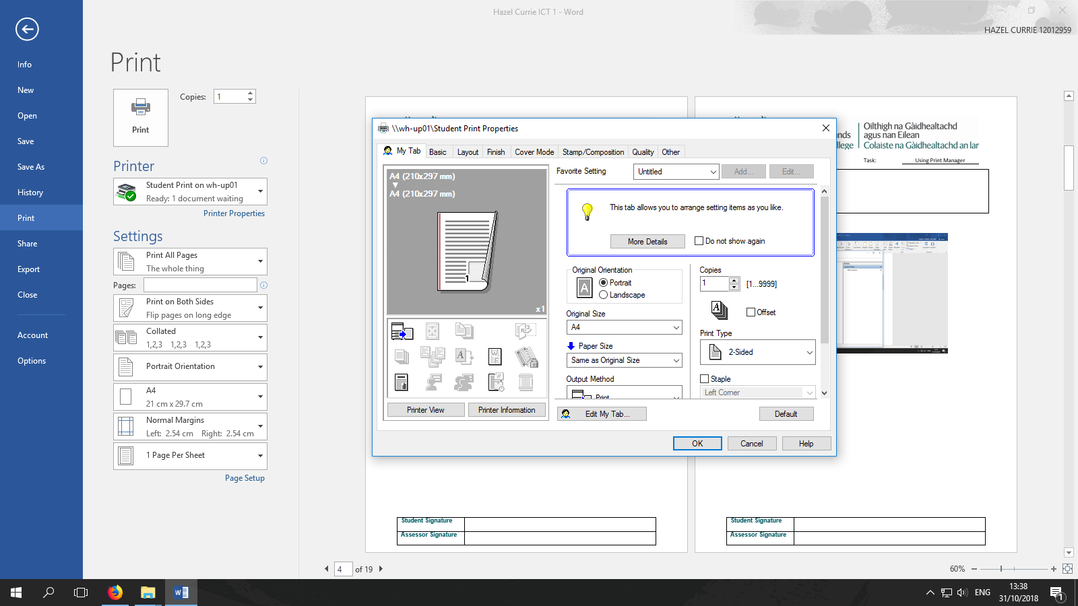

|  |  |  |  |  |
| --- | --- | --- | --- | --- |
| Evidence No: | 2 |  | Task: | Using Control Panel |

Reason: Control Panel allows me to change settings in windows. I can change settings like, time, language and theme. Settings can be changed for personal preference or accessibility. Here I am changing the colour and app mode of the theme.

Screen Print:

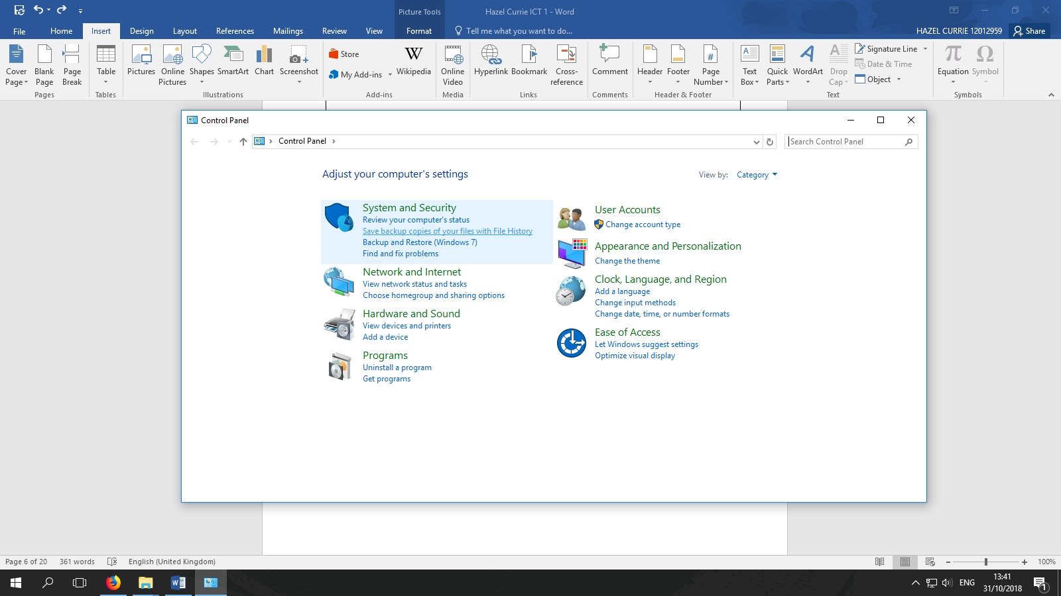

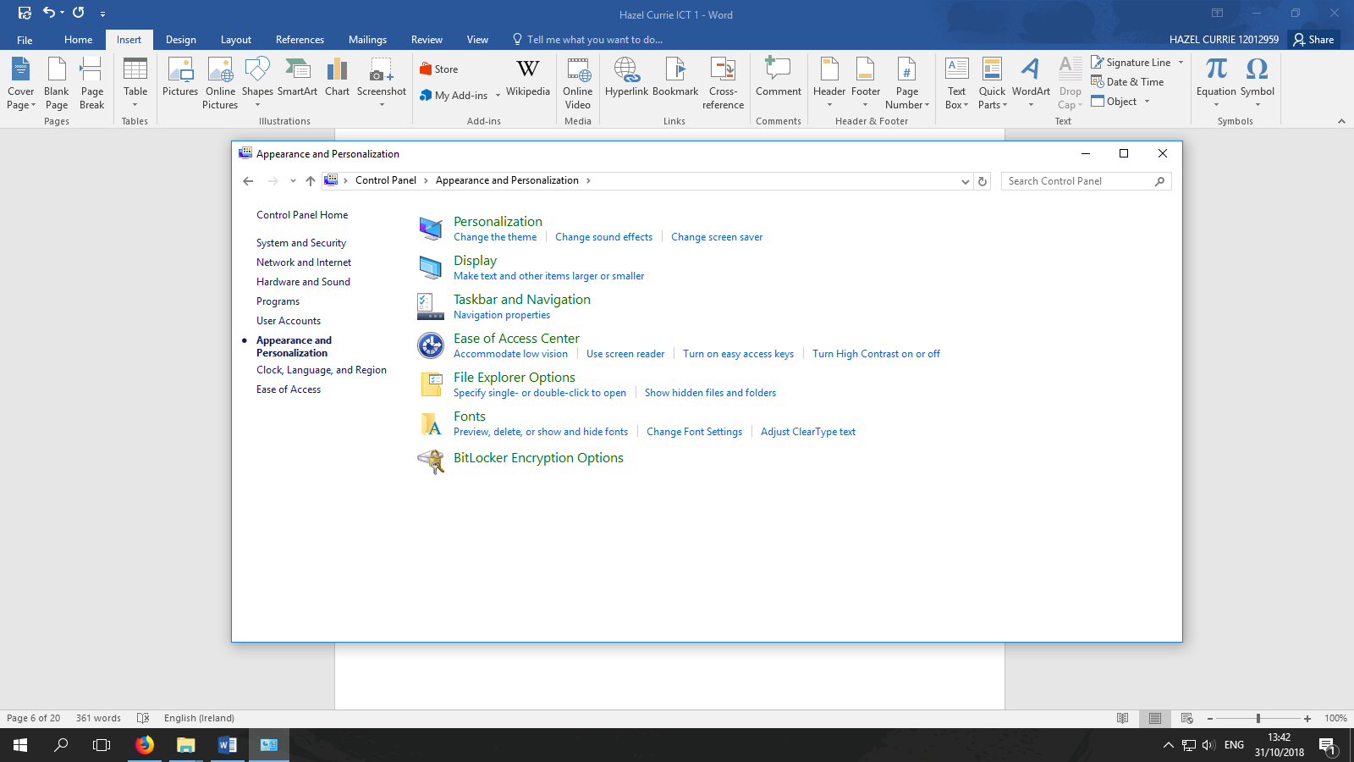

|  |  |  |  |  |
| --- | --- | --- | --- | --- |
| Evidence No: | 3 |  | Task: | Using Anti Virus Software  (Running a scan) |

Reason: This is Windows Defender, the default anti-virus program included with Windows 10. It is good practice to run a scan every time I download a new file. This will help us to avoid malware and viruses.

Screen Print:

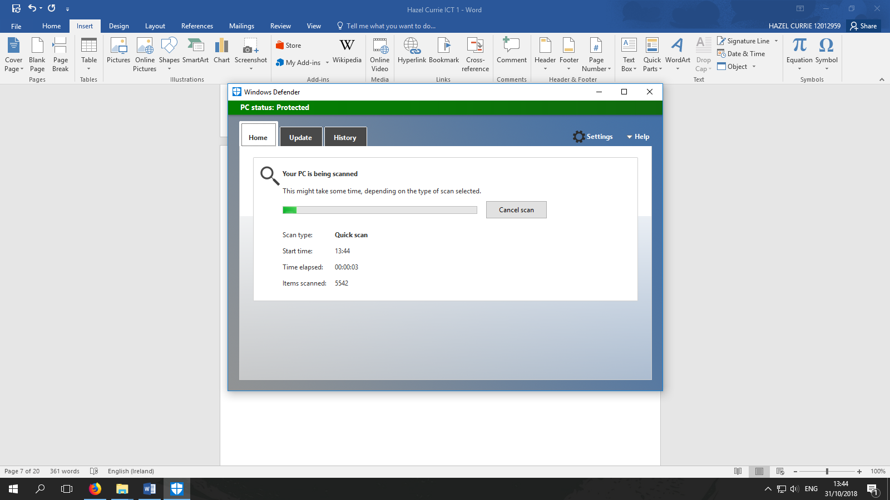

|  |  |  |  |  |
| --- | --- | --- | --- | --- |
| Evidence No: | 3 |  | Task: | Using Anti Virus Software  (Updating the Software) |

Reason: It is important to keep our antivirus software up to date as new threats and malware are produced and/or discovered every day.

Screen Print:

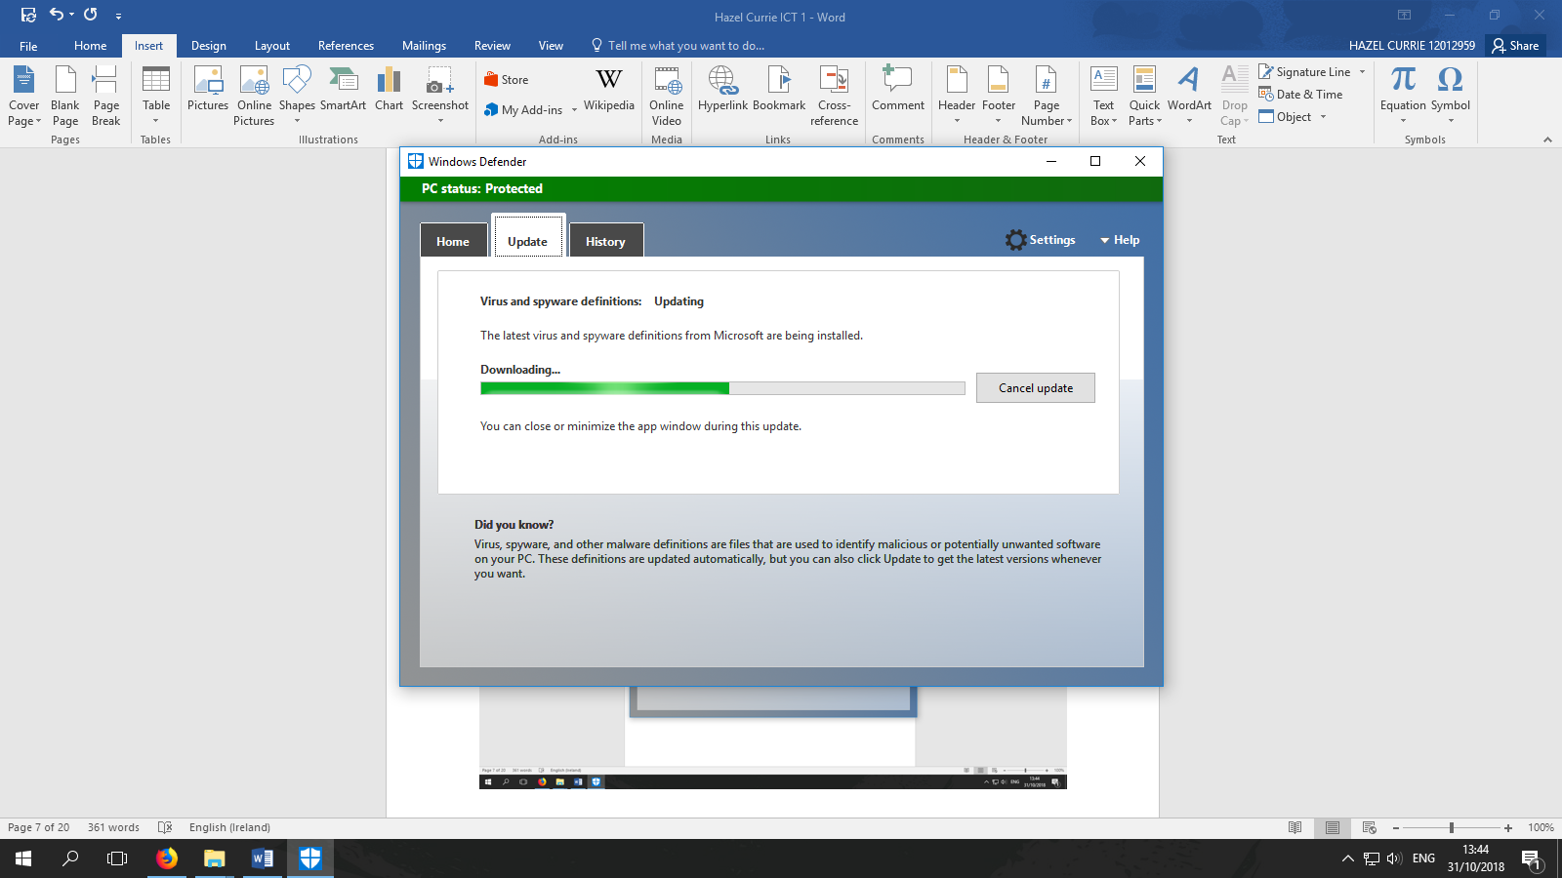

|  |  |  |  |  |
| --- | --- | --- | --- | --- |
| Evidence No: | 4 |  | Task: | Folder Management  Evidence 1 |

Reason: Here I am using File Explorer which is a folder management tool built into Windows 10. This shows that I can store, name and retrieve folders over time. 7/11/2018

Screen Print:

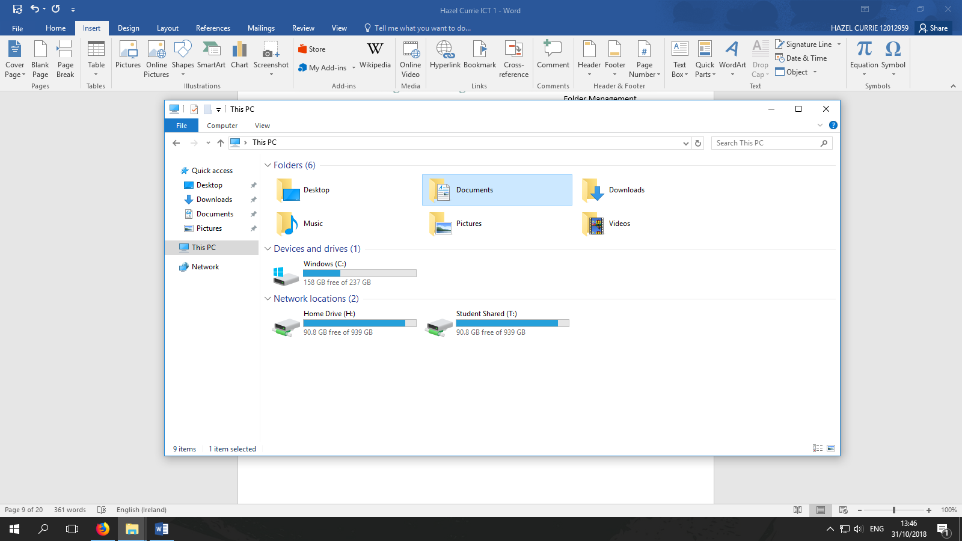

|  |  |  |  |  |
| --- | --- | --- | --- | --- |
| Evidence No: | 4 |  | Task: | Folder Management  Evidence 2 |

Reason: Here I am using File Explorer which is a folder management tool built into Windows 10. This shows that I can store, name and retrieve folders over time. 14/11/2018

Screen Print:

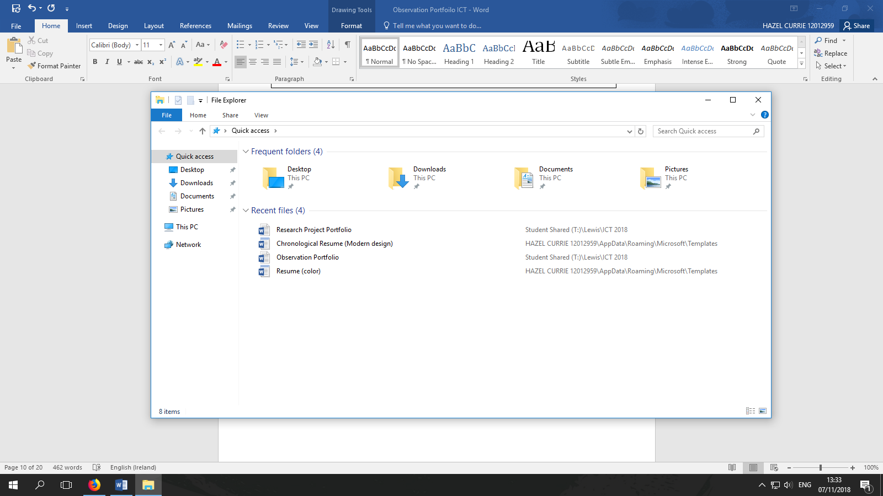

|  |  |  |  |  |
| --- | --- | --- | --- | --- |
| Evidence No: | 4 |  | Task: | Folder Management  Evidence 3 |

Reason: Here I am using File Explorer which is a folder management tool built into Windows 10. This shows that I can store, name and retrieve folders over time. 20/11/2018

Screen Print:

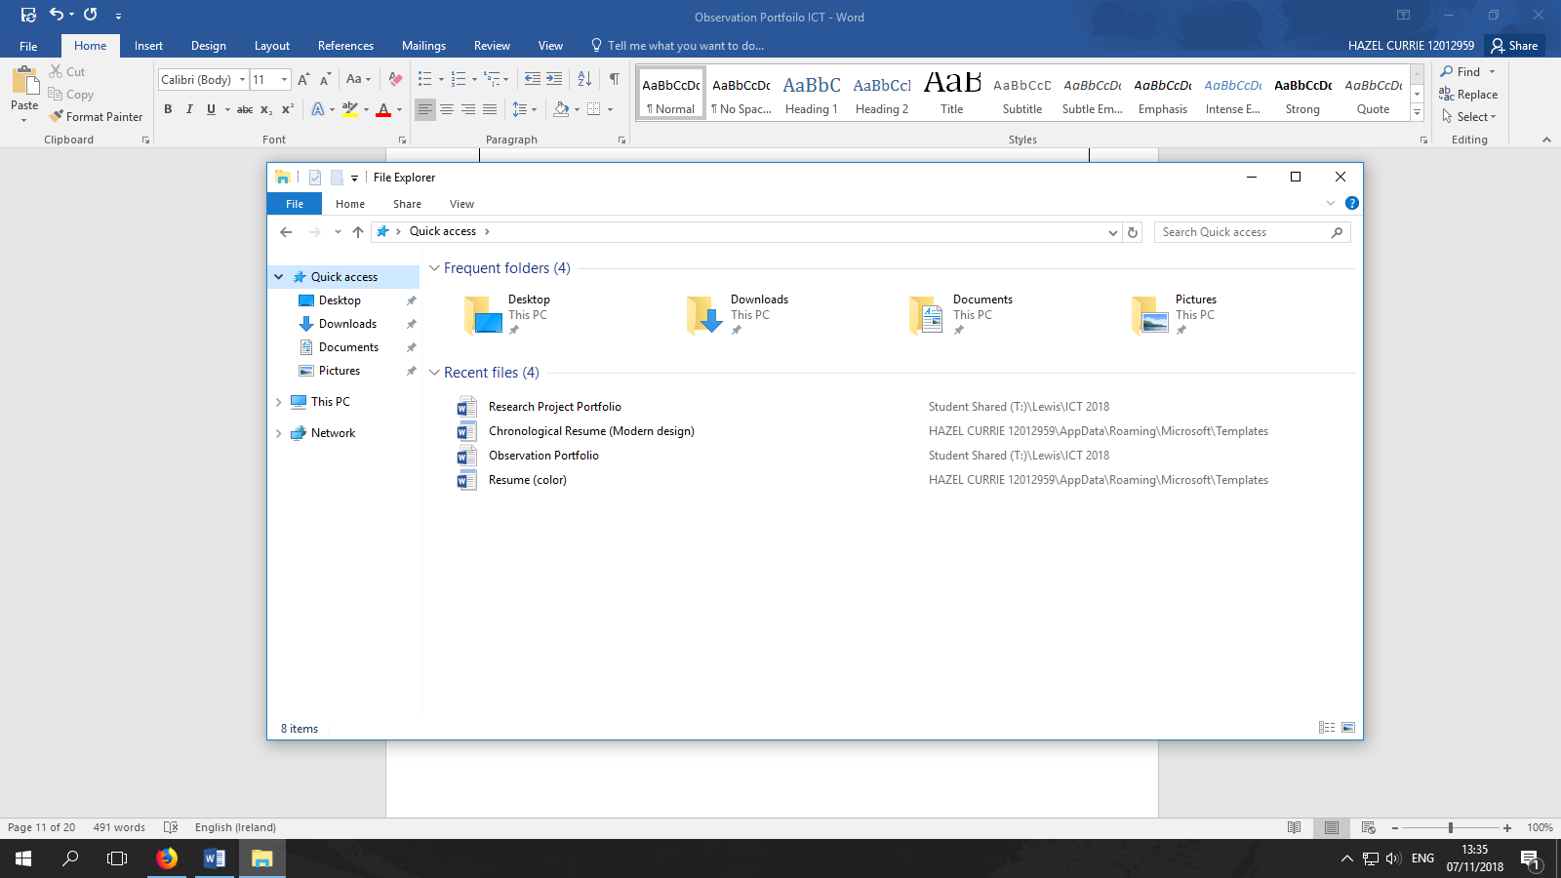

|  |  |  |  |  |
| --- | --- | --- | --- | --- |
| Evidence No: | 5 |  | Task: | Using Software  Evidence 1 |

Reason: Here I am editing a document in Microsoft word 2016, which is a paid part of the Microsoft Office Suite. Word is used to edit Letters and Documents.

Screen Print:

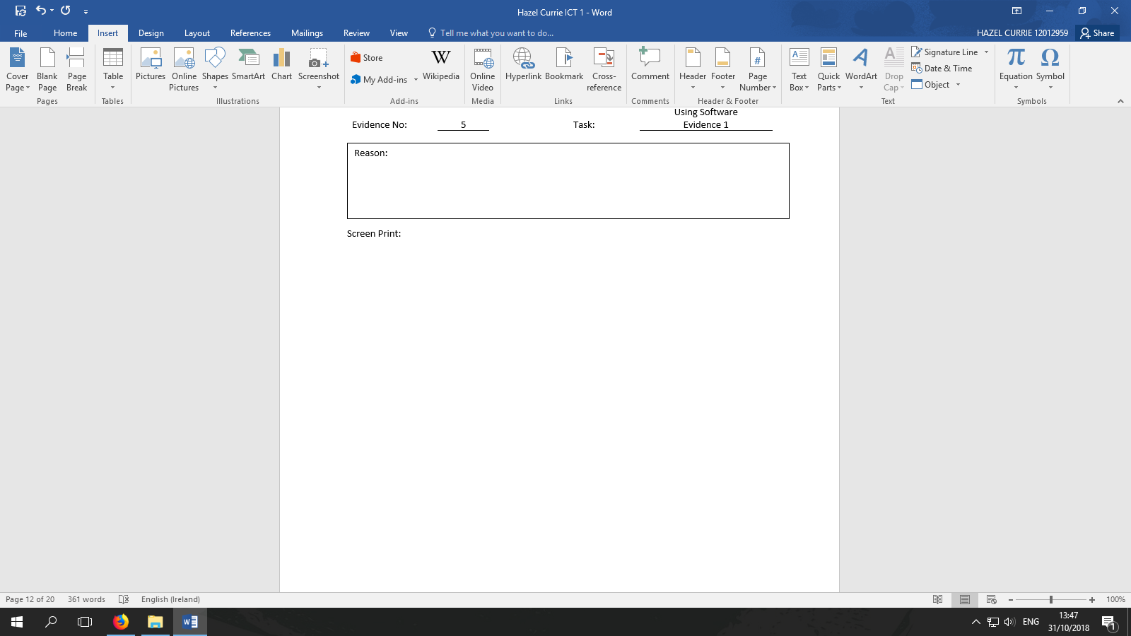

|  |  |  |  |  |
| --- | --- | --- | --- | --- |
| Evidence No: | 5 |  | Task: | Using Software  Evidence 2 |

Reason: Here I am editing a presentation in Microsoft PowerPoint 2016 which is a paid part of Microsoft Office Suite. PowerPoint is used for Presentations and Communicating Information.

Screen Print:

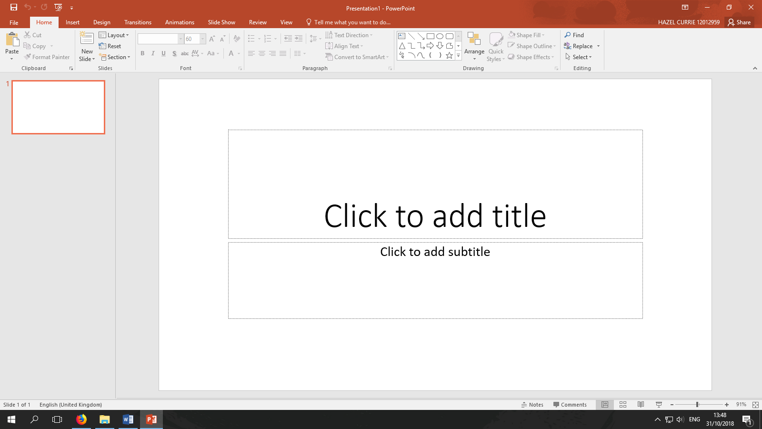

|  |  |  |  |  |
| --- | --- | --- | --- | --- |
| Evidence No: | 5 |  | Task: | Using Software  Evidence 3 |

Reason: Here I am selecting some cells in Microsoft Excel 2016, which is a paid part of Microsoft Office Suite. Excel is primarily used for working data and numbers.

Screen Print:

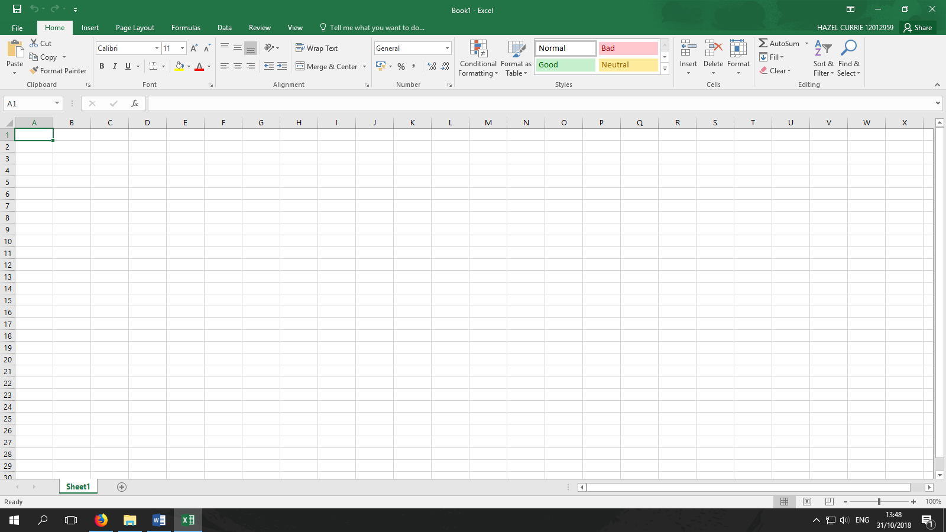

|  |  |  |  |  |
| --- | --- | --- | --- | --- |
| Evidence No: | 6 |  | Task: | Using Help Function  - Searching |

**Insert Table**

Problem Encountered:

Screen Print of **Help Search**:

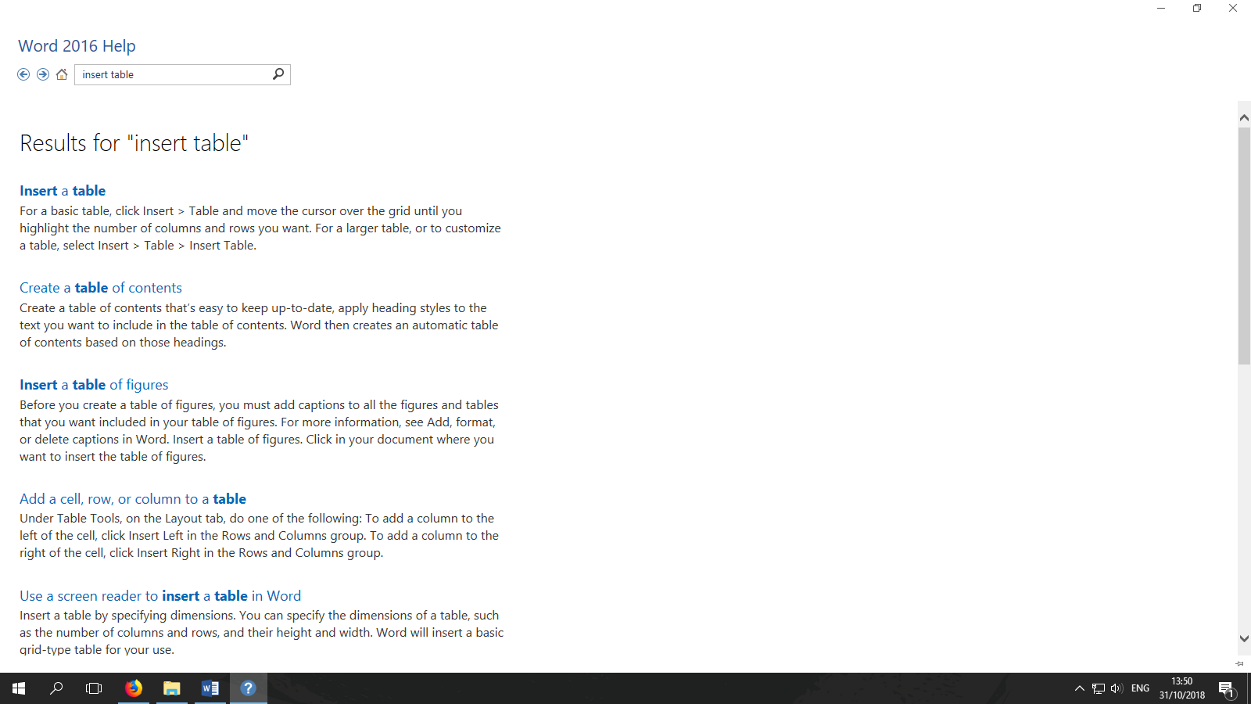

|  |  |  |  |  |
| --- | --- | --- | --- | --- |
| Evidence No: | 6 |  | Task: | Using Help Function  - Finding solution |

Screen Print **of Solution Found**:

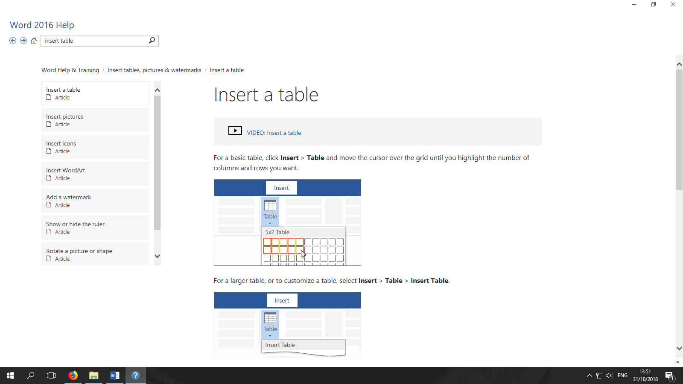

|  |  |  |  |  |
| --- | --- | --- | --- | --- |
| Evidence No: | 7 |  | Task: | Security Questions |

**All questions below to be answered as fully as possible:**

1. When purchasing items on the internet which of the following symbols would you look for to confirm the website is secure for processing payments:
2. **closed padlock**
3. key
4. padlock
5. gate
6. You have been asked by the office manager about the best way to choose a computer password. What would you advise?

Choose 3 random words, and then substitute some letters for numbers and symbols

Projector watch mouse

Pr0ect08 w4t3h M06SE

1. A person in the office has been surfing the web for information and has received a message asking them to download software from an unknown source. How would you best advise this person?

No, don’t open it, tell your colleagues and report it to IT.

1. Which of the following indicate a secure website:
2. http:
3. **https:**
4. www2:
5. www:

|  |  |  |  |  |
| --- | --- | --- | --- | --- |
| Evidence No: | 8 |  | Task: | Backing up  Evidence 1 |

Reason: When I send my tutor an email with my work, we both have access to a copy in the cloud. This means if I lose my password or break/damage the PC we can both still access my work.

Screen Print:

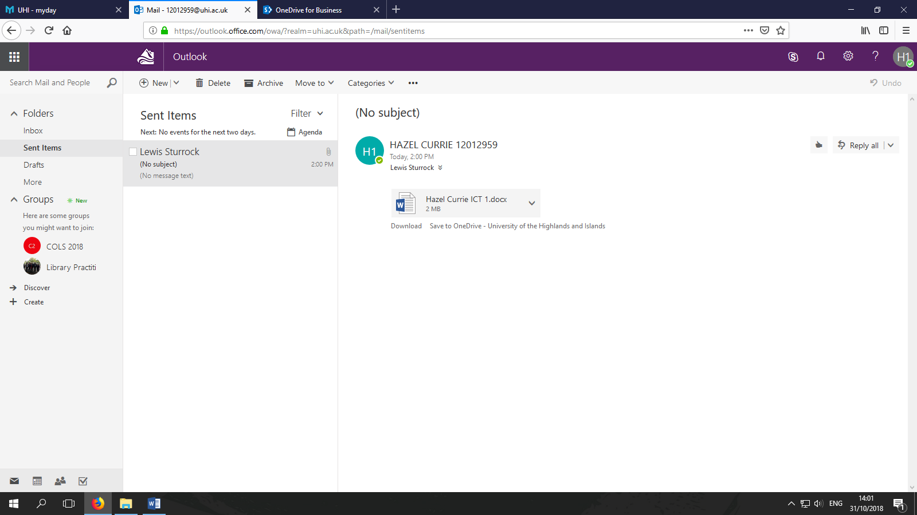

|  |  |  |  |  |
| --- | --- | --- | --- | --- |
| Evidence No: | 8 |  | Task: | Backing up  Evidence 2 |

Reason: When I save my work to OneDrive it means I can access it from any computer in the world allowing me to work across locations and ensuring that I don’t lose my files.

Screen Print:

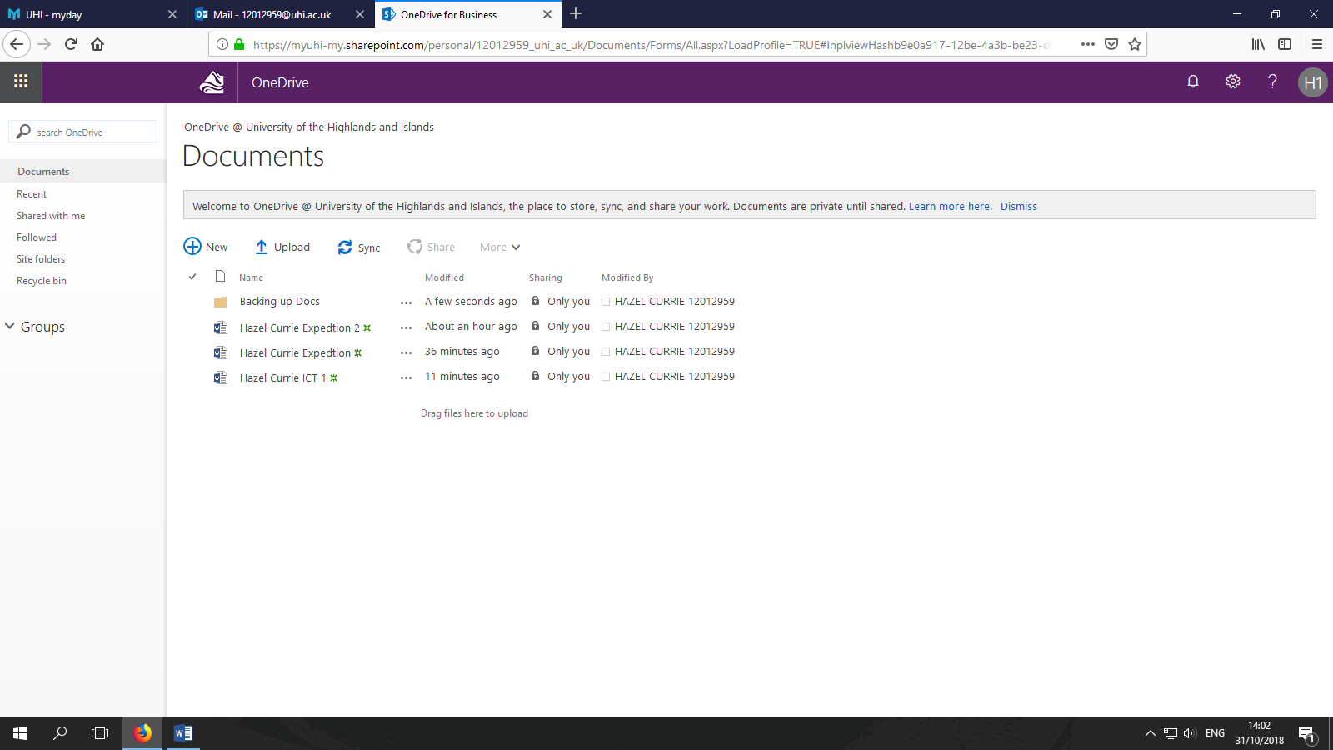

|  |  |  |  |  |
| --- | --- | --- | --- | --- |
| Evidence No: | 8 |  | Task: | Backing up  Evidence 3 |

Reason: When I make a duplicate version of my files, this greatly reduces the chances that my files will become corrupted- thus ensuring I have access to my work.

Screen Print:

