
▸ I N T E L L I G E N C E B R I E F · R E F P H P 2 S H E L L - 0 0 1 / V 1 · T L P : C L E A R
PHP2Shell:
The Blast Radius Assessment
Two engine-level flaws put every live PHP site one unauthenticated request from compromise. The NSA's October 21 advisory says patch now or pull the plug. This brief maps who is exposed, what a breach costs, and the seventy-two-hour path out.
┌─ PIPELINE ─────────────────────────────────────────────┐
│ NSA ADVISORY → EXPOSURE MAP → DAMAGES → DEFENSE ORDERS │
└────────────────────────────────────────────────────────┘
O C T O B E R 2 1 , 2 0 2 6 · R E S E A R C H W I N D O W O C T 2 0 – 2 1 2 0 2 6 U T C
A N A L Y S T O F R E C O R D : B A R R Y H U R D · B A R R Y H U R D I N T E L L I G E N C E L A B · B A R R Y H U R D . C O M
▸ E X E C U T I V E R E A D

The weapon, the targets, and the clock
A five-sentence government advisory, a twenty-four-million-site attack surface, and a patch that leaked before it shipped.
On October 21, 2026, the National Security Agency published a press release titled NSA Advisory: PHP Updates. It runs five sentences, names no CVE, and tells every organization running PHP to prepare for an update addressing “two critical vulnerabilities” that “often provide a direct path to the server's file system or database.” The technical substance arrived the same day from the PHP project, CISA, CERT-EU, and the UK NCSC: CVE-2026-109618 and CVE-2026-109619 — researchers call the pair PHP2Shell — are memory-safety failures in the PHP engine itself, CVSS v4.0 9.2, reachable by a single unauthenticated multipart POST before any application code runs. Every PHP release since 5.4 is affected. Exactly four builds are safe: 8.5.12, 8.4.27, 8.3.36, and 8.2.35.
Because the flaw sits in the interpreter, application quality is no defense — Wiz notes that “even a simple 'Hello World' application running on an affected PHP version can be vulnerable.” The blast radius is therefore the full installed base: BuiltWith counts 24,429,280 live PHP sites, 9,218,655 of them hosted in the United States. Inside that population sit 1,362 top-10k properties, 1,155 enterprises with $100M+ in sales, and 102 e-commerce platforms carrying 100k+ SKUs. Roughly a third of the population — about 8.5 million sites on PHP 7 or older — will never receive an upstream fix.
The disclosure itself was compromised: CVE identifiers leaked on October 20, a researcher's exploit video posted early, and pre-hardened container images let attackers diff the fix hours before release. Cloudflare reports attack traffic from 07:43 UTC — six hours before the coordinated release. CISA has confirmed no compromise and neither CVE sits on the KEV list yet, but public write-ups and exploit tooling are already circulating. Treat this as an n-day measured in hours: patch internet-facing systems first, isolate what cannot patch, and assume any host that was reachable and unpatched after October 20 may already be holding someone else's webshell.

“If an immediate update is not feasible, it is recommended that organizations take the system offline until it can be fully mitigated.”
N S A P R E S S R E L E A S E · O C T 2 1 2 0 2 6 D I R E C T I V E

24.4M  L I V E P H P S I T E S , G L O B A L | 9.2M  I N T H E U . S . — 3 7 . 7 % | $1.3B  1 0 % B R E A C H , $ 1 0 0 M + T I E R
▸ S E C T I O N 0 1 · T H E W E A P O N

Deconstructing the NSA advisory
What Fort Meade said, what it left out, and what the engineering record actually shows.

1.1 What the NSA actually said
The release is terse by design. Its three operative instructions: prepare to update; plan for the attacker reaching “the server's file system or database,” not just the web tier; and if updating is not feasible, take the system offline. NSA promised to “follow up shortly with more specific guidance” — as of this writing, no follow-up and no joint NSA/CISA/FBI Cybersecurity Advisory has appeared, and the release names no CVE, no version, and no threat actor.
CISA's same-day alert, Critical Vulnerabilities in PHP Require Immediate Patching, fills the operational gap with five directives: inventory all PHP, noting it is “often a component of other software”; apply the patch immediately, prioritizing internet-facing systems; take offline anything that cannot update or that runs PHP 8.1 or earlier; treat a WAF as partial interim protection only; and monitor for “PHP worker processes launching shells or downloading tools.” CERT-EU (advisory 2026-018) and the UK NCSC issued parallel guidance the same day.

1.2 Vulnerability mechanics
This is unauthenticated remote code execution, not privilege escalation and not a supply-chain implant — though it reaches most victims through the software supply chain, because PHP ships inside products that never advertise it. The two CVEs share a root pathology: PHP's handling of fatal errors mid-request leaves memory in states the engine later trusts.
CVE | ROOT CAUSE | CLASS | CVSS V4.0
CVE-2026-109618 | memory_limit is enforced with a longjmp() abort. An out-of-memory abort can interrupt a request mid-parse — a multipart upload, say — leaving data half-initialized; cleanup then frees attacker-influenced memory. | CWE-824 · unauth RCE | 9.2 Critical
CVE-2026-109619 | Engine state owned by one request survives its fatal error. The next request on the same worker consumes the freed state before re-initialization — a use-after-free. | CWE-824 · unauth RCE | 9.2 Critical

Five findings matter most for defenders:
▸ Pre-application execution. PHP confirms the risk is highest for Apache mod_php, “with a demonstrated exploit where an unauthenticated request can trigger the attack before any application code runs.” Every web-serving SAPI is in scope: PHP-FPM, mod_php, php-cgi, FrankenPHP, LiteSpeed.
▸ Application-agnostic impact. Wiz demonstrated pre-auth RCE on WordPress, Drupal, and Joomla; Calif extended it to Magento 2.4.9, MediaWiki, Roundcube, phpMyAdmin, Nextcloud, Laravel, Symfony, and WHMCS. Four exploitable bug instances group under the two CVEs.
▸ Credential leakage without RCE. A Heartbleed-style path returns freed worker memory inside a PHPSESSID cookie — passwords, session tokens, API keys, TLS private keys from other requests — even if the application never calls session_start().
▸ Read the 9.2 as a floor. Attack complexity is rated High — the only thing holding the score under 10. Wiz's central finding is that frontier AI collapsed that complexity: “a single researcher completed in a week what previously would have taken a world-class team months of work.”
▸ Scoring noise. Pre-release CVE copies circulated with a wrong 10.0 score, and 9.4 appeared in early press. The authoritative CNA score for both is 9.2.
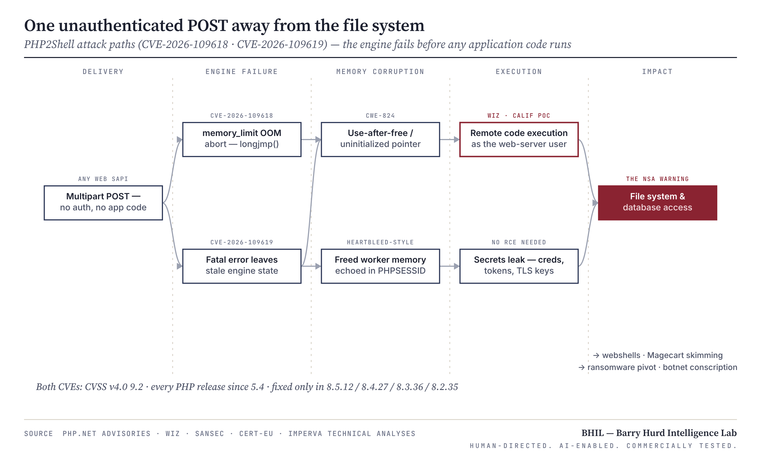
E X H I B I T 0 1 · P H P 2 S H E L L K I L L C H A I N — E N G I N E F A I L U R E T O I M P A C T

1.3 Exploitation status — contested telemetry
No reviewed reporting attributes PHP2Shell activity to a named APT or state actor, and the NSA release makes no exploitation claim. The telemetry is split, and moving:
SOURCE | CLAIM · OCT 21 (UTC) | BHIL READ
Cloudflare | “Observed attack traffic targeting our customers” from 07:43; WAF rules live since 03:02. | Pre-release attack traffic — the strongest early signal.
Hadrian | Exploitation “at scale,” mostly via the session upload-progress path (11:35). | Vendor telemetry; unverified.
watchTowr | “Active exploitation attempts” against both CVEs (14:19). | The post-release scanning wave.
Patchstack | Probing only — “no hard evidence of breaches yet.” | The counterweight to “at scale.”
Huntress | Nothing observed on partner systems as of 4:30 pm ET. | SMB fleets quiet at day's close.
CISA | “Has not observed exploitation of these vulnerabilities as of the time of publication.” | No federal confirmation.
PHP security team | “Did not identify any functional exploits at the time of release.” | Official stance at release.
CISA KEV | Neither CVE listed (catalog 2026.10.21). | A confirmation lag — not evidence of safety.

Assessment. This is a leaked-before-patch vulnerability that became an n-day within hours, not a classic zero-day exploited before discovery. Coordination failed twice — the CVE IDs leaked October 20 around 15:00 UTC, then an exploit demo video posted in error and pre-release patched container images gave attackers a diffable fix six hours early. Sansec had predicted mass attacks within fifteen minutes of the patch. Plan for opportunistic mass exploitation first — webshells, cryptominers, botnet loaders — with targeted ransomware and data-theft operators following.
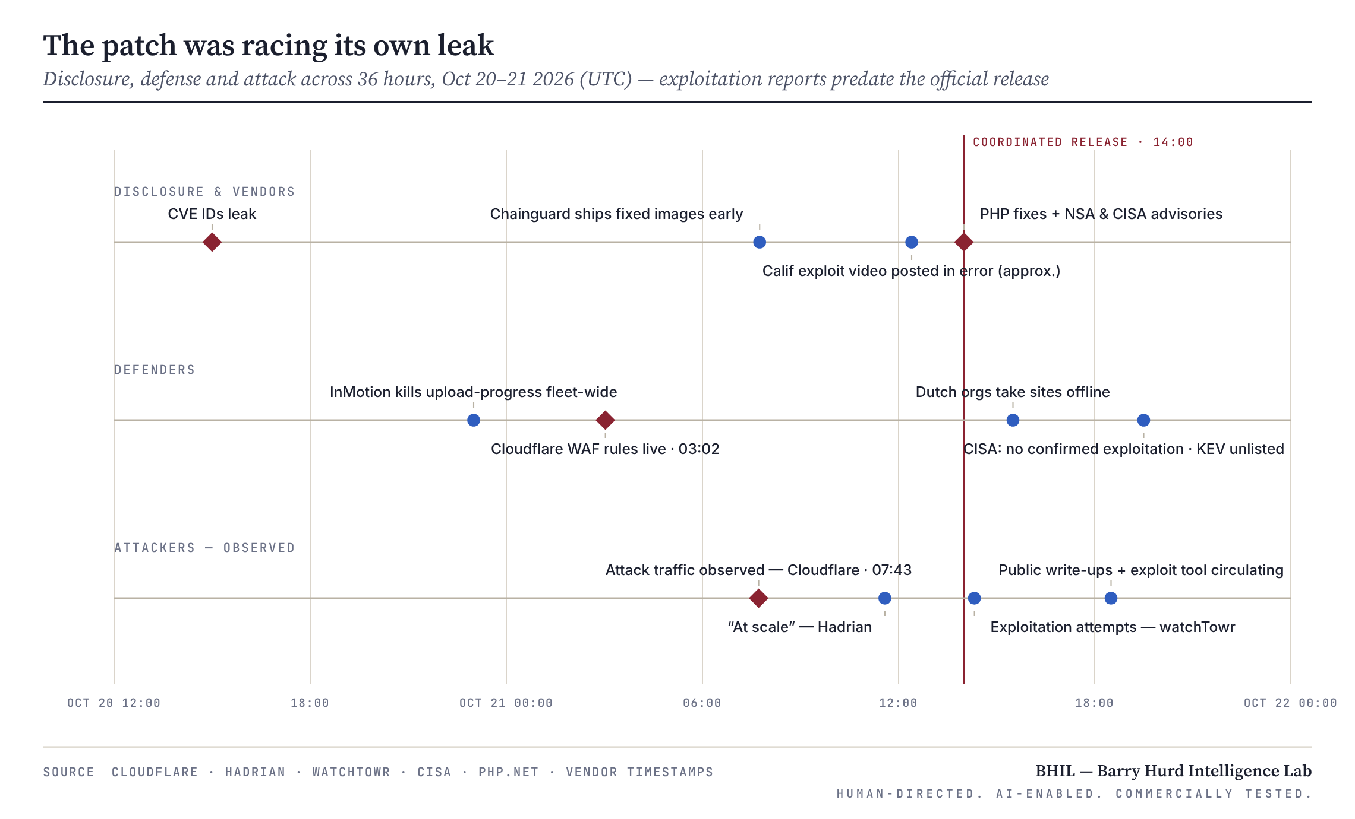
E X H I B I T 0 2 · T H E 3 6 - H O U R D I S C L O S U R E R A C E , O C T 2 0 – 2 1 2 0 2 6 ( U T C )

1.4 Affected and fixed versions
Wiz: “every PHP version released in the last decade is affected by at least one of these vulnerabilities, going back to version 5.4.” Distributions and LTS vendors received patches in advance, so package numbering may differ from upstream — verify against vendor advisories, not version strings. One release-day gap: the Remi repository, widely used on RHEL-family servers, had no packages at launch.
BRANCH | SUPPORT STATUS | FIXED BUILD | ORDER
8.5 | Active support | 8.5.12 | Upgrade now.
8.4 | Active support | 8.4.27 | Upgrade now.
8.3 | Security-only | 8.3.36 | Upgrade now.
8.2 | Security-only · EOL Dec 31, 2026 | 8.2.35 | Upgrade now; plan the exit to 8.4/8.5.
8.1 · 8.0 · 7.4 | End of life | Source-only backports | Rebuild from backport or take an LTS/distro build; migrate.
7.3 and older · 5.x | End of life | None — ever | Isolate or take offline; migrate.

▸ S E C T I O N 0 2 · T H E T A R G E T - R I C H E N V I R O N M E N T

Quantifying the threat landscape
BuiltWith's census turns a technical advisory into a map of who, exactly, is standing in the open.
Four risk profiles emerge from the data. High-visibility properties — BuiltWith's PHP lists include cnbc.com, t-mobile.com, nist.gov, un.org, zoom.us, delta.com, morganstanley.com, samsclub.com, staples.com, and siemens.com, often via subdomains or inner pages rather than core transactional systems, which still hands attackers reach and a perimeter foothold. Revenue-bearing enterprises, whose PHP estate sits beside customer data, payment flows, and internal networks — the ransomware and extortion target set. Transactional commerce platforms — Magento/Adobe Commerce, WooCommerce, Shopware are all PHP; Sansec stresses these stores “are exposed even when their own code is clean.” And the long tail: millions of agency-built, hobbyist, and abandoned sites whose patching depends entirely on hosting providers.
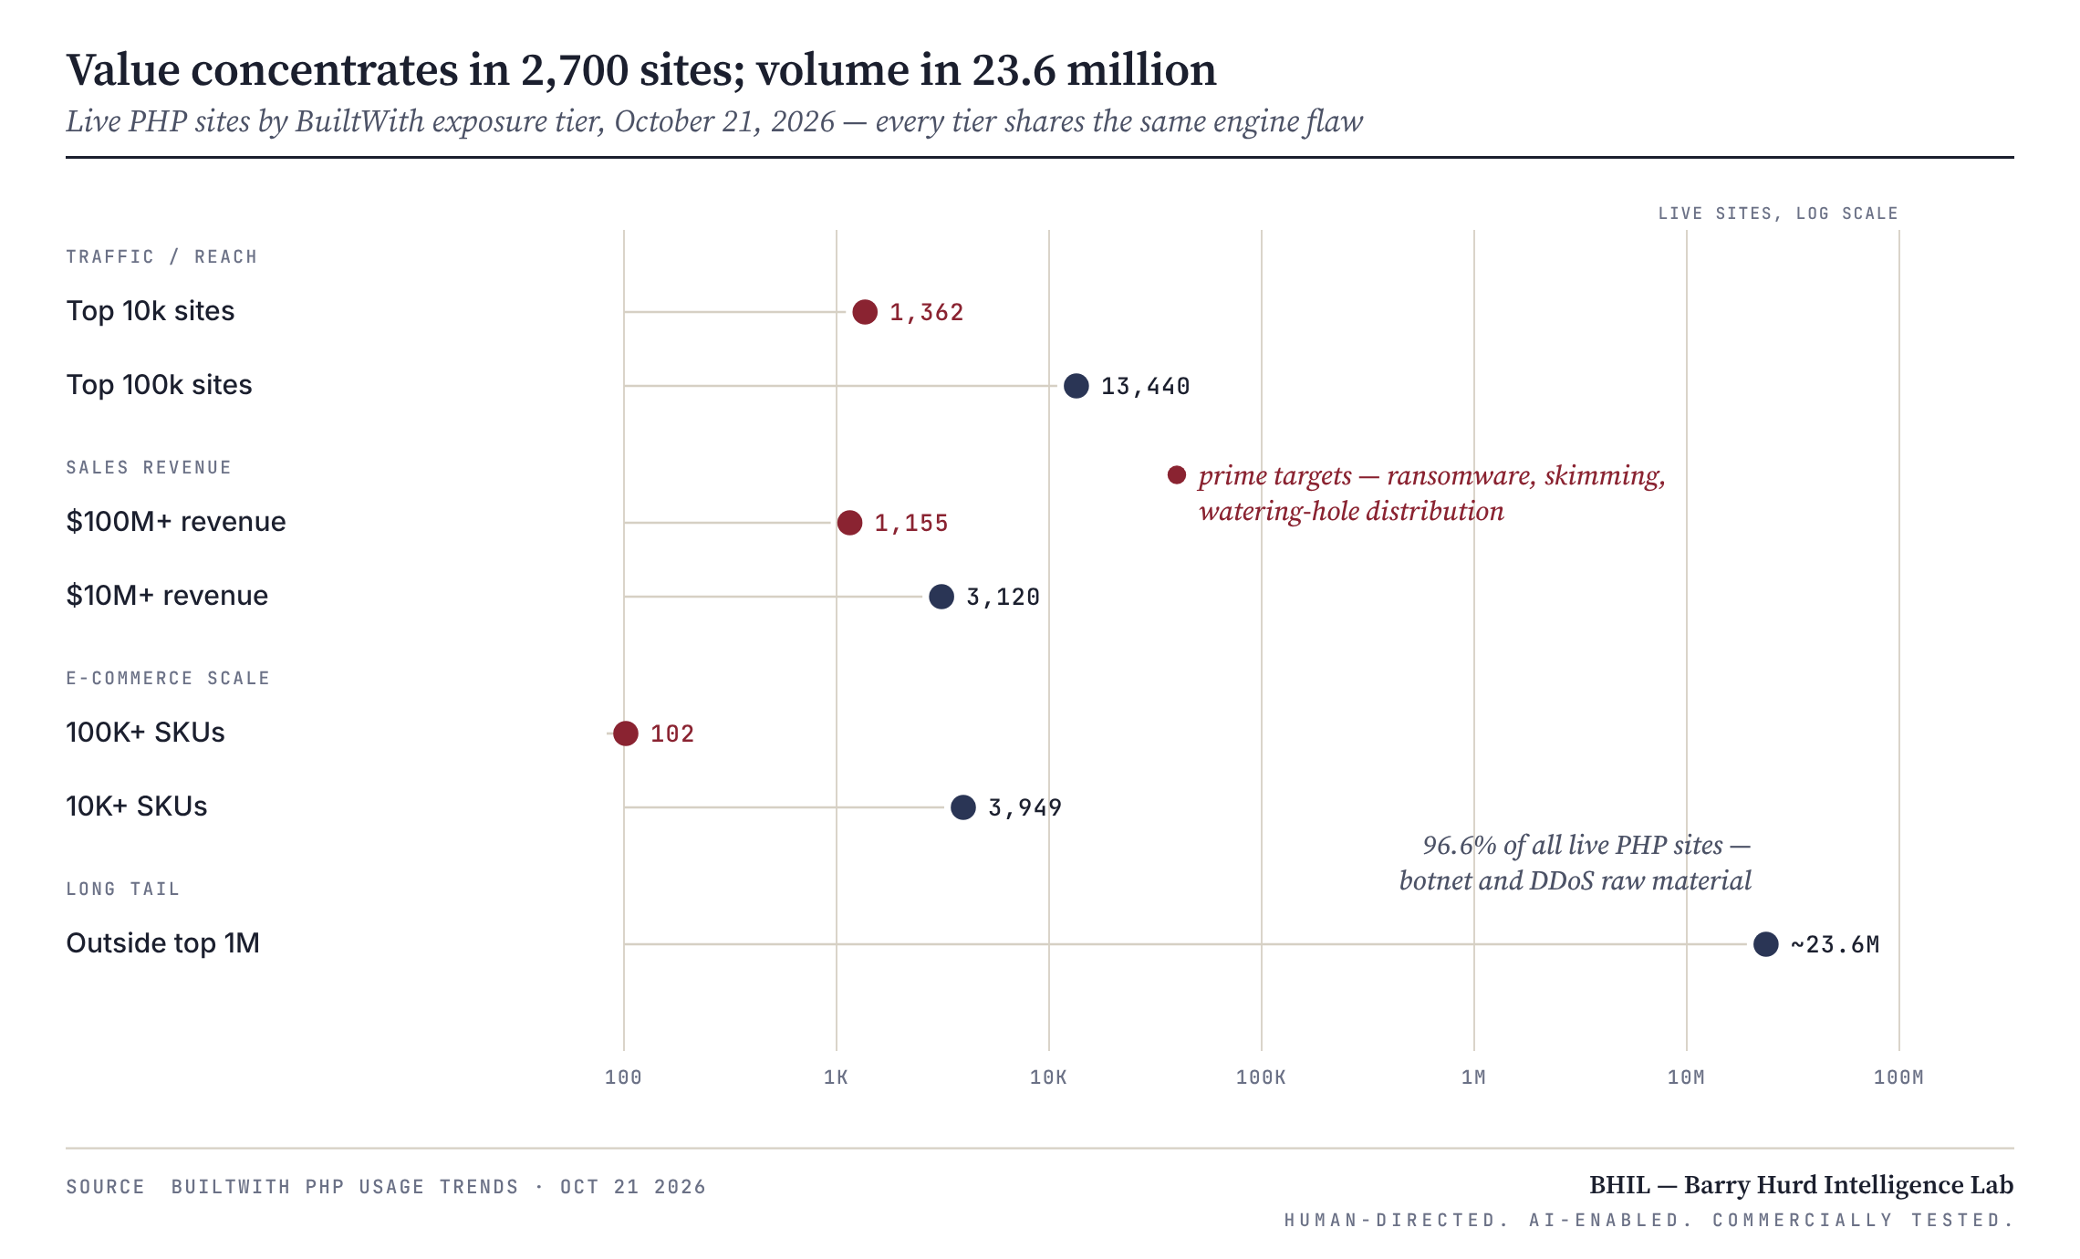
E X H I B I T 0 3 · T H E E X P O S U R E P A R A D O X — V A L U E V S . V O L U M E , L O G S C A L E

2.1 The exposure matrix
EXPOSURE CATEGORY | RISK TIER | VOLUME OF SITES | PRIMARY RISK PROFILE / MOTIVATION FOR ATTACKERS
Traffic / Reach | Top 10k | 1,362 | High-profile defacement, massive malware distribution (watering hole attacks).
 | Top 100k | 13,440 | Significant brand damage, high-value data exfiltration.
Sales Revenue | $100m+ | 1,155 | Prime targets for targeted ransomware, corporate espionage, and massive financial extortion.
 | $10m+ | 3,120 | Highly lucrative targets for financial data theft and ransomware.
E-Commerce (SKUs) | 100k+ SKUs | 102 | Massive enterprise e-commerce platforms; extreme risk of credit card skimming (Magecart) and customer data breaches.
 | 10k+ SKUs | 3,949 | Large retail operations; high risk of business disruption and inventory manipulation.
Long-Tail / Zombie | Outside Top 1m | ~23.6 Million | Creation of massive botnets, DDoS staging grounds, and crypto-mining infrastructure (often unmaintained “abandonware” sites).

Reading the matrix:
▸ The high-value tiers are numerically tiny. Top 10k, $100M+, and 100k-SKU together total fewer than 2,700 sites — about 0.01% of the population — yet carry most of the per-incident economic loss.
▸ The long tail carries the systemic risk. At ~96.6% of live sites by count, it is where botnet capacity and DDoS staging come from.
▸ The top-tier count is a floor, not a ceiling. BuiltWith fingerprints the primary property; W3Techs finds PHP on 59.7% of top-10k sites with a known server-side language. True exposure among top sites likely runs several times the 1,362 shown.
▸ Tiers overlap. A $100M retailer can also be a 10k-SKU store — these are views of one population, never additive counts.
T I E R I · C O N C E N T R A T E D V A L U E — F E W E R T H A N 2 , 7 0 0 S I T E S
Hours decide outcomes here.
Top-10k properties, $100M+ enterprises, and 100k-SKU storefronts. Targeted ransomware, Magecart skimming, corporate espionage. Patch inside the first 24 hours or stand down the system — the arithmetic in Section 03 favors the maintenance window every time.

T I E R I I · R E V E N U E M I D - M A R K E T — R O U G H L Y 1 7 , 0 0 0 S I T E S
Patch latency is the dominant risk.
The $10M+ and 10k-SKU tiers: lucrative, thinner security teams, heavier reliance on agencies and managed hosts. The exposure is the same engine flaw — the variable is how many days their vendors take.

T I E R I I I · S Y S T E M I C V O L U M E — ~ 2 3 . 6 M I L L I O N S I T E S
Nobody patches what nobody owns.
The long tail outside the top million, heavy with end-of-life PHP. Compromise even 1% and attackers gain ~236,000 servers with real bandwidth and clean IP reputations — botnet capacity rarely available from a single vulnerability.

2.2 The unpatchable third
W3Techs' version census (October 21) puts 65.2% of PHP sites on PHP 8, 27.0% on PHP 7, and 7.8% on PHP 5 or 4. Applied to BuiltWith's live count, roughly 8.5 million sites run versions with no upstream fix — and host telemetry agrees: Mallory counted 883,717 internet-facing hosts (59% of ~1.5M disclosing a version) still advertising PHP 8.1 or older on October 20. An unquantified further share of the PHP 8 population sits on EOL 8.0 and 8.1.
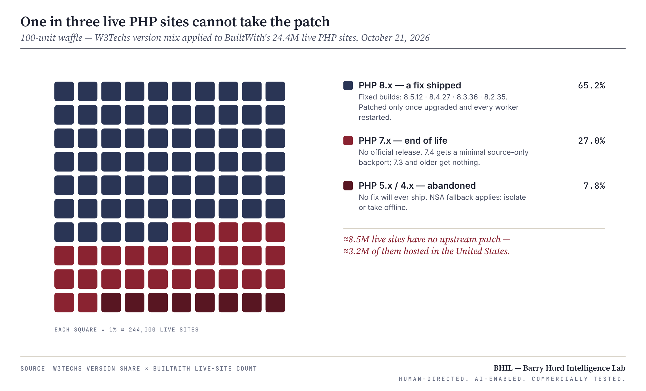
E X H I B I T 0 4 · V E R S I O N M I X A N D T H E N O - F I X P O P U L A T I O N
▸ S E C T I O N 0 3 · T H E P O T E N T I A L D A M A G E S

Economic and strategic impact
What an engine-level RCE does to a commerce backend, priced against the benchmarks boards already trust.

3.1 The enterprise e-commerce threat
Code execution as the web-server user on a PHP commerce backend yields five things: the application configuration — database credentials and payment-gateway keys, NSA's “direct path” made literal; the ability to modify checkout templates and JavaScript, the precondition for Magecart skimming; bulk extraction of customer and order data; a pivot point for ransomware deployment; and, via the memory-disclosure path, session tokens and secrets even where RCE fails.
The benchmarks: IBM's 2026 report puts the average U.S. breach at $11.5M (global $4.99M). Coveware's Q2 2026 average ransomware payment is $1,880,612 against a $150,000 median; Sophos puts average recovery at $1.7M excluding ransom. ITIC's 2024 survey found 41% of firms price an hour of downtime at $1M–$5M+. And the Magecart precedent: British Airways drew a proposed £183.39M GDPR fine — £20M final — for a skimming breach affecting roughly 429,612 people, from a redirect that ran eleven days. The 102 mega-catalog storefronts face exactly that asymmetry, on Magento-class stacks where emergency upgrades carry real breakage risk.
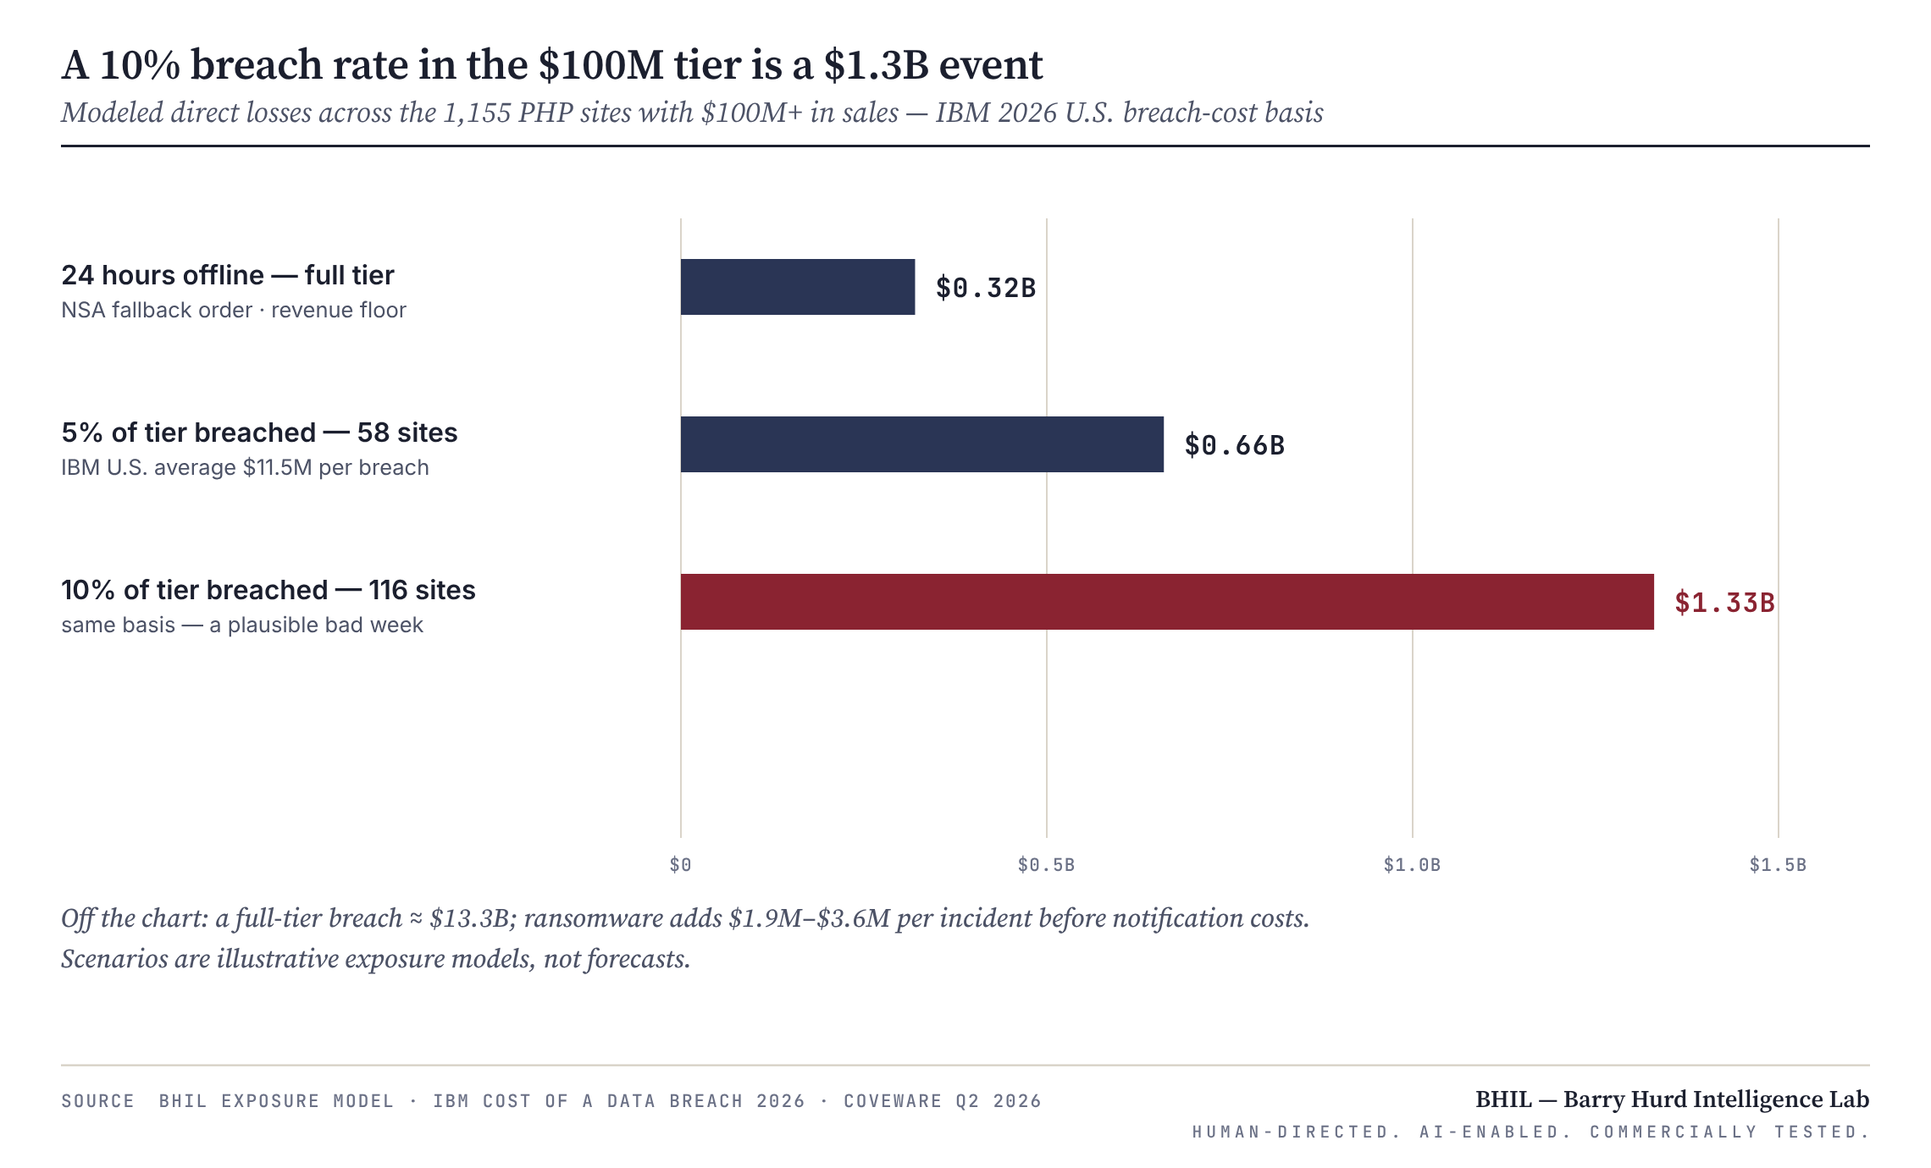
E X H I B I T 0 5 · M O D E L E D L O S S S C E N A R I O S — T H E $ 1 0 0 M + T I E R
The board math. The downtime bar is the number executives should stare at: NSA's fallback for unpatchable systems is going offline, so delay converts directly into lost revenue — and the revenue-floor figure is the minimum; ITIC's cross-industry rates run two orders of magnitude higher. The expected cost of a two-to-four-hour controlled maintenance window is trivial next to a single breach. Authorize the emergency change window today. For the 3,120-site $10M+ tier the same logic applies with one twist: patch latency, not exploit difficulty, is the dominant risk factor.

3.2 The “zombie PHP” problem
The ~79 million expired PHP sites are not live attack surface — a site that no longer resolves cannot be exploited. They matter as evidence: deployment without decommissioning is the same organizational behavior that produced today's unpatched estate, and expired domains with dangling DNS, forgotten staging subdomains, and never-deprovisioned hosting accounts resurface on their own schedule.
The ~23.6 million live long-tail sites are the real systemic risk. A third or more can only be protected by migration or isolation — abandonware owners will do neither. Patching is outsourced to hosts, and host behavior split on day one: InMotion disabled the vulnerable session setting fleet-wide overnight; the Remi repository had no release-day packages. Exploitation is cheap at scale because one toolchain works across WordPress, Joomla, Drupal, and custom code alike.
The precedent. CVE-2024-4577, the previous PHP-CGI RCE: TellYouThePass ransomware weaponized it within about two days of the June 2024 patch; in January 2025 — seven months later — GreyNoise still logged 1,089 unique IPs attempting exploitation, with 79 public exploits circulating, and Cisco Talos documented a fresh campaign against Japanese organizations into February 2025. Expect PHP2Shell-derived infections to persist for years.

3.3 The U.S. domestic risk
Roughly two in five of the world's live PHP sites are U.S.-hosted — 9.2M of 24.4M, far more than any other country — which concentrates three things domestically. Attack surface: ~3.2M U.S. sites sit on no-fix versions. Cost: IBM's U.S. average breach runs 2.3× the global figure, driven by regulatory, litigation, and notification costs. And public-sector exposure: BuiltWith's U.S. list includes nist.gov and un.org, while CISA warns that “PHP is often a component of other software and prevalence may not be directly observable” — federal, state, and local inventories are almost certainly incomplete.
The policy gap. No KEV listing means no binding federal remediation deadline, though PHP2Shell meets every practical criterion. Allied responses went further on day one — Dutch organizations including the House of Representatives, NCSC-NL, and Tweakers took sites offline as a precaution. The push: KEV listing the moment exploitation is confirmed, and directive-level action for federal PHP estates.
▸ S E C T I O N 0 4 · D E F E N S E O R D E R S

Remediation roadmap
Three phases, seventy-two hours, and a standing assumption of breach for anything that waited.
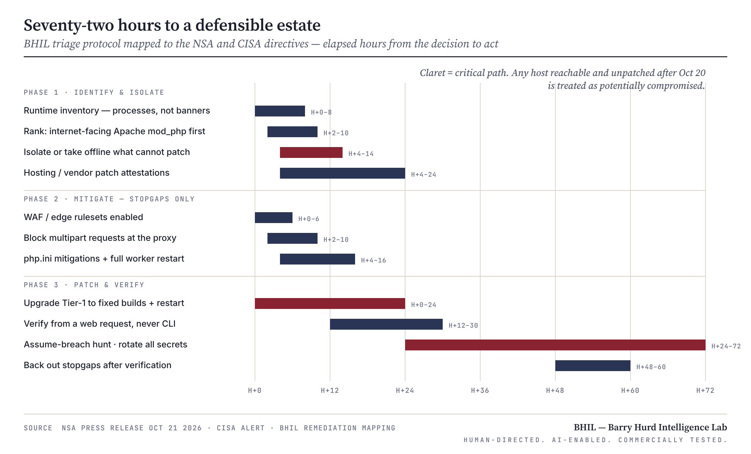
E X H I B I T 0 6 · T H E 7 2 - H O U R T R I A G E P R O T O C O L

4.1 Phase 1 — Identify & isolate (H+0–12)
▸ Inventory from runtime evidence, not banners. Check loaded binaries in running processes across web servers, containers, CI runners, control panels (cPanel, Plesk), vendor appliances, and Windows software bundling php-cgi.exe. Use NCSC-NL's php2shell repository to spot products that embed PHP.
▸ Rank by exposure × value. Internet-facing Apache mod_php first — the confirmed pre-application path — then checkout, payment, and authentication systems, then regulated-data systems, then the rest.
▸ Cover third parties. Written patch attestations from hosts, agencies, SaaS vendors, and appliance suppliers. CERT-EU: products using PHP as a backend may be affected “even if they do not directly expose a PHP installation.”
▸ Isolate what cannot patch today. Network ACLs, VPN-only access, or a static page with PHP-FPM stopped. Application-level maintenance modes do not help — PHP parses the request before the application checks the flag.
▸ Preserve evidence on suspect hosts first. Restarting workers wipes the in-memory state CVE-2026-109619 abuses.

4.2 Phase 2 — Mitigate (stopgaps only)
▸ Edge rules. Enable vendor PHP2Shell rulesets — Cloudflare protected WAF customers by default from 03:02 UTC; Fastly, Akamai, Imperva, and the clouds shipped equivalents. Cloudflare's own CTO calls the rules “a STOPGAP only.”
▸ Block the trigger class. Every known trigger is a multipart/form-data request. Rejecting multipart at nginx/Apache — or allowing only GET/HEAD on read-only storefronts — closes known paths. It breaks uploads; test it.
▸ Apply the php.ini set together, then restart every worker. session.upload_progress.enabled=0; memory_limit=-1 via php_admin_value, paired with container/cgroup caps and never RLIMIT; a low post_max_size; on 8.5, fatal_error_backtraces=0. Set at pool level, not ini_set().
▸ Know the limit. PHP: these measures “do not make an installation safe.” Core developer Gina Peter Banyard: “the only mitigation is patching / upgrading PHP.” Mitigations buy hours, not weeks.
▸ Detect. Alert on php-fpm/httpd spawning shells or downloaders; multipart bursts followed by memory-limit errors or 500s; oversized PHPSESSID cookies; unexplained worker churn; new .php files in web roots; new cron jobs, users, or SSH keys.

4.3 Phase 3 — Patch & verify (H+0–72)
▸ Upgrade, then restart everything. Fixed builds or vendor backports — a patched binary on disk does not protect a running worker.
▸ Verify from a web-served request, never CLI. Pool and CLI configurations differ; confirm version and effective ini values, then close the loop with authenticated scans (Tenable, Qualys, Rapid7 checks shipped day one).
▸ Assume breach for the exposure window. Any host reachable and unpatched after October 20: hunt webshells and persistence; rotate database credentials, API keys, session secrets, and TLS keys — the leak path harvests them without RCE; run client-side integrity scans on checkout pages.
▸ Back out the stopgaps once patched and verified — multipart blocks and memory_limit=-1 are not permanent architecture.

4.4 The legacy-code challenge
For business-critical applications on PHP 5.x or 7.x there is no upstream fix, and a rushed version jump can break revenue. In order of preference:
▸ Contain first, migrate second. Never leave legacy PHP directly internet-exposed: reverse proxy or WAF stripping multipart, strict request limits, VPN where the business allows, and segmentation so a compromise cannot reach core databases or the domain. This is what “fully mitigated” realistically means for unpatchable code.
▸ Buy time with supported backports. PHP's source-only backports (7.4/8.0/8.1) or commercial LTS builds — a bridge with a hard expiry, not a destination. PHP 8.2 itself dies December 31, 2026.
▸ Run a time-boxed compatibility sprint. Static analysis plus AI-assisted refactoring to 8.4/8.5 — the same acceleration that weaponized PHP2Shell cuts migration effort. Test against production-like traffic before cutover.
▸ Strangler-fig the remainder. New endpoints on a supported runtime, traffic progressively routed off the legacy core, then decommission.
▸ Make it a governance decision. Every legacy system that stays online unpatched gets a recorded risk acceptance — owner, compensating controls, review date — with the Section 03 arithmetic beside it. Funded migration beats carrying a pre-auth RCE.

4.5 Action register
PRIORITY | ACTION | OWNER | TIMEFRAME
P0 | Upgrade internet-facing PHP to 8.5.12 / 8.4.27 / 8.3.36 / 8.2.35; restart every worker. | Platform engineering | H+0–24
P0 | Isolate or take offline every system that cannot patch — NSA directive. | Network operations | H+4–14
P1 | WAF rules, multipart blocking, php.ini stopgaps on everything awaiting patch. | Security operations | H+0–16
P1 | Written patch attestations from every host, agency, and vendor shipping PHP. | Third-party risk | H+4–24
P2 | Assume-breach hunt and full secret rotation for hosts exposed after Oct 20. | IR / SOC | H+24–72
P2 | Legacy migration program with recorded risk acceptances for every stay-behind. | CISO + board | Q4 2026
P3 | Fund upstream PHP security capacity — the Foundation calls the stall a “structural failure.” | CISO | FY 2027

Strategic note. The PHP Foundation acknowledges these fixes stalled for months and that PHP security “still depends on a small group of foundation-funded developers.” Organizations whose revenue rides on PHP should treat funding that capacity as risk reduction, not charity.
▸ A N A L Y T I C C A V E A T S

Where this assessment is soft
▸ The NSA release is thin. No CVEs, versions, or indicators; the technical record here comes from PHP, CISA, CERT-EU, NCSC, and vendor research. The promised follow-up may change recommended controls.
▸ Exploitation telemetry conflicts. Cloudflare, watchTowr, and Hadrian report attacks; CISA, PHP, Huntress, and BSI report no confirmed compromise as of October 21. All of it is unverified vendor telemetry in motion.
▸ The economic model is illustrative. Breach-rate scenarios are assumptions, not forecasts; IBM figures average across breach types; Coveware's average is skewed by outliers ($1.88M mean vs. $150K median); downtime uses revenue floors.
▸ Sources measure different things. BuiltWith counts fingerprinted sites; W3Techs measures share among sites with a detectable language; Shodan-style counts (1.3–1.9M) measure hosts. Applying W3Techs ratios to BuiltWith counts is an approximation, and tiers overlap — never sum them.
▸ Some circulating numbers are wrong. “70% of the internet” is W3Techs' share of sites with a known server-side language (69.3%); pre-release claims of CVSS 10.0 and “all versions since 2004” were incorrect.

▸ C O L O P H O N
I N S T R U M E N T S — C L A U D E A D V A N C E D R E S E A R C H · B H I L V I S U A L C A T A L O G · B U I L T W I T H · W 3 T E C H S
A N A L Y S T O F R E C O R D — B A R R Y H U R D · B A R R Y H U R D I N T E L L I G E N C E L A B
R E S E A R C H W I N D O W — O C T 2 0 – 2 1 2 0 2 6 U T C · A S S E M B L E D O C T 2 1 2 0 2 6 · M A R Y S V I L L E W A
M E T H O D — T H R E A T P A R S I N G · D A T A T I E R I N G · I M P A C T M O D E L I N G · R E M E D I A T I O N M A P P I N G
H A N D L I N G — T L P : C L E A R · P U B L I C R E P O R T I N G O N L Y · S O U R C E S I N A P P E N D I X A
▸ A P P E N D I X A

Source register
Reliability graded on the Admiralty scale. All sources accessed October 21, 2026, unless noted.
# | SOURCE | TYPE | RELIABILITY
1 | NSA Press Release — “NSA Advisory: PHP Updates” (nsa.gov, Article 4630238) | Primary · government | A1
2 | CISA Alert — “Critical Vulnerabilities in PHP Require Immediate Patching” | Primary · government | A1
3 | PHP project security advisories GHSA-w8hw-w9fx-j79w / GHSA-6wmf-4rv5-p3rp + release posts | Primary · vendor | A1
4 | CERT-EU Security Advisory 2026-018 | Primary · government | A1
5 | UK NCSC — critical security issue affecting PHP | Primary · government | A2
6 | The PHP Foundation — security release & process post | Primary · vendor | A2
7 | Wiz Research — PHP2Shell technical analysis | Vendor research | B2
8 | Sansec — PHP2Shell commerce exposure analysis | Vendor research | B2
9 | Cloudflare — WAF protection & attack telemetry | Vendor telemetry | B2
10 | watchTowr · Hadrian · Patchstack · Huntress — exploitation reporting | Vendor telemetry | B3
11 | Tenable · Qualys · Rapid7 — vulnerability FAQs & detection notes | Vendor research | B2
12 | BuiltWith Trends — PHP usage statistics (trends.builtwith.com/framework/PHP) | Measurement | B2
13 | W3Techs — PHP version share, Oct 21, 2026 | Measurement | B2
14 | IBM Cost of a Data Breach 2026 (industry summaries) | Benchmark | B3
15 | Coveware Q2 2026 · Sophos State of Ransomware 2026 · ITIC 2024 hourly downtime survey | Benchmark | B3
16 | UK ICO — British Airways penalty notice (Oct 16, 2020) | Primary · regulatory (historical) | A1
17 | GreyNoise · Cisco Talos — CVE-2024-4577 exploitation precedent (2024–2025) | Vendor telemetry | B2
18 | Press corroboration — SecurityWeek · BleepingComputer · The Hacker News · The Stack | Press | B2–C3

Full URL set retained in the BHIL research file for this REF code and available on request.

