**Cave Selection (4.2.4 Experimental Logic, Approach, and Method of Investigation)**

The Mars Global Cave Candidate Catalog was used to select a cave for exploration. The process began by eliminating all caves except for “skylight” caves (described as *“an entrance into a lava tube”*) and “lateral” caves (described as *“a lateral entrance often located in cliff walls”*) (Cushing, 2017). Then among the skylight and lateral caves, only candidates with a *“Targeting Priority”* of 0 remained within consideration. A *“Targeting Priority”* of 0 means that *“A rating of ‘0’ indicates ‘zero priority’ because at least one HiRISE observation of the target already exists and is publicly available as of 03/2017.”* (Cushing, 2017). Between the skylight and lateral cave typing, lateral was selected as the preferred type since this type could be traversed by a more conventional rover as opposed to a flying drone. Below is a cluster of lateral caves found via JMARS (9.618°N, 161.117°E).

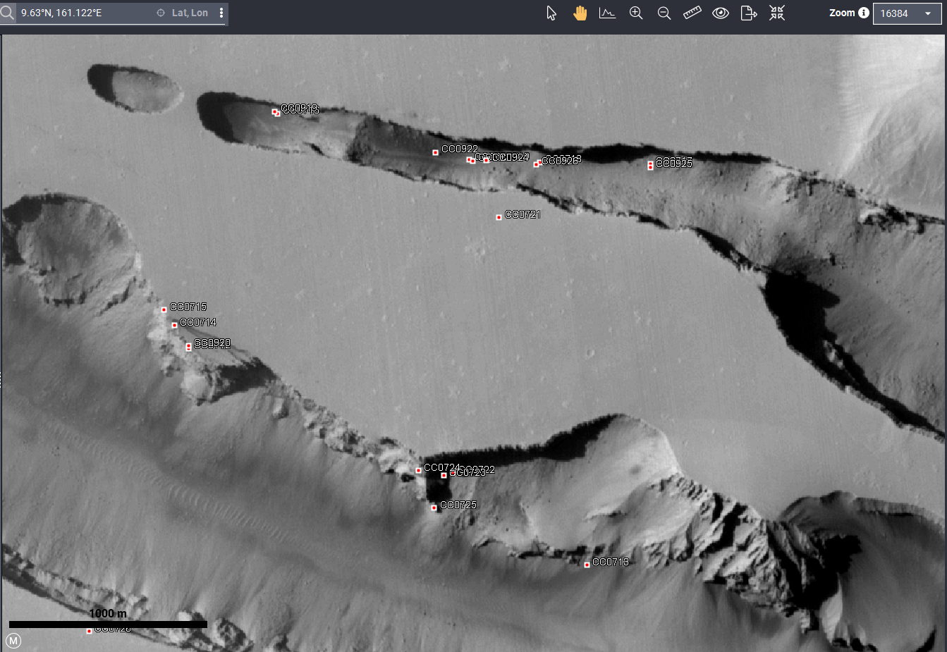

Figure : Lateral Cave Clusters (caves marked with red squares)

Here, the densest cluster of lateral caves with a targeting priority of 0 are listed:

|  |  |  |  |  |
| --- | --- | --- | --- | --- |
| Cave Label (name) | Latitude | Longitude | Targeting Priority | Comment (from MGC^3) |
| CC0722 | 9.61913 | 161.12 | 0 | cliff wall fracture intersect. |
| CC0723 | 9.6189 | 161.1192 | 0 | cliff wall fracture intersect. |
| CC0724 | 9.61935 | 161.117 | 0 | cliff wall fracture intersect. |
| CC0725 | 9.6161 | 161.1184 | 0 | Cliff wall lateral tube candidate. |

*Lateral Cave Cluster (Cushing, 2017)*

Selecting one of the pictured caves as the target cave allows for multiple backup caves should the original target be unviable upon vehicle arrival on Mars. CC0724 will be the target cave; the entrance appears quite large in terms of width and height (an entrance of about 90 meters)



**1.4 Payload and Science Instrumentation Summary**

**

* *Source:* [*RAD for Scientists | RAD – NASA Mars Exploration*](https://mars.nasa.gov/msl/spacecraft/instruments/rad/for-scientists/)
* Used on the Mars Curiosity Rover.
* Identifies high-energy particles to determine radiation levels on the surface of mars.
* RAD is a charged particle telescope (made of three solid-state detectors) and a cesium iodide calorimeter.
* Does not have to be fully powered continuously; sample measurements can be taken at (TBD) regular intervals. Curiosity’s RAD only runs 15 minutes every hour.
* Must be faced towards the sky. Will be placed on top of the vehicle.

**Science Instrument: LiDAR Scanner**

* LiDAR scanners target a surface with a laser and measure the time for the reflected light to return to the receiver. This can be used to make a 3D representation of the target cave.
* May have one mounted on a flexible arm or multiple stationary scanners on the vehicle.
* Must protect the lens from sandstorms with a shutter.

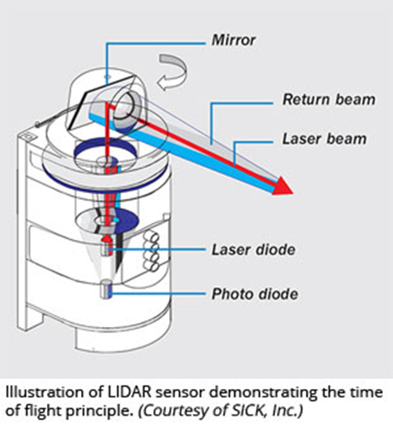

**Science Instrument: Alpha Particle X-Ray Spectrometer (APXS)**

* *Source:* [Alpha Particle X-Ray Spectrometer (APXS) - NASA Mars](https://mars.nasa.gov/mer/mission/instruments/apxs/)
* Determines the elemental chemistry of rocks and regolith.
* Emits alpha particles from a source, which bounce back from the science target into a detector in the APXS, along with some X-rays. The X-rays result from the science target being excited from the alpha particle emission.
* The energy distribution of the bounced-back alpha particles and X-rays are analyzed to determine ethe elemental composition of the sample.
* Data can be used to gain information about the formation of the cave interior.

**Science Instrument: Rover Environmental Monitoring Station (REMS)**

* *Source:* [*https://mars.nasa.gov/msl/spacecraft/instruments/rems/#:~:text=MEDLI-,REMS,meteorological%20conditions%20around%20the%20rover*](https://mars.nasa.gov/msl/spacecraft/instruments/rems/#:~:text=MEDLI-,REMS,meteorological%20conditions%20around%20the%20rover)*.*
* Measures atmospheric pressure, temperature, humidity, winds, and UV radiation levels.
* Records at least 5 minutes of data at 1 Hz each hour over one sol.
* Can run, at most, 3 hours per sol.
* The instrument must be mounted onto a “chimney” to measure changes in pressure. A filter will be necessary to protect the sensor from dust.

**2.3 Evolution of Payload and Science Instrumentation**

**Iteration 1:**

* **NEW Instrumentation - Radiation:** Ionizing Radiation measuring instrument, Non-Ionizing Radiation measuring instrument, Neutron Radiation measuring instrument.
* **NEW Instrumentation - Temperature:** A simple thermometer capable of recording temperatures on mars.
* **NEW Instrumentation - Structural Integrity:** Spectrometer capable of measuring and identifying silicon dioxide (SiO2) and aluminum oxide (AlO3). Also a seismograph to examine the structure of the cave walls.
* **Issues:** A seismograph may not be the appropriate instrument for this. In the past, seismographs used by other Mars rovers are quite large and would claim much of the vehicle’s allowed mass.

**Iteration 2:**

* **Instrumentation - Radiation**: Ionizing Radiation measuring instrument, Non-Ionizing Radiation measuring instrument, Neutron Radiation measuring instrument.
* **Issues:** This is a lot of equipment capable of taking up a majority of allocated mass. Neutron Radiation measuring instruments on the market tend to be quite heavy in particular.
* **Instrumentation - Temperature:** A simple thermometer capable of recording temperatures on mars.
* **Issues:** There may be more advanced instruments available to accomplish this task.
* **EDITED Instrumentation - Structural Integrity:** Spectrometer capable of measuring and identifying silicon dioxide (SiO2) and aluminum oxide (AlO3).

**Iteration 3:**

* **NEW Instrumentation - Radiation:** Radiation Assessment Detector (RAD). RAD can measure all types of radiation and is proven to be useful already; it is used on the Mars Curiosity Rover.
* **NEW Instrumentation - Temperature:** Thermographic camera. A thermographic camera will help visually represent the temperature of the cave. Will not be significantly heavier than a thermometer, but provides more data.
* **Instrumentation - Structural Integrity:** Spectrometer capable of measuring and identifying silicon dioxide (SiO2) and aluminum oxide (AlO3).
* **Issues:** Although visual data will be obtained with the thermographic camera, that data alone would not create a detailed map of the cave.

**Iteration 4:**

* **Instrumentation - Radiation:** Radiation Assessment Detector (RAD). RAD can measure all types of radiation and is proven to be useful already; it is used on the Mars Curiosity Rover.
* **Instrumentation - Temperature:** Thermographic camera. A thermographic camera will help visually represent the temperature of the cave. Will not be significantly heavier than a thermometer, but provides more data.
* **Issues:** A thermographic camera has not been used on Mars before. It is unknown if the images produced would provide enough differentiation between low temperatures (below -100 °C)
* **NEW Instrumentation - Structural Integrity:** Mössbauer Spectrometer and LiDAR scanner.
* **Mössbauer Spectrometer (MB)** - Measures the makeup and quantity of iron-containing minerals in rock and regolith. This is interesting, as it can measure the iron contents of the cave walls. The instrument has been proven useful; it is used on the Mars Spirit and Mars Opportunity Rovers. It is also very small.
* **Issues**: Although this instrument is proven usable on Mars, there many be other instrument choices that can examine a wider range of molecules (molecules other than those only containing iron).
* **LiDAR** - Not only a way for the vehicle to navigate the cave, but the LiDAR data can also be saved and used to create a detailed 3D map of the cave.

**Iteration 5:**

* **Instrumentation - Radiation:** Radiation Assessment Detector (RAD). RAD can measure all types of radiation and is proven to be useful already; it is used on the Mars Curiosity Rover.
* **LiDAR** - Not only a way for the vehicle to navigate the cave, but the LiDAR data can also be saved and used to create a detailed 3D map of the cave.
* **EDITED Instrumentation - Structural Integrity**: Alpha Particle X-Ray Spectrometer (APXS). This instrument is determined to be a better instrument than the MB for this mission. APXS is still lightweight and can collect X-ray spectra from the elements sodium to yttrium.
* **EDITED Instrumentation - Temperature:** Rover Environmental Monitoring Station (REMS). This instrument will provide more data than a thermographic camera and has proven to be usable on Mars rovers.

**3.1.6 FMEA and Risk Mitigation**

**4.2 Science Value**

**4.2.1 Science Payload Objectives**

The mission will collect data to describe the cave environment in three categories: ambient radiation, temperature, and cave structure. The Radiation Assessment Detector (RAD) will be used to measure ambient radiation - this will yield valuable data on the amount of radiation shielding the cave provides when compared to Mars’ surface environment. Temperature and air pressure data will be recorded with a Rover Environmental Monitoring Station (REMS) - this data can be compared to the temperature of Mars’ surface to determine how insulated the cave is. The cave’s physical structure will be examined with a LiDAR sensor; the sensor will produce a point cloud that can be converted into a detailed 3D image. The composition of the cave’s walls will be examined with an Alpha Particle X-ray Spectrometer (APXS) - this instrument will provide qualitative and quantitative data of elements present in the cave wall (from sodium to yttrium). These objectives will yield data that will be useful for more complex missions in the future; it is possible that Martian caves could house facilities for human habitation or simply for long-term equipment storage.

**Citations (APA)**

Cushing, G. (2017, June 1). Mars global cave candidate catalog (MGC^3) V1 Cushing: USGS Astrogeology Science Center. Mars Global Cave Candidate Catalog (MGC^3) v1 Cushing | USGS Astrogeology Science Center. Retrieved July 22, 2022, from https://astrogeology.usgs.gov/search/map/Mars/MarsCaveCatalog/mars_cave_catalog

NASA. (n.d.). Alpha Particle X-ray Spectrometer (APXS). NASA Mars Exploration Rovers. Retrieved July 23, 2022, from <https://mars.nasa.gov/mer/mission/instruments/apxs/>

NASA. (2021, April 15). RAD for Scientists. NASA Science Mars Exploration Program. Retrieved July 23, 2022, from <https://mars.nasa.gov/msl/spacecraft/instruments/rad/for-scientists/>

NASA. (2021, April 9). REMS. NASA Science Mars Exploration Program. Retrieved July 23, 2022, from <https://mars.nasa.gov/msl/spacecraft/instruments/rems/#:~:text=MEDLI-,REMS,meteorological%20conditions%20around%20the%20rover>.

Washington University in St. Louis - PDS Geosciences Node. (n.d.). Alpha Particle X-ray Spectrometer (APXS). Analyst's Notebook. Retrieved July 23, 2022, from <https://an.rsl.wustl.edu/help/Content/About%20the%20mission/MER/Instruments/MER%20APXS.htm>