**Instrument Trade Studies**

**Temperature Instrument Trade Study**

**Alternatives**

|  |  |  |
| --- | --- | --- |
| # | Instrument | Description |
| 1 | Thermographic Camera | Captures IR-images of the environment. Long-Wave Infrared (LWIR) Camera. |
| 2 | Rover Environmental Monitoring Station (REMS) | Measures temperature, humidity, and wind speed/direction. |

**Criteria**

|  |  |  |  |  |  |  |
| --- | --- | --- | --- | --- | --- | --- |
| # | Criteria | Description | Importance (1-9) | Analytic Hierarchy Process (AHP) | Pairwise Weighting | Linear Weighting |
| 1 | Technology Readiness Level (TRL) | Measures the maturity level of the technology in the context of the mission. | 8 | 56.6% | 56.46% | 42.11% |
| 2 | Mass (kg) | Entire vehicle has a mass limit of 50kg. | 4 | 12.29% | 12.26% | 21.05% |
| 3 | Lowest Operating Temperature (°C) | The area of the target cave has no recorded temperature less than -103°C. Instrument can be heated into operational range, if necessary, but it will consume power. | 6 | 26.52% | 26.70% | 31.58% |
| 4 | Highest Operating Temperature (°C) | The area of the target cave has no recorded temperature more than 21.3°C. | 1 | 4.63% | 4.58% | 5.26% |

**Performance**

|  |  |  |  |  |
| --- | --- | --- | --- | --- |
| # | Criteria | Subjectivity | Thermographic Camera | Rover Environmental Monitoring Station |
| 1 | Technology Readiness Level (TRL) | Quantitative – Highest Value Best | 0.182 | 0.818 |
| 2 | Mass (kg) | Quantitative – Lowest Value Best | 0.877 | 0.123 |
| 3 | Lowest Operating Temperature (°C) | Quantitative – Lowest Value Best | 0.765 | 0.235 |
| 4 | Highest Operating Temperature (°C) | Quantitative – Highest Value Best | 0.500 | 0.500 |

**Analytic Hierarchy Process (AHP) Results**

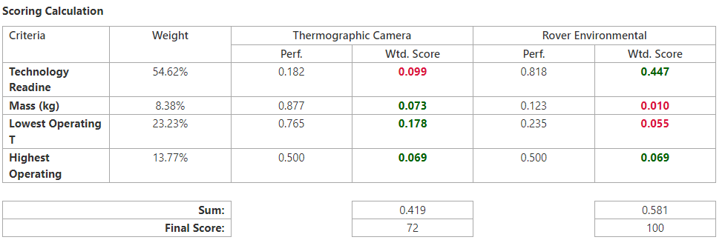

**Pairwise Weighting**

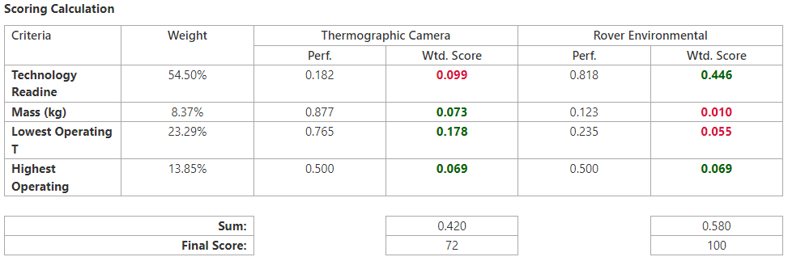

**Linear Weighting**

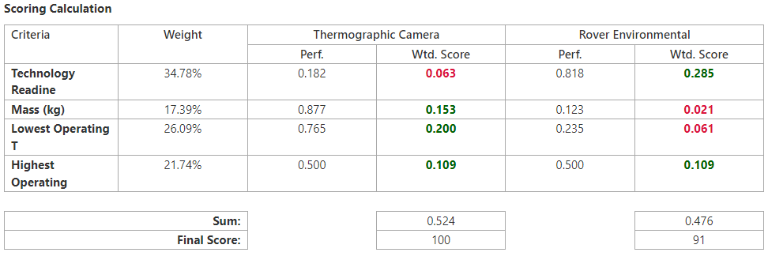

**Spectrometer Trade Study**

**Alternatives**

|  |  |  |
| --- | --- | --- |
| # | Instrument | Description |
| 1 | Mössbauer Spectrometer | Measures the makeup and quantity of iron-containing minerals in rock and regolith. |
| 2 | Alpha Particle X-Ray Spectrometer | Measures quantity of elements from sodium to yttrium of rock and regolith. |

**Criteria**

|  |  |  |  |  |  |  |
| --- | --- | --- | --- | --- | --- | --- |
| # | Name | Description | Importance (1-9) | Analytic Hierarchy Process (AHP) | Pairwise Weighting | Linear Weighting |
| 1 | Mass (kg) | Entire vehicle has a mass limit of 50kg. | 4 | 6.56% | 6.55% | 15.38% |
| 2 | Sampling Time (minutes) | Amount of time it takes for a measurement to be taken of a sample. | 5 | 10.25% | 10.26% | 19.23% |
| 3 | Technology Readiness Level (TRL) | Measures the maturity level of the technology in the context of the mission. | 8 | 32.41% | 32.43% | 30.77% |
| 4 | Number of Elements Detected | Number of different elements detectable by the spectrometer. | 9 | 50.78% | 50.76% | 34.62% |

**Performance**

|  |  |  |  |  |
| --- | --- | --- | --- | --- |
| # | Criteria | Subjectivity | Mössbauer Spectrometer | Alpha Particle X-Ray Spectrometer |
| 1 | Mass (kg) | Quantitative – Lowest Value Best | 0.615 | 0.385 |
| 2 | Sampling Time (minutes) | Quantitative – Lowest Value Best | 0.200 | 0.800 |
| 3 | Technology Readiness Level (TRL) | Quantitative -Highest Value Best | 0.500 | 0.500 |
| 4 | Number of Elements Detectable | Quantitative – Highest Value Best | 0.034 | 0.966 |

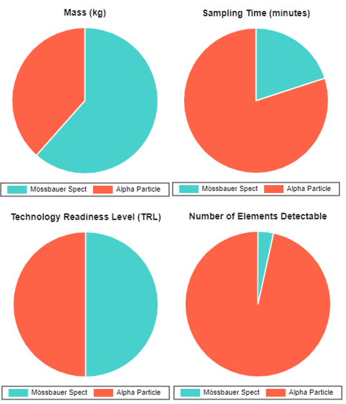

**Results**

**Analytic Hierarchy Process (AHP) Results**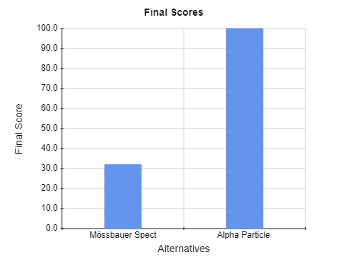

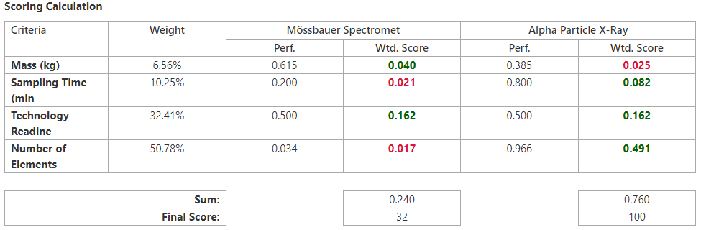

**Pairwise Weighting**

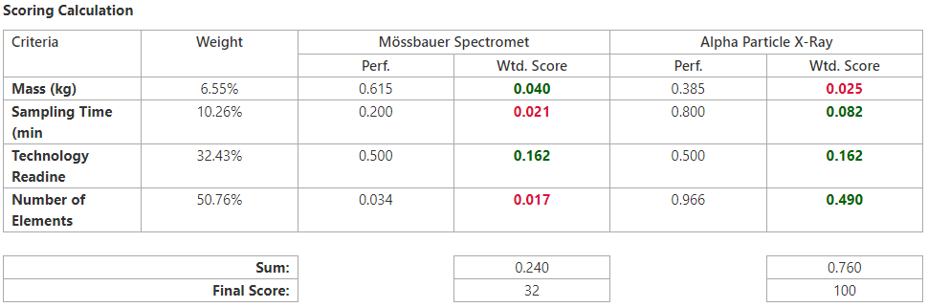

**Linear Weighting**

