1. **What is data compression and what is it good for? Give advantages and drawbacks.**
   1. Data compression is a reduction in the number of bits needed to represent data. Compressing data can save storage capacity, speed up file transfer, and decrease costs for storage hardware and network bandwidth.
   2. Some files might be bigger after compression.

If compression is lossy, compressed file will lose data.

Slower access to the data

Compressed data are harder to recover in case of, e.g., HW failure

1. **What is the definition of redundancy of a code for a given message X? In which units it is measured?**

**?**

1. **What is the basic principle (idea) of data compression? Which phenomena it usually employs?**
   1. basic compression principle: remove redundancy in the data

objective redundancy – property of the data itself

subjective redundancy – human is not capable of perceiving certain part of the data

1. **What is the difference between lossy and lossless data compression? In which situations can we afford to use lossy compression and when not?**
2. lossy – original data may be decoded from the compressed version only approximately

lossless – original data may be decoded exactly

1. Lossy compression can only be used on data which is destined for human perception, e.g. audio/image/video/.
2. **What is compression ratio? Is it constant for a given algorithm? If not, which factors may influence it?**
3. a measurement of the relative reduction in size of data representation produced by a data compression algorithm. It is typically expressed as the division of uncompressed size by compressed size
4. No, size, redundancy(repetitions in data), type of data itself makes difference.
5. **Is Morse alphabet a compression method? Give reasoning. Is it unambiguously decodable? Is it necessary to use symbol delimiters? Give reasoning.**
   1. **Netuším**
   2. No, e.g.: “ ._” is A or ”. _” E and T ???
6. **Which methods of data compression do you know? In which situations would you use each individual method and why?**
   1. Stejná otázka –goto 4.
7. **What is the difference between a continuous and a discrete signal? Give examples, draw...**

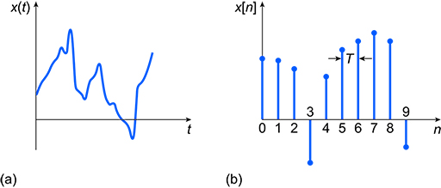

1. **What is a periodic signal? Define mathematically.**

A periodic signal is one that repeats the sequence of values exactly after a fixed length of time, known as the period.



1. **Explain the following terms: period, frequency, amplitude, phase. Demonstrate them using an example, draw...**

* **period** time that it takes for the point to go around the circle, i.e., the time after which the signal starts to repeat itself
* **amplitude** A – maximum deflection of the point from the equilibrium
* **phase** ϕ– shift of the beginning of the process from the origin
* **frequency**, *f*=1/T, gives the number of periods per second, in Hertz (Hz)

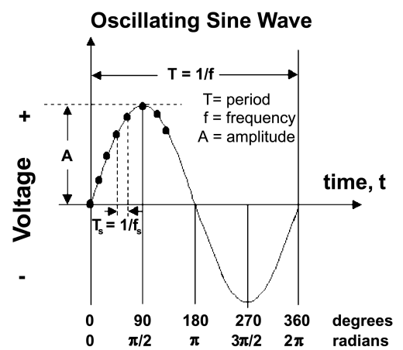

1. **In a Fourier series, can a ratio of two frequencies be irational? Give reasoning.**

**?**

1. **Let's have a signal containing two spectral components with frequencies of 400 Hz a 500.sqrt(2) where sqrt() denotes square root function. Is this signal periodic?**

**?**

1. **Is spectrum of a periodic signal given unambiguously, uniquely? Which algorithms/mathematical tools for transformation of a signal (both periodic and nonperiodic) from temporal to spectral domain do you know?**

**?**

1. **Which frequencies in spectrum correspond to fast (abrupt) changes in temporal course of a signal? Low or high? Draw an example of such a signal.**

**?**

1. **Draw amplitude spectrum of an ideal Dirac pulse.**

**?**

1. **Draw amplitude spectrum of signal given as: x(t) = sin(200*pi*t+5) - 0.5*sin(400*pi*t+5).**

**?**

1. **Is spectrum of an analogue nonperiodic signal continuous or discrete? Which mathematical tool can be used for computation of such spectrum?**

**?**

1. **Explain these terms: sampling, quantization. Demonstrate them on an example, draw...**
   1. Sampling converts a time-varying voltage signal into a discrete-time signal, a sequence of real numbers. Quantization replaces each real number with an approximation from a finite set of discrete values.
   2. 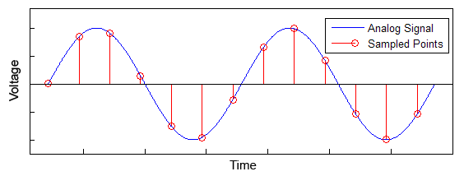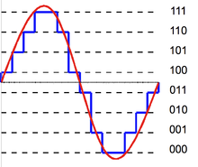
2. **Give and explain the sampling theorem**
   1. It establishes a sufficient condition for a sample rate that permits a discrete sequence of samples to capture all the information from a continuous-time signal of finite bandwidth.

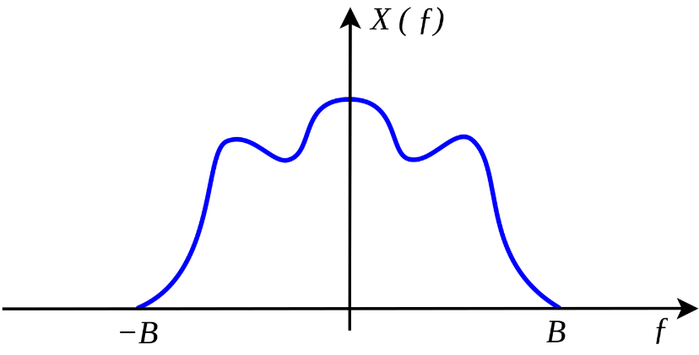**.**

1. **Explain what aliasing in a sound signal means, explain the principles by which it emerges. How can we avoid it?**
   1. Aliasing is an effect that causes different signals to become indistinguishable (or aliases of one another) when sampled
   2. Aliasing occurs when a signal contains frequencies higher than what the sample-rate can store, and those high frequencies get 'folded' back into the range the sample-rate is capable of storing.
   3. Use oversampling