

**Milo Manual**

**Converter**

**Overlay**

**Splicing**

**CONVERTER MANUAL**

*Date: 30/08/2019*

**Step1.** Ensure your PC can access <DETROIT> Server. Open ‘milo_main.exe’, and click on ‘Converter’ Button

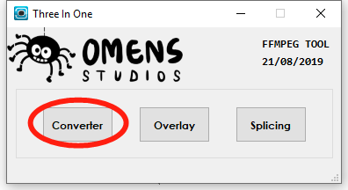

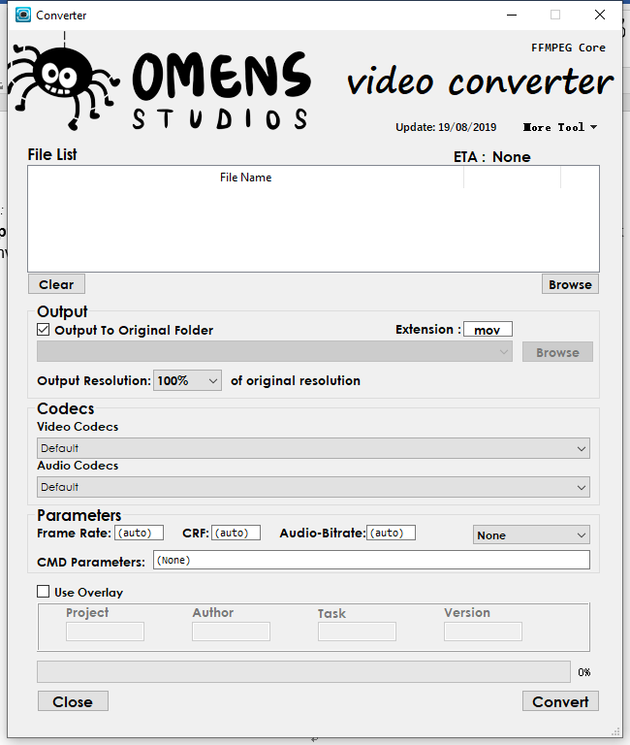

**Step 2. Select input files.**

Simply drag file(s) and drop into the box stated below. Or click on ‘Browse’ button.

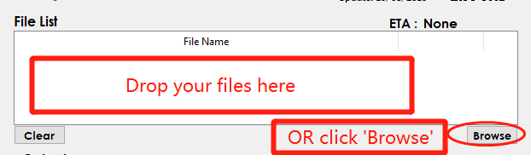

Press and hold ‘Ctrl’ to enable multiple selections.

Common directories and current working directory will be shown under dropdown at the top.

Select or key in any directory, then press ‘Go’ button

Press ‘🏠’ return to home directory

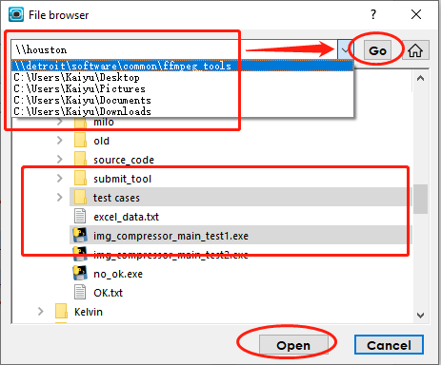

**Step 3. Select Output Options**

Specify output directory (Default output to original directory, uncheck to use alternate folder)

Specify output extension (Default is ‘mov’ eg. ‘mp4’ and ’avi’)

Specify compression of resolution of output video (Range from 100% to 20 % compression)

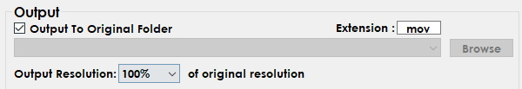

**Step 3. Select codecs and parameters**

Presets are available under preset dropdown

NOTE:

* Frame rate is pure number
* CRF is output video quality ranging from 0 to 51, the smaller the crf better output quality and longer conversion time taken. Reasonable range is 18 to 28.
* Audio-bitrate, a unit is required, for example 128k and 1M (UPPER CASE ‘M’ , lower case ‘k’)
* If you wish to use FFMPEG default rate, leave it as ‘(auto)’

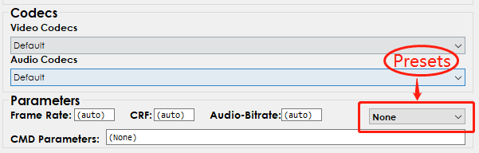

**Step 4. (OPTIONAL) Use overlay**

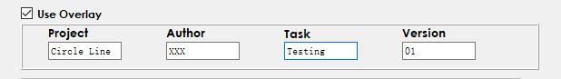

**Step 5. Convert**

* Estimated time will be shown, however it may not be accurate.
* Percentage of completion will be shown as well, it is accurate.

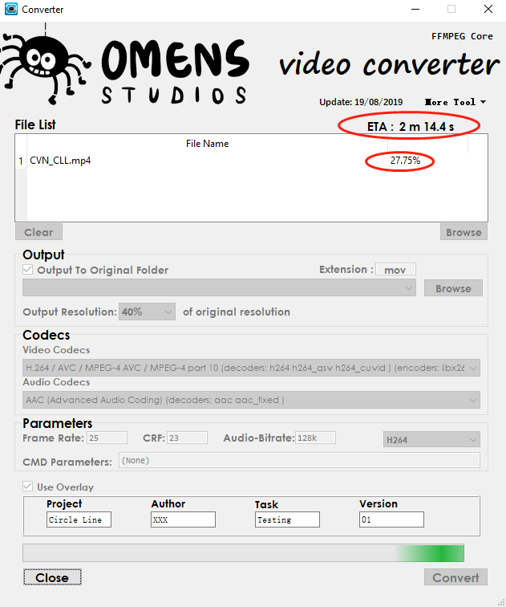

Click ‘Clear’ to enable next conversion.

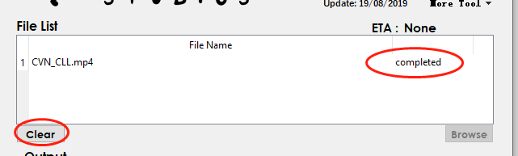

**Other Functions:**

* Help links
* Presets

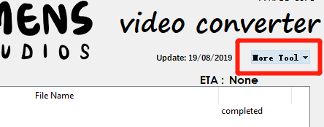

**‘Help Tool’**

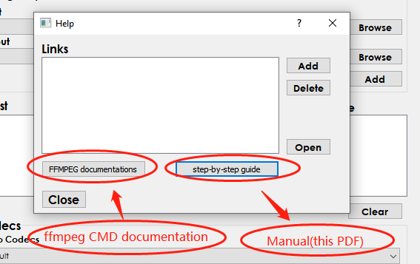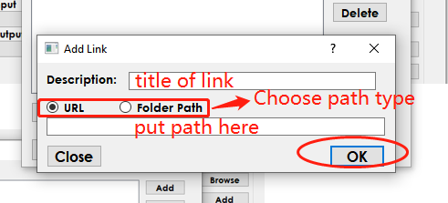

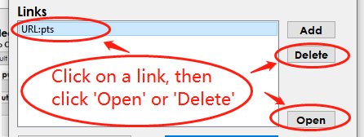

**‘Pre-set Tool’**

* Edit existing presets or add new preset

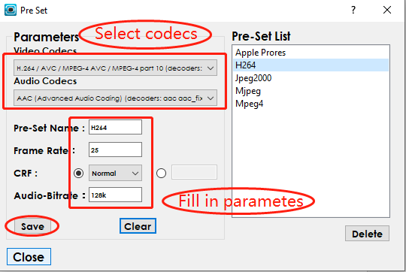

**OVERLAY MANUAL**

*Date: 30/08/2019*

**Step 1.**

Click on ‘Overlay’

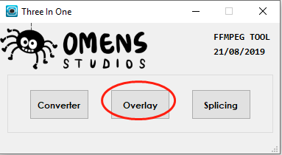

**Step 2. Select input files**

Simply drag file(s) and drop into the box stated below. Or click on ‘Browse’ button.

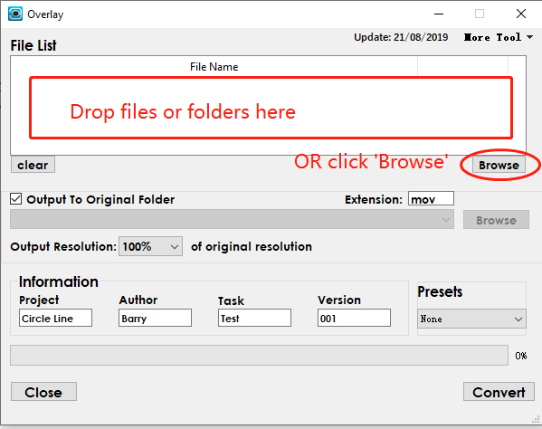

Press and hold ‘Ctrl’ to enable multiple selections.

Common directories and current working directory will be shown under dropdown at the top.

Select or key in any directory, then press ‘Go’ button

Press ‘🏠’ return to home directory



**Step 3. Select Output Options**

Specify output directory (Default output to original directory, uncheck to use alternate folder)

Specify output extension (Default is ‘mov’ eg. ‘mp4’ and ’avi’)

Specify compression of resolution of output video (Range from 100% to 20 % compression)



**Step 4. Fill in overlay information**

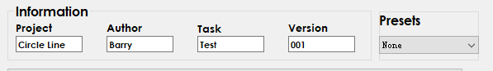

**Step 5. Select Preset**

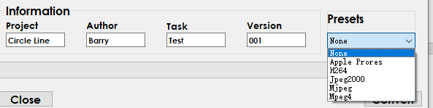

**Other Functions**

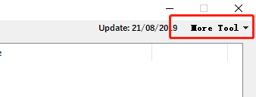

**‘Help Tool’**





**‘Pre-set Tool’**

* Edit existing presets or add new preset



**SPLICE MANUAL**

*Date: 30/08/2019*

Step1.

Click on ‘Splicing’

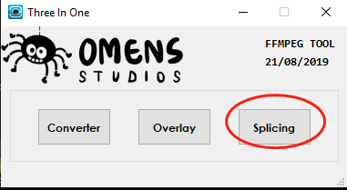

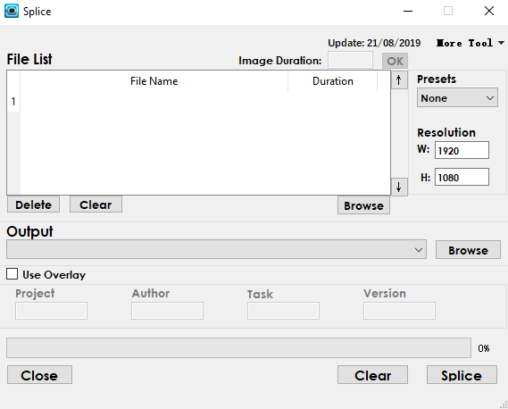

**Step 2. Select input files**

Simply drag file(s) and drop into the box stated below. Or click on ‘Browse’ button.

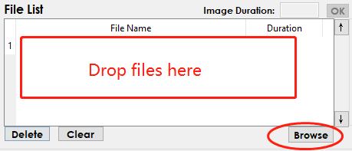

Press and hold ‘Ctrl’ to enable multiple selections.

Common directories and current working directory will be shown under dropdown at the top.

Select or key in any directory, then press ‘Go’ button

Press ‘🏠’ return to home directory



Modify sequence by clicking up (down) arrows

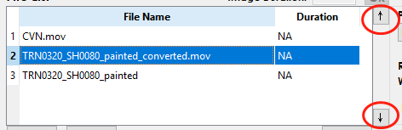

If input is still image, do specify a duration for it.

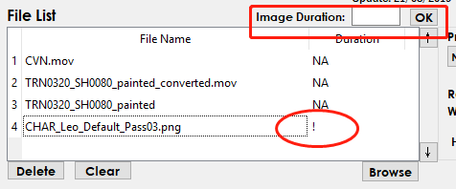

Delete unwanted files

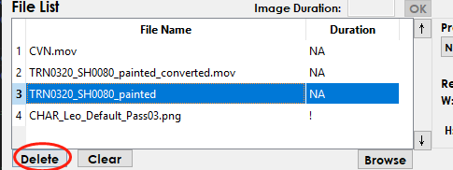

**Step 3. Specify output file**

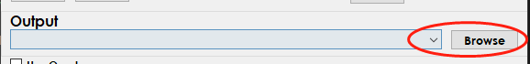

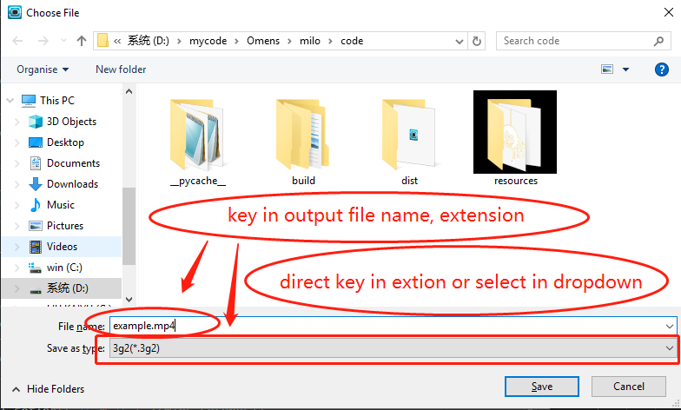

**Step 4. Preset and resolution**

Select preset

Key in output resolution (Default is 1920x1080)

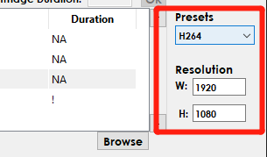

**Step 5. (OPTIONAL) Use overlay**

Check overlay box to use overlay

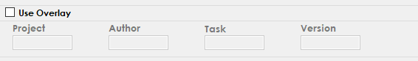

**Other Funtions**

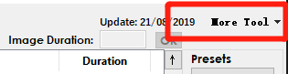

**‘Help Tool’**







**‘Pre-set Tool’**

* Edit existing presets or add new preset

