**OVERLAY MANUAL**

*Date: 30/08/2019*

**Step 1.**

Click on ‘Overlay’

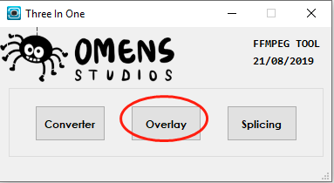

**Step 2. Select input files**

Simply drag file(s) and drop into the box stated below. Or click on ‘Browse’ button.

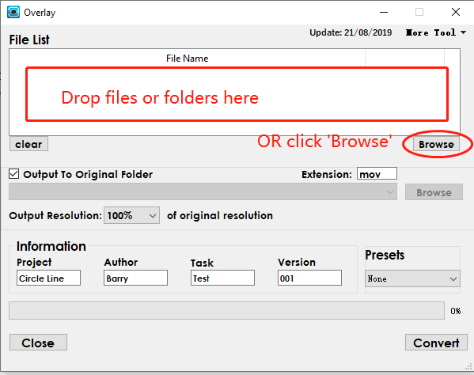

Press and hold ‘Ctrl’ to enable multiple selections.

Common directories and current working directory will be shown under dropdown at the top.

Select or key in any directory, then press ‘Go’ button

Press ‘🏠’ return to home directory

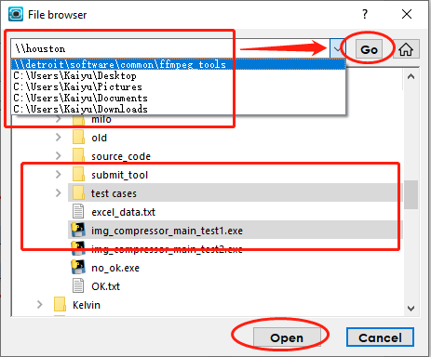

**Step 3. Select Output Options**

Specify output directory (Default output to original directory, uncheck to use alternate folder)

Specify output extension (Default is ‘mov’ eg. ‘mp4’ and ’avi’)

Specify compression of resolution of output video (Range from 100% to 20 % compression)

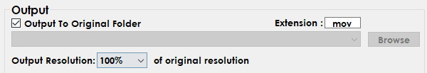

**Step 4. Fill in overlay information**

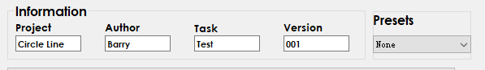

**Step 5. Select Preset**

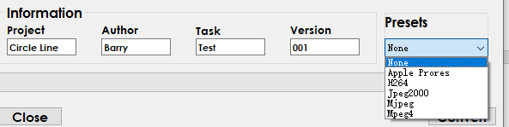

**Other Functions**

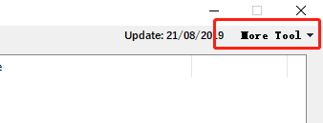

**‘Help Tool’**

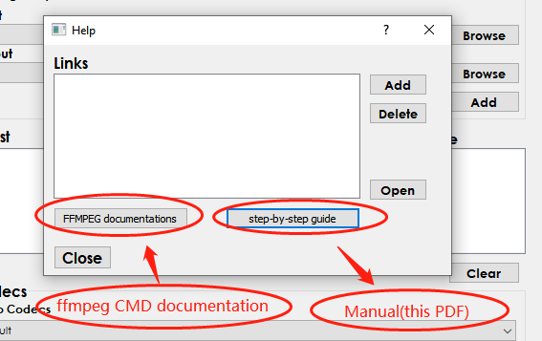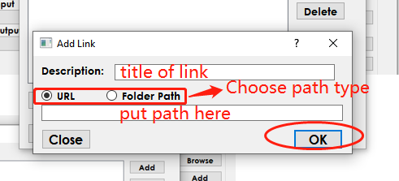

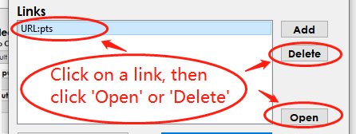

**‘Pre-set Tool’**

* Edit existing presets or add new preset

