**SPLICE MANUAL**

*Date: 30/08/2019*

Step1.

Click on ‘Splicing’

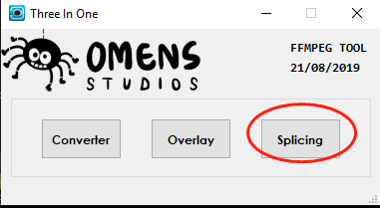

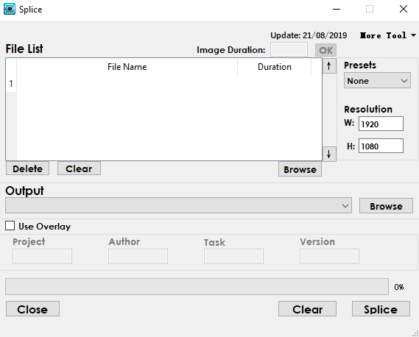

**Step 2. Select input files**

Simply drag file(s) and drop into the box stated below. Or click on ‘Browse’ button.

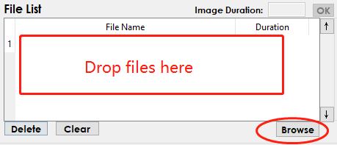

Press and hold ‘Ctrl’ to enable multiple selections.

Common directories and current working directory will be shown under dropdown at the top.

Select or key in any directory, then press ‘Go’ button

Press ‘🏠’ return to home directory

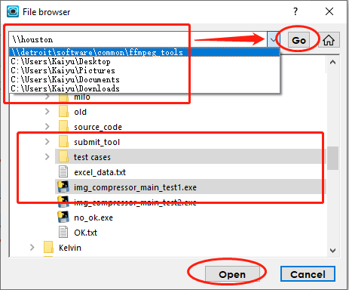

Modify sequence by clicking up (down) arrows

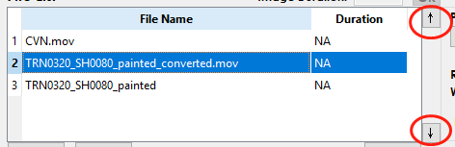

If input is still image, do specify a duration for it.

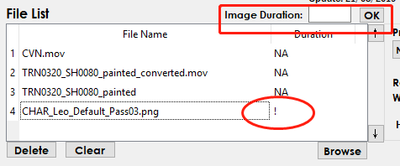

Delete unwanted files

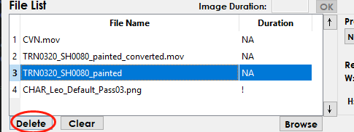

**Step 3. Specify output file**

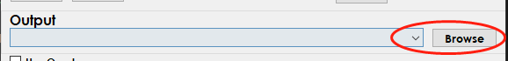

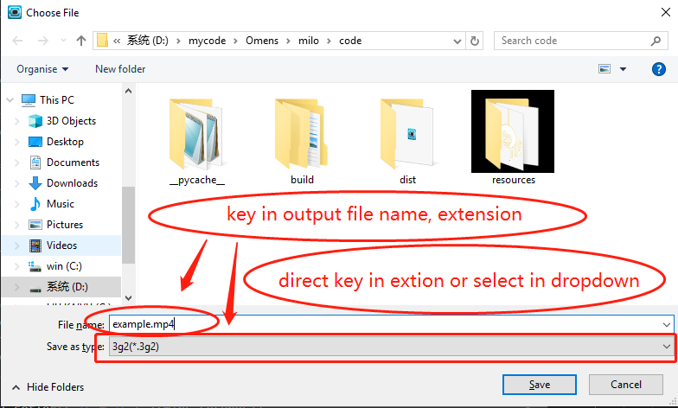

**Step 4. Preset and resolution**

Select preset

Key in output resolution (Default is 1920x1080)

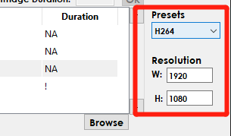

**Step 5. (OPTIONAL) Use overlay**

Check overlay box to use overlay

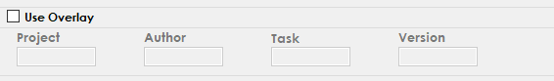

**Other Funtions**

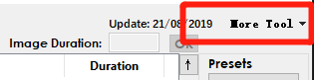

**‘Help Tool’**

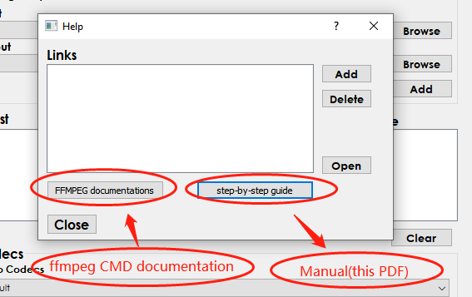

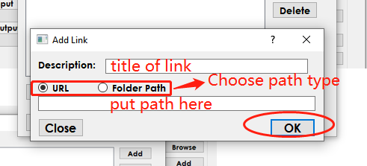

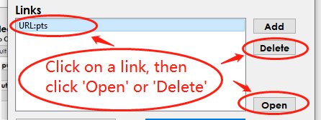

**‘Pre-set Tool’**

* Edit existing presets or add new preset

