Помельцев И.С.

Лабораторная работа 2. Настройка vlan на коммутаторах

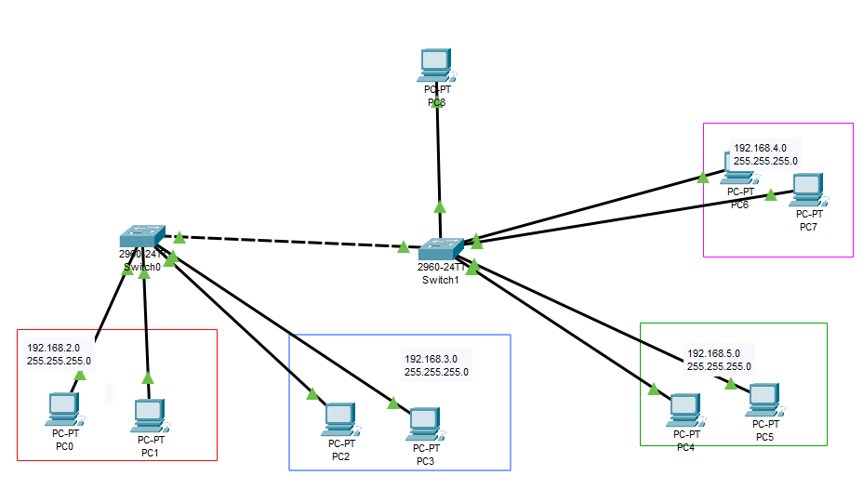

Рисунок 1. Топология сети с VLAN

1. Добавление VLAN

interface Vlan2

ip address 192.168.2.240 255.255.255.0

interface Vlan3

ip address 192.168.3.240 255.255.255.0

interface Vlan4

ip address 192.168.4.240 255.255.255.0

interface Vlan5

ip address 192.168.5.240 255.255.255.0

1. Настройка физических портов

interface FastEthernet0/1

switchport access vlan 2

switchport mode access

!

interface FastEthernet0/2

switchport access vlan 2

switchport mode access

!

interface FastEthernet0/3

switchport access vlan 3

switchport mode access

!

interface FastEthernet0/4

switchport access vlan 3

switchport mode access

1. Настройка trunk

interface GigabitEthernet0/1

switchport trunk allowed vlan 2-5

switchport mode trunk