**Staff Page**

**Owner – Dr. Charles Lin (he/him)**

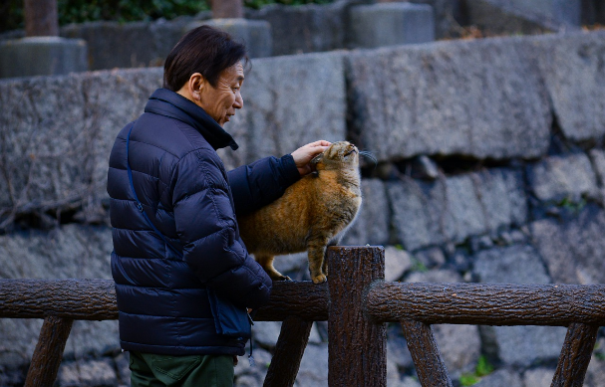Charles is the owner of **Fluffy Friends Cat Daycare** and lives with 34 former stray cats which he has rescued off the streets of Ottawa. Charles reads bedtime stories to his many cats every night in the hopes that they will fall asleep, they rarely do. He also enjoys cooking his cats fancy fish dinners. Charles is caretaker for both programs at Fluffy Friends as well as chef. Most days you will find him cooking and preparing delicious lunches for your cat to enjoy. Before opening **Fluffy Friends Cat Daycare**, Charles worked as a veterinarian with the Ottawa Cat Hospital. Your cats are in great hands with Charles.

**Caretaker – Lillian Anwar (she/her)**

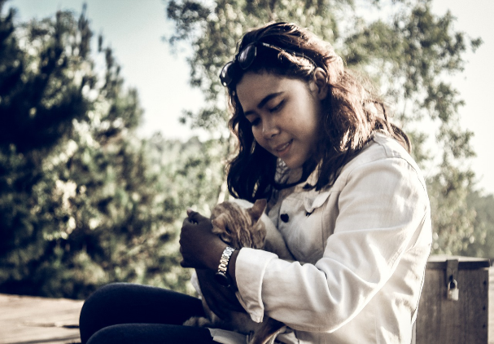Lilian is a self-taught carpenter and cat enthusiast. Lilian spends most of her free time building cat trees, many of which end up at **Fluffy Friends Cat Daycare**. At Fluffy Friends Lilian runs a Saturday cat tree building course and takes care of the cats in the adult cat program. She also designed and built our brand-new cat porch. Lillian has an orange and white tabby cat named Buttercup Sprinkles, Lillian enjoys eating cat food with Buttercup Sprinkles. Click here to see her guide to building cat trees.

**Caretaker – Alex Peacock (they/them)**

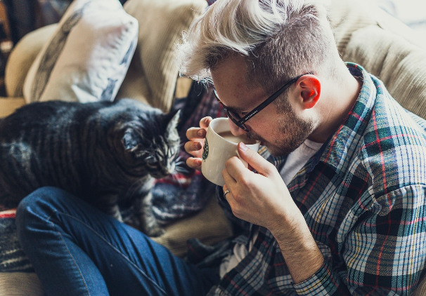Alex is the kitten caretaker at **Fluffy Friends Cat Daycare**. Alex is equally passionate about cats and dogs. They are a professional cat and dog trainer who employs the clicker training method to teach cats and dogs to play tiny musical instruments. Alex hopes to one day to conduct an animal orchestra and maybe even take the orchestra on a tour of the world. Alex has big dreams and an even bigger heart. You can often find them enjoying a cup of catnip tea with their adorable tabby cat named Teddy.

**Schedule Page**

At **Fluffy Friends Cat Daycare**, we know that older cats have different needs from younger cats. We have carefully developed programs that will keep your favourite pet healthy and happy while you are away at work. Intake begins at 6AM weekday mornings and our program day ends at 6PM. We often offer workshops on the weekends, ask about these when you drop off your fluffy friend.

**Weekly Adult Cat Program**

|  |  |  |  |  |  |  |
| --- | --- | --- | --- | --- | --- | --- |
|  | Mon | Tue | Wed | Thu | Fri | Sat |
| 6AM | Early Cat Intake | | | | |  |
| 8AM | Cat Porch opens (weather permitting) | | | | |  |
| 9AM |  | Integration with kittens |  | Integration with kittens |  |  |
| 10AM |  |  |  | Cat Tree Workshop with Lillian |
| 11AM | Playtime in Adult Cat Area with Lillian | | | | |
| NOON | Lunchtime | | | | |
| 1PM | Cat Porch closes | | | | |  |
| 5PM | Cat Pickup | | | | |  |
| 6PM | Daycare closes | | | | |  |

Register your cat here.

**Weekly Kitten Program**

|  |  |  |  |  |  |  |
| --- | --- | --- | --- | --- | --- | --- |
|  | Mon | Tue | Wed | Thu | Fri | Sat |
| 6AM | Early Kitten Intake | | | | |  |
| 8AM | Kitten Walks with Alex (weather permitting) | | | | |  |
| 9AM |  | Integration with adult cats |  | Integration with adult cats |  |  |
| 10AM |  |  |  | Cat Tree Workshop with Lillian |
| 11AM | Playtime in Kitten Area with Alex | | | | |
| NOON | Lunchtime | | | | |
| 1PM | Playtime in Kitten Area with Alex | | | | |  |
| 3PM | Kitten Stories and Teatime with Charles and Alex | | | | |  |
| 5PM | Kitten Pickup | | | | |  |
| 6PM | Daycare closes | | | | |  |

Register your cat here.

(Note that you should put the two tables on the same web page, I just move them so that it was clear that the kitten program was a single table.)

**Registration Page**

Registering your cat is easy, fill out the form below and send it to us with the register button. We will contact you within 24 business hours to enroll your cat in the appropriate program.

|  |  |
| --- | --- |
| Name of Cat: |  |
| Age of Cat: |  |
| Your Name: |  |
| Email: |  |
| Telephone Number: |  |
| Check if your cat requires a special diet | |
| REGISTER | |

You can contact us at:

123 Fluffy Street

Ottawa, Ontario

(613) 123 – CATS

[fluffyfriends@catdaycare.ca](mailto:fluffyfriends@catdaycare.ca)

We would love to hear from you today.

**Project Page**

Making a cat tree is a fun way to create a special place for your cat to hang out at home. Cat trees double as scratching posts, so your cat is sure to enjoy the addition to your living space.

For this simple cat tree project, you will need the following materials and tools (all of which can be obtained from your local hardware store):

|  |  |
| --- | --- |
| Materials | Tools |
| * ¾” plywood for base and platforms * 1” by 2” boards for connecting the platforms to the base * ¼” hemp rope for wrapping the boards * Carpet for covering the base and platforms * Wood screws for securing the parts together | * Saw * Screwdriver * Drill * Staplegun * Hot glue gun |

**Steps**

1. Cut the plywood into four pieces, the largest piece will be for the bottom. Use the image as a guide. Do not worry about being precise, cat trees come in all different shapes and sizes.
2. Cut two of the lengths of boards into equal lengths and a third board about half as long as the long board and a fourth half as long as the short board. The longer your equal length boards the higher your cat will be on this cat tree.
3. Attach the ends of the two long boards to the upper platform, make sure that you space them so that they are supporting the ends of the platform from the middle of that platform. Pre-drill your screw holes so that you do not split your boards.
4. Attach the second largest platform to the shortest board and then attach this platform the long boards as shown in the picture.
5. Finally attach the smallest platform as shown making sure to predrill your holes.
6. Attach all the boards to the base.
7. Using the hot glue wrap one or more of the boards in hemp rope, this will be great for scratching. Make sure you glue it well and staple the ends.
8. Finally carpet the platforms and you have a great new cat tree!

For more complex cat tree projects our own Lillian Anwar offers Saturday morning classes where you can build exactly the cat tree you have always dreamed of.