**E-commerce Platform Search Function**

**Main.java**

import java.util.Arrays;

public class Main {

public static void main(String[] args) {

Product[] products = {

new Product(101, "Laptop", "Electronics"),

new Product(102, "Shoes", "Fashion"),

new Product(103, "Phone", "Electronics"),

new Product(104, "T-shirt", "Fashion"),

new Product(105, "Watch", "Accessories")

};

System.out.println("Linear Search:");

Product result1 = SearchUtil.linearSearch(products, "Phone");

System.out.println(result1 != null ? result1 : "Product not found");

System.out.println("\nBinary Search:");

Arrays.sort(products, (a, b) -> a.productName.compareToIgnoreCase(b.productName));

Product result2 = SearchUtil.binarySearch(products, "Phone");

System.out.println(result2 != null ? result2 : "Product not found");

}}

**Product.java**

public class Product {

int productId;

String productName;

String category;

public Product(int productId, String productName, String category) {

this.productId = productId;

this.productName = productName;

this.category = category;

}

public String toString() {

return "[" + productId + "] " + productName + " (" + category + ")";

}}

class SearchUtil {

public static Product linearSearch(Product[] products, String targetName) {

for (Product product : products) {

if (product.productName.equalsIgnoreCase(targetName)) {

return product;

}}

return null; }

public static Product binarySearch(Product[] products, String targetName) {

int left = 0, right = products.length - 1;

while (left <= right) {

int mid = (left + right) / 2;

int compare = products[mid].productName.compareToIgnoreCase(targetName);

if (compare == 0) {

return products[mid];

} else if (compare < 0) {

left = mid + 1;

} else {

right = mid - 1;

} }

return null;

}}

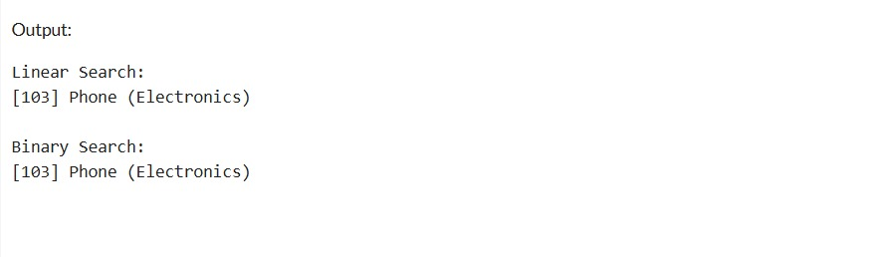

**Financial Forecasting**

**Main.java**

public class Main {

public static double futureValue(double amount, double growthRate, int years) {

if (years == 0) {

return amount;

} else {

return futureValue(amount, growthRate, years - 1) * (1 + growthRate);

} }

public static void main(String[] args) {

double initialAmount = 1000.0;

double growthRate = 0.05;

int years = 3;

double result = futureValue(initialAmount, growthRate, years);

System.out.printf("Future Value after %d years: ₹%.2f\n", years, result);

}}

