

24EEE432 Cyber Physical System for Industrial Applications

HealthX-CPS based Smart Health Band

Report

Submitted by

CB.EN.U4EEE23104 Anusree Mannathuparambu Satheeshkumar
CB.EN.U4EEE23126 Ponabirami A
CB.EN.U4EEE23155 Harshita VP

DEPARTMENT OF ELECTRICAL AND ELECTRONICS ENGINEERING AMRITA SCHOOL OF ENGINEERING,
AMRITA VISHWA VIDYAPEETHAM,
COIMBATORE - 641112
MARCH 2026

Amrita School of Engineering, Coimbatore
Department of Electrical and Electronics Engineering

Vision

Mould generations of electrical and electronics engineers on global standards with multi-disciplinary perspective to meet evolving societal needs.

Mission

- Empower students with knowledge in Electrical, Electronics and allied Engineering facilitated in innovative classrooms and state-of-the art laboratories.
- Inculcate technical competence and promote research through industry interactions, field exposures and global collaborations.
- Promote professional ethics and selfless service.

Program Educational Objectives (PEOs)

PEO1: Graduate can demonstrate electrical and electronics engineering problem solving skill along with proficiency in communication and professional excellence in project management and execution.

PEO2: Graduate can be employable in engineering services including ICT enabled sectors and also motivated for entrepreneurship.

PEO3: Graduate will be competent for higher studies in world class universities and research in industrial organizations.

PEO4: Graduate will manifest social commitment, environmental awareness and moral and ethical values in professional
and other discourses.

Program Specific Outcome (PSOs)
PSO1: Build and manage electro dynamic systems using Knowledge on electrical technology and semiconductor devices for allied services.
PSO2: Use computational tools and network dynamics for design, analysis and control of power systems integrated with renewable energy and Electric Vehicle.
PSO3: Leverage digital technologies employing state-of-the art control techniques and embedded controllers for industrial applications.

24EEE432 CYBER PHYSICAL SYSTEM FOR INDUSTRIAL APPLICATIONS L-T-P-C: 3-0-0-3

Course Objective:
- Understand and develop hardware and software design requirements of Cyber Physical System for Engineering Applications from Embedded Perspective
- Design and implement a prototype of Embedded Cyber Physical Systems using ARM processor and programming skills in Embedded C, Micro python
- Develop embedded projects for Smart City, Smart Civil Structures, Health Care Application, Automotive Mechatronics, Hybrid Electric Vehicles, Robots for Industrial Automation

Course Outcomes:
CO1: Program for ARM Processor STM32F103 in C language using STM Cube IDE Software Development Environment
CO2: Gain skills for interfacing ARM processor STM32F103 with sensors like Ultrasonic sensor, Hall effect sensor, Tilt Sensor, actuators like servo Motors and displays like OLED and LCD Displays
CO3: Program Raspberry Pi Pico using the Micropython language using Thonny IDE Software Development Environment and develop simple embedded system prototypes using Raspberry Pi Pico to interface with sensors, OLED and LCD displays, motor
CO4: Develop Applications of CPS from embedded perspective in Automotive Mechatronics and Healthcare Applications
CO5: Develop Applications of CPS from embedded perspective in Hybrid Electric Vehicle, Industrial Motor Control and Robotics

CO-PO Mapping
PO/PSO | PO1 | PO2 | PO3 | PO4 | PO5 | PO6 | PO7 | PO8 | PO9 | PO10 | PO11 | PSO1 | PSO2 | PSO3
CO
CO1 | 3 | 3 |  |  | 3 |  |  |  |  |  |  | 1 | 2 | 3
CO2 | 3 | 3 |  |  |  |  |  |  |  |  |  | 1 | 2 | 3
CO3 | 3 | 3 |  |  | 3 |  |  |  |  |  |  | 1 | 2 | 3
CO4 | 3 | 3 | 3 | 2 | 3 |  | 2 | 2 | 2 | 2 | 1 |  | 2 | 3
CO5 | 3 | 3 | 3 | 2 | 3 |  | 2 | 2 | 2 | 2 | 1 |  | 2 | 3

PO1-Engineering Knowledge, PO2-Problem Analysis, PO3-Design/Development of Solutions, PO4-Conduct Investigations of Complex Problems, PO5-Modern Tool Usage, PO6-The Engineer and Society, PO7-Environment and Sustainability, PO8-Ethics, PO9-Individual and Team Work, PO10-Communication, PO11-Project Management and Finance.

Washington Accord  Knowledge Profiles (WK) mapping | Strongly Supports POs | Justification
WK2 (Mathematics & Computation) | PO1, PO2 | Embedded logic, timing, and control algorithms
WK3 (Engineering Fundamentals) | PO1, PO2, PO3 | ARM architecture, sensors, actuators
WK4 (Engineering Specialization) | PO1, PO2, PO4 | CPS, Embedded Systems, STM32, Pico
WK5 (Engineering Design) | PO3, PO5 | CPS application design & prototyping
WK6 (Engineering Practice) | PO4, PO11 | IDEs, debugging, and hardware interfacing
WK7 (Engineering Tools) | PO5 | STM Cube IDE, Thonny, MicroPython
WK8 (Ethics, Environment & Sustainability) | PO6, PO7 | Healthcare, EV, safety-critical CPS
WK9 (Individual & Team Work) | PO9, PO10 | Projects-CPS applications



BONAFIDE CERTIFICATE

This is to certify that the cyber-physical system project report entitled
“HealthX-CPS based Smart Health Band”

submitted by

Roll Nos. Student Names
CB.EN.U4EEE23104 Anusree Mannathuparambu Satheeshkumar
CB.EN.U4EEE23126 Ponabirami A
CB.EN.U4EEE23155 Harshita VP

SUBMITTED TO:

Dr. K.R.M. Vijaya Chandrakala

Associate Professor, Department of Electrical and Electronics, School of Engineering, Coimbatore

is in partial fulfillment of the requirements for the award of the Degree of Bachelor of Technology in “Electrical and Electronics Engineering” is a bonafide record of the work carried out at Amrita School of Engineering, Coimbatore.

Internal Examiner External Examiner

CONTENTS

Sl. No. | Items | Page No.
1. | Aim | 6
2. | Problem Statement | 6
3. | Proposed Solution | 6
4. | Key features of the proposed Solution | 7
5. | Project design and Architechture | 7
6. | System Overview | 8
7. | Working Principle | 8-9
8. | Hardware | 9
9. | Software Architechture | 10
10. | Bill of the materials | 10
11. | Results and Discussions | 10-11
12. | Future scope and applications | 11
13. | Project Outcomes | 11-12
14. | References | 12
15. | Contribution to sustainable goals | 13-14

- Aim

The aim of this project is to design and develop a Cyber-Physical System (CPS) based wearable health monitoring band using the ESP32 microcontroller capable of continuously monitoring vital physiological parameters such as heart rate (BPM), body temperature, and blood oxygen saturation (SpO₂) in real time. The system acquires sensor data from integrated biomedical sensors and processes it through the ESP32 to provide immediate feedback to the user.
The measured physiological parameters are displayed on a compact OLED interface, allowing users to easily visualize their health status directly on the wearable device. The system also incorporates an emergency alert mechanism that can be activated through a push-button interface. A long-press activation feature is implemented to trigger an emergency state, which can notify caregivers or medical personnel through network-based communication.
The proposed health band is designed to ensure portability, low power consumption, and user comfort, making it suitable for continuous health monitoring applications. In addition, the system architecture is IoT-enabled and scalable, allowing future integration with cloud platforms, mobile applications, and remote healthcare monitoring systems. This makes the device particularly useful for elderly individuals, patients with chronic health conditions, and users requiring continuous physiological monitoring and emergency support.

- Problem Statement
Continuous monitoring of vital physiological parameters such as heart rate, body temperature, and blood oxygen saturation (SpO₂) is essential for the early detection of health abnormalities, particularly for elderly individuals, patients with chronic illnesses, and people living alone. Traditional health monitoring methods typically depend on manual measurements or periodic clinical checkups, which do not provide continuous real-time health information and may delay medical response during critical situations.
With the advancement of wearable electronics and embedded systems, there is a growing demand for compact, portable, and energy-efficient health monitoring devices capable of continuously tracking vital signs. A wearable system that can monitor multiple physiological parameters in real time, provide immediate feedback to the user, and support emergency alert functionality can significantly enhance personal healthcare and safety.
Therefore, there is a need for a low-cost wearable health monitoring band that integrates biomedical sensors with an embedded processing unit to continuously measure vital parameters and display them clearly to the user. The system should also incorporate a reliable emergency alert mechanism, enabling the user to request assistance instantly during critical situations. Furthermore, the system should be designed to be IoT-enabled and scalable, allowing future integration with mobile applications, cloud platforms, and remote healthcare monitoring systems.

- Proposed Solution

The proposed solution involves the design and implementation of a Cyber-Physical System (CPS) based wearable health monitoring band that enables real-time monitoring of important physiological parameters while supporting IoT connectivity and emergency alert functionality. The system is built around the ESP32 microcontroller, which acts as the central processing and communication unit responsible for sensor data acquisition, processing, and wireless transmission.
The health band integrates a MAX30105 optical biomedical sensor to measure heart rate (BPM) and estimate blood oxygen saturation (SpO₂) using photoplethysmography techniques. Additionally, a DS18B20 digital temperature sensor is used to measure the user's body temperature accurately through the 1-Wire communication interface. These sensors continuously collect physiological data, which is processed by the ESP32 to generate meaningful health metrics.
A OLED display is incorporated to provide a compact and user-friendly interface for real-time data visualization. The display presents multiple information screens, including current time (Indian Standard Time), heart rate, body temperature, SpO₂ level, BPM trend graph, and overall health status. User interaction with the device is facilitated through a single push-button interface, which enables screen navigation using short presses and activates an emergency alert mode through long-press detection.
The system also includes Wi-Fi connectivity, allowing real-time transmission of health parameters to the Blynk IoT platform, where the data can be monitored remotely using a mobile dashboard. In emergency situations, the device utilizes the Twilio communication API to send an instant SMS alert to predefined contacts, ensuring immediate notification and assistance.
The proposed wearable health band is designed to be portable, low-cost, energy-efficient, and scalable, making it suitable for continuous health monitoring applications. Furthermore, its CPS architecture enables seamless integration between physical health sensing, embedded computation, and network communication, allowing future expansion toward cloud-based health analytics, mobile healthcare applications, and remote patient monitoring systems.

4. Key Features of the Solution
Wearable and Compact Design:
The system is implemented as a lightweight and portable wearable health band, ensuring user comfort and making it suitable for continuous daily use. The compact design enables convenient monitoring of vital health parameters, particularly beneficial for elderly individuals and patients requiring continuous observation.
Real-Time Health Monitoring:
The health band continuously monitors critical physiological parameters such as heart rate (BPM), body temperature, and blood oxygen saturation (SpO₂). The real-time acquisition and processing of sensor data allow users to observe their health status instantly without the need for manual measurements.
Accurate Sensor Integration:
The system integrates the MAX30105 optical biomedical sensor, which measures heart rate and estimates blood oxygen saturation using photoplethysmography (PPG). Additionally, the DS18B20 digital temperature sensor provides accurate and stable body temperature measurements using the 1-Wire communication protocol.

OLED-Based User Interface:
A compact SSD1306 OLED display (128×64) is used to present health information clearly. The display shows multiple information screens including current time (IST), heart rate, body temperature, SpO₂ level, BPM trend graph, and overall health status, allowing users to easily view their physiological parameters.
Multi-Functional Push Button Control:
A single push button is used for simple user interaction. Short presses allow navigation between different display screens, while a long press (approximately 3 seconds) activates the emergency alert mode.
Emergency Alert Mechanism:
The system includes an emergency feature that provides a visual emergency indication on the OLED display and simultaneously sends an SMS alert to predefined contacts using the Twilio API. This feature ensures rapid response and improves user safety during critical situations.
IoT-Based Remote Monitoring:
The health band supports Wi-Fi connectivity through the ESP32, enabling real-time transmission of health parameters to the Blynk IoT platform. Users and caregivers can remotely monitor heart rate, temperature, and SpO₂ through a mobile dashboard.
Non-Blocking Button Detection:
The system uses millis()-based timing logic for button press detection, allowing accurate recognition of short and long presses without interrupting sensor measurements or system operation.
Scalable CPS Architecture:
The system follows a Cyber-Physical System architecture, integrating physical health sensing, embedded processing, and network communication. This architecture allows future expansion toward cloud-based health data storage, machine learning-based health analysis, and advanced remote healthcare monitoring services.
- Project Design and Architecture

The proposed system is designed as a compact, energy-efficient wearable health monitoring band based on a Cyber-Physical System (CPS) architecture, with the ESP32 microcontroller serving as the central processing and communication unit. The ESP32 is responsible for acquiring sensor data, processing physiological parameters, controlling the display interface, and managing wireless communication.
The system integrates a MAX30105 optical biomedical sensor to measure heart rate (BPM) and estimate blood oxygen saturation (SpO₂) using photoplethysmography techniques. In addition, a DS18B20 digital temperature sensor is used to measure body temperature accurately. The MAX30105 sensor communicates with the ESP32 using the I²C protocol, while the DS18B20 sensor utilizes the 1-Wire communication interface, enabling efficient data transfer with minimal wiring, which is suitable for compact wearable systems.

A SSD1306 OLED display is incorporated to provide a clear and low-power user interface. The display presents multiple information screens, including current time (Indian Standard Time), heart rate, body temperature, SpO₂ level, BPM trend graph, and overall health status, allowing users to conveniently monitor their physiological parameters.
User interaction with the system is implemented using a single push button. Short presses allow the user to navigate between different display screens, while a long press of approximately three seconds activates an emergency alert mode. The button press duration is detected using millis()-based non-blocking timing logic, ensuring accurate detection without interrupting continuous sensor monitoring and system operation.
The ESP32’s built-in Wi-Fi capability enables the system to transmit health parameters to the Blynk IoT platform, allowing remote monitoring through a mobile dashboard. In emergency situations, the system uses the Twilio communication API to send instant SMS alerts to predefined contacts, enabling rapid response and improving user safety.
The overall architecture emphasizes portability, reliability, low power consumption, and scalability, making the device suitable for continuous wearable health monitoring. Furthermore, the modular system design allows future enhancements such as cloud-based health data storage, mobile health applications, and advanced remote healthcare monitoring systems.

- System Overview

The proposed system is a wearable health monitoring band designed to continuously track important physiological parameters such as heart rate (BPM), blood oxygen saturation (SpO₂), and body temperature using an ESP32 microcontroller as the central processing unit. The system integrates a MAX30105 optical biomedical sensor to measure heart rate and estimate SpO₂ using photoplethysmography, along with a DS18B20 digital temperature sensor to accurately monitor body temperature. The collected physiological data is processed by the ESP32 and displayed on a compact SSD1306 OLED display, enabling users to easily observe their health parameters in real time.
A single push button provides a simple user interface, allowing users to navigate between different information screens through short presses. A long press of approximately three seconds activates an emergency alert mode, which displays a clear emergency message on the OLED display and triggers an alert notification. This emergency feature improves user safety by enabling quick assistance during critical health situations.
The system also incorporates Wi-Fi connectivity, enabling the transmission of real-time health data to the Blynk IoT platform for remote monitoring. In addition, the system uses Twilio SMS services to send emergency alerts to predefined contacts when the emergency mode is activated. The device is designed to be portable, low-cost, and energy-efficient, making it suitable for continuous daily use. Its modular and scalable architecture allows future integration with cloud-based data storage, mobile healthcare applications, and remote health monitoring systems, thereby extending its applicability in advanced IoT-enabled healthcare solutions.
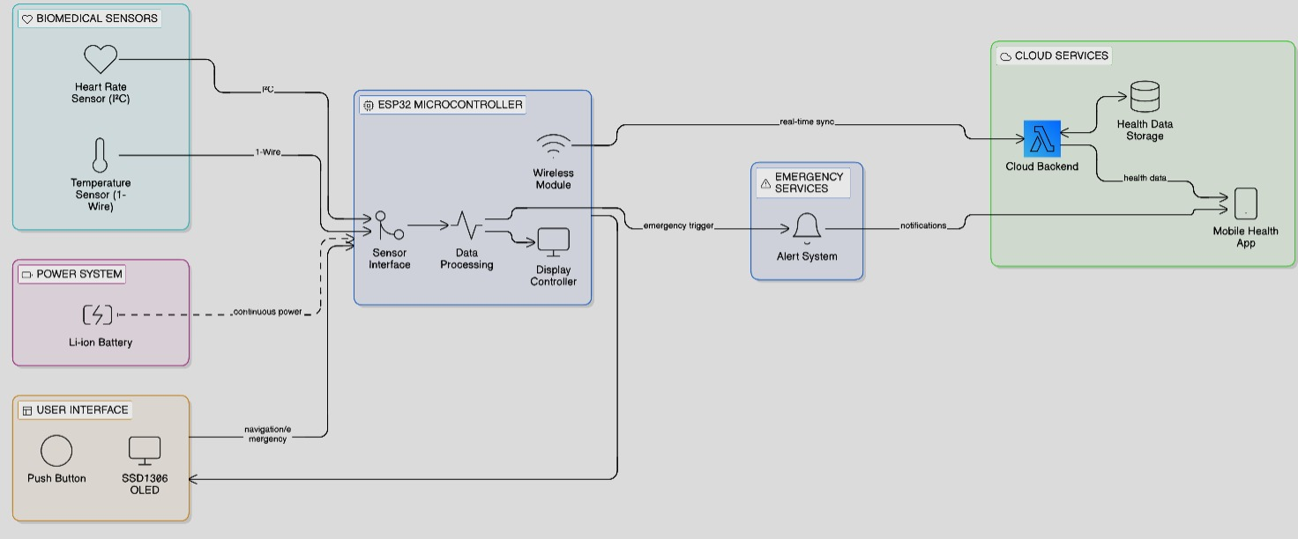
Figure 1: Block diagram of our system

- Working Principle
The proposed system is a wearable ESP32-based smart health monitoring band designed to continuously track important physiological parameters while providing a reliable emergency alert mechanism. The system integrates a MAX30105 optical biomedical sensor to measure heart rate (BPM) and estimate blood oxygen saturation (SpO₂) using photoplethysmography techniques, along with a DS18B20 digital temperature sensor to accurately measure body temperature. A compact SSD1306 OLED display is used to present multiple information screens including Indian Standard Time (IST), heart rate, body temperature, SpO₂ level, BPM trend graph, and overall health status. User interaction is implemented using a single push button, which allows screen navigation through short presses and emergency activation through long-press detection.
The system is powered by a rechargeable 3.7 V Li-ion battery, making it suitable for continuous wearable operation. A TP4056 charging module is used to safely charge the battery through a USB interface, providing protection against over-charging and over-discharging. Since the ESP32 and peripheral components require a stable operating voltage, a DC-DC boost converter is used to regulate and increase the battery voltage to the required level, ensuring stable and uninterrupted system operation. This power management architecture enhances portability, energy efficiency, and operational reliability, while allowing the device to be reused without frequent battery replacement.
When the device is powered on, the ESP32 microcontroller initializes all connected hardware components, establishes a Wi-Fi connection, synchronizes Indian Standard Time (IST) using an NTP server, and connects to the Blynk IoT platform and Twilio messaging service. The MAX30105 sensor continuously emits red and infrared light into the skin and detects variations in reflected light caused by changes in blood volume, enabling the calculation of heart rate and estimation of SpO₂ levels. At the same time, the DS18B20 sensor measures body temperature using the 1-Wire communication protocol, and the ESP32 processes these readings for local display and remote monitoring.
The processed physiological parameters are displayed across multiple OLED interface screens, allowing users to view time, heart rate, body temperature, SpO₂ level, BPM trend graph, and overall health status. During normal operation, the measured health parameters are periodically transmitted to the Blynk cloud platform for real-time visualization and remote monitoring.

When the push button is pressed continuously for approximately three seconds, the system activates emergency mode. In this state, a flashing emergency alert message is displayed on the OLED screen, and an SMS notification is immediately sent through the Twilio communication API to a predefined emergency contact. This integrated working mechanism ensures continuous health monitoring, efficient power management, reliable emergency detection, and instant remote notification, making the system suitable for wearable healthcare monitoring and personal safety applications.
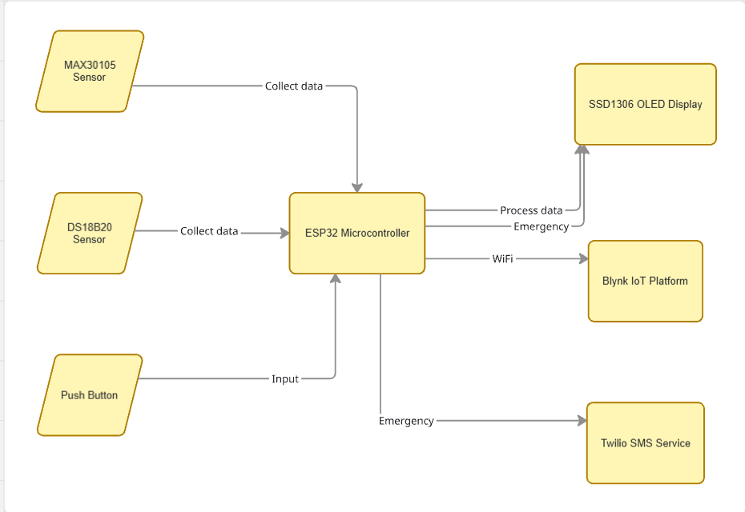
Figure 2: Flow of our system
- Hardware

The proposed wearable health band is built around the ESP32 microcontroller, which functions as the central processing and control unit of the system. The ESP32 is selected due to its high processing capability, integrated Wi-Fi connectivity, and low power consumption, making it well suited for battery-powered wearable healthcare applications. It is responsible for acquiring sensor data, processing physiological parameters, handling user inputs, controlling the display interface, and transmitting health data to cloud platforms for remote monitoring.
The system integrates two biomedical sensors for continuous health monitoring: the MAX30105 optical biomedical sensor and the DS18B20 digital temperature sensor. The MAX30105 sensor measures heart rate (BPM) and estimates blood oxygen saturation (SpO₂) using the photoplethysmography (PPG) principle, where red and infrared light are emitted into the skin and the reflected light variations are analyzed to determine blood volume changes. The sensor communicates with the ESP32 through the I²C communication interface, enabling reliable and efficient data transfer. The DS18B20 temperature sensor measures body temperature using a 1-Wire communication protocol and is supported by a 4.7 kΩ pull-up resistor, ensuring stable and accurate digital temperature readings suitable for wearable health monitoring systems.

The user interface and power subsystem consist of a 128 × 64 SSD1306 OLED display, a push button, and a rechargeable 3.7 V Li-ion battery. The OLED display provides clear visualization of health parameters such as time, heart rate, body temperature, SpO₂ level, BPM trend graph, and system health status, while maintaining very low power consumption. The push button allows users to navigate between different display screens using short presses and activate an emergency alert mode through a long press of approximately three seconds.
To support wearable operation, the device is powered using a rechargeable Li-ion battery, which enhances portability and allows long operating duration. A TP4056 charging module is used for safe battery charging through a USB interface, providing protection against over-charging and over-discharging. In addition, a DC-DC boost converter is employed to regulate and step up the battery voltage to the required operating level for the ESP32 and peripheral components, ensuring stable and uninterrupted system operation.
Furthermore, the ESP32’s built-in Wi-Fi module enables IoT connectivity, allowing the system to transmit health parameters to the Blynk IoT platform for remote monitoring. In emergency situations, the system uses the Twilio messaging service to send instant SMS alerts to predefined contacts, improving user safety and enabling quick response during critical health conditions.

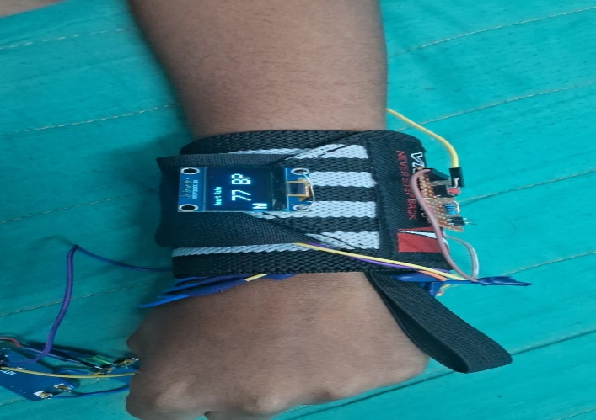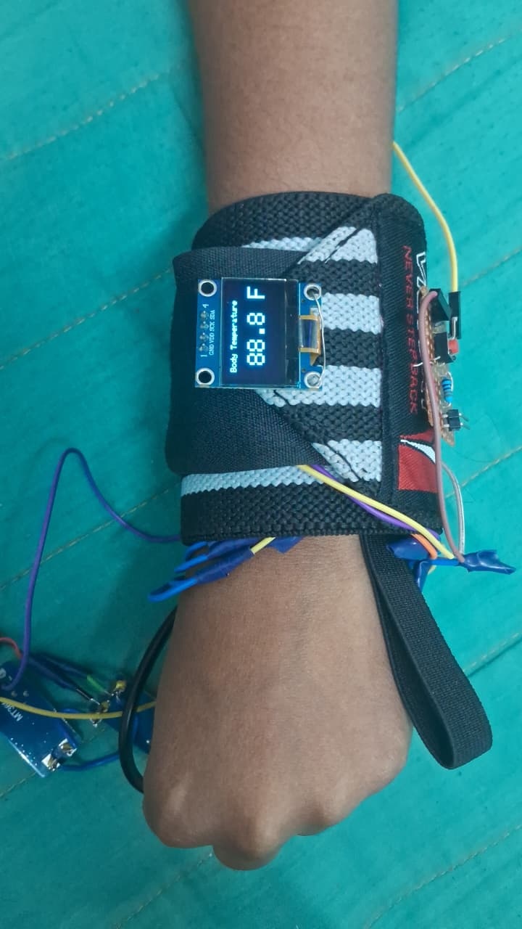

Figure 2: Hardware Setup

- Software Architecture
The software architecture of the proposed wearable health band is designed using a modular and layered approach to ensure reliability, scalability, and real-time performance. The ESP32 microcontroller is programmed using the Arduino IDE in Embedded C/C++, and the software is structured into several functional layers, including sensor data acquisition, data processing, user interface management, communication, and cloud integration. This structured approach enables efficient task execution while maintaining low power consumption, which is essential for wearable healthcare devices.
At the sensor acquisition layer, the ESP32 communicates with the MAX30105 optical sensor using the I²C communication protocol to obtain heart rate signals and infrared data used for estimating blood oxygen saturation (SpO₂). Simultaneously, the ESP32 interfaces with the DS18B20 temperature sensor through the 1-Wire communication protocol to measure body temperature. The raw sensor signals are periodically sampled and processed using appropriate algorithms to calculate heart rate (BPM), SpO₂ percentage, and body temperature values. These processed values are then forwarded to the display control module for real-time visualization.

The user interface layer manages the OLED display and user interaction. The SSD1306 OLED display presents multiple information screens, including current time (IST), heart rate, body temperature, SpO₂ level, BPM trend graph, and overall health status. Screen navigation is controlled through a single push button, allowing users to switch between different display modes easily.
The user interaction and control module implements millis()-based non-blocking timing logic to detect button press durations accurately. Short presses are used to navigate between display screens, while a long press of approximately three seconds activates the emergency mode without interrupting continuous sensor monitoring.
In the communication and cloud integration layer, the ESP32 establishes a Wi-Fi connection and connects to the Blynk IoT platform for remote monitoring. Health parameters such as heart rate, temperature, and SpO₂ levels are periodically transmitted to the Blynk mobile dashboard for real-time visualization. In emergency situations, the system also uses the Twilio messaging service to send instant SMS alerts to predefined emergency contacts, ensuring rapid response and enhanced user safety.
This layered software architecture enables efficient coordination between sensing, processing, user interaction, and network communication, ensuring reliable real-time operation of the wearable health monitoring band.
- Bill of Materials

S.no | Name | Cost
1. | ESP32 | Rs.450
2. | MAX30102 | Rs.210
3. | DS18B20 | Rs.120
4. | OLED display | Rs.150
5. | Push Button | Rs.20
6. | Pull-up resistor | Rs.5
7. | Li-ion Battery (3.7v 500mAh) | Rs.250
8. | TP4056 charging module | Rs.80
9. | Wrist Band | Rs.100
 | Total | Rs.1,385

- Results & Discussions

The proposed ESP32-based wearable health monitoring band was successfully designed, implemented, and tested to monitor important physiological parameters including heart rate (BPM), blood oxygen saturation (SpO₂), and body temperature in real time. The system demonstrated reliable acquisition of physiological data using the MAX30105 optical sensor for heart rate and SpO₂ measurement and the DS18B20 digital temperature sensor for body temperature monitoring. The collected sensor data was accurately processed by the ESP32 microcontroller, ensuring stable and consistent physiological parameter readings.

The real-time measurements were clearly displayed on the SSD1306 OLED display, allowing users to monitor their health parameters directly from the wearable device. The OLED interface successfully presented multiple information screens including Indian Standard Time (IST), heart rate, body temperature, SpO₂ level, BPM trend graph, and overall health status, enabling convenient visualization of health data.
The push-button-based user interface functioned effectively, enabling seamless navigation between different display screens through short presses. The emergency alert feature, activated by a continuous button press of approximately three seconds, reliably triggered the emergency mode without false activation. This confirmed the effectiveness of the millis()-based non-blocking timing logic, which allows accurate button press detection while maintaining uninterrupted sensor monitoring.
When emergency mode was activated, a flashing emergency alert message was displayed on the OLED screen, providing clear visual indication. At the same time, the system successfully sent an SMS alert through the Twilio messaging service to a predefined emergency contact, ensuring immediate notification and response capability.
Integration with the Blynk IoT platform enabled successful wireless transmission, visualization, and logging of health parameters on a mobile dashboard. The system was able to transmit heart rate, body temperature, and SpO₂ data in real time, allowing remote monitoring through the Blynk mobile application.
Overall, the experimental results confirm that the proposed wearable health band effectively achieves its intended objectives of accurate real-time health monitoring, reliable emergency alert functionality, and IoT-based remote data visualization, while maintaining low power consumption, portability, and user convenience. The system demonstrates strong potential for applications in personal healthcare monitoring, elderly care, and wearable safety devices.
- Future Scope and Applications

The proposed wearable health monitoring band provides a solid foundation for the development of advanced smart healthcare systems and can be further enhanced in several ways. Additional biomedical sensors such as ECG sensors, blood pressure monitoring modules, and respiratory sensors can be integrated to enable more comprehensive physiological monitoring. Since the current system already measures heart rate, body temperature, and blood oxygen saturation (SpO₂), the addition of these sensors would allow the device to perform multi-parameter health analysis and provide deeper insights into a user’s medical condition.
The system can also be extended by incorporating advanced signal processing techniques and machine learning algorithms to automatically detect abnormal health patterns, identify early symptoms of medical conditions, and predict potential health risks. Integration of a GPS module would enable real-time location tracking during emergency situations, allowing caregivers or medical personnel to quickly locate the user when an alert is triggered. Furthermore, improved cloud connectivity and data management systems could enable long-term health data storage, trend analysis, and secure access by healthcare professionals for continuous monitoring and diagnosis.
Further optimization of power management techniques, including efficient sleep modes and low-power communication protocols, can significantly improve battery life and make the device more suitable for continuous long-term wearable use.

The proposed system has wide applicability in both personal and professional healthcare environments. It can be used for continuous personal health monitoring, particularly for elderly individuals, patients with chronic illnesses, and individuals requiring regular observation of physiological parameters. The integrated emergency alert mechanism makes the system highly suitable for home healthcare and assisted living environments, where rapid medical response may be necessary.
In addition, the device can support remote patient monitoring, enabling doctors and caregivers to track vital parameters through IoT cloud platforms such as Blynk. The wearable band can also be adapted for fitness monitoring, rehabilitation support, and preventive healthcare, helping users maintain awareness of their health status and encouraging proactive health management.

- Project Outcomes
The successful implementation of the proposed project resulted in the development of a functional and reliable wearable health monitoring band capable of measuring heart rate (BPM), blood oxygen saturation (SpO₂), and body temperature in real time. The system effectively integrates biomedical sensors with the ESP32 microcontroller to acquire, process, and display physiological data on a compact SSD1306 OLED display, thereby fulfilling the primary objective of continuous and accessible health monitoring.
The project also demonstrated an efficient user interaction mechanism using a single push button, which allows seamless navigation between different display screens and reliable activation of an emergency alert mode using millis()-based non-blocking timing logic. The emergency feature was observed to operate consistently without false triggering, providing a dependable safety mechanism for users during critical situations.
Furthermore, the integration of Wi-Fi connectivity and the Blynk IoT platform enabled successful wireless transmission, visualization, and monitoring of physiological parameters through a mobile dashboard. In addition, the Twilio SMS alert system ensured that emergency notifications were immediately sent to predefined contacts when the emergency mode was activated, demonstrating the system’s capability for remote health monitoring and rapid response during emergencies.
Overall, the results confirm that the proposed system is cost-effective, portable, scalable, and energy-efficient, making it suitable for wearable healthcare monitoring applications. The project establishes a strong foundation for further enhancements such as advanced sensor integration, cloud-based health analytics, and intelligent healthcare monitoring systems, enabling its potential use in real-world healthcare environments
REFERENCES (IEEE Style)
  - Majumder, A. K. Roy, T. Mondal and M. J. Deen, "Flexible Sensors for IoT-Based Health Monitoring," in IEEE Journal on Flexible Electronics, vol. 4, no. 2, pp. 63-88, Feb. 2025, doi: 10.1109/JFLEX.2025.3538808.
  - Thottempudi, P., Konduru, R. M., Valiveti, H. B., Kuraparthi, S., & Kumar, V. (2025). Digital health resilience: IoT solutions in pandemic response and future healthcare scenarios. Discover Sustainability, 6(1), 144.
  - Bollineni, C., Sharma, M., Hazra, A., Kumari, P., Manipriya, S., & Tomar, A. (2025). IoT for next-generation smart healthcare: A comprehensive survey. IEEE Internet of Things Journal.
  - Georgieva-Tsaneva, G., Cheshmedzhiev, K., Tsanev, Y. A., Dechev, M., & Popovska, E. (2025). Healthcare monitoring using an Internet of Things-based cardio system. IoT, 6(1), 10.

  - Raja, G. B. (2025). Advancements of IoT and sensor informatics in wearable, implantable, mobile, and remote healthcare. In Innovations in Biomedical Engineering (pp. 87-121). Academic Press.
  - Robin, C. R., & Thuhfa, M. A. (2025, April). Smart Health Monitoring for Industrial Workers: A Predictive IoT Solution for COPD and Asthma. In 2025 International Conference on Computing and Communication Technologies (ICCCT) (pp. 1-6). IEEE.
  - Lakshmi, S. G., Lalitha, C. N., Lavanya, S., Vijaya, L. S., & Sri, L. P. S. (2025). IOT-enabled cloud solutions for reliable health monitoring. In Emerging Trends in Computer Science and Its Application (pp. 278-282). CRC Press.
  - Baiense, J., Zdravevski, E., Coelho, P., Pires, I. M., & Velez, F. J. (2025). Driving Healthcare Monitoring with IoT and Wearable Devices: A Systematic Review. ACM Computing Surveys, 57(11), 1-38.
  - Naveed, M. H., Samin, O. B., Bilal, M., & Waseem, M. (2025). IoT Based Health Monitoring with Diet, Exercise and Calories recommendation Using Machine Learning. Human-Centric Intelligent Systems, 5(2), 246-258.
  - Rajaram, G., Padmamalini, N., Praveen, D. S., & Malarkodi, K. (2025, April). An Intelligent IoT-Enabled Healthcare Framework for Early Cardiovascular Disease Detection Using a Hybrid Deep Learning Model. In 2025 8th International Conference on Trends in Electronics and Informatics (ICOEI) (pp. 608-613). IEEE.

CONTRIBUTION TO SUSTAINABLE DEVELOPMENT GOALS

Title of the Project : HealthX-CPS based Smart Health Band
Project Member(s) Name & Register Number :
CB.EN.U4EEE23104 Anusree Mannathuparambu Satheeshkumar
CB.EN.U4EEE23126 Ponabirami A
CB.EN.U4EEE23155 Harshita VP

Guide Name & Designation : Dr. K.R.M. Vijaya Chandrakala, Associate Professor, Department of Electrical and Electronics, School of Engineering, Coimbatore

SDGs | Justification to the Contribution
3 (Good health and well-being) | The proposed wearable health band enables continuous monitoring of vital health parameters such as heart rate and body temperature, supporting early detection of health abnormalities and promoting preventive healthcare, thereby contributing directly to improved health and well-being.
9 (Industry, Innovation and Infrastructure) | The project promotes technological innovation through the development of a low-cost, IoT-enabled wearable healthcare device using ESP32 and cloud platforms, encouraging research, innovation, and smart healthcare infrastructure.
10 (Reduced Inequalities) | By providing an affordable and accessible health monitoring solution, the system helps bridge the healthcare gap for elderly individuals, patients, and economically disadvantaged populations, thereby reducing inequalities in access to healthcare services.
11 (Sustainable Cities and Communities) | The system supports smart healthcare initiatives within communities by enabling remote health monitoring and emergency alerts, contributing to safer, healthier, and more resilient urban and rural communities.
12 (Responsible Consumption and Production) | The use of energy-efficient components, rechargeable Li-ion batteries, and modular design promotes responsible resource usage, reduced electronic waste, and sustainable product development practices.
17 (Partnerships for the Goals) | Integration with cloud platforms such as Blynk enables collaboration between users, caregivers, healthcare providers, and technology platforms, fostering partnerships that support sustainable healthcare solutions.



