1.four types of access modifier

1. Default
2. Public
3. Private
4. Protected

1.Default:

When access is not specified it is considered as default. The scope of default level specifier within the package.

2.Public:

The entity is accessible throughout from within or outside class, within or outside the package.

3.Protected:

It allows access to entities through child class and parent class in which the entity is declared.

4.Private:

It is accessible only within the class. It is not accessible outside the class.

2.Difference between exception and error?

Error:

Errors indicate unrecoverable system issues beyond program control.

Exception:

Exception represent unexpected events within the program that can often be handled.

3.What is the difference between checked exception and unchecked exception?

Checked Exception:

Java itself will know it might throw an exception and it will you to handle forcefully.

Types:

* IOException
* FIleNotFound Exception
* SqlException

Unchecked Exception:

It is an Runtime Exception. It is not compulsory to handle it.

Types:

* Arithmetic Exception
* ArrayIndexOutofBound Exception
* Null Pointer Exception

It will have try and catch block.

Try Block:

If the exception occurs in first line of statement it will not proceed to execute the other statement present in the block.

Catch Block:

At a time only one exception can occur and only one catch block is executed.

All catch block must be ordered from more specific to general.

Finally block:

It is used to execute the important part of code.

Even if you don’t handle exception, before terminating the program JVM will execute finally block.

4.Divison by 0

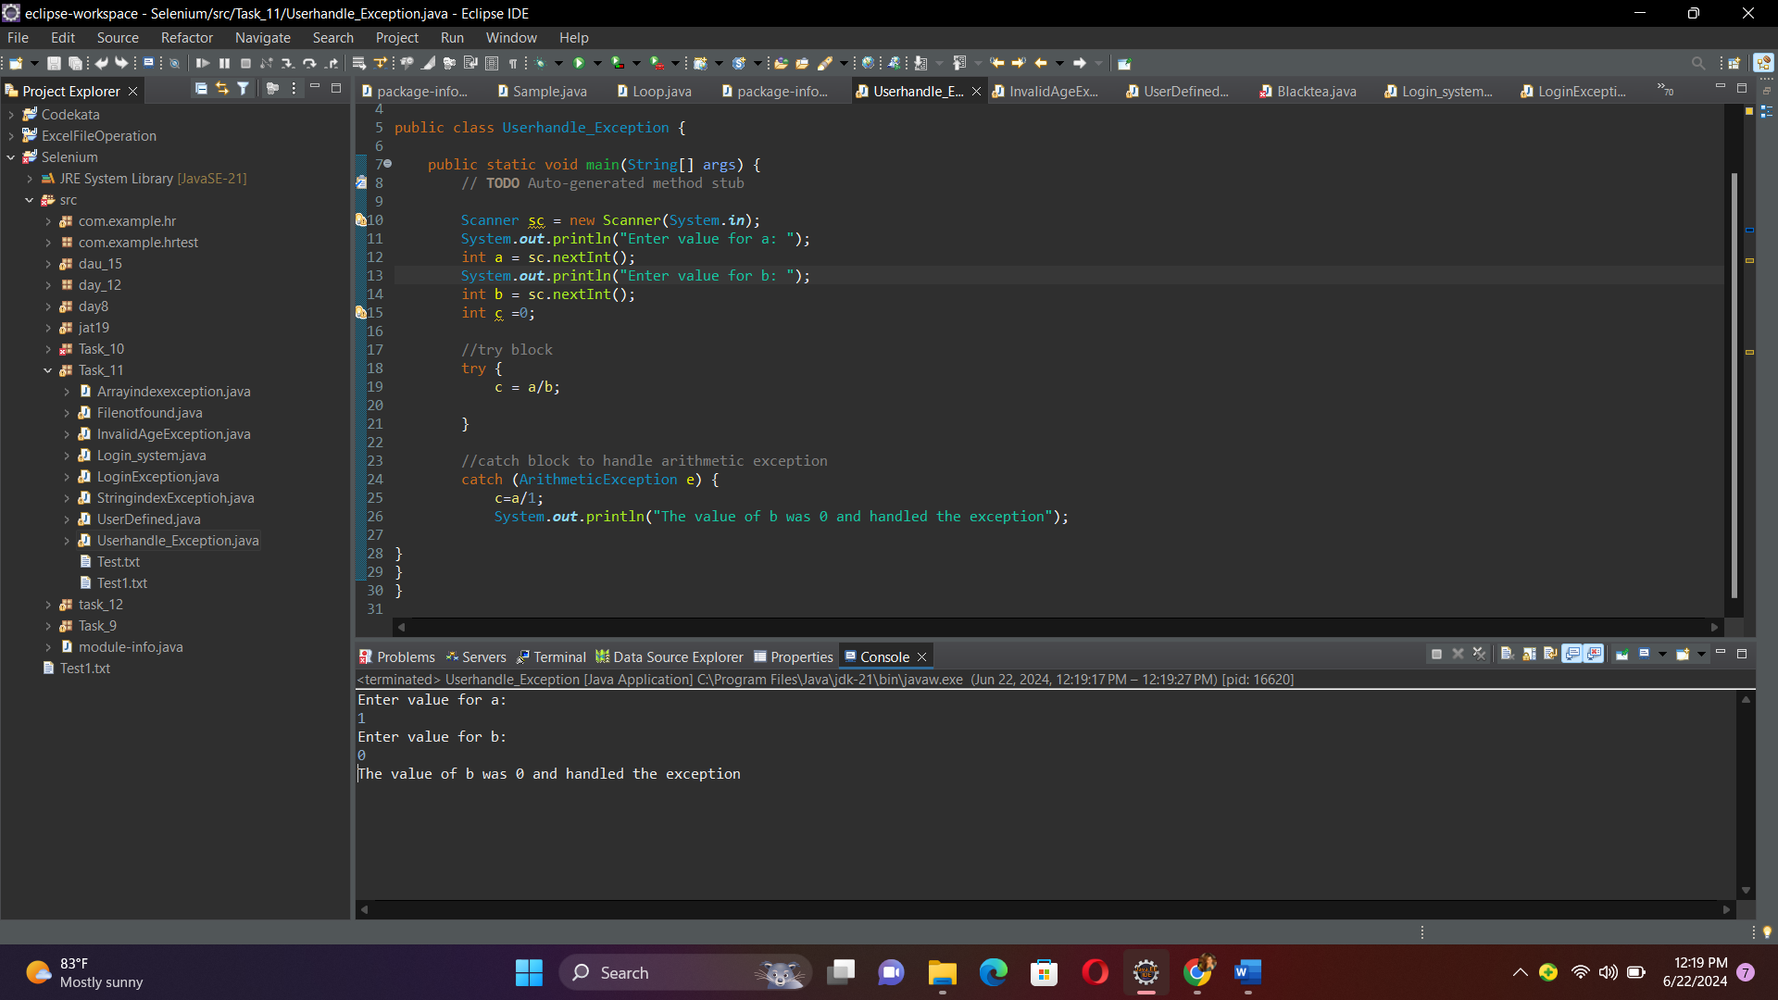

6.login system

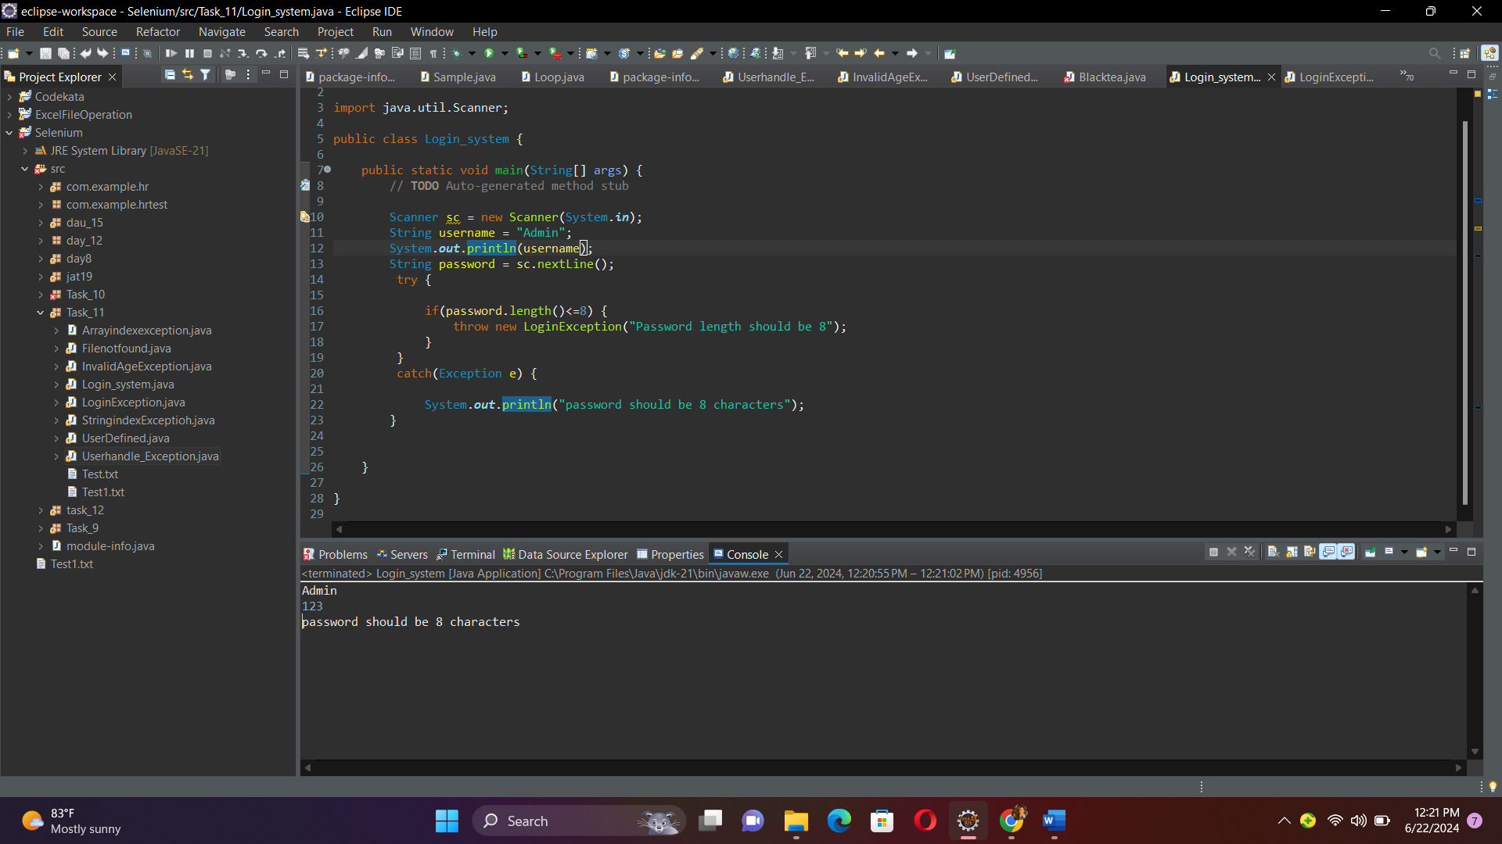

5.ArrayindexoutofException and StringIndexoutofException

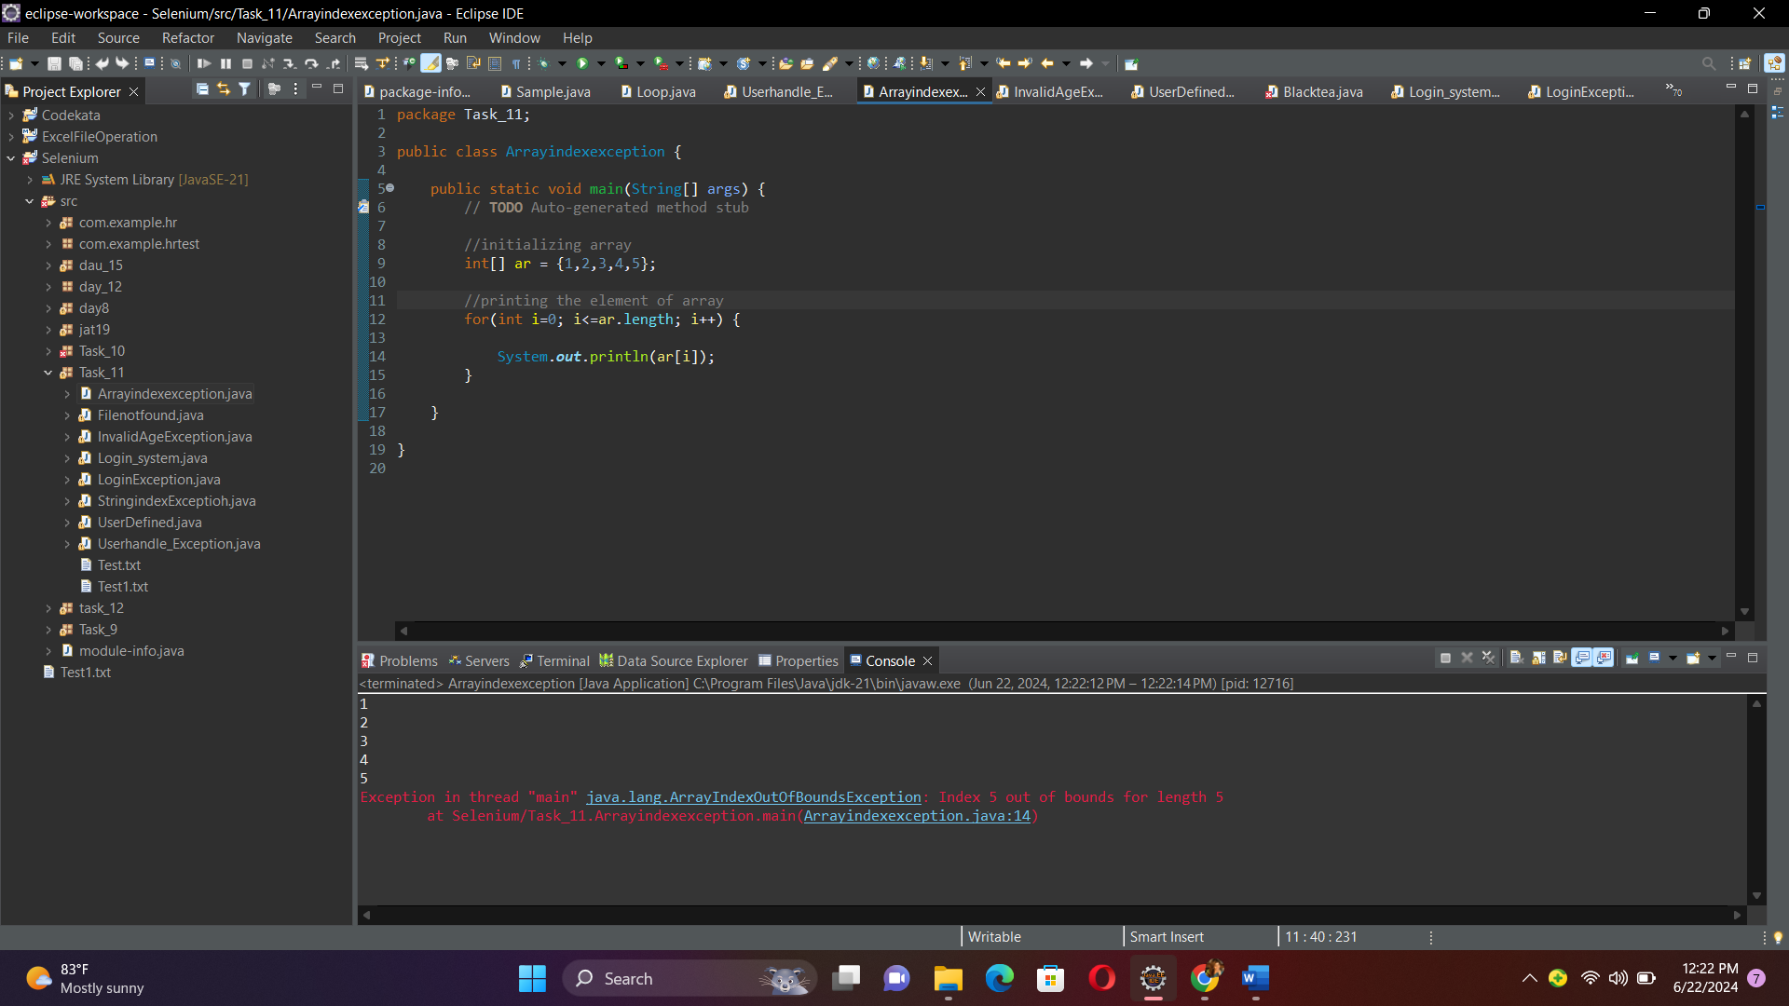

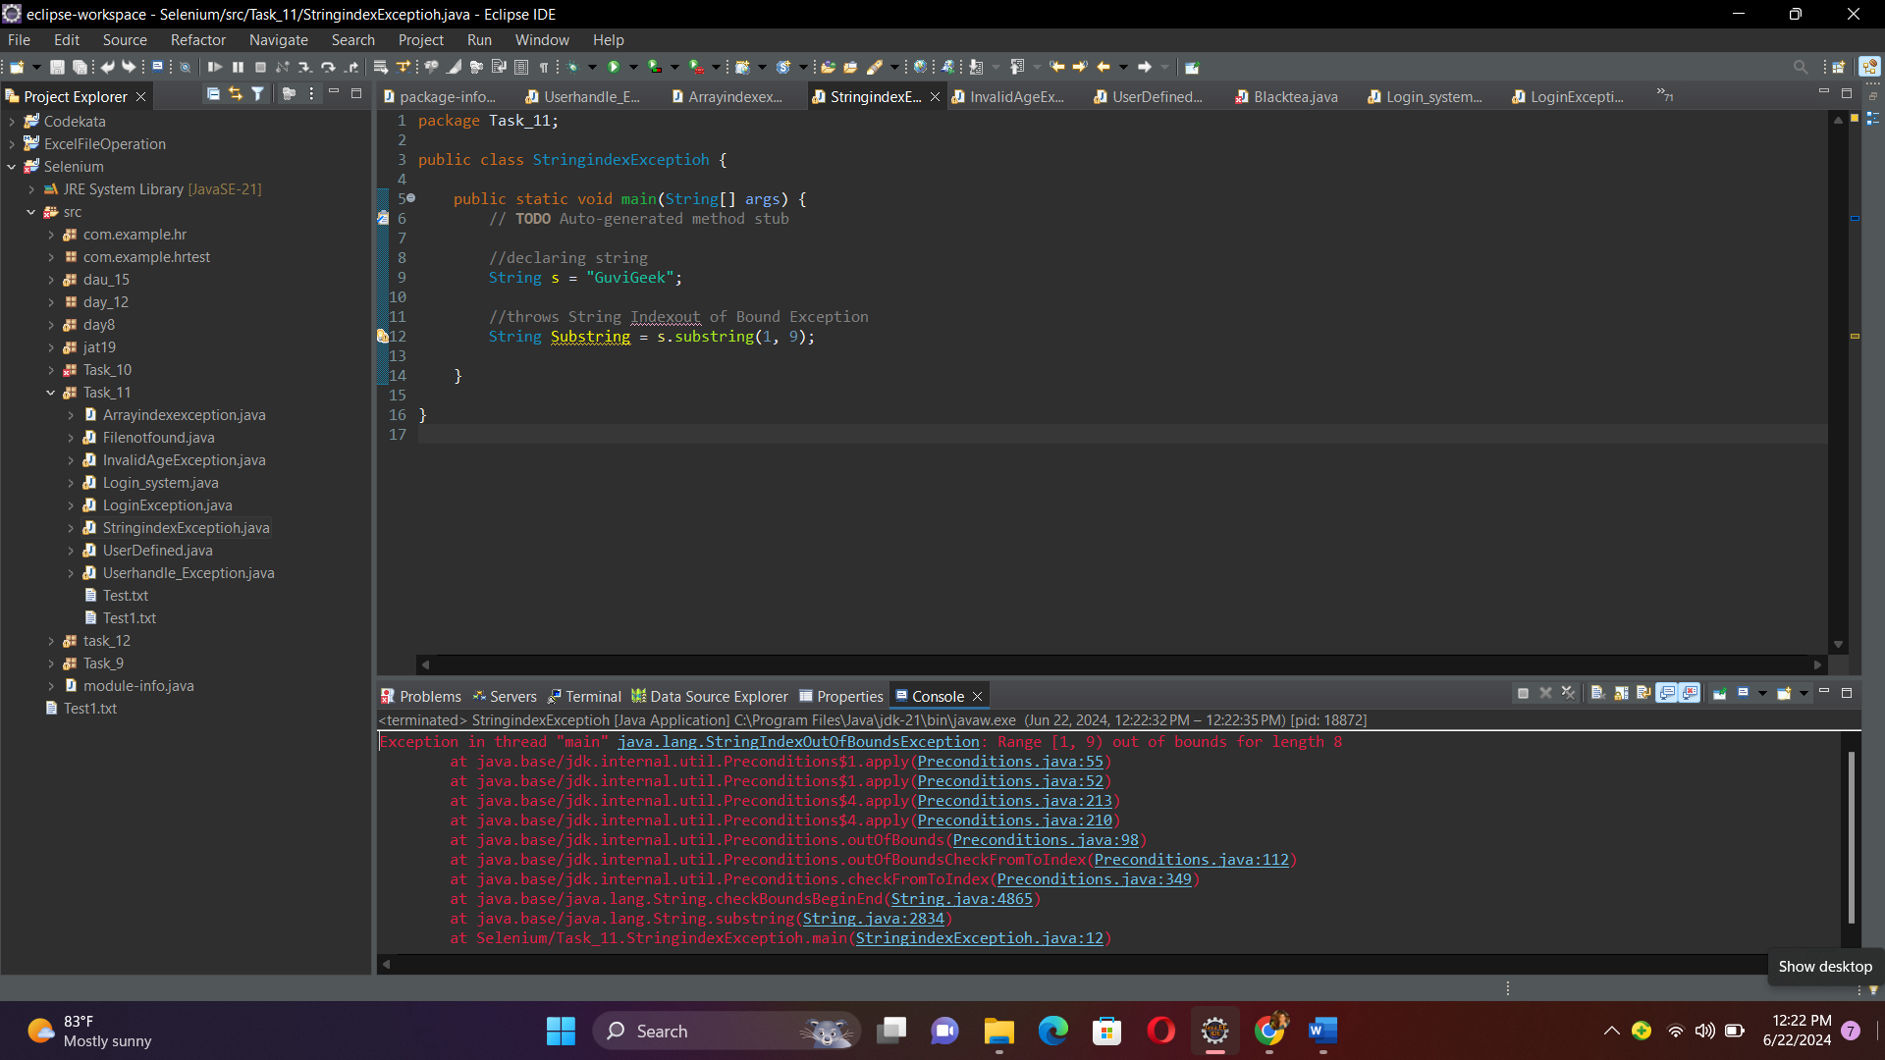



7.Invalid age exception

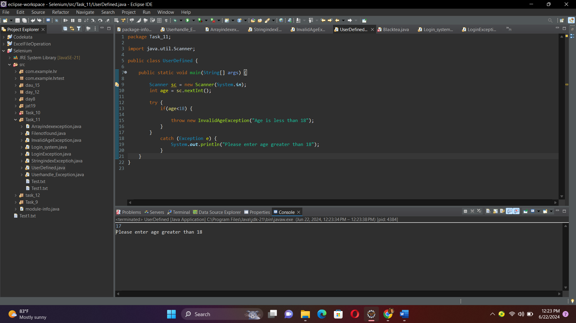

8.FileindexoutofException

