Using Valid input
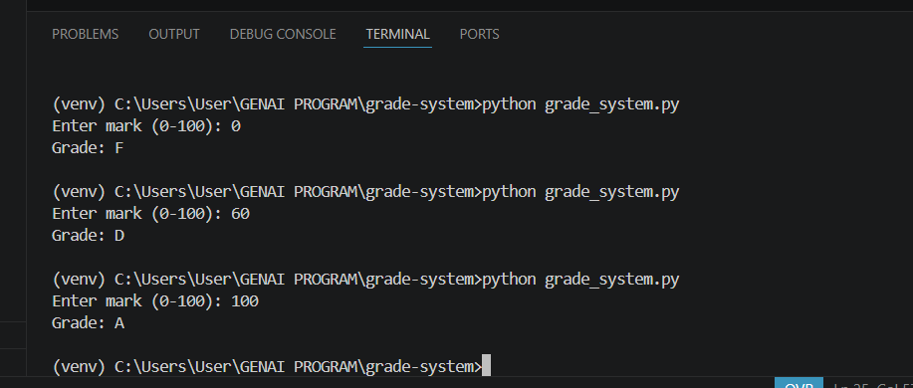

Using >100 and <0
In try block I am checking if it is valid input then call the function grade else throw error message
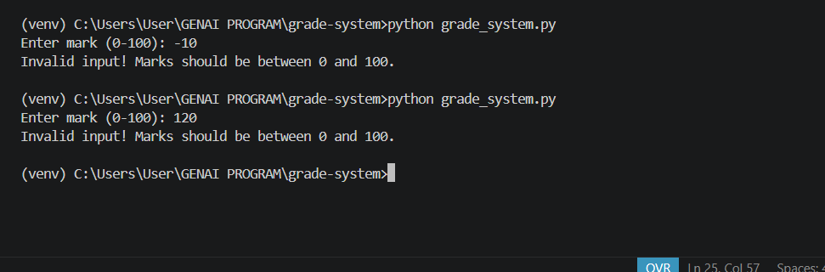

Using string
If user entered string value it will be handled in except block

