Test Evidence for Scenarios: Online Bookstore

**Scenarios**

The core features of the application tested in Unit testing are.

* Test Scenario 1: Browsing books by category.
* Test Scenario 2: Adding items to the shopping cart.

**Test cases status:**

1. Total test cases: 15
2. Passed Test cases :15
3. Failed Test cases :0

**The below screenshot 1 consists of the passed status results for the fifteen executed test cases**

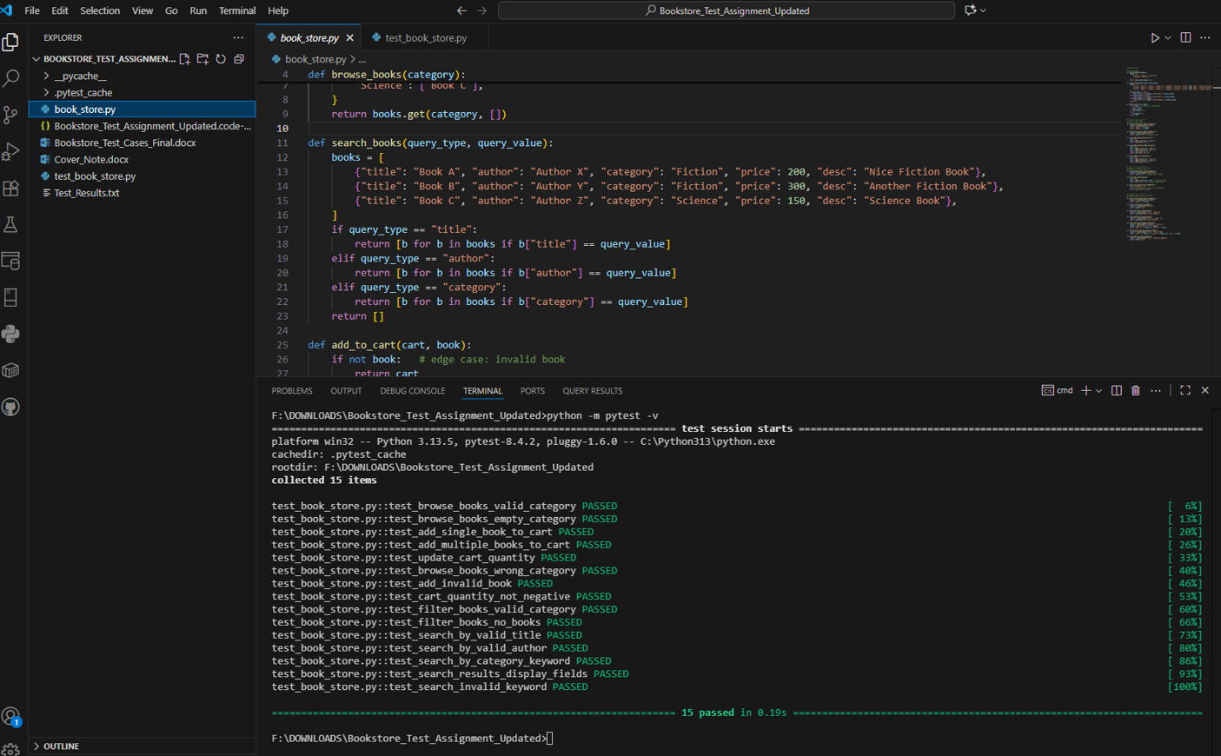

**screenshot 2 : Consists of the accumulated passed status of all fifteen test cases**

