A CRM Application to Manage the Services offered by an Institution
Phase 2: Org Setup & Configuration
Step 1: Goal of Phase 2
- Prepare Salesforce environment.
- Setup Users, Roles, Profiles, Permissions.
- Configure Company Info, Business Hours, Holidays, Fiscal Year.
- Expected Outcome (Phase 2 Goal): Org ready for Phase 3 (Data Modeling & Relationships).

Step 2: Salesforce Editions
- Use Developer Edition Org (free).
- Already account exists → login.
- Dev Org = sandbox for build/test.
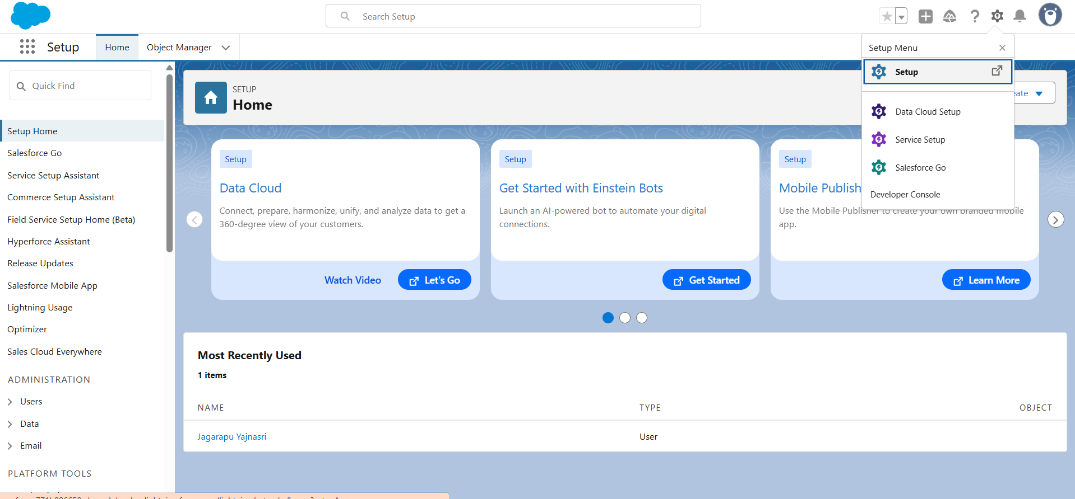

Step 3: Company Profile Setup
- Setup → Company Settings → Company Information.
- Fill details: Name, Timezone, Currency.
- Save.
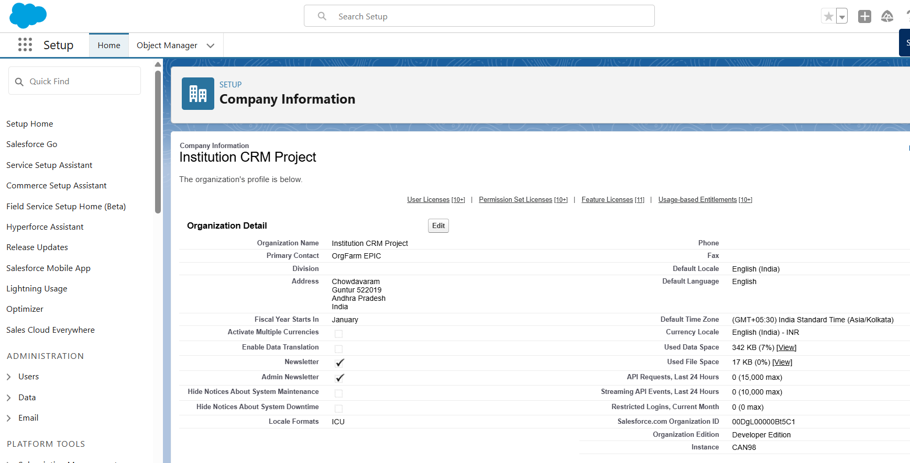

Step 4: Business Hours & Holidays
- Setup → Business Hours → New → 9 AM – 6 PM.
- Holidays → Add public holidays.
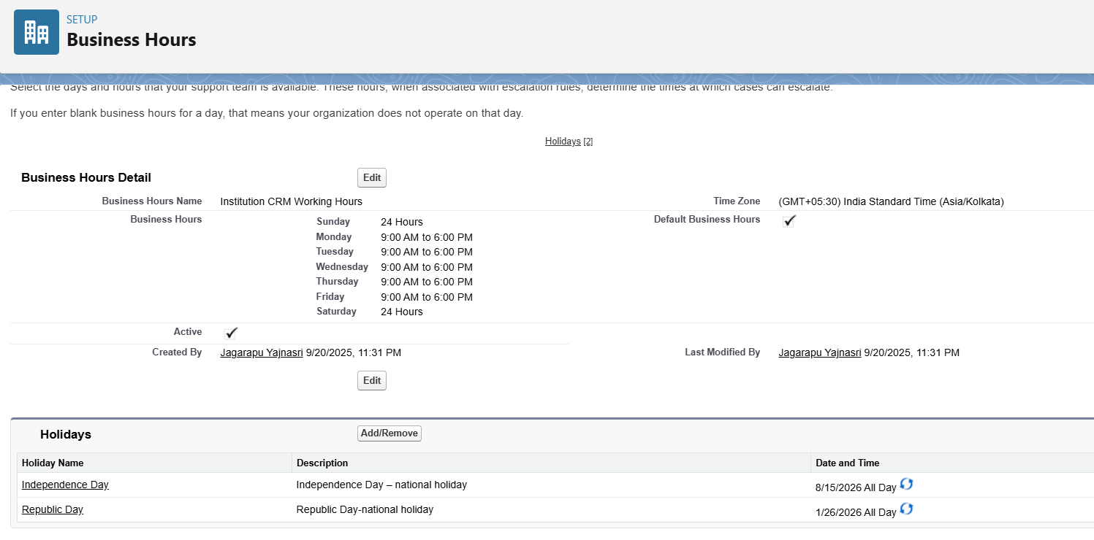
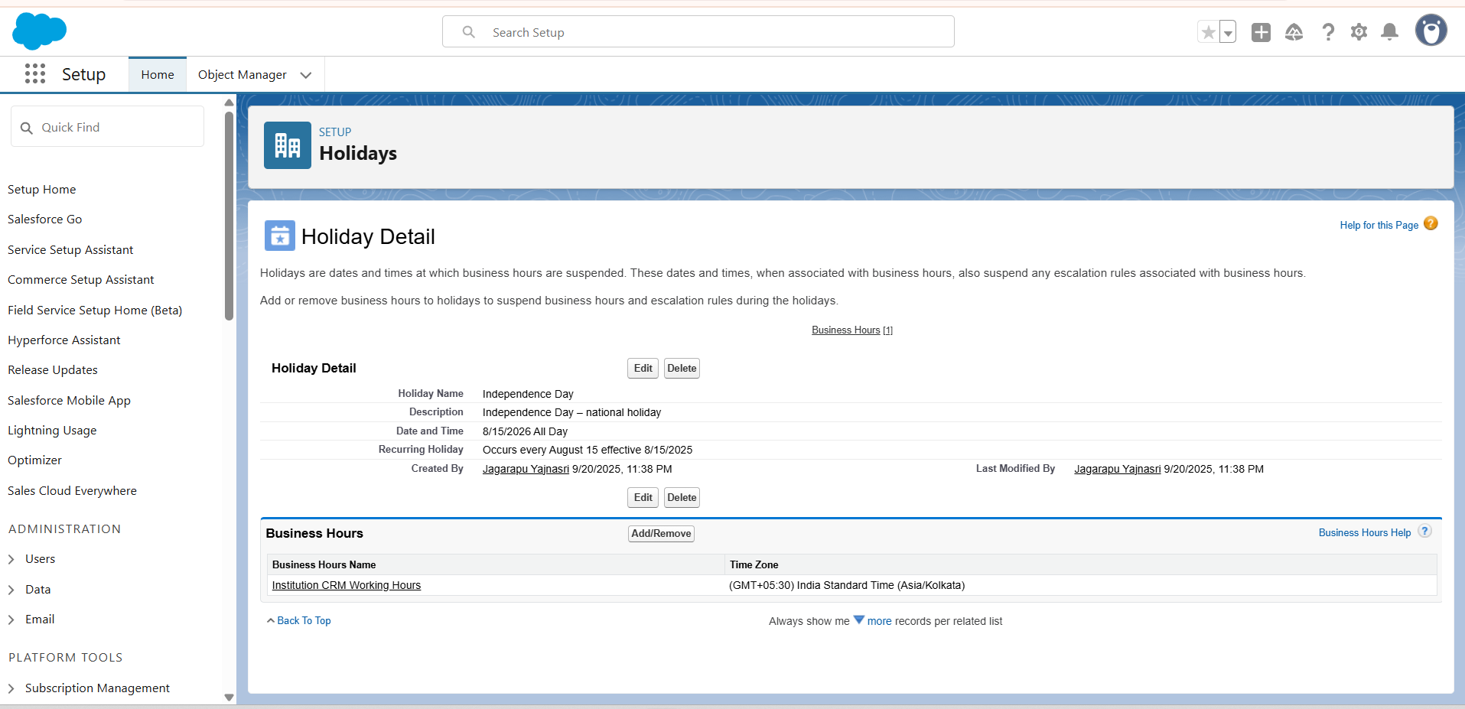

Step 5: Fiscal Year settings
- Setup-> Fiscal Year -> standard (jan-Dec)
- Save

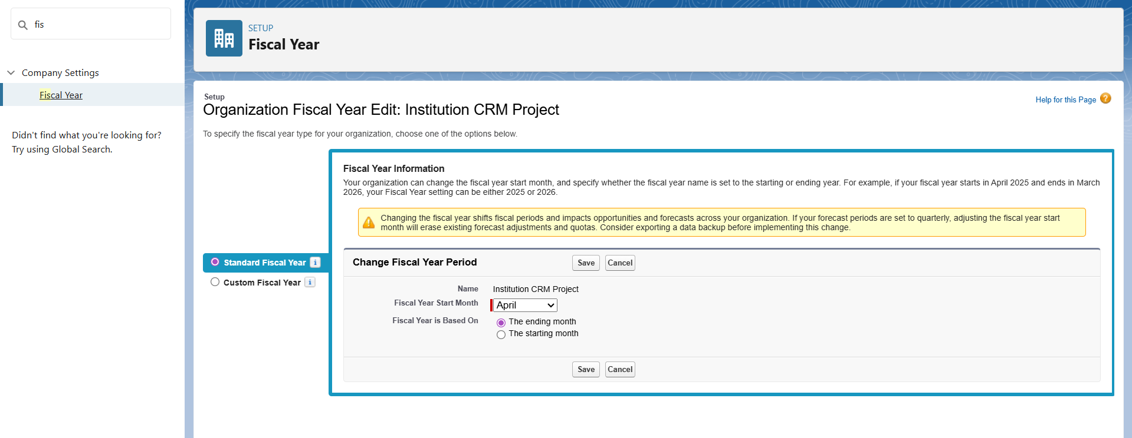
Step 6: Users & Licenses
- Setup → Users → New User
- Create: Admin, Manager, Collection Staff
- Assign Salesforce license
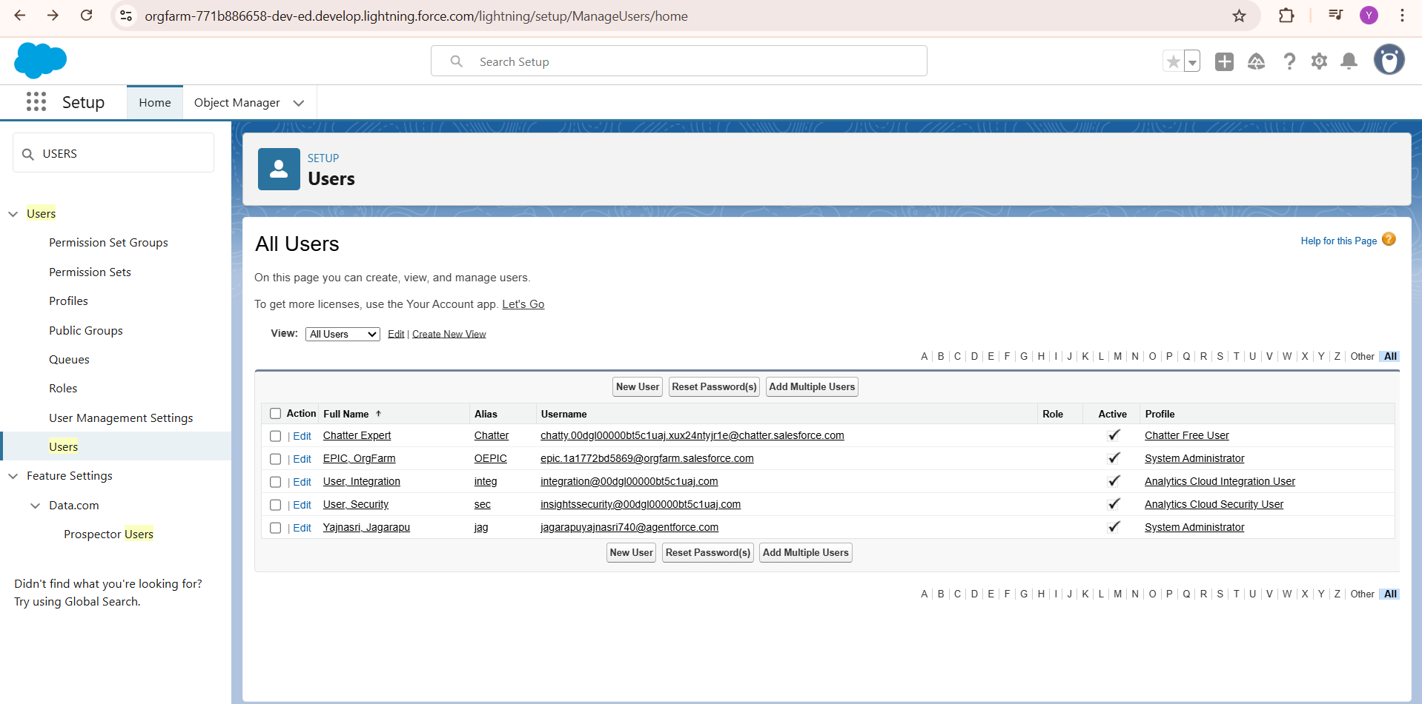
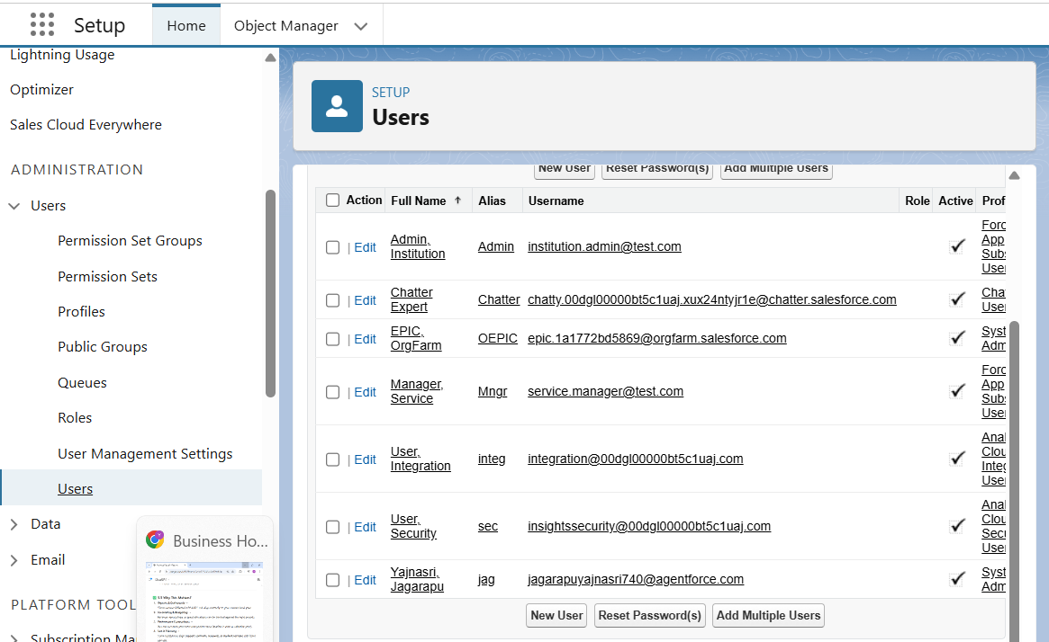
Step 7: Profiles
- Collection Staff → create/update tasks
- Manager → full access
- Admin → full + setup permissions
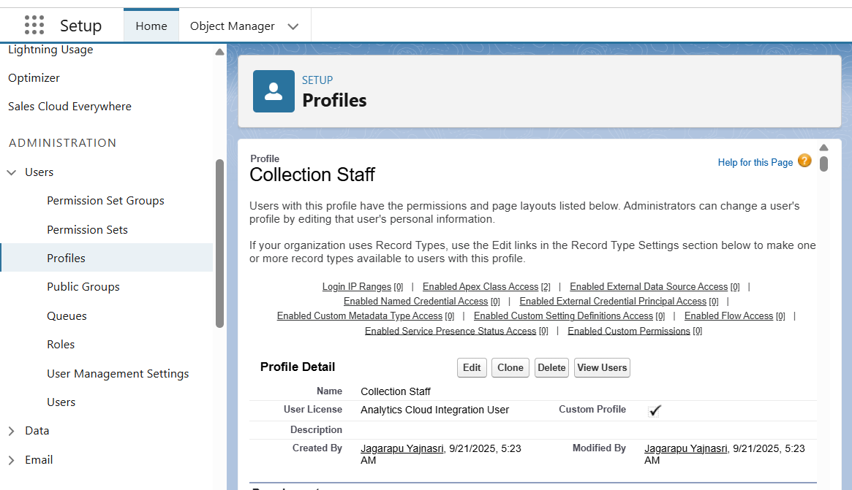

Step 8: Roles & Hierarchy
- Manager → Top
- Collection Staff → Below Manager
- 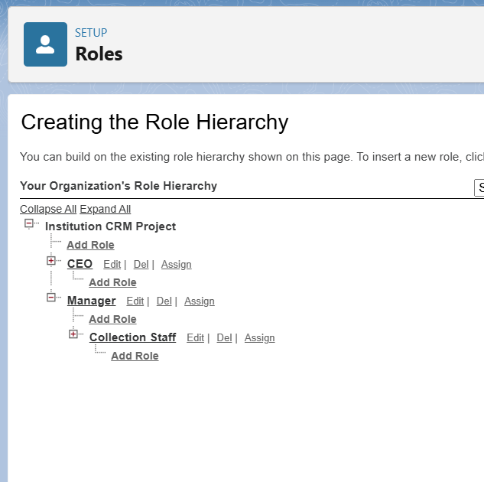

Step 9: Permission Sets
- Provide extra access for specific users by creating Permission Sets.
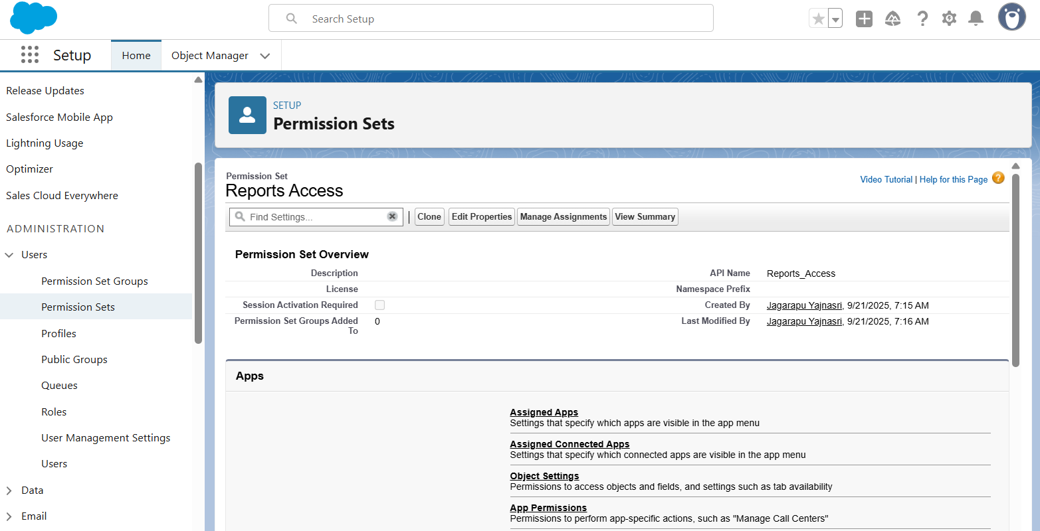

Step 10: Org-Wide Defaults (OWD)
- Sensitive/Personal Data → Private
- Reference Data (like courses, programs) → Public Read Only
- Collaboration Data (like service requests) → Public Read/Write
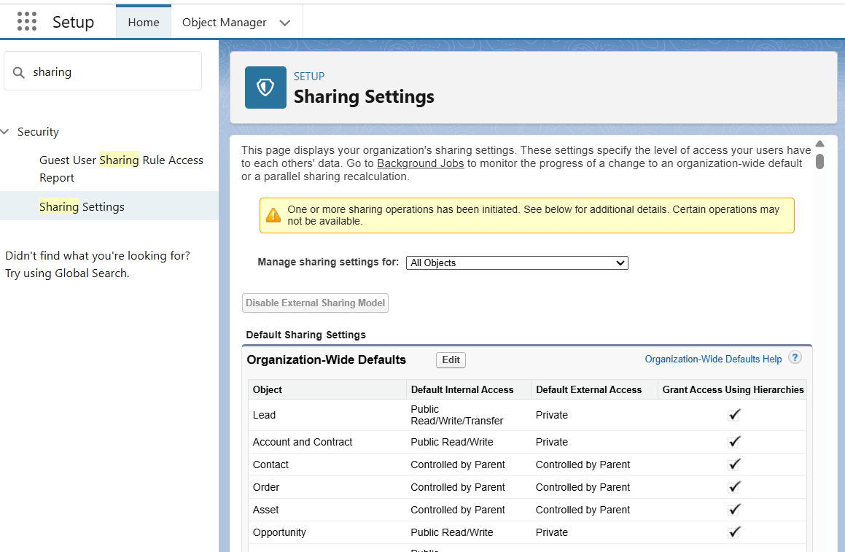

Step 11: Sharing Rules
- Create a rule to share CollectionRecord__c with Manager.

Step 12: Login Access Policies
- Restrict login hours for Collection Staff → 9 AM – 6 PM.
- 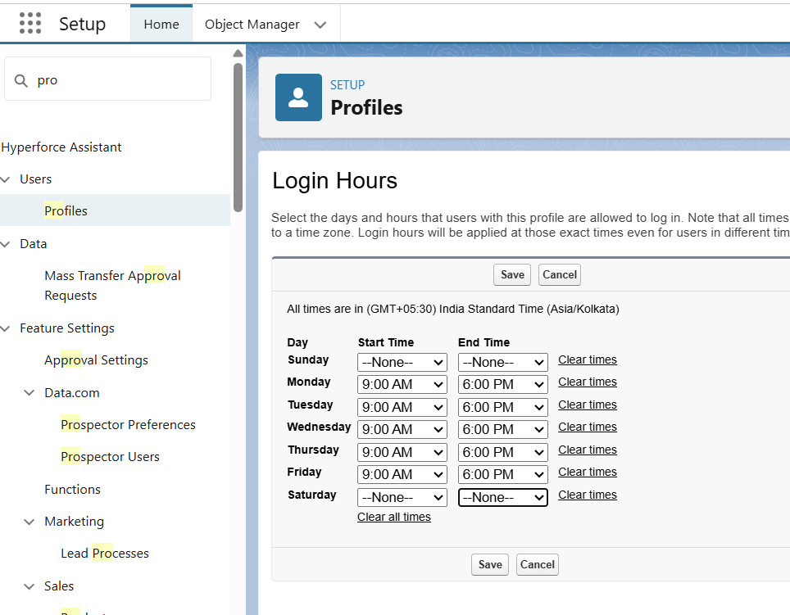

Step 13: Dev Org & Sandbox
- Build configurations in Developer Org.
- Sandbox → mirrors production for testing & practice.

Step 14: Deployment Basics
- Move changes sandbox → production using:
  - Change Sets
  - VS Code + SFDX

Step 15: Expected Outcome (Phase 2 Completion)
- Salesforce org fully setup.
- Users, Roles, Profiles, Permission Sets, OWD, Business Hours, Holidays configured.

