1. The Line Chart: Tracking Trends
- Dataset: AirPassengers (Historical airline passenger data).
- Why: To visualize the "flow of time" and the velocity of growth.
- Psychological Win: It prevents the viewer from seeing data as isolated snapshots and forces them to see the continuous narrative of growth.
R code:

# Saving for Linux
png("traffic_trend.png")

# Using 'AirPassengers' dataset
data(AirPassengers)
plot(AirPassengers, col="blue", lwd=2,
main="Monthly Passenger Traffic (1949-1960)",
xlab="Year", ylab="Total Passengers",
sub="Psychological Win: Visualizing the flow of time")
dev.off()

Output:
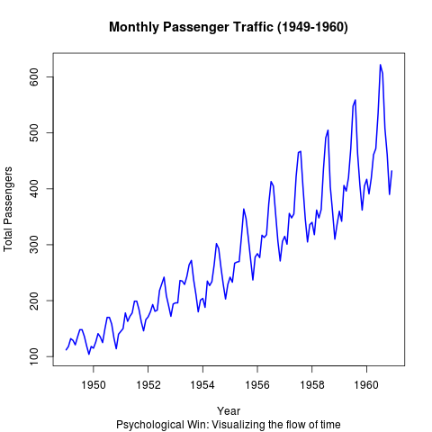

2. The Bar Chart: Categorical Ranking
- Dataset: mtcars (Motor Trend Car Road Tests).
- Why: Humans are extremely accurate at judging differences in length/height from a common baseline.
- Psychological Win: It makes "Who is winning?" or "Which category is the biggest?" instantly obvious without needing to read raw numbers.
R code:

png("car_comparison.png")

# Counting how many cars have 4, 6, or 8 cylinders
cyl_counts <- table(mtcars$cyl)

barplot(cyl_counts, col=c("skyblue", "orange", "red"),
main="Car Count by Cylinder",
xlab="Number of Cylinders", ylab="Number of Cars",
sub="Psychological Win: Instant ranking via relative heights")

dev.off()

Output:
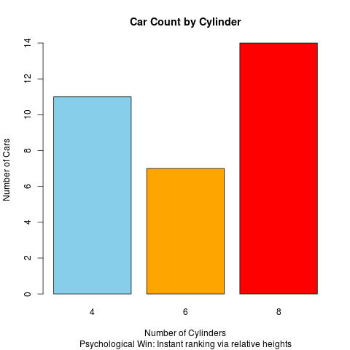

3. The Scatter Plot: Correlation Analysis
- Dataset: trees (Girth and Volume of Black Cherry Trees).
- Why: To identify the relationship between two variables and spot outliers.
- Psychological Win: It answers the "What if?" question. For example: "If Girth increases, what happens to Volume?"
R code:

png("tree_correlation.png")
# Relationship between Tree Girth and Volume
data(trees)
plot(trees$Girth, trees$Volume, pch=19, col="darkgreen",
main="Tree Girth vs Volume",
xlab="Girth (inches)", ylab="Volume (cubic ft)")
# Adding a trend line (Linear Regression)
abline(lm(Volume ~ Girth, data=trees), col="red", lwd=2)
dev.off()

Output:

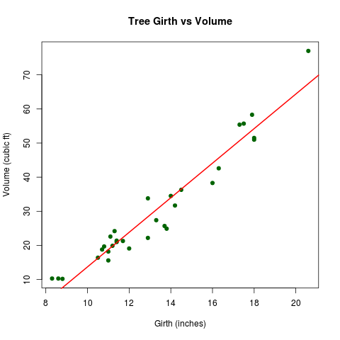

4. The Boxplot: Quality & Consistency
- Dataset: chickwts (Chicken weights based on different feed types).
- Why: A simple average can be misleading; a boxplot shows the distribution and variance.
- Psychological Win: It visualizes Risk and Consistency. It tells the viewer: "How much can I trust this specific group?"
R code:

png("feed_consistency.png")
# Comparing weights across different feed types
data(chickwts)
boxplot(weight ~ feed, data=chickwts, col="lightgray", las=2,
main="Chicken Weight by Feed Type",
ylab="Weight (grams)",
sub="Psychological Win: Visualizing Risk and Consistency")
dev.off()

Output:

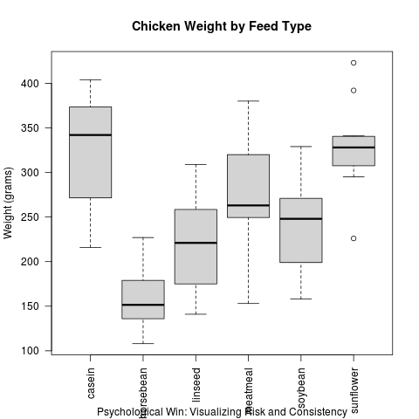

5. The Histogram: Frequency Distribution
- Dataset: faithful (Waiting time between eruptions for the Old Faithful geyser).
- Why: It reveals the "density" and underlying patterns of a population.
- Psychological Win: It reveals the "Normal Curve" (the bell curve) or Bi-modal patterns (two distinct peaks).
R code:

png("eruption_frequency.png")
# Distribution of waiting time between eruptions
data(faithful)
hist(faithful$waiting, col="darkorchid", border="white",
main="Waiting Time Between Eruptions",
xlab="Minutes", ylab="Frequency",
sub="Psychological Win: Revealing the Distribution Density")
dev.off()

Output:
