**Contiki installation.**

1. Install Linux based operating system preferably (UBUNTU).

2. Install git package

$ **sudo apt-get install git.**

3. Install msp430-gcc toolchain.

$ **sudo apt-get install build-essential binutils-msp430 gcc-msp430 msp430-libc msp430mcu mspdebug binutils-avr gcc-avr gdb-avr avr-libc avrdude openjdk-7-jdk openjdk-7-jre ant libncurses5-dev**

4. Use git clone cmd from terminal to download contiki OS.

$ **git clone** [**https://github.com/contiki-os/contiki.git**](https://github.com/contiki-os/contiki.git)

**/home/user/ . In this document we refer to it as [INSTALL DIR]**

**Starting Cooja simulation.**

1. To start cooja simulation.

**$ cd [INSTALL DIR]/tools/cooja/**

**$ ant run.**

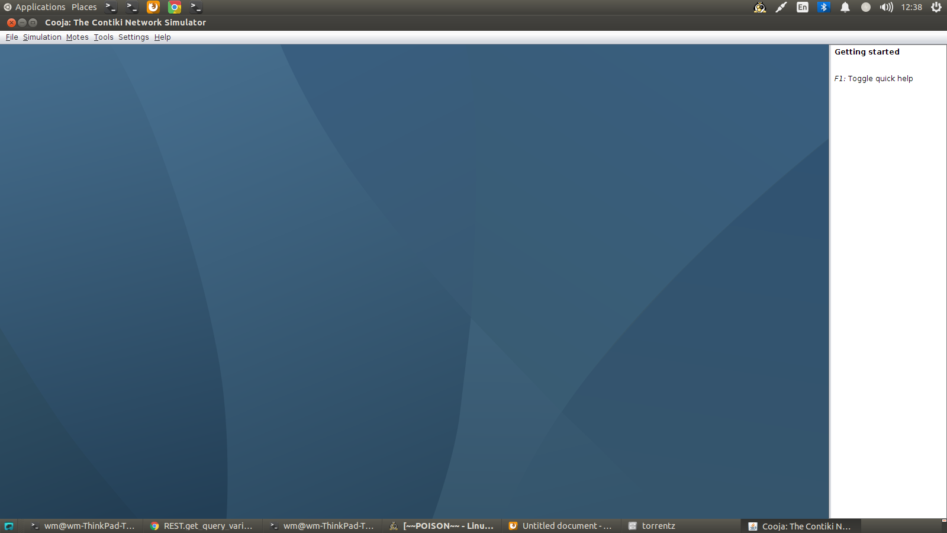

2. Then click on File → New Simulation.

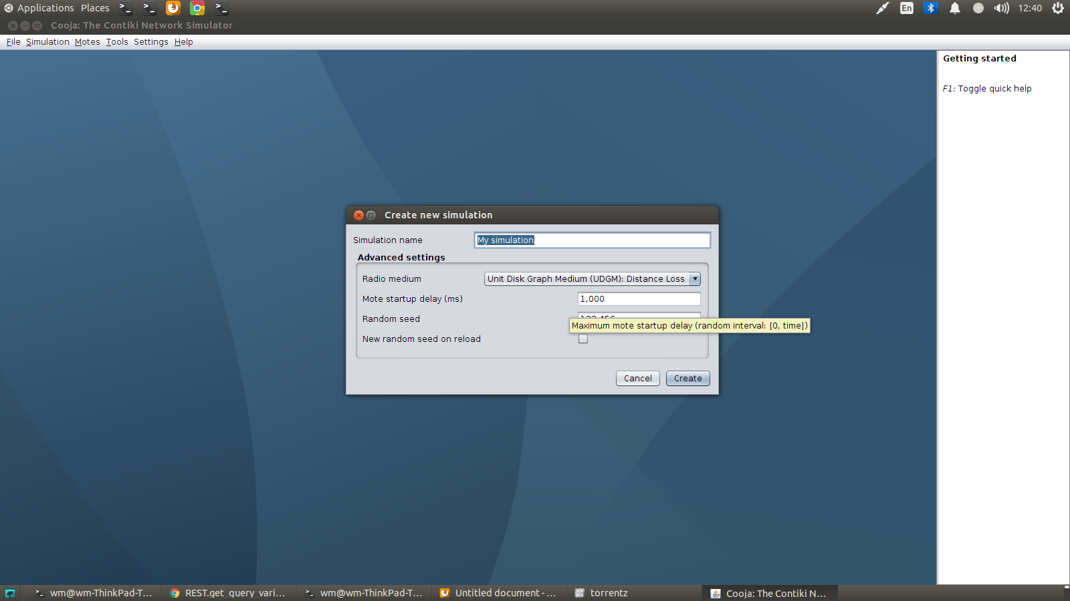

3. Click on Create tab.

