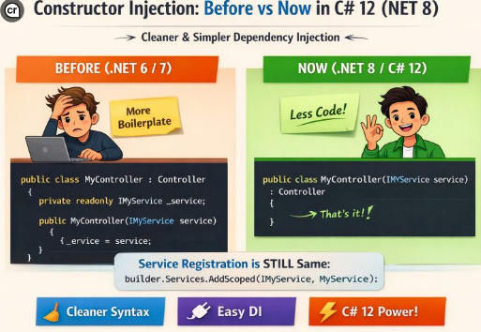

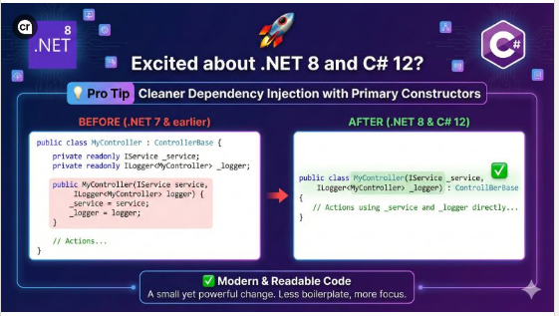
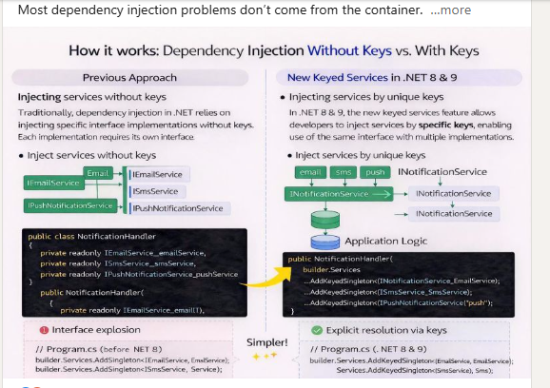

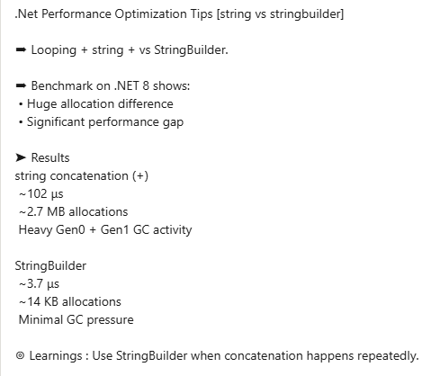
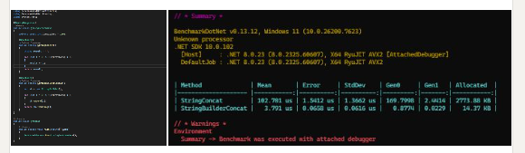

🔍 ADO.NET vs Dapper vs Entity Framework – How do you choose?
Choosing the right data access approach in .NET is not about popularity, it’s about use case.
🔵 ADO.NET
✔ Maximum performance
✔ Full SQL & transaction control
✔ Best for large, complex, legacy systems
🟢 Dapper
✔ High-performance APIs
✔ Clean & minimal code
✔ Great balance for medium-scale systems
🔴 Entity Framework (EF Core)
✔ Rapid development
✔ Built-in security & change tracking
✔ Ideal for medium to large enterprise apps
👨‍💻 Developer Perspective
ADO.NET → Total control, no hidden queries
Dapper → Fast results with less code
EF Core → Productivity & maintainability
🧠 Expert Rule
ADO.NET = Control
Dapper = Performance
EF Core = Productivity
💡 Most real-world applications use a hybrid approach: EF Core for CRUD, Dapper for heavy queries, and ADO.NET for edge cases.
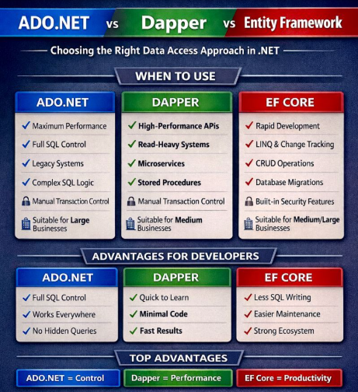

NET 8 vs .NET 9 — What’s the Real Difference?
Whether you're running enterprise apps or experimenting with AI-powered microservices, choosing between .NET 8 and .NET 9 depends on your goals.
Here’s a quick breakdown:
🔹 .NET 8 (LTS)
✅ Long-Term Support (until 2026)
✅ Blazor United, Native AOT, MAUI enhancements
✅ Improved Minimal APIs & performance
✅ Strong OpenTelemetry support
✅ Stable for enterprise & production
🔹 .NET 9 (LTS)
⚡ Focus on Cloud-Native & AI-first development
⚡ Deeper integration with ONNX, TorchSharp, and inferencing
⚡ Project Tye support for microservices orchestration
⚡ Blazor becomes a true full-stack web UI
⚡ More AOT/JIT performance boosts
⚡ Enhanced diagnostics, tracing & security by default
.NET 9 for the latest innovations in cloud, AI, and modern web UI.

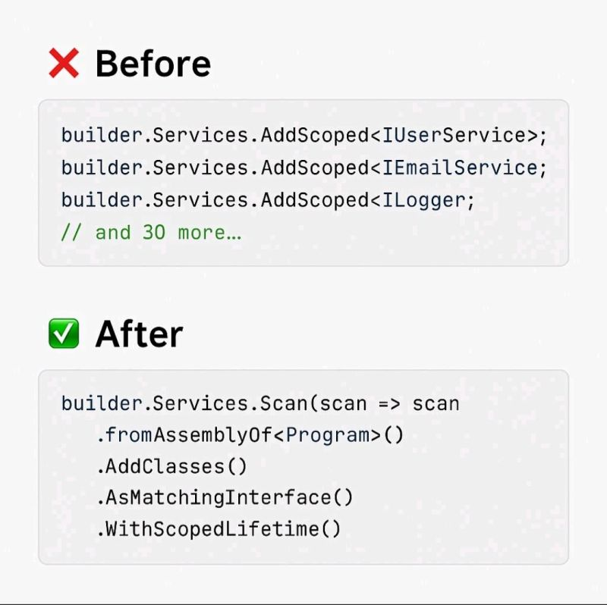.NET Developers: Stop Writing the Same Code Over and Over Again!
If your Services folder is drowning in 20+ lines of repetitive AddScoped boilerplate just to register classes, it's time for an upgrade. 💡
.NET has evolved — and so should we.
🔴 The Old Way (Boilerplate Overload)
📄 Tedious manual registration
🧠 Mentally draining
🔧 Prone to human error
✅ The Modern Way (.NET 6+)
Use Scrutor or Reflection-based registration:
✔ Just one line
✔ Follows the DRY principle
✔ Scales with your team
✔ Perfect for clean architecture
Boilerplate hides real logic. Modern .NET gives us the tools to write cleaner, faster, and more maintainable code.

.𝐍𝐄𝐓 𝟖 𝐯𝐬 .𝐍𝐄𝐓 𝟏𝟎: 𝐓𝐡𝐞 𝐄𝐯𝐨𝐥𝐮𝐭𝐢𝐨𝐧 𝐂𝐨𝐧𝐭𝐢𝐧𝐮𝐞𝐬! 🚀
The .NET ecosystem keeps getting better with each release! Here's what's changing as we move from the solid foundation of .NET 8 to the refined evolution of .NET 10:
⚡ Performance:
Faster JIT + fewer allocations → smoother apps under real load.
📦 AOT (Native):
Now truly practical for APIs & microservices (not just niche scenarios).
🧩 C# Version:
C# 14 brings cleaner syntax, richer patterns, and more expressive code.
🔍 Async Debugging:
Stack traces finally make sense. Debugging is now human-friendly.
⚙️ Configuration:
Unified config layering → no more “why is this value coming from??” chaos.
🐳 Containers:
Optimized for Kubernetes with smarter resource usage.
.NET 10 feels like the version built for real teams shipping real software.
Less friction → more speed.
Less guessing → more clarity.
Less boilerplate → more creativity. 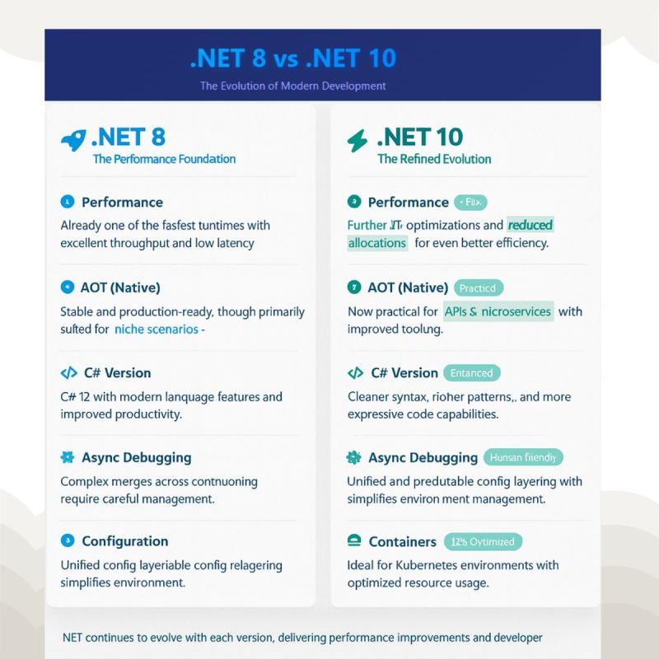
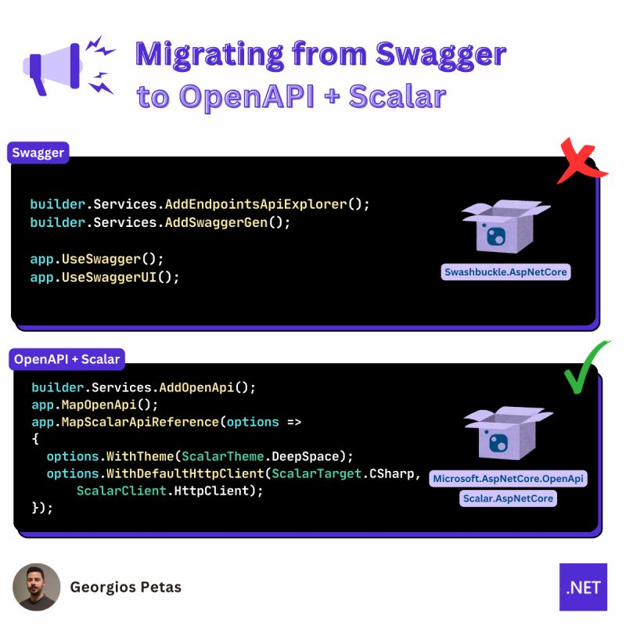
1️⃣ The "Free" Performance Boost I benchmarked my Gym Management API on .NET 10 vs .NET 8. Without changing a single line of code, throughput increased by ~15%. Microsoft’s work on the JIT Compiler and Garbage Collection in this release is insane.
2️⃣ LINQ is finally "Smart" We used to write complex foreach loops to avoid LINQ allocations in hot paths. In .NET 10, the new Span<T> optimizations in LINQ mean I can write clean code without the performance penalty. Clean Code + High Performance = Architect’s Dream.
3️⃣ Cloud-Native Defaults The integration with OpenTelemetry and Aspire is now seamless. On .NET 8, setting up observability took me a day. On .NET 10, it feels native to the framework.
My Verdict: If you are still on .NET 6 or 8, the wait is over. The ecosystem is ready. I am planning the migration for my core services next week. 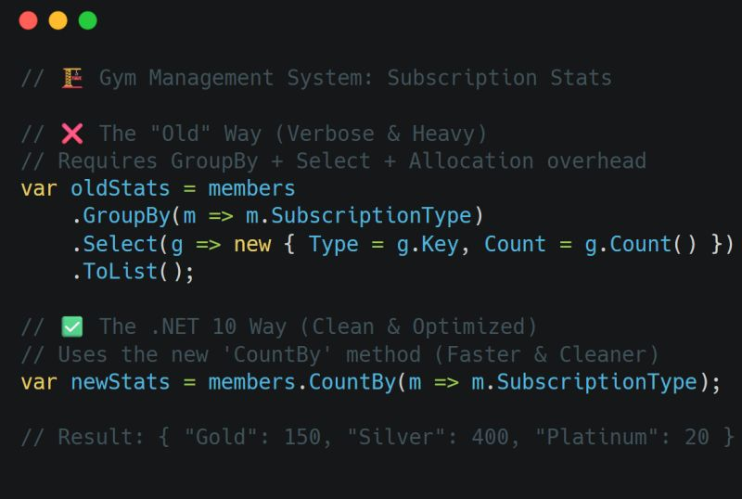

**OpenAPI in .NET 10 with Scalar UI – Modern API Documentation Made Simple**
Excited to explore the new OpenAPI support in **.NET 10** and how seamlessly it integrates with **Scalar UI** for clean, interactive API documentation.
🔹 **What’s New in .NET 10?**
.NET 10 provides improved built-in OpenAPI generation with better performance and cleaner configuration. You can now generate API documentation with minimal setup.
🔹 **Why Scalar UI?**
Scalar UI is a modern alternative to Swagger UI that provides:
✅ Clean and beautiful interface
✅ Fast performance
✅ Better API testing experience
✅ Developer-friendly customization
🔹 **Basic Setup in .NET 10**
```csharp
builder.Services.AddOpenApi();
var app = builder.Build();
if (app.Environment.IsDevelopment())
{
app.MapOpenApi();
}
```
Then integrate **Scalar UI** to visualize and test your API endpoints with a modern UI.
💡 Combining **.NET 10 + OpenAPI + Scalar UI** gives you:
* Automatic API documentation
* Interactive endpoint testing
* Clean developer experience
* Production-ready API structure
If you're building REST APIs in .NET, this stack is definitely worth trying.

C# 14 introduces Extension Members.
Not just methods anymore. Now you can add to any type you don't own:
- Extension properties → list.IsEmpty instead of !list.Any()
- Static extension methods → List<T>.Create(1, 2, 3) as a factory
- Static extension properties → List<T>.Empty
- Extension operators → left + right to concatenate collections
The new syntax groups everything in a single extension block:
extension(string text)
{
public int WordCount => ...
public string Reversed => ...
public string Truncate(int max) => ...
}
Clean. Readable. No more static class wrappers with "this" parameters everywhere.
Requires .NET 10 / C# 14.
---
Which one are you most excited to use — extension properties or extension operators? 