Program 1
Define a class ‘product’ with data members pcode,pname and price. Create 3 objects of the class and find the product having the lowest price.

Product.java
import java.util.Objects;
public class Product
{
String pname,pcode;
int price;
public String getPname()
{
return pname;
}
public Product()
{

}
public Product(String pname, String pcode, int price)
{
this.pname=pname;
this.pcode=pcode;
this.price=price;
}
public void setPname(String pname)
{
this.pname=pname;
}
public String getPcode()
{
return pcode;
}
public void setPcode(String pcode)
{
this.pcode=pcode;
}
public int getPrice()
{
return price;
}
public void setPrice(int price)
{
this.price=price;
}
public void display()
{
System.out.println("pcode:" + this.pcode);
System.out.println("pname:" + this.pname);
System.out.println("price:" + this.price);
}
}

Exp1.java
public class Exp1
{
public static void main(String[] args)
{
System.out.println("PONNU AUGUSTINE");
System.out.println("23MCA044");
System.out.println("13/02/24");
System.out.println("Product");
Product p1=new Product();
p1.pcode="Car123";
p1.pname="Maruti";
p1.price=50000;
System.out.println(".................Displaying p1..................");
p1.display();

Product p2=new Product("Benz","Car456",90000);
System.out.println("...............Displaying p2................");
p2.display();

Product p3=new Product("Jaguar","Car789",80000);
System.out.println("...............Displaying p3................");
p3.display();

Product p=p3.getPrice()<(p1.price<p2.price?p1.price:p2.price)?p3:(p1.price<p2.price?p1:p1);
System.out.println("\n.....Displaying product with lowest price.....");
p.display();
}
}

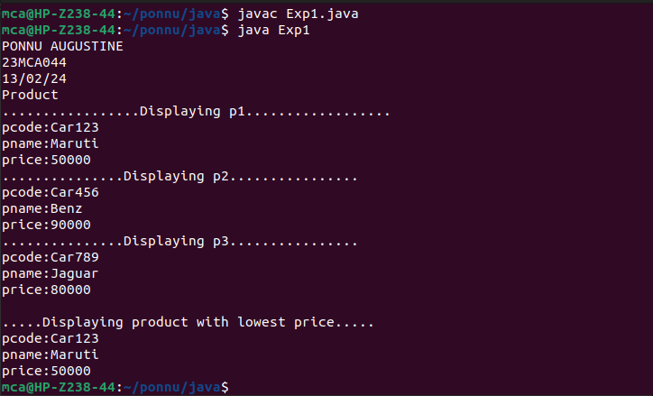

Program 2
Read 2 matrices from the console and perfrom matrix addition.

MatrixAdd.java
import java.util.Scanner;
public class MatrixAdd
{
public static void main(String[] args)
{
int p,q,m,n;
System.out.println("PONNU AUGUSTINE");
System.out.println("23MCA044");
System.out.println("13/02/24");
System.out.println("MatrixAdd");
Scanner s=new Scanner(System.in);
System.out.println("Enter number of rows in matrix1:");
p=s.nextInt();
System.out.println("Enter number of columns in matrix1:");
q=s.nextInt();
System.out.println("Enter number of rows in matrix2:");
m=s.nextInt();
System.out.println("Enter number of columns in matrix2:");
n=s.nextInt();
if(p==m && q==n)
{
int a[][]=new int[p][q];
int b[][]=new int[m][n];
int c[][]=new int[m][n];
System.out.println("Enter elements of matrix1:");
for(int i=0;i<p;i++)
{
for(int j=0;j<q;j++)
{
a[i][j]=s.nextInt();
}
}
System.out.println("Enter elements of matrix2:");
for(int i=0;i<m;i++)
{
for(int j=0;j<n;j++)
{
b[i][j]=s.nextInt();
}
}
System.out.println("First Matrix:");
for(int i=0;i<p;i++)
{
for(int j=0;j<q;j++)
{
System.out.print(a[i][j]+" ");
}
System.out.println("");
}
System.out.println("Second Matrix:");
for(int i=0;i<m;i++)
{
for(int j=0;j<n;j++)
{
System.out.print(b[i][j]+" ");
}
System.out.println("");
}
for(int i=0;i<p;i++)
{
for(int j=0;j<n;j++)
{
for(int k=0;k<q;k++)
{
c[i][j]=a[i][j]+b[i][j];
}
}
}
System.out.println("Matrix after addition:");
for(int i=0;i<p;i++)
{
for(int j=0;j<n;j++)
{
System.out.print(c[i][j]+" ");
}
System.out.println("");
}
}
else
{
System.out.println("Addition is not possible");
}
}
}
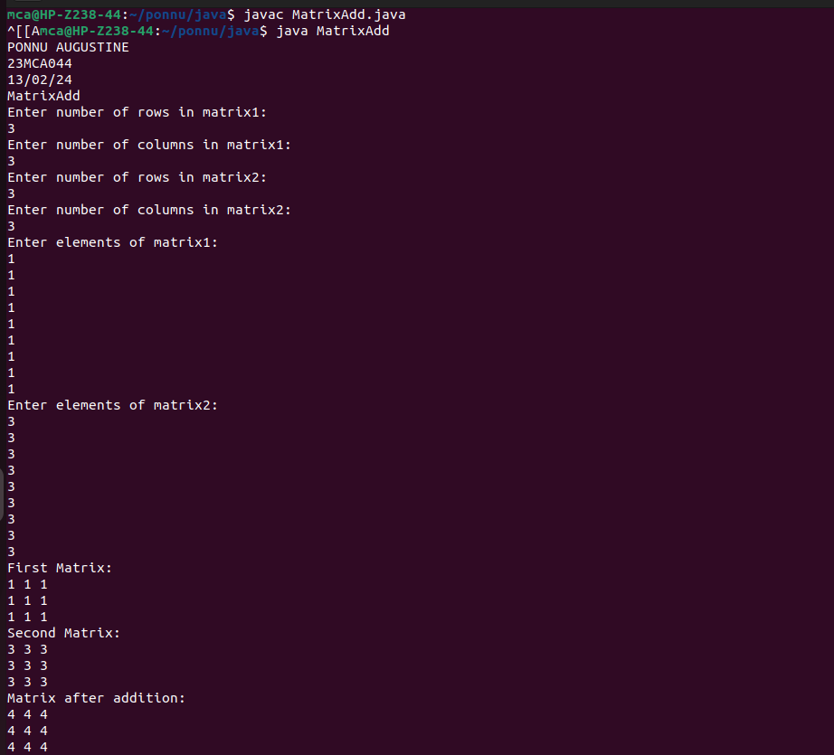

Program 3
Add complex numbers

ComplexNumber.java
public class ComplexNumber
{
double real,img;

ComplexNumber(double r,double i)
{
this.real=r;
this.img=i;
}
public static ComplexNumber sum(ComplexNumber c1,ComplexNumber c2)
{
ComplexNumber temp=new ComplexNumber(0,0);
temp.real=c1.real+c2.real;
temp.img=c1.img=c2.img;
return temp;
}
public static void main(String[] args)
{
ComplexNumber c1=new ComplexNumber(5.5,4);
ComplexNumber c2=new ComplexNumber(1.2,3.5);
ComplexNumber temp=sum(c1,c2);
System.out.println("PONNU AUGUSTINE");
System.out.println("23MCA044");
System.out.println("13/02/24");
System.out.println("ComplexNumber");
System.out.println("Sum is: "+ temp.real +" + "+ temp.img +"i");
}
}

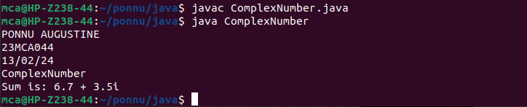

Program 4
Read a matrix from the console and check whether it is symmetric or not.

SymmetricMatrix.java
import java.util.Scanner;
public class SymmetricMatrix
{
public static void main(String[] args)
{
Scanner s=new Scanner(System.in);
System.out.println("PONNU AUGUSTINE");
System.out.println("23MCA044");
System.out.println("13/02/24");
System.out.println("SymmetricMatrix");
System.out.println("Enter the no. of rows:");
int rows=s.nextInt();
System.out.println("Enter the no.of columns:");
int cols=s.nextInt();
int matrix[][]=new int[rows][cols];
System.out.println("Enter the elements:");
for(int i=0;i<rows;i++)
{
for(int j=0;j<cols;j++)
{
matrix[i][j]=s.nextInt();
}
}
s.close();
System.out.println("Printing the matrix:");
for(int i=0;i<rows;i++)
{
for(int j=0;j<cols;j++)
{
System.out.print(matrix[i][j]+" ");
}
System.out.println("");
}
if(rows!=cols)
{
System.out.println("The matrix is not a square matrix.");
}
else
{
boolean symmetric=true;
for(int i=0;i<rows;i++)
{
for(int j=0;j<cols;j++)
{
if(matrix[i][j]!=matrix[j][i])
{
symmetric =false;
break;
}
}
}
if(symmetric)
{
System.out.println("The matrix is symmetric.");
}
else
{
System.out.println("The matrix is not symmetric.");
}
}
}
}

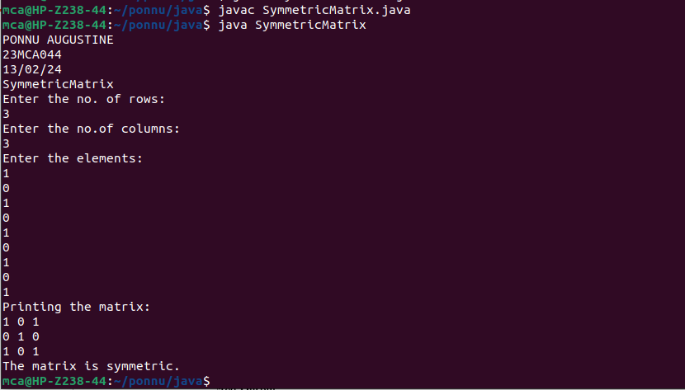

Program 5
Create CPU with attribute price. Create inner class Processor (no. of cores, manufacturer) and static nested class RAM (memory, manufacturer). Create an object of CPU and printinformation of Processor and RAM.

CPUDetails.java
class CPU
{
double price;
class Processor
{
double cores;
String manufacturer;
double getCache()
{
return 4.3;
}
}
protected class RAM
{
double memory;
String manufacturer;
double getClockSpeed()
{
return 5.5;
}
}
}
public class CPUDetails
{
public static void main(String[] args)
{
CPU cpu=new CPU();
CPU.Processor processor=cpu.new Processor();
CPU.RAM ram=cpu.new RAM();
System.out.println("Processor Cache=" + processor.getCache());
System.out.println("Ram Clock speed" + ram.getClockSpeed());
}
}

