1. Program to sort Strings

import java.util.Arrays;
import java.util.Scanner;
public class SortString
{
public static void main(String[] args)
{
Scanner scanner = new Scanner(System.in);
System.out.println("PONNU AUGUSTINE");
System.out.println("23MCA044");
System.out.println("26/02/24");
System.out.println("SortString");
System.out.println("Enter strings separated by spaces:");
String input = scanner.nextLine();
String[] strings = input.split("\\s+");
Arrays.sort(strings);
System.out.println("Sorted strings:");
for (String str : strings)
{
System.out.println(str);
}
scanner.close();
}
}

Output

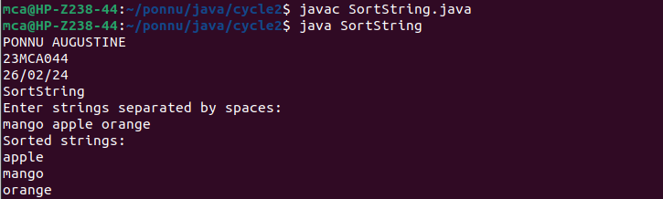

2. Search an element in an Array

import java.util.Scanner;
public class StringArray
{
public static void main(String[] args)
{
Scanner scanner = new Scanner(System.in);
System.out.println("PONNU AUGUSTINE");
System.out.println("23MCA044");
System.out.println("26/02/24");
System.out.println("StringArray");
System.out.print("Enter the size of the array: ");
int size = scanner.nextInt();
scanner.nextLine();
String[] array = new String[size];
System.out.println("Enter the elements of the array:");
for (int i = 0; i < size; i++) {
array[i] = scanner.nextLine();
}
System.out.print("Enter the string to search for: ");
String target = scanner.nextLine();
int foundIndex = -1;
for (int i = 0; i < size; i++)
{
if (array[i].equals(target))
{
foundIndex = i;
break;
}
}
if (foundIndex != -1)
{
System.out.println("String \"" + target + "\" found at position " + foundIndex + " in the array.");
}
else
{
System.out.println("String \"" + target + "\" not found in the array.");
}
scanner.close();
}
}

Output

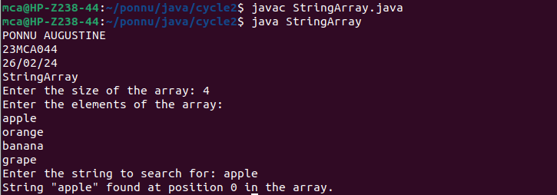

3. Perform string manipulations

import java.util.Scanner;
public class StringManipulation {
public static void main(String[] args) {
Scanner scanner = new Scanner(System.in);
System.out.println("PONNU AUGUSTINE");
System.out.println("23MCA044");
System.out.println("01/04/24");
// Ask the user to enter a string
System.out.println("Enter a string:");
String str = scanner.nextLine();

// Length of the string
int length = str.length();
System.out.println("Length of the string: " + length);

// 2. Convert to uppercase
String upperCase = str.toUpperCase();
System.out.println("Uppercase string: " + upperCase);

// Convert to lowercase
String lowerCase = str.toLowerCase();
System.out.println("Lowercase string: " + lowerCase);

// Concatenation
System.out.println("Enter a string to concatenate with:");
String concatStr = str.concat(scanner.nextLine());
System.out.println("Concatenated string: " + concatStr);

// Substring
System.out.println("Enter the starting index for substring:");
int startIndex = scanner.nextInt();
String substring = str.substring(startIndex);
System.out.println("Substring: " + substring);

// Consume newline character
scanner.nextLine();

// Replace
System.out.println("Enter the character to replace:");
char oldChar = scanner.nextLine().charAt(0);
System.out.println("Enter the replacement character:");
char newChar = scanner.nextLine().charAt(0);
String replacedStr = str.replace(oldChar, newChar);
System.out.println("Replaced string: " + replacedStr);

// Split
System.out.println("Enter the delimiter for splitting:");
String delimiter = scanner.nextLine();
String[] splitStr = str.split(delimiter);
System.out.println("Split string:");
for (String s : splitStr) {
System.out.println(s);
}
scanner.close();
}
}

Output

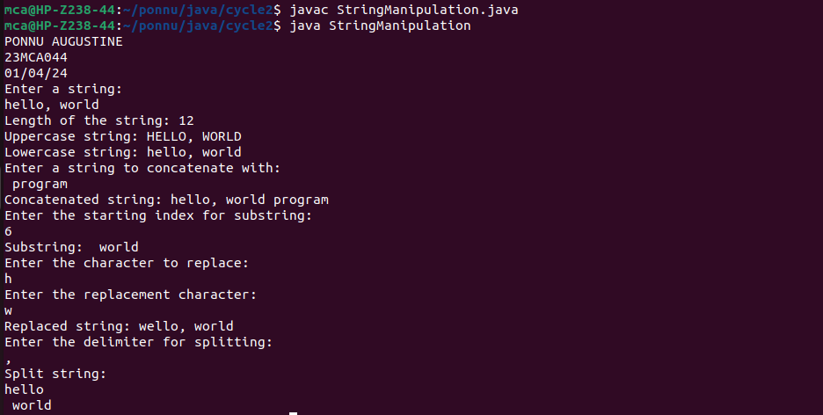

4. Program to create a class for Employee having attributes eNo, eName eSalary. Read n
employ information and Search for an employee given eNo, using the concept of Array of
Objects.

import java.util.Scanner;
class Employee{
int eNo, eSalary;
String eName;

public Employee(int no, String name, int salary) {
this.eNo = no;
this.eName = name;
this.eSalary = salary;
}
}
class EmpMain{
public static void main(String arg[]){
System.out.println("PONNU AUGUSTINE");
System.out.println("23MCA044");
System.out.println("01/04/24");
Scanner scanner = new Scanner(System.in);
System.out.print("Enter the no of Employees : ");
int n = scanner.nextInt();
Employee arr[] = new Employee[n];
for(int i=0; i<n; i++){
System.out.println("Enter the details of employee " + Integer.toString(i+1));
System.out.print("Enter the employee id : ");
int no = scanner.nextInt();
System.out.print("Enter the employee name : ");
scanner.nextLine();
String name = scanner.nextLine();
System.out.print("Enter the salary : ");
int salary = scanner.nextInt();
arr[i] = new Employee(no, name, salary);
}
System.out.print("\nEnter the employee id to search : ");
int id = scanner.nextInt();
int flag = 0;
for(int i=0; i<n; i++){
if(arr[i].eNo == id){
System.out.println("Employee found.\nid : " + Integer.toString(id) + "\nname : " + arr[i].eName + "\nsalary : " + Integer.toString(arr[i].eSalary));
flag = 1;
break;
}
}
if(flag == 0) System.out.println("Employee not found");

scanner.close();
}
}

Output

