1. Area of different shapes using overloaded functions

import java.util.Scanner;
public class AreaCalculator
{
void calculateArea(float x)
{
System.out.println("Area of the square: " + x * x + " sq units");
}
void calculateArea(float x, float y)
{
System.out.println("Area of the rectangle: " + x * y + " sq units");
}
void calculateArea(double r)
{
double area = 3.14 * r * r;
System.out.println("Area of the circle: " + area + " sq units");
}

public static void main(String args[])
{
Scanner scanner = new Scanner(System.in);
AreaCalculator obj = new AreaCalculator();
System.out.println("PONNU AUGUSTINE");
System.out.println("23MCA044");
System.out.println("02/04/24");
System.out.println("Enter the dimensions:");
System.out.print("Enter side length of the square: ");
float side = scanner.nextFloat();
obj.calculateArea(side);
System.out.print("Enter length of the rectangle: ");
float length = scanner.nextFloat();
System.out.print("Enter width of the rectangle: ");
float width = scanner.nextFloat();
obj.calculateArea(length, width);
System.out.print("Enter radius of the circle: ");
double radius = scanner.nextDouble();
obj.calculateArea(radius);
scanner.close();
}
}

Output
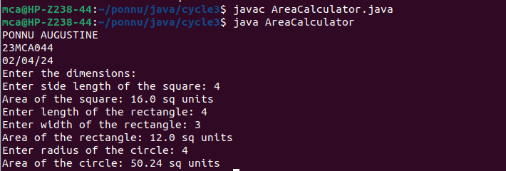

2. Create a class ‘Employee’ with data members Empid, Name, Salary, Address and
constructors to initialize the data members. Create another class ‘Teacher’ that inherit the
properties of class employee and contain its own data members department, Subjects taught
and constructors to initialize these data members and also include display function to
display all the data members. Use array of objects to display details of N teachers.

import java.util.Scanner;
class Employee
{
int Empid;
String Name;
double Salary;
String Address;
Employee(int no, String na, double sal, String add)
{
this.Empid = no;
this.Name = na;
this.Salary = sal;
this.Address = add;
}
}
public class Teacher extends Employee
{
String dept;
String subject;
Teacher(int no, String na, double sal, String add, String dep, String sub)
{
super(no,na,sal,add);
this.dept= dep;
this.subject=sub;
}

void display()
{
System.out.println("Employee id: "+Empid);
System.out.println("Name: "+Name);
System.out.println("Salary: "+Salary);
System.out.println("Address: "+Address);
System.out.println("Department: "+dept);
System.out.println("Subject: "+subject);
}
public static void main(String[] args)
{
System.out.println("PONNU AUGUSTINE 23MCA044 02/04/24");
System.out.println("Enter the No. of Employee's");
Scanner sc1 = new Scanner(System.in);
int num = sc1.nextInt();
Teacher arr[]=new Teacher[num];
for(int i =0;i<num;i++)
{
Scanner sc =new Scanner(System.in);
System.out.println("Enter Employee id: ");
int Empid=sc.nextInt();
System.out.println("Enter Employee Name: ");
String Name=sc.next();
System.out.println("Enter Salary: ");
double Salary=sc.nextDouble();
System.out.println("Enter Address: ");
String Address=sc.next();
System.out.println("Enter department: ");
String dept=sc.next();
System.out.println("Enter Subject: ");
String subject=sc.next();
arr[i]=new Teacher(Empid,Name,Salary,Address,dept,subject);
}
System.out.println("********Informations of all the employee's************");
for(int i=0;i<num;i++)
{
int j=i+1;
System.out.println(+j+").");
arr[i].display();
}
sc1.close();
}
}

Output

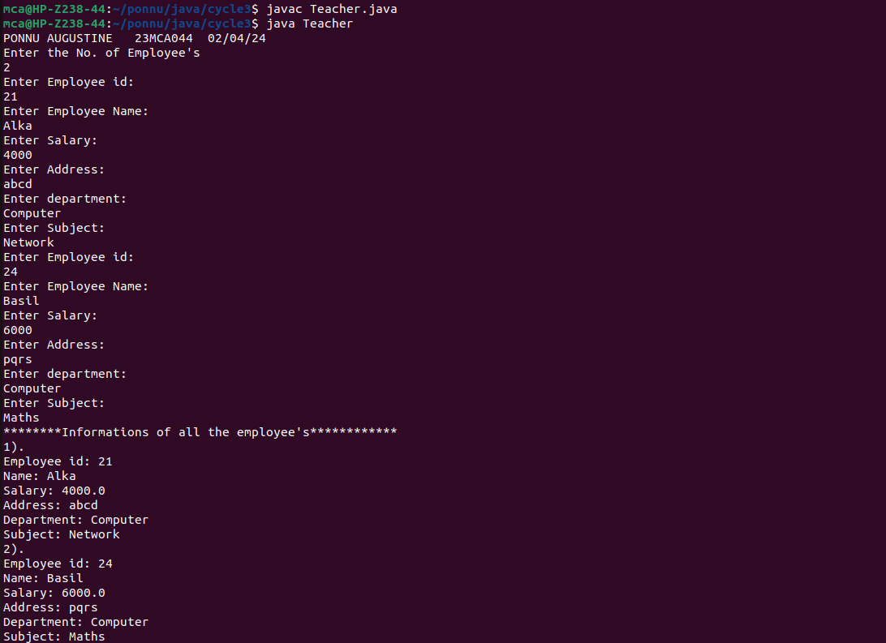

3. Create a class ‘Person’ with data members Name, Gender, Address, Age and a constructor
to initialize the data members and another class ‘Employee’ that inherits the properties of
class Person and also contains its own data members like Empid, Company_name,
Qualification, Salary and its own constructor. Create another class ‘Teacher’ that inherits
the properties of class Employee and contains its own data members like Subject,
Department, Teacherid and also contain constructors and methods to display the data
members. Use array of objects to display details of N teachers.

import java.util.Scanner;
class person
{
String Name;
String Gender;
String Address;
int Age;
person(String name,String gender,String address, int age)
{
this.Name = name;
this.Gender = gender;
this.Address = address;
this.Age = age;
}
}
class Employee extends person
{
int Empid;
String Company_name;
String Qualification;
long Salary;

Employee(String name,String gender,String address, int age,int empid, String company_name, String qualification,long salary)
{
super(name,gender,address,age);
this.Empid= empid;
this.Company_name=company_name;
this.Qualification=qualification;
this.Salary=salary;
}
}

public class Teacher2 extends Employee
{
String Subject;
String Department;
String Teacherid;
Teacher2(String name,String gender,String address, int age,int empid, String company_name, String qualification,long salary, String subject, String department, String teacherid)
{
super(name,gender,address,age,empid,company_name,qualification,salary);
this.Subject=subject;
this.Department=department;
this.Teacherid=teacherid;
}

void display()
{
System.out.println("Name: "+Name);
System.out.println("Gender: "+Gender);
System.out.println("Address: "+Address);
System.out.println("Age: "+Age);
System.out.println("Employee id: "+Empid);
System.out.println("Company Name: "+Company_name);
System.out.println("Qualification: "+Qualification);
System.out.println("Salary: "+Salary);
System.out.println("Subject: "+Subject);
System.out.println("Department: "+Department);
System.out.println("Teacher id: "+Teacherid);
}
public static void main(String[] args)
{
System.out.println("PONNU AUGUSTINE 23MCA044 02/04/24");
System.out.println("Enter the No. of Teacher's");
Scanner sc1 = new Scanner(System.in);
int num = sc1.nextInt();
Teacher2 arr[]=new Teacher2[num];
System.out.println("Enter the Teacher Details");
int x = 0,j=0;
Scanner sc =new Scanner(System.in);
for(int i =0;i<num;i++)
{
x = i +1;
System.out.println(+x+").");
System.out.println("Name: ");
String a =sc.next();
System.out.println("Gender: ");
String b =sc.next();
System.out.println("Address: ");
String c =sc.next();
System.out.println("Age: ");
int d =sc.nextInt();
System.out.println("Employee id: ");
int e =sc.nextInt();
System.out.println("Company name: ");
String f =sc.next();
System.out.println("Qualification: ");
String g =sc.next();
System.out.println("Salary: ");
long h =sc.nextLong();
System.out.println("Subject: ");
String k =sc.next();
System.out.println("Department: ");
String l =sc.next();
System.out.println("Teacher Id: ");
String n =sc.next();
arr[i]=new Teacher2(a,b,c,d,e,f,g,h,k,l,n);
}
sc.close();
System.out.println("********Informations of all the Teacher's************");
for(int i=0;i<num;i++)
{
j=i+1;
System.out.println(+j+").");
arr[i].display();
}
sc1.close();
}
}

Output

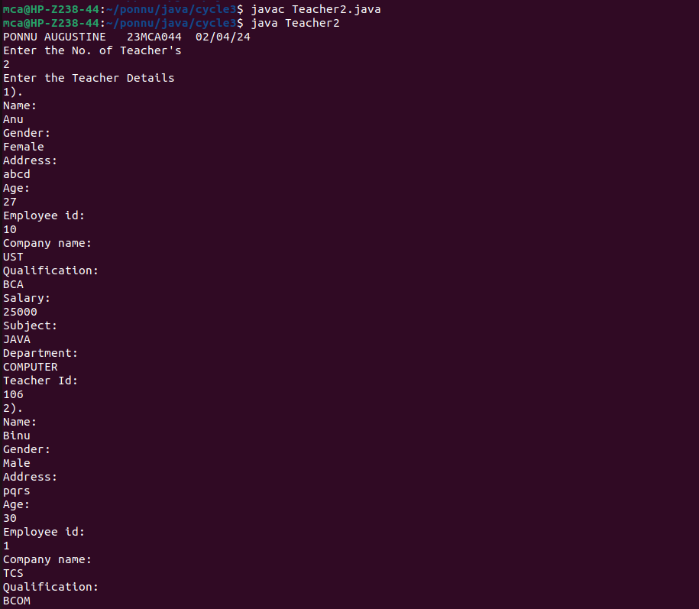

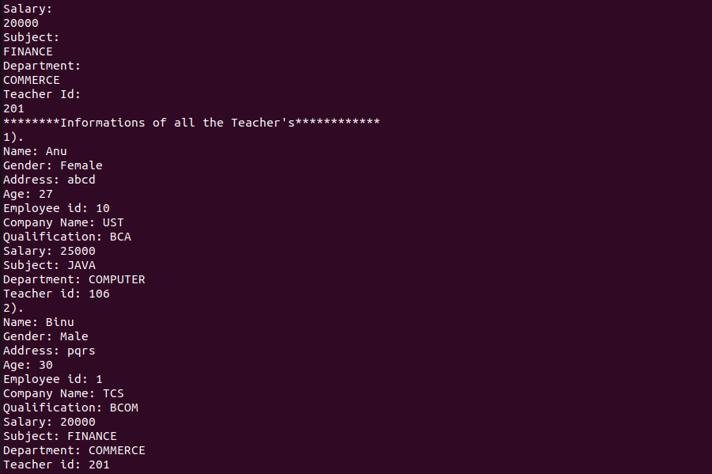

4. Write a program has class Publisher, Book, Literature and Fiction. Read the information
and print the details of books from either the category, using inheritance.

import java.util.Scanner;
class Publisher
{
String name;

Publisher(String name)
{
this.name = name;
}
}
class Book extends Publisher
{
String title;
String author;
Book(String title, String author, String publisher)
{
super(publisher);
this.title = title;
this.author = author;
}
void display()
{
System.out.println("Title: " + title);
System.out.println("Author: " + author);
System.out.println("Publisher: " + name);
}
}
class Literature extends Book
{
Literature(String title, String author, String publisher)
{
super(title, author, publisher);
}
}
class Fiction extends Book
{
Fiction(String title, String author, String publisher)
{
super(title, author, publisher);
}
}
public class BookDetails
{
public static void main(String[] args)
{
Scanner scanner = new Scanner(System.in);
System.out.println("PONNU AUGUSTINE");
System.out.println("23MCA044");
System.out.println("06/04/24");
System.out.print("How many Literature books do you want to add? ");
int numLiteratureBooks = scanner.nextInt();
scanner.nextLine(); // Consume newline character

System.out.print("How many Fiction books do you want to add? ");
int numFictionBooks = scanner.nextInt();
scanner.nextLine(); // Consume newline character

Book[] literatureBooks = new Book[numLiteratureBooks];
Book[] fictionBooks = new Book[numFictionBooks];

for (int i = 0; i < numLiteratureBooks; i++)
{
System.out.println("\nEnter details for Literature book " + (i + 1) + ":");
literatureBooks[i] = createBook(scanner, "Literature");
}

for (int i = 0; i < numFictionBooks; i++)
{
System.out.println("\nEnter details for Fiction book " + (i + 1) + ":");
fictionBooks[i] = createBook(scanner, "Fiction");
}
System.out.println("\nLiterature Books:");
displayBooks(literatureBooks);
System.out.println("\nFiction Books:");
displayBooks(fictionBooks);
scanner.close();
}
private static Book createBook(Scanner scanner, String type)
{
System.out.print("Enter the title of the book: ");
String title = scanner.nextLine();

System.out.print("Enter the author of the book: ");
String author = scanner.nextLine();

System.out.print("Enter the publisher of the book: ");
String publisher = scanner.nextLine();

if (type.equals("Literature"))
{
return new Literature(title, author, publisher);
} else if (type.equals("Fiction"))
{
return new Fiction(title, author, publisher);
} else
{
return null;
}
}
private static void displayBooks(Book[] books)
{
for (Book book : books)
{
book.display();
System.out.println();
}
}
}

Output

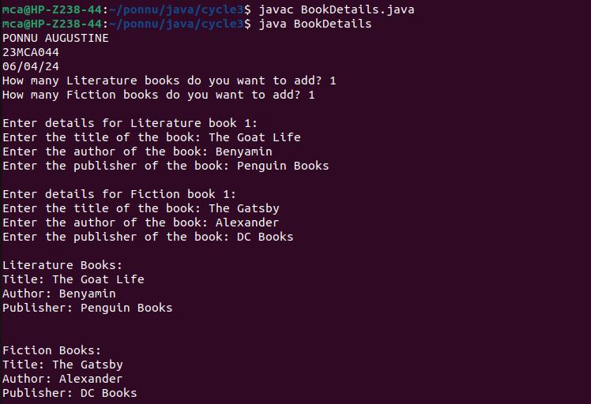

5. Create classes Student and Sports. Create another class Result inherited from Student and
Sports. Display the academic and sports score of a student.

import java.util.Scanner;
class sports
{
String sport;
int Rating;
sports(String spo, int ra)
{
sport = spo;
Rating = ra;
}

}
class student extends sports
{
String Grade;
double Overall_per;
student(String spo, int ra,String gd, double per )
{
super(spo, ra);
Grade = gd;
Overall_per = per;
}
}
public class Result extends student {
Result(String spo, int ra,String gd, double per )
{
super(spo, ra, gd, per);
}
void display()
{
System.out.println("\nSports Details of Student");
System.out.println("No. of Sport items:"+sport);
System.out.println("Rating:"+Rating);
System.out.println("\nAcademic Details of Student");
System.out.println("Academic Grade :"+Grade);
System.out.println("Overall percentage :"+Overall_per+ "%");
}

public static void main(String[] args)
{
Scanner sc =new Scanner(System.in);
System.out.println("PONNU AUGUSTINE");
System.out.println("23MCA044");
System.out.println("06/04/24");
System.out.println("Enter the Sports Details of Student");
System.out.println("no. of Sport items: ");
String a =sc.next();
System.out.println("Sport Rating out of 10: ");
int b =sc.nextInt();
System.out.println("\nEnter the Sports Details of Student");
System.out.println("Academic Grade: ");
String c =sc.next();
System.out.println("Overall percentage: ");
double d =sc.nextDouble();
sc.close();
Result obj= new Result(a,b,c,d);
obj.display();
}
}

Output

