**Health-tech Requirement Elicitation using Quantitative and Qualitative Analysis**

Natcha Sriwichien and Ponrudee Netisopakul

School of Information Technology, King Mongkut's Institute of Technology Ladkrabang

[64607016@kmitl.ac.th](mailto:64607016@kmitl.ac.th), ponrudee@it.kmitl.ac.th

**Abstract.** This research presents quantitative and qualitative analysis methods to prioritize features for health technology products. The quantitative data is collected from a survey with 361 respondents and qualitative data from in-depth interviews with 20 participants. The interview reveals four customer groups: Wellness enthusiasts, Loyalists, Price conscious participants and Passive participants. In addition, the survey and interview reveal that the top three important features for health technology apps are: 1) chat for consultation with doctors or pharmacists, 2) articles on health care such as weight loss, nutrition, and 3) video calls for consultation with doctors or pharmacists.

**Keywords**: Healthtech application, Healthcare, Quantitative analysis, Qualitative analysis, Human computer interaction, User experience research, User interface

**1 Introduction**

The COVID-19 pandemic in 2020 caused difficulties for the public to access medical services in Thailand due to a shortage of medical personnel. This crisis prompted the public and medical personnel to change their behavior related to technology use, focusing more on healthcare and health-related applications. However, how well-suite of these applications to the users requirements is unclear.

The objective of this research is to elicit healthtech application requirements utilizing both quantitative and qualitative analysis. This article analyzes the quantitative data collected from a survey regarding the healthcare of Thai customers and qualitative data obtained from interviews with customers to create a customer profile, identify customer needs regarding health technology, and design a sample screen using Figma. The sample screen was then tested on 16 customers to collect feedback, which was measured using the Single Ease Question (SEQ) Score and the System Usability Scale (SUS) Score to analyze customer needs regarding health technology and present suitable features to enhance their usability.

This article is intended as a guide for individuals or companies interested in User Experience, and can be applied to both learning and working effectively in the field of Human-Computer Interaction (HCI).

**2 Related Article in Healthcare research**

**Table 1.** Related articles on healthcare services

|  |  |  |  |
| --- | --- | --- | --- |
| Research study | Objectives of the research study | Methods used in the research study | Results of the research study |
| Business Start-up Survey for the Healthcare Industry in Thailand [xx] | Conduct a survey on the needs of elderly people regarding healthcare provided by startup companies. | Use qualitative research methods by conducting in-depth interviews with 15 health technology startup companies. | All 15 startup companies provide guidance and care services for elderly people. |

|  |  |  |  |
| --- | --- | --- | --- |
| A Toolkit for Building and Growing a Sustainable Telehealth Program in Your Practice [xx] | To make telehealth play a role in transforming the healthcare experience of elderly patients. | To use quantitative research methods by conducting surveys to gather feedback from patients and improve the user experience. | Survey results from the United States found that patients who use telehealth services prefer to see specialist doctors for chronic diseases, child development, obstetrics and gynecology, elderly patients, and mental health. |

|  |  |  |  |
| --- | --- | --- | --- |
| Access to Telehealth Services and Care [xx] | In order for medical industry companies to effectively use Telehealth in patient care. | Conduct quantitative and qualitative research by conducting surveys and interviews with staff and patients to assess compliance with JCI standards. | Some medical companies are still unable to collect patient treatment history. |

Please summarize each article shortly.

Based on the analysis of the three research studies, it can be concluded that this article will conduct both quantitative and qualitative analysis to search for innovations and health technologies that meet the needs of customers in Thailand. Additionally, it will also identify the features that customers prefer to use and the specific types of doctors they prefer to access through health technology applications.

**3 Methodology**

This article applies the Design Thinking process to conduct both quantitative and qualitative analysis, which includes the following steps:

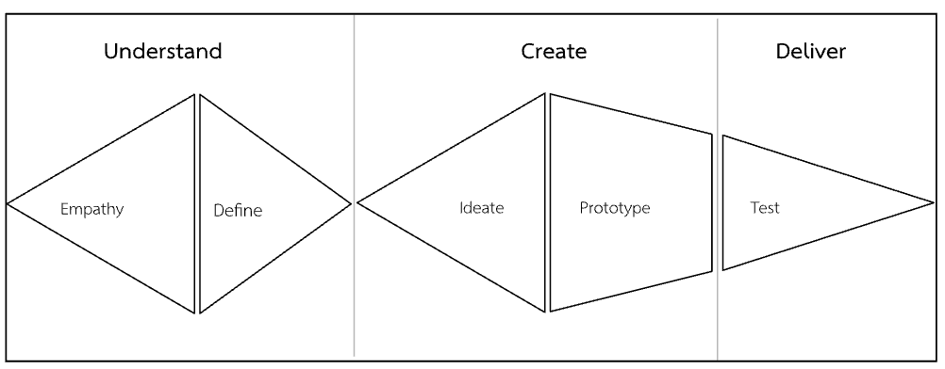

**Fig. 1.** Design thinking process

Process 1: Empathy - This step involves observing and asking users about their needs, which is equivalent to analyzing "who the users are" from a UX perspective. This is a process of quantitative and qualitative analysis.

Process 2: Define - This step summarizes the data collected from the Empathy process to identify what users want or don't want. This is the process of creating user personas.

Process 3: Ideate - This step involves grouping and sequencing the features based on the results obtained from the Define process.

The above processes can be carried out as follows.

**3.1 Quantitative analysis methods**

This article employs quantitative analysis through surveying, card sorting, and A/B testing. The sample size is determined based on Taro Yamane's theory with the following equation:

n = N / (1 + (N x (e ^2)))

* N is the size of the total population of interest.
* e is the acceptable percentage of margin of error (for example, if the acceptable margin of error is 5%, e would be 0.05 or 5/100).

Calculate the result of the equation to find the value of n, which indicates the sample size needed for the research.

Based on the theory, it can be concluded that if the total number of respondents in the questionnaire is 400, this means that the population size is 1,000,000 people. The questionnaire conducted had a total of 361 respondents, which means that the population size is less than 1,000,000 people. Using the formula of Taro Yamane for calculation, we can determine the appropriate sample size for the research.

* If the sample size of the survey is 286, the population size will be 1,000 people.
* If the sample size of the survey is 385, the population size will be 10,000 people.

This means that if there are 361 survey respondents, there will be a population size between 1,000 - 10,000 people.

**3.2 Survey Results and Card Sorting**

Top 3 features that customers want:

1. Chatting with doctors or pharmacists
2. Articles on health care, such as weight loss and diet tips
3. Video calls with doctors or pharmacists

Top 3 specific doctors that customers want:

1. Psychiatrists
2. Dermatologists
3. Geriatricians (doctors specialized in elderly care)

**3.3 Qualitative analysis methods**

The analysis was conducted through interviews to gather in-depth information about the current situation, motivation, and customer needs regarding health technology products in Thailand. The selection criteria were based on customer data from hospitals, with the exclusion of chronic patients, to identify interesting health-related behaviors for individuals. The following criteria were used to select interview participants:

* 10 male participants
* 10 female participants
* Age range between 20-50 years old

The separation of 10 males and 10 females is a criterion for selecting customers to be interviewed with a clear and equal division of numbers. This is because we want to have a perspective from both male and female customers in an authentic and representative sample group.

In-depth interviews are conducted for 60 minutes per person, and prior to the interview, participants are asked to sign a consent form to allow their data to be collected for research purposes. The data collected will be kept confidential and the identity of the participants will not be disclosed.

**3.4 Customer Insights**

Customer insights refer to the understanding and knowledge gained about customers' behaviors, needs, preferences, and attitudes through various research methods and data analysis. Customer insights can provide businesses with valuable information to improve customer experience, develop effective marketing strategies, and create new products or services that meet customers' needs and expectations. By using customer insights, businesses can make data-driven decisions that lead to better outcomes and increased customer loyalty.

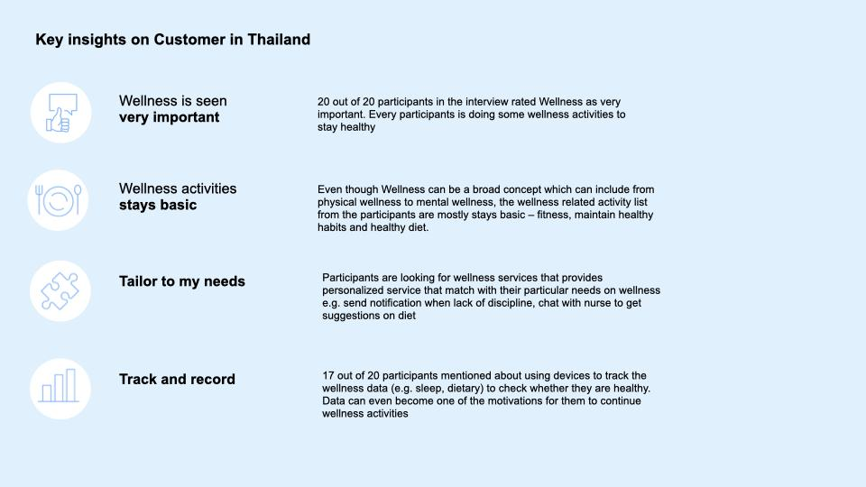**Fig. 2.** Key insight on Customer in Thailand

**3.5 Persona**

Persona is a fictional representation of a typical user or customer, created to help businesses understand their target audience better. A persona typically includes information about a user's demographics, behaviors, goals, motivations, and pain points, as well as their preferred channels of communication and their typical user journey. By creating personas, businesses can gain a deeper understanding of their customers' needs and preferences, and use this information to design better products, services, and user experiences. Personas are often used in product design, marketing, and customer service.

For creating a persona, the analysis is done by grouping customers with similar or comparable behavior into one group. From the analysis of customer behavior, four sample groups have been created: 1) Wellness enthusiasts group, 2) Loyalists group,, 3) Price conscious participants group, and 4) Passive participants group**.**.

3.5.1 There were 18 interviewees, including 10 males and 10 females who exercise regularly. Two interviewees were from the time-constrained group, who did not have time to exercise regularly but instead focused on taking health supplements for a healthy lifestyle.

3.5.2 There were eight interviewees with digital expertise out of 20 who efficiently use health-related applications due to regular use of two or more applications, such as Huawei Health, Good Doctor, Garmin Health Record, Fitwhey, and Fitbit. Six interviewees had moderate abilities to use health-related applications as they only used Xiaomi Health Record and the pharmacy application in Bangkok, while four interviewees had little ability to use health-related applications, as they only used the Doctor Ready application to update vaccine information. Two interviewees did not use any health-related applications and regularly visited a doctor.

3.5.3 Six interviewees give importance to their health due to their past experiences with obesity, and eight interviewees are looking for cost-effective services for their health-related decisions. Six interviewees are unsure about using health-related services, as they regularly have their health checked up at a hospital.

**Fig. 3.** Wellness enthusiasts group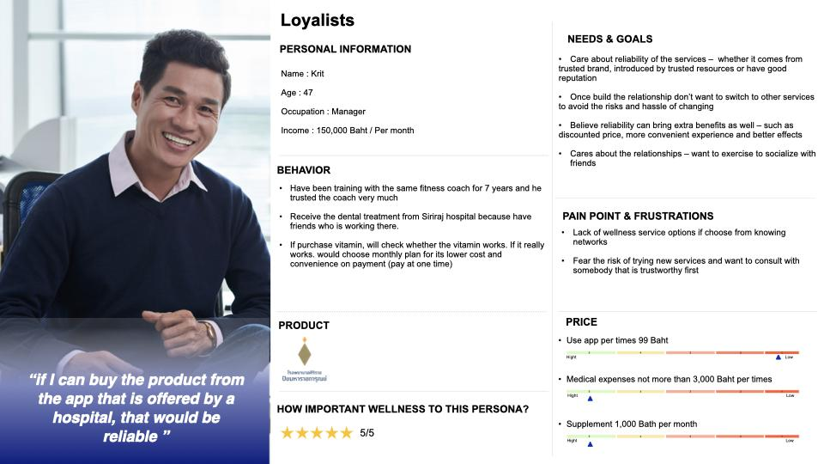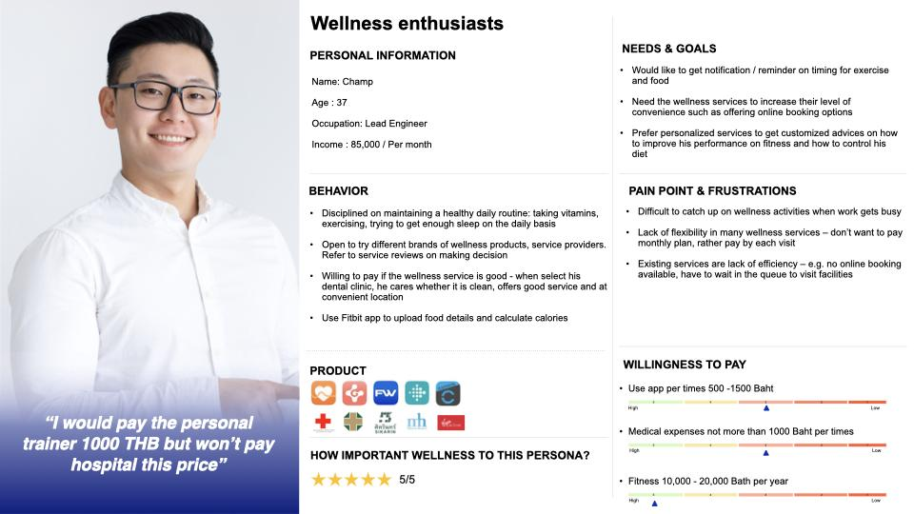

**Fig. 4.** Loyalists group

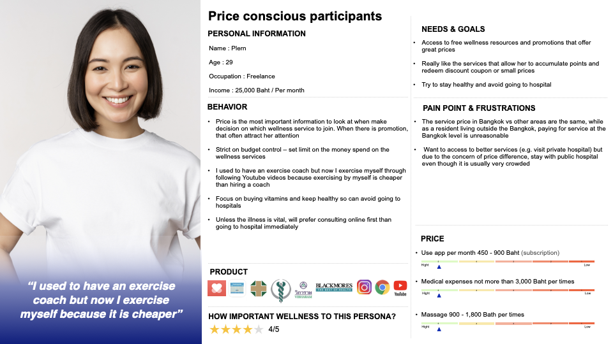**Fig. 5.** Price conscious participants group

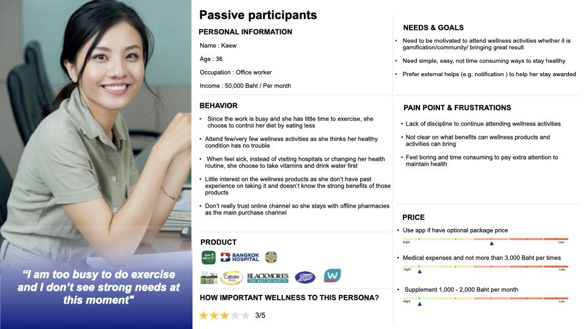

**Fig. 6.** Passive participants group

**3.6 Prototype and Test Process**

Process 4: Prototype - Taking what was generated from Ideation and designing the User Interface (UI) to allow users to see how data works quickly. This design process used Figma to execute.

Process 5: Test - This is to test whether the Prototype meets the needs of real users, using qualitative analysis or Usability testing, and quantitative analysis or A/B testing. The test was conducted with 16 users for 2 rounds. The first round was with 8 users and the second round was also with 8 users. The testing time was 60 minutes per person. Prior to testing, participants were asked to sign a Consent form, which granted permission to collect their data.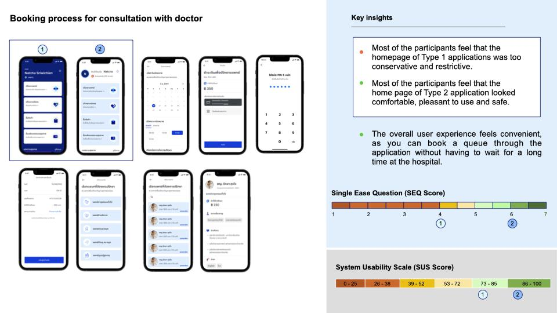

**Fig. 7.** Booking process for consultation with doctor

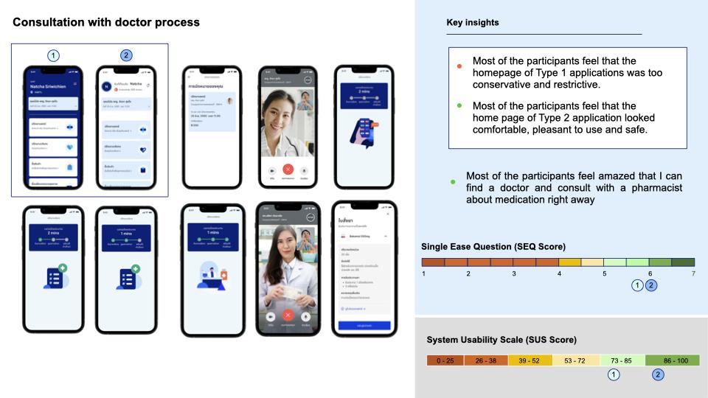

**Fig. 8.** Consultation with doctor process

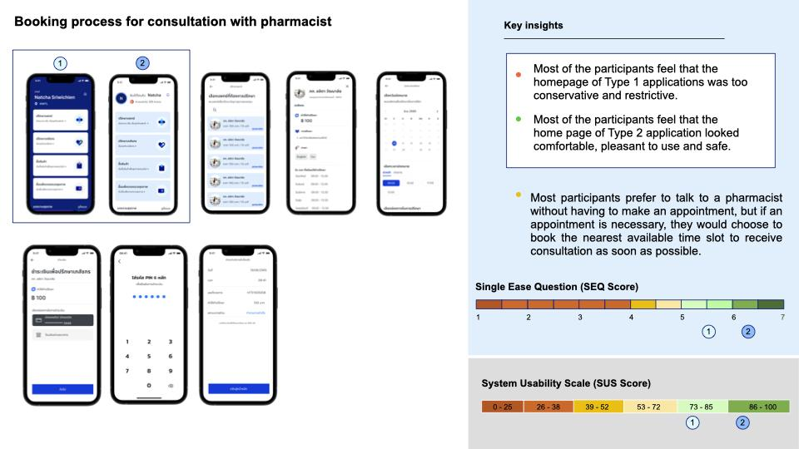**Fig. 9.** Booking process for consultation with pharmacist

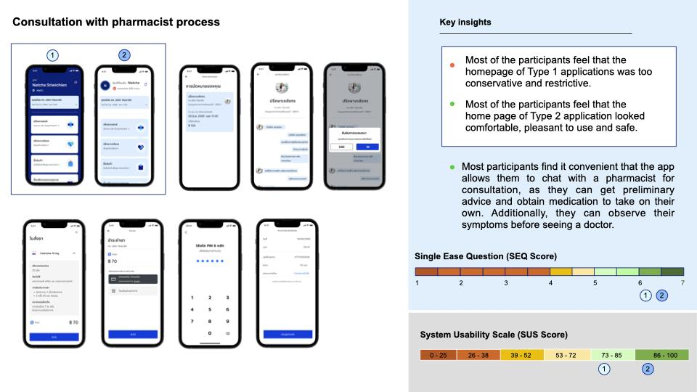

**Fig. 10.** Consultation with pharmacist process

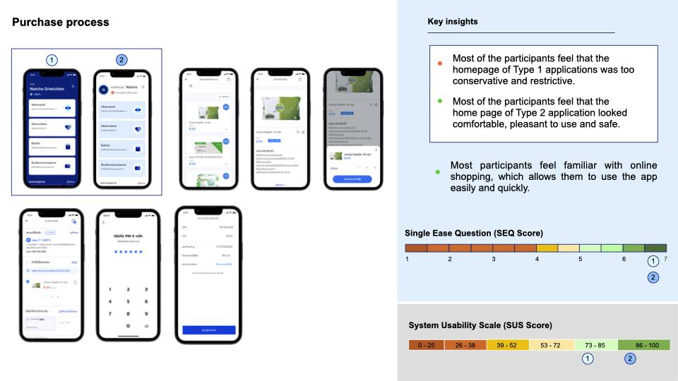**Fig. 11.** Purchase process

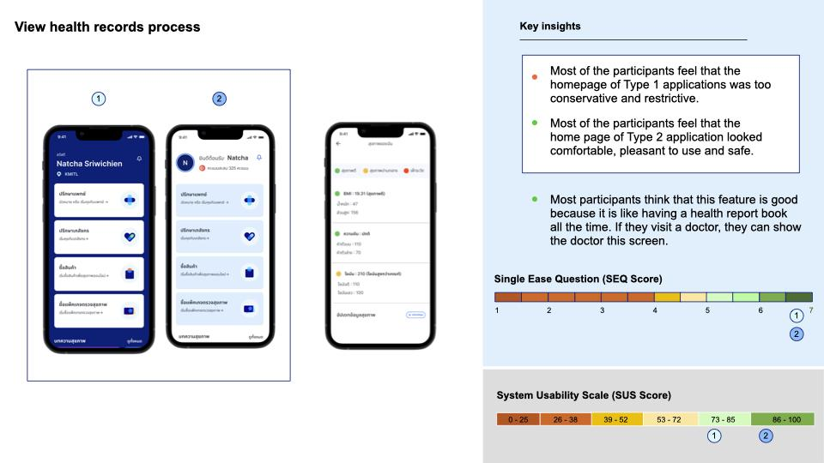

**Fig. 12.** View health records process

**4 Conclusion and Suggestion**

From the two rounds of testing, it can be concluded that the second round scored higher on the Single Ease Question (SEQ Score) and System Usability Scale (SUS Score) compared to the first round. This is due to the adjustment made on the design of the initial app screen, which resulted in the SEQ Score of each process being higher than 5.5, which is considered as passing the standard, and the SUS Score being higher than 68, which is also considered as passing the standard. Therefore, based on the second round of testing, the app screen design can be considered acceptable to users.

There is a continuous process of collecting customer feedback and using it to improve in order to avoid disruption, as technology is continuously developing and customer behavior changes accordingly. Therefore, it is important to collect feedback from customers in every quarter to ensure that the feedback is in line with current trends. The data can be collected through phone interviews lasting no more than 10 minutes, or by scheduling interviews for no more than 1 hour, or by sending questionnaires to gather both quantitative and qualitative data. The collected data is then analyzed to present solutions or better ways for the organization, with the development of features and testing with customers to see if they meet the user's needs.

**References**

1. Anastacia Valdespino. 2019. Single Ease Question (SEQ). [Online article]. Retrieved from: https://help.qualaroo.com/hc/en-us/articles/360039069992-Single-Ease-Question-SEQ .
2. ATSC. 2566 . Joint Commission International Certification Standards forTelehealth. Access to Telehealth Services and Care
3. BetterUXUI. 2563 . System Usability Scale (SUS). [Online article]. Retrieved from:https://betteruxui.com/how-to-use-the-system-usability-scale-sus-to-evaluate-the-usability/
4. Chanuan Uakarn, Kajohnsak Chaokromthong, และ Nittaya Sintao. 2564 . Sample Size Estimation using Yamane. Kasem Bundit University and Rajamangala University of Technology Suvarnabhumi
5. Chafkin C. 2556. Harvard’s Clay Christensen: The Wrong Kind of Innovation. [Online article]. Retrieved from: https://www.inc.com/christine-lagorio/clayton-christensen-capitalist-dilemma.html.
6. Clayton M. Christensen, Taddy Hall, และ Karen Dillon and David S. Duncan. 2559. Competing Against Luck: The Story of Innovation and Customer Choice. Harvard Business School.
7. Edith Coakley Stowe, Jared Augenstein และ Michelle N. Savuto. 2565. A Toolkit for Building and Growing a Sustainable Telehealth Program in Your Practice. A A F P. O R G
8. Eeva Ilama. 2558 . Creating Personas . [Online article]. Retrieved from: https://www.uxbooth.com/articles/creating-personas/.
9. Jakob Nielsen , และ Thomas Landauer. 2536 . A mathematical model of the finding of usability problems . Proceedings of ACM INTERCHI '93 Conference.
10. Jakob Nielsen. 2537. How to Conduct a Heuristic Evaluation. [Online article]. Retrieved from: https://www.nngroup.com/articles/how-to-conduct-a-heuristic-evaluation/.
11. Jakob Nielsen. 2561. UX Research.[Online article]. Retrieved from: https://www.nngroup.com/search/?q=Jakob%20Nielsen
12. Kasidis Satangmongkol. 2562 . Yamane-sample-size-calculation. [Online article]. Retrieved from: https://datarockie.com/blog/yamane-sample-size-calculation/ .
13. Kate Moran. 2561. Quantitative User-Research Methodologies: An Overview.[Online article]. Retrieved from: https://www.nngroup.com/articles/quantitative-user-research-methods/
14. Nick Babich. 2560 . Putting Personas to Work in UX Design: What They Are and Why They’re Important. [Online article]. Retrieved from: https://blog.adobe.com/en/publish/2017/09/29/putting-personas-to-work-in-ux-design-what-they-are-and-why-theyre-important#gs.a9m2dg .
15. Nopadol Rompho, Sakun Boon-Itt, และ Sukrit Vinayavekhin. 2564 . Study 4: Business Start-up Survey for the Healthcare Industry in Thailand. [Online article]. Retrieved from: https://www.eria.org/uploads/media/Research-Project-Report/Study-4_Business-Start-up-Survey-for-the-Healthcare-Industry-in-Thailand.pdf.
16. Raluca Budiu. 2560. Quantitative vs Qualitative. [Online article]. Retrieved from: https://www.nngroup.com/articles/which-ux-research-methods/ .
17. Upskill. 2564. User Flow. [Online article]. Retrieved from: https://medium.com/upskill-ux/
18. Upskill. 2564. User Journey . [Online article]. Retrieved from: https://medium.com/upskill-ux/user-journey