TalentZup 3.0 - System Design

**Introduction**

Talentzup 3.0 is not just a career platform; it is a revolution that fights against the deep rooted issues in the education system, job market, and corporate hiring and biggest opponent is misalignment—between students and their careers, between companies and their workforce, and between the job market and the real needs of the economy.

**System Flow & Components**

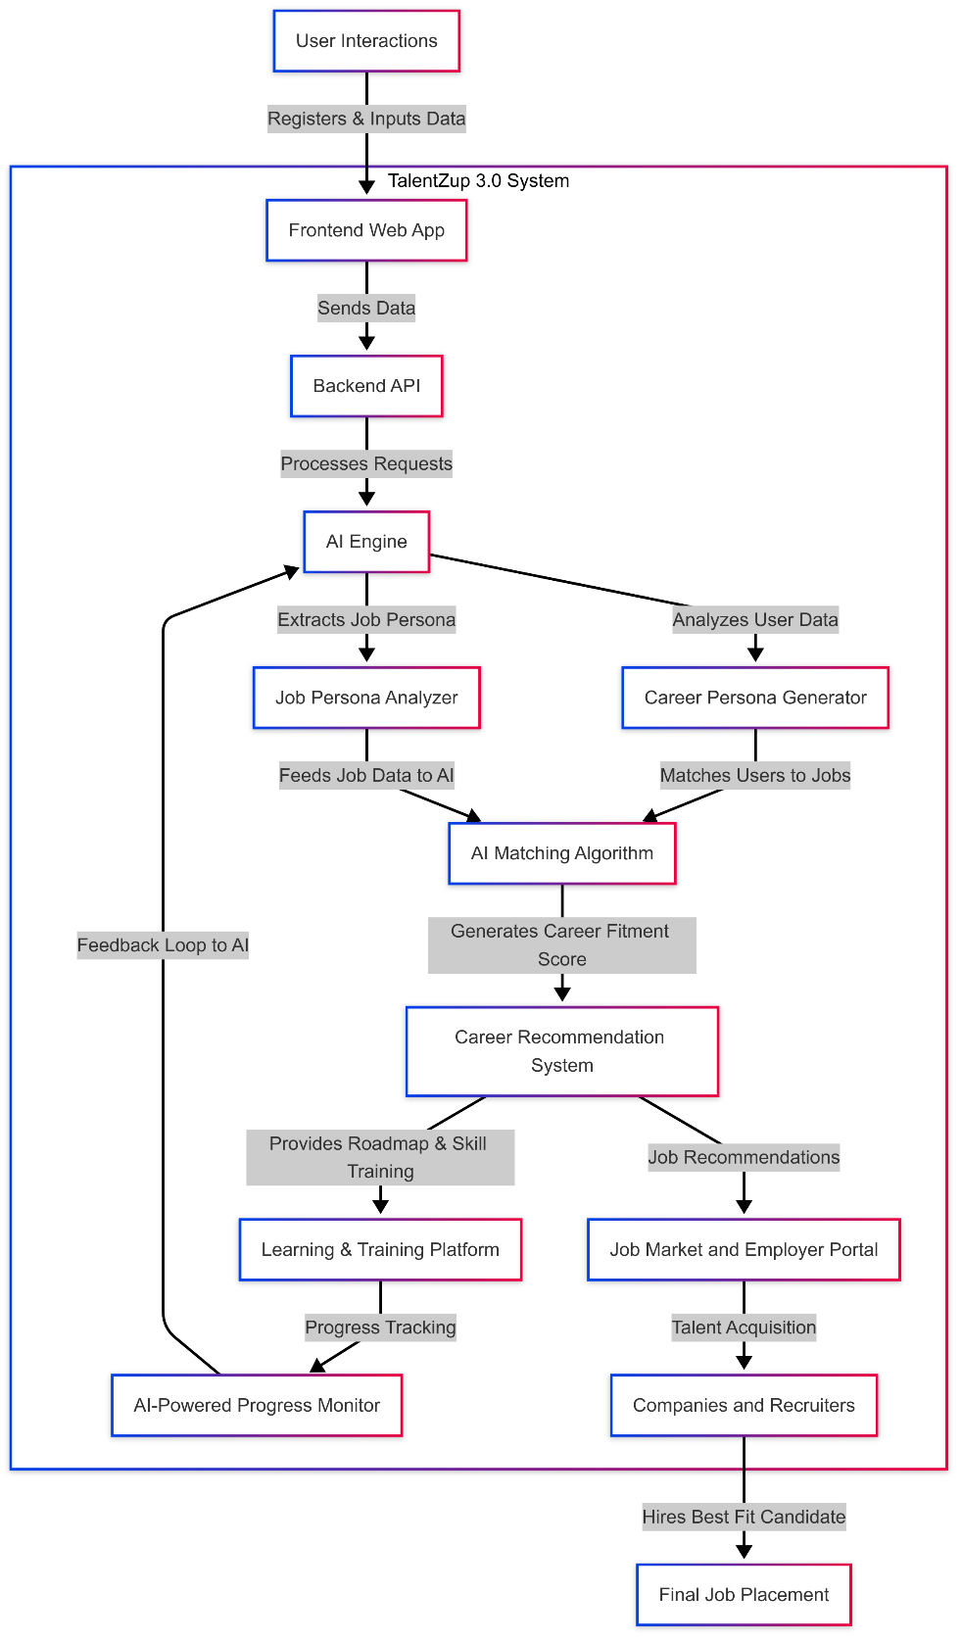

1. User Interactions

* Users interact with the system via a web or mobile application.
* They register and input their details, career aspirations, and skill levels.

2. Frontend Web Application

* The frontend UI allows users to input data and interact with the system.
* It sends the user data to the backend API.

3. Backend API

* The backend processes incoming requests from the frontend.
* It communicates with the AI Engine for processing user data.

4. AI Engine

* The core component of the system that processes career-related data.
* It consists of two main submodules:
  + Job Persona Analyzer: Extracts job persona from industry job descriptions.
  + Career Persona Generator: Analyzes user data to create a career persona.

5. AI Matching Algorithm

* Matches user career persona with job persona.
* Generates a Career Fitment Score to rank job suitability.

6. Career Recommendation System

* Suggests career paths based on AI-matched results.
* Recommends necessary skill upgrades and learning resources.

7. Learning & Training Platform

* Provides AI-recommended courses for technical and soft skills.
* Users receive project-based learning and hands-on training.

8. AI-Powered Progress Monitor

* Tracks learning progress and career development.
* Updates career recommendations dynamically.

9. Job Market & Employer Portal

* Connects job-ready users with hiring companies.
* AI suggests best-fit candidates to recruiters.

10. Companies & Recruiters

* Employers access pre-screened, AI-recommended candidates.
* Companies hire the best-fit talent based on AI insights.

11. Final Job Placement

* Candidates successfully get placed in suitable job roles.
* The AI system continues tracking career growth and future job shifts.

|  |  |  |  |
| --- | --- | --- | --- |
| Step No. | Component | Functionality | Process Flow |
| 1 | User Interactions | Users (students, professionals, employers) interact with the system. | Register &inputs data into the system. |
| 2 | Frontend (web APP) | User-facing platform for registration, input and access. | Sends user data to the backend. |
| 3 | Backend API | Processes user data and requests. | Transfers data between frontend and AI engine. |
| 4 | AI Engine | Core procession unt for AI-driven analysis. | Extracts and analyses data for career matching. |
| 5 | Job Persona Analyzer | Converts job descriptions into structured job personas. | Feeds job data into the AI. |
| 6. | Career Persona Generator | Creates user career profiles based on input data. | Matches users to job personas. |
| 7. | AI Matching Alorithm | Finds the best-fit job for the user. | Generates a Career Fitment Score. |
| 8. | Career Recommendation System | Suggests career options based on AI analysis. | Provides job recommendations. |
| 9. | Learning & Training platform | Provides skill enhancement & mindset training. | Tracks progress & adjusts learning paths. |
| 10. | AI-Powered Progress Monitor | Monitors career growth & skill improvements. | Provides real-time feedback. |
| 11. | Job Market & Employer Portal | Connects users with job opportunities. | Displays job recommendations. |
| 12. | Companies & Recruiters | Employers searching for candidates. | Hires best-fit candidates based on AI scores. |
| 13. | Final Job Placement | The final stage where a user gets hired. | Ensures the right talent is matched with the right job. |

**Working Process Summary:**

**User Registration & Date Input**: Users register, enter details, and interact with the system.

**AI Processing**: The AI engine analyses the user and job data.

**Career Fitment & Recommendations**: AI suggests career paths and job opportunities.

**Skill Enhancement & Monitoring**: Users receive learning resources and career tracking.

**Job Matching & Hiring**: The best-fit candidates get hired through AI-driven recommendations.

**Conclusion**

TalentZup 3.0 integrates AI to streamline career development, training, and job placement. It enhances workforce productivity by aligning individual aspirations with industry needs, benefiting both job seekers and employers.