Scholtz Emánuel István

Neptun kód: XI7WZ9

# Első feladat/First exercise

## The create table statement

CREATE TABLE vaccinations (country text,

iso_code text,

date1 date,

total_vaccinations decimal,

people_vaccinated decimal,

people_fully_vaccinated decimal,

daily_vaccinations_raw decimal,

daily_vaccinations decimal,

total_vaccinations_per_hundred decimal,

people_vaccinated_per_hundred decimal,

people_fully_vaccinated_per_hundred decimal,

daily_vaccinations_per_million decimal,

vaccines text,

source_name text,

source_website text,

PRIMARY KEY (iso_code, date1));

### Copy statement

COPY vaccinations ( country, iso_code, date1, total_vaccinations, people_vaccinated, people_fully_vaccinated, daily_vaccinations_raw, daily_vaccinations, total_vaccinations_per_hundred, people_vaccinated_per_hundred,

people_fully_vaccinated_per_hundred, daily_vaccinations_per_million, vaccines, source_name, source_website)

FROM 'country_vaccinations.csv'

WITH HEADER =TRUE;

## The SELECT query that returns percentage of vaccinated people in Hungary for the dates between 2022-03-01 and 2022-03-30, inclusive.

SELECT country, date1, people_vaccinated_per_hundred

FROM vaccinations

WHERE iso_code = 'HUN' AND date1 >= '2022-03-01' AND date1 <= '2022-03-30'

ORDER BY date1 DESC;

## The output of the SELECT statement

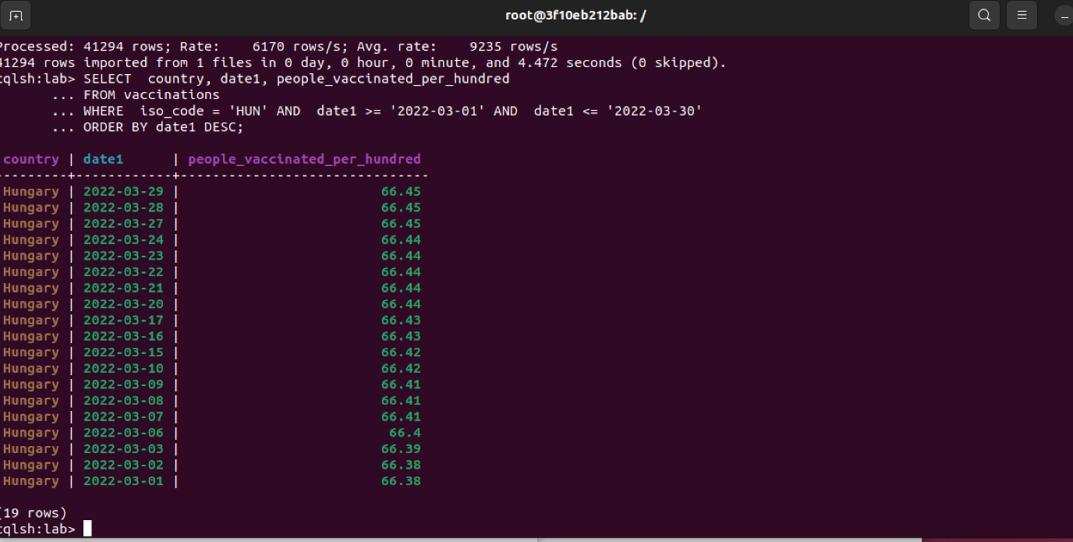

# Második feladat/Second exercise

## The create table statement

CREATE TABLE vaccinations_exc2(country text, iso_code text, date1 date, total_vaccinations decimal, people_vaccinated decimal, people_fully_vaccinated decimal, daily_vaccinations_raw decimal, daily_vaccinations decimal, total_vaccinations_per_hundred decimal, people_vaccinated_per_hundred decimal, people_fully_vaccinated_per_hundred decimal, daily_vaccinations_per_million decimal, vaccines text, source_name text, source_website text, PRIMARY KEY((date1), people_vaccinated_per_hundred)) with clustering order by

(people_vaccinated_per_hundred DESC);

### Copy statement

COPY vaccinations_exc2 (

country, iso_code, date1, total_vaccinations, people_vaccinated, people_fully_vaccinated, daily_vaccinations_raw, daily_vaccinations, total_vaccinations_per_hundred, people_vaccinated_per_hundred, people_fully_vaccinated_per_hundred, daily_vaccinations_per_million, vaccines, source_name, source_website) FROM 'country_vaccinations.csv' WITH HEADER=TRUE;

## The SELECT query that returns the top 30 countries by the highest percentage of vaccinated people on the day 2022-03-29

SELECT country, date1, people_vaccinated_per_hundred FROM vaccinations_exc2 where date1='2022-03-29' limit 30;

## The output of the SELECT statement

