Scholtz Emánuel István

Neptun kód: XI7WZ9

Start server:

sudo systemctl start mongodb

Start client:

mongo

Import data/Adatok importalása

ls

cd Desktop

(I copied the two json file to the virtual machine/bemásoltam a két json fájlt a virtuális gépre)

mongoimport --db test --collection movie --file movies.json

mongoimport --db test --collection crew --file crew.json

**1) Exercise/Feladat: Insert a new document into the crew collection, which contains your name and birth year in the name and birthYear fields. Write a query to show the existence of this record!**

db.crew.insertOne({ "name": "Scholtz Emánuel István", "birthYear": "1999" })

db.crew.find({ "name": "Scholtz Emánuel István" })

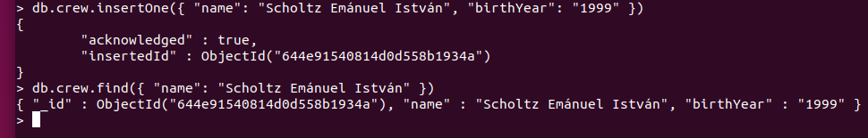

**2) Exercise/Feladat: List all movies that were released after 2000**

db.movie.find({year:{$gt:2000}})

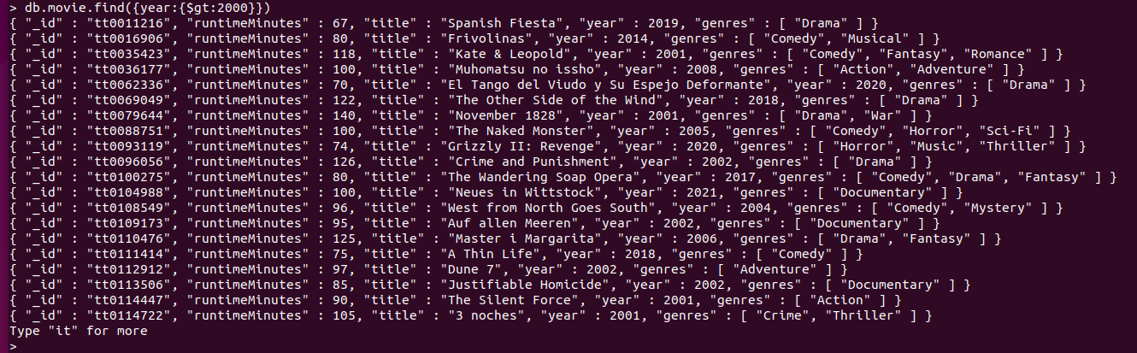

**3) Exercise/Feladat: List all the family dramas (where genres includes both “Family” and “Drama”)**

db.movie.find({genres:{$all:[ 'Family', 'Drama']}})

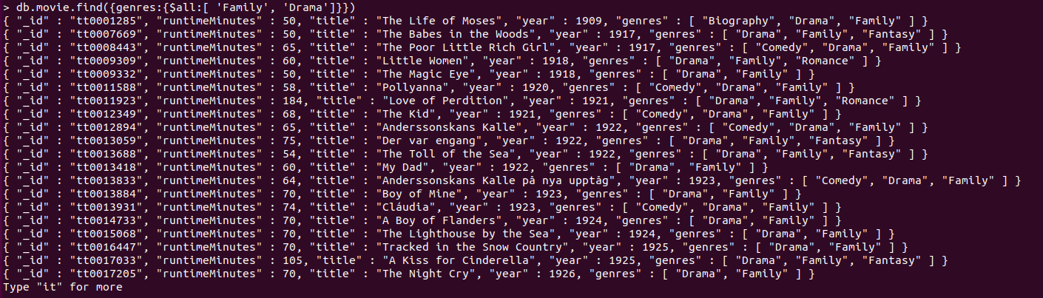

**4) Exercise/Feladat: Get the number of all comedies that were released this year (2021).**

db.movie.find({genres: 'Comedy', year:2021}).count()



**5) Exercise/Feladat: Find the title of the longest movie**

db.movie.find({}, { "_id": 0, "title": 1 }).sort({ "runtimeMinutes": -1 }).limit(1)



**6) Exercise/Feladat: List the name of “one-shot” directors (people with a single director credit to their name). List only the names and no other fields!**

db.crew.find(

{directed: {$size: 1}},

{name: 1, _id: 0}

)

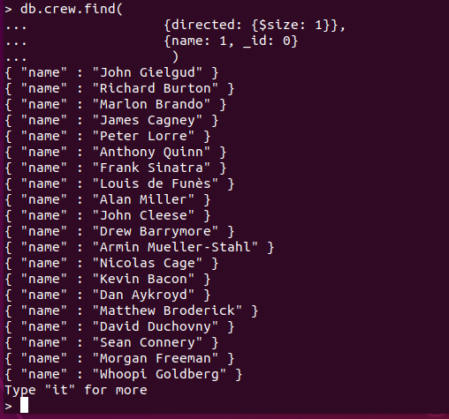

**7) Exercise/Feladat: Find the list of writer-directors, i.e. people who have at least one credit in each category (not necessarily on the same movie).**

db.crew.find({

$and: [

{"directed.1": { $exists: true }},

{"written.1": { $exists: true}}

]},

{name: 1})

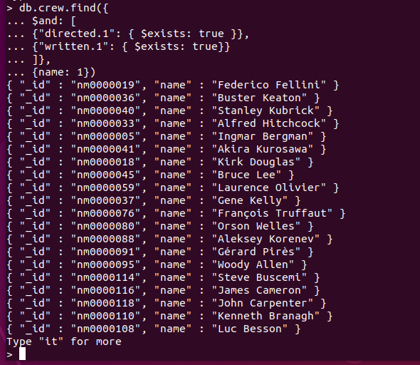

**8) Exercise/Feladat: Find the list of people who contributed to title tt0071853 (Monty Python and the Holy Grail) either as writer or director. List each person only once even if they have credits in both categories.**

db.crew.find({ $or: [{directed: 'tt0071853'}, {written: 'tt0071853' } ]}, {name: 1 })

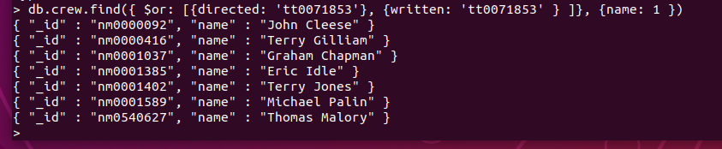

**9) Exercise/Feladat: Mark people where date of birth or date of death is supposedly missing from the database. Find people who have either no birthdate or have no deathDate and were born before 1900 and add a new Boolean field missingDate with value true to their documents. Do not modify the documents of other people.**

db.crew.updateMany({

$and: [

{ $or: [

{ birthYear: { $exists: false }},

{ deathYear: { $exists: false }}

] },

{ birthYear: { $lt: 1900 }}

]},

{ $set: { missingDate: true } }

)

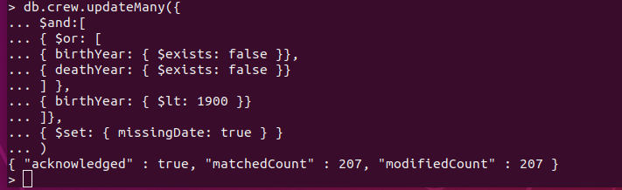

**10 Extra Exercise/Extra Feladat:Find movies that were codirections, i.e. have more than one directors. It is enough to list their ids.**

db.crew.aggregate( [

{ $unwind: "$directed" },

{

$group: {

_id: "$directed",

numberOfDirectors: { $sum: 1 }

}

},

{ $match: { numberOfDirectors: { $gt: 1 } } }

] )

