Project 2 Report
MJ2505, Practical Optimization of Energy Networks

Group name | Group 1
Students | Pontus Chaderton, Didrik Gimdal, Elisabeth Dahlskog
Submission date | 20 October 2026

1. Project summary

1.1 What we did
We designed and optimised a district heating (DH) network around Odenplan, Stockholm, in five steps. DHNx selected routes and pipe sizes for five consumers and two producers (Step 1), then ten consumers and five producers (Step 2). Step 3 optimised producer capacities and houlrly dispatch over 8,760 h in oemof.solp without storage. Step 4 added DHNx losses and re-optimized. Step 5 fixed Step 4 capacities and compared fuel, operating and CO₂ cost (Scenario A) with CO₂ cost alone (B), using 134 €/t.

1.2 Main findings
- Pipe size follows accumulated flow: DN-50 next to the producers (up to 197 kW), DN-30 on small branches; both types are used. The Step 1 network costs 431 k€ for 1,435 m and loses 12.7 kW.
- Expansion is a redesign: 2,635 m and 748 k€ (×1.73) for 2.3 times the design load, so cost per kW falls from 1,235 to 940 €/kW; losses are a constant 23.1 kW (202 MWh/yr, 7.0 % of demand).
- Heat pumps supply 94.8 % of the heat and nearly reach their assumed 0.20 MW site limits (96 %); the electric and biomethane boilers cover peaks. System cost is 83.2 k€/yr (29.0 €/MWh); demand is met in every hour.
- Losses change the design: +7.0 % heat, +6.0 % cost, both heat-pump limits become binding, and the Step 3 plant would be 23 kW short in 10 winter hours.
- A 134 €/t carbon price cuts CO₂ by 31 % (34.6 to 23.8 t/yr, biogenic CO₂ counted) for +0.6 % economic cost (46 €/t avoided) by replacing pellet heat with electric-boiler heat; Scenario B removes only 0.7 t/yr more.

2. Step 1 — Baseline heating network

2.1 What we did
Consumers are real buildings and producers sit at sites with a plausible heat source (Fig. 1a); street intersections are DHNx forks (junction nodes). Coordinates come from Google Maps [12] and each pipe length is the great-circle distance between its nodes. The candidate streets form a ladder with three loops, so DHNx has real route choices (19 candidates, 2,147 m). The five consumers (school, hotel, hospital building, two residential blocks) have different demand shapes so their peaks do not coincide. P0 is a heat pump on Odenplan station exhaust air (north), P1 a wood-pellet boiler on the Sabbatsberg campus (south). Node data: Appendix A1.
Table 1. Step 1 assumptions (02_inputs/; step1_base_network.ipynb).
Assumption | Value [unit] | Rationale | Ref.
Demand profiles | Loads 6, 5, 3, 4, 2 (C0–C4), hourly, kW | Only 6 of 50 profiles are independent; five shapes give peak diversity. Load 6 gap (31 Dec) filled with 30 Dec | course data
Demand scale factor | 0.4 on all profiles, Steps 1–5 | Unscaled peaks sum to 873 kW but two producers behind one DN-50 each (208.9 kW) supply at most 418 kW: infeasible (tested). Profiles are used as building-type shapes | own calc.
Design load | Simultaneity 1: 349 kW | Conservative design hour; coincident peak is 250 kW (factor 0.72) | [10]
Pipe capacity | DN-30 53.6 kW, DN-50 208.9 kW | ΔT 40 K (80/40 °C), ≈100 Pa/m; our Darcy–Weisbach check gives 57 and 206 kW | own calc.
Pipe investment | DN-30 264.1 €/m, DN-50 323.8 €/m | Fixed cost per metre if built (nonconvex), overnight cost; producers are free in DHNx, so annualising would rescale every option equally | [13]
Heat loss | DN-30 8.29 W/m, DN-50 9.18 W/m | Flow-independent: driven by the water–ground temperature difference; same order as DHNx example data | [13], [10]
Pipe operating cost | None in DHNx | No pumping cost; losses are the operating effect, priced in Step 4 | –
Producers in DHNx | Unlimited heat at zero cost | DHNx designs the network; supply economics follow in Step 3 | [10]
Added rules | ≤ 1 pipe type per edge; one connected network | DHNx 0.0.4 otherwise builds two sizes in parallel on one street (its result code then fails) and builds islands because heat is free; Steps 3–5 need one shared network | own

Optimisation problem. DHNx builds a mixed-integer linear program (MILP) for one design hour. Decision variables are a binary build variable y(e,k,d) per candidate edge e, pipe type k and direction d, the pipe capacity and flow q [kW], and each producer's injection [kW]:
min Σ L_e · c_k · y(e,k,d) s.t. nodal heat balance; consumer receives P_heat_max; q ≤ cap_k · y; outflow = inflow − L_e · l_k · y; Σ_k,d y ≤ 1; connected
with length L_e [m], cost c_k [€/m] and loss l_k [kW/m]. CBC (COIN-OR Branch and Cut) solves it to proven optimality (gap 0, 62 binaries, ≈1 s). Since the hourly load never exceeds the design load (250 vs 349 kW), the network is feasible in all 8,760 hours and the constant loss gives the annual loss.

2.2 Key results
Table 2. Step 1 results (03_outputs/step1/summary.csv, pipe_types_used.csv).
Quantity | DN-30 | DN-50 | Total
Capacity [kW] / cost [€/m] / loss [W/m] | 53.6 / 264.1 / 8.29 | 208.9 / 323.8 / 9.18
Cost per metre and kW [€/(m·kW)] | 4.93 | 1.55
Pipes built (of 19) / length [m] | 5 / 559 | 9 / 876 | 14 / 1,435
Investment [k€] | 147.6 | 283.6 | 431.1
Heat loss [kW] (constant) | 4.6 | 8.0 | 12.7 = 111 MWh/yr (10.9 % of demand)
Producer supply at design hour [kW] |  |  | P0 197.4, P1 164.5
Without connectivity rule |  |  | 2 islands, 424.3 k€ (−1.6 %)

- Both required types are selected. DN-50 on both producer connections, the Dalagatan trunk from P0 (195–197 kW, 94 % utilised) and the services to school, hotel and hospital (73–109 kW); DN-30 on the two small residential services (20, 44 kW), the Frejgatan main F1–F7 (21 kW) and the link F3–F5 to Sabbatsberg.
- The producer-to-producer link binds: DN-30 F3–F5 runs at 97–100 %, so only 52 kW flows south from P0.
- Investment is 431 k€ (73 % street mains); 5 candidates (713 m) are not built. The only operating effect is the 12.7 kW loss, valued in Step 4.

2.3 Interpretation
DN-50 carries 3.9 times more heat than DN-30 for 23 % more cost per metre: three times cheaper per kW, but paid in full where the flow is small. The optimiser therefore uses DN-50 wherever the accumulated design flow exceeds 53.6 kW (near producers and large consumers) and DN-30 elsewhere. Losses per metre are almost equal and only add a little flow, so length dominates. Connecting the two producer areas costs 6.9 k€ (+1.6 %). These results (summary.csv, pipes_result.csv) are the reference for Step 2.

3. Step 2 — Heating network expansion

3.1 Connection-point selection
All Step 1 nodes and assumptions are kept. Five consumers are added to the north and east (care home C5, large school C6, residential blocks C7–C9), and candidates extend to Upplandsgatan and Norrtullsgatan (35 candidates, 3,808 m, six loops). New producers sit where their input exists: P2 electric boiler beside P0, sharing its grid connection; P3 biomethane boiler at Odengatan 69 on the gas grid; P4 heat pump on refrigeration heat at the Hemköp supermarket. DHNx chooses the connections (Fig. 1b).
Table 3. Step 2 assumptions in addition to Table 1 (step2_network_expansion.ipynb).
Assumption | Value [unit] | Rationale | Ref.
New consumers | Loads 11, 18, 10, 16, 22 (C5–C9); peaks 52–183 kW | Derived profiles matched to building type; scale 0.4 | course data
Design load | 796 kW (coincident 613 kW, factor 0.77) | Simultaneity 1 as in Step 1 | [10]
New pipe types | DN-25 35.9 kW, 256.7 €/m, 7.56 W/m; DN-40 115.4 kW, 284.5 €/m, 9.55 W/m; DN-60 339.0 kW, 355.9 €/m, 10.42 W/m | Same method as Step 1; DN-30, DN-50 unchanged | [13]
P2 / P3 / P4 sites | Beside P0 / Odengatan 69 / Hemköp | Peak unit on existing grid connection; peak and reserve on gas grid; documented waste-heat source | [4], [11]

Table 4. Step 2 results vs Step 1 (03_outputs/step2/summary.csv, pipes_result.csv).
Quantity | Step 1 | Step 2 | Ratio
Design load [kW] | 349 | 796 | 2.28
Pipes built / length [m] | 14 / 1,435 | 27 / 2,635 | 1.84
Pipe mix | DN-30 ×5, DN-50 ×9 | DN-25 ×7, DN-30 ×4, DN-40 ×9, DN-50 ×3, DN-60 ×4 | –
Investment [k€] / per kW design load [€/kW] | 431.1 / 1,235 | 747.9 / 940 | 1.73 / 0.76
Heat loss [kW] / annual [MWh/yr] / share of demand | 12.7 / 111 / 10.9 % | 23.1 / 202 / 7.0 % | 1.82
Producer supply at design hour [kW] | P0 197, P1 164 | P0 287, P1 209, P2 0.3, P3 54, P4 269 | –
Binaries / CBC solve time | 62 / ≈1 s | 275 / ≈14 s | 4.4 / ≈15
Without connectivity rule | 2 islands, −1.6 % | 4 islands (P2 unconnected), −22 % | –

Resulting connections. The Step 1 Dalagatan trunk is dropped. P0 feeds north-east along Vanadisvägen in DN-60 (285 kW) to C6 and C9; P4 takes the centre through DN-60 and DN-40 mains; P1 still feeds Sabbatsberg; P3 feeds Odengatan 75 in DN-30. DN-40 replaces the oversized DN-50 services of Step 1, and DN-25 serves the smallest building and links that mainly keep the network connected (0–35 kW).
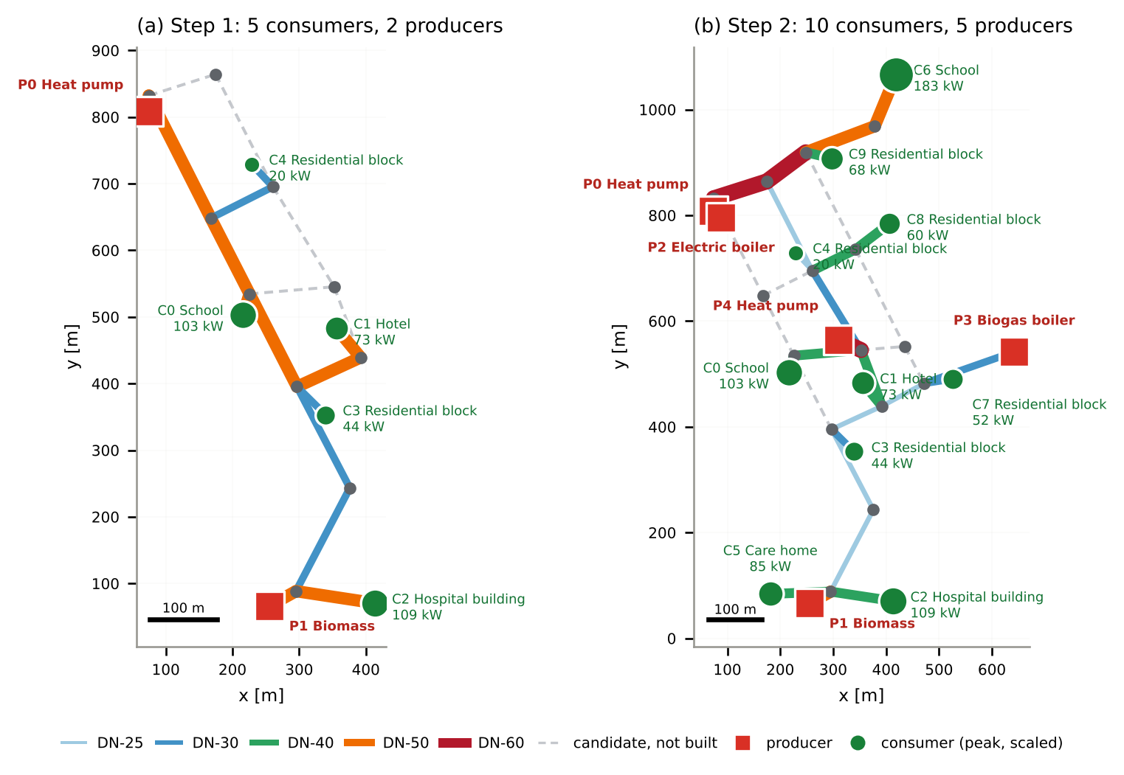
Figure 1. Optimised networks, built pipes coloured by size: (a) Step 1, (b) Step 2. Coordinates in metres; labels show scaled peak demand (03_outputs/report_figures/fig1_networks.png).

3.2 Interpretation
More producers at more locations shorten heat paths, and in-between sizes remove the oversizing of Step 1, so investment grows less than load. Step 3 receives the ten consumers' hourly demand (demand_selected.csv) and the producers P0–P4; Step 4 receives the constant loss of 23.07 kW (network_losses.csv). Seven pipes run above 95 % of capacity; the P1 (DN-50) and P3 (DN-30) connections cap those producers and P2 supplies about 0 kW. This split is a network artefact: without production costs DHNx lets the cheapest-to-connect producers carry the load, and the economic split is left to Step 3. The largest losses are on long DN-25/30 links (1.3–1.5 kW); a constant loss weighs most in summer. One network costs 28 % more than four islands, the price of letting every producer serve the aggregate demand assumed in Steps 3–5.

4. Step 3 — Energy system optimization (OEMOF)​

4.1 Assumptions for selected technologies
Table 5. Step 3 technology and price assumptions (02_inputs/step3/technology_parameters.csv). ¹ Mean fuel/electricity plus O&M per MWh of heat at the 2019 mean SE3 price of 38.4 €/MWh.
Unit | Technology | η / COP | CAPEX [€/MW] | Var. O&M [€/MWh] | Input price | Life [yr] | Max cap. [MW] | Var. cost¹ [€/MWh] | Ann. CAPEX [k€/MW/yr] | Source
P0 | Heat pump, station exhaust air | 3.10 | 1,130,000 | 3.07 | SE3 spot, hourly; source heat free | 25 | 0.20 | 15.4 | 80.2 | [1], [2], [11]
P1 | Wood-pellet boiler | 1.01 | 750,000 | 2.08 | 27.76 €/MWh | 25 | 0.15 | 29.6 | 53.2 | [1], [3]
P2 | Electric boiler | 0.99 | 150,000 | 0.95 | SE3 spot, hourly | 20 | 0.15 | 39.7 | 12.0 | [1], [2]
P3 | Biomethane boiler | 1.03 | 60,000 | 1.17 | 102.4 €/MWh | 25 | 0.15 | 100.6 | 4.3 | [1], [4]
P4 | Heat pump, supermarket heat | 3.10 | 1,130,000 | 3.07 | as P0 | 25 | 0.20 | 15.4 | 80.2 | [1], [2], [11]

DEA data [1] represent waste-heat pumps, pellet and electric boilers, and a natural-gas boiler as a biomethane proxy. Applying the 1 MW HP reference to station and supermarket heat is an assumption; boiler efficiencies above 1 reflect condensation. Electricity uses hourly 2019 SE3 prices [2], with two gaps interpolated and UTC shifted to fixed CET. Pellets cost 294 SEK/MWh [3], biomethane 102.4 €/MWh [4]. Electricity tax (≈33 €/MWh [8]), grid fees and fixed O&M are excluded, favouring electric units. CAPEX is annualized at 5 %. Assumed capacity bounds total 0.85 MW: 0.20 MW per HP for base load and 0.15 MW per boiler for intermediate/peak load. These are unverified upper bounds, not installed sizes. No storage or solar collector is included.

4.2 Infrastructure design
Five converters feed one heat bus (Fig. 2), following district_heating_supply_2. Each HP draws electricity Q/COP and free recovered heat Q(COP−1)/COP from a separate source bus. Ten scaled Step 2 profiles give a 0.613 MW peak, 0.327 MW mean and 2,868.3 MWh/yr. The connected DHNx system is aggregated without pipe constraints. The 8,760 h linear program is:
min Σ_u epc_u · P_u + Σ_t Σ_u (c_in,u,t · F_u,t + c_OM,u · Q_u,t) s.t. Σ_u Q_u,t = D_t; 0 ≤ Q_u,t ≤ P_u; Q_u,t = η_u F_u,t; 0 ≤ P_u ≤ P_max,u
Variables are capacity P_u, hourly heat Q_u,t and input F_u,t [MW]; epc_u is annualized CAPEX. CBC returns an optimum. Hourly imbalance is at most 7·10⁻⁹ MW, and summed unit costs equal the objective.
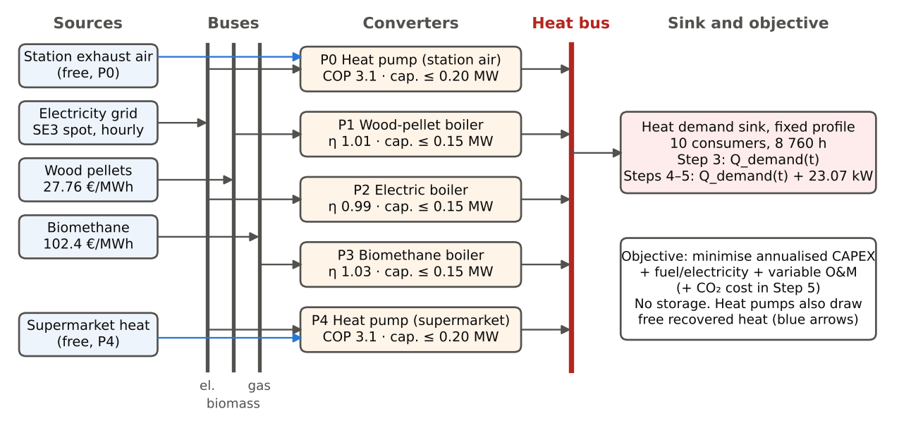
Figure 2. Energy system model in oemof.solph (Steps 3–5).

4.3 Energy system model result
Table 6. Step 3 results (03_outputs/step3/unit_summary.csv). The heat pumps have identical data, so only their sum is unique (199 + 186 kW in this run). Total cost includes 33.1 k€/yr annualised CAPEX.
Unit | Capacity [kW] | Heat [MWh/yr] | Share [%] | Full-load hours [h] | Hours at capacity [h] | Operating cost [€/yr] | Total cost [€/yr]
Heat pumps P0 + P4 (limit 2 × 200) | 385 | 2,718.0 | 94.76 | 7,061 | ≈5,460 each | 43,064 | 73,925
Wood-pellet boiler P1 | 5.1 | 11.6 | 0.40 | 2,256 | 2,187 | 342 | 615
Electric boiler P2 | 132.1 | 134.3 | 4.68 | 1,017 | 236 | 6,226 | 7,815
Biomethane boiler P3 | 90.4 | 4.4 | 0.15 | 49 | 3 | 442 | 827
Total | 612.6 | 2,868.3 | 100 |  |  | 50,074 | 83,183 (29.0 €/MWh)

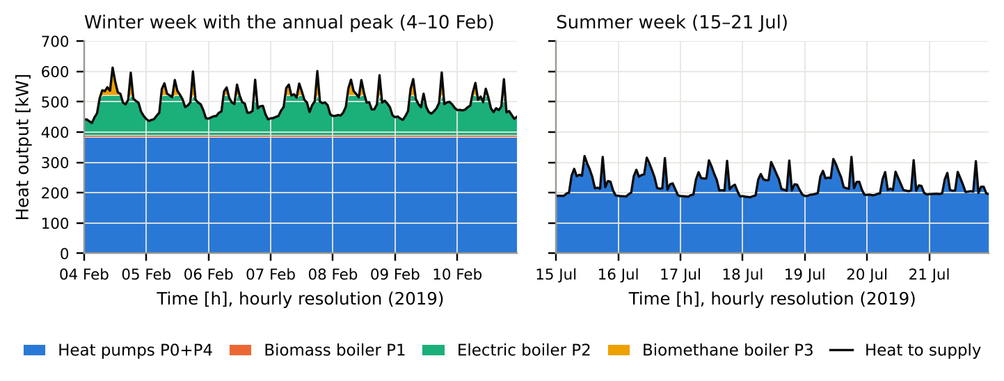
Figure 3. Step 3 hourly heat output by unit [kW] in the peak winter week and a summer week; black line: demand.
- Heat pumps supply 94.8 % of the heat at 15.4 €/MWh. They run ≈7,060 full-load hours, far above the ≈2,800 h at which they beat the electric boiler despite their CAPEX.
- Limits bind all year. Heat pumps are at full output ≈5,460 h each (≈690 h in January, >300 h in July); the pellet boiler 2,187 h (mostly November–April); the electric boiler 236 h, mostly January–February plus 64 h in May–June when the SE3 price is below 3.1 €/MWh and it undercuts the heat pumps; the biomethane boiler 3 h at the peaks.
- Peaks go to cheap-to-build units: pellets are cheaper to run but cost 41 k€/(MW·yr) more to own than the electric boiler, so only 5 kW of pellet boiler is built; the biomethane boiler runs 49 full-load hours.
- Heat pumps carry 86 % of operating cost (43.1 of 50.1 k€/yr). Total cost 83.2 k€/yr (29.0 €/MWh); demand is met in all hours with exactly 0.613 MW installed, i.e. no reserve margin.

4.5 Interpretation
Step 4 reuses all Step 3 inputs (02_inputs/step3/) and changes only the demand. Because the Step 3 plant equals the peak exactly, any extra load requires extra capacity within the same site limits.

5. Step 4 — Integration of district heating network (DHNx) with the energy system model (OEMOF)

5.1 Data consistency and check up
The 27 built pipes of Step 2 lose L = 23.07 kW (network_losses.csv). Every pipe type has l_factor = 0, so each pipe loses l_factor_fix × length regardless of flow, and L is the same in every hour; this is physically reasonable, as losses follow the temperature difference between water and ground, not the flow. L is converted to 0.02307 MW, Q_total(t)=Q_demand(t)+L, and saved as 02_inputs/step4_loss/oemof_input_with_losses.csv. Two checks pass: L equals the sum of per-pipe losses, and Step 2 demand [kW] equals Step 3 demand [MW] × 1,000 in all 8,760 h. Losses are 6.6 % of annual supply ices and site limits are unchanged from Step 3.

5.2 Optimization
The Step 3 linear program is re-solved with D_t replaced by D_t + L. Capacities are re-optimised within the same site limits, so every difference from Step 3 stems from the losses; keeping the Step 3 capacities (0.613 MW) would leave demand unmet in 10 h (up to 23 kW), as the new peak is 0.636 MW. DHNx is not re-run: L is the loss of the Step 2 design itself, and the network, sized for the sum of peaks (796 kW), has margin over the 636 kW coincident peak. CBC returns an optimal solution and supply equals demand plus losses in every hour.

5.3 Results
Table 7. Step 3 vs Step 4 (03_outputs/step4_loss/comparison_step3_step4_system.csv).
Quantity | Step 3 | Step 4 | Change
Heat produced [MWh/yr] | 2,868 | 3,070 | +7.0 %
Installed capacity [kW] (heat pumps / pellet boiler) | 613 (385 / 5) | 636 (400 / 13) | +3.8 %
Operating cost [k€/yr] | 50.1 | 53.4 | +6.7 %
Total cost [€/MWh delivered] | 29.00 | 30.74 | +6.0 %
Delivered / produced heat [%] | 100 | 93.4 | −6.6 pts

5.4 Interpretation
The losses act as a constant extra demand, covered by the cheapest unit with spare capacity: the heat pumps in summer; in winter they reach their 0.20 MW limits, which become newly binding, so the extra 8 kW of peak capacity goes to the pellet boiler. Of the extra 202 MWh, heat pumps supply 182.5 and the pellet boiler 19.3; the losses therefore affect design, not only operation. Pipe investment (≈43.6 k€/yr) is outside the oemof objective, and the electric and biomethane boilers exceed their DHNx connections in ≈1,480 h and 19 h, a limit of the sequential approach. Step 5 starts from the Step 4 capacities and the loss-adjusted demand.

6. Step 5 — Environmental Optimization

6.1 Reformulated objective function
Capacities are fixed at the Step 4 result, so only dispatch is optimised and CAPEX is a sunk cost. A CO₂ cost is added on each unit's input:
$$\min{\sum_{t}{\sum_{u}{\left[wc_{in,u,t}F_{u,t}+w c_{OM,u}Q_{u,t}+p_{CO_{2}} ef_{u}F_{u,t}\right]}}}$$
where u ∈ U denotes the five generating units (P0–P4) and t ∈ T the 8,760 hours of 2019; $F_{u,t}$ is the fuel or electricity input and $Q_{u,t}$ the heat output of unit u in hour t [MW]; $c_{in,u,t}$is the fuel or electricity price, $c_{OM,u}$he variable O&M cost [€/MWh], $ef_{u,t}$ the emission factor of the unit’s input [t CO₂/MWh], $p_{CO2}$the carbon price [€/t].
Scenario A sets w = 1 and Scenario B w = 0. One carbon price of 134 €/t [7] applies to every tonne, since a carbon price is by definition uniform, so the technologies differ only through their emission factors: 0.020 t/MWh for electricity [6], and 0.403 (wood pellets) and 0.197 (biomethane) t/MWh fuel [5]. Divided by each unit’s efficiency or COP, this gives a CO₂ cost per MWh of heat of 0.9 € for the heat pumps, 2.7 € for the electric boiler, 25.6 € for biomethane and 53.5 € for pellets. Biogenic CO₂ is counted at the stack: the biomass regrows elsewhere and later, while the emission is local. This departs from the IPCC and EU ETS convention of zero [5], which is tested as a sensitivity; only direct emissions are included. A reference run without CO₂ cost reproduces the Step 4 operating cost, and all runs are evaluated at real price

6.2 Results
Table 8. Step 5 scenarios, capacities fixed at Step 4 (03_outputs/step5_emissions/system_comparison.csv).
Quantity | Step 4 | A: cost + CO₂ | B: CO₂ only
CO₂ [t/yr] | 34.6 | 23.8 (−31 %) | 23.2 (−33 %)
Economic cost incl. CAPEX [k€/yr] | 88.16 | 88.66 (+0.6 %) | 88.86 (+0.8 %)
Abatement cost [€/t avoided] | – | 46 | 61
Heat: heat pumps / electric / pellet / biomethane [MWh/yr] | 2,901 / 135 / 30.9 / 4.4 | 2,910 / 153 / 3.0 / 4.1 | 2,910 / 154 / 0.04 / 6.6

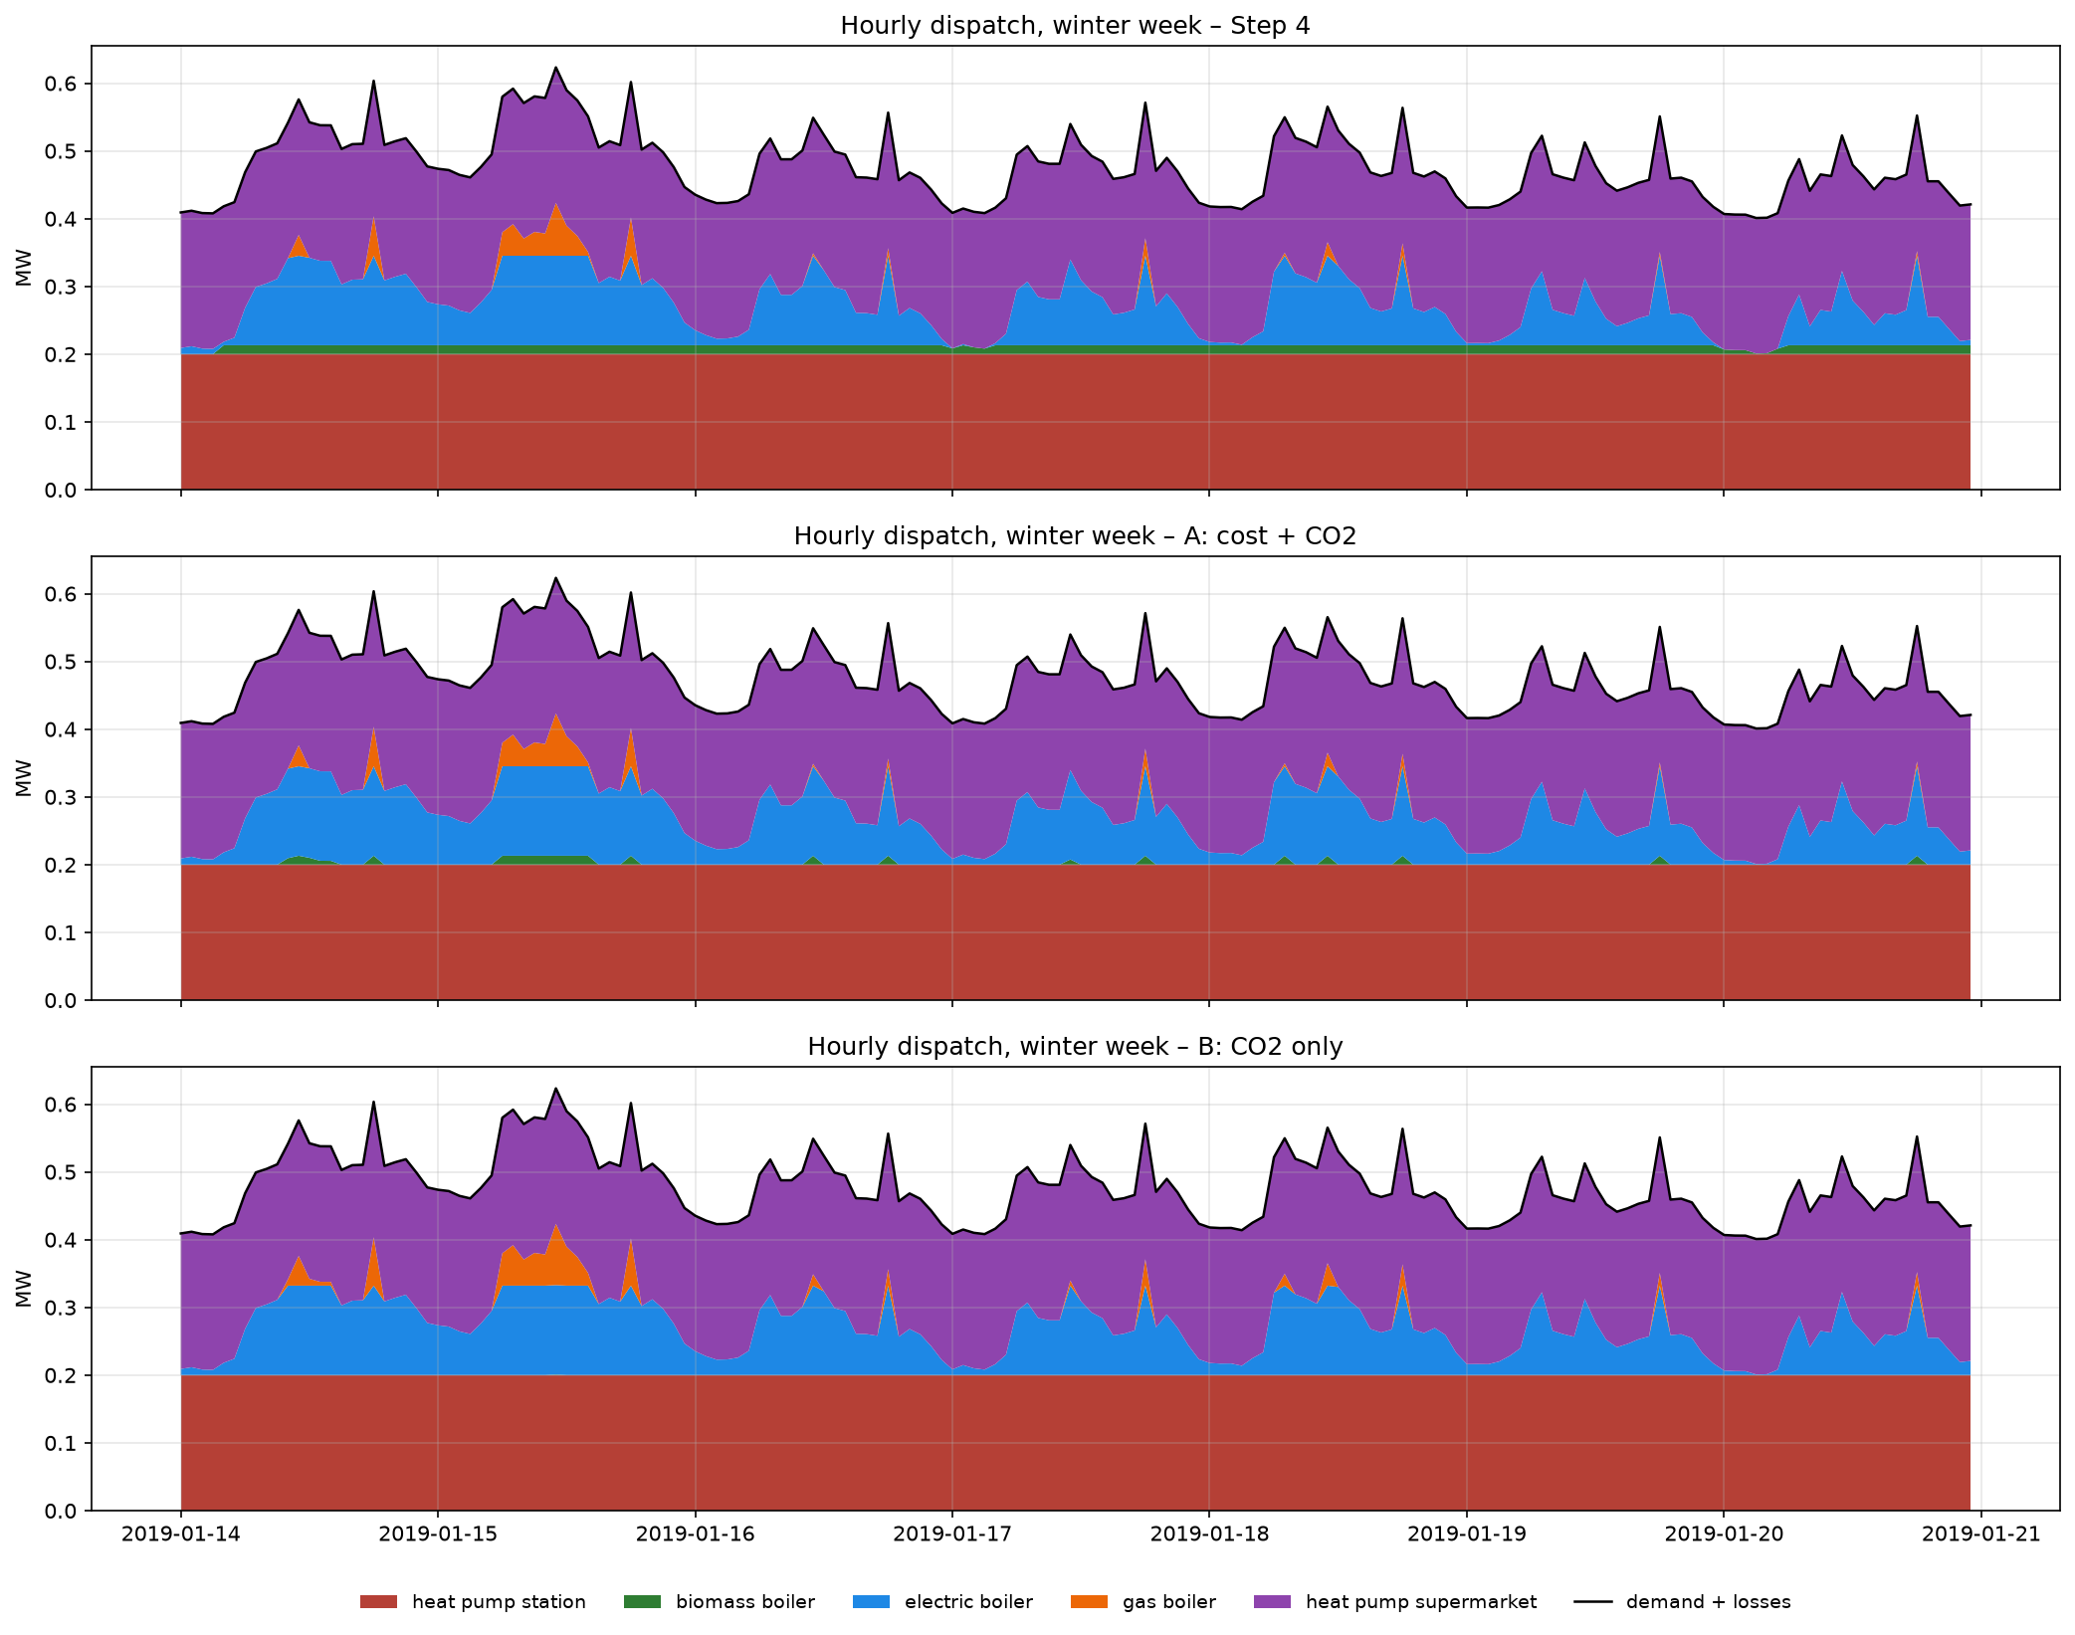
Figure 5. Hourly heat output by unit [MW] in the peak winter week (14–20 January 2019) for the Step 4 reference and Scenarios A and B (03_outputs/step5_emissions/dispatch_winter_week_comparison.png).
A: the pellet boiler becomes less competitive. Its cost per MWh of heat rises from 29.6 to 83.1 €, behind the electric boiler (42.4 €); its heat falls 90 % and the electric boiler takes over.
B: low-carbon units dominate. The order follows emissions per MWh of heat: heat pumps (0.0065 t/MWh thanks to the COP) and the electric boiler supply 99.8 %. Pellets come last and run only in the few peak hours when the other units (0.622 MW) cannot meet 0.636 MW.
Why the effect is small. The heat pumps are both the cheapest and the cleanest unit and already run at their limits, so a carbon price can only reshuffle the peak units (5.5 % of heat). The only conflict between cost and emissions is the pellet boiler, which accounts for nearly all of the reduction; larger cuts need more heat-pump capacity or storage.
Trade-off. A avoids 10.8 t/yr for +493 €/yr (46 €/t) and has the lowest total cost including CO₂; B avoids 0.7 t/yr more at about 300 €/t at the margin.
Sensitivity (App. A4). Most of the reduction occurs between 25 and 100 €/t. With biogenic CO₂ = 0, B burns 792 MWh of biomethane (211 t/yr at the stack): the accounting rule decides which system looks clean.

7. Conclusion and recommendations
Findings and trade-offs. Network design is governed by accumulated design flow and length; more producers at more locations cut pipe size and cost per kW, and one connected network costs 1.6 % (Step 1) and 28 % (Step 2) more than islands. Heat pumps on recovered heat are the cheapest and cleanest supply and are limited only by the assumed site limits; boilers trade low CAPEX against high running cost. Losses (7 % of demand) raise cost per delivered MWh by 6 % and make the heat-pump limits binding. A 134 €/t carbon price removes a third of emissions at 46 €/t avoided; with fixed capacities larger cuts need more heat-pump capacity or storage, not another dispatch.
Model results vs group assumptions. Topology, pipe sizes, capacities, dispatch, costs, losses and emissions are model results. The 0.4 demand scale, producer sites and technologies, site limits, pipe data, prices, carbon price and biogenic-CO₂ rule are our assumptions; the heat-pump share, the binding limits and the small carbon-price effect depend directly on the site limits.
Limitations and recommendations. (1) Sequential models: the electric and biomethane boilers exceed their DHNx connections, so the models should be iterated. (2) One design hour, simultaneity 1 and constant losses oversize the network. (3) Constant COP, no taxes or grid fees, perfect foresight and no reserve margin favour electric units and understate cost. (4) Direct emissions and an average (not marginal) electricity factor. (5) Site limits and recovered-heat availability are unverified; the two identical heat pumps split arbitrarily. (6) Step 2 redesigns rather than extends Step 1; a staged study should treat Step 1 pipes as existing.

8. Reproducibility and submitted files
The ZIP contains the project repository. Run the notebooks in order from the root folder, which also holds helpers.py (shared functions), requirements.txt and README.md. All paths are relative to the root.
- Notebooks (root folder):
  - step1_base_network.ipynb: Step 1, DHNx base network
  - step2_network_expansion.ipynb: Step 2, DHNx expansion
  - step3_oemof_dispatch.ipynb: Step 3, oemof capacity and dispatch optimisation
  - step4_loss.ipynb: Step 4, DHNx–oemof integration (network losses added to demand)
  - step5_emissions.ipynb: Step 5, environmental scenarios with fixed capacities
- data/: inputs
  - Demand profiles_heating.xlsx (heat-demand profiles, cached as demand_profiles.csv) and pipe_types.csv (pipe costs and losses)
  - step1/, step2/: DHNx inputs (twn_data/, invest_data/) and the selected demand
- results/: outputs, one subfolder per step
  - step1/, step2/: optimised network, pipe sizes, network losses (network_losses.csv, losses_per_pipe.csv) and maps
  - step3/, step4_loss/: capacity sizing (unit_summary.csv), hourly dispatch (dispatch.csv), costs, Step 3–4 comparison tables, figures and an Excel summary
  - step5_emissions/: scenario comparison (system_comparison.csv), emission factors, carbon-price and biogenic-CO₂ sensitivities, dispatch, figures and an Excel summary

9. Disclosure of AI use
Generative AI (Claude, Anthropic) was used iteratively throughout the project. It generated and debugged code, which the group then ran locally, checked against the model output and adjusted. It was also used as a discussion partner to question modelling choices (fixed vs optimised capacities, carbon-price formulation, biogenic CO₂ accounting), interpret results and find sources, which the group verified. Finally, it helped summarise and rewrite report text for clarity and length. All assumptions, results and conclusions were reviewed by the group, which takes full responsibility for the content.

References
[1] Danish Energy Agency, Technology Data for Generation of Electricity and District Heating. https://ens.dk/en/analyses-and-statistics/technology-data-generation-electricity-and-district-heating
[2] Open Power System Data (2020), Time series, version 2020-10-06, SE_3_price_day_ahead 2019. https://data.open-power-system-data.org/time_series/2020-10-06
[3] Energimyndigheten, EN0307 Trädbränsle- och torvpriser 2019 (refined wood fuels to heating plants). https://www.energimyndigheten.se/globalassets/statistik/officiell-statistik/statistikprodukter/tradbransle-och-torvpriser/en0307_kd_2019_mk_190605.pdf
[4] European Commission (2024), C/2024/1921 (biomethane reference price). https://eur-lex.europa.eu/eli/C/2024/1921/oj
[5] IPCC (2006), Guidelines for National Greenhouse Gas Inventories, Vol. 2, Ch. 2, Table 2.2 and Section 2.3.3.4. https://www.ipcc-nggip.iges.or.jp/public/2006gl/pdf/2_Volume2/V2_2_Ch2_Stationary_Combustion.pdf
[6] Uniper, El och klimat (Swedish electricity production ≈20 g CO₂/kWh). https://www.uniper.energy/sv/sverige/en-elforsorjning-som-levererar/elektrifieringen/el-och-klimat
[7] IEA, World Energy Outlook, CO₂ prices in the Net Zero Emissions by 2050 Scenario (advanced economies, USD 140/t CO₂ in 2030). https://www.iea.org/reports/world-energy-outlook-2023
[8] Skatteverket, Skattesatser på el t.o.m. 2022. https://www.skatteverket.se/download/18.1997e70d1848dabbac932d9/1671032271889/skattesatser%20el%20t.o.m.%202022.pdf
[9] U. Krien et al. (2020), oemof.solph: a model generator for linear and mixed-integer linear optimisation of energy systems, Software Impacts 6, 100028.
[10] oemof developers, DHNx v0.0.4 (district heating and cooling network optimisation). https://github.com/oemof/DHNx
[11] IEA DHC, Guidelines for low-temperature district heating, best practice on open DH from waste heat. https://iea-dhc-guidelines-wiki.readthedocs.io/en/latest/toolkit/best-practices.html
[12] Google Maps, street intersections and building addresses, Vasastan, Stockholm (accessed October 2026).
[13] DHNx fluid mechanics python functions for pipe properties.

Appendix
A1. Consumers and producers (02_inputs/step2/node_info.csv). Peaks and annual demand after scaling by 0.4.
Id | Building / site (address) | Type | Profile | Peak [kW] | Annual [MWh] | Step
C0 | Vasa Real, Karlbergsvägen 15 | School | Load 6 | 103.2 | 223.6 | 1
C1 | ibis Styles Odenplan, Västmannagatan 61 | Hotel | Load 5 | 72.8 | 418.0 | 1
C2 | Sabbatsbergs sjukhus, Olivecronas väg 1 | Hospital building | Load 3 | 109.3 | 245.4 | 1
C3 | Dalagatan 46 | Residential | Load 4 | 43.6 | 70.4 | 1
C4 | Västmannagatan 79 | Residential (small) | Load 2 | 20.2 | 60.2 | 1
C5 | Sabbatsbergsbyn, Eastmansvägen 29 | Care home | Load 11 | 84.8 | 523.1 | 2
C6 | Matteusskolan, Vanadisvägen 16 | School (large) | Load 18 | 183.2 | 696.1 | 2
C7 | Odengatan 75 | Residential | Load 10 | 51.6 | 140.4 | 2
C8 | Frejgatan 34 | Residential | Load 16 | 59.6 | 210.5 | 2
C9 | Upplandsgatan 82 | Residential | Load 22 | 67.6 | 280.6 | 2
P0 | Odenplan commuter-rail station | Heat pump, exhaust air | – | – | – | 1
P1 | Sabbatsberg campus (assumed site) | Wood-pellet boiler | – | – | – | 1
P2 | Odenplan, beside P0 (assumed) | Electric boiler | – | – | – | 2
P3 | Odengatan 69 (assumed boiler room) | Biomethane boiler | – | – | – | 2
P4 | Hemköp, Karlbergsvägen 24 | Heat pump, refrigeration heat | – | – | – | 2

A2. Step 2 built pipes (03_outputs/step2/pipes_result.csv).
Id | Street / kind | From–to | Length [m] | Type | Design flow [kW] | Loss [kW] | Util. [%] | Cost [€]
22 | producer connection | P2–F0 | 38.7 | DN-25 | 0.0 | 0.29 | 1 | 9,934
23 | producer connection | P3–F13 | 180.6 | DN-30 | 52.0 | 1.50 | 100 | 47,696
21 | producer connection | P1–F5 | 45.5 | DN-50 | 208.5 | 0.42 | 100 | 14,733
20 | producer connection | P0–F0 | 23.7 | DN-60 | 286.6 | 0.25 | 85 | 8,435
24 | producer connection | P4–F8 | 47.1 | DN-60 | 268.9 | 0.49 | 79 | 16,763
29 | service pipe | F7–C4 | 46.7 | DN-25 | 20.2 | 0.35 | 59 | 11,988
28 | service pipe | F3–C3 | 60.1 | DN-30 | 43.6 | 0.50 | 84 | 15,872
32 | service pipe | F13–C7 | 54.8 | DN-30 | 51.6 | 0.45 | 99 | 14,473
25 | service pipe | F2–C0 | 32.6 | DN-40 | 103.2 | 0.31 | 90 | 9,275
26 | service pipe | F9–C1 | 57.3 | DN-40 | 72.8 | 0.55 | 64 | 16,302
27 | service pipe | F5–C2 | 119.4 | DN-40 | 109.3 | 1.14 | 97 | 33,969
30 | service pipe | F5–C5 | 113.9 | DN-40 | 84.8 | 1.09 | 75 | 32,405
33 | service pipe | F11–C8 | 80.7 | DN-40 | 59.6 | 0.77 | 53 | 22,959
34 | service pipe | F10–C9 | 49.7 | DN-40 | 67.6 | 0.47 | 59 | 14,140
31 | service pipe | F14–C6 | 106.8 | DN-50 | 183.2 | 0.98 | 89 | 34,582
3 | Dalagatan | F3–F4 | 172.0 | DN-25 | 9.4 | 1.30 | 30 | 44,152
4 | Sabbatsberg campus road | F4–F5 | 175.4 | DN-25 | 10.7 | 1.33 | 34 | 45,025
5 | Västmannagatan | F6–F7 | 190.3 | DN-25 | 29.6 | 1.44 | 87 | 48,850
11 | Odengatan | F3–F9 | 105.0 | DN-25 | 34.6 | 0.79 | 99 | 26,954
19 | Odengatan | F9–F13 | 90.2 | DN-25 | 0.0 | 0.68 | 2 | 23,154
6 | Västmannagatan | F7–F8 | 176.6 | DN-30 | 52.1 | 1.46 | 100 | 46,640
7 | Västmannagatan | F8–F9 | 113.8 | DN-40 | 109.5 | 1.09 | 96 | 32,376
10 | Karlbergsvägen | F2–F8 | 127.1 | DN-40 | 103.5 | 1.21 | 91 | 36,160
17 | Frejgatan | F7–F11 | 91.1 | DN-40 | 60.3 | 0.87 | 53 | 25,918
16 | Vanadisvägen | F10–F14 | 139.2 | DN-50 | 184.2 | 1.28 | 89 | 45,073
8 | Vanadisvägen | F0–F6 | 105.0 | DN-60 | 285.5 | 1.09 | 85 | 37,370
15 | Vanadisvägen | F6–F10 | 92.0 | DN-60 | 253.5 | 0.96 | 75 | 32,743
 | Total (27 pipes) |  | 2,635.3 |  |  | 23.07 |  | 747,940

A3. Step 3 hours per month at installed capacity (03_outputs/step3/hours_at_capacity_by_month.csv).
Month | 1 | 2 | 3 | 4 | 5 | 6 | 7 | 8 | 9 | 10 | 11 | 12
HP P0 | 688 | 629 | 542 | 404 | 360 | 351 | 310 | 375 | 369 | 371 | 481 | 601
HP P4 | 685 | 617 | 550 | 404 | 374 | 320 | 350 | 336 | 352 | 399 | 443 | 608
Pellet P1 | 597 | 561 | 316 | 77 | 15 | 0 | 0 | 0 | 1 | 21 | 181 | 418
Electric P2 | 52 | 81 | 5 | 3 | 27 | 37 | 0 | 0 | 0 | 1 | 4 | 26
Biomethane P3 | 2 | 1 | 0 | 0 | 0 | 0 | 0 | 0 | 0 | 0 | 0 | 0

A4. Step 5 sensitivities (sensitivity_carbon_price.csv, sensitivity_biogenic_co2.csv).
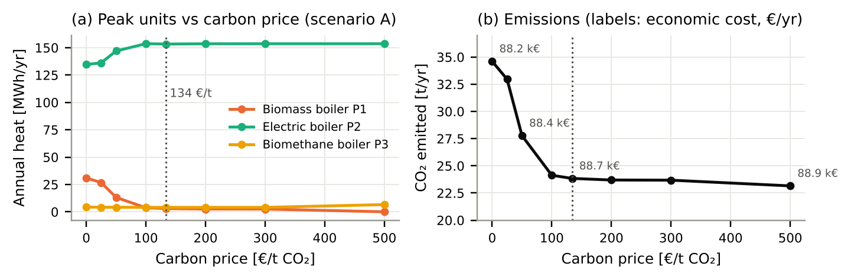
Figure 6. Carbon-price sensitivity of Scenario A (0–500 €/t): (a) heat from peak units, (b) CO₂ with economic cost labels (03_outputs/step5_emissions/sensitivity_carbon_price.csv).
Carbon price [€/t] | 0 | 25 | 50 | 100 | 134 | 200 | 300 | 500
CO₂ [t/yr] | 34.6 | 33.0 | 27.8 | 24.1 | 23.8 | 23.7 | 23.7 | 23.2
Economic cost [k€/yr] | 88.16 | 88.19 | 88.39 | 88.62 | 88.66 | 88.68 | 88.68 | 88.86
Pellet boiler heat [MWh/yr] | 30.9 | 26.7 | 13.2 | 3.7 | 3.0 | 2.6 | 2.6 | 0.04

Biogenic CO₂ rule | A: counted (main) | A: zero | B: counted (main) | B: zero
Heat pumps / pellets / electric / biomethane [MWh/yr] | 2,910 / 3 / 153 / 4 | 2,910 / 31 / 125 / 4 | 2,910 / 0 / 154 / 7 | 2,147 / 115 / 17 / 792
Economic cost [k€/yr] | 88.7 | 88.2 | 88.9 | 153.2
CO₂ incl. biogenic / fossil and electricity only [t/yr] | 23.8 / 21.9 | 34.5 / 21.3 | 23.2 / 21.9 | 211.2 / 14.2

A5. Software and solver. Python 3.12–3.13, DHNx 0.0.4, oemof.solph 0.6.5 [9], Pyomo 6.10.1, CBC 2.10.12 (HiGHS 1.15 as fallback). Step 1: 201 variables, 62 binary, 314 constraints; Step 2: 859 variables, 275 binary, 1,224 constraints; all solved to optimality (MIP gap 0). Steps 3–5 are linear programs over 8,760 hourly time steps (infer_last_interval = True so that the last hour is included).

