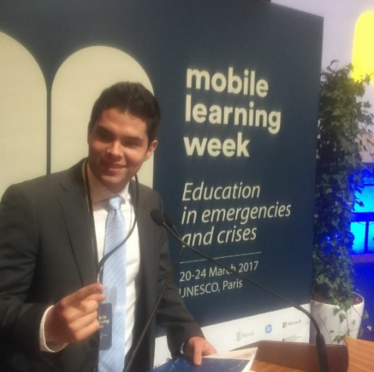

International forums. - 2015 - 2017

**WFUCA UNESCO**

I was invited to be part of some international forums in China and in France

ADITIONAL EXPERIENCES

mechatronics engineering – 2015 - 2020

UNAM – Mexico City, Mexico

EDUCATION

math teacher. - 2014 - 2017

**National school of mathematics** – Mexico city, Mexico

I started at a very young age to teach math and phyisics.

Test automation intern- 2019

**Chamberlain** - Sonora, Mexico

Five months full time internship in the industrial factory where I had the opportunity to work with engineers from Sonora and Chicago.

Major accomplishments:

* Equipment for Mechanical and RF testing
* Engineering presentation in Chicago.

Fullstack dev. - JAN. 2018 - Present

**Freelance** – Mexico city, Mexico

I was responsible for front and back-end web development using html, css, js, PHP, SQL and .net

Major accomplishment:

* National School of Mathematics internal web service.

EXPERIENCE

B1

Native

C1

**A confident and highly creative engineer with a strong passion for design and innovation.**

**Fast learner who loves any type of challenge.**

PROFILE

English

French

Spanish

LabVIEW

Python

MVC

.NET

SKILLS

JavaScript

jQuery

React

PHP

Laravel

SQL

ponx.987@gmail.com

(+52 1)5538942026

LANGUAGES

Alfonso

Vega Garza

MECHATRONIC

ENGINEER