**Assignment 4**

1. Use one hidden layer with 4 hidden units. Plot the error as a function of the number of iterations. Remember the initial weights.

Solution:

clear all

close all

clc

%% input vector

X = [ 0,0;

0,1;

1,0;

1,1];

%% vector %%

t = [0;

1;

1;

0];

input_size = 2;

Hidden_unit = 4;

output_unit = 1;

bias_v = 0.5;

bias_w = 0.5;

max_iteration = 200;

%% choosing the weights in range of -0.5 to 0.5

a = 0.5;

b = -0.5;

V = (b-a).*rand(input_size,Hidden_unit) + a;

W = (b-a).*rand(output_unit,Hidden_unit) + a;

i = 1;

for iteration = 1:max_iteration

Error_value = 0;

for i = 1: 4

%% forward multiplication.

%% level1

Z_In = (X(i,:)*V) + bias_v;

z = 1.0 ./ (1.0 + exp(-Z_In));

z = z';

%% level2

Y_In = W*z + bias_w;

y = 1.0 ./ (1.0 + exp(-Y_In));

%% Backward propagation.%%

%% Find error

Error = t(i) - y;

alpha = 0.9;

%% level 2

Derivative_y = y'*(1-y);

Delta_y = Error * Derivative_y;

Delta_w = alpha * Delta_y .* z;

Delta_w_bias = alpha * Delta_y;

%% level 1

Derivative_z = z' *(1-z);

Delta_z = Derivative_z .* (W * Delta_y');

Delta_v = alpha* Delta_z' * X(i,:);

Delta_v_bias = alpha * sum(Delta_z);

%% update the weights

W = (W' + Delta_w)' ;

bias_w = bias_w + Delta_w_bias;

V= V + Delta_v';

bias_v = bias_v + Delta_v_bias ;

%% incrementing loop

Error_value = Error_value + Error;

end

Error_plot(iteration) = abs(Error_value);

end

plot(Error_plot);

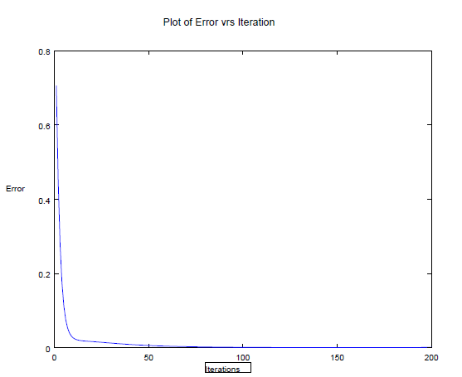

fig 1: Plot Error vrs Iteration using Back propagation method.

1. Verify that momentum term indeed improves convergence ( = 0.5). Use initial weights remembered in (1).

Solution:

clear all

close all

clc

%% input vector

X = [ 0,0;

0,1;

1,0;

1,1];

%% vector %%

t = [0;

1;

1;

0];

input_size = 2;

Hidden_unit = 4;

output_unit = 1;

bias_v = 0.5;

bias_w = 0.5;

max = 60;

%% choosing the weights in range of -0.5 to 0.5

a = 0.5;

b = -0.5;

V = (b-a).*rand(input_size,Hidden_unit) + a;

W = (b-a).*rand(output_unit,Hidden_unit) + a;

i = 1;

past_w = 0;

past_w0 = 0;

past_v = 0;

past_v0 =0;

present_w= W;

present_w0= bias_w ;

present_v= V;

present_v0= bias_v;

for iteration = 1:max

Error_value = 0;

for i = 1: 4

%% forward multiplication.

%% level1

Z_In = (X(i,:)*V) + bias_v;

z = 1.0 ./ (1.0 + exp(-Z_In));

z = z';

%% level2

Y_In = W*z + bias_w;

y = 1.0 ./ (1.0 + exp(-Y_In));

%% Backward propagation.%%

%% Find error

Error = t(i) - y;

alpha = 0.85;

%% level 3

Derivative_y = y'*(1-y);

Delta_y = Error * Derivative_y;

Delta_w = alpha * Delta_y .* z;

Delta_w_bias = alpha * Delta_y;

%% level 2

Derivative_z = z' *(1-z);

Delta_z = Derivative_z .* (W * Delta_y');

Delta_v = alpha* Delta_z' * X(i,:);

Delta_v_bias = alpha * sum(Delta_z);

**%% update the weights**

**myu = 0.5;**

W = (W' + Delta_w)' + myu * (present_w - past_w) ;

bias_w = bias_w + Delta_w_bias + myu* (present_w0 - past_w0);

V= V + Delta_v' + myu*(present_v - past_v) ;

bias_v = bias_v + Delta_v_bias + myu* (present_v0 - past_v0) ;

past_w = present_w;

past_w0 = present_w0;

past_v = present_v;

past_v0 =present_v0;

present_w= W;

present_w0= bias_w ;

present_v= V;

present_v0= bias_v;

%% Finding the total error

Error_value = Error_value + Error;

end

Error_plot(iteration) = abs(Error_value);

end

plot(Error_plot);

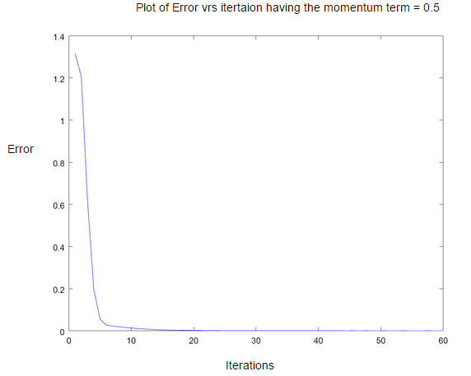

fig 2 Plot of Error vrs iteration having the momentum term = 0.5

1. Repeat (1) using bipolar sigmoid and bipolar representation for X-OR function. The network should converge faster.

Solution:

clear all

close all

clc

%% input vector

X = [ 0,0;

0,1;

1,0;

1,1];

%% vector %%

t = [0;

1;

1;

0];

input_size = 2;

Hidden_unit = 4;

output_unit = 1;

bias_v = 0.5;

bias_w = 0.5;

max = 50;

%% choosing the weights in range of -0.5 to 0.5

a = 0.5;

b = -0.5;

V = (b-a).*rand(input_size,Hidden_unit) + a;

W = (b-a).*rand(output_unit,Hidden_unit) + a;

i = 1;

for iteration = 1:max

Error_value = 0;

for i = 1: 4

%% forward multiplication.

%% level1

Z_In = (X(i,:)*V) + bias_v;

z = Bipolarsigmoid(Z_In);

z = z';

%% level2

Y_In = W*z + bias_w;

y = Bipolarsigmoid(Y_In);

%% Backward propagation.%%

%% Find error

Error = t(i) - y;

alpha = 0.9;

%% level 3

Derivative_y = y'*(1-y);

Delta_y = Error * Derivative_y;

Delta_w = alpha * Delta_y .* z;

Delta_w_bias = alpha * Delta_y;

%% level 2

Derivative_z = z' *(1-z);

Delta_z = Derivative_z .* (W * Delta_y');

Delta_v = alpha* Delta_z' * X(i,:);

Delta_v_bias = alpha * sum(Delta_z);

%% update the weights

W = (W' + Delta_w)' ;

bias_w = bias_w + Delta_w_bias;

V= V + Delta_v';

bias_v = bias_v + Delta_v_bias ;

%% incrementing loop

Error_value = Error_value + Error;

end

Error_plot(iteration) = abs(Error_value);

end

plot(Error_plot);

Bipolarsigmoid.m

function g = Bipolarsigmoid(z)

%SIGMOID Compute sigmoid functoon

% J = BIPOLAR SIGMOID(z) computes the sigmoid of z.

g = (1.0 - exp(-z)) ./ (1.0 + exp(-z));

end

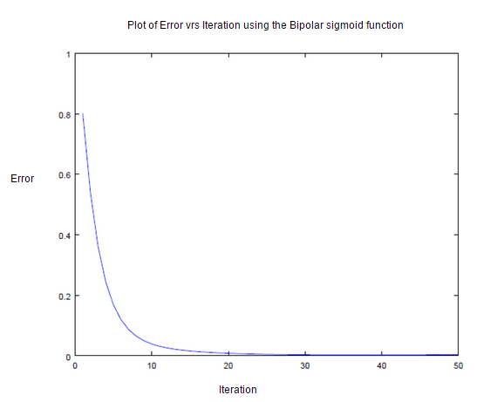

fig 3: Error vrs iteration using Bipolar sigmoid function.

1. Verify that Nguyen – Widrow approach of assigning initial weights improves convergence.

**Solution:**

Set vij to random values between [-0.5, +0.5].

Calculate β = 0.7(h)1/n, where n and h are numbers of input and hidden units, respectively.

Reinitialize weights as vij(new) = β vij(old) / ||vj||. Set bias to a number between [- β, + β].

**Obtained beta value is**  β = 0.7(h)1/n

**h = 4**

**n = 2**

**beta = 1.4;**

clear all

close all

clc

%% input vector

X = [ 0,0;

0,1;

1,0;

1,1];

%% vector %%

t = [0;

1;

1;

0];

input_size = 2;

Hidden_unit = 4;

output_unit = 1;

bias_v = 1;

bias_w = 1;

max = 200;

%% choosing the weights in range of -0.5 to 0.5

a = 0.5;

b = -0.5;

V = (b-a).*rand(input_size,Hidden_unit) + a;

%% Applying Nguyen-Widrow Formula.

beta = 0.7 * (Hidden_unit)^(1/input_size)

V = (beta * V) / norm(V)

W = (b-a).*rand(output_unit,Hidden_unit) + a;

i = 1;

for iteration = 1:max

Error_value = 0;

for i = 1: 4

%% forward multiplication.

%% level1

Z_In = (X(i,:)*V) + bias_v;

z = 1.0 ./ (1.0 + exp(-Z_In));

z = z';

%% level2

Y_In = W*z + bias_w;

y = 1.0 ./ (1.0 + exp(-Y_In));

%% Backward propagation.%%

%% Find error

Error = t(i) - y;

alpha = 0.9;

%% level 3

Derivative_y = y'*(1-y);

Delta_y = Error * Derivative_y;

Delta_w = alpha * Delta_y .* z;

Delta_w_bias = alpha * Delta_y;

%% level 2

Derivative_z = z' *(1-z);

Delta_z = Derivative_z .* (W * Delta_y');

Delta_v = alpha* Delta_z' * X(i,:);

Delta_v_bias = alpha * sum(Delta_z);

%% update the weighs

W = (W' + Delta_w)' ;

bias_w = bias_w + Delta_w_bias;

V= V + Delta_v';

bias_v = bias_v + Delta_v_bias ;

%% incrementing loop

Error_value = Error_value + Error;

end

Error_plot(iteration) = abs(Error_value);

end

plot(Error_plot);

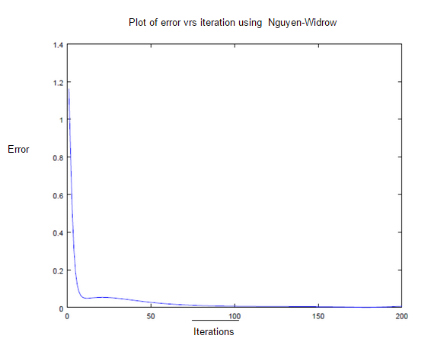

fig 4: plot of error vrs iterations using the Nguyen-Window

1. Use two hidden layers (3 units in the first hidden layer and 2 units in the second hidden layer)

Solution:

clear all

close all

clc

%% input vector

X = [ 0,0;

0,1;

1,0;

1,1];

%% vector %%

t = [0;

1;

1;

0];

input_size = 2;

Hidden_unit1 = 3;

Hidden_unit2 = 2;

output_unit = 1;

bias_v = 0.5;

bias_w = 0.5;

bias_u = 0.5;

max = 200;

%% choosing the weights in range of -0.5 to 0.5

a = 0.5;

b = -0.5;

V = (b-a).*rand(input_size,Hidden_unit1) + a;

U= (b-a).*rand(Hidden_unit1,Hidden_unit2) + a;

W = (b-a).*rand(output_unit,Hidden_unit2) + a;

i = 1;

for iteration = 1:max

Error_value = 0;

for i = 1: 4

%% forwarrd multiplication.

%% level1

Z_In = (X(i,:)*V) + bias_v;

z = 1.0 ./ (1.0 + exp(-Z_In));

z = z';

%% level2

Y_In = U'*z + bias_u;

y = 1.0 ./ (1.0 + exp(-Y_In));

%% level3

P_In = W*y + bias_w;

p = 1.0 ./ (1.0 + exp(-P_In));

%% Backward propagation.%%

%% Find error

Error = t(i) - p;

alpha = 0.9;

%% level 3

Derivative_p = p'*(1-p);

Delta_p = Error * Derivative_p;

Delta_w = alpha * Delta_p .* y;

Delta_w_bias = alpha * Delta_p;

%% level 2

Derivative_y = y *(1-y)';

Delta_y = Delta_p .* W * Derivative_y;

Delta_u = alpha .* (z * Delta_y ) ;

Delta_u_bias = alpha * sum (Delta_y);

%% level 3

Derivative_z = z' *(1-z);

Delta_z = Derivative_z .* (U * Delta_y');

Delta_v = alpha* Delta_z * X(i,:);

Delta_v_bias = alpha * sum(Delta_z);

%% update the weighs

W = (W' + Delta_w)' ;

bias_w = bias_w + Delta_w_bias;

U = U + Delta_u;

bias_u = bias_u + Delta_u_bias ;

V= V + Delta_v';

bias_v = bias_v + Delta_v_bias ;

%% incrementing loop

Error_value = Error_value + Error;

end

Error_plot(iteration) = abs(Error_value);

end

plot(Error_plot);

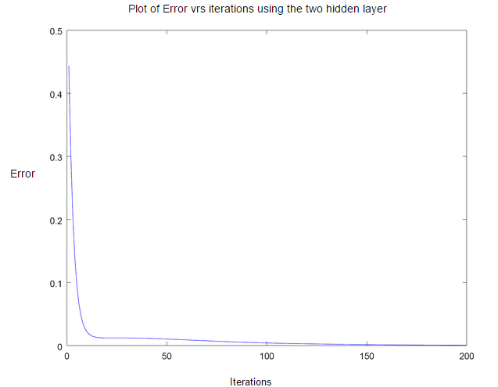

fig 5: plot of error vrs iterations using two hidden layers