PraxeMaster

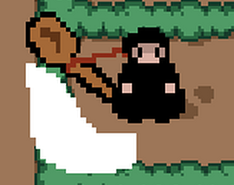

Short Description

PraxeMaster is a survival game where you must survive the hordes of undead engineers, relying only on your trustworthy “Colher da Praxe” and your coffee cup. Beware not to let the zombies gang up on you or it’ll be too late…

Installation

Download the “DDJD-PP-G17-PraxeMaster-game.zip” file and unzip it. Inside that folder, click on “PraxeMaster.exe” and play the game!

Playing Instructions

Move around the map with the “WASD” or arrow keys.

M1 – Primary Fire – Swing the “Colher” in any of the 4 directions (combine the directional key, with M1) or Shoot a Coffee Bullet with the coffee cup in the direction of your mouse.

M2 – Special Attack – Do a Spin Attack if the “Colher” is equipped or charge up with the coffee cup in order to shoot a coffee beam in the direction of your mouse.

E – Switch to the coffee cup

R – Switch to the Colher

When you get to the “fino” threshold, the game will pause for you to pick an upgrade to one of your two weapons:

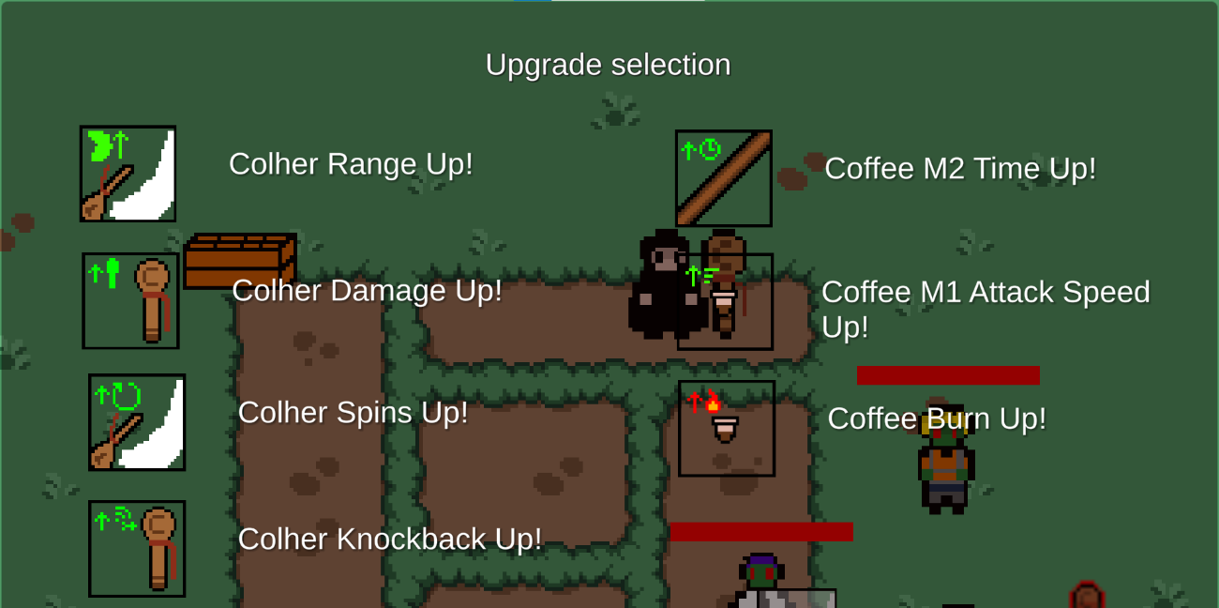

Zombies drop a “fino” on death, so kill as many of them as you can, collect the beers and upgrade your weapons as much as you can until you die! Zombies get progressively stronger as the game goes on longer.

Gameplay

Main Menu

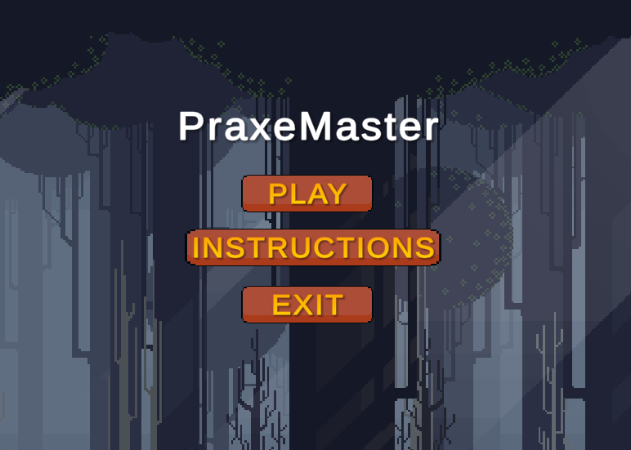

UI



Full UI



Current Player Health and Fino collectible count

M2 cooldown and weapon selection

Developing Process

Resources Used and Corresponding Sources

The assets for the weapons and the player itself were made by us, using Piskel.

The tileset for the map is from the Mystic Woods 16x16 free pack: <https://game-endeavor.itch.io/mystic-woods>

The game process followed a normal order of making the core game mechanics of attacking with both the ranged and melee weapon, then the enemy behavior followed by the various weapon upgrades and finally tweaking some parameters in order to create a somewhat balanced experience.

For the civil engineering’s brick attack the usage of animation curves in Unity proved to be a challenge.

The enemy’s pathfinding uses the A-star algorithm and was implemented with the help of an auxiliary package found here: <https://arongranberg.com/astar/>

Group Members Info

* up201906159 – Miguel Norberto Costa Freitas
* up201906422 - Diogo Miguel Chaves dos Santos Antunes Pereira