A Verifiable AI Interview Practice Coach Designed from Evidence on the AVI Dataset
Jakkarin Kaweepan
[Department / School]
[University]
[City, Country]
[email]
[Advisor name]
[Department / School]
[University]
[City, Country]
[email]

Abstract—Most AI video-interview systems output a score without evidence, and feedback written by large language models (LLMs) can describe behaviour that never happened. We follow an evidence-informed design for a Thai/English interview practice coach. First, we compare six ways (M0–M5) to predict recruiter hireability ratings on the AVI dataset, with cross-validation, a locked 130-person test set, and pre-registered hypotheses. Audio/text features perform best (Spearman ρ = 0.46), beating an answer-length baseline by 0.19; visual features do not help; and LLM scores mostly follow answer length. The ranking holds across four other learners. Second, we turn these findings into design rules for a web prototype that gives no hire score but points at measured behaviour with timestamps. A local LLM (Typhoon 2.5, 4B) writes advice that must cite evidence IDs, and a verifier removes unsupported points. Third, we test the app on 28 staged clips labelled by two annotators. It locates 74% of look-away moments and names the behaviour correctly in 58% of cases, but strict precision is only 13%, mostly from the head-pose classifier, which matches the first finding that the visual channel is weak. Reports from the Typhoon coach and from a rule template both mention 56% of staged problems.
Keywords—asynchronous video interview, automated coaching, evidence-grounded feedback, local LLM, length bias
I. Introduction
Asynchronous video interviews (AVIs) ask candidates to answer questions to a camera with no interviewer present. Practice helps, but practising alone rarely tells a candidate what to fix first or where in the answer the problem is.
Most AI systems for this setting predict a score, such as hireability or personality, without evidence the user can check. Letting an LLM write feedback directly carries two risks: advice may describe behaviour that did not occur, and LLM judges tend to reward length rather than quality [9], [10].
We therefore start from experiments on a dataset rated by experts, to learn which signals agree with expert judgement, and use the findings as design rules for an app, without using any model trained on that dataset to judge users. Our objectives are: (1) to compare methods for predicting expert hireability ratings and measure how much visual, audio and text signals add over answer length (RQ1); (2) to build a local Thai/English web app that points at behaviour with timestamps and gives verifiable advice; and (3) to evaluate its behaviour detection (RQ2) and advice (RQ3) on clips with known ground truth.
II. Related Work
A. Predicting interview outcomes
AVI-Personality [18] contains mock asynchronous interviews from 646 participants, six questions each. At least two of five professional recruiters rated each participant on a 1–5 behaviourally anchored scale, and the mean is the final score; inter-rater agreement is moderate (MAICC 0.32–0.46). In the AVI Challenge [19], teams typically fuse modality-specific encoders [1] or use frozen embeddings with small regressors [2]. RecruitView [3] reports the visual channel as most informative. These works target score accuracy and rarely report an answer-length baseline.
B. Evidence-grounded assessment
E-AVI [4] has an MLLM extract timestamped evidence before scoring and finds that most errors come from wrong evidence. Video-LLM benchmarks show that temporal grounding remains a key weakness [11], which motivates a separate measurement layer.
C. LLM judges and the length shortcut
Zero-shot LLMs agree only weakly to moderately with HR experts on interview transcripts [5] and show scale collapse and cross-model disagreement [6]. Answer length is a recurring shortcut both in interview prediction [7], [8] and in LLM-as-judge settings [9], [10].
D. Practice systems and fairness
AI practice systems such as SimInterview [12] are evaluated mainly by user experience, not by whether behavioural feedback matches the video. Facial analysis in hiring has been criticised as unfair to people who express themselves differently, and a commercial vendor dropped it [20].
E. What is different here
We (1) measure evidence with deterministic tools (MediaPipe, Whisper, Parselmouth) rather than an MLLM; (2) use evidence to write advice instead of scores, with a length baseline in every comparison; and (3) verify each advice point against the evidence log and evaluate on clips with known ground truth.
III. Method
A. RQ1 experiment on AVI
Data. We use answers to questions 1–2. In our copy (644 people) hireability ranges from 1.4 to 4.8 (mean 3.05, SD 0.60). The training pool has 514 people for audio/text features and 300 for visual features (limited by processing time); 130 people were held out from the start. All AVI data was processed only on the researcher’s computer.
Measurement. MediaPipe [13] tracks face, head and hand landmarks, turned into events of at least 1 s (looking away, head down, head turned). WhisperX [15] transcribes English with word timestamps; Thai uses faster-whisper [14] with PyThaiNLP. Parselmouth [16] measures pauses, silence and pitch.
Methods. All six methods use Ridge regression with α chosen by inner cross-validation, and differ only in their inputs (Table I).
Table I. The six compared methods
Method | Inputs
M0 | Answer length (word count, speaking time); baseline
M1 | Hand-written behaviour rule score
M2 | Measured features: audio/text, visual, all
M3 | Answer meaning (MiniLM embedding)
M4 | M3 plus audio/text features
M5 | 1–10 score from a local LLM (qwen2.5 3B), alone and with length or audio/text

Evaluation. During development we used 5-fold cross-validation repeated 20 times. Before opening the test set we pre-registered four hypotheses: (H1) M2 audio/text beats M0; (H2) M3 beats M0; (H3) M5 adds to length; (H4) visual features add to audio/text. The test set was opened once. We report Spearman ρ and paired bootstrap Δρ with 95% CIs, and check robustness with four other learners (ElasticNet, random forest, gradient boosting, SVR) in cross-validation.
B. App design
The app runs on the user’s computer (127.0.0.1). A clip passes through the same measurement layer and becomes an evidence log in which every entry has an ID and a time (S = clip summary, E = visual event, P = pause, T = transcript sentence). Design rules come from RQ1 (Table II); the pipeline is shown in Fig. 1.
Table II. Design rules derived from RQ1
RQ1 evidence | App decision
Best ρ is only moderate (≈0.46) | No hire score
Audio/text carries most signal | Focus on content and delivery
Visual does not help | Video only points at moments
LLM judge follows length | LLM writes advice, never scores
LLMs can make things up | Every point cites evidence; verifier

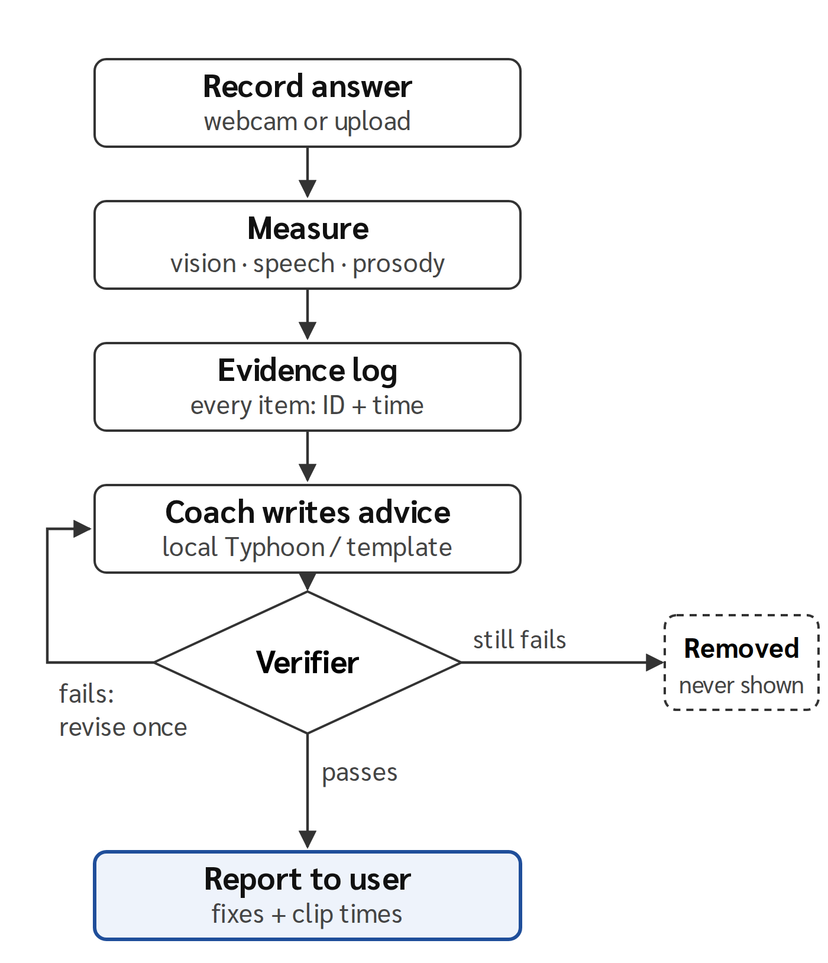
Fig. 1. Pipeline of the app.
Coach. We use Typhoon 2.5 (Qwen3 4B base) [17], 4-bit GGUF i1-Q4_K_M, served by Ollama on a 4 GB GPU laptop (context 6,144 tokens, temperature 0.2), so no data leaves the machine. The model receives the question, rule-based bands, a “most important” section and a compact evidence log, and must return JSON in which each point cites 1–4 evidence IDs.
Verifier. Each point is checked against the full log for unknown IDs, wrong evidence type, time mismatch (±1 s), claims contradicting measured shares, mentions of filler words (not measured), duplicates, and numbers not found in the speech or résumé. A failing point is sent back once for revision and removed if it still fails. A rule-based template coach (no LLM) passes through the same verifier as a comparison.
C. App evaluation (RQ2, RQ3)
Two speakers recorded 14 clips each (7 Thai, 7 English), 28 in total, from scripts with planned problems such as reading notes, turning away, slow start, long pauses, too short or too long answers, plus clean control clips. Two annotators labelled them independently (46 items). For RQ2 an alert counts as a hit when its behaviour type matches and its time overlaps the label (±2 s). For RQ3 we count how many staged problems each coach’s report mentions on the 24 non-control clips, and how many points the verifier removed.
D. Ethics
No AVI data was sent to any cloud service, and no model trained on AVI is used in the app. Test clips come from consenting participants and were processed locally. Users can switch off advice on facial expression, eye contact, gestures or head pose, since people express themselves differently (e.g. autistic candidates); this option was added after the 28-clip evaluation.
IV. Results
A. RQ1: which method agrees with experts?
Audio/text features (M2) agree most with experts on the test set (ρ = 0.46, 95% CI 0.32–0.58); the length baseline reaches 0.27 (0.12–0.41) (Fig. 2). Hypothesis results are in Table III.
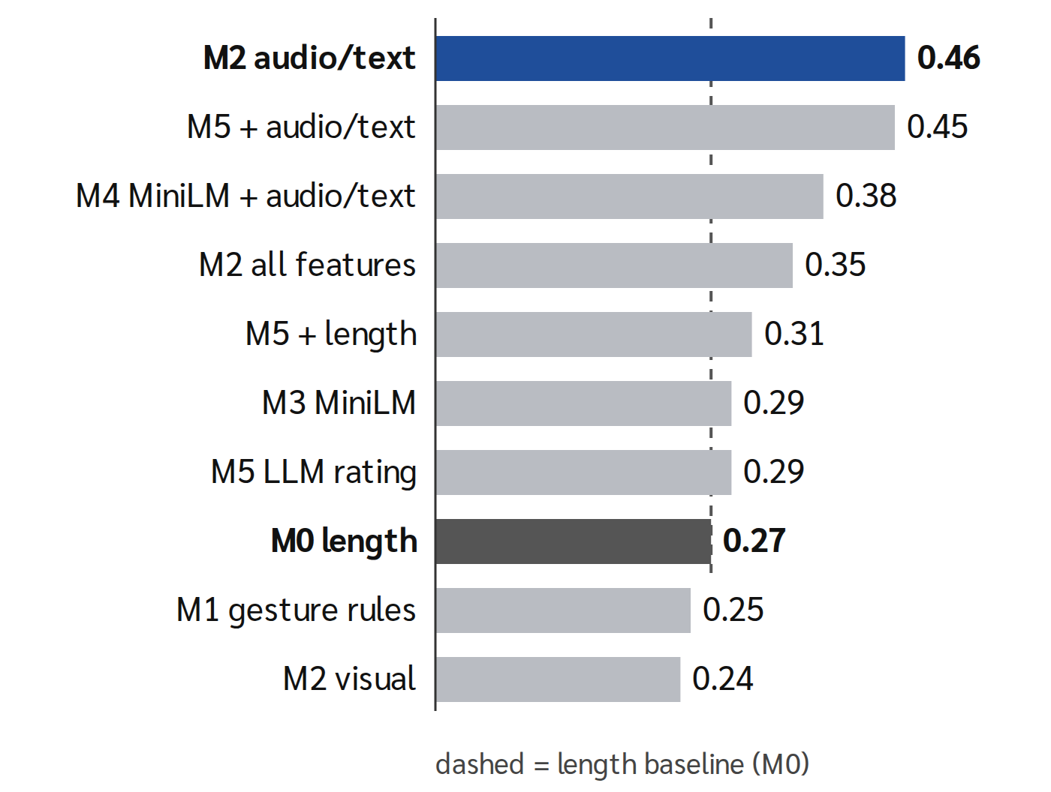
Fig. 2. Spearman ρ of each method on the 130-person AVI test set.
Table III. Pre-registered hypotheses (paired Δρ)
Hypothesis | Δρ [95% CI] | Result
H1 M2 > M0 | +0.19 [0.07, 0.32] | Supported
H2 M3 > M0 | +0.02 [−0.13, 0.17] | No evidence
H3 M5 adds to length | +0.04 [−0.08, 0.17] | No evidence
H4 visual adds | −0.11 [−0.21, −0.01] | Does not help

For H4, models with visual features were trained on 300 people and audio/text on 514. On the same 300 people (a post-hoc check), audio/text reaches 0.366 and adding visual gives 0.353, so the fair reading is that visual features do not help, not that they hurt. M5 scores correlate with word count at ρ = 0.46, more than expert ratings do (0.31), and combining the LLM score with audio/text gives 0.45, no better than M2 alone: the LLM adds no new information.
B. Robustness across learners
In cross-validation on 514 people, audio/text beats length with all five learners (+0.06 to +0.11), visual is lowest for every learner (ρ ≤ 0.13), and a linear learner is best or within 0.02 of best for 7 of 8 feature sets (Table IV).
Table IV. Cross-validated ρ by learner
Set | Ridge | EN | RF | GBM | SVR
M0 length | .33 | .33 | .26 | .20 | .31
M2 audio/text | .39 | .40 | .38 | .31 | .37
M2 visual | .07 | .05 | .07 | .06 | .13
M2 all | .35 | .34 | .34 | .31 | .32
M3 | .41 | .42 | .39 | .35 | .37
M4 | .43 | .45 | .44 | .39 | .39
M5 + length | .39 | .39 | .34 | .27 | .37
M5 + audio | .43 | .43 | .39 | .34 | .39

C. RQ2: behaviour detection
The two annotators agreed on all 46 items, and all 18/18 timed ranges overlapped (mean boundary difference 0.8 s). The app detected 18 of 31 behaviours (recall 58%), and 74% when only the timing of look-away moments must match (Table V).
Table V. Detection by behaviour
Behaviour | Detected
Slow start | 2/2
Too short / too long | 2/2 · 1/1
Hands out of frame | 2/2
Looking away | 2/2
Long pause | 3/4
Turn left / right | 2/2 · 1/2
Fast speech (EN) | 1/2
Head down | 2/6
Neutral face / busy hands | 0/4 · 0/2
Total (recall) | 18/31 = 58%

Missed note-reading moments were logged as looking away at the right time, but the head-pose classifier chose the wrong direction. A neutral face was missed because the expression classifier reported smiling 78–89% of the time. Of 142 alerts, 18 matched a label (precision 13%); most others were head-down alerts (53, including 11 on control clips), suggesting head pitch depends on camera angle.
D. RQ3: advice
During analysis we found a verifier bug that read recommended actions as factual claims and removed correct points. We fixed it and re-checked the saved outputs without calling the LLM again; Table VI reports both versions.
Table VI. Advice on 24 problem clips (41 problems)
Coach / verifier | Mentioned | Kept | Removed
Typhoon v1 | 20/41 = 49% | 28 | 36
Typhoon v2 | 23/41 = 56% | 38 | 26
Template v1 | 20/41 = 49% | 40 | 6
Template v2 | 23/41 = 56% | 46 | 0

Both coaches mention the same share of problems, but more Typhoon points are removed, mostly for citing times not in the evidence. On control clips both gave 5 fix-first points. Typhoon took 333 s per clip on average (124–613 s).
V. Discussion
On AVI, audio/text features predict expert ratings best, visual features do not help, and an LLM judge mostly follows length, in line with the strong role of text [2] and with verbosity bias [9], [10]. Because even the best result is moderate, close to the raters’ own agreement, the app gives no hire score; it points at behaviour with timestamps, lets a local LLM write evidence-citing advice, and removes points that cannot be verified.
The staged-clip test shows that speech and timing measurements are reliable, while finer visual classifiers are not, matching RQ1. The verifier itself must also be tested against ground truth, since an over-strict verifier removes correct advice. Our main message is that AI can help interview practice when it points at what was actually measured, rather than judging the person.
Limitations. AVI is English and only one rated dataset was used; hireability comes from at least two raters with moderate agreement; the test clips are staged by two speakers; some measurement thresholds are hand-set; and advice was checked for coverage, not audited point by point by humans.
VI. Conclusion and Future Work
We showed how experimental evidence can shape an interview practice coach: measure first, score nothing, cite everything, and verify. Future work will test across datasets and with more real users, including people who express themselves differently; calibrate head pose to each user’s camera to cut false alarms; add human audits of each advice point and filler-word counting; and try larger local LLMs as hardware allows.
References
[1] “Listening to the unspoken: Exploring ‘365’ aspects of multimodal interview performance assessment,” arXiv:2507.22676, 2025.
[2] Hung, Suen, Yeh, and Wang, “Frozen multimodal embeddings for AI-assisted interview assessment of personality and cognitive ability,” arXiv:2606.11930, 2026.
[3] Gupta, Sheth, et al., “RecruitView: A multimodal dataset for predicting personality and interview performance for HR applications,” arXiv:2512.00450, 2025.
[4] Wang, Che, Xie, Du, Hua, and Wang, “E-AVI: Evidence-grounded multimodal assessment for automated video interviews,” arXiv:2609.20001, 2026.
[5] “Towards smarter hiring: Are zero-shot and few-shot pre-trained LLMs ready for HR spoken interview transcript analysis?” arXiv:2504.05683, 2025.
[6] Zhu, Sheng, Liu, and Tan, “Scale collapse, model disagreement, and false precision: A multi-model audit of LLM behavioral interview scoring,” Preprints.org 202607.1567, 2026.
[7] I. Naim, M. I. Tanveer, D. Gildea, and M. E. Hoque, “Automated prediction and analysis of job interview performance,” arXiv:1504.03425, 2015.
[8] L. Hickman, N. Bosch, V. Ng, R. Saef, L. Tay, and S. E. Woo, “Automated video interview personality assessments: Reliability, validity, and generalizability investigations,” J. Appl. Psychol., 2022.
[9] L. Zheng et al., “Judging LLM-as-a-judge with MT-Bench and Chatbot Arena,” in Proc. NeurIPS, 2023.
[10] Z. Hu et al., “Explaining length bias in LLM-based preference evaluations,” arXiv:2407.01085, 2024.
[11] “VideoZeroBench,” arXiv:2604.01569, 2026.
[12] “SimInterview,” arXiv:2508.11873, 2025.
[13] C. Lugaresi et al., “MediaPipe: A framework for building perception pipelines,” arXiv:1906.08172, 2019.
[14] A. Radford et al., “Robust speech recognition via large-scale weak supervision,” in Proc. ICML, 2023.
[15] M. Bain, J. Huh, T. Han, and A. Zisserman, “WhisperX: Time-accurate speech transcription of long-form audio,” in Proc. Interspeech, 2023.
[16] Y. Jadoul, B. Thompson, and B. de Boer, “Introducing Parselmouth: A Python interface to Praat,” J. Phonetics, 2018.
[17] SCB 10X, “Typhoon 2.5 (Qwen3 4B),” 2025. [Online]. Available: https://huggingface.co/mradermacher/typhoon2.5-qwen3-4b-i1-GGUF
[18] Zhang, Shang, Koutsoumpis, Zong, de Vries, and Zheng, “AVI-Personality: A trait-activated multimodal dataset for personality and competency assessment in asynchronous video interviews,” arXiv:2608.25316, 2026.
[19] Zhang et al., “Assessing personality traits and interview performance from asynchronous video interviews,” in Proc. ACM MM, 2025, pp. 13895–13900.
[20] SHRM, “HireVue discontinues facial analysis screening,” 2021. [Online]. Available: https://www.shrm.org/in/topics-tools/news/talent-acquisition/hirevue-discontinues-facial-analysis-screening

