A Verifiable AI Interview Practice Coach Designed from Evidence on the AVI Dataset

Jakkarin Kaweepan
School of Information Technology
King Mongkut’s Institute of Technology Ladkrabang
Bangkok, Thailand
67070208@kmitl.ac.th
Pongsura Pongpisan
School of Information Technology
King Mongkut’s Institute of Technology Ladkrabang
Bangkok, Thailand
67070253@kmitl.ac.th
Anuntapat Anuntachai
School of Information Technology
King Mongkut’s Institute of Technology Ladkrabang
Bangkok, Thailand
anuntapat.an@kmitl.ac.th

Abstract—Most AI video-interview systems output a score without evidence, and feedback written by large language models (LLMs) can describe behaviour that never happened. We follow an evidence-informed design for a Thai/English interview practice coach. First, we compare six ways (M0–M5) to predict recruiter hireability ratings on the AVI dataset, with cross-validation, a locked 130-person test set, and pre-registered hypotheses. Audio/text features perform best (Spearman ρ = 0.46), beating an answer-length baseline by 0.19; visual features do not help; and LLM scores mostly follow answer length. The ranking holds across four other learners. Second, we turn these findings into design rules for a web prototype that gives no hire score but points at measured behaviour with timestamps. A local LLM (Typhoon 2.5, 4B) writes advice that must cite evidence IDs, and a verifier removes unsupported points. Third, we test the app on 28 staged clips labelled by two annotators. It locates 74% of look-away moments and names the behaviour correctly in 58% of cases, but strict precision is only 13%, mostly from the head-pose classifier, which matches the first finding that the visual channel is weak. Reports from the Typhoon coach and from a rule template both mention 56% of staged problems.
Keywords— asynchronous video interview, automated coaching, evidence-grounded feedback, local LLM, length bias

Introduction
Asynchronous video interviews (AVIs) ask candidates to answer questions to a camera with no interviewer present. Practice helps, but practising alone rarely tells a candidate what to fix first or where in the answer the problem is.
Most AI systems for this setting predict a score, such as hireability or personality, without evidence the user can check. Letting an LLM write feedback directly carries two risks: advice may describe behaviour that did not occur, and LLM judges tend to reward length rather than quality [9], [10].
We therefore start from experiments on a dataset rated by experts, to learn which signals agree with expert judgement, and use the findings as design rules for an app, without using any model trained on that dataset to judge users. Our objectives are: (1) to compare methods for predicting expert hireability ratings and measure how much visual, audio and text signals add over answer length (RQ1); (2) to build a local Thai/English web app that points at behaviour with timestamps and gives verifiable advice; and (3) to evaluate its behaviour detection (RQ2) and advice (RQ3) on clips with known ground truth.
The contributions are empirical evidence of which signals agree with recruiters, with a length baseline and pre-registered hypotheses; design rules for a coach that cites evidence instead of scoring, together with a verifier; and a prototype that never sends video off the user’s computer, plus a set of test clips labelled by two annotators.

LITERATURE REVIEW

Predicting interview outcomes
AVI-Personality [18] contains mock asynchronous interviews from 646 participants, six questions each. At least two of five professional recruiters rated each participant on a 1–5 behaviourally anchored rating scale (BARS), and the mean is the final score; inter-rater agreement is moderate (MAICC 0.32–0.46). BARS ties each score level to observable example behaviours to reduce differences in interpretation, yet even with it the target scores carry their own noise, which limits how closely any model can match them. In the AVI Challenge [19], teams typically fuse modality-specific encoders [1] or use frozen embeddings with small regressors [2]. RecruitView [3] reports the visual channel as most informative. These works target score accuracy and rarely report an answer-length baseline.

Evidence-grounded assessment
E-AVI [4] has an MLLM extract timestamped evidence before scoring and finds that most errors come from wrong evidence. Video-LLM benchmarks show that temporal grounding remains a key weakness [11], which motivates a separate measurement layer.

LLM judges and the length shortcut
Zero-shot LLMs agree only weakly to moderately with HR experts on interview transcripts [5] and show scale collapse and cross-model disagreement [6]. Answer length is a recurring shortcut both in interview prediction [7], [8] and in LLM-as-judge settings [9], [10].

Practice systems and fairness
AI practice systems such as SimInterview [12] are evaluated mainly by user experience, not by whether behavioural feedback matches the video. Facial analysis in hiring has been criticised as unfair to people who express themselves differently, and a commercial vendor dropped it [20].

Statistical methods
Spearman ρ measures how well a predicted ranking matches the true ranking, from −1 to 1; it suits ratings with many ties when ranking matters more than absolute values. To compare two methods we use a paired bootstrap: participants in the test set are resampled with replacement many times, both methods’ ρ are computed on the same resample, and the central 95% of the differences forms the confidence interval. If it excludes 0, one method is better. Hypotheses, metrics and decision rules were pre-registered before the test set was opened, to prevent selective reporting. Ridge regression is linear regression with an L2 penalty on coefficients, which makes it robust when features are many relative to about 500 training people; we use it for all methods so that differences come only from the inputs. During development we use repeated k-fold cross-validation split by participant, so one person’s answers never appear in both training and test folds.

What is different here
We (1) measure evidence with deterministic tools (MediaPipe, Whisper, Parselmouth) rather than an MLLM; (2) use evidence to write advice instead of scores, with a length baseline in every comparison; and (3) verify each advice point against the evidence log and evaluate on clips with known ground truth.

Methodology

A. RQ1 experiment on AVI
We use answers to questions 1–2. In our copy (644 people) hireability ranges from 1.4 to 4.8 (mean 3.05, SD 0.60). The training pool has 514 people for audio/text features and 300 for visual features (limited by processing time); 130 people were held out from the start. All AVI data was processed only on the researcher’s computer.
MediaPipe [13] tracks face, head and hand landmarks, turned into events of at least 1 s (looking away, head down, head turned). WhisperX [15] transcribes English with word timestamps; Thai uses faster-whisper [14] with PyThaiNLP. Parselmouth [16] measures pauses, silence and pitch. This yields 45 clip-level features, 17 audio/text and 28 visual (Table I), and a participant’s features are the mean over the two answers. Features that reflect detection quality rather than behaviour, such as the number of usable frames, are excluded, and mean pitch is dropped because it mainly encodes speaker gender. The three length features belong to the audio/text group, so M2 versus M0 measures what the other features add beyond length. Filler counts are usable for AVI, but on new clips Whisper usually drops fillers, so the app does not advise on them.
- Features used in M2 by group
Group | Measured values | n
Length | clip duration, word count, speaking time | 3
Speech rhythm | speech and articulation rate; count, mean, max and total of pauses; long pauses | 7
Fillers | count and ratio of transcribed fillers | 2
Voice | pitch variation, intensity, jitter, HNR, silence ratio | 5
Gaze | camera-gaze ratio, iris position and stability, no-face ratio | 6
Head | pitch, yaw and roll (mean, SD, range) | 8
Hands | hand presence, movement speed, fidgeting | 5
Face | smile ratio, mouth opening and width, brows, eyes, expressiveness | 9
All six methods use Ridge regression with α chosen by inner cross-validation, and differ only in their inputs (Table II).
- The six compared methods
Method | Inputs
M0 | Answer length (word count, speaking time); baseline
M1 | Hand-written behaviour rule score
M2 | Measured features: audio/text, visual, all
M3 | Answer meaning (MiniLM embedding)
M4 | M3 plus audio/text features
M5 | 1–10 score from a local LLM (qwen2.5 3B), alone and with length or audio/text
During development we used 5-fold cross-validation repeated 20 times. Before opening the test set we pre-registered four hypotheses: (H1) M2 audio/text beats M0; (H2) M3 beats M0; (H3) M5 adds to length; (H4) visual features add to audio/text. The test set was opened once. We report Spearman ρ and paired bootstrap Δρ with 95% CIs, and check robustness with four other learners (ElasticNet, random forest, gradient boosting, SVR) in cross-validation.

B. App design
The app runs on the user’s computer (127.0.0.1). A clip passes through the same measurement layer and becomes an evidence log in which every entry has an ID and a time (S = clip summary, E = visual event, P = pause, T = transcript sentence). Design rules come from RQ1 (Table III); the pipeline is shown in Fig. 1.
- Design rules derived from RQ1
RQ1 evidence | App decision
Best ρ is only moderate (≈0.46) | No hire score
Audio/text carries most signal | Focus on content and delivery
Visual does not help | Video only points at moments
LLM judge follows length | LLM writes advice, never scores
LLMs can make things up | Every point cites evidence; verifier
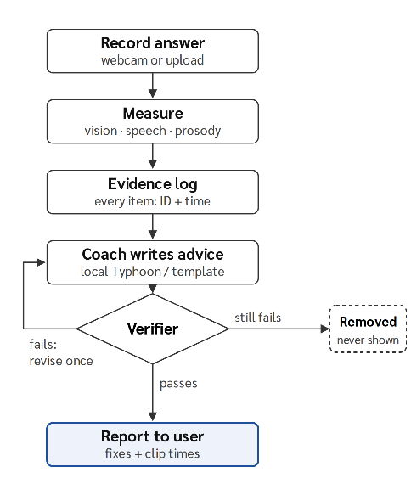
- Pipeline of the app
The prototype is a web app (FastAPI, HTML and JavaScript) running on the user’s laptop. It has three modes, single-question practice, a continuous multi-question interview and opening past reports, and can also generate questions from a résumé. The user picks Thai or English and a coach, records an answer with the browser camera, and receives a report ordered as fixes first, then strengths, an event timeline and an improved sample answer, with no hire score (Fig. 2). The cloud coach and résumé-based question generation send text only, never video, and only after the user ticks a consent box.
An excerpt of one clip’s evidence log: [S2] head turned left 56%, down 40% of measured time · [S4] smiling 78%, neutral 22% · [P1] silence before the first word, 0–1.1 s · [S7] filler words: not measured, the recogniser drops them.
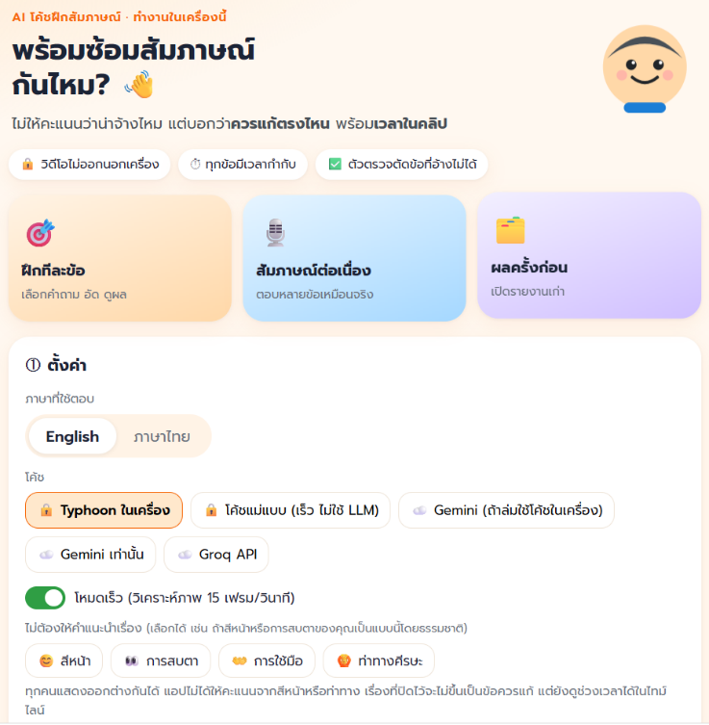
- Home screen of the web app (Thai interface)
We use Typhoon 2.5 (Qwen3 4B base) [17], 4-bit GGUF i1-Q4_K_M, served by Ollama on a 4 GB GPU laptop (context 6,144 tokens, temperature 0.2), so no data leaves the machine. The model receives the question, rule-based bands, a “most important” section and a compact evidence log, and must return JSON in which each point cites 1–4 evidence IDs. The response has four parts: an overall summary, strengths, fixes and an improved sample answer. Each fix states its dimension (e.g., eye contact, head pose or answer quality), priority, the problem, next-time action steps and the cited evidence IDs. The improved answer quotes one span of the transcript, rewrites it and explains why it is better. All parts are written in both Thai and English.
Each point is checked against the full log for unknown IDs, wrong evidence type, time mismatch (±1 s), claims contradicting measured shares, mentions of filler words (not measured), duplicates, and numbers not found in the speech or résumé. A failing point is sent back once for revision and removed if it still fails. A rule-based template coach (no LLM) passes through the same verifier as a comparison.

C. App evaluation (RQ2, RQ3)
Two speakers recorded 14 clips each (7 Thai, 7 English), 28 in total, from scripts with planned problems such as reading notes, turning away, slow start, long pauses, too short or too long answers, plus clean control clips. Two annotators labelled them independently (46 items). Both speakers used the same 14 scripts (Table IV). Content and filler problems are used only for RQ3 because the app does not measure them directly, which leaves 31 measurable behaviours for RQ2. For RQ2 an alert counts as a hit when its behaviour type matches and its time overlaps the label (±2 s). For RQ3 we count how many staged problems each coach’s report mentions on the 24 non-control clips, and how many points the verifier removed.
- Test clip scripts (same for both speakers)
Clip | Lang | Staged problems
1 | TH | None (control)
2 | TH | Head down reading notes
3 | TH | Slow start (≥3 s) + long pause (≥3 s)
4 | TH | Turn left + turn right
5 | TH | Hands out of frame + neutral face
6 | TH | Too short (<30 s) + no concrete example
7 | TH | Too fast + filler words
8 | EN | None (control)
9 | EN | Looking away
10 | EN | Long pause
11 | EN | Head down (two periods)
12 | EN | Busy hands + neutral face
13 | EN | Too long (>150 s) + no concrete example
14 | EN | Too fast + filler words

D. Ethics
No AVI data was sent to any cloud service, and no model trained on AVI is used in the app. Test clips come from consenting participants and were processed locally. Users can switch off advice on facial expression, eye contact, gestures or head pose, since people express themselves differently (e.g., autistic candidates); this option was added after the 28-clip evaluation.

Experimental and Results

RQ1: which method agrees with experts?
Audio/text features (M2) agree most with experts on the test set (ρ = 0.46, 95% CI 0.32–0.58); the length baseline reaches 0.27 (0.12–0.41) (Fig. 3). Hypothesis results are in Table V.
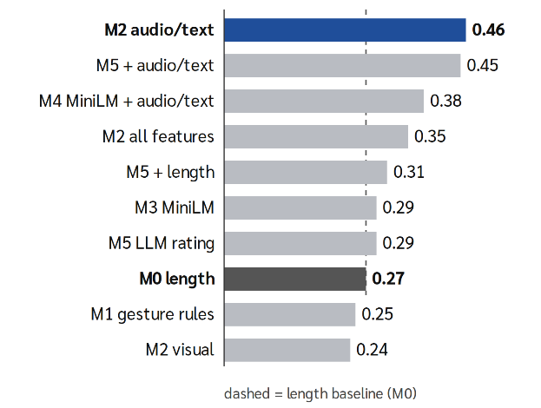
- Spearman ρ of each method on the 130-person AVI test set

- Pre-registered hypotheses (paired Δρ)
Hypothesis | Δρ [95% CI] | Result
H1 M2 > M0 | +0.19 [0.07, 0.32] | Supported
H2 M3 > M0 | +0.02 [−0.13, 0.17] | No evidence
H3 M5 adds to length | +0.04 [−0.08, 0.17] | No evidence
H4 visual adds | −0.11 [−0.21, −0.01] | Does not help
For H4, models with visual features were trained on 300 people and audio/text on 514. On the same 300 people (a post-hoc check), audio/text reaches 0.366 and adding visual gives 0.353, so the fair reading is that visual features do not help, not that they hurt. M5 scores correlate with word count at ρ = 0.46, more than expert ratings do (0.31), and combining the LLM score with audio/text gives 0.45, no better than M2 alone: the LLM adds no new information.

Robustness across learners
In cross-validation on 514 people, audio/text beats length with all five learners (+0.06 to +0.11), visual is lowest for every learner (ρ ≤ 0.13), and a linear learner is best or within 0.02 of best for 7 of 8 feature sets (Table VI).
- Cross-validated ρ by learner
Set | Ridge | EN | RF | GBM | SVR
M0 length | .33 | .33 | .26 | .20 | .31
M2 audio/text | .39 | .40 | .38 | .31 | .37
M2 visual | .07 | .05 | .07 | .06 | .13
M2 all | .35 | .34 | .34 | .31 | .32
M3 | .41 | .42 | .39 | .35 | .37
M4 | .43 | .45 | .44 | .39 | .39
M5 + length | .39 | .39 | .34 | .27 | .37
M5 + audio | .43 | .43 | .39 | .34 | .39
Note: EN = ElasticNet, RF = random forest, GBM = gradient boosting.
The learning curve in Fig. 4 trains on random subsets of participants within each fold, repeated 20 times. Audio/text stays above length at every size and levels off after about 200 people (0.37–0.38), whereas visual stays near zero and reaches only 0.06 at 240 people. Visual features therefore do not lose merely because they have less data, which supports the H4 conclusion. In the model with all features, the two largest standardised weights are speech features, silence ratio (−0.08) and the longest pause (−0.05): more silence and longer pauses go with lower ratings (exploratory).
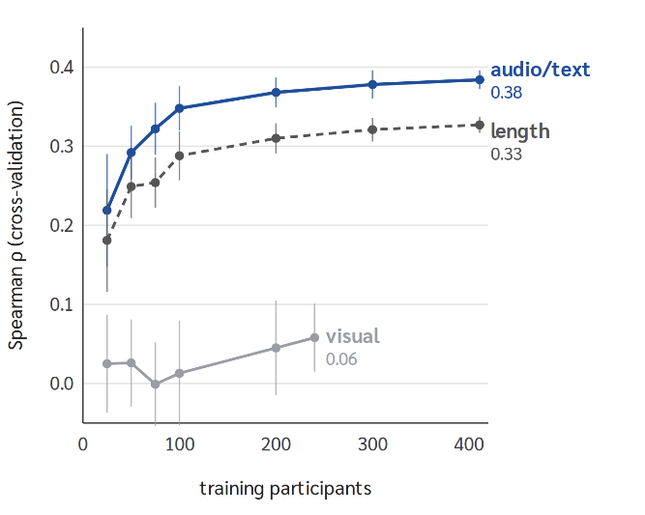
- Learning curve: cross-validated Spearman ρ as training size grows (dots = mean of 20 repeats, bars = ±1 SD)

RQ2: behaviour detection
The two annotators agreed on all 46 items, and all 18/18 timed ranges overlapped (mean boundary difference 0.8 s). The app detected 18 of 31 behaviours (recall 58%), and 74% when only the timing of look-away moments must match (Table VII).
- Detection by behaviour
Behaviour | Detected
Slow start | 2/2
Too short / too long | 2/2 · 1/1
Hands out of frame | 2/2
Looking away | 2/2
Long pause | 3/4
Turn left / right | 2/2 · 1/2
Fast speech (EN) | 1/2
Head down | 2/6
Neutral face / busy hands | 0/4 · 0/2
Total (recall) | 18/31 = 58%
Missed note-reading moments were logged as looking away at the right time, but the head-pose classifier chose the wrong direction. A neutral face was missed because the expression classifier reported smiling 78–89% of the time. Of 142 alerts, 18 matched a label (precision 13%); most others were head-down alerts (53, including 11 on control clips), suggesting head pitch depends on camera angle.

RQ3: advice
During analysis we found a verifier bug that read recommended actions as factual claims and removed correct points. We fixed it and re-checked the saved outputs without calling the LLM again; Table VIII reports both versions.
- Advice on 24 problem clips (41 problems)
Coach | Mentioned | Kept | Removed
Typhoon v1 | 20/41 = 49% | 28 | 36
Typhoon v2 | 23/41 = 56% | 38 | 26
Template v1 | 20/41 = 49% | 40 | 6
Template v2 | 23/41 = 56% | 46 | 0
Note: v1 = original verifier; v2 = verifier after the bug fix, applied to the same saved outputs.
Both coaches mention the same share of problems, but more Typhoon points are removed, mostly for citing times not in the evidence. On control clips both gave 5 fix-first points. Typhoon took 333 s per clip on average (124–613 s).
Table IX shows points the verifier removed from Typhoon reports after one failed revision. The first two are correct removals: the coach cited evidence IDs that do not exist, and a number and topic that were not measured. The last shows an over-strict check: advising a right turn back to the camera is reasonable, but the rule matched the direction literally against the evidence “turned left”.

- Examples of points removed by the verifier
Coach’s point (short) | Reason removed
Strength: full STAR structure (cites T4–T9) | T4–T9 are not in the evidence log
Answer too long (104.3 s), with filler-like pauses (cites P3) | P3 is a pause at 25.4–31.9 s, not answer length; fillers are not measured
At 17.3–25.9 s, turn slightly right to face the camera (cites E13) | E13 records “turned left”, not “turned right”
Note: Points from the Typhoon coach, checked with verifier v1.

Conclusion

Summary and discussion
On AVI, audio/text features predict expert ratings best, visual features do not help, and an LLM judge mostly follows length, in line with the strong role of text [2] and with verbosity bias [9], [10]. Because even the best result is moderate, close to the raters’ own agreement, the app gives no hire score; it points at behaviour with timestamps, lets a local LLM write evidence-citing advice, and removes points that cannot be verified.
Several reasons may explain why visual features do not help. First, they come from only two answers per person and vary with camera angle and lighting, as RQ2 shows with frequent false head-down alerts. Second, the 28 visual features are many and correlated relative to only 300 people with video. Third, recruiters may weigh content and delivery more than gestures. This differs from RecruitView [3], which reports the visual channel as most informative, possibly because of different data, rating methods and feature extractors, so it should not be generalised. For this work, however, scoring faces and gestures carries a fairness risk [20] without adding accuracy, which supports using video only to point at moments and letting users switch such advice off.
The staged-clip test shows that speech and timing measurements are reliable, while finer visual classifiers are not, matching RQ1. The verifier itself must also be tested against ground truth, since an over-strict verifier removes correct advice. Our main message is that AI can help interview practice when it points at what was actually measured, rather than judging the person.

Limitations
AVI is English and only one rated dataset was used; hireability comes from at least two raters with moderate agreement; the test clips are staged by two speakers; some measurement thresholds are hand-set; and advice was checked for coverage, not audited point by point by humans. In addition, visual data covered only 300 people versus 514 for audio/text; although the learning curve suggests that visual features barely improve with more data, they were not tested on the full sample. The verifier still matches directions and numbers literally, so it removes some reasonable advice (Table IX), and the Typhoon coach takes about 5.6 minutes per clip on a 4 GB GPU laptop, which is too slow for instant interactive practice.

Future Directions
Cross-dataset tests, for example on RecruitView [3], should check whether the ranking found on AVI holds, and a Thai interview dataset rated by at least two recruiters is needed because all RQ1 results are in English. The fairness of the measurement layer should be checked across user groups such as gender, accent and language, and the app should be tested on real, unstaged clips where behaviour is less clear-cut.
First, head pose should be calibrated to each user’s camera, for example by recording a short neutral pose first, to cut the false head-down alerts behind the low precision. Second, the verifier should separate corrective advice, such as “turn right back to the camera”, from factual claims, and its own accuracy should be measured against human judgement. Third, a speech recogniser that keeps filler words would allow measuring and advising on them. Fourth, the processing time of about 5.6 minutes per clip should be reduced, for example by showing speech and timing results first while the LLM writes advice, or by trying other local LLMs as hardware allows.
Studies with more users practising repeatedly should test whether advice actually improves measured behaviour, such as start delay, long pauses and answer length. Humans should audit each advice point for truth and usefulness, and people who express themselves differently, such as autistic candidates, should be included to judge whether switching off certain advice is enough.

References

