1.> Create DataBase "student_records" ?

use student_records

2.> create Collection "student, teacher, etc"?

db.createCollection(“student”)
db.createCollection(“teacher”)

3.> Insert a Document in following format in student collection
{
"address": {
"building": "74",
"street": "sector 19",
"zipcode": "201302"
},
"email": "a@b.com",
"stdname": "abc",
"grades": [
{ "date": new Date(), "grade": "A", "score": 2,"subject":"Java" },
{ "date": new Date(), "grade": "A", "score": 6, "subject":"C" },
{ "date": new Date(), "grade": "A", "score": 10,"subject":"C++" },
{ "date": new Date(), "grade": "A", "score": 9, "subject":"PHP" },
{ "date": new Date(), "grade": "B", "score": 14, "subject":"MongoDB" }
],
"std_id": "30075445"
}

db.student.insert(
{
"address": {
"building": "74",
"street": "sector 19",
"zipcode": "201302"
},
"email": "a@b.com",
"stdname": "abc",
"grades": [
{ "date": new Date(), "grade": "A", "score": 2,"subject":"Java" },
{ "date": new Date(), "grade": "A", "score": 6, "subject":"C" },
{ "date": new Date(), "grade": "A", "score": 10,"subject":"C++" },
{ "date": new Date(), "grade": "A", "score": 9, "subject":"PHP" },
{ "date": new Date(), "grade": "B", "score": 14, "subject":"MongoDB" }
],
"std_id": "30075445"
} )

4.> Insert a document inside teacher collection

db.teacher.insert({“name”:Mrs Nandita Goyal”,”subject”:”Edp”})

5.> Write a query to show all collection, documents?

db.showCollections()

db.student.find().pretty()

db.teacher.find().pretty()

6.> Query to show only email,stdname of all the student?

db.student.find({},{“stdname”:1,”email”:1})

7.> Query to show 5 student records, those have more than 10 score in C++?

8.> Query to show student those having more than 15 total score?

9.> Query to show students Java and C grades records?

10.> how to get only _id form student collect?

db.student.find({},{“_id”:1})

11.> Insert 10 records inside teacher collection together?

db.teacher.insert(
[
{"name":"A","subject":"Java"},
{"name":"B","subject":"C"},
{"name":"C","subject":"Java"},
{"name":"D","subject":"C++"},
{"name":"E","subject":"Php"},
{"name":"F","subject":"C"},
{"name":"G","subject":"Java"},
{"name":"H","subject":"C++"},
{"name":"I","subject":"MongoDb"},
{"name":"J","subject":"C"},
{"name":"K","subject":"C++"},
{"name":"L","subject":"Php"}
])

12.> NoSQL vs RDBMS

13.> query to show student stdname whose street is sector 19

db.student.find({“address.street”:”sector 19”},{“stdname”:1})

14.> query to show only zipcode of student

db.student.find({},{“address.zipcode”:1,”_id”:0})

15.> drop collections

16.> drop database

db.dropDatabase()

Screenshot 1-4

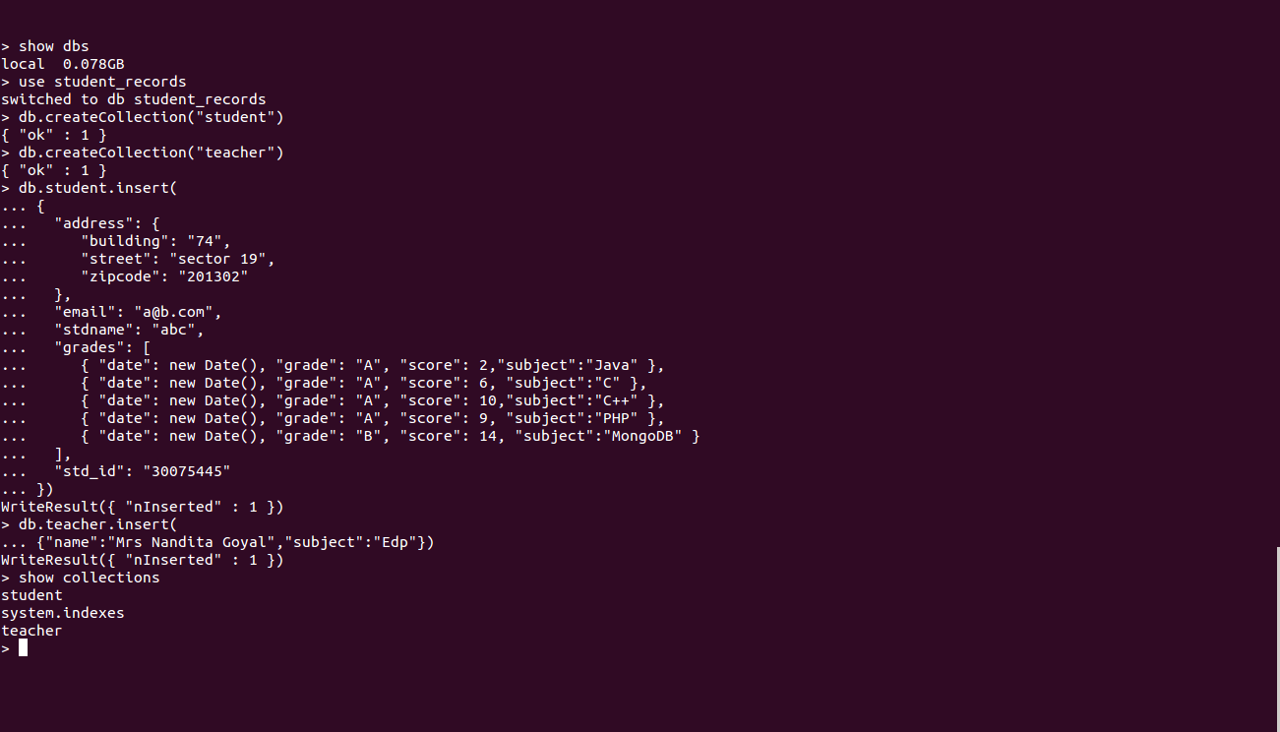

Screenshot -5

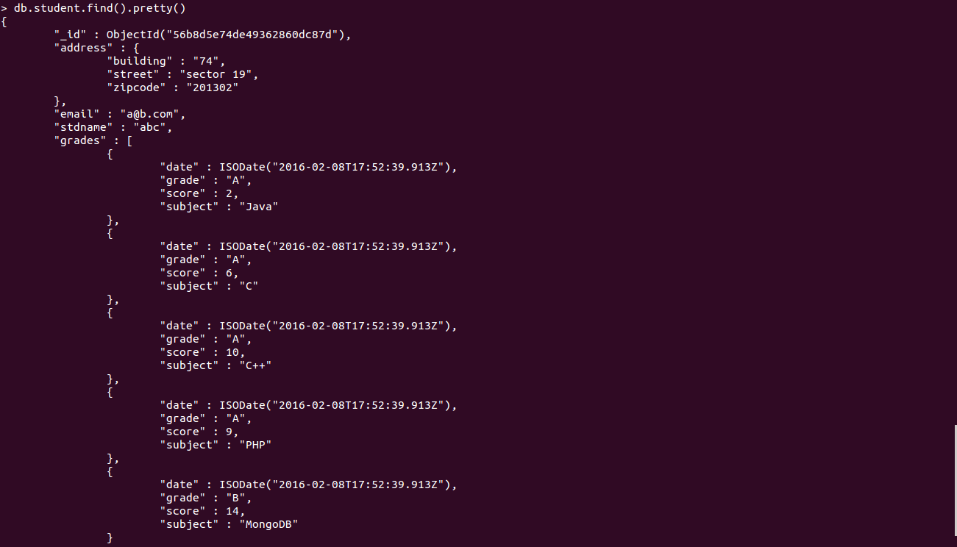

Screenshot – 5,6

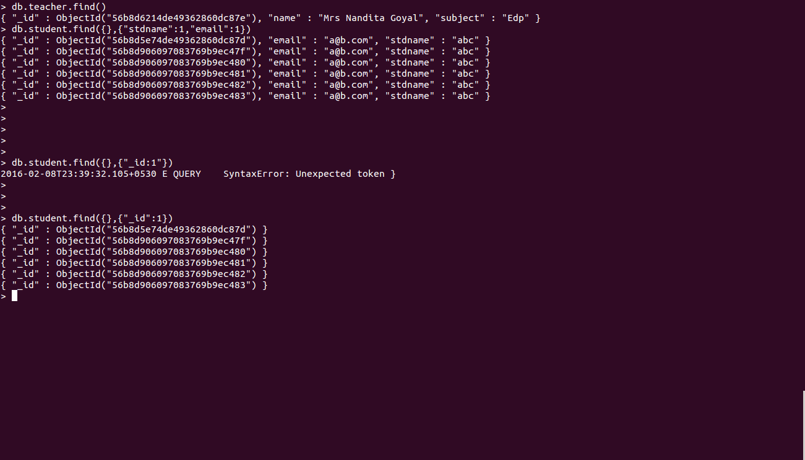

Screenshot – 10

Screenshot –11



Screenshot -13

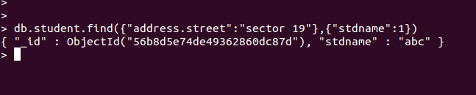
Screenshot -14

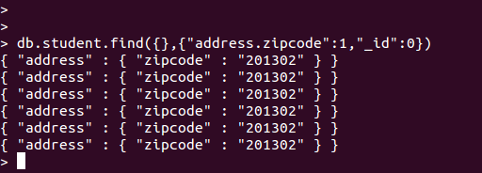

Screenshot -16

