HTML
HTML (Hypertext Markup Language) is the most basic building block of the Web. It defines the meaning and structure of web content. Other technologies besides HTML are generally used to describe a web page's appearance/presentation (CSS) or functionality/behaviour (JavaScript).
"Hypertext" refers to links that connect web pages to one another, either within a single website or between websites. Links are a fundamental aspect of the Web.
HTML (HyperText Markup Language) uses markup (called tags) to describe and structure content on a web page. These tags tell the web browser how to display text, images, links, tables, forms, and other elements.
< Starts a tag or declaration | < Starts a tag or declaration
> Ends a tag or declaration | > Ends a tag or declaration
</tag> Closing tag | </tag> Closing tag
<!DOCTYPE html> Declares the document as HTML5 | <!DOCTYPE html> Declares the document as HTML5
html Root element of the page | html Root element of the page
Attributes provide additional information about an element.
HTML entities are a way to represent characters that have special meanings in HTML or are not easily typed on a standard keyboard. These entities start with an ampersand (&) and end with a semicolon (;). They are used to display reserved characters, invisible characters, or characters that are difficult to type.
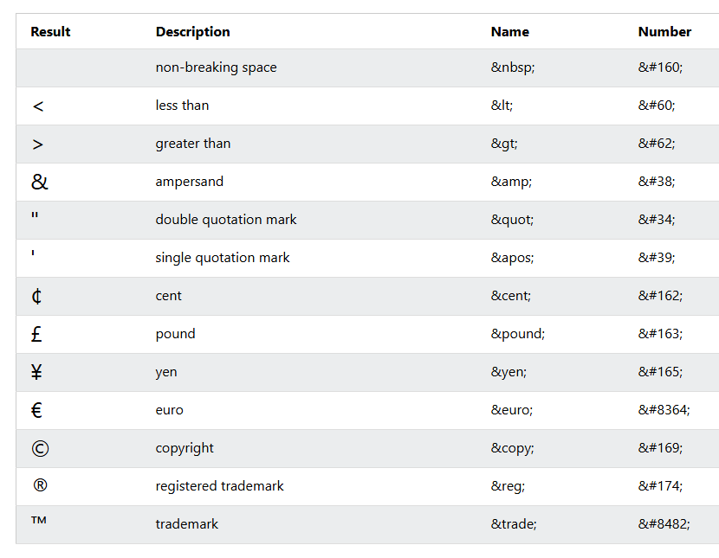
Semantic tags clearly describe their meaning and purpose to both the browser and developers, rather than just defining presentation.
